DESIGN AND FABRICATION OF FRICTIONLESS BRAKING SYSTEM

Submitted in partial fulfilment of the requirements of the degree of

**Bachelor of Engineering**

(In The Subject Mechanical Engineering)

By

**NIKHILA VIJAY PATIL NITIN PARSHURAM KHULE**

**PREETI RAMKRUSHNA JADHAV SUSHANT DATTU CHORAGHE**

Under the guidance of

**Prof. Amol J. Ghude**



**Department of Mechanical Engineering**

**Datta Meghe College of Engineering**

Sector-3, Airoli, Navi Mumbai-400708, India.

University of Mumbai 2019-2020

**Datta Meghe College of Engineering**

**Department of Mechanical Engineering**

Plot No.98, Sector 3, Airoli, Navi Mumbai, Maharastra-400708 Affiliated to University of Mumbai

**CERTIFICATE**

This is to certify that the project entitled “**Design and Fabrication of Frictionless Braking System**”is a bonafide work of “**Nikhila Vijay Patil, Nitin Parshuram Khule, Preeti Ramkrushna Jadhav, Sushant Dattu Choraghe**” submitted to the University of Mumbai in partial fulfilment of the requirement for the award of the degree of “Undergraduate” in “**Bachelor of Engineering in the Subject Mechanical Engineering**”.

( Prof. Amol J. Ghude) ( Prof. Rajesh R. Shekapure)

**(Guide) (Co-Guide)**

( Prof. (Dr.) Vilas B. Shinde) (Prof. (Dr) S.D. Sawarkar)

**(Head of the Department) (Principal)**

**Datta Meghe College of Engineering**

**Department of Mechanical Engineering**

Plot No.98, Sector 3, Airoli, Navi Mumbai, Maharastra-400708 Affiliated to University of Mumbai

**Project Report Approval**

This project report entitled “**DESIGN AND FABRICATION OF FRICTIONLESS BRAKING SYSTEM**”by **Nikhila Vijay Patil, Nitin Parshuram Khule, Preeti Ramkrushna Jadhav, Sushant Dattu Choraghe,** is approved for the degree of Bachelor of Engineering.

Examiner 1

Examiner 2

Date:

Place:

**Declaration**

We hereby declare that written submission represents our ideas in our own words and where others ideas or words have been included, we have been adequately cited and referenced the original sources. We also declared that we have adhered to all principles of academic honesty and integrity and have not misrepresented or fabricated or falsified any idea/data/fact/source in our submission. We understand that any violation of the above will be cause for disciplinary action by the institute and can also evoke penal action from the sources which have thus not been properly cited or from whom proper permission has not been taken when needed.

(Nikhila Vijay Patil)

(Nitin Parshuram Khule)

(Preeti Ramkrushna Jadhav)

(Sushant Dattu Choraghe)

Date: /06/2020

**Acknowledgement**

We sincerely express my deep sense of gratitude to my guide **Prof. Amol J. Ghude** and Head of the Department, **Prof. (Dr). Vilas Shinde**, for his valuable guidance and encouragement during the course if this work.

We are also thankful to **Prof. (Dr). S.D. Savarkar**, Principal and other staff member of Mechanical Engineering Department who are involved in making this part of the project successful.

Last but not the least, we acknowledge our friends and family for their contribution, continuous support and encouragement in the completion of the project.

# Abstract

Majority of braking systems work on the principle of dissipation of kinetic energy to heat energy. This method has its own drawbacks and must be replaced with a more reliable braking system that is quick in response, doesn’t heat up and is maintenance free.

This project is about development and analysis of Frictionless braking system. In which it is planned to demonstrate the “Design and Fabrication of Frictionless Braking System”, where, it shows the Copper’s or Aluminium is sudden reaction to Strong Neodymium Magnets. Braking System should ensure the safety and comfort of the passenger or pillion, driver and other road user. The brake must be strong enough to stop the vehicle during emergency within shortest distance. A frictionless braking system tends to increase life span and reliability of the components of brakes since absence of friction leads to less wearing of brakes also it requires less maintenance and lubrication as compared to other braking mechanisms.

The conventional braking systems are bulky and power to weight ratio is low. Proper lubrication and maintenance must be used to operate braking system safely, effective and progressive with minimum fatigue to driver. Frictionless braking system is high-tech braking system which we found in locomotives, trains, and roller coasters. This project is about introducing frictionless braking system in motorcycle in order to increase efficiency and safety to avoid accidents. It also reduces the maintenance of braking system. The effectiveness of brake increases. This system provides better response time for emergency situations.

# Table of Contents

Abstract 1

Table of Contents 2

List of Figures 5

List of Tables 7

Nomenclature 8

Chapter 01: Introduction 10

1.1-Various Convectional Types of Brakes 10

1.2-Background of Frictionless brakes 12

1.3- Problem Statement 13

1.4-Objective 13

1.5-Scope 14

1.6-Expected Outcomes 14

Chapter 02: Literature Review 15

2.1-Review of finding 15

Chapter 03: Research Methodology 17

3.1-Flow Chart 17

3.2-Action plan 18

Chapter 04: Working of Fictional Braking 19

4.1-Fictionless Braking 19

Chapter 05: Concept of Neodymium Magnet 21

5.1-Discription 22

5.2-History 22

5.3-Production 23

5.4-Corrosion problems 23

5.5-Magnetic Properties 24

5.6- Hazards 26

5.7-Applications 26

Chapter 06: Material Selection 29

6.1- The mechanical properties of the metals 29

6.2-Concepts of General Selection of Material 30

6.3-Material Used 32

6.4-Tools Used 33

6.5-Raw Material & Standard Material 35

Chapter 07: Cost Estimation 36

7.1- Purpose of Cost Estimation 36

7.2-Tyres of Cost Estimation 36

7.3- Procedure for calculation of Material Cost 37

7.4-Labour Cost 37

7.5-Calculation of total Cost 38

Chapter 08: Machine Design 41

8.1-Consideration in Machine Design 41

8.2-General Procedure in Machine Design 42

Chapter 9: Calculation 43

9.1-Motor Design 43

9.2-To Find Reduction Ratio 44

9.3-Pully Design 47

9.4-Shaft Design 47

9.5-Bearing Selection 48

9.6-Design of Transverse Fillet Welded Part 49

9.7-Design of Angle Stand 49

9.8-Design of Bolt 50

9.9-Braking Time Calculation For Disc Brake 51

Chapter 10: 2D Drafting 54

10.1-2D Drafting of Frictionless Braking System 54

10.2-Bill of Material 55

10.3-2D Drafting of Parts 57

Chapter 11: Manufacturing& Result 65

11.1-Frame Manufacturing 67

11.2-Shaft Manufacturing 68

11.3-Pulley Manufacturing 69

11.4-Slide Bush Manufacturing 70

11.5-Results 71

Chapter 12: Maintenance 72

12.1-Autonomous Maintenance Activity 72

12.2-Cleaning 72

12.3-Visual Aids to Maintain Correct Equipment Condition 73

12.4-Equipment Responsibility of operator 75

Chapter 13: Bibliography 76

13.1-Address of Supplier 76

13.2-Refrences 77

# List of Figures

Figure(1.1):T bolt-skid brakes[1] 10

Figure(1.2): Steel roller coaster -Fin brakes[2] 11

Figure(1.3): linear Frictionless brake in a German ICE 3high-speed train in action[3] 12

Figure(3.1): Flow chart of Methodology/ experimental setup 17

Figure(4.1): Frictionless Braking System 19

Figure(4.2):Usable Magnetic Field 20

Figure(6.1): Mild Steel plate 33

Figure(6.2): Steel plate cutter 33

Figure(6.3): Welding machine & Figure(6.4): Lathe Machine 33

Figure(6.5): Drill machine & Figure(6.6): Electric motor 33

Figure(6.7): Iron angles & Figure(6.8): Steel file tool 34

Figure(6.9): Vices & Figure(6.10): Measuring tape 34

Figure(10.1): 2D Drafting of Frictionless Braking system 54

Figure(10.2): Bill of Material 55

Figure(10.3): 100 mm Pulley 57

Figure(10.4): 75 mm Pulley 57

Figure(10.5): V-Belt 58

Figure(10.6): Stopping Plate 58

Figure(10.7): Magnetic Disc 59

Figure(10.8): Main Frame 59

Figure(10.9): Shaft 60

Figure(10.10): Countersunk Hex Head Bolt M8 60

Figure(10.11) : M8 Bolt 61

Figure(10.12): Hex Screw M8 61

Figure(10.13): M8 Nut 62

Figure(10.14): M10 Nut 62

Figure(10.15): M8 Washer 63

Figure(10.16): M10 Washer 63

Figure(10.17): Shaft 64

Figure(10.18): Hood 64

Figure(11.1): CAD model of frictionless braking system 66

Figure(11.2): Basic fabrication of frictionless brakes 66

Fig(11.3): Graph of Braking time VS Distance 71

# List of Tables

Table(3.1): Action Plan 18

Table(5.1): Comparison of magnetic performance of neodymium magnets with other types of permanent magnets. 25

Table(6.1): Raw Material & Standard Material 35

Table(7.1): Raw Material Cost& Standard Part Cost 38

Table(7.2): Direct Labour Cost 39

Table(10.1): Bill of Material 56

Table(11.1): Transformation Process 65

Table(11.2): Frame Manufacturing 67

Table(11.3): Shaft Manufacturing 68

Table(11.4): Pulley Manufacturing 69

Table(11.5): Slide Bush Manufacturing 70

Table(11.6): Result of Braking effect 71

Table(12.1): Cleaning Inspection 73

Table(12.2): Chronic Defects 74

# Nomenclature

|  |  |
| --- | --- |
| Bmax | Maximum magnetic flux density |
| Br | Flux Density |
| Hci | Permanence |
| hp | Horse power |
| hr/day | Hour per day |
| kA/m | Kilo Ampere per meter |
| kg | Kilogram |
| kgf | Kilogram-force |
| kgf/cm | Kilogram-force per centimeter |
| kmph | Kilo meter per hour |
| kw | Kilo watt |
| m | Meter |
| m/s | Meter per second |
| mm | Millimeter |
| mm2 | Meter square |
| N | Newton |
| N/mm2 | Newton per meter square |
| N-m | Newton meter |
| N-mm | Newton millimeter |
| rpm | Radian per minute |
| T | Tesla |
| Tc | Case temperature |

|  |  |
| --- | --- |
| W | Watt |
| OC | Centigrade Celsius |
| OF | Fahrenheit |

# Chapter 01: Introduction

This chapter professes about the background of the project along with its objective, scope and its expected outcomes. The background gives the detail idea of why this project was chosen and what are its basic requirements. A sketch of approved concept and also its reasoning is given. The objective and scope stream towards the methodology to be adopted for the project.

## 1.1-Various Convectional Types of Brakes

Various types of braking exist when dealing with roller coasters, some of which have been recently developed due to technological advancements in design.

1. **Skid Brakes**

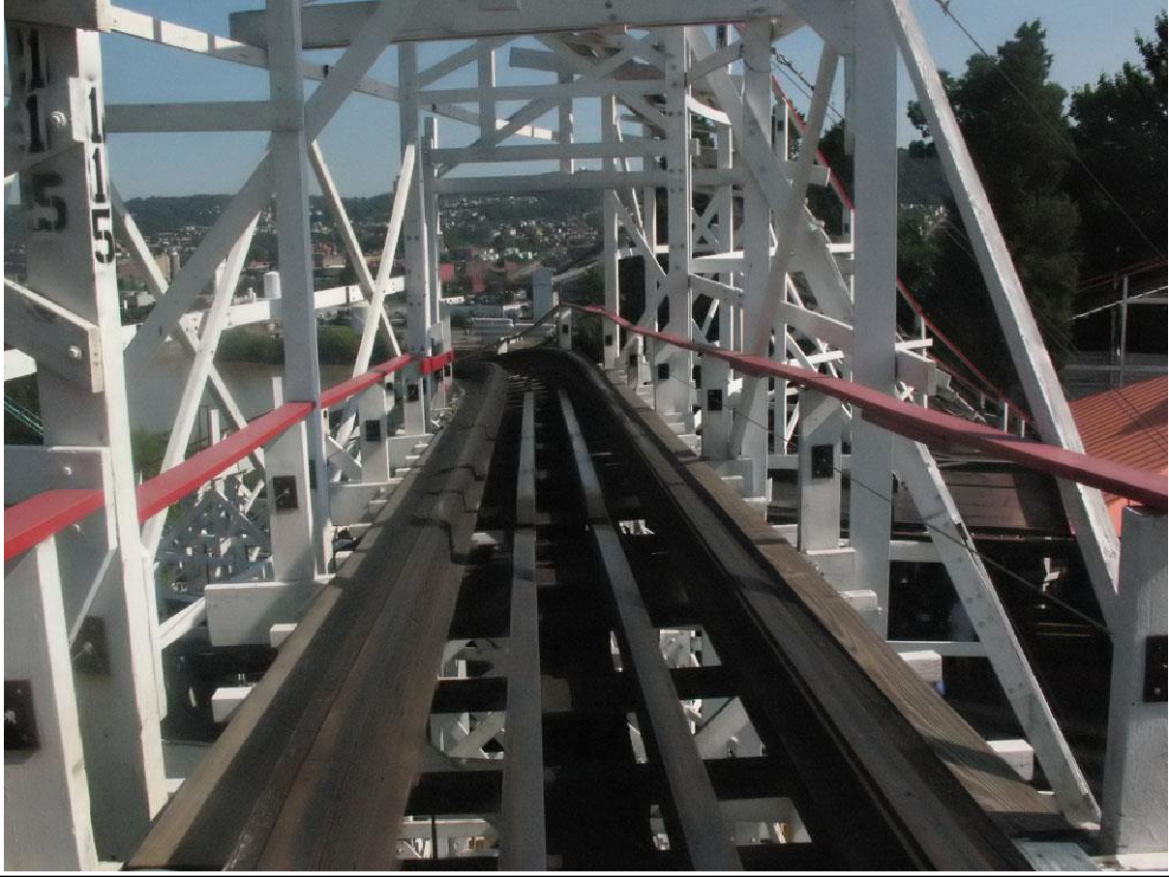

**Figure(1.1):**T bolt-skid brakes[1]

Skid brakes essentially involve a long piece of material, often ceramic-covered, situated in the middle of the track parallel to the rails. When the brake is engaged, the skid raises and friction against the underside of the train causes the train to slow and eventually stop. Skid brakes were one of the first advancements in roller coaster braking and are typically not utilized in modern

creations with the exception of Twister at Knoebels Amusement Park in Elysburg, PA and the Matterhorn at Disneyland in California[2]

1. **Fin Brakes**

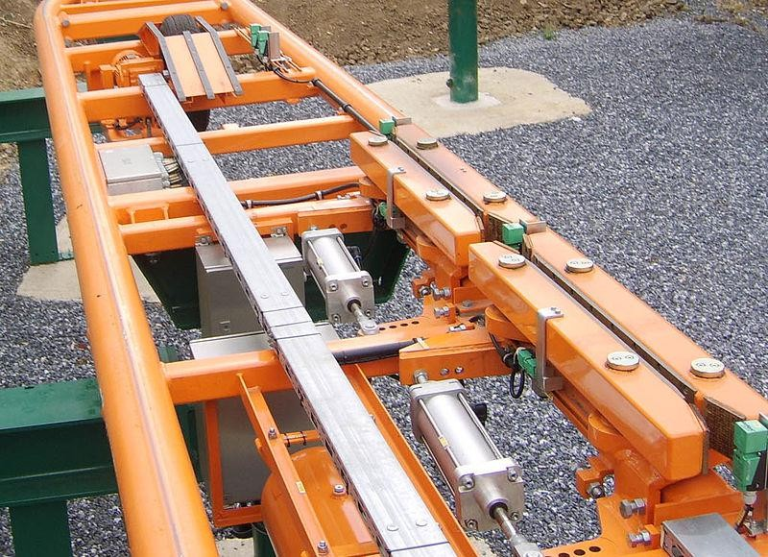

**Figure(1.2):** Steel roller coaster -Fin brakes[3]

Fin brakes involve a metal fin being attached to the underside of a train. The track is fitted with two computer-controlled squeezing mechanisms which upon closing, squeeze the fin and either slow or stop the train. Fin brakes are the most common form of brakes on roller coasters today. Sometimes they are thick metal box beams (mostly on Bolliger & Mabillard roller coasters), others are thin metal plates. They slide between pairs of friction pads similar to automotive brake pads. Fin brakes are designed to be fail-safe, so that a loss of power will cause them to engage. Brakes are constructed according to a certain measure of redundancy, meaning the ride is usually fitted with one extra set of brakes to bring the train to a hold even if one brake fails. Closing is done by a bellow type of air operated actuator. Each set of brakes is fitted with its own air supply system and normally opened supply valves which actuate the brake in a closed position in case a power down occurs. A heavy springs, usually made of steel, is used to open the brake.

## 1.2-Background of Frictionless brakes

Frictionless brakes are a relatively new technology that is beginning to gain popularity due to their high degree of safety. Rather than slowing a train via friction (such as air or pneumatic brakes), which can often be affected by various elements such as rain, Frictionless brakes rely completely on certain magnetic properties and resistance.

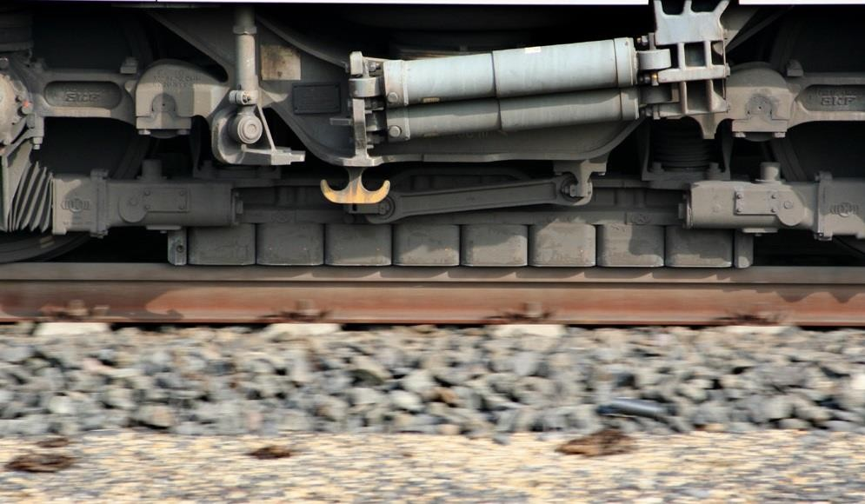

**Figure(1.3):** linear Frictionless brake in a German ICE 3high-speed train in action[4]

In locomotive frictionless brakes are made up of one or two rows of neodymium magnets. When a metal fin (typically copper or a copper/aluminium alloy) passes between the rows of magnets, eddy currents are generated in the fin, which creates a magnetic field opposing the fin's motion. The resultant braking force is directly proportional to the speed at which the fin is moving through the brake element.

Frictionless brakes are silent and are much smoother than friction brakes, gradually increases braking power so that the people on the ride do not experience rapid changes in deceleration. Many modern roller coasters, especially those being manufactured by Intiman, have utilized frictionless braking for several years. Another major roller coaster designer implementing these brakes is Bollinger & Maxillary in 2004 on their Silver Bullet inverted coaster, making it the first suspended roller coaster to feature magnetic brakes, and again used them on their newer projects, such as Leviathan at Canada's Wonderland.[5] These later applications have proven effectively comfortable and relevant for these inverted coasters which often give the sense of

flight. There also exist third party companies such as Magnatar tech.[6] which provide various configurations of the technology to be used to replace and retrofit braking systems on existing roller coasters to increase safety, improve rider comfort, and lower maintenance costs and labor.

## 1.3- Problem Statement

The conventional brakes used in current automobile vehicles have two major problems. One is, wear and tear and other is unnecessary excessive temperature attained during the motion which results in reduction in efficiency of braking system. Hence, we are trying to make Frictionless brakes which have better efficiency with no wear and tear.

## 1.4-Objective

* 1. To design and fabricate Frictionless Braking system with greater performance replacing conventional braking system.
  2. To achieve better braking efficiency.
  3. To increase the reliability and life span of brakes. 04-To obtain optimum heat dissipation.

05-To increase power to weight ratio. 06-To reduce the maintenance cost.

07-To analyses the stresses in braking system.

## 1.5-Scope

1. Frictionless brakes satisfy all the energy requirements of braking without use of friction. They have better heat dissipation capability to avoid problems that friction brake faces with the time.
2. With the help of frictionless braking system, the braking time is reduced.
3. They can also use as supplementary retardation equipment in addition to the regular friction brakes in heavy vehicles.
4. These brake components have less cost, so the installation cost is less. 05-With the use of this technology noise will be reduced.

This can be used as an alternative method for the future crisis of the oils.

## 1.6-Expected Outcomes

1. Braking efficiency and safety of vehicle increases. 02-Stopping time of vehicle decreases.

03-Stopping distance of vehicle decreases. 04-Power consumption of vehicle reduces. 05-Heat dissipation rate increases.

# Chapter 02: Literature Review

This chapter briefs about the findings of the research paper. The research papers related to the topic are discussed and reviewed. The literature gap explains about the uniqueness of the project as referred from the review.

## 2.1-Review of finding

1. Ajay Yadav : 2013

Area of Interest: Electromagnetic brakes in two wheelers.

Electromagnetic brakes can be applicable in two wheeler at high speed with low maintenance cost. Electromagnetic brake slows or stops the motion using electromagnetic force. Hence the name is electromechanical brakes but over the years it is change to electromagnetic brakes. It was used in mid 20th century specially in trains and trolleys and for variety of application. Both the electromagnetic brakes and eddy current brakes use electromagnetic force but electromagnetic brakes ultimately depend on friction and eddy current brakes use magnetic force directly[7].

1. Sergey Kitanov and Anatoly Podol’skii : 2008

Area of Interest: Eddy current and magnetic rail brakes for high speed trains

A rail brake that combines both the magnetic rail brake and eddy current brake permits profitable braking action through the range of acceptable speed. These brakes are characterized by least feasible mass and dimension. The magnetic eddy current brakes containing permanent magnet pieces offer several advantages over convention braking system[8].

1. Akshaykumar S. Puttewar, Nagnath U. Kakade : 2014 Area of Interest: Electromagnetic brakes in automobile

In oil braking system or air braking system even a small leakage may lead to complete failure of brakes. While in electromagnetic braking system as four disc plates, coils and firing circuits are attached individually on each wheel, even any coil fails the brake does not completely fails and remaining three coils work properly. This system needs very low maintenance. In addition, it is found that electromagnetic brakes make up approximately 80% of all of the power applied brake applications[9].

# Chapter 03: Research Methodology

This chapter used pictorial tools to justify the process and methodology followed for the execution of the project. It shows a flow chart and action plan of the process.

## 3.1-Flow Chart

The chart describes about the process flow of the project along with the detail fragmentation of the steps to be followed.



Studying Frictionless Braking system working principle

Introduction of components

Selection of material

Design of Braking System

Manufacturing of Braking System and Stress analysis

Analysis of Braking System

To get experimental result

**Figure(3.1):** Flow chart of Methodology/ experimental setup

## 3.2-Action plan

**Table(3.1):** Action Plan

|  |  |  |  |  |
| --- | --- | --- | --- | --- |
| SR NO | PROJECT ACTIVITIES | RESOURCE | STAT DATE | COMP DATE |
| 1 | PLANNING THE TASK | Humble Guide | 19/8/19 | 14/9/19 |
| 2 | MARKET SURVEY | T.T.C.M.I.D.C. | 4/10/19 | 18/10/19 |
| 3 | DESIGN & PLANNING THE FABRICATION PROCESS | WITH HOMBLE GUIDE | 14/12/19 | 28/12/19 |
| 4 | PREPAIRING DRAWING AND ESTIMATION OF MATERIAL | GROUP DISCUSSION | 3/01/2020 | 17/01/2020 |
| 5 | MARKET SURVEY FOR PURCHASE AND PROCURING THE MATERIAL | SURROUNDING MARKET | 30/1/2020 | 8/02/2020 |
| 6 | PLANNING AND PROCESS | TOOL ROOM | 21/2/2020 | 23/02/2020 |
| 7 | MANUFACTURING THE SUBCOMONENTS | TOOL ROOM/WORKSHOP | 28/2/2020 | 04/06/2020 |
| 8 | ASSEMBLY | WORKSHOP | 05/06/2020 | 08/06/2020 |
| 9 | COMPARATIVE STUDY | GROUP DISCUSSION | - | - |

# Chapter 04: Working of Fictional Braking

## 4.1-Fictionless Braking

When an electrical conductor, such as copper or aluminium, moves through the field of a permanent magnet or an electromagnet, electromagnetic induction creates eddy currents, which dissipate some of the kinetic energy into Joule heat and results in slowing the motion of the conductor.[10]

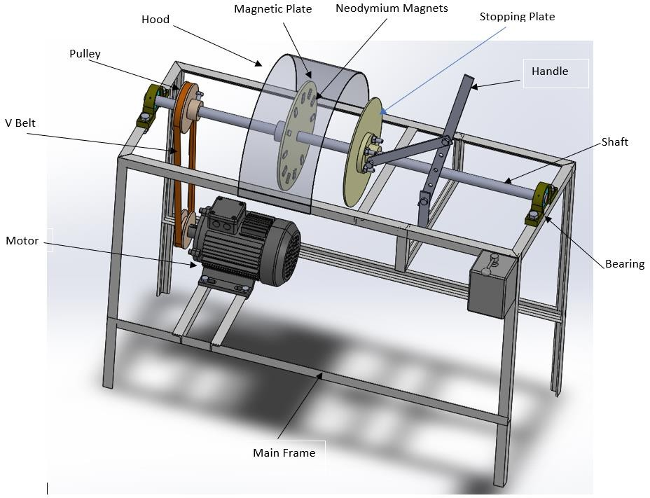

**Figure(4.1):** Frictionless Braking System

This principle is utilized in the construction of frictionless brakes. This Demonstration shows frictionless braking applied to a rotating metallic plate. Frictionless braking can also find applications in roller coasters and railroad trains, in which the metallic conductor has the shape of a linear rail. In contrast to conventional friction brakes, there is no direct contact between interacting surfaces, which makes frictionless braking more reliable and reduces wear and tear. A frictionless brake is a device that leverages strong magnetic forces to stop vehicle. There are various different types of frictionless brake systems, including ones that use electromagnets to actuate traditional friction pads, and those that leverage magnetic repulsion itself to provide resistance. These can be found on a variety of vehicles, from trains to roller coasters.

By increasing or decreasing the amount of electric current, the stopping power of an Eddy current electromagnetic brake can be correspondingly attenuated up or down. Rather than pads pressing harder on a rotor, the resistive magnetic force is applied on rotor. Though there is no physical contact, the process still generate heat, as a result of the resistance. It is also known as eddy current brake systems. [11]

A sub-type of the Eddy current brake is known as the linear Eddy current brake. Instead of the normal circular design, magnetic coils are wound around a straight rail. The coils alternate between a positive and negative magnetic charge, so, when activated, generate resistance and slowing action.

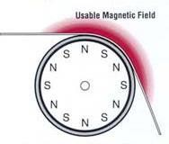

**Figure(4.2):**Usable Magnetic Field

Unpowered versions of the linear design, which instead use permanent, rare Earth magnets are the brake of choice on most roller coasters. As anyone who has ridden a roller coasterwill be aware, these non-electromagnetic types work on an on-off basis, and cannot be easily modulated.

**Chapter 05: Concept of Neodymium Magnet**

Reason behind introducing concept of Neodymium Magnet

Frictionless brakes are a relatively new technology that is beginning to gain popularity due to their high degree of safety but for designing and fabricating Frictionless Braking system with greater performance and to obtain objectives like following-

* To achieve better braking efficiency.
* To increase the reliability and life span of brakes.
* To obtain optimum heat dissipation.
* To increase power to weight ratio.
* To reduce the maintenance cost.

We have to be very much specific in terms of magnets which we are using in this project.

When an electrical conductor, such as copper or aluminium , moves through the field of a specifically Neodymium Magnet, electromagnetic induction creates eddy current very effectively, due to which it dissipate some of the kinetic energy into Joule heat and results in slowing the motion of the conductor.

A neodymium magnet (also known as NdFeB, NIB or Neo magnet), the most widely used type of rare-earth magnet, is permanent magnet made from an alloy of neodymium, iron and boron to form the Nd2Fe14B tetragonal crystalline structure. Developed in 1982 by General Motors and Sumitomo Special Metals, neodymium magnets are the strongest type of permanent magnet commercially available. They have replaced other types of magnets in the many applications in modern products that require strong permanent magnets, such as motors in cordless tools, hard disk drives and magnetic fasteners.[12]

## 5.1-Discription

The tetragonal Nd2Fe14B crystal structure has exceptionally high uniaxial magneto-crystalline anisotropy (HA~7 tesla - magnetic field strength H in A/m versus magnetic moment in A.m2).[4] This gives the compound the potential to have high-coercivity (i.e., resistance to being demagnetized). The compound also has a high saturation magnetization (Js ~1.6 T or 16 kg) and typically 1.3 tesla. Therefore, as the maximum energy density is proportional to *J*s2, this magnetic phase has the potential for storing large amounts of magnetic energy (*BH*max ~ 512 kJ/m3 or 64 MG·Oe). This property is considerably higher in NdFeB alloys than in samarium cobalt (SmCo) magnets, which

were the first type of rare-earth magnet to be commercialized. In practice, the magnetic properties of neodymium magnets depend on the alloy composition, microstructure, and manufacturing technique employed.[13]

## 5.2-History

In 1982, General Motors (GM) and Sumitomo Special Metals discovered the Nd2Fe14B compound. The research was initially driven by the high raw materials cost ofSmCo permanent magnets, which had been developed earlier. GM focused on the development of melt-spun nanocrystalline Nd2Fe14B magnets, while Sumitomo developed full-density sintered Nd2Fe14B magnets.

GM commercialized its inventions of isotropic Neo powder, bonded Neo magnets, and the related production processes by founding Magnequench in 1986 (Magnequench has since become part of Neo Materials Technology, Inc., which later merged into Molycorp). The company supplied melt-spun Nd2Fe14B powder to bonded magnet manufacturers.

The Sumitomo facility became part of the Hitachi Corporation, and currently manufactures and licenses other companies to produce sintered Nd2Fe14B magnets. Hitachi holds more than 600 patents covering neodymium magnets.[14]

Chinese manufacturers have become a dominant force in neodymium magnet production, based on their control of much of the world's sources of rare earth ores.

The United States Department of Energy has identified a need to find substitutes for rare earth metals in permanent magnet technology, and has begun funding such research. The Advanced Research Projects Agency-Energy has sponsored a Rare Earth Alternatives in Critical Technologies (REACT) program, to develop alternative materials. In 2011, ARPA-E awarded

31.6 million dollars to fund Rare-Earth Substitute projects.

## 5.3-Production

As of 2012, 50,000 tons of neodymium magnets are produced officially each year in China, and 80,000 tons in a "company-by-company" build-up done in 2013.China produces more than 95% of rare earth elements, and produces about 76% of the world's total rare-earth magnets. Bonded Nd-magnets are prepared by melt spinning a thin ribbon of the NdFeB alloy. The ribbon contains randomly oriented Nd2Fe14B nano-scale grains. This ribbon is then pulverized into particles, mixed with a polymer, and either compression- or injection molded into bonded magnets. Bonded magnets offer less flux intensity than sintered magnets, but can be net-shape formed into intricately shaped parts, as is typical with Halbach arrays or arcs, trapezoids and other shapes and assemblies (e.g. Pot Magnets, Separator Grids, etc.). There are approximately 5,500 tons of Neo bonded magnets produced each year. In addition, it is possible to hot-press the melt spun nanocrystalline particles into fully dense isotropic magnets, and then upset-forge or back-extrude these into high-energy anisotropic magnets.[15]

## 5.4-Corrosion problems

Sintered Nd2Fe14B tends to be vulnerable to [corrosion](https://en.wikipedia.org/wiki/Corrosion), especially along [grain boundaries](https://en.wikipedia.org/wiki/Grain_boundary) of a sintered magnet. This type of corrosion can cause serious deterioration, including crumbling of a magnet into a powder of small magnetic particles, or [spalling](https://en.wikipedia.org/wiki/Spalling) of a surface layer.

This vulnerability is addressed in many commercial products by adding a protective coating to prevent exposure to the atmosphere. Nickel plating or two-layered copper-nickel plating are the standard methods, although plating with other metals, or polymer and lacquer protective coatings are also in use[16]

## 5.5-Magnetic Properties

Neodymium magnets are graded according to their maximum energy product, which relates to the magnetic flux output per unit volume. Higher values indicate stronger magnets and range from N35 up to N52. Letters following the grade indicate maximum operating temperatures (often the Curie temperature), which range from M (up to 100 degrees Celsius) to EH (200 degrees Celsius).

Some important properties used to compare permanent magnets are:

* remanence (Br) - Which measures the strength of the magnetic field
* coercivity (Hci) - The material's resistance to becoming demagnetized
* energy product (BHmax) - The density of magnetic energy
* Curie temperature (TC) - The temperature at which the material loses its magnetism Neodymium magnets have higher remanence, much higher coercivity and energy product, but often lower Curie temperature than other types. Neodymium is alloyed with terbium and dysprosium in order to preserve its magnetic properties at high temperatures

Following table shows the Comparison of magnetic performance of neodymium magnets with other types of permanent magnets.

**Table(5.1):** Comparison of magnetic performance of neodymium magnets with other types of permanent magnets.[17]

|  |  |  |  |  |  |
| --- | --- | --- | --- | --- | --- |
| **Magnet** | [**Br**](https://en.wikipedia.org/wiki/Remanence) **(T)** | [**Hci**](https://en.wikipedia.org/wiki/Coercivity) **(kA/m)** | **BHmax (kJ/m3)** | [**TC**](https://en.wikipedia.org/wiki/Curie_Temperature) **(°C)** | [**TC**](https://en.wikipedia.org/wiki/Curie_Temperature) **(°F)** |
| Nd2Fe14B (sintered) | 1.0–1.4 | 750–2000 | 200–440 | 310–400 | 590–752 |
| Nd2Fe14B (bonded) | 0.6–0.7 | 600–1200 | 60–100 | 310–400 | 590–752 |
| SmCo5 (sintered) | 0.8–1.1 | 600–2000 | 120–200 | 720 | 1328 |
| Sm(Co, Fe, Cu, Zr)7 (sintered) | 0.9–1.15 | 450–1300 | 150–240 | 800 | 1472 |
| Alnico (sintered) | 0.6–1.4 | 275 | 10–88 | 700–860 | 1292–1580 |
| Sr-ferrite (sintered) | 0.2–0.4 | 100–300 | 10–40 | 450 | 842 |

## 5.6- Hazards

The greater force exerted by [rare-earth magnets](https://en.wikipedia.org/wiki/Rare-earth_magnet) creates hazards that are not seen with other types of magnet. Neodymium magnets larger than a few cubic centi-meters are strong enough to cause injuries to body parts pinched between two magnets, or a magnet and a metal surface, even causing broken bones.

Magnets allowed to get too near each other can strike each other with enough force to chip and shatter the brittle material, and the flying chips can cause injuries. There have even been cases where young children who have swallowed several magnets have had sections of the [digestive](https://en.wikipedia.org/wiki/Gastrointestinal_tract) [tract](https://en.wikipedia.org/wiki/Gastrointestinal_tract) pinched between two magnets, causing injury or death.[[19]](https://en.wikipedia.org/wiki/Neodymium_magnet#cite_note-19) The stronger magnetic fields can be hazardous to mechanical and electronic devices, as they can erase magnetic media such as [floppy disks](https://en.wikipedia.org/wiki/Floppy_disk) and credit cards, and magnetize watches and the [shadow masks](https://en.wikipedia.org/wiki/Shadow_mask) of [CRT](https://en.wikipedia.org/wiki/Cathode_ray_tube) type monitors at a greater distance than other types of magnet.[18]

## 5.7-Applications

1. Existing magnet applications

Neodymium magnets have replaced [alnico](https://en.wikipedia.org/wiki/Alnico) and [ferrite magnets](https://en.wikipedia.org/wiki/Ferrite_(magnet)) in many of the myriad applications in modern technology where strong permanent magnets are required, because their greater strength allows the use of smaller, lighter magnets for a given application. Some examples are:

01-Head actuators for computer [hard disks](https://en.wikipedia.org/wiki/Hard_disk) 02-Erase heads for cheap cassette recorders 03-[Magnetic resonance imaging](https://en.wikipedia.org/wiki/Magnetic_resonance_imaging) ([MRI](https://en.wikipedia.org/wiki/Magnetic_resonance_imaging))

04-Mechanical [e-cigarette](https://en.wikipedia.org/wiki/Electronic_cigarette) firing switches 05-Locks for doors

06-[Loudspeakers](https://en.wikipedia.org/wiki/Loudspeaker) and [headphones](https://en.wikipedia.org/wiki/Headphone)

07-[Magnetic bearings](https://en.wikipedia.org/wiki/Magnetic_bearing) and couplings 08-[Benchtop NMR spectrometers](https://en.wikipedia.org/wiki/Benchtop_NMR_spectrometer) 09-[Electric motors](https://en.wikipedia.org/wiki/Electric_motors):

10-[Servomotors](https://en.wikipedia.org/wiki/Servomotor)

11-Lifting and [compressor](https://en.wikipedia.org/wiki/Gas_compressor) motors 12-[Synchronous motors](https://en.wikipedia.org/wiki/Synchronous_motor)

13-Spindle and [stepper motors](https://en.wikipedia.org/wiki/Stepper_motor) 14-Electrical [power steering](https://en.wikipedia.org/wiki/Power_steering)

15-Drive motors for [hybrid](https://en.wikipedia.org/wiki/Hybrid_vehicle) and [electric vehicles.](https://en.wikipedia.org/wiki/Electric_vehicle) The electric motors of each [Toyota](https://en.wikipedia.org/wiki/Toyota_Prius) [Prius](https://en.wikipedia.org/wiki/Toyota_Prius) require 1 kilogram (2.2 pounds) of neodymium.

16-[Electric generators](https://en.wikipedia.org/wiki/Electric_generator) for [wind turbines](https://en.wikipedia.org/wiki/Wind_turbine) (only those with permanent magnet excitation) 17-direct-drive wind turbines require c. 600 kg of PM material per [megawatt](https://en.wikipedia.org/wiki/Megawatt)[[20]](https://en.wikipedia.org/wiki/Neodymium_magnet#cite_note-20)

18-turbines using gears require less PM material per megawatt Neodymium content is estimated to be 31% of magnet weight

1. New applications

01-Neodymium magnet spheres constructed in the shape of a cube

1. In addition, the greater strength of neodymium magnets has inspired new applications in areas where magnets were not used before, such as magnetic jewellery clasps, children's magnetic building sets (and other [neodymium magnet toys](https://en.wikipedia.org/wiki/Neodymium_magnet_toys)) and as part of the closing mechanism of modern sport parachute equipment.[[21]](https://en.wikipedia.org/wiki/Neodymium_magnet#cite_note-21) They also are the main metal in the formerly popular desk-toy magnets, "Bucky balls", though some retailers have chosen not to sell them due to child-safety concerns.
2. The strength and magnetic field homogeneity on neodymium magnets has also opened new applications in the medical field with the introduction of open [magnetic resonance](https://en.wikipedia.org/wiki/Magnetic_resonance_imaging)

[imaging](https://en.wikipedia.org/wiki/Magnetic_resonance_imaging) (MRI) scanners used to image the body in radiology departments as an alternative to superconducting magnets that use a coil of superconducting wire to produce the magnetic field

1. Neodymium magnets are used as a surgically placed anti-reflux system which is a band of magnets[[23]](https://en.wikipedia.org/wiki/Neodymium_magnet#cite_note-23) surgically implanted around the [lower esophagael sphincter](https://en.wikipedia.org/wiki/Lower_esophageal_sphincter) to treat [gastroesophageal reflux disease](https://en.wikipedia.org/wiki/Gastroesophageal_reflux_disease) (GERD).

# Chapter 06: Material Selection

The proper selection of material for the different part of a machine is the main objective in the fabrication of machine. For a design engineer it is must that he be familiar with the effect, which the manufacturing process and heat treatment have on the properties of materials.

The Choice of material for engineering purposes depends upon the following factors:

* 1. Availability of the materials.
  2. Suitability of materials for the working condition in service.
  3. The cost of materials.
  4. Physical and chemical properties of material.
  5. Mechanical properties of material

## 6.1- The mechanical properties of the metals

The mechanical properties of the metals are those, which are associated with the ability of the material to resist mechanical forces and load.

We shall now discuss these properties as follows:

1. Strength: It is the ability of a material to resist the externally applied forces
2. Stress: Without breaking or yielding. The internal resistance offered by a part to an externally applied force is called stress.
3. Stiffness: It is the ability of material to resist deformation under stresses. The modules of elasticity of the measure of stiffness.
4. Elasticity: It is the property of a material to regain its original shape after deformation when the external forces are removed. This property is desirable for material used in tools and machines. It may be noted that steel is more elastic than rubber.
5. Brittleness: It is the property of material opposite to ductile. It is the property of breaking of a material with little permanent distortion. Brittle materials when subjected to tensile loads snap off without giving any sensible elongation. Cast iron is a brittle material
6. Malleability: It is a special case of ductility, which permits material to be rolled or hammered into thin sheets, a malleable material should be plastic but it is not essential to be so strong. The malleable materials commonly used in engineering practice are lead, soft steel, wrought iron, copper and aluminium.
7. Toughness: It is the property of a material to resist the fracture due to high impact loads like hammer blows. The toughness of the material decreases when it is heated. It is measured by the amount of absorbed after being stressed up to the point of fracture. This property is desirable in parts subjected to shock an impact load.
8. Resilience: It is the property of a material to absorb energy and to resist rock and impact loads. It is measured by amount of energy absorbed per unit volume within elastic limit. This property is essential for spring material.
9. Creep: When a part is subjected to a constant stress at high temperature for long period of time, it will undergo a slow and permanent deformation called creep. This property is considered in designing internal combustion engines, boilers and turbines.
10. Hardness: It is a very important property of the metals and has a wide

verity of meanings. It embraces many different properties such as resistance to wear scratching, deformation and much inability etc. It also means the ability of the metal to cut another metal. The hardness is usually expressed in numbers, which are dependent on the method of making the test.

The hardness of a metal may be determined by the following test

* 1. Brinell hardness test
  2. Rockwell hardness test
  3. Vickers hardness (also called diamond pyramid) test and
  4. Share scaleroscope.

## 6.2-Concepts of General Selection of Material

The science of the metal is a specialized and although it overflows in to realms of knowledge it tends to shut away from the general reader. The knowledge of materials and their properties is of great significance for a design engineer. The machine elements should be made of such a material which has properties suitable for the conditions of operations.

In addition to this a design engineer must be familiar with the manufacturing processes and the heat treatments have on the properties of the materials. In designing the various part of the machine it is necessary to know how the material will function in service. For this certain characteristics or mechanical properties mostly used in mechanical engineering practice are commonly determined from standard tensile tests. In engineering practice, the machine parts are subjected to various forces, which may be due to either one or more of the following.

1. Energy transmitted
2. Weight of machine
3. Frictional resistance
4. Inertia of reciprocating parts
5. Change of temperature
6. Lack of balance of moving parts

The selection of the materials depends upon the various types of stresses that are set up during operation. The material selected should with stand it. Another criteria for selection of metal depend upon the type of load because a machine part resist load more easily than a live load and live load more easily than a shock load.

Selection of the material depends upon factor of safety, which in turn depends upon the following factors.

1. Reliabilities of properties
2. Reliability of applied load
3. The certainty as to exact mode of failure
4. The extent of simplifying assumptions
5. The extent of localized
6. The extent of initial stresses set up during manufacturing
7. The extent loss of life if failure occurs
8. The extent of loss of property if failure occurs Materials selected in m/c Base plate, motor support, sleeve and shaft

## 6.3-Material Used

Mild steel:

Reasons:

1. Mild steel is readily available in market
2. It is economical to use
3. It is available in standard sizes
4. It has good mechanical properties i.e. it is easily machinable
5. It has moderate factor of safety, because factor of safety results in unnecessary wastage of material and heavy selection. Low factor of safety results in unnecessary risk of failure
6. It has high tensile strength
7. Low co-efficient of thermal expansion Properties of Mild Steel:

M.S. has a carbon content from 0.15% to 0.30%. They are easily wieldable thus can be hardened only. They are similar to wrought iron in properties. Both ultimate tensile and compressive strength of these steel increases with increasing carbon content. They can be easily gas welded or electric or arc welded. With increase in the carbon percentage weld ability decreases.

Mild steel serve the purpose and was hence was selected because of the above purpose

## 6.4-Tools Used

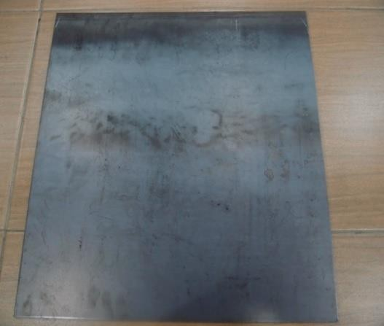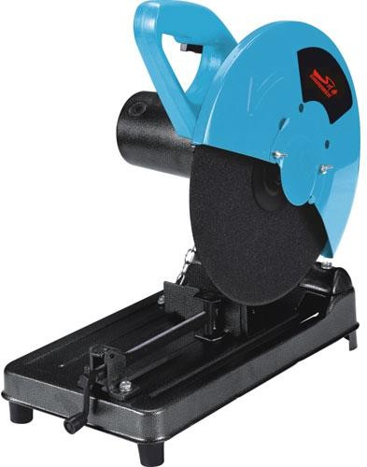

**Figure(6.1):** Mild Steel plate **Figure(6.2):** Steel plate cutter

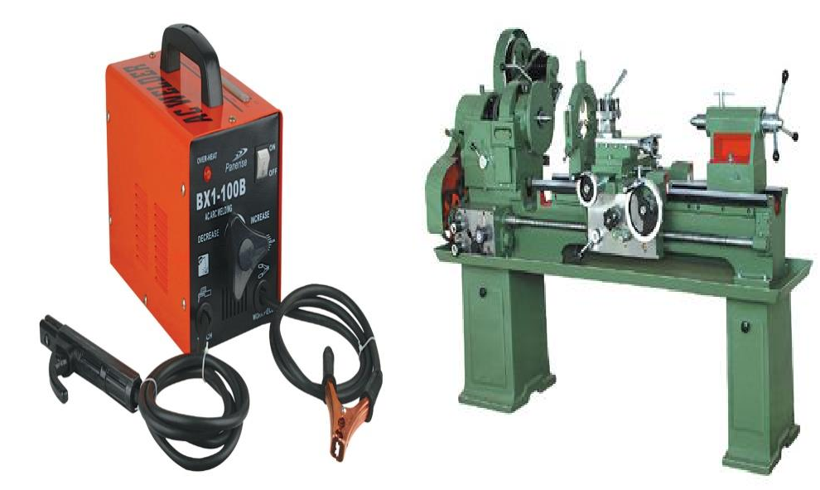

**Figure(6.3):** Welding machine **Figure(6.4**): Lathe Machine

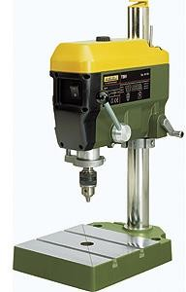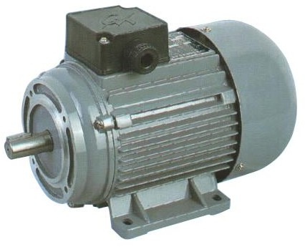

**Figure(6.5):** Drill machine **Figure(6.6):** Electric motor

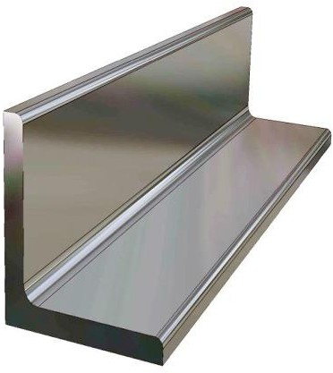 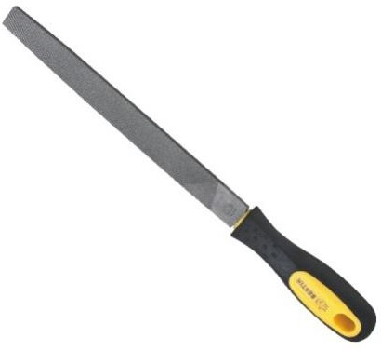

**Figure(6.7):** Iron angles **Figure(6.8):** Steel file tool

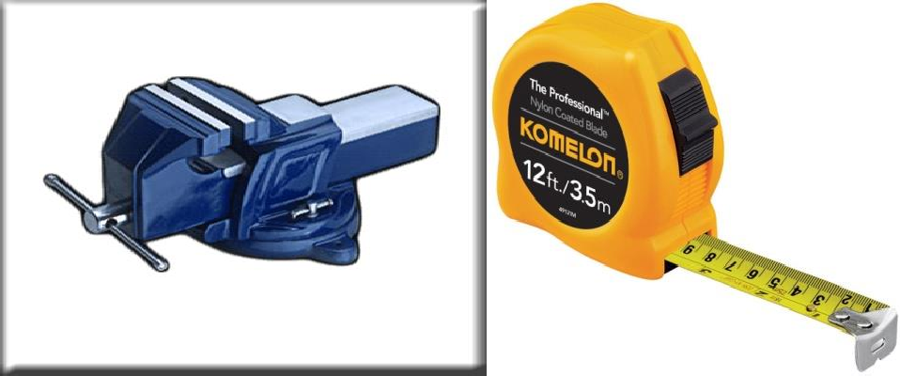

**Figure(6.9):** Vices **Figure(6.10):** Measuring tape

## 6.5-Raw Material & Standard Material

**Table(6.1):** Raw Material & Standard Material

|  |  |  |  |
| --- | --- | --- | --- |
| SR NO | PART NAME | MAT | QTY |
| 1 | FRAME | MS | 1NOS |
| 2 | MAGNET | NEO DYNEUM | 12 NOS |
| 3 | SHAFT DIA 20 MM | EN 8 | 2 NOS |
| 4 | 0.5 HP 3 PHASE AC MOTOR 1400 | STD | 1 NOS |
| 5 | PULLEY | MS | 2 NOS |
| 6 | FLYWHEEL | STD | 1NOS |
| 7 | ALUMINUM WHEEL | AL | 1 NOS |
| 8 | PEDESTAL BEARING | CI | 2NOS |
| 9 | FREE WHEEL | STD | 1 NOS |
| 10 | NUT BOLT WASHER M 10 | MS | 8 NOS |
| 11 | WELDING ROD | - | 1 50 NOS |
| 12 | COLOUR | - | 2 LIT |

# Chapter 07: Cost Estimation

Cost estimation may be defined as the process of forecasting the expenses that must be incurred to manufacture a product. These expenses take into a consideration all expenditure involved in a design and manufacturing with all related services facilities such as pattern making, tool, making as well as a portion of the general administrative and selling costs.

## 7.1- Purpose of Cost Estimation

1. To determine the selling price of a product for a quotation or contract so as to ensure a reasonable profit to the company.
2. Check the quotation supplied by vendors.
3. Determine the most economical process or material to manufacture the product.
4. To determine standards of production performance that may be used to control the cost.

## 7.2-Tyres of Cost Estimation

1. Material cost
2. Machining cost

MATERIAL COST ESTIMATION:

Material cost estimation gives the total amount required to collect the raw material which has to be processed or fabricated to desired size and functioning of the components.

These materials are divided into two categories.

1. Material for fabrication:

In this the material in obtained in raw condition and is manufactured or processed to finished size for proper functioning of the component.

1. Standard purchased parts:

This includes the parts which was readily available in the market like allen screws etc. A list is forecast by the estimation stating the quality, size and standard parts, the weigh of raw material and cost per kg. For the fabricated parts.

MACHINING COST ESTIMATION:

This cost estimation is an attempt to forecast the total expenses that may include manufacturing

apart from material cost. Cost estimation of manufactured parts can beconsidered as judgment on and after careful consideration which includes labour, material and factory services required to produce the required part.

## 7.3- Procedure for calculation of Material Cost

The general procedure for calculation of material cost estimation is

1. After designing a project a bill of material is prepared which is divided into two categories.
   1. Fabricated components
   2. Standard purchased components
2. The rates of all standard items are taken and added up.
3. Cost of raw material purchased taken and added up

## 7.4-Labour Cost

It is the cost of remuneration (wages, salaries, commission, bonus etc.) of the employees of a concern or enterprise

Labour cost is classifies as:

1. Direct labour cost
2. Indirect labour cost

Direct labour cost:-The direct labour cost is the cost of labour that can be identified directly with the manufacture of the product and allocated to cost centres or cost units. The direct labour is one who counters the direct material into saleable product; the wages etc. of such employees constitute direct labour cost. Direct labour cost may be apportioned to the unit cost of job or either on the basis of time spend by a worker on the job or as a price for some physical measurement of product.

Indirect labour cost:-It is that labour cost which cannot be allocated but which can be apportioned to or absorbed by cost centres or cost units. This is the cost of labour that doesn’t alters the construction, confirmation, composition or condition of direct material but is necessary for the progressive movement and handling of product to the point of dispatch e.g. maintenance, men, helpers, machine setters, supervisors and foremen etc.

The total labour cost is calculated on the basis of wages paid to the labour for 8 hours per day.

## 7.5-Calculation of total Cost

TOTAL COST = Raw Material Cost + STD Parts Cost + Direct Labour Cost +Indirect Cost

* 1. Raw Material Cost & Standard Part Cost

**Table(7.1):** Raw Material Cost& Standard Part Cost

|  |  |  |  |  |
| --- | --- | --- | --- | --- |
| SR NO | PART NAME | MAT | QTY | COST |
| 1 | FRAME | MS | 10 kg | 600 |
| 2 | MAGNET | NEODYMUM | 10 NOS | 2000 |
| 3 | SHAFT DIA 20 MM | EN 8 | 1 NOS | 350 |
| 4 | 0.75 hp ac 3 PH MOTOR | STD | 1 NOS | 3500 |
| 5 | PULLEY | MS | 2 NOS | 650 |
| 6 | FLYWHEEL | MS | 1NOS | 800 |
| 7 | ALUMINUM WHEEL | AL | 1 NOS | 650 |
| 8 | PEDESTAL BEARING P204 | CI | 2NOS | 500 |
| 9 | FREE WHEEL | STD | 1 NOS | 120 |
| 10 | NUT BOLT WASHER M 10 | MS | 8 NOS | 75 |
| 11 | WELDING ROD | - | 150 NOS | 150 |
| 12 | COLOUR | - | 2 LIT | 100 |
|  |  |  |  |  |
|  |  |  | TOTAL | 9495/- |

Total Raw Material Cost& Standard Part Cost = 9495 Rs.

* 1. Direct Labour Cost

**Table(7.2):** Direct Labour Cost

|  |  |  |  |  |
| --- | --- | --- | --- | --- |
| SR. NO. | OPERATION | HOURS | RATE / LABOUR | AMOUNT |
| 1. | Turning | 10 | 150 | 1500 |
| 2. | Milling | 2 | 150 | 300 |
| 3. | Drilling | 7 | 100 | 700 |
| 4. | Welding | 16 | 175 | 2800 |
| 5. | Grinding | 3 | 60 | 180 |
| 6. | Tapping | 3 | 40 | 120 |
| 7. | Cutting | 8 | 40 | 320 |
| 8. | Gas cutting | 8 | 50 | 400 |
| 9. | Assembly | 2 | 100 | 200 |
| 10. | Painting | 2 | 100 | 200 |
|  | | | TOTAL | 6720/- |

Total Direct Labour Cost = 6720 Rs.

* 1. Indirect Cost
     1. Transportation cost = 500/-
     2. Coolent& lubricant = 100/-
     3. Drawing cost = 500/-
     4. Project report cost = 2000 Total Indirect Cost = 3100 Rs.

Total Cost = Raw Material Cost + STD Parts Cost + Direct Labour Cost +Indirect Cost Total cost of project = (9495 + 6720 +3100) Rs.

Total cost of project = 19315 Rs.

# Chapter 08: Machine Design

The subject of MACHINE DESIGN deals with the art of designing machine of structure. A machine is a combination of resistance bodies with successfully constrained relative motions which is used for transforming other forms of energy into mechanical energy or transmitting and modifying available design is to create new and better machines or structures and improving the existing ones such that it will convert and control motions either with or without transmitting power. It is the practical application of machinery to the design and construction of machine and structure. In order to design simple component satisfactorily, a sound knowledge of applied

science is essential. In addition, strength and properties of materials including some metrological are of prime importance. Knowledge of theory of machine and other branch of applied mechanics is also required in order to know the velocity. Acceleration and inertia force of the various links in motion, mechanics of machinery involve the design.

## 8.1-Consideration in Machine Design

When a machine is to be designed the following points to be considered: -

1. Types of load and stresses caused by the load.
2. Motion of the parts and kinematics of machine. This deals with the type of motion i.e. reciprocating .Rotary and oscillator .
3. Selection of material & factors like strength, durability, weight, corrosion resistant, weld ability, machine ability are considered.
4. Form and size of the components.
5. Frictional resistances and ease of lubrication.
6. Convince and economical in operation.
7. Use of standard parts.
8. Facilities available for manufacturing.
9. Cost of making the machine.
10. Number of machine or product are manufactured.

## 8.2-General Procedure in Machine Design

The general steps to be followed in designing the machine are as followed.

1. Preparation of a statement of the problem indicating the purpose of the machine.
2. Selection of groups of mechanism for the desire motion.
3. Calculation of the force and energy on each machine member.
4. Selection of material.
5. Determining the size of component drawing and sending for manufacture.
6. Preparation of component drawing and sending for manufacture.
7. Manufacturing and assembling the machine.
8. Testing of the machine and for functioning.

# Chapter 9: Calculation

## 9.1-Motor Design

We want speed upto 43 kmph as average speed of bike on road is 40 to 45 kmph from research.

 43kmph= 11.944 m/s & D=0.22 M

N=1036.88 RPN≈1036 RPM

The flywheel speed = 1036 RPM Now for motor torque,

Weight of flywheel =1.5Kg Taking G=10 𝑚/𝑠2

Now breaking force F= 1.5 x 10= 15 N Torque= F x R

= 15 X 0.11

= 1.65 Nm

𝑉 = 𝜋

𝐷𝑁 60

P=2𝜋𝑁𝑇

60

= 2𝜋𝑥 1036 𝑥 1.65

60

= 179 watt

= 179

746

= 0.2399 HP

≈ 0.24 HP

This is minimum power required for motor.

From psg 5.124 we select standard motor of 0.5 HP AND 1380 RPM

## 9.2-To Find Reduction Ratio

Now from motor speed and flywheel speed we will find the reduction ratio.

Reduction ratio =𝑛

T1 (Tight Side)

d

Flywheel

D

T2 (Slack Side)

(rpm-N)

𝑁

=1036

1380

= 0.75

And speed ratio (i) = 𝑁 =1380 =1.332

𝑛 1036

i =𝑁 = 𝑑 = 1.332

𝑛 𝐷

Motor (rpm-n)

 d=1.332D

for belt design (v belt design)

P= 0.5HP=0.373 =KW & 10 Hr/day duty shift

[P] = 0.373*1= 0.373 KW (PSG 7.69)

Now selection of belt type from PSG 7.58

|  |  |  |  |
| --- | --- | --- | --- |
| C/S symbol  A | Load of drive (KW)  0.75 ~ 5 | Width (mm)  13 | Thickness (mm)  8 |

Since power required for us is not available in data book so we are taking value near to our requirement and design according to it.

Now,

Using saverian criteria,

3

1100 √

[𝑃]

𝑁

3

≤ 𝐷 ≤ 1300 √

[𝑃]

𝑛

3

1100 √

0.373

1036

3

≤ 𝐷 ≤ 1300 √

0.373

1380

73.25 mm ≤ D ≤ 84.05 mm

D =71 mm (PSG 7.54)

Now selecting D= 75 mm ( for std pulley design )

Belt velocity (V) =𝛱𝐷𝑛

60

= 𝛱∗75∗1036∗10−3

60

=4.068 m/s < 25 m/s Now diameter of flywheel pulley

d= D * i * n n=0.98

d= 75*1.33*0.98 d= 97.902 mm

selecting standard pulley = 100 mm (PSG 7.54) Now for calculation of length of belt ,

𝐶𝑚𝑎𝑥= 2*(D+d) = 350 mm

&𝐶𝑚𝑖𝑛=0.55*(D+d)+thickness =104.25mm

Now for our convenience we are taking centre distance as 335 mm

L=2C+𝛱 (𝐷 + 𝑑) + (𝐷−𝑑)2

2

L= 945.356 mm

L=37.22 inch L≈ 37 Inch

Arc of contact (𝜃) =2 ∗ 𝑐𝑜𝑠−1

4𝐶

𝐷−𝑑

( )

=2 ∗ 𝑐𝑜𝑠−1(100−75)

2∗335

2𝐶

=175.723°= 3.067 radian

Correction factor (𝑓𝑑 ) for 175.723° is 0.99 Let assume,

Semi groove angle (∝) = 20°

Friction( 𝜇)= 0.25 For 𝑇1&𝑇2,

𝑇1=𝑒𝜇𝜃𝑐𝑜𝑠𝑒𝑐𝛼

𝑇2

𝑇1=𝑒0.25∗3.067∗𝑐𝑜𝑠𝑒𝑐 20

𝑇2

𝑇1=9.412

𝑇2

𝑇1=9.412𝑇2

100 mm

T1 T2

𝑇𝑚𝑎𝑥=(𝑇1 − 𝑇2)*r …..(d=100mm) For 𝑇𝑚𝑎𝑥,

P =2𝛱𝑁𝑇

60

T=0.5∗746∗60

2𝛱∗1380

𝑇𝑚𝑎𝑥= 2581 N-mm

2581= (𝑇1 − 𝑇2)*50

𝑇1 − 𝑇2 =51.62

9.412𝑇2 - 𝑇2 =51.62

𝑇2=6.136N

𝑇1=6.136*9.412

𝑇1=57.752 N

Now, Power that is deliver by belt P= (𝑇1 − 𝑇2)*v

= (57.752-6.136)*𝛱∗0.075∗1380

60

P = 279.72 Watt

Now no of belt required to deliver power, No of belt= 𝑃𝑜𝑤𝑒𝑟𝑑𝑒𝑙𝑖𝑣𝑒𝑟𝑏𝑦𝑏𝑒𝑙𝑡

𝑇𝑜𝑡𝑎𝑙𝑝𝑜𝑤𝑒𝑟𝑑𝑒𝑙𝑖𝑣𝑒𝑟𝑝𝑒𝑟𝑏𝑒𝑙𝑡

= 279.72

373

= 0.7499 ≈ 0.75= 1

Hence only one belt is sufficient to deliver power.

## 9.3-Pully Design



f

lp

b

h

A

For selection ,

𝑙𝑝=11mm

b=3.3mm dp

h= 8.7mm

𝑑𝑝=67 to 75 mm

Edge to centre pulley distance (f)= 10 mm l= 2*f = 20 mm ( width of pulley)

l

## 9.4-Shaft Design

Taking moment at A , (𝑅2* 830) = 63.888* 300

𝑅2 =23.092 N

&𝑅1+𝑅2= 𝑇1 + 𝑇2

𝑅1=40.796 N

Moment = (𝑇1 + 𝑇2)* l – ( 𝑅2*830 ) Moment = (𝑇1 + 𝑇2)* l

l

300 mm

(T1 + T2)

= 63.888*300

= 19.166Nm

R1

& Torque = 𝑇𝑚𝑎𝑥= 2.581 Nm

𝑇𝑒𝑞=√𝑇2 + 𝑀2…..(𝐾𝑏 = 𝐾𝑡 =1)

=√19.1662 + 2.5812

R2

830 mm

𝑇𝑒𝑞 = 19.34 Nm

= 19.34 * 103Nmm

Now selecting EN8 material for shaft.

From specification,

Maximum stress (ultimate) = 700 -850 N/𝑚𝑚2

Yield stress = 465 N/𝑚𝑚2 Now from ASME code,

𝜏𝑝𝑒𝑟𝑚𝑖𝑠𝑠𝑖𝑏𝑙𝑒= 30 % of yield stress

= 18 % of maximum stress

𝜏𝑝𝑒𝑟𝑚𝑖𝑠𝑠𝑖𝑏𝑙𝑒= 0.3 * 465 = 139.5 N/𝑚𝑚2

= 0.18 * 700 = 126 N/𝑚𝑚2

𝜏𝑝𝑒𝑟𝑚𝑖𝑠𝑠𝑖𝑏𝑙𝑒= 126 N/𝑚𝑚2

We are using grinder for mounting for mounting of flywheel and extra shaft . So the strength is reduced by 25%.

𝜏𝑓𝑖𝑛𝑎𝑙= 0.75 ∗ 𝜏𝑝𝑒𝑟𝑚𝑖𝑠𝑠𝑖𝑏𝑙𝑒

𝜏𝑓𝑖𝑛𝑎𝑙= 0.75 * 126

𝜏𝑓𝑖𝑛𝑎𝑙 = 94.5 N/𝑚𝑚2

𝜏𝑓𝑖𝑛𝑎𝑙 = 95 N/𝑚𝑚2 Now for shaft diameter,

𝑇 = 𝛱 ∗ 𝑑3 ∗ 𝜏

𝑒𝑞 16

𝑓𝑖𝑛𝑎𝑙

19.34*103= 𝛱 ∗ 𝑑3 ∗ 95

16

𝑑3=1036.82

d=10.12 mm

for safety purpose we are taking diameter of shaft 20 mm.

## 9.5-Bearing Selection

We have shaft diameter is 20 mm. Hence we are using P204 bearing.

Where,

P= Pedestal bearing 2=Spherical ball / DGBB

04=5*04 =20 mm …..(bore diameter)

## 9.6-Design of Transverse Fillet Welded Part

From PSG 11.4,

For 5 mm thick plate,

Weld size = 3 mm (diameter )

In practical model weld size = 3.2 mm(diameter)

Area of weld ( for single fillet weld )=0.707* weld size *L

A= 0.707*3.2*25

= 56.56 𝑚𝑚2

Here we use bare electrodes and reversed loading conditions .



25 mm

5 mm

𝜎𝑓𝑜𝑟𝑤𝑒𝑙𝑑𝑗𝑜𝑖𝑛𝑡

𝜎=𝐹

𝐴

=20.60 N/𝑚𝑚2…( PSG 11.42)5 mm

F=20.60*56.56 F=1185.136 N=118.77 Kgf

5 mm

F/L =118.75/2.5 =47.508 Kgf/cm < 170 Kgf/cm …(PSG 11.4)

Hence welding is safe and applicable.

## 9.7-Design of Angle Stand

Now weight of our project/machine is 40 kg

W= 40 kg/leg M= W *L

20 mm

49

16 mm

4 mm

= 10*560*9.81

= 54938 Nmm

Z=𝐵3 − 𝑏4

6 6∗𝐵

Z= 203 − 164

6 6∗20

Z=787.2 mm

𝜎 =𝑀

𝑏 𝑍

= 54938

787.2

= 69.789 N/𝑚𝑚2 < 90 N/𝑚𝑚2

Hence design is safe.

## 9.8-Design of Bolt

Selecting hexagonal bolt, Material = C45

Shear stress (𝜎𝑠) = 45 N/𝑚𝑚2 Tensile stress (𝜎𝑡) = 90 N/𝑚𝑚2

We are taking bolt of size 9.31 mm. …( from market )

To check the safety of bolt,

From PSG data book we have select the series M8

𝑑𝑒= 8 mm

& for maximum condition we assume  dc

P = tightening force = 100 kg = 981 N

P = 𝛱 ∗ 𝑑

𝑒

4

3 ∗ 𝜎𝑡

𝜎 = 981∗4

𝑡 𝛱∗8

𝜎𝑡= 19.52 N/𝑚𝑚2 <90 N/𝑚𝑚2

Since 𝜎𝑡𝑒𝑛𝑠𝑖𝑙𝑒 is always ≥ 𝜎𝑠ℎ𝑒𝑎𝑟

Hence bolt will sustain both 𝜎𝑡𝑒𝑛𝑠𝑖𝑙𝑒&𝜎𝑠ℎ𝑒𝑎𝑟. Therefore design is safe.

## 9.9-Braking Time Calculation For Disc Brake

1. Name of Bike = Honda Shine
2. Kerb Weight = 125 Kg
3. Weight with driver and pinion with luggage = 200 Kg
4. Total Weight = 325 Kg
5. Diameter of Calliper Piston = 0.032 m
6. Diameter of master cylinder = 0.01905 m
7. Diameter of Wheel = 0.508 m
8. Diameter of Brake Disk = 0.22 m
9. Rolling Friction Coefficient (μr) = 0.04
10. Coefficient of friction between wheel and road with dry condition (μrw) = 0.8
11. Coefficient of friction between wheel and road with wet condition = 0.45
12. Coefficient of friction between brake pad and brake disk(μ) = 0.3 Now,
    1. The braking process starts with the application of force on the brake pedal with leverage and fluid in the master cylinder gets pressurized.

Hence,

P = Pedal force∗leverage Master cylinder area

e

392∗3

=

π∗(0.1905)2 4

= 4.126 *106 N⁄m2

* 1. Friction force on each disc,

Fe = μ ∗ Pe *2 * area of calliper cylinder

= 0.3 * 4.126 *106* π ∗ (0.032)2

4

= 1990.995 N

≈ 1991 N

* 1. The friction force provides braking torque to wheel and then this braking torque is converted into the braking force which can be calculated by the following equation. Brake force by each disc,

F = Fe∗Re

d

Rw

1991∗0.11

=

0.508

2

= 862.244 N

* 1. In addition to the braking force exerted by braking system addition rolling friction also acts against the motion of the vehicle.

Rolling friction force,

Ffr = μr * m * g

= 0.04 * 325 * 9.81

= 127.53 N

* 1. Now total braking force is the summation of forces exerted on disc brakes and rolling friction. Hence,

Total makeforce,

Ft = Ffr + Fd

= 127.53 + 862.244

= 989.774 N

≈ 990 N

* 1. Now, for the Braking Time calculation we take, speed of bike = 11.944 m/s

F = m * a 990 = 325 * a

a = 3.0461 m/s2

a = v

t

t = v

a

t = 11.944

3.046

t = 3.921 sec

# Chapter 10: 2D Drafting

The 2D drafting of components used in the frictionless braking system are drafted for front, top, side and section view.

## 10.1-2D Drafting of Frictionless Braking System

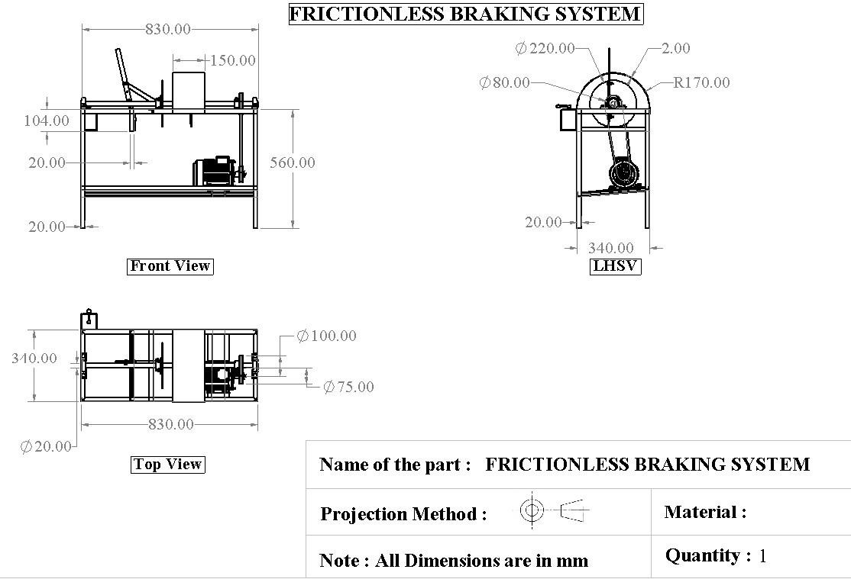

**Figure(10.1):** 2D Drafting of Frictionless Braking system

## 10.2-Bill of Material

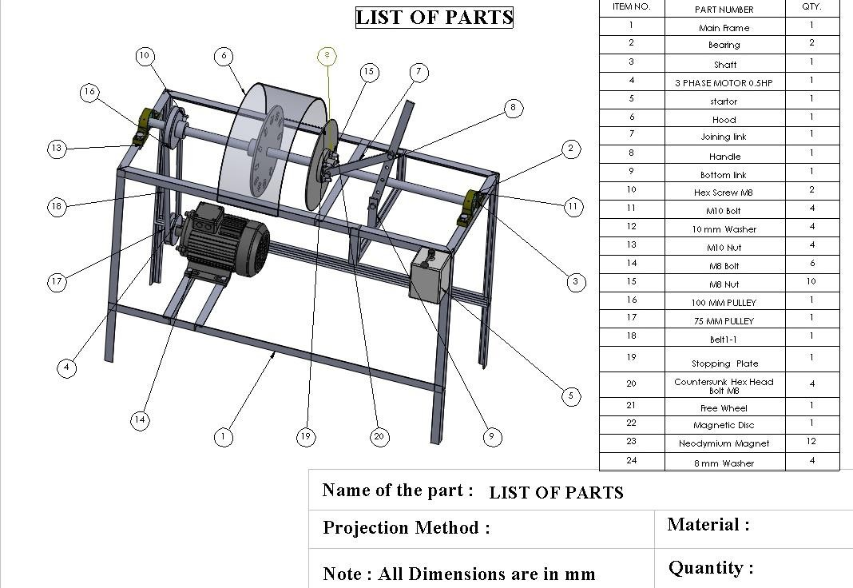

**Figure(10.2):** Bill of Material

**Table(10.1):** Bill of Material

|  |  |  |  |
| --- | --- | --- | --- |
| Sr No. | Part Name | Material | Quantity |
| 1 | Main Frame | M.S. | 1 |
| 2 | Bearing | C.I. | 1 |
| 3 | Shaft | EN 8 | 1 |
| 4 | Three Phase Motor 0.5HP | STD | 1 |
| 5 | Stator | STD | 1 |
| 6 | Hood | M.S. | 1 |
| 7 | Joining Link | M.S. | 1 |
| 8 | Handle | M.S. | 1 |
| 9 | Bottom Link | M.S. | 1 |
| 10 | Hex Screw M8 | C45 | 2 |
| 11 | M10 Bolt | C45 | 4 |
| 12 | 10mm Washer | C45 | 4 |
| 13 | M10 Nut | C45 | 4 |
| 14 | M8 Bolt | C45 | 6 |
| 15 | M8 Nut | C45 | 10 |
| 16 | 100 mm Pulley | M.S. | 1 |
| 17 | 75 mm Pulley | M.S. | 1 |
| 18 | Belt 1-1 | STD | 1 |
| 19 | Stopping Plate | Al | 1 |
| 20 | Countersunk Hex Head Bolt M8 | C45 | 4 |
| 21 | Free Wheel | STD | 1 |
| 22 | Magnetic Plate | M.S. | 1 |
| 23 | Neodymium Magnet | Neodymium | 12 |
| 24 | 8 mm Washer | C45 | 4 |

## 10.3-2D Drafting of Parts

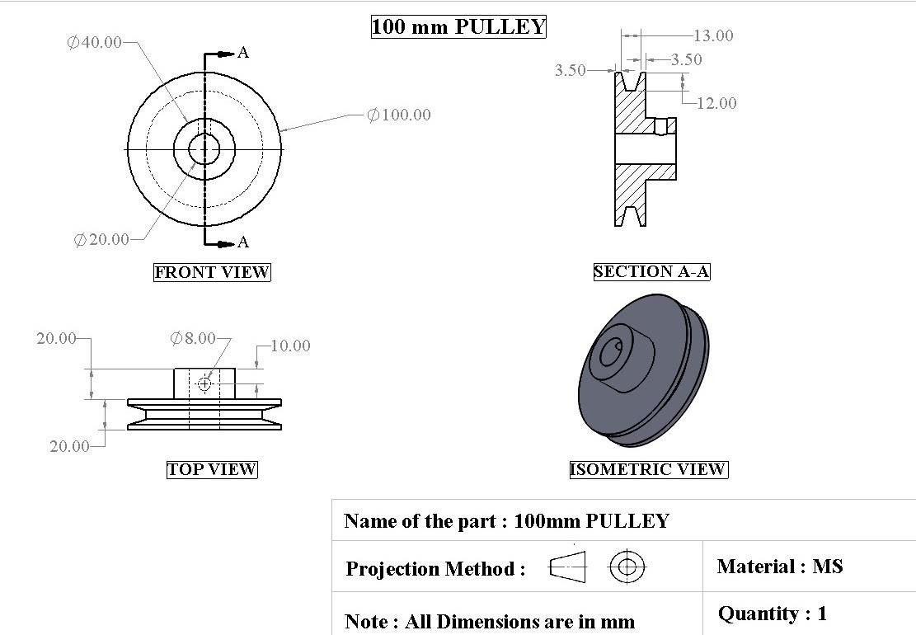

**Figure(10.3):** 100 mm Pulley

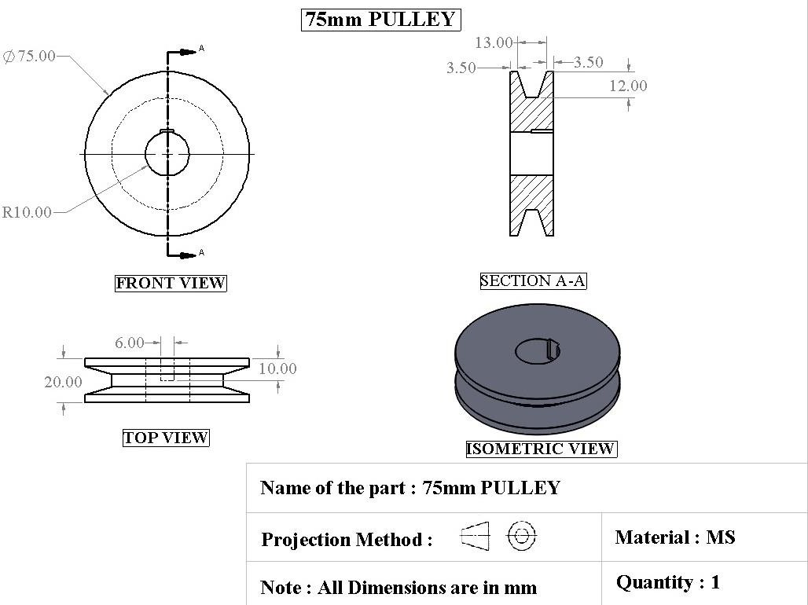

**Figure(10.4):** 75 mm Pulley

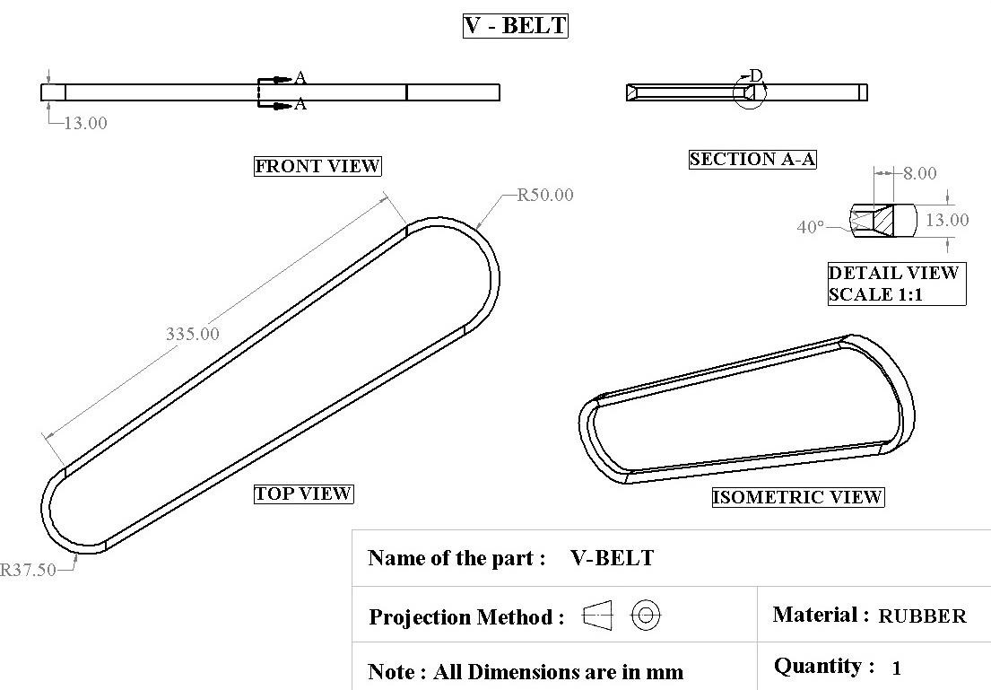

**Figure(10.5):** V-Belt

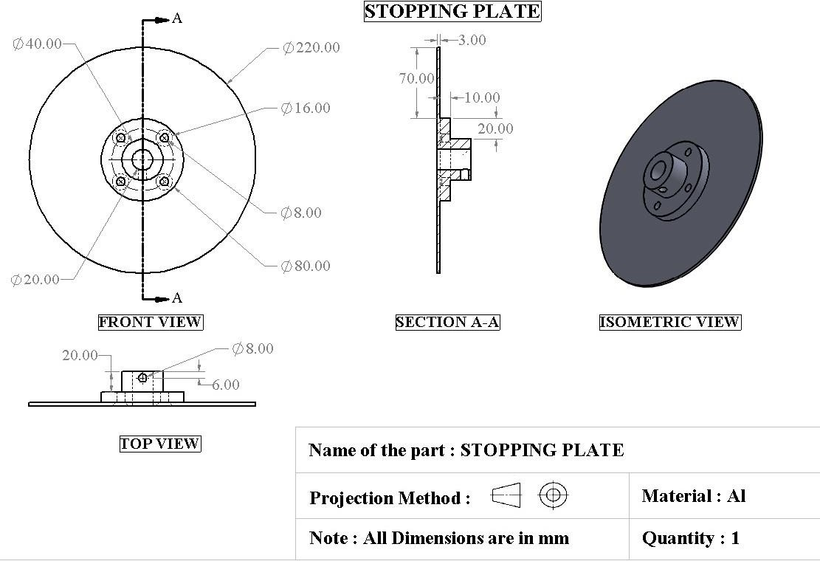

**Figure(10.6):** Stopping Plate

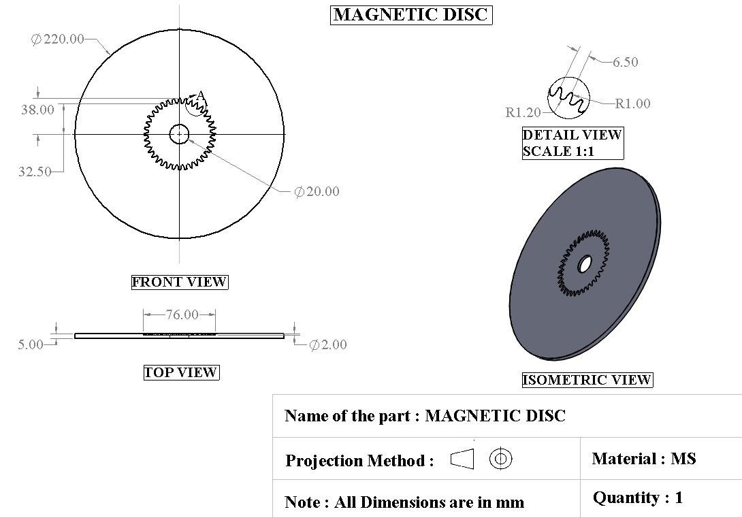

**Figure(10.7):** Magnetic Disc

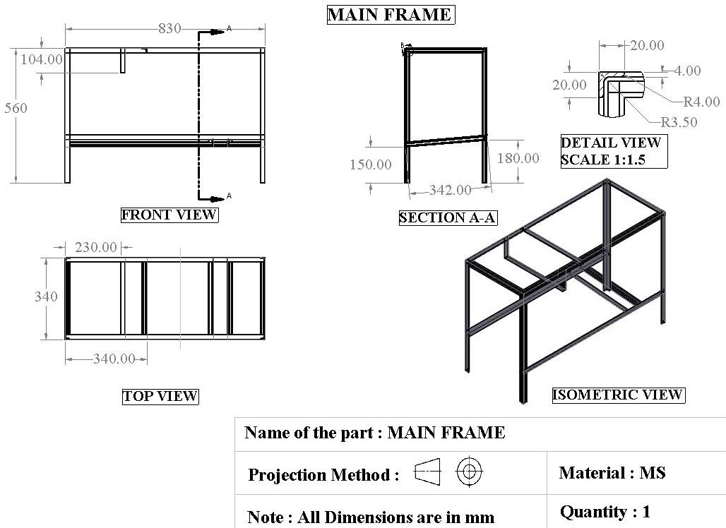

**Figure(10.8):** Main Frame

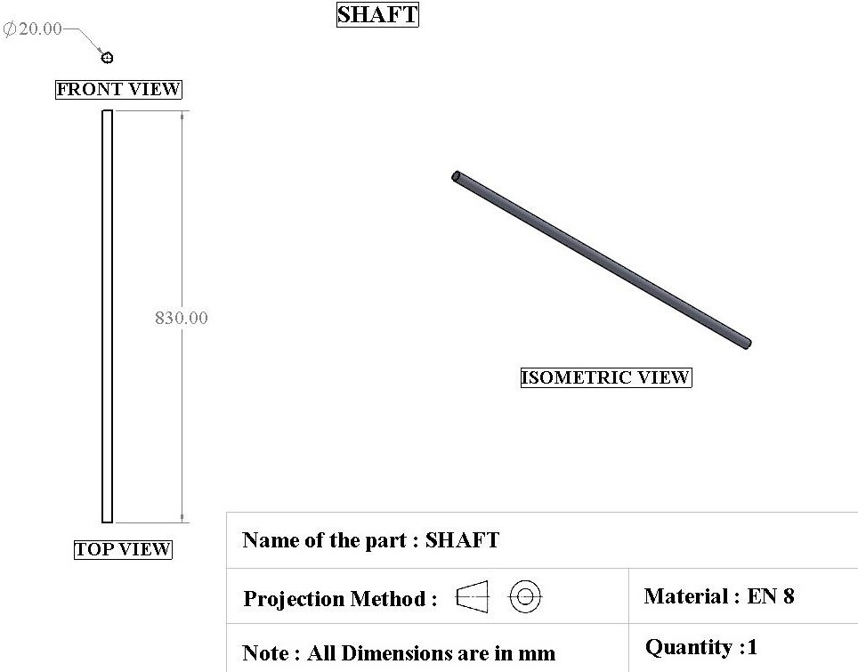

**Figure(10.9):** Shaft

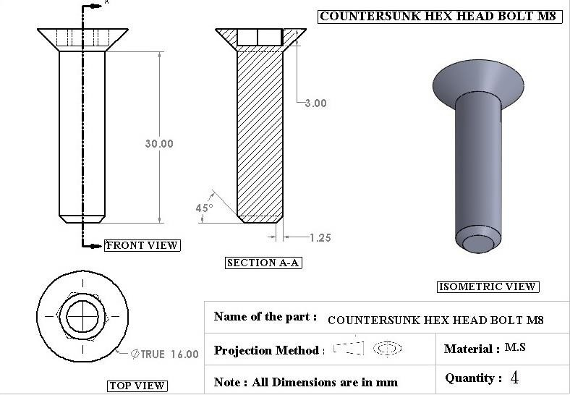

**Figure(10.10):** Countersunk Hex Head Bolt M8

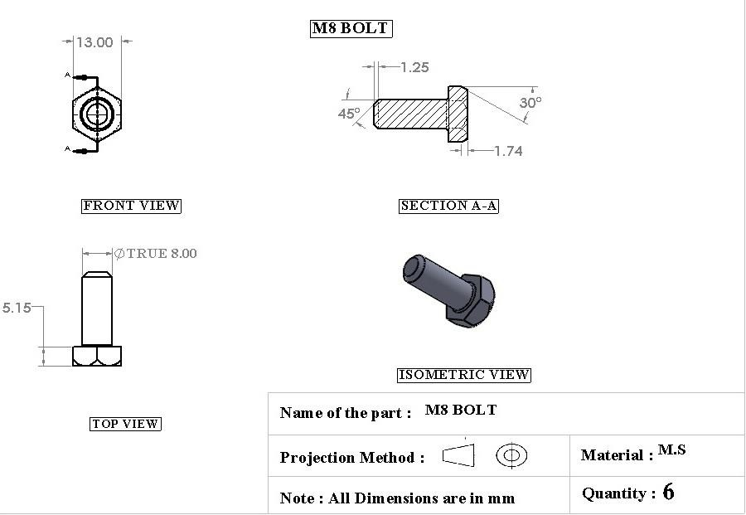

**Figure(10.11) :** M8 Bolt

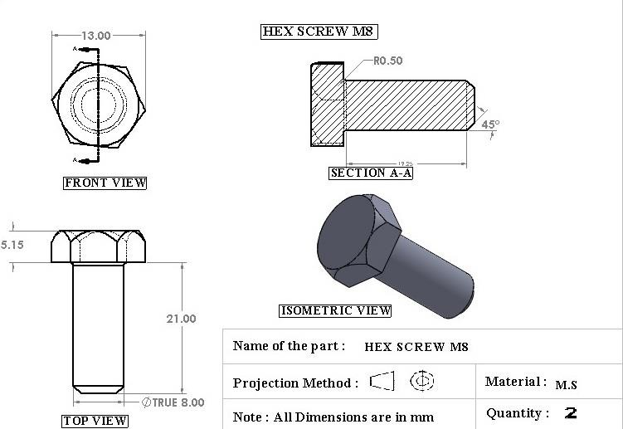

**Figure(10.12):** Hex Screw M8

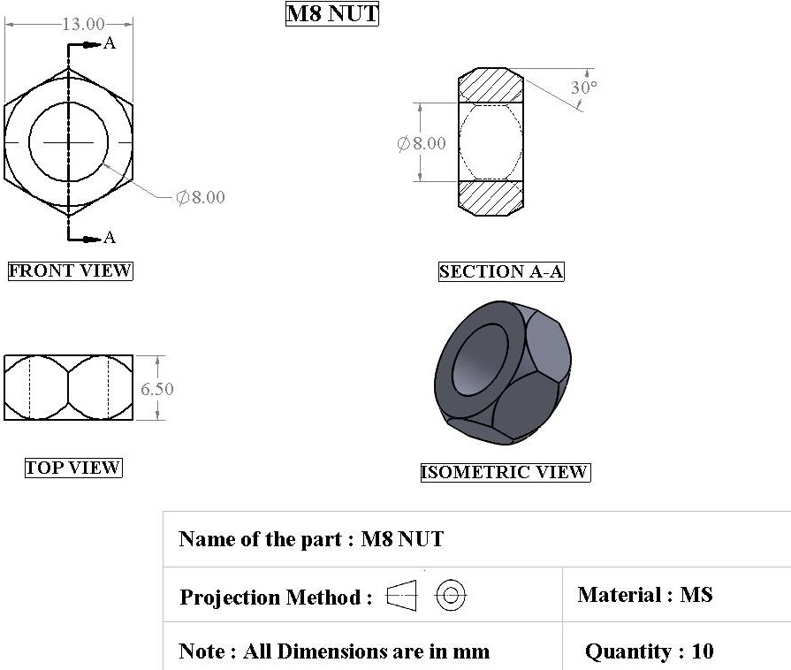

**Figure(10.13):** M8 Nut

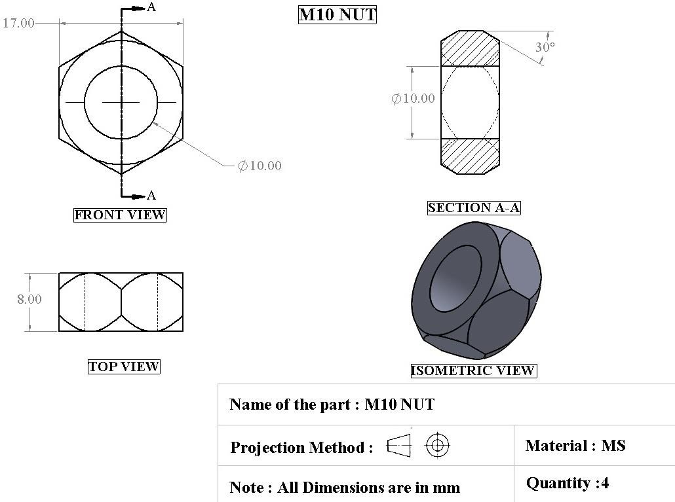

**Figure(10.14):** M10 Nut

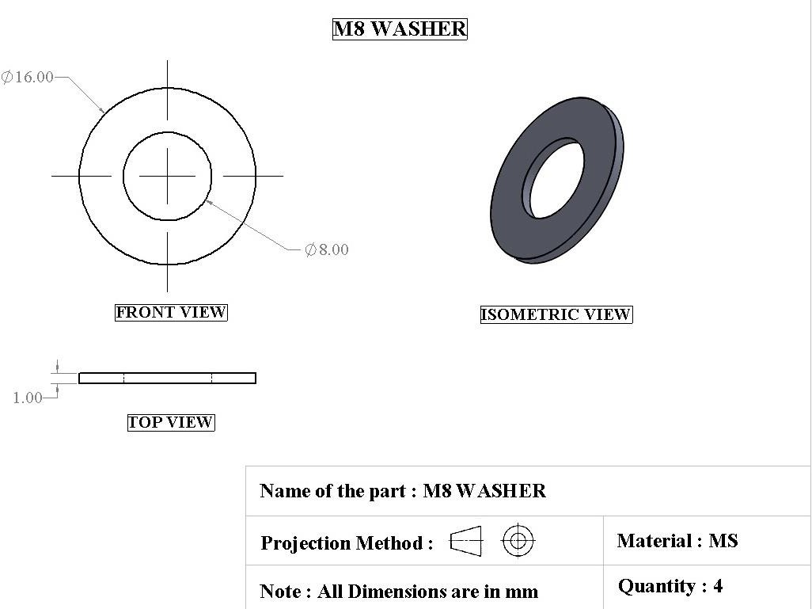

**Figure(10.15):** M8 Washer

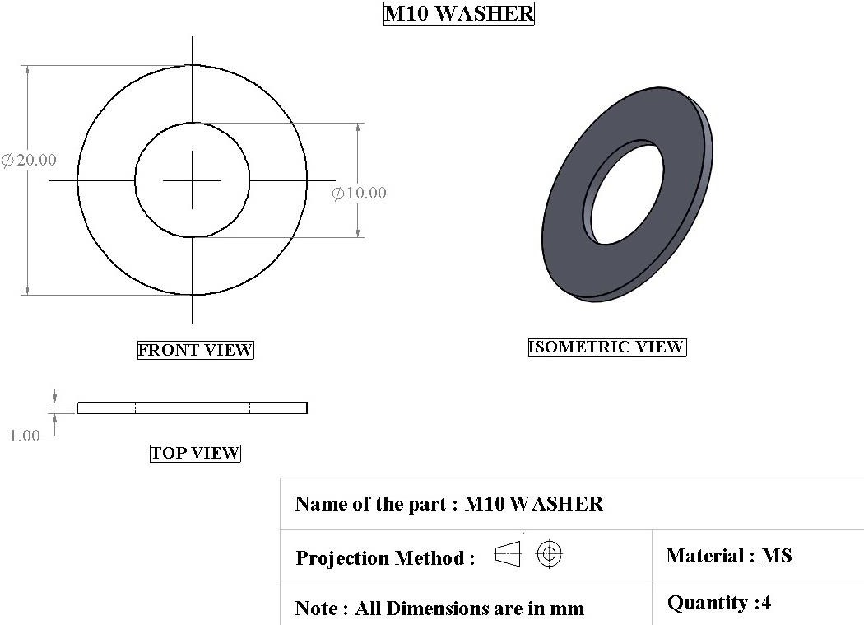

**Figure(10.16):** M10 Washer



**Figure(10.17**): Shaft

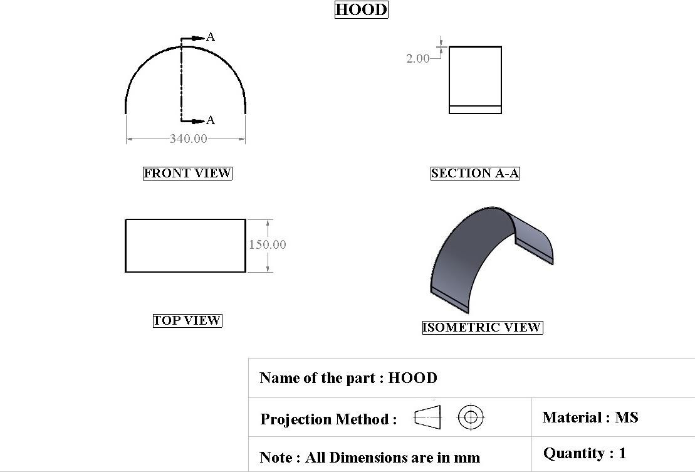

**Figure(10.18):** Hood

# Chapter 11: Manufacturing& Result

The process of conversion of raw material in to finished products using the three resources as Man, machine and finished sub-components.

Manufacturing is the term by which we transform resource inputs to create Useful goods and services as outputs. Manufacturing can also be said as an intentional act of producing something useful . The transformation process is Shown below-

Input

**Table(11.1):** Transformation Process

out put

conventional process

Transformation

Useful product

Machines

Products

Interpretation

Knowledge

Skill

Services

Element

Material Data Energy

Variable cost Fixed cost Revenue

It is the phase after the design. Hence referring to the those values we will plan The various processes using the following machines:-

* + 1. Universal lathe
    2. Milling machine
    3. Grinding machine
    4. Power saw
    5. Drill machine
    6. Electric arc welding machine

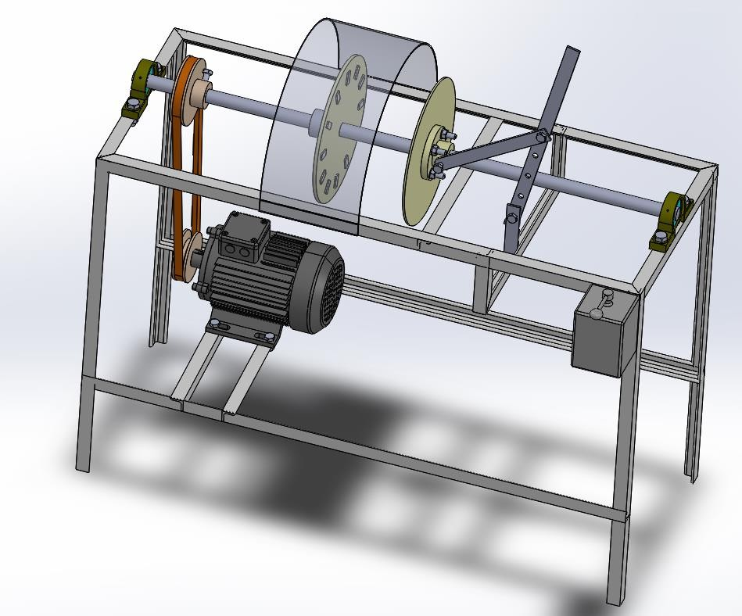

**Figure(11.1):** CAD model of frictionless braking system

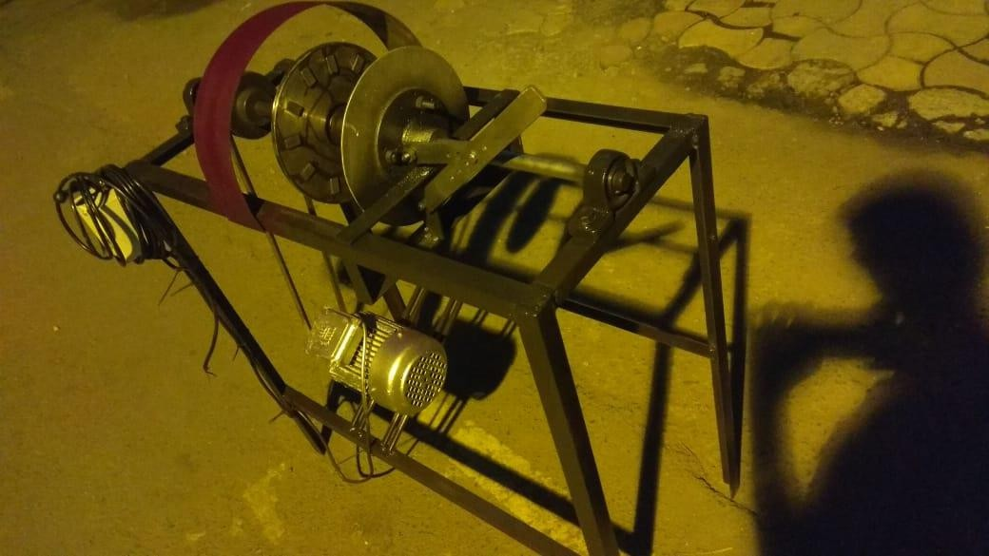

**Figure(11.2):** Basic fabrication of frictionless brakes

## 11.1-Frame Manufacturing

Component--Fame Material--M.S.Angle Quantity—01

**Table(11.2):** Frame Manufacturing

|  |  |  |  |  |
| --- | --- | --- | --- | --- |
| SR. NO | DESCRIPTION OF OPERATION | MACHINE USED | CUTTING | MEASUREMENT |
| 1 | Cutting the angle in to length as per dwg | Gas cutting machine | Gas cutter | Steel rule |
| 2 | Cutting the angle in to number of piece as per dwg | Gas cutting machine | Gas cutter | Steel rule |
| 3 | Filing operation can be performed on cutting side and bring it in perpendicular C.S. | Bench vice | File | Try square |
| 4 | Weld the angles to the required size as per the drawing | Electric arc welding machine | ------- | Try square |
| 5 | Drilling the frame at required points as per the drawing. | Radial drill machine | Twist drill | Vernier calliper |

## 11.2-Shaft Manufacturing

Component--Shaft Material--Bright Steel Quantity—02

**Table(11.3):** Shaft Manufacturing

|  |  |  |  |  |  |
| --- | --- | --- | --- | --- | --- |
| SR.NO. | DETAIL OPER. | M/C. USED | TOOL USED | ACCES | MEA.INST. |
| 1. | Marking on shaft | - | - | - | Scale |
| 2. | Cutting as per dwg | Power hack saw | Hock saw blade | Jig & fixtures | Scale |
| 3. | Facing both side of shaft | Lathe machine | Single point cutting tool | Chuck | Verniercaliper |
| 4. | Turning as per dwg size | - | - | - | - |
| 5. | Key way on end of shaft | Milling m/c. | Milling cutter | - | Verniercaliper |
| 6. | Filling on both end | Flat file |  | Vice | - |

## 11.3-Pulley Manufacturing

Component--Pulley Material--C.I. Quantity—02

**Table(11.4):** Pulley Manufacturing

|  |  |  |  |  |  |
| --- | --- | --- | --- | --- | --- |
| SR. NO | DESCRIPTION OF OPERATION | MACHINE USED | CUTTING | MEASUREMENT | TIME |
| 1 | Take standard pulley as per design | ------ | ---------- | ------------- | --------- |
| 2 | Face both side of hub portion | Lathe machine | Single point cutting tool | Verniercaliper | 15 min. |
| 3 | Hold it in three jaw chuck & bore inner dia as per shaft size | Lathe machine | Single point cutting tool | Verniercaliper | 20 min. |
| 4 | Drilling the hub at required points as per the drawing | Radial drill machine | Twist drill | Vernier calliper | 10 min. |
| 5 | Tap the hub at drill area. | Hand tap set | Tap | Vernier calliper | 10 min. |

## 11.4-Slide Bush Manufacturing

Component--Slide Bush Material--M.S. Quantity—02

**Table(11.5):** Slide Bush Manufacturing

|  |  |  |  |  |  |
| --- | --- | --- | --- | --- | --- |
| SR.NO. | DETAIL OPER. | M/C. USED | TOOL USED | ACCES | MEA.INST. |
| 1. | Marking on pipe | - | - | - | Scale |
| 2. | Cutting as per dwg | Power hack saw | Hock saw blade | Jig & fixtures | Scale |
| 3. | Facing both side of pipe | Lathe machine | S.P.C.T | Chuck | Verniercaliper |
| 4. | Turning as per dwg size | - | - | - | - |
| 5 | Filling on both end | Flat file |  | Vice |  |
| 6 | Drill number of holes on pipe | Drilling m/c | Drill bit | Clamp | Verniercaliper |

## 11.5-Results

BRAKING EFFECT

**Table(11.6):** Result of Braking effect

BRAKING TIME (sec)

|  |  |  |
| --- | --- | --- |
| Sr no. | DISTANCE (mm) | BRAKING TIME (sec) |
| 1 | 30 | 88 |
| 2 | 25 | 40 |
| 3 | 20 | 30 |
| 4 | 15 | 18 |
| 5 | 10 | 8 |
| 6 | 5 | 3 |

**Fig(11.3):** Graph of Braking time VS Distance



BRAKING TIME VS DISTANCE

100

90

80

70

60

50

40

30

20

10

0

0

5

10

15

20

25

30

35

DISTANCE (mm)

# Chapter 12: Maintenance

No machine in the universe is 100% maintenance free machine. Due to its continuous use it is undergoing wear and tear of the mating and sliding components. Also due to the chemical reaction takes place when the material comes in the contact with water, makes its corrosion and corrosion. Hence it is required to replace or repair. This process of repairing and replacing is called as maintenance work.[19]

## 12.1-Autonomous Maintenance Activity

1. Conduct initial cleaning & inspection.
2. Eliminate sources of dirt debris excess lubricants.
3. Improve cleaning maintainability.
4. Understand equipment functioning.
5. Develop inspection skills.
6. Develop standard checklists
7. Institute autonomous inspection
8. Organize and manage the work environment
9. Manage equipment reliability.

## 12.2-Cleaning

Why cleaning?

Prevent or eliminate contamination.

Find ways to simplify the cleaning process.

Facilitates through inspection when done by knowledgeable operators and \ or maintainers

* + What to look for when cleaning.
    - Missing part
    - Wear
    - Rust and corrosion
    - Noise
    - Cracks
    - Proper alignment
    - Leaks
    - Play or sloppiness

CLEANING IS INSPECTION

**Table(12.1):** Cleaning Inspection



Free equipment from

contamination

Look at and touch every area on the equipment

Clean equipment

Detect deterioration and defective parts in

Expose hidden

Remarkable sources of contamination

Identify difficulties to clean areas

Normal Or

## 12.3-Visual Aids to Maintain Correct Equipment Condition

* + - Match marks on nut and bolts
    - Colour marking of permissible operating ranges on dials and gauges
    - Marking of fluid type and flow direction of pipes
    - Marking at open / closed position on valves
    - Labelling at lubrication inlets and tube type
    - Marking minimum / maximum fluid levels
    - Label inspection sequences

Adjust and Minor Repair Minor repairs if

* Trained
* Experienced
* Performs safety
* Simple tool required
* Not longer than 20/30 minutes

**Table(12.2):** Chronic Defects

CHRONIC DEFECTS



LOSS IS

CHRONIC

LOSSES

LOSS IS

Remedial action is not taken

Remedial action

Remedial action

Equipment Requirement

* 1. Restore obvious deterioration throughout.
  2. Establish plan select pilot area , determine bottleneck.
  3. Study and understand the production process.
  4. Establish goals for improvement.
  5. Clarify the problem, collect the reference manuals contact resources.
  6. Conduct evaluation through such techniques as RCM analysis, FMECA, FTA (Root cause failure analysis).
  7. Determine improvement priorities, costs and benefits.
  8. Execute improvement in pilot area standardize technique and document what you have done.
  9. Monitor results and optimize based on those results.
  10. Implement plant wide

## 12.4-Equipment Responsibility of operator

* + 1. Operation with the proper standard procedure.
    2. Failure prevention.
    3. Failure resolution.
    4. Inspection.
    5. Equipment up keep.
    6. Cleaning.
    7. Lubricating.
    8. Lightning fasteners.
    9. Minor repairs.
    10. Trouble shooting.

# Chapter 13: Bibliography

A bibliography is a list of all of the sources you have used (whether referenced or not) in the process of researching your work. In general, a bibliography should include: the authors' names. the titles of the works. the names and locations of the companies that published your copies of the sources.

## 13.1-Address of Supplier

ESBEE ENGINEERING.

Authorized Dealer & Distributor; pumps & motors

2, Amrapli, 90 Feet Road, Mulund (E) Mumbai – 400081. VENUS NUT BOLT MFG . CO

Manufacturer of All Types of Nut & Bolts

30, TrimbakParshuram Street, Kasam Building, 6thKumbharwada Mumbai – 400004.

PRABATH METAL CORPORATION

Suppliers Of: - S.S.Steel Rod, Aluminum, Brass, Copper, M.S Angle, M.S PatrawallaChawl, 169, TrimbakParshuram Street, Kasam Building, 6th Kumbharwada Mumbai – 400004.

RELIANCE TOOLS & BEARING.

Dealers in All Kind Of: - Ball Roller & Tapered Bearing 163 Mutton Street,. Mumbai 400003

MAGNETO ENGINEERING

AUTHORIZED DEALERS IN ALL KIND OF: - FERRITE AND NEDEODIEM MAGNETS

SHOP NO B/53

110 NAGDEVI STREET

MASJID BUNDER MUMBAI 400003

## 13.2 Reference

|  |  |
| --- | --- |
| [01] | ["Foundation Brakes".](https://www.ontario.ca/document/official-ministry-transportation-mto-drivers-handbook/foundation-brakes) ontario.ca. Retrieved 2017-07-22 |
| [02] | [Roller Coaster History: Early Years In America.](http://www.ultimaterollercoaster.com/coasters/history/start/america.shtml) Retrieved 26 July 2007 |
| [03] | [Cedar Point To Build World's Tallest Roller Coaster](https://www.ultimaterollercoaster.com/coasters/new00/cp_millennium/cp_mf_pr.shtml). Ultimate Rollercoaster |
| [04] | [Chen, 2001](https://www.sciencedirect.com/science/article/pii/S2095756415302956#bbb0005)A.F. ChenICE 3 pioneers application of eddy-current rail brakesForeign Rolling Stock, 38 (4) (2001), pp. 37-39 |
| [05] | ["Silver Bullet Trademark"](http://tsdr.uspto.gov/#caseNumber%3D76517716%26caseType%3DSERIAL_NO%26searchType%3DstatusSearch). United States Patent and Trademark Office.  Retrieved April 3, 2013 |
| [06] | Kaspi, Victoria M.; Beloborodov, Andrei M. (2017). "Magnetars". Annual Review of Astronomy and Astrophysics. 55 (1): 261–  301. [*arXiv*](https://en.wikipedia.org/wiki/ArXiv_(identifier)):[*1703.00068*](https://arxiv.org/abs/1703.00068). [*Bibcode*](https://en.wikipedia.org/wiki/Bibcode_(identifier)):[*2017ARA&A..55..261K*](https://ui.adsabs.harvard.edu/abs/2017ARA%26A..55..261K). [*doi*](https://en.wikipedia.org/wiki/Doi_(identifier)):[*10.1146/annurev-*](https://doi.org/10.1146%2Fannurev-astro-081915-023329)  [*astro-081915-023329*](https://doi.org/10.1146%2Fannurev-astro-081915-023329) |
| [07] | Ajay Yadav, “Electronic Motor Braking,” IEEE Trans. On Industry Applications,  vol.IA-19,pp.824-831,Apr.1983 |
| [08] | A. Podol’skii, “On a numerical solution of a case of magnetization of  ferromagnetic materials” (in Russian), Electrichestvo, No 8, pp. 80-84, Aug. 1990 |
| [09] | Akshyakumar S Puttewar “Enhancement of Braking System in Automobile Using  Electromagnetic Braking” IJAREEIE, 2010 |
| [10] | Lenz, E. (1834), "Ueber die Bestimmung der Richtung der durchelektodynamischeVertheilungerregtengalvanischenStröme", Annalen der Physik und Chemie, 107 (31), pp. 483–494. A partial translation of the paper is available in Magie, W. M. (1963), A Source Book in Physics, Harvard: Cambridge  MA, pp. 511–513 |
| [11] | Schmitt, Ron. [Electromagnetics explained.](https://archive.org/details/electromagnetics0000schm/page/75) 2002. Retrieved 16 July 2010 |
| [12] | ["What is a Strong Magnet?".](http://www.adamsmagnetic.com/blogs/2012/what-is-a-strong-magnet/) The Magnetic Matters Blog. [Adams Magnetic](http://www.adamsmagnetic.com/) [Products.](http://www.adamsmagnetic.com/) October 5, 2012. Retrieved October 12, 2012 |
| [13] | [Jump up to:a](https://en.wikipedia.org/wiki/Neodymium_magnet#cite_ref-Fraden_2-0) [b](https://en.wikipedia.org/wiki/Neodymium_magnet#cite_ref-Fraden_2-1) Fraden, Jacob (2010). [Handbook of Modern Sensors: Physics,](http://books.google.com/books?id=W0Emv9dAJ1kC&pg=PA73&lpg=PA73&dq=%22neodymium%2Bmagnet%22%2Bstrongest)  [Designs, and Applications, 4th Ed.](http://books.google.com/books?id=W0Emv9dAJ1kC&pg=PA73&lpg=PA73&dq=%22neodymium%2Bmagnet%22%2Bstrongest) USA: Springer. p. 73. [ISBN](https://en.wikipedia.org/wiki/International_Standard_Book_Number) 1441964657 |
| [14] | [Jump up^](https://en.wikipedia.org/wiki/Neodymium_magnet#cite_ref-4) ["Magnetic Anisotropy"](http://www.irm.umn.edu/hg2m/hg2m_c/hg2m_c.html). Hitchhiker's Guide to Magnetism. Retrieved 2  March2014 |

|  |  |
| --- | --- |
| [15] | [Jump up^](https://en.wikipedia.org/wiki/Neodymium_magnet#cite_ref-7) ["Research Funding for Rare Earth Free Permanent Magnets".](http://arpa-e.energy.gov/?q=arpa-e-programs/react) ARPA-E.  Retrieved 23 April 2013 |
| [16] | Drak, M.; Dobrzanski, L.A. (2007). "Corrosion of Nd-Fe-B permanent magnets" (PDF). Journal of Achievements in Materials and Manufacturing  Engineering. 20 (1–2). Archived from [the original](http://www.journalamme.org/papers_vol20/1369S.pdf) (PDF) on 2012-04-02 |
| [17] | [As hybrid cars gobble rare metals, shortage looms,](https://www.reuters.com/article/newsOne/idUSTRE57U02B20090831) Reuters, August 31, 2009. |
| [18] | "CPSC Safety Alert: Ingested Magnets Can Cause Serious Intestinal  Injuries" (PDF)*. U.S. Consumer Product Safety Commission. Archived from* [the](https://www.cpsc.gov/cpscpub/pubs/5221.pdf) [original](https://www.cpsc.gov/cpscpub/pubs/5221.pdf) (PDF) *on 8 January 2013*. Retrieved 13 December 2012 |
| [19] | Sears, Francis Weston; Zemansky, Mark W. (1955). [University Physics](https://archive.org/details/universityphysic00searrich) (2nd ed.).  Reading, MA: Addison-Wesley |