HEALTHCARE OPERATIONS INTELLIGENCE
Enhanced Healthcare Data Analysis, Operational Insights and Exploratory ML
IBM SkillsBuild Data Analytics with AI Internship 2026
Student: Nitin Kohli
Source dataset: synthetic healthcare data for educational purposes
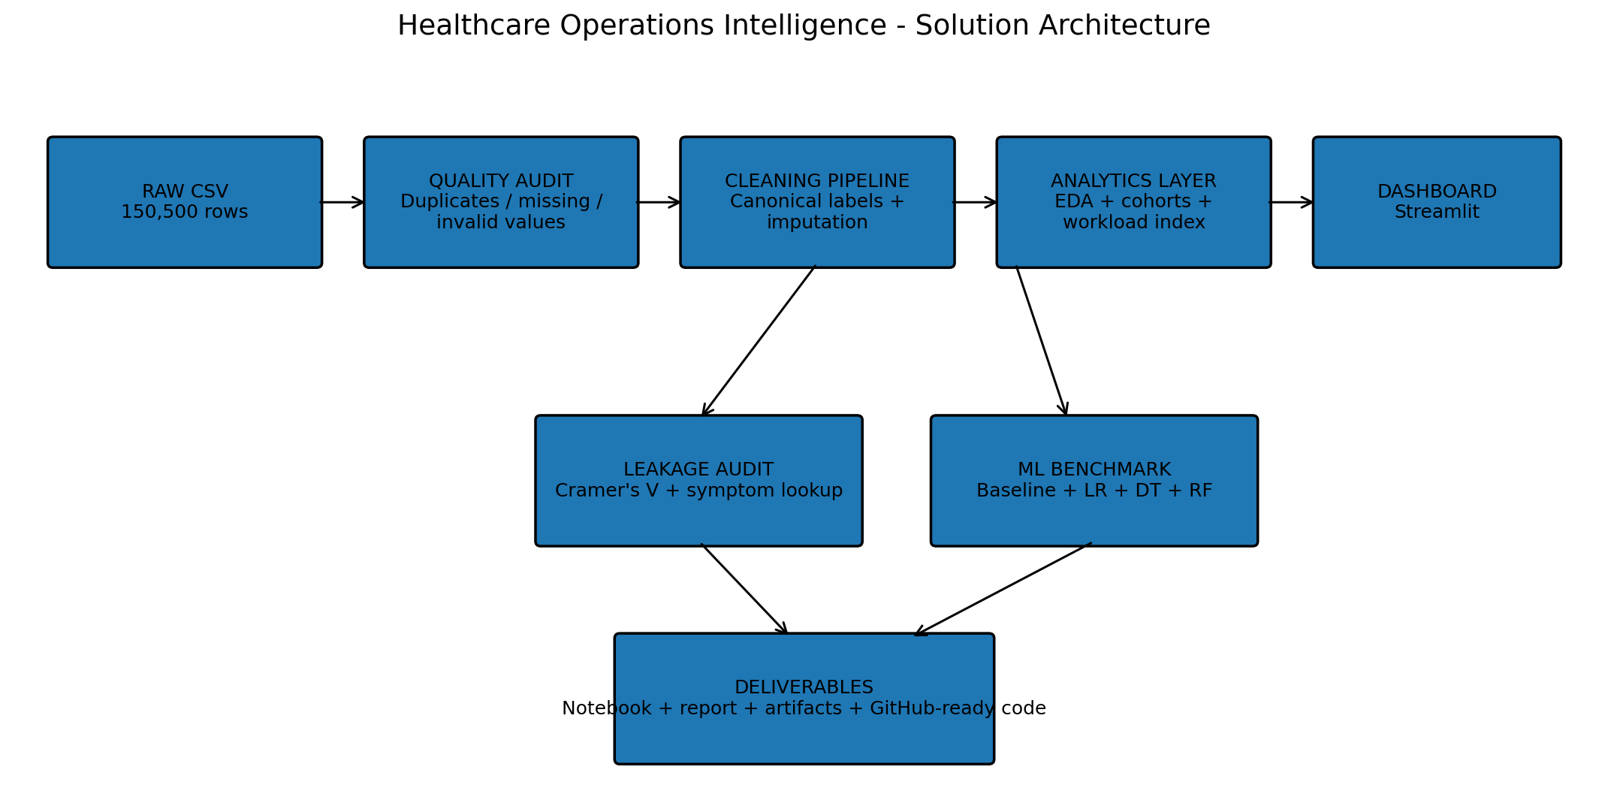
Figure 1. Enhanced project architecture.
Healthcare disclaimer
This project uses synthetic healthcare data. It is intended for education and analytics practice only and must not be used for diagnosis, treatment, triage, or clinical decision-making.

1. Executive Summary
This project transforms the original Healthcare Data Analysis and Patient Insights notebook into a reusable Healthcare Operations Intelligence product. The original work analyzed 150,500 raw rows, removed 500 duplicate records, cleaned data-quality issues, performed exploratory analysis, answered healthcare-focused questions, and evaluated a Decision Tree model. The enhanced version retains those core findings while adding a reusable data pipeline, row-level quality auditing, an interactive Streamlit dashboard, a transparent department Operations Load Index, quantitative synthetic-leakage detection, and a four-model exploratory ML benchmark.
The cleaned dataset contains 150,000 records and 14 original columns. The average patient age is 49.05 years, the busiest department is Dermatology with 24,447 records, and 37.28% of records have a chronic-condition label of Yes. The strong symptom-to-department association is explicitly audited rather than silently used to inflate model performance.
Main project value
The deliverable is not only a notebook. It is a reproducible analytics system: raw data -> auditable cleaning -> analytics -> operational views -> ML audit -> dashboard -> report.

2. Baseline Project Retained and Enhanced
The submitted baseline notebook and report were used as the factual starting point. Their terminology, core findings and dataset were retained so that the enhanced project remains traceable to the internship requirement.
Baseline approach | Enhanced project
Static notebook | Reusable pipeline + notebook + Streamlit dashboard
Cleaning cells | Cleaning module + issue flags + quality report
Fixed EDA | Filterable cohort and department exploration
Single Decision Tree | Majority baseline + Logistic Regression + Decision Tree + Random Forest
Narrative leakage explanation | Cramer's V + symptom lookup audit
Operational observations | Transparent Operations Load Index with adjustable weights
Manual outputs | Generated CSV/JSON/PNG artifacts
One-time work | Reproducible build script + automated tests

3. Problem Statement
Healthcare facilities can generate large amounts of structured patient information. Without a systematic analysis workflow, patterns in demographics, symptoms, department workloads, vital-sign measurements, severity labels and chronic-condition fields can be difficult to inspect consistently. The project therefore asks: how can a synthetic patient dataset be converted into a transparent, reusable analytical product that surfaces operational patterns, validates data quality and evaluates whether non-symptom features contain useful predictive signal for department assignment?
The project does not attempt to diagnose patients or recommend treatment.

4. Objectives
- Audit the raw dataset for duplicates, missing values, category inconsistencies and invalid numeric values.
- Clean the dataset without overwriting the original raw file.
- Describe the patient population, symptoms, severity, chronic-condition mix and department workload.
- Add cohort analysis using age groups and duration/pain bands.
- Create a transparent, operationally focused department index with visible components.
- Quantify the unusually strong synthetic relationship between symptoms and departments.
- Benchmark multiple ML models using the department target while excluding the high-leakage symptom feature.
- Expose findings through an interactive dashboard.
- Produce reproducible artifacts, tests, a report and GitHub-ready documentation.

5. Dataset and Data Dictionary
The raw CSV contains 150,500 rows and 14 columns. After cleaning, 150,000 unique patient rows remain. The data is explicitly synthetic and exists for educational analytics.
Column | Type | Description
patient_id | Integer | Patient identifier
age | Numeric | Age in years
gender | Categorical | Male / Female
symptoms | Categorical | Primary reported symptom
temperature | Numeric | Body temperature in degrees F
duration_days | Numeric | Reported symptom duration
bp_systolic | Numeric | Systolic BP value in the source dataset
bp_diastolic | Numeric | Diastolic BP value in the source dataset
heart_rate | Numeric | Heart rate
oxygen_saturation | Numeric | Oxygen saturation
pain_level | Numeric | Self-reported pain scale 0-10
symptom_severity | Categorical | Mild / Moderate / Severe
chronic_condition | Categorical | Yes / No
department | Categorical | One of 9 hospital departments

6. Data Quality Audit
Quality metric | Value | Treatment / interpretation
Raw rows | 150,500 | 150,500
Exact duplicates removed | 500 | 500
Raw missing cells | 16,402 | 0.778% of all cells
Oxygen > 100 | 6,246 | Capped at 100
Extreme systolic BP | 158 | Set to missing, then median-imputed
Final missing cells | 0 | 0
Final unique patient IDs | 150,000 | 150,000
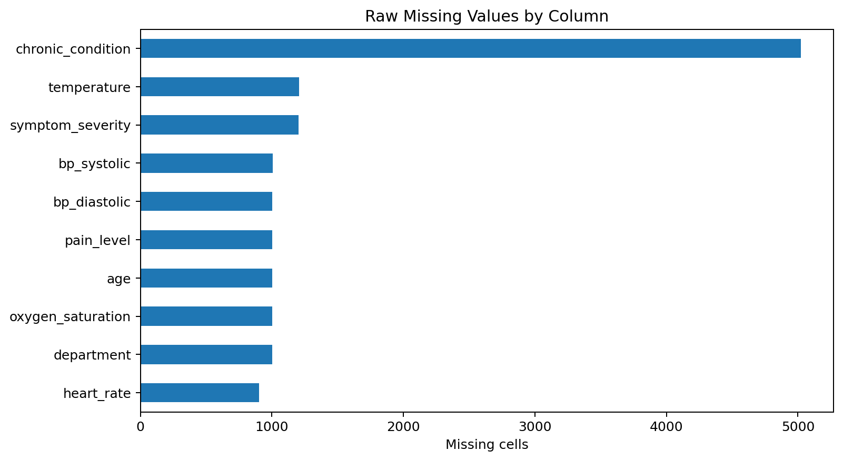
Figure 2. Raw missingness profile.
The enhanced pipeline also stores row-level flags in the enriched output. This makes it possible to distinguish records that were clean from the start from records that required one or more corrections/imputations.

7. Cleaning Methodology
Step | Implementation
1. Preserve raw data | The original CSV remains untouched.
2. Remove exact duplicates | 500 exact duplicate rows are removed.
3. Normalize categories | Variant casing and whitespace are mapped to canonical labels, including preserving ENT as an acronym.
4. Correct oxygen values | 6,246 values above 100 are capped at 100.0.
5. Handle extreme systolic BP | 158 values below 60 or above 200 are set to missing and then median-imputed.
6. Impute numeric missing values | Column medians are used.
7. Impute categorical missing values | Column modes are used.
8. Add audit flags | Row-level quality flags and status are stored in the enriched dataset.

8. Exploratory Data Analysis
The cleaned dataset has an average age of 49.05 years and a median of 49.00 years. The largest age group is 61-80 with 47,402 records.
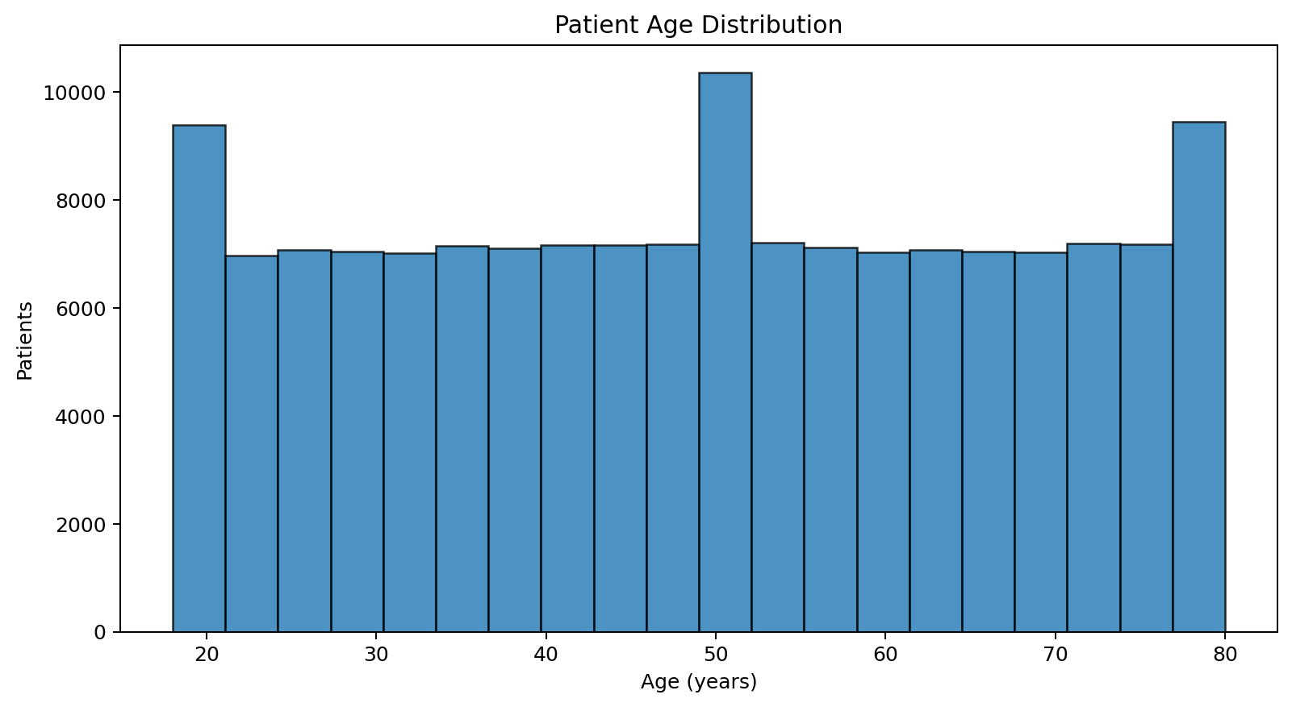
Figure 3. Patient age distribution.
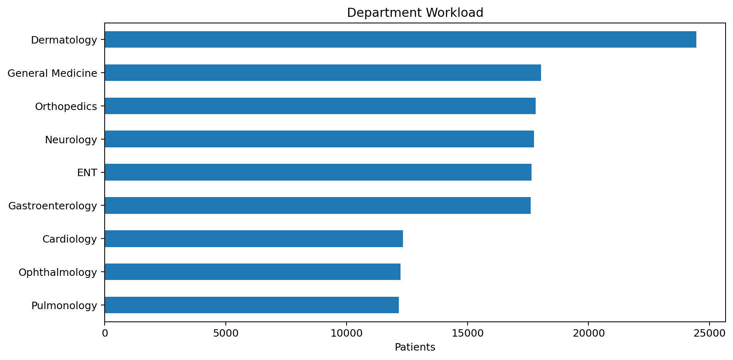
Figure 4. Department workload.
Among departments, Dermatology has the highest volume at 24,447 records. Department volume is treated as an operational workload pattern, not a measure of clinical severity.
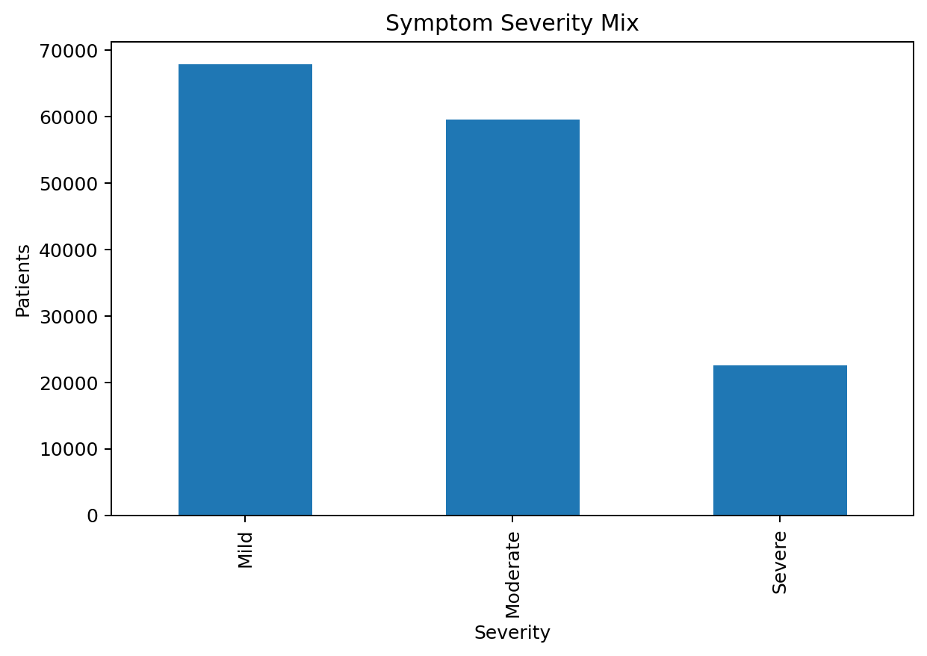
Figure 5. Symptom severity mix.
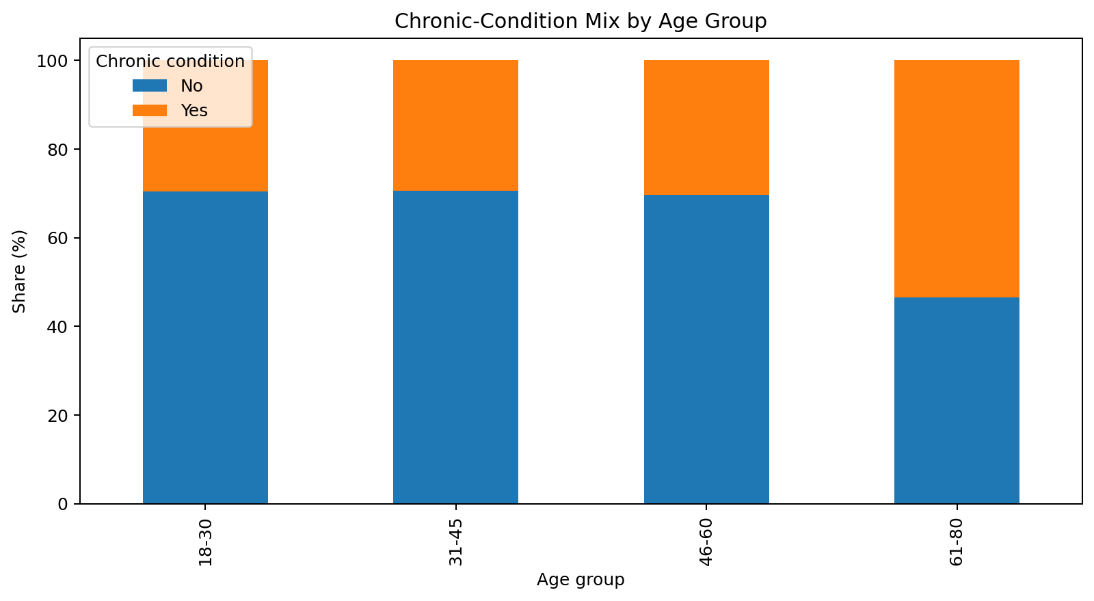
Figure 6. Chronic-condition mix by age group.
The dataset contains 37.28% records labeled with a chronic condition. The 61-80 group is the largest and also contains the largest count of chronic-condition records.
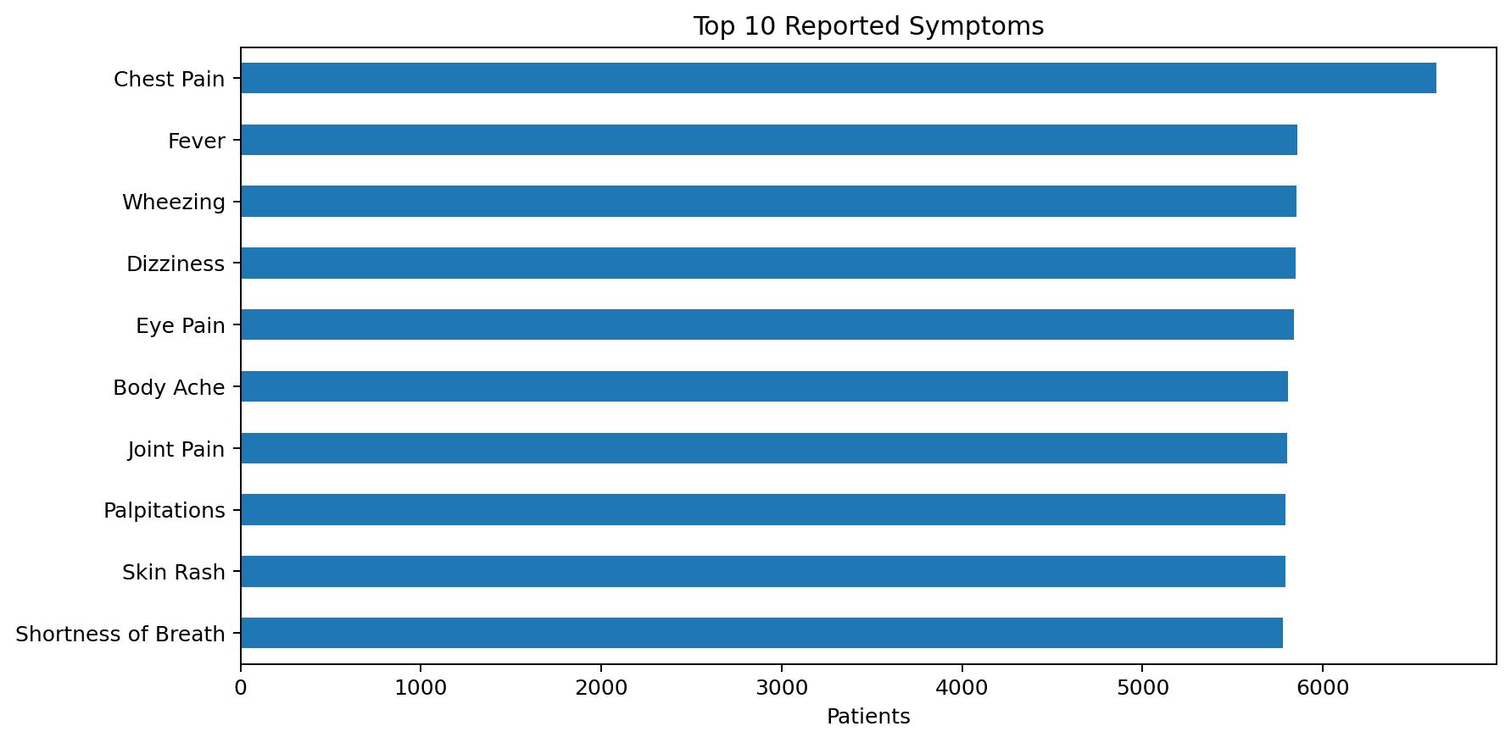
Figure 7. Top reported symptoms.

9. Ten Key Questions and Answers
Question | Answer
Average patient age | 49.05 years
Most common gender | Male (52.1% in the baseline report)
Most common symptom | Chest Pain (6,629)
Busiest department | Dermatology (24,447)
Most common severity | Mild (45.26%)
Average heart rate | 77.48 bpm
Highest average heart rate department | Cardiology (87.59 bpm)
Chronic-condition prevalence | 37.28%
Largest age group | 61-80 (47,402)
Highest average pain department | Orthopedics (6.90/10)

10. Department Operations Intelligence
The enhanced project introduces an Operations Load Index. It is a custom analytical score designed to summarize operational dimensions in one transparent view. It combines four components: patient volume share (40%), severe-case share (25%), chronic-condition share (15%) and average symptom duration (20%). Each component is min-max normalized across departments before the weighted sum. The score is not a medical severity or risk score.
Department | Patients | Volume % | Severe % | Chronic % | Avg duration | Ops load
Dermatology | 24,447 | 16.30% | 14.82% | 37.35% | 15.61 | 70.04
General Medicine | 18,031 | 12.02% | 15.10% | 37.76% | 15.36 | 46.52
Orthopedics | 17,813 | 11.88% | 15.03% | 37.52% | 15.53 | 52.78
Neurology | 17,744 | 11.83% | 15.00% | 37.46% | 15.57 | 54.59
ENT | 17,644 | 11.76% | 15.40% | 36.69% | 15.53 | 56.63
Gastroenterology | 17,605 | 11.74% | 14.80% | 37.32% | 15.53 | 39.78
Cardiology | 12,328 | 8.22% | 14.84% | 36.92% | 15.59 | 24.38
Ophthalmology | 12,222 | 8.15% | 15.27% | 36.86% | 15.57 | 38.72
Pulmonology | 12,166 | 8.11% | 14.98% | 37.37% | 15.47 | 25.70
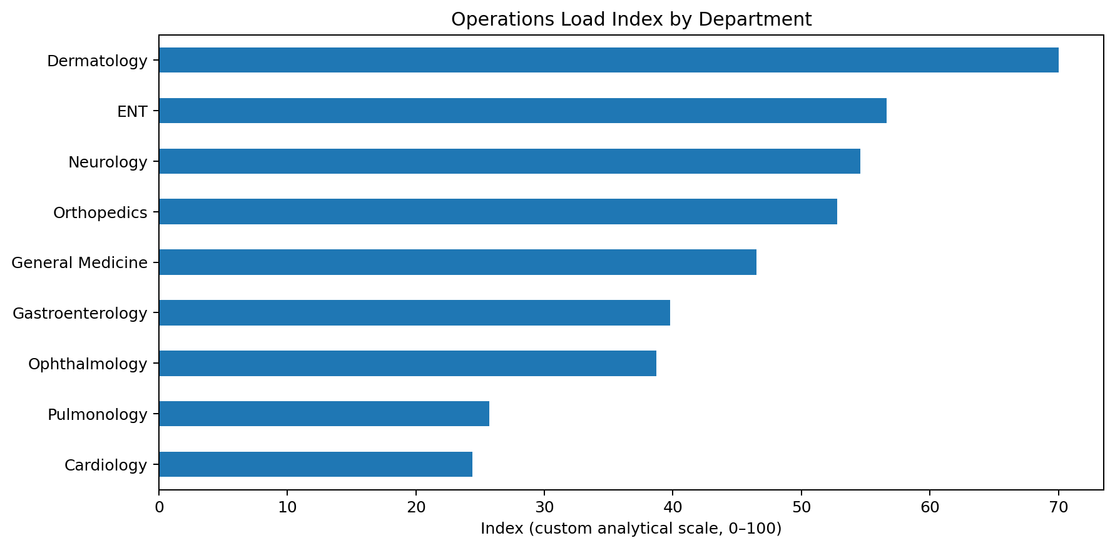
Figure 8. Transparent Operations Load Index.
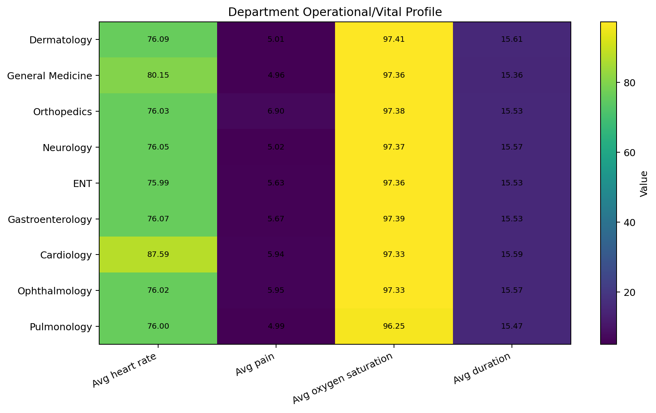
Figure 9. Department profile across selected metrics.

11. Synthetic Data-Generation Audit: Symptom to Department
The most important data-quality insight is not a missing value; it is the structure of the synthetic data itself. The symptom feature is extremely associated with department. Cramer's V is 0.969, and a simple symptom-to-most-common-department lookup reaches 95.63% accuracy.
This means a model that uses symptoms could obtain very high accuracy by learning a relationship that is already almost hard-coded in the synthetic data. The enhanced project therefore treats symptoms as an audit target and excludes it from the final benchmark. This is a methodological decision to keep the ML evaluation educationally meaningful.
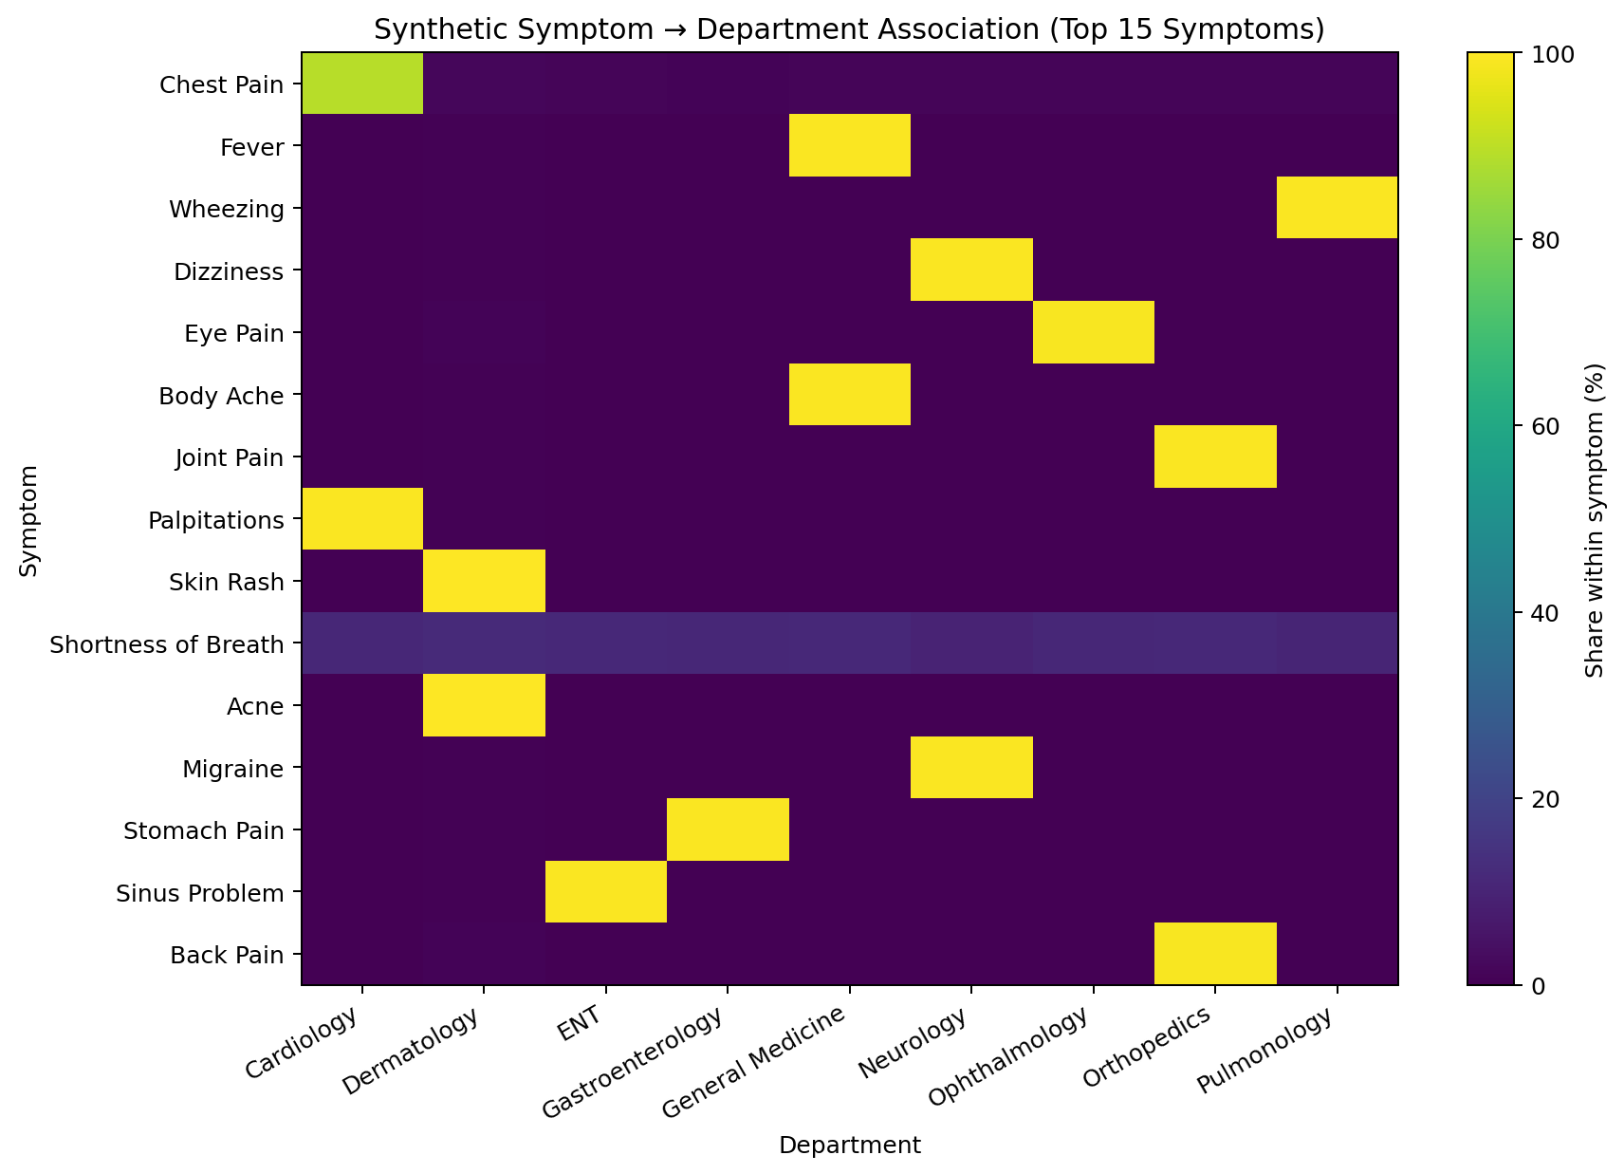
Figure 10. Strong synthetic symptom-to-department association.

12. Exploratory Machine Learning
The target variable is department (9 classes). Gender, symptom severity and chronic-condition status were considered as alternative categorical targets, but the project focuses on department because it provides an operational classification problem. The symptoms feature is excluded because of the strong synthetic leakage-like relationship described above.
Final feature set:
- age
- temperature
- duration_days
- bp_systolic
- bp_diastolic
- heart_rate
- oxygen_saturation
- pain_level
- gender
- chronic_condition
- symptom_severity

12.1 Baseline and enhanced model benchmark
Experiment | Model | Accuracy | Balanced accuracy | Macro F1 | Notes
Original baseline report | Decision Tree | 16.83% | - | - | Reported in submitted baseline report
Enhanced benchmark | Random Forest | 22.49% | 21.35% | 0.163 | 80/20 stratified split
Enhanced benchmark | Logistic Regression | 21.97% | 20.09% | 0.155 | 80/20 stratified split
Enhanced benchmark | Decision Tree | 16.79% | 15.85% | 0.157 | 80/20 stratified split
Enhanced benchmark | Majority Baseline | 16.30% | 11.11% | 0.031 | 80/20 stratified split
The enhanced benchmark's strongest model by accuracy is Random Forest at 22.49% accuracy and 21.35% balanced accuracy. Although this improves on the majority baseline and the single Decision Tree, the absolute performance remains modest. The result is therefore reported as an exploratory ML finding rather than a clinical prediction capability.
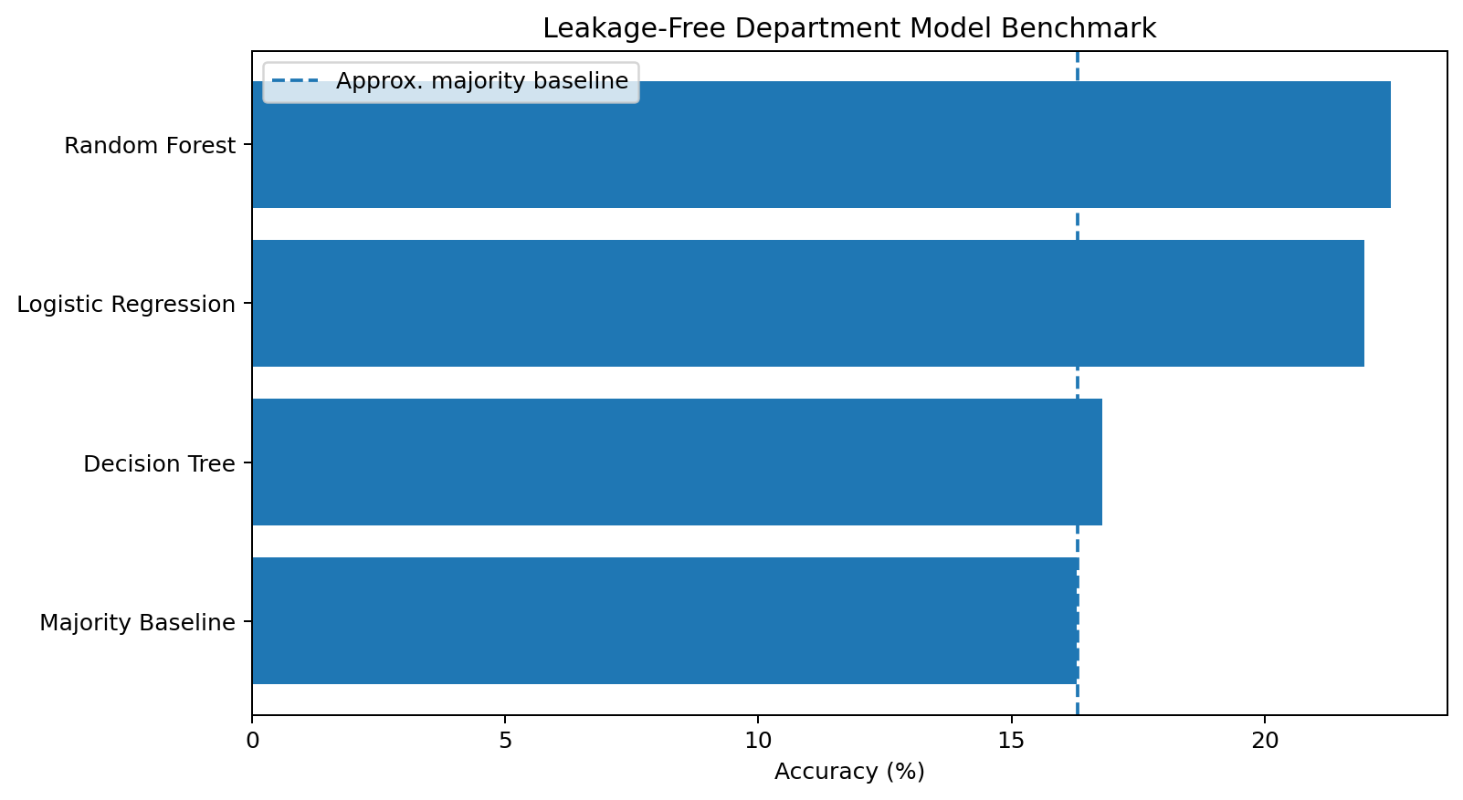
Figure 11. Four-model exploratory benchmark.
The original baseline report's Decision Tree value (16.83%) and the enhanced reproducible benchmark's Decision Tree value (16.79%) are very close. Small differences can arise from implementation details such as preprocessing and encoding, so the enhanced project emphasizes relative comparison, baselines and transparent methodology rather than claiming a large model-performance leap.

13. Operational Considerations
The baseline report proposed operational considerations tied to the descriptive findings. The enhanced project preserves the intent of those considerations while clearly separating analytical evidence from clinical decisions.
Area | Analytical observation
Department resource planning | Dermatology has the highest record volume (24,447). This can inform a workload discussion when actual time and capacity data are available.
Cardiology workload context | Cardiology has the highest average heart rate in this synthetic dataset (87.59 bpm). This is a descriptive pattern, not a clinical threshold.
Orthopedics pain context | Orthopedics has the highest average pain value (6.90/10). Operational teams could use this type of descriptive metric in a broader service-review context.
Pulmonology vital-sign context | Pulmonology has the lowest average oxygen saturation in the synthetic dataset (96.25% in the baseline/enhanced analysis). This should not be interpreted as a clinical recommendation.
Older cohort planning | The 61-80 age group is the largest cohort (47,402) and contains the highest count of chronic-condition records. In real settings, capacity planning would require validated temporal and operational data.
Data-quality controls | The raw dataset contains duplicates, missing values, mixed labels and invalid measurements. A real information system should validate inputs before downstream analytics.

14. Interactive Dashboard
The Streamlit application turns the analysis into an interactive product. Users can navigate between executive KPIs, data quality, department intelligence, patient/symptom exploration, ML audit, evidence-based Q&A and downloads.
- Executive Overview - high-level KPIs, workload, severity mix and narrative insights.
- Data Quality - missingness, duplicate count, correction counts and row-level quality status.
- Department Intelligence - workload table, adjustable Operations Load Index and department drill-down.
- Patient & Symptom Explorer - department filters, age cohorts, chronic-condition mix and symptom patterns.
- ML Audit - model benchmark, synthetic leakage explanation and optional confusion matrix.
- Evidence Q&A - fixed evidence-based answers calculated directly from the cleaned dataset.
- Downloads - cleaned/enriched CSVs and analytical artifacts.
Because Streamlit is not required for the notebook itself, the project remains usable in a notebook-only environment while the dashboard provides the presentation layer for a final submission or demonstration.

15. Implementation and Reproducibility
Main components:
Component | Purpose
src/data_pipeline.py | Cleaning, feature engineering, department summary and leakage audit functions
src/analytics.py | Four-model benchmark and metrics
scripts/build_artifacts.py | Rebuilds cleaned data, charts, tables and ML artifacts
app.py | Streamlit dashboard
notebooks/Healthcare_Operations_Intelligence.ipynb | End-to-end analytical notebook
tests/test_pipeline.py | Automated cleaning and feature tests
outputs/charts/ | Generated PNG charts
artifacts/ | JSON/CSV evidence artifacts
Windows run sequence:
python -m venv .venv
.venv\Scripts\activate
pip install -r requirements.txt
python scripts/build_artifacts.py
pytest -q
streamlit run app.py

16. Limitations
- The dataset is synthetic and cannot be generalized to real patient populations.
- There is no time dimension, so longitudinal trends and per-day workload cannot be inferred.
- The symptom-to-department relationship is unusually strong because of synthetic data generation.
- The cleaned dataset relies on median/mode imputation for missing values.
- The final ML task is department classification, not a clinical outcome prediction.
- The Operations Load Index is a custom descriptive score, not a clinical risk or severity score.
- The project does not contain diagnoses, lab results, treatment outcomes, hospital stay duration, medication history or imaging data.
- No external clinical validation has been performed.

17. Future Scope
- Add timestamps and evaluate workload trends over time.
- Add operational outcomes such as service time, length of stay or cost when ethically and appropriately available.
- Compare additional ensemble methods under strict validation controls.
- Add explainability methods such as permutation importance or SHAP for validated datasets.
- Add Power BI/Tableau views for business audiences.
- Introduce model monitoring and data-drift checks when a real deployment context exists.
- Use appropriately governed anonymized real-world data only after privacy, security and domain review.

18. Conclusion
The enhanced Healthcare Operations Intelligence project demonstrates a complete, reproducible analytics workflow on a synthetic healthcare dataset. It preserves the baseline project's important findings - including 150,000 cleaned records, the dominance of Dermatology in volume, the prominence of Chest Pain, the 37.28% chronic-condition prevalence and the age-group patterns - while adding stronger engineering and analytical layers.
The most important methodological improvement is the explicit audit of synthetic feature structure. With Cramer's V = 0.969 and symptom lookup accuracy of 95.63%, the project avoids presenting an artificially high symptom-based model as genuine predictive performance. The enhanced model benchmark then provides a more honest comparison among multiple models using features independent of the strongest synthetic shortcut.
Overall, the project is positioned as a data analytics and operational intelligence demonstration - not as a medical decision system.

Appendix A. Final Deliverables
Deliverable | Location
Streamlit dashboard | app.py
Cleaned dataset | data/healthcare_cleaned_150000.csv
Enriched audit dataset | data/healthcare_enriched_150000.csv
Analysis notebook | notebooks/Healthcare_Operations_Intelligence.ipynb
Project report | docs/Healthcare_Operations_Intelligence_ProjectReport.docx
README | README.md
Requirements | requirements.txt
Test suite | tests/test_pipeline.py
Charts | outputs/charts/
Analytical artifacts | artifacts/

Appendix B. Submission checklist
- Run build_artifacts.py successfully on a clean environment.
- Run pytest -q and confirm all tests pass.
- Run the Streamlit dashboard and capture final screenshots.
- Open and review the DOCX report.
- Commit the complete project to GitHub.
- Paste the GitHub repository URL into the final submission form.

