1. **Write a trigger such that if the Opportunity Stage Name is Closed Won or Closed Lost then the Close Date must be populated with today's date.**
2. trigger jun30TriggerOpportunity on Opportunity (before insert ,before update)
3. {
4. if(trigger.isBefore)
5. {
6. if( trigger.isinsert || trigger.isUpdate)
7. {
8. jun30Assignments.task1(trigger.new,trigger.oldmap);
10. }
11. }
12. }

**Output:-**

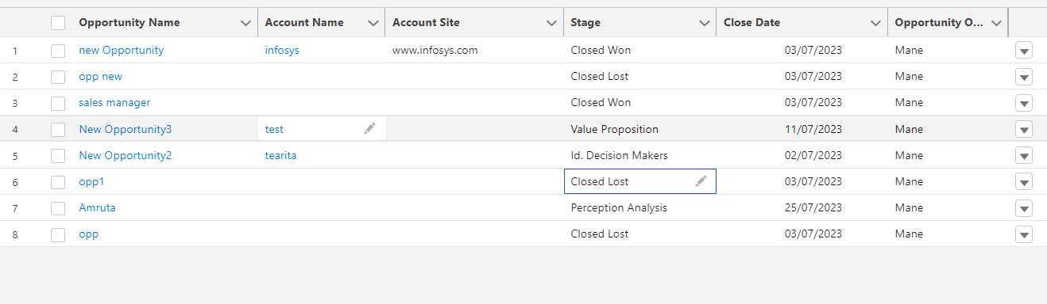

**2.Create a custom object Calculator. Create below fields on the object:-**

* **Number 1**
* **Number 2**
* **Addition**
* **Subtraction**
* **Multiplication**
* **Division**
* trigger jan30Calculator on Calculator__c (before insert ,before update)
* {
* if(trigger.isBefore)
* {
* if(trigger.isinsert)
* {
* jun30Assignments.task2(trigger.new,trigger.oldmap);
* }
* else {
* {
* if(trigger.isupdate)
* {
* jun30Assignments.task2(trigger.new,trigger.oldmap);
* }
* }
* }
* }
* }

**Output:-**

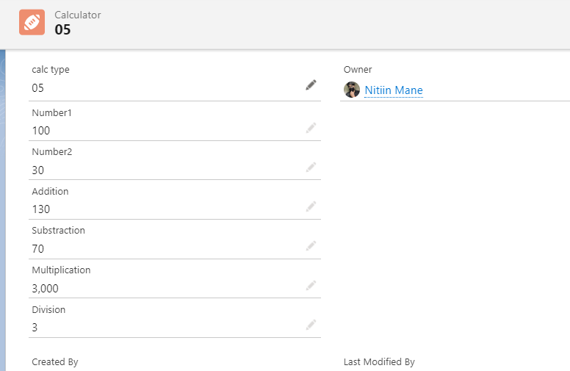

**3.Write a trigger such that if an Account has any Child Opportunity having StageName as ‘Closed Won’ then prevent deletion of that Account.**

trigger jun30TriggerAccount on Account (before delete)

 {

        if(trigger.isBefore)

        {

            if(trigger.isDelete)

            {

                jun30Assignments.task3(trigger.old);

            }

        }

}

**Output:-**

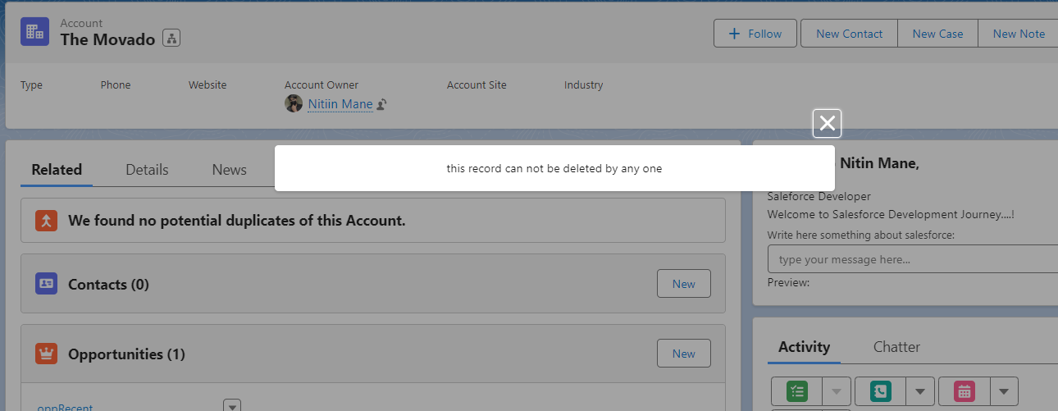

**4.Write a trigger such that when you create a new Lead with Email as not null. Check if an existing lead is present with the same email. If present throw an error message that “Duplicate lead found with same email”.**

1. trigger jun30LeadTrigger on Lead (before insert)
2. {
3. if(trigger.isbefore)
4. {
5. if(trigger.isInsert)
6. {
7. jun30Assignments.task4(trigger.new);
8. }
9. }
10. }

**Output:-**

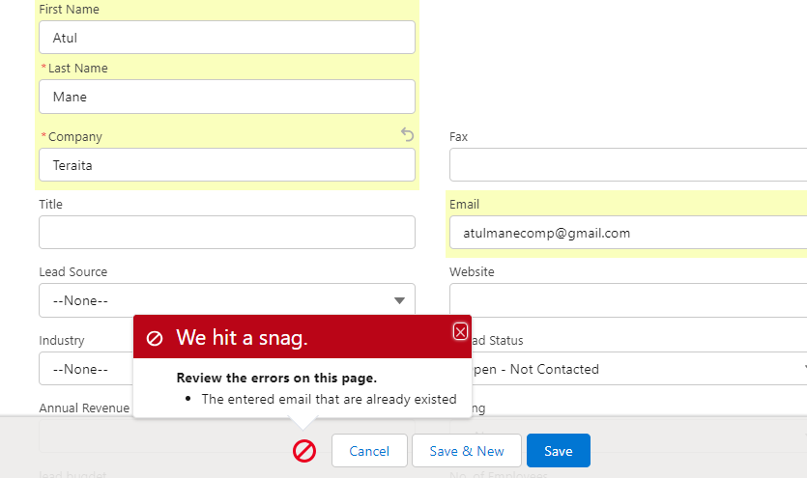

**5.Write a trigger on Account, when an account is inserted or updated, automatically account billing address should populate into the account shipping address**

trigger addressAccount on Account (before insert)

{

    for(Account aObj : Trigger.new)

    {

        if(aObj.BillingStreet!=null)

        {

            aObj.ShippingStreet=aObj.BillingStreet;

        }

        if(aObj.BillingCity!=null)

        {

            aObj.ShippingCity=aObj.BillingCity;

        }

        if(aObj.BillingState!=null)

        {

            aObj.ShippingState=aObj.BillingState;

        }

        if(aObj.BillingPostalCode!=null)

        {

            aObj.ShippingPostalCode=aObj.BillingPostalCode;

        }

        if(aObj.BillingCountry!=null)

        {

            aObj.ShippingCountry=aObj.BillingCountry;

        }

    }

}

**Output:-**

