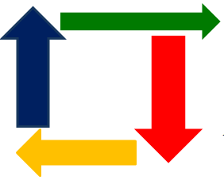



Business Requirements Document

Prepared by: Jyoti Agarwal & Nitin Poddar

Version: 0.1

Creation Date: July 28, 2019

Table of Contents

Table of Contents 2
1. Introduction 4
1.1. Document Purpose 4
1.2. Intended Audience 4
1.3. Project Background 5
1.4. Purpose of the Business Requirements 5
1.5. Business Goals/Objectives to be achieved 6
1.6. Benefits/Rationale 6
1.7. Stakeholders 6
1.8. Dependencies on existing systems 6
1.9. References 6
1.10. Assumptions 6
2. Requirements Scope 7
2.1. In Scope 8
2.2. Out of Scope 8
3. Functional Requirements 8
3.1. Actor Profiles Specification 8
3.2. Essential Use Case Diagram 9
3.3. Essential Use Case Specifications 9
3.4. Function Hierarchy Diagram 11
3.5. Function Definition Report 11
3.6. Business Rules 12
4. Data Requirements 13
4.1. Data Architecture 13
4.1.1. Domain Class Diagram 13
4.1.2. Entity Relationship Diagram 14
4.2. Data Volumes 14
4.3. Data Conversion 14
4.4. Data Retention and Archiving 14
4.5. FOI/Privacy Implications 14
4.6. Data Definition Reports 15
4.6.1. Domain Class Definition Report 15
4.6.2. Entity Definition Report 16
5. Non-Functional requirements 17
5.1. Security Requirements 17
5.1.1. Authentication 17
5.1.2. Authorization and Access Controls 18
5.1.3. Information Security Classification and labelling 19
5.2. Availability Requirements 20
5.3. Usability Requirements 21
5.4. System Help Requirements 21
5.5. Performance Requirements 22
5.6. Scalability Requirements 22
5.6.1. User Scalability 22
5.6.2. Application Scalability 22
6. Interface Requirements 23
6.1. User Interface Requirements 23
6.2. System Interface Requirements 23
7. Business Glossary 23
APMS Update 24
Revision Log 24
Appendices 24
Approval 25

Introduction

Document Purpose
The purpose of this document is to describe business requirements of an Application completely, accurately and unambiguously in Technology-independent manner. All attempts have been made in using mostly business terminology and business language while describing the requirements in this document. Very minimal and commonly understood Technical terminology is used. Use case / Designer approach is used in modeling the business requirements in this document.

Intended Audience

The main intended audience for this document are the business owners of the proposed system. This document should be readable by business owners of the proposed system. They must be able to verify that their business requirements have been documented here completely, accurately and unambiguously.

Data Architects, Application Architects and Technical Architects would also find the information in this document useful when they need to design a solution that will address these business requirements.

Since the requirements are documented here in Technology-independent manner, the end-users of the system should be able to comprehend the requirements fairly easily from this document.

Project Background

The requirement document prepared is on the basis of prior discussion had with peers concluding importance of having proper documentation in place before rushing into solutions.

Purpose of the Business Requirements

The purpose of the Business Requirements is for new application development (“Bahi-e-Khaata”)

Business Goals/Objectives to be achieved

The goal of the business is to empower small and medium firms by providing digital platform for their accounting, e-commerce, analysis and production needs

Benefits/Rationale

The major benefits from implementation is tapping into unexplored market for digitalisation and accounting in tier 2 and tier 3 cities. Tapping into these markets would create huge cross selling opportunities in future along with valuable data warehousing

Stakeholders
Apart from producer and designer of the product other stakeholders includes future partners in marketing and end users of the product.

Requirements Scope

This section shows what business functionality is in scope and out of scope for Implementation. In Use case approach, the out of scope Use cases are indicated in a separate boundary box. In Oracle Designer approach the out of scope Functions are shown in grey coloured boxes.

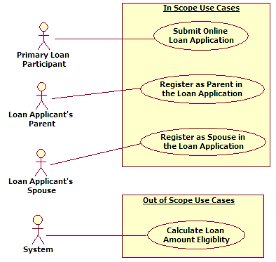

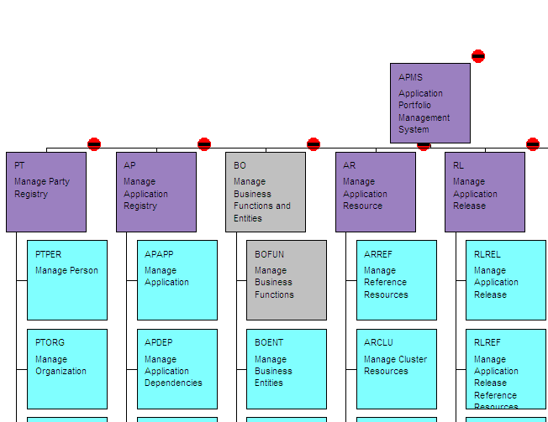

In Scope

Out of Scope

Functional Requirements

This section describes the Functional requirements part of the Business Requirements. In Use case approach, the Functional Requirements comprises of Actor Profile Specification, Essential Use case diagram and Essential Use case specification in narrative text form. In Oracle Designer approach the Functional Requirements comprises of Business Unit Definition Report, Function Hierarchy Diagram and Function Definition Report.

Actor Profiles Specification

This section describes all the Actors and their profiles within the context of the Business Requirements being documented. An Actor is a person, organization or an external system/sub-system/program that has interactions with the Application. Actors, by definition, are external to the system with which they are having interactions. Actors have goals that are achieved by use cases. Typically, Actors have behaviour and are represented by the roles they play in the use cases. An Actor stimulates the system by providing input and/or receiving something of measurable value from the system.

In Use case approach, the Actor Profile is documented in a separate template available on the ADE web site.

In Oracle Designer approach the Actor Profile information is documented under “Business Units” folder of Oracle Designer and the “Business Units Definition” report from Oracle Designer is generated and attached with these Business Requirements.

Actor Name | Actor Type | Access Type needed | Comments
 | Stakeholder  Primary Actor  Supporting Actor | Create Print  Read Export  Update Others  Delete
 | Stakeholder  Primary Actor  Supporting Actor | Create Print  Read Export  Update Others  Delete
 | Stakeholder  Primary Actor  Supporting Actor | Create Print  Read Export  Update Others  Delete
 | Stakeholder  Primary Actor  Supporting Actor | Create Print  Read Export  Update Others  Delete

Essential Use Case Diagram

This section is applicable only to Use case approach. This section depicts the Business Requirements in the form of Essential Use case diagram. In the Use case approach, the Functional Requirements are decomposed into a number of Essential Use cases. Essential use cases are of primary importance early in a project’s requirements/analysis phase. Their purpose is to document the business process that the Application must support without bias to technology and implementation.

Essential Use Case Specifications

This section is applicable only to Use case approach. This section describes each Essential Use case in narrative text form. A use case typically has one basic course of action and one or more alternate courses of actions. The basic course of action is the main start-to-finish path that the use case will follow, where as the alternate courses represent the infrequently used paths and exceptions, error conditions etc. The complete business logic of a use case such as basic course of action, alternate course of action, pre-condition, post-condition etc is not depicted in the Use case diagram. Rather they are documented in narrative style in use case specifications.

If the number of use cases is less than 15, the Essential Use case specifications in narrative form are included in this BRD in tabular format. Each use case is described in a separate table. If the number of use cases is greater than 15, the Essential Use case specifications in narrative form are attached as a separate document with this BRD.

Use Case Id : ##

Use Case Name
Description
Actors
Business Rules |  | List the business rules of Section 3.6 that this use case references. Mention only the Business rule Id here. Provide hyperlinks to the business rules of section 3.6.
Basic Flow |  | Alternate Flows
Non-Functional Requirements
Pre-Conditions
Post-Conditions
Extension Points | Extension Condition |  | Extending Use Case
List of <<included>> use cases | List of <<extended>> use cases |  | List of “inherited from (parent)” use cases

Function Hierarchy Diagram

This section is applicable only to Designer approach. This section depicts the Business Requirements in the form of Function Hierarchy Diagram (FHD). In the Oracle Designer approach, the Functional Requirements are decomposed into a number of Business Functions.

Function Definition Report

This section is applicable only to Designer approach. This section describes each Business Function in narrative text form.

Business Rules

This section lists and describes the business rules applicable to the proposed system.

Business Rule Id | Rule Name | Rule Description | Rule Source
BR#### |  |  | - Policy manual  - Strategic decisions  - Contractual obligations  - Subject matter experts  - Other Sources (mention the sources)

Data Requirements

This section describes the Data requirements part of the Business Requirements.

Data Architecture

This section describes the Data Architectural requirements part of the Business Requirements.

Domain Class Diagram

This section is applicable only to Use case approach. This section depicts the Data Architecture in the form of Domain Class Diagram. In the Use case approach, the conceptual data architecture (structural aspects) for the Business Requirements is modeled using Domain Class Diagram. The Domain Class Diagram is used to model the conceptual classes, its attributes (fields) and operations (methods) and also the interrelationships (association, composition, aggregation and generalization) between the classes. Domain model is a representation of real world conceptual classes, not of software components.

Entity Relationship Diagram

This section is applicable only to Oracle Designer approach. This section depicts the Data Architecture in the form of Entity Relationship Diagram (ERD). In the Oracle Designer approach, the conceptual data architecture (structural aspects) for the Business Requirements is modeled using Entity Relationship Diagram (ERD).

Data Volumes

This section describes the expected approximate Data volumes (initial volume and annual growth %) for each conceptual Class or Entity.

Data Conversion

This section describes the high-level Data Conversion Requirements.

Data Retention and Archiving

This section describes the Data retention (time frames for online Data retention before archiving) and also the archiving requirements.

FOI/Privacy Implications

This section describes the sensitivity levels of each class of data. The following criteria are used in determining the sensitivity level of each conceptual class/entity in line with the Government Core Policy Manual).

- Non-sensitive information that would not reasonably be expected to cause injury (harm) if released to the public;

- Protected A: information that, if compromised, could reasonably be expected to cause injury (harm), e.g. loss of privacy;

- Protected B: information that, if compromised, could reasonably be expected to cause serious injury (harm), e.g. the conduct of a court proceeding would be adversely affected;

- Protected C: information that, if compromised, could reasonably be expected to cause extremely grave injury (harm), e.g. loss of life.

Conceptual Class / Entity Name | Data Sensitivity Level  (Non-sensitive,  Protected A,  Protected B,  Protected C)

Data Definition Reports

This section describes the Data Architecture / definition in a report format.

Domain Class Definition Report

This section is applicable only to Use case approach. This section describes Data Architecture / definition (Domain Class model) in narrative text form.

Class Name
Class Description
Initial Data Volume (approx.)
Annual Data growth rate (in approx. %)
Attributes (fields) of the class | Name :  Description :
Attributes (fields) of the class | Name :  Description :
Attributes (fields) of the class | Name :  Description :
Attributes (fields) of the class | Name :  Description :
Attributes (fields) of the class | Name :  Description :
Attributes (fields) of the class | Name :  Description :

Entity Definition Report

This section is applicable only to Oracle Designer approach. This section describes Data Architecture / definition (Entity Relationship model) in narrative text form.

Entity Name
Entity Description
Initial Data Volume (approx.)
Annual Data growth rate (in approx. %)
Attributes (fields) of the Entity | Name :  Description :
Attributes (fields) of the Entity | Name :  Description :
Attributes (fields) of the Entity | Name :  Description :
Attributes (fields) of the Entity | Name :  Description :
Attributes (fields) of the Entity | Name :  Description :
Attributes (fields) of the Entity | Name :  Description :

Non-Functional requirements

This section describes the non-functional requirements part of the Business Requirements. A non-functional requirement is typically a special requirement that is not easily or naturally specified in the text of the use case’s or function’s event flow. Examples of non-functional requirements include legal and regulatory requirements, application standards, and quality attributes of the system to be built including usability, reliability, performance or supportability requirements.

Security Requirements

This section describes the Security requirements part of the Business Requirements.

Authentication

This section describes the Authentication requirements part of the Business Requirements. Authentication is the process of verifying the genuineness of claims that a person/group makes to establish identity/eligibility for access to services. In order to ascertain the Authentication requirements of the Application, it is required to analyse the type of transactions that different Use cases/Business Functions trigger within the Application. The following criteria is used in determining transaction types of each use case/function (in line with the Government Core Policy Manual) :

Level 0 : Anonymous transaction – triggers transactions that do not require or allow a person to be identified, or transactions which require protection of a person's identity. For example, access to online information about government programs or services or protecting a person's identity. Combining the transaction data with other data must not allow identification of a particular individual.
Level 1 : Pseudonymous transaction – triggers transactions that do not require a person to be identified but do require a means for further contact to deliver a product or service. For example, a note from someperson@internet.ca can not be readily translated into an individual’s name, but it may be sufficient to request information, to provide some services, or on-going follow up.
Level 2 : Identified transaction – triggers transactions that require that a person be specifically identified. The nature of the transaction may require confirmation of a person's identity (e.g., name, address, birth date, etc.) and/or data linking the person to a transaction (e.g., invoice number, personal health number, etc.).
Level 3 : Verified transaction – triggers transactions that require: the person to be specifically identified; verification of the integrity of the data exchanged and the exchange itself; and, the creation of sufficient evidence to indicate that the person agreed to be bound by the transaction. For example, a note signed with a digital certificate, audit trails and security logs may provide sufficient evidence that a specific person intended to conduct a transaction.

Use Case / Business Function Name | Transaction type triggered  (Level 0 : Anonymous,  Level 1 : Pseudonymous,  Level 2 : Identified,  Level 3 : Verified)

Authorization and Access Controls

This section describes the Authorization and Access Control requirements part of the Business Requirements at a high-level. Authorization is the process of determining if the person/group, once identified through the “Authentication process”, is permitted to have access to certain services. The Authorization and Access Control requirements are best described through a matrix.

Actor / Business Unit Name | Conceptual Class / Business Entity Name | Type of Access Control needed on the Conceptual Class / Business Entity :  C → Create  R → Read  U → Update  D → Delete

Information Security Classification and labelling

This section is provided for information purposes only. Please do not delete this section while creating the Business requirements Document from this template.

The “Information security classification and labeling of information assets” is a process published and managed by OCIO. According to this process, all government “records” as defined in the Interpretation Act need to be classified. (“record” includes books, documents, maps, drawings, photographs, letters, vouchers, papers and any other thing on which information is recorded or stored by any means whether graphic, electronic, mechanical or otherwise).

There are no business requirements (functional or non-functional requirements) applicable to the Information security classification of the application/project/initiative for which the BRD is being written. Hence there is no need to fill-in anything in this section.

However, please be aware that the finished application/initiative/project and all its output deliverables (such as documents, models, diagrams etc) need to be classified and labelled in accordance with the OCIO guidelines. This will help in determining how much protection the finished application and its data will need commensurate with its sensitivity levels determined during information security classification process. It will also help in evaluation of risks associated with authorized and unauthorized disclosures of the application’s data.

Availability Requirements

This section describes the system availability requirements.

Use Case / Business Function Name | Availability Requirements  - Regular work hours  - 24x7  - Any other (please describe)

Usability Requirements

This section describes the system usability requirements. A usability requirement specifies how easy the system must be to use. Usability is a non-functional requirement, because in its essence it doesn't specify parts of the system functionality, but specifies only how that functionality is to be perceived by the user, for instance how easy it must be to learn and operate the system.

System Help Requirements

This section describes what kind of System Help features are needed to be built into the system.

Use Case / Business Function Name | Help Requirements  - Field level (online)  - Screen level (online)  - Help Printing Options  - Operations Manual (Offline)  - Any other (please describe)

Performance Requirements

This section describes system performance expectation levels (response times).

Use Case Name / Business Function Name / Transaction description | Performance Requirements (response time)  (in seconds or minutes)

Scalability Requirements

This section describes how the system is expected to scale to new higher or lower levels. Both user and application scalability requirements are described here. Data scalability is not described here as it is already described in the “data volumes” section earlier.

User Scalability

Application Scalability

Interface Requirements

This section describes User and System Interface requirements for the proposed system.

User Interface Requirements

System Interface Requirements

Business Glossary

APMS Update

APMS update required? Yes No
APMS updated/to be updated on (date):

Comments:

Revision Log

Date | Version | Change Reference | Reviewed by
[date]

Appendices

Enter content here.

Approval
This document has been approved as the official Business Requirements Document for the Project Name project.
Following approval of this document, changes will be governed by the project’s change management process, including impact analysis, appropriate reviews and approvals, under the general control of the Master Project Plan and according to Project Support Office policy.
Prepared by | Signature | Date
Author's Name
[Title]
[Organization]
Approved by | Signature | Date
[Client Acceptor’s Name]
[Title]
[Organization]

