

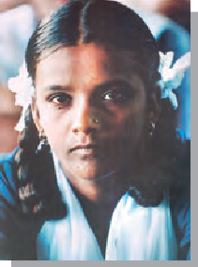

Now find the Sulaiman and Kirthar hills to the northwest. Some of the areas where women and men first began to *grow crops* such as wheat and barley about 8000 years ago are located here. People also began *rearing animals* like sheep, goat, and cattle, and lived in *villages*. Locate the Garo hills to the north-east and the Vindhyas in central India. These were some of the other areas where

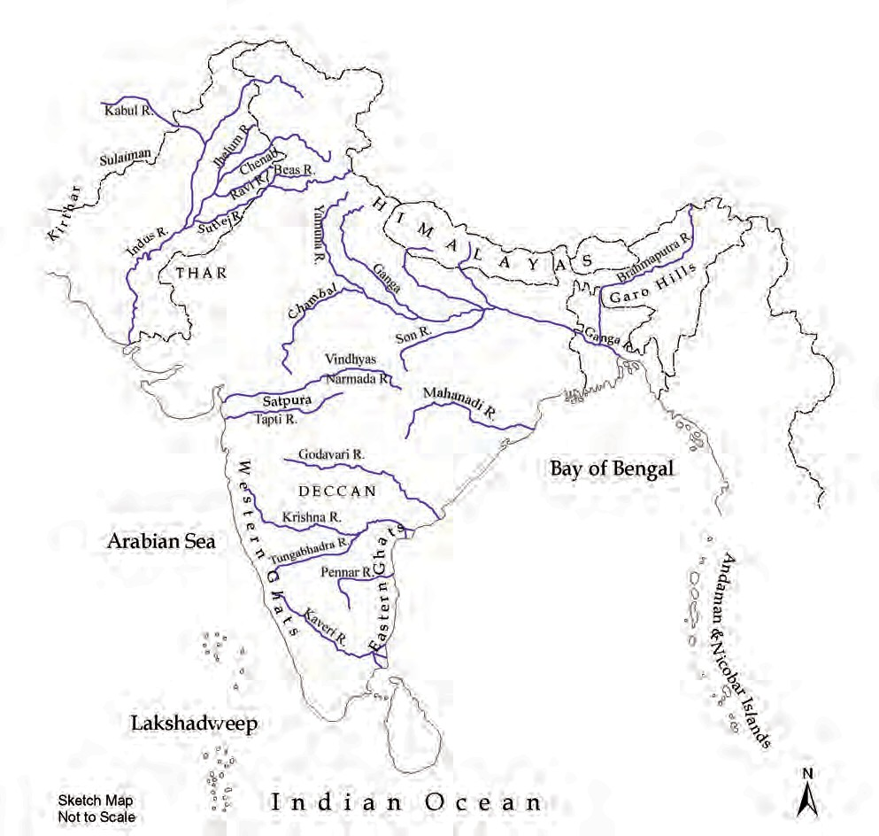

MAP : 1

Physical Map of the Subcontinent

* 2

OUR PASTS–I

agriculture developed. The places where rice was first grown are to the north of the Vindhyas.

Trace the river Indus and its tributaries (tributaries are smaller rivers that flow into a larger river). About 4700 years ago, some of the earliest *cities* flourished on the banks of these rivers. Later, about 2500 years ago, cities developed on the banks of the Ganga and its tributaries, and along the sea coasts.

Locate the Ganga and its tributary called the Son. In ancient times the area along these rivers to the south of the Ganga was known as Magadha now lying in the state of Bihar. Its rulers were very powerful, and set up a *large kingdom*. Kingdoms were set up in other parts of the country as well. Throughout, people *travelled* from one part of the subcontinent to another. The hills and high mountains including the Himalayas, deserts, rivers and seas made journeys dangerous at times, but never impossible. So, men and women moved in search of livelihood, as also to escape from natural disasters like floods or droughts. Sometimes men marched in armies, conquering others’ lands. Besides, merchants travelled with caravans or ships, carrying valuable goods from place to place. And religious teachers walked from village to village, town to town, stopping to offer instruction and advice on the way. Finally, some people perhaps travelled driven by a spirit of adventure, wanting to discover new and exciting places. All these led to the sharing of ideas between people.

Why do people travel nowadays?

Look at Map 1 once more. Hills, mountains and seas form the natural frontiers of the subcontinent. While it was difficult to cross these frontiers, those who wanted could and did scale the mountains and cross the seas. People from across the frontiers also came into the subcontinent and settled here.

Facing Page: This is a map of South Asia (including the present countries of India, Pakistan, Bangladesh, Nepal, Bhutan and Sri Lanka) and the neighbouring countries of Afghanistan, Iran, China and Myanmar. South Asia is often called a subcontinent because although it is smaller than a continent, it is very large, and is separated from the rest of Asia by seas, hills and mountains.

3 ■

WHAT, WHERE, HOW AND WHEN?

A page from a palm leaf manuscript.

This manuscript was written about a thousand years ago. The palm leaves were cut into pages and tied together to make books. To see a birch bark manuscript, turn to page 45.

These movements of people enriched our cultural traditions. People have shared new ways of carving stone, composing music, and even cooking food over several hundreds of years.

# Names of the land

Two of the words we often use for our country are India and Bharat. The word India comes from the Indus, called Sindhu in Sanskrit. Find Iran and Greece in your atlas. The Iranians and the Greeks who came through the northwest about 2500 years ago and were familiar with the Indus, called it the Hindos or the Indos, and the land to the east of the river was called India. The name Bharata was used for a group of people who lived in the north- west, and who are mentioned in the Rigveda, the earliest composition in Sanskrit (dated to about 3500 years ago). Later it was used for the country.

# Finding out about the past

There are several ways of finding out about the past. One is to search for and read books that were written long ago. These are called *manuscripts*, because they were written by hand (this comes from the Latin word ‘*manu’*, meaning hand). These were usually written on palm leaf, or on the specially prepared bark of a tree known as the birch, which grows in the Himalayas.

Over the years, many manuscripts were eaten away by insects, some were destroyed, but many

■ 4

OUR PASTS–I

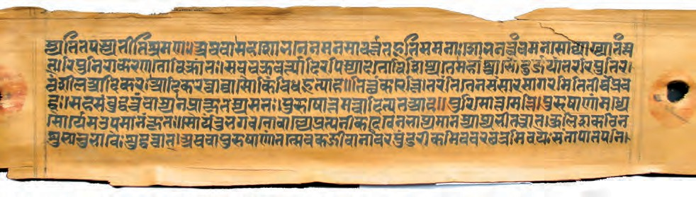

have survived, often preserved in temples and monasteries. These books dealt with all kinds of subjects: religious beliefs and practices, the lives of kings, medicine and science. Besides, there were epics, poems, plays. Many of these were written in Sanskrit, others were in Prakrit (languages used by ordinary people) and Tamil.

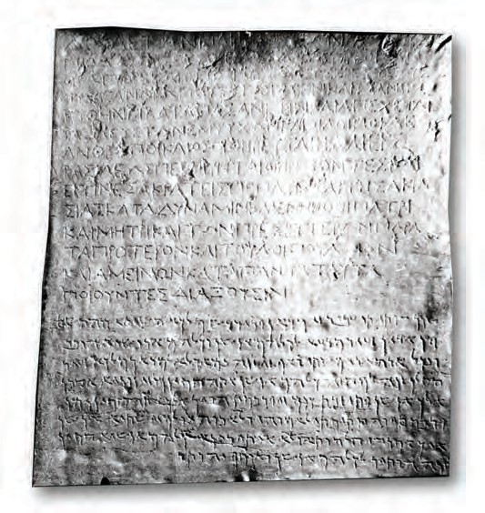We can also study *inscriptions*. These are writings on relatively hard surfaces such as stone or metal. Sometimes, kings got their orders inscribed so that people could see, read and obey them. There are other kinds of inscriptions as well, where men and women (including kings and queens) recorded what they did. For example, kings often kept records of victories in battle.

Can you think of the advantages of writing on a hard surface? And what could have been the difficulties?

There were many other things that were made and used in the past. Those who study these objects are called *archaeologists*.

They study the

remains of buildings made of stone and brick, paintings and sculpture. They also explore and *excavate* (dig under the surface of the earth) to find tools, weapons, pots, pans, ornaments and coins. Some of these objects may be made of stone, others of bone, baked clay or metal. Objects that are made of hard, imperishable substances usually survive for a long time.

An old inscription. This inscription dates to about 2250 years ago, and was found in Kandahar, present-day Afghanistan. It was

inscribed on the orders of a ruler named Ashoka. You will read about him in Chapter

8. When we write anything, we use a script. Scripts consist of letters or signs. When we read what is written, or speak, we use a language. This inscription was inscribed in two different scripts and languages, Greek (top) and Aramaic (below), which were used in this area.

5 ■

WHAT, WHERE HOW AND WHEN?

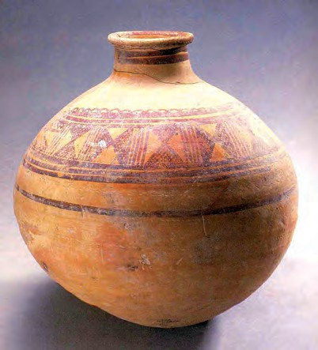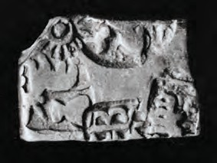Left : A pot from an old city.

Pots like these were used about 4700 years ago.

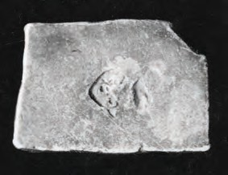Right : An old silver coin. Coins such as this one were in use from about 2500 years ago.

*In what ways is the coin different from the ones we use today?*

Archaeologists also look for bones — of animals, birds, and fish — to find out what people ate in the past. Plant remains survive far more rarely — if seeds of grain or pieces of wood have been burnt, they survive in a charred form. Do you think cloth is found frequently by archaeologists?

*Historians*, that is, scholars who study the past, often use the word *source* to refer to the information found from manuscripts, inscriptions and archaeology. Once sources are found, learning about the past becomes an adventure, as we reconstruct it bit by bit. So historians and archaeologists are like detectives, who use all these sources like clues to find out about our pasts.

■ 6

OUR PASTS–I

# One past or many?

Did you notice the title of this book, *Our Pasts*? We have used the word ‘pasts’ in plural to draw attention to the fact that the past was *different* for different groups of people. For example, the lives of herders or farmers were different from those of kings and queens, the lives of merchants were different from those of crafts persons, and so on. Also, as is true even today, people followed different practices and customs in different parts

of the country. For example, today most people living in the Andaman Islands get their own food by fishing, hunting, and collecting forest produce. By contrast, most people living in cities depend on others for supplies of food. Differences such as these existed in the past as well.

Besides, there is another kind of difference. We know a great deal about kings and the battles they fought because they kept records of their victories. Generally, ordinary people such as hunters, fishing folk, gatherers, farmers or herders did not keep records of what they did. While archaeology helps us to find out about their lives, there is much that remains unknown.

# What do dates mean?

If somebody asks you the date, you will probably mention the day, month and year, 2000 and something. These years are counted from the date generally assigned to the birth of Jesus Christ, the founder of Christianity. So, 2000 means 2000 years after the birth of Christ. All dates before the birth of Christ are counted backwards and usually have the letters BC (Before Christ) added on. In this book, we will refer to dates going back from the present, using 2000 as our starting point.

7 ■

WHAT, WHERE, HOW AND WHEN?