**Project Deliverable - 1**

**Secure Data Sharing using blockchain Technology**

**Team Sigma**

**Group Members List**

1)Jyothi Anjan Manini (Student Id: 11715079)

2)Akshara Reddy Bathula (Student id: 11713259)

3)Lakshmichatura Medidi (Student id:11682526)

4)Sumuk Reddy Kalagiri (Student id: 11702970)

5)Manoj Kumar bandari (Student id :11711378)

6)Satya Laxman Pranav Vadlamani (Student id:11701928)

7)Nitin Reddy Balaiahgari (Student id: 11698724)

8)Akhila Pam (Student id : 11711224)

9)Nimitha Bangalore Sathyanarayana (Student id : 11649788)

**Project Description**

The Internet of Things has undergone advancements and one of its applications in cloud computing is data sharing. Despite its appeal, ensuring data security remains a challenge due to the misuse and resulting damages. In this article we suggest a method calledIntermediary Key Conversion to enhance the security of data sharing, in cloud environments. By employing identity based encryption data owners can securely store their encrypted data in the cloud while an Intermediary Key Conversion mechanism allows authorized users to access that data Because Internet of Things (IoT) devices have resources we utilize edge devices as proxy servers to handle calculations. Moreover we employ information centric networking capabilities to efficiently distribute cached content through the proxy thereby improving the quality of service and making use of network capacity. Our system concept is built on technology, which revolutionizes data sharing by enabling control and reducing inefficiencies found in centralized systems. The security analysis and evaluation of our plan illustrate the potential for ensuring data security, confidentiality and integrity.

**Hardware Requirements**

1)Processor : The Pentium IV 2.4 GHz processor, released in the early 2000s, was a significant advancement in computing power for its time, offering improved processing speed and efficiency compared to its predecessors. It contributed to the evolution of personal computing by delivering enhanced performance for various applications and tasks.

2)Hard Disk: Any Hardisk with a minimum capacity of 40 gigabytes will be required for this project.

3)Ram : The capacity of the random access memory we are going to use for the processing of this project is 1 GB.

4)Graphics Card: A dedicated graphics card with at least 512 megabytes of video memory is Required to ensure smooth rendering and support for graphics-intensive tasks in this project.

5)Network Adapter: A network adapter with Ethernet capability is essential for connectivity and data transfer within the project. It allows for seamless communication between peers.

**Software Requirements**

1)Operating System - Windows 10: User-Friendly Interface: Windows 10 is known for its intuitive and user-friendly graphical user interface (GUI), making it accessible for a wide range of users. Its Start Menu, taskbar, and streamlined navigation make it a popular choice for both personal and professional computing environments.

2)Coding Language - JAVA:Platform Independence: Java is renowned for its "write once, run anywhere" capability, thanks to its platform independence. This means that Java applications can run on various operating systems without modification, making it a preferred choice for cross-platform development.

3)Database - MS SQL: Scalability and Performance: Microsoft SQL Server (MS SQL) is known for its scalability, making it suitable for handling both small and large datasets. It offers advanced optimization techniques and indexing options, enhancing the performance of database operations.

4)Server - Apache Tomcat:Apache Tomcat is an open-source application server that is lightweight and easy to configure. It is widely used for hosting Java-based web applications due to its simplicity and community-driven development.

5)IDE - Netbeans: NetBeans is a popular Integrated Development Environment (IDE) for Java development. It offers features like code templates, smart code completion, and project management tools that enhance productivity for Java developers.

**Gannt Chart**

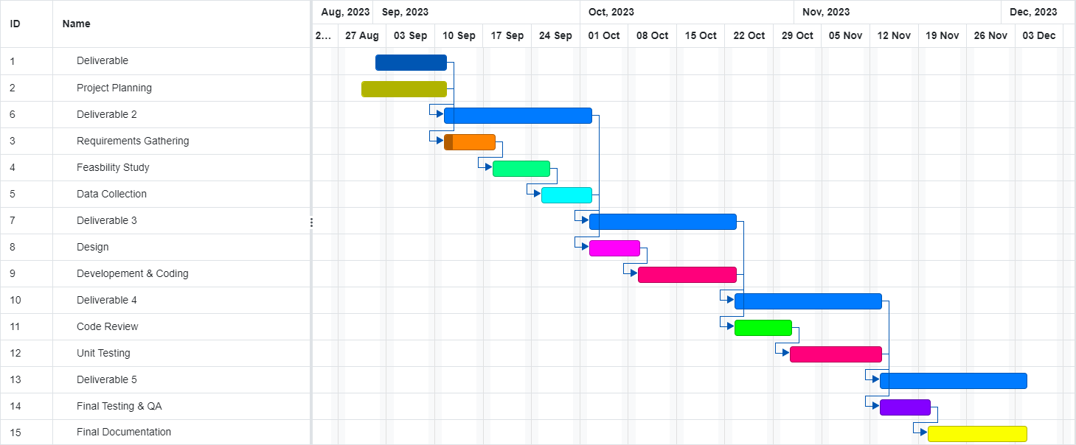

Secure data sharing using blockchain is a complex project with several inherent risks. Below are the three biggest risks for this project. As a team we plan to meet regularly to assess the status of these risks and take appropriate actions.

**Risk Management**

**Risk 1: Security and Privacy Risks:**

* Despite the inherent security features, vulnerabilities can still exist in the implementation of blockchain technology when integrating with other systems. These vulnerabilities will lead to security breaches which will expose sensitive data to the world.
* Also, ensuring data privacy while sharing information on a public blockchain is important. Even with intermediary key conversion, the risk of data leakage still exists.
* **Monitoring:** We are planning to use continuous security monitoring tools for detecting any unusual activities. Also, we plan to use risk-mitigating features like access controls, encryption and intrusion detection systems.
* **Re-evaluation:** We are planning to periodically assess the security posture of the system and adjust security measures based on the latest threats and vulnerabilities.
* **Contingency Plan:** In case of a security breach, we plan to isolate compromised systems, and to implement patches or fixes.

**Risk 2: Technological and Integration Risks**

* Integrating intermediary key conversion with blockchain and other existing systems is technically challenging because there is a chance of incompatibilities, data mapping issues, and synchronization issues.
* There's a risk in blockchain and encryption technologies because these are rapidly evolving, so new and more efficient solutions may emerge during the project's duration.
* **Monitoring:** We are planning to implement strong encryption methods and security protocols and also to regularly update and patch blockchain and encryption technologies. We also have a plan to continuously monitor for technical issues, especially when integrating blockchain and intermediary key conversion technologies.
* **Re-evaluation:** Also, regularly reviewing the project deliverables and its timelines to adjust them as needed to accommodate any unforeseen technical challenges.
* **Contingency Plan:** We also have backup solutions in mind that can be implemented if significant technical challenges arise and threaten project timelines.

**Risk 3: Regulatory and Compliance Changes**

* The regulatory environment for blockchain and data sharing can be uncertain and subject to change. Complying with evolving data protection laws and blockchain-specific regulations is crucial.
* **Monitoring:** We are planning to be updated with the changes in data privacy regulations and blockchain-related regulations for the entire project duration.
* **Re-evaluation:** We plan to conduct periodic compliance checks to ensure the project remains aligned with evolving regulations.
* **Contingency Plan:** We also have a plan for rapidly adapting to changes in regulations, and modifying the project's design or operation if necessary.

**Roles assigned to team members**

**Tasks assigned:-**

Project management Lead - Nitin Reddy Balaiahgari

Requirements Lead - Lakshmi Chatura Medidi

Design Lead - Jyothi Anjan Manini

Implementation Lead for front end - Akshara Reddy Bathula

Implementation Lead for Back end - Akhila Pam

Configuration Management Lead - Manoj Kumar Banderi

Testing Lead - Nimita Banglore Sathyanarayana

Documentation Lead - Sumuk Reddy

Demo and Presentation Lead - Nimita Banglore Sathyanarayana

System Administrator Lead - Sathya Lakshman Pranav Vadlamani

**Technologies Assigned to Team members:-**

| Language/Technology | Assigned to: |
| --- | --- |
| HTML,CSS | Akshara Reddy Bathula |
| Javascript | Lakshmi Chatura Medidi, Jyothi Anjan Manini, Manoj Kumar Bandari |
| Java | Nitin Reddy Balaiahgari, Sumuk Reddy |
| React JS | Nimitha Banglore Sathyanarayana, Sathya Laxman Pranav Vadlamani, Akhila Pam |
| SQL | Sathya Laxman Pranav Vadlamani, Lakshmi Chatura Medidi, Jyoti Anjan Manini |