# User Manual for Vaze Leave Management System

## Introduction

The Vaze College Leave Management System simplifies leave applications for faculty and provides HODs, the Principal, vice principal, and admin staff with tools for efficient review and approval. Key features include streamlined leave submission, multi-level approval processes, and role-based access for secure interactions. The system enhances transparency, reduces paperwork, and ensures efficiency in managing leave records and approvals.

## Notations

• TD – Teacher Degree  
• TJ – Teacher Junior  
• NL – Non-Teaching Laboratory  
• NO – Non-Teaching Office  
• OO – Office Operator

## Pages Overview

• Login Page

• Forgot Password

• Change Password

• Apply Leave

• CL (Casual Leave)

• DL (Duty Leave)

• OFF PAY (Off Pay Leave)

• EMHM (Earned, Medical, Half Pay, Maternity)

• Check Status

• Summary & Remaining

• Leave Request

• New Registration

• Assign Leave

• Update Details

• Deactivate Users

• Report

• User Status Log

## Users and Roles

### Principal (Super Admin)

* Leave Request
* New Registration
* Assign Leave
* Update Details
* Deactivate Users
* Report
* Principal Leave Request

### Office Operator (Sub Admin)

* Leave Request
* New Registration
* Assign Leave
* Update Details
* Deactivate Users
* Report

### HOD / Vice Principal (Departmental Admin)

* Leave Request
* New Registration
* Assign Leave
* Update Details
* Deactivate Users
* Report
* HOD Leave Request

### Teaching and Non-Teaching Staff

* Login
* Forgot Password
* Change Password
* Apply Leave
* Check Status
* Summary & Remaining

### Registrar

* User Status Log

## Leave Types and Rules

### Leave Types

* DL – Special / Duty Leave
* CL – Casual Leave (Cannot be Carried Forward)
* OFF Pay Leave – Special leave if Worked on an off day
* MHM – Medical, Half Pay, Maternity Leave
* EHM – Earned, Half Pay, Maternity Leave

### Academic Year

• Teaching Staff: 1st June – 31st May  
• Non-Teaching Staff: 1st January – 31st December

• HOD, Principal, and Office Remarks Cannot be Null.

## Important Notes

1. Change Password must be done at the first login.  
2. HOD, Principal, and Office Remarks cannot be null.  
3. Initially, password for every user is ‘NEW’

## Detailed Interface Descriptions

### Login Page / Forgot Password / Change Password

### New User Login

STEP 1: Enter your registered mail and “NEW” as the password and click the login button.

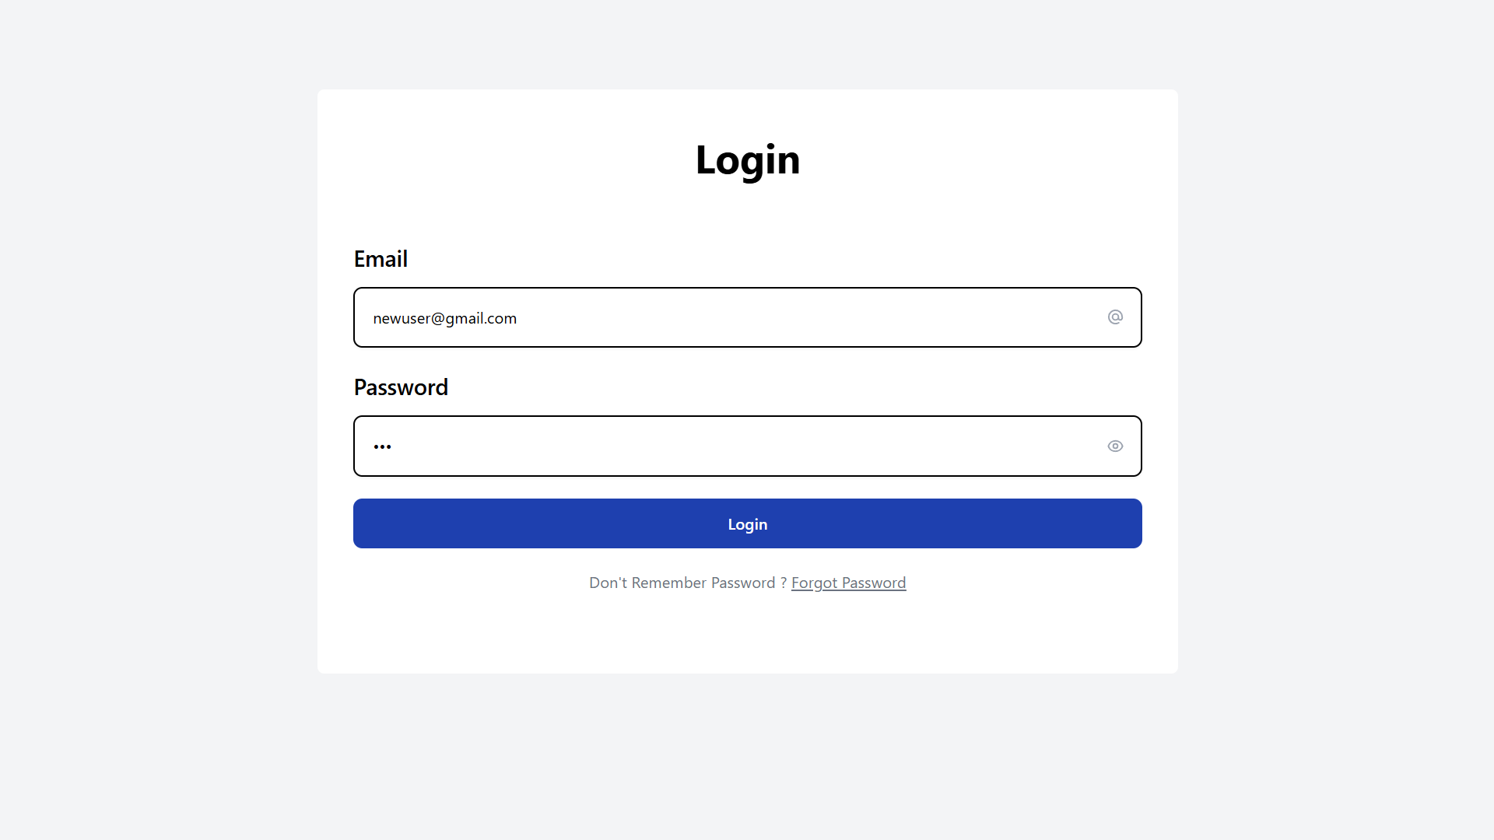

STEP 2: you will be redirected to change password page. Enter “NEW” as the old password, set new password, confirm it and click change password.

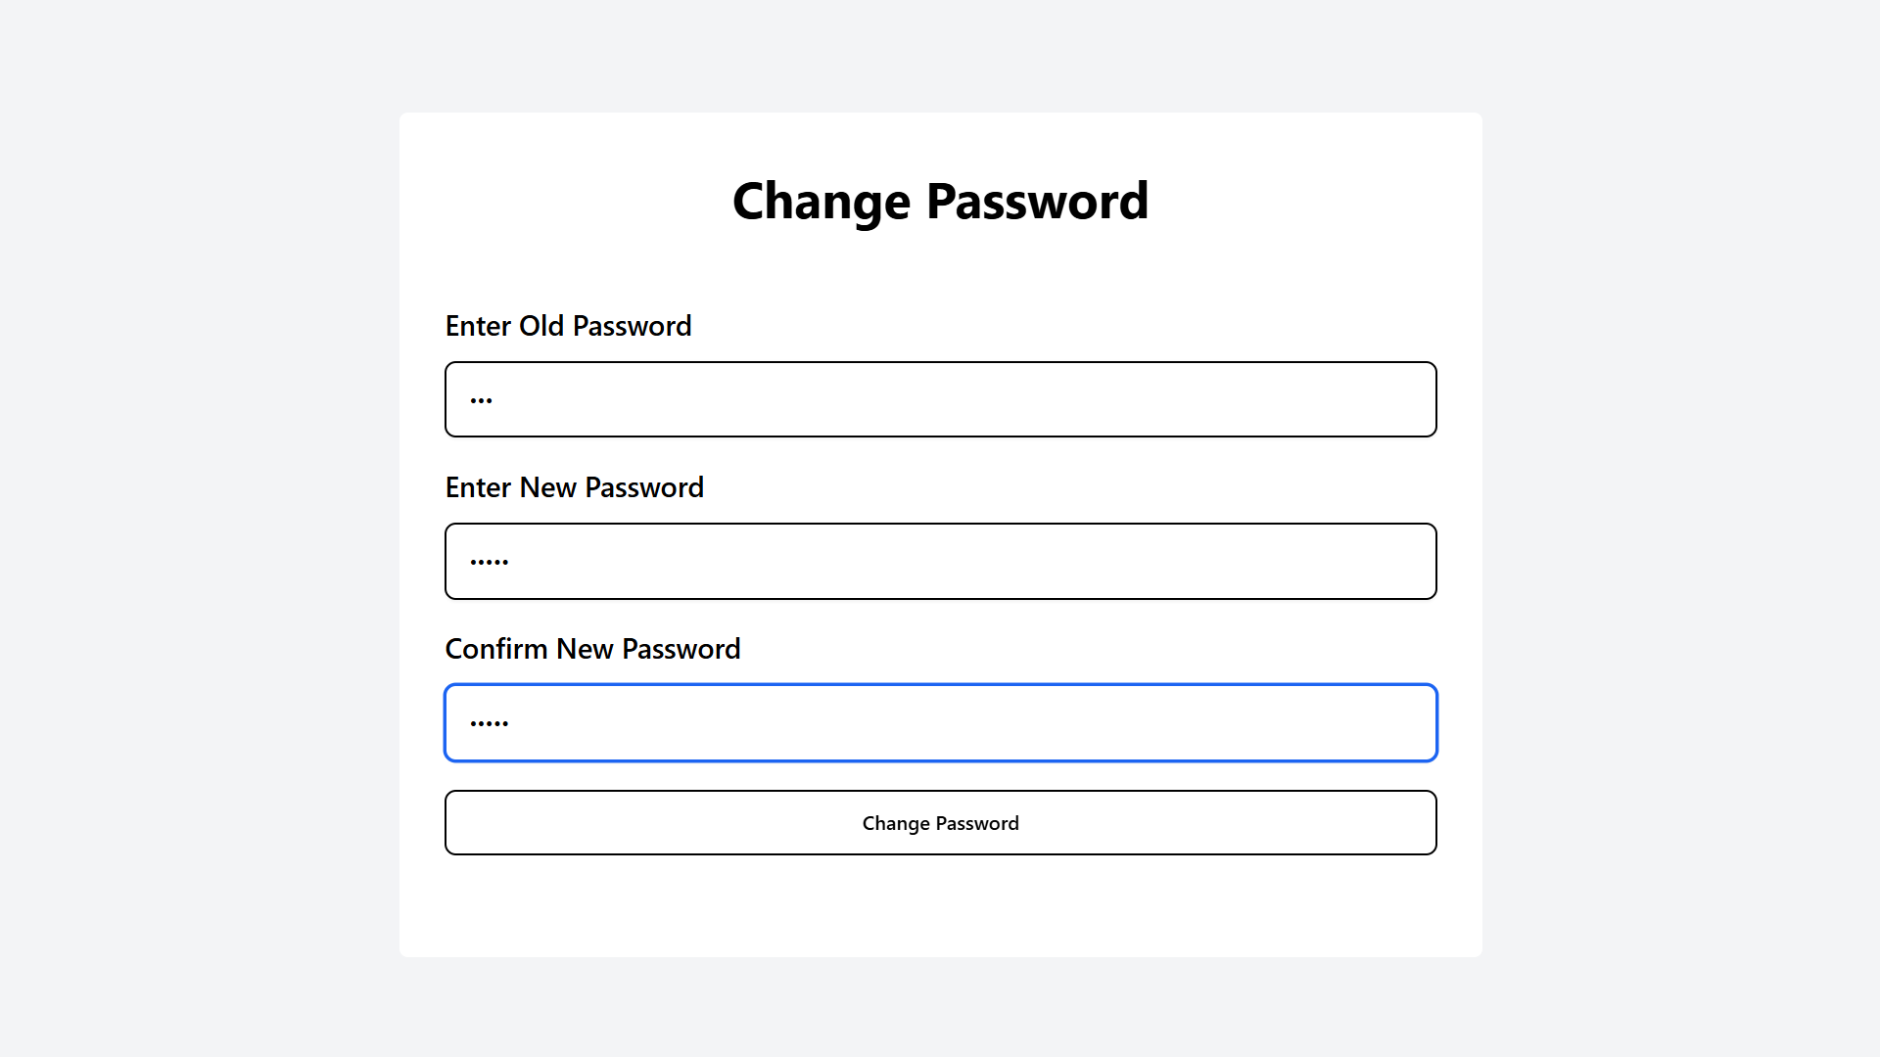

A success popup will appear, and will be redirected to the home page.

### Forgot Password

STEP 1: Click on forgot password

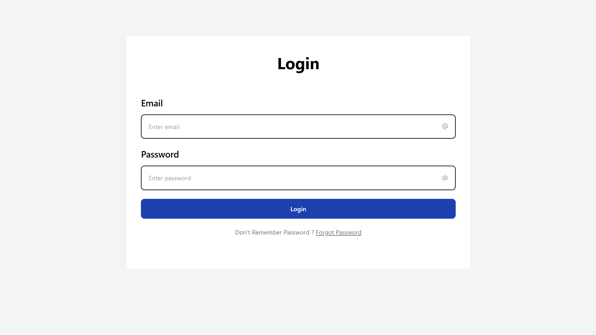

STEP 2: Enter your registered mail

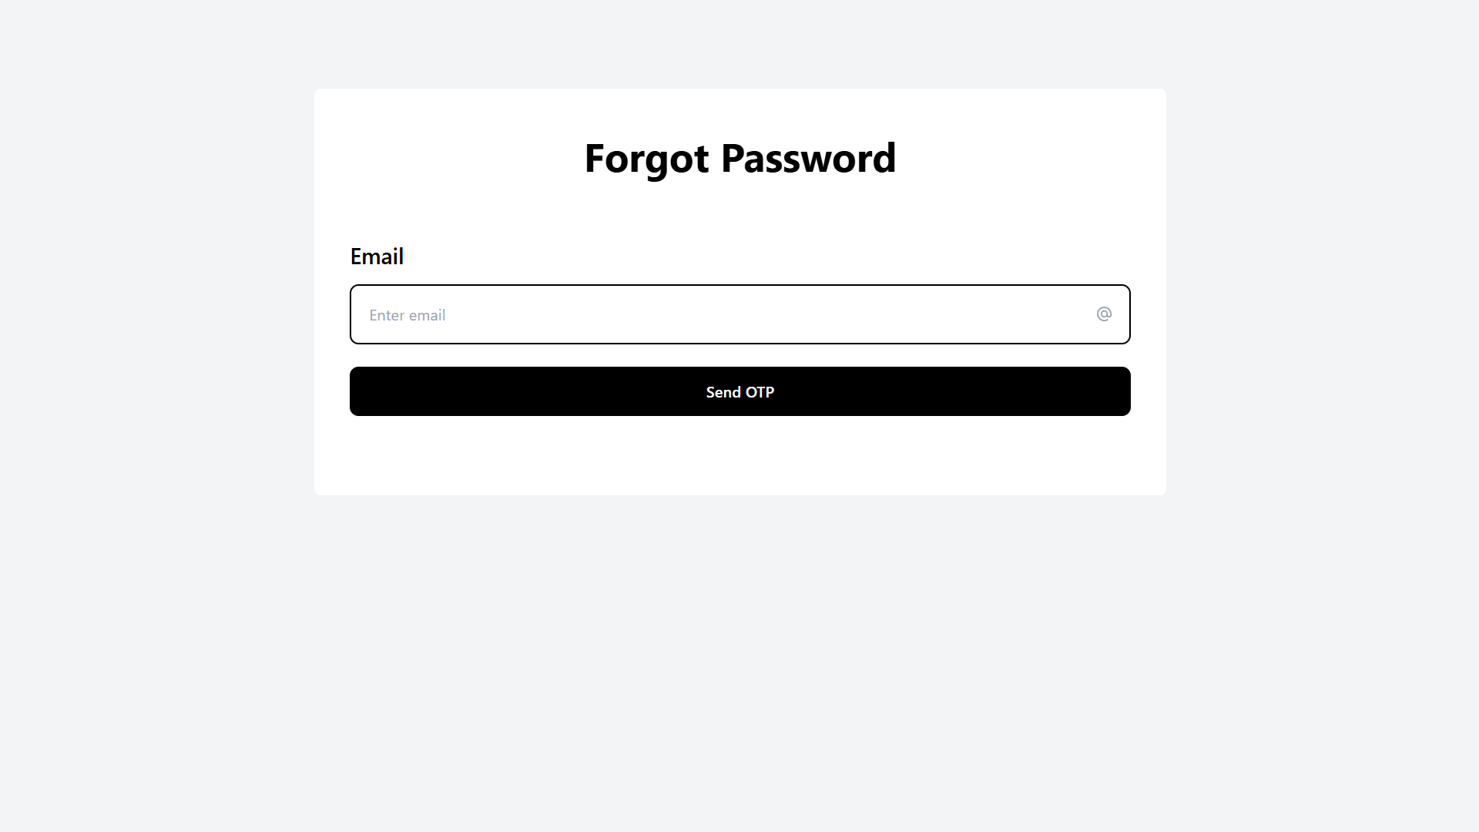

STEP 3: Click send OTP. A success popup will confirm the email has been sent.

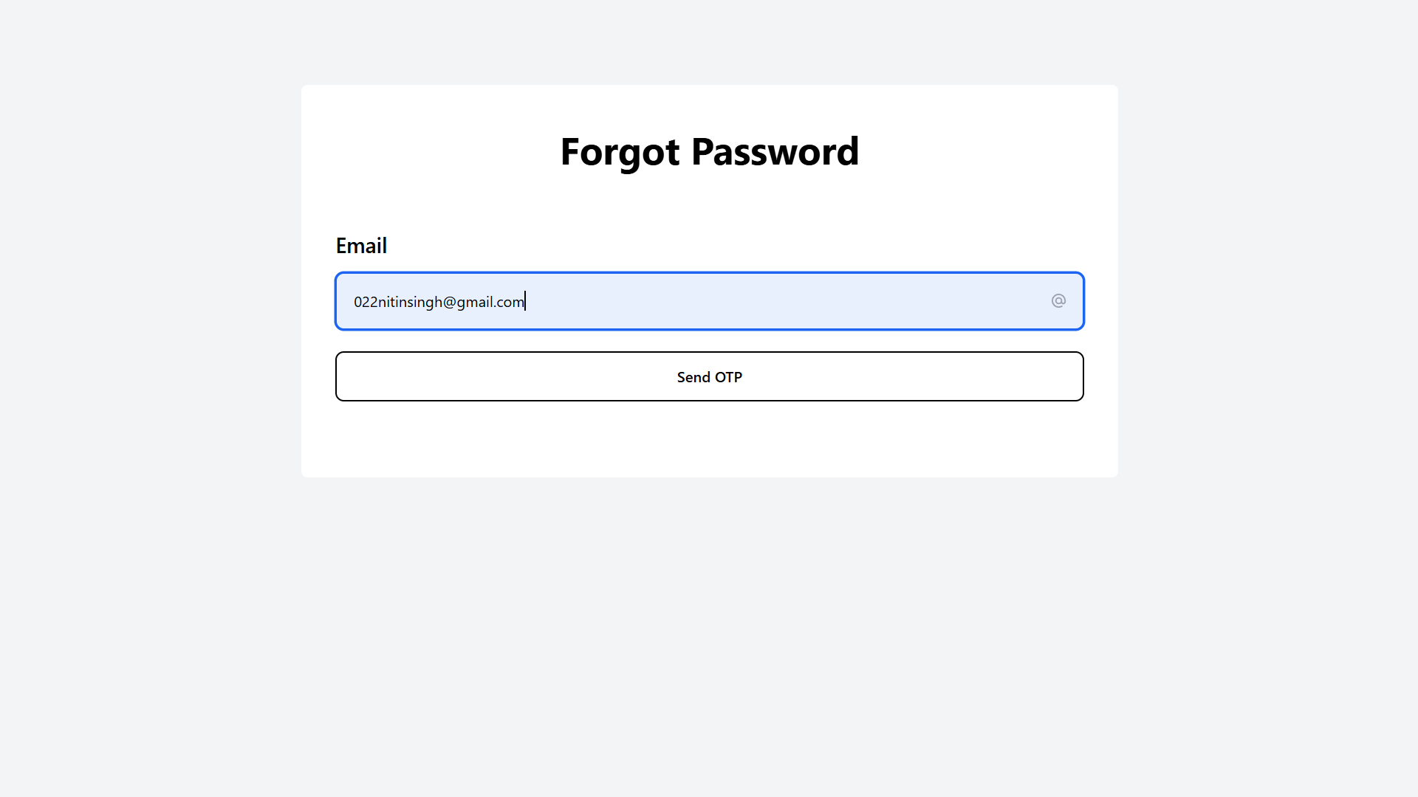

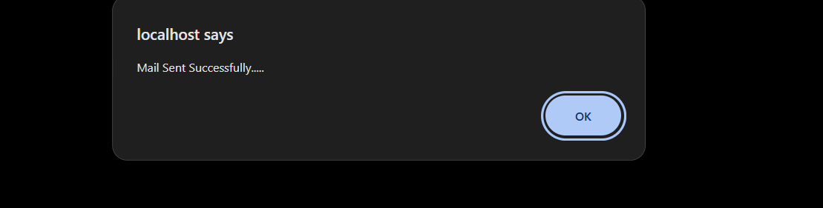

STEP 5: Check your email for OTP

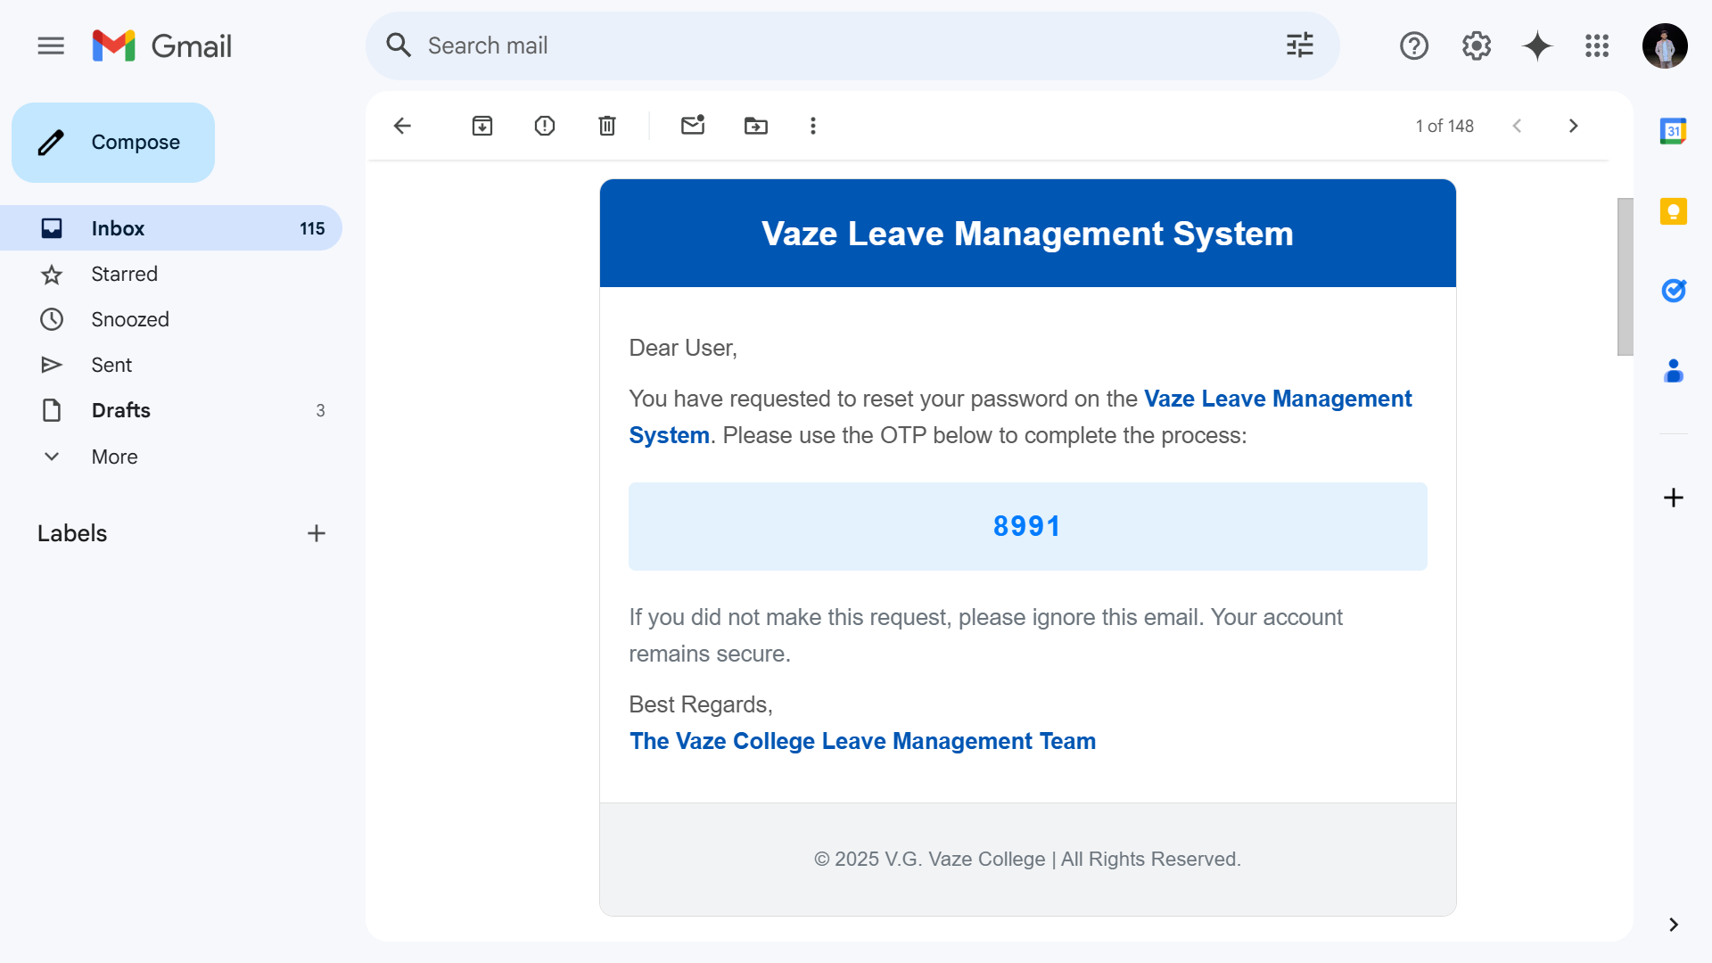

STEP 6: Enter your OTP and click verify OTP

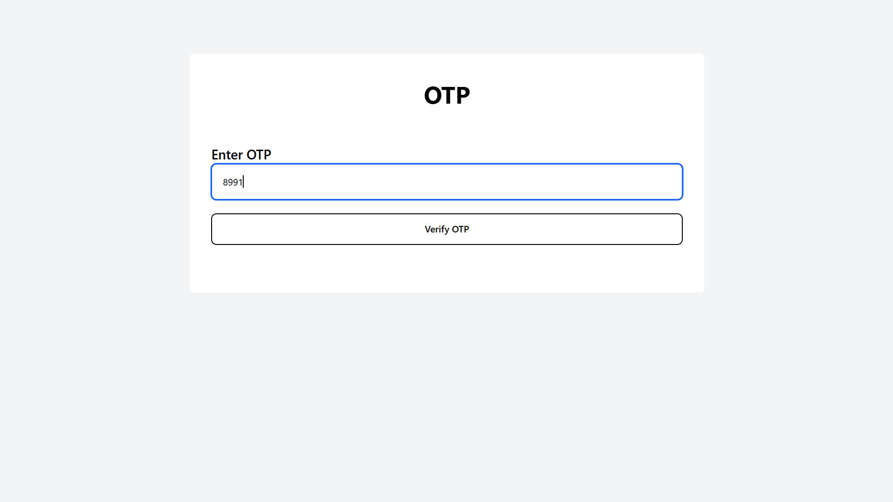

STEP 7: Set a new password, confirm it, and click change password.

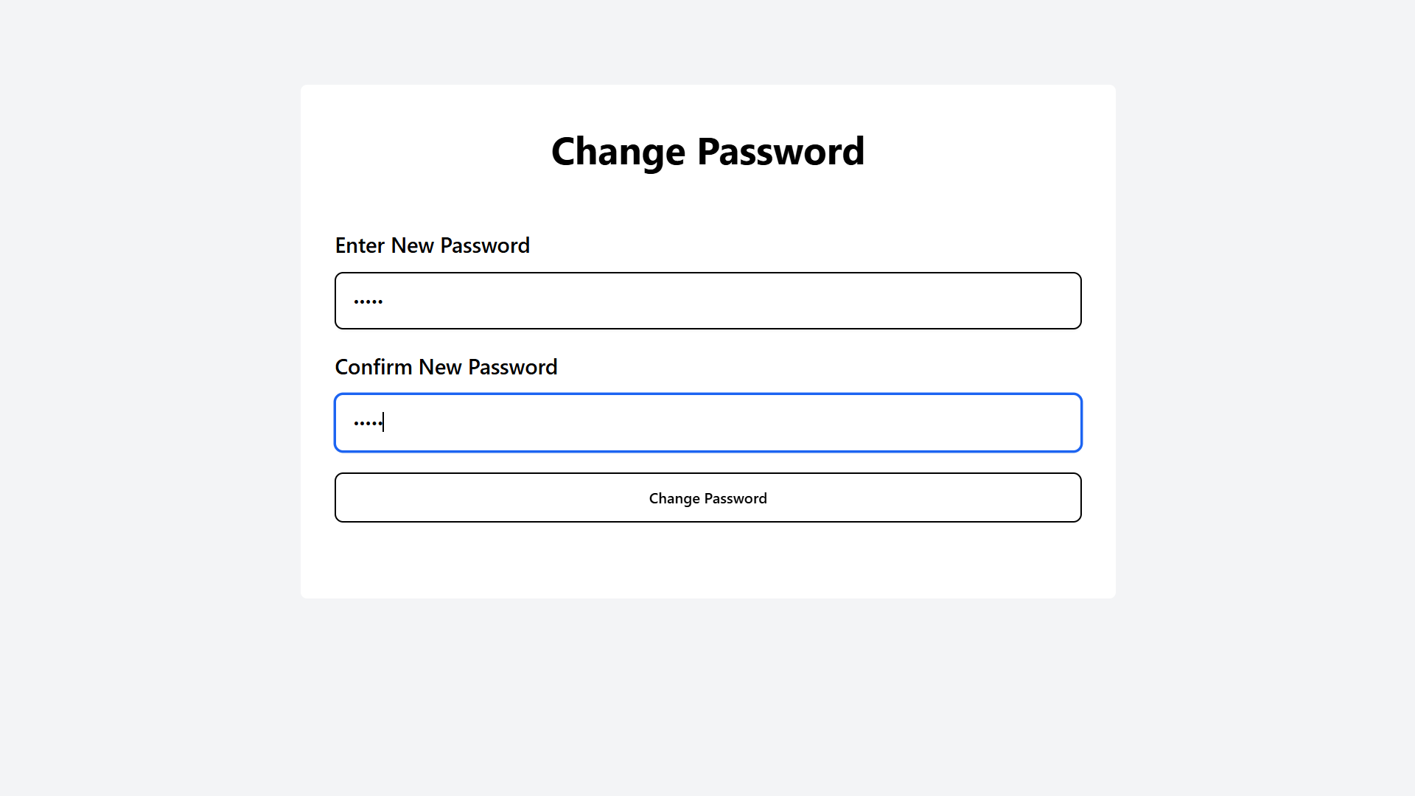

A success popup will appear confirming the password change.

### Task Menu

Sidebar displaying the list of available actions based on user role, such as Apply Leave, Check Status, and more.

Principal

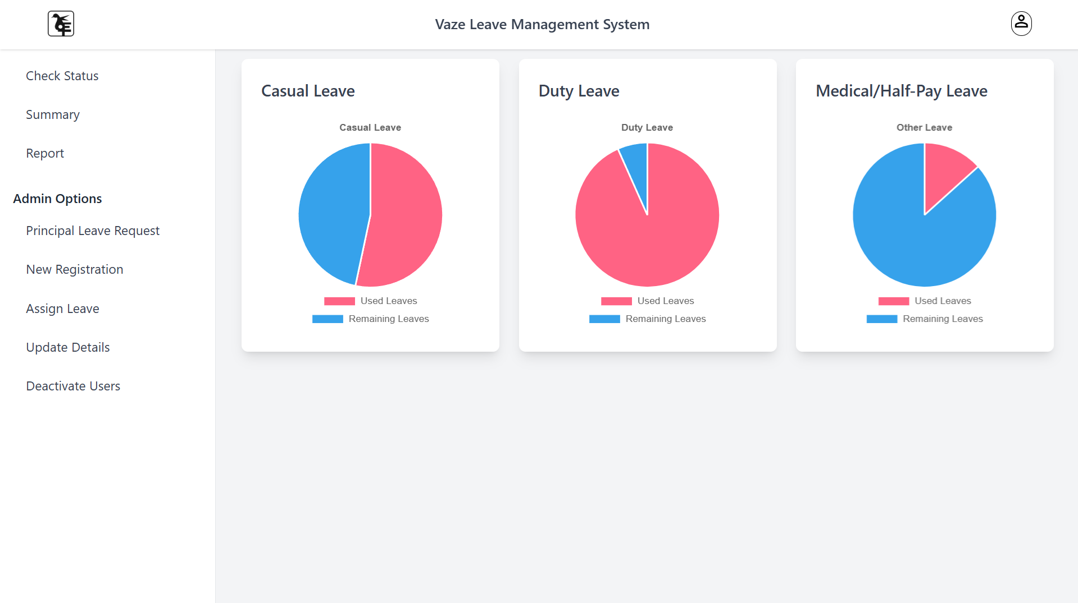

HOD

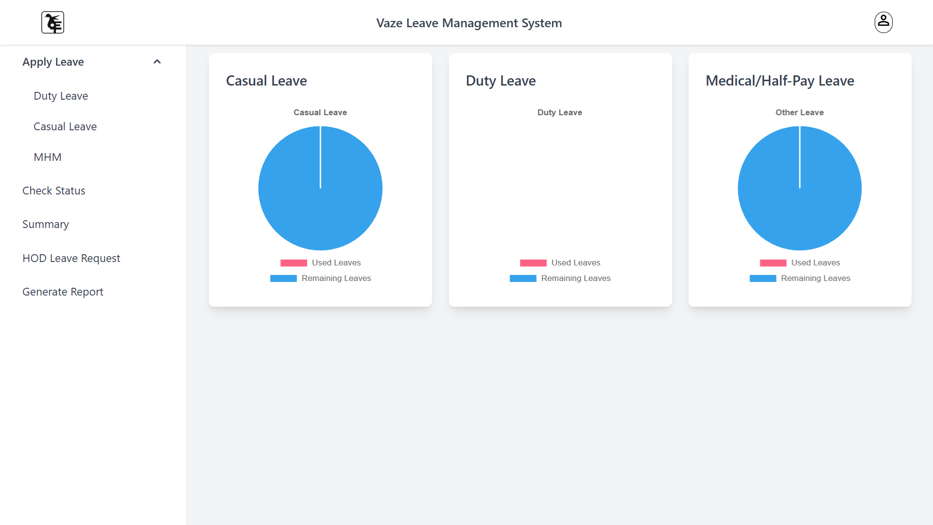

Vice Principal

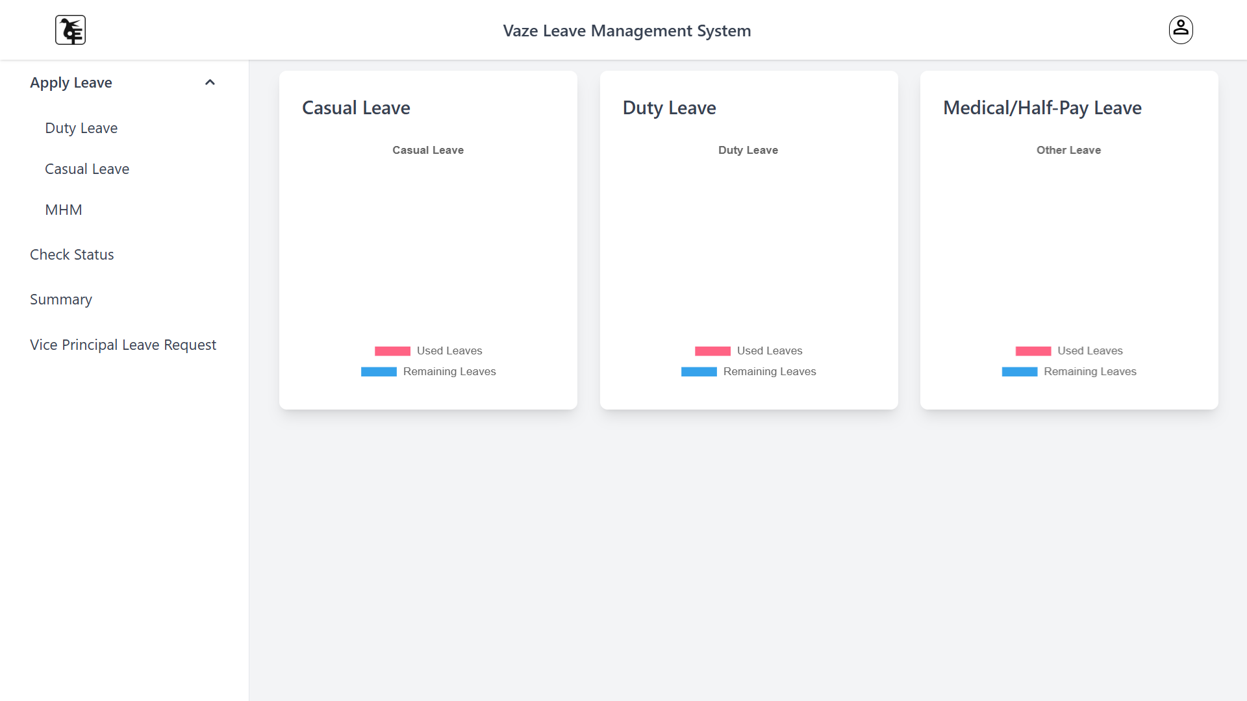

Registror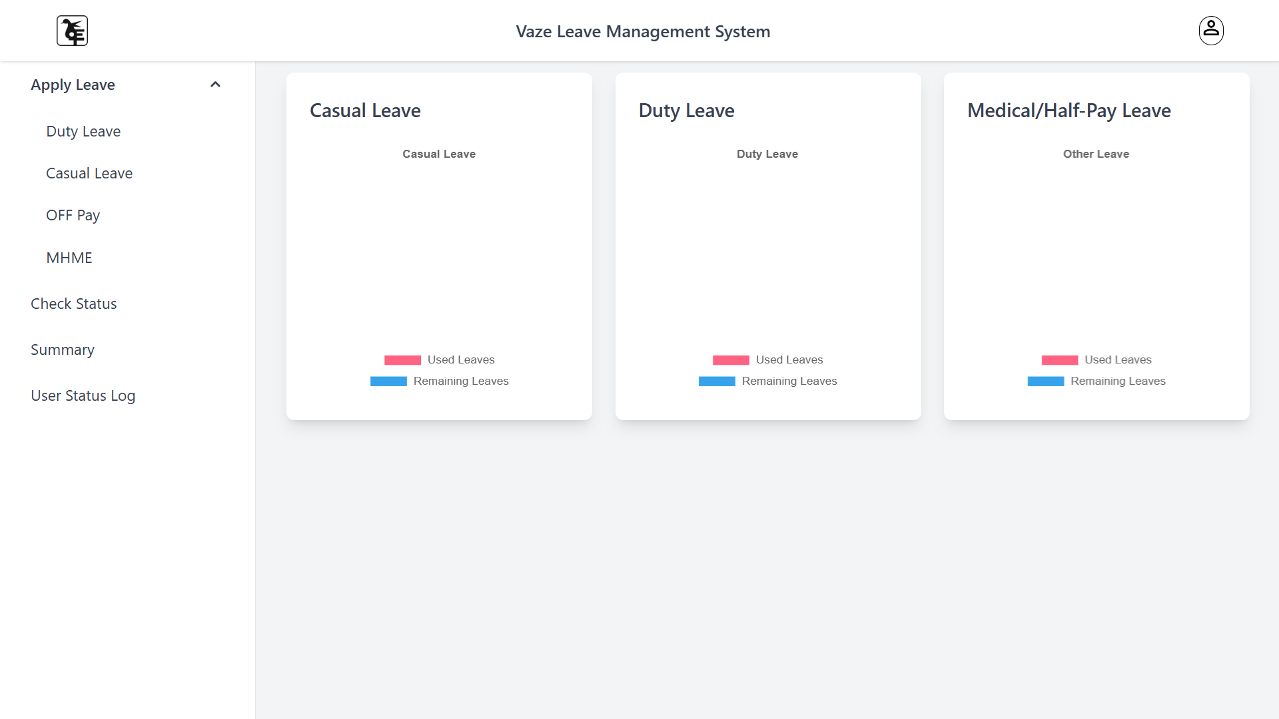

Teacher degree

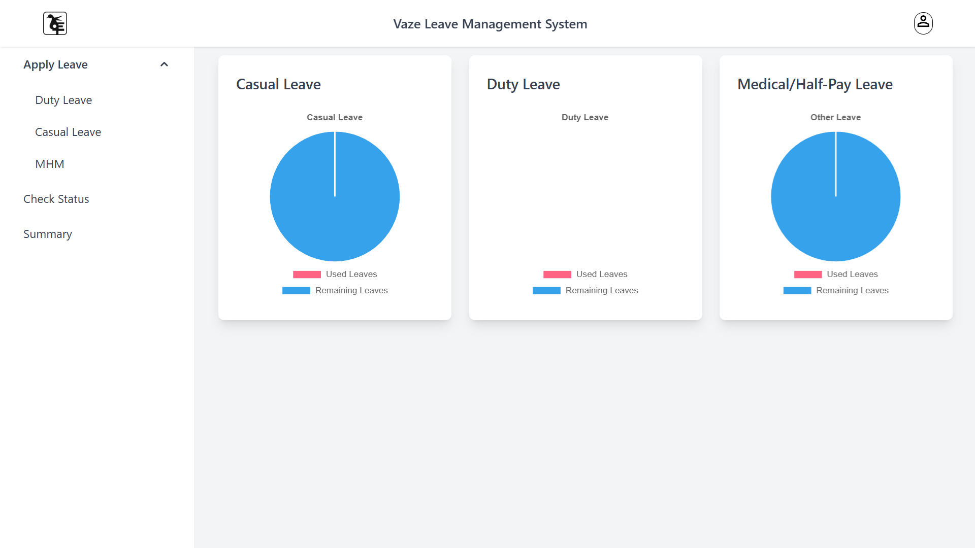

Non Teacher office

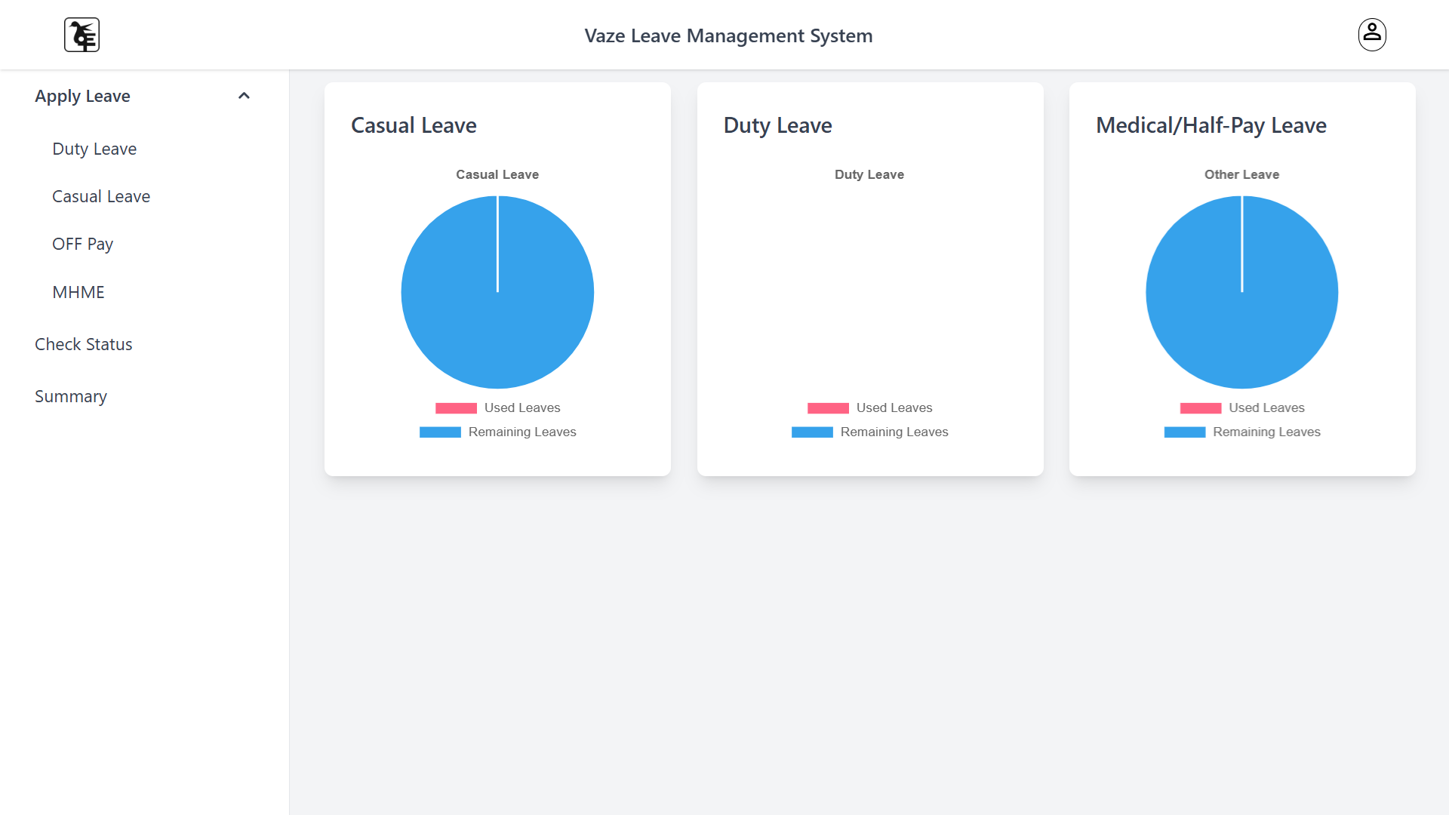

HOD Junior

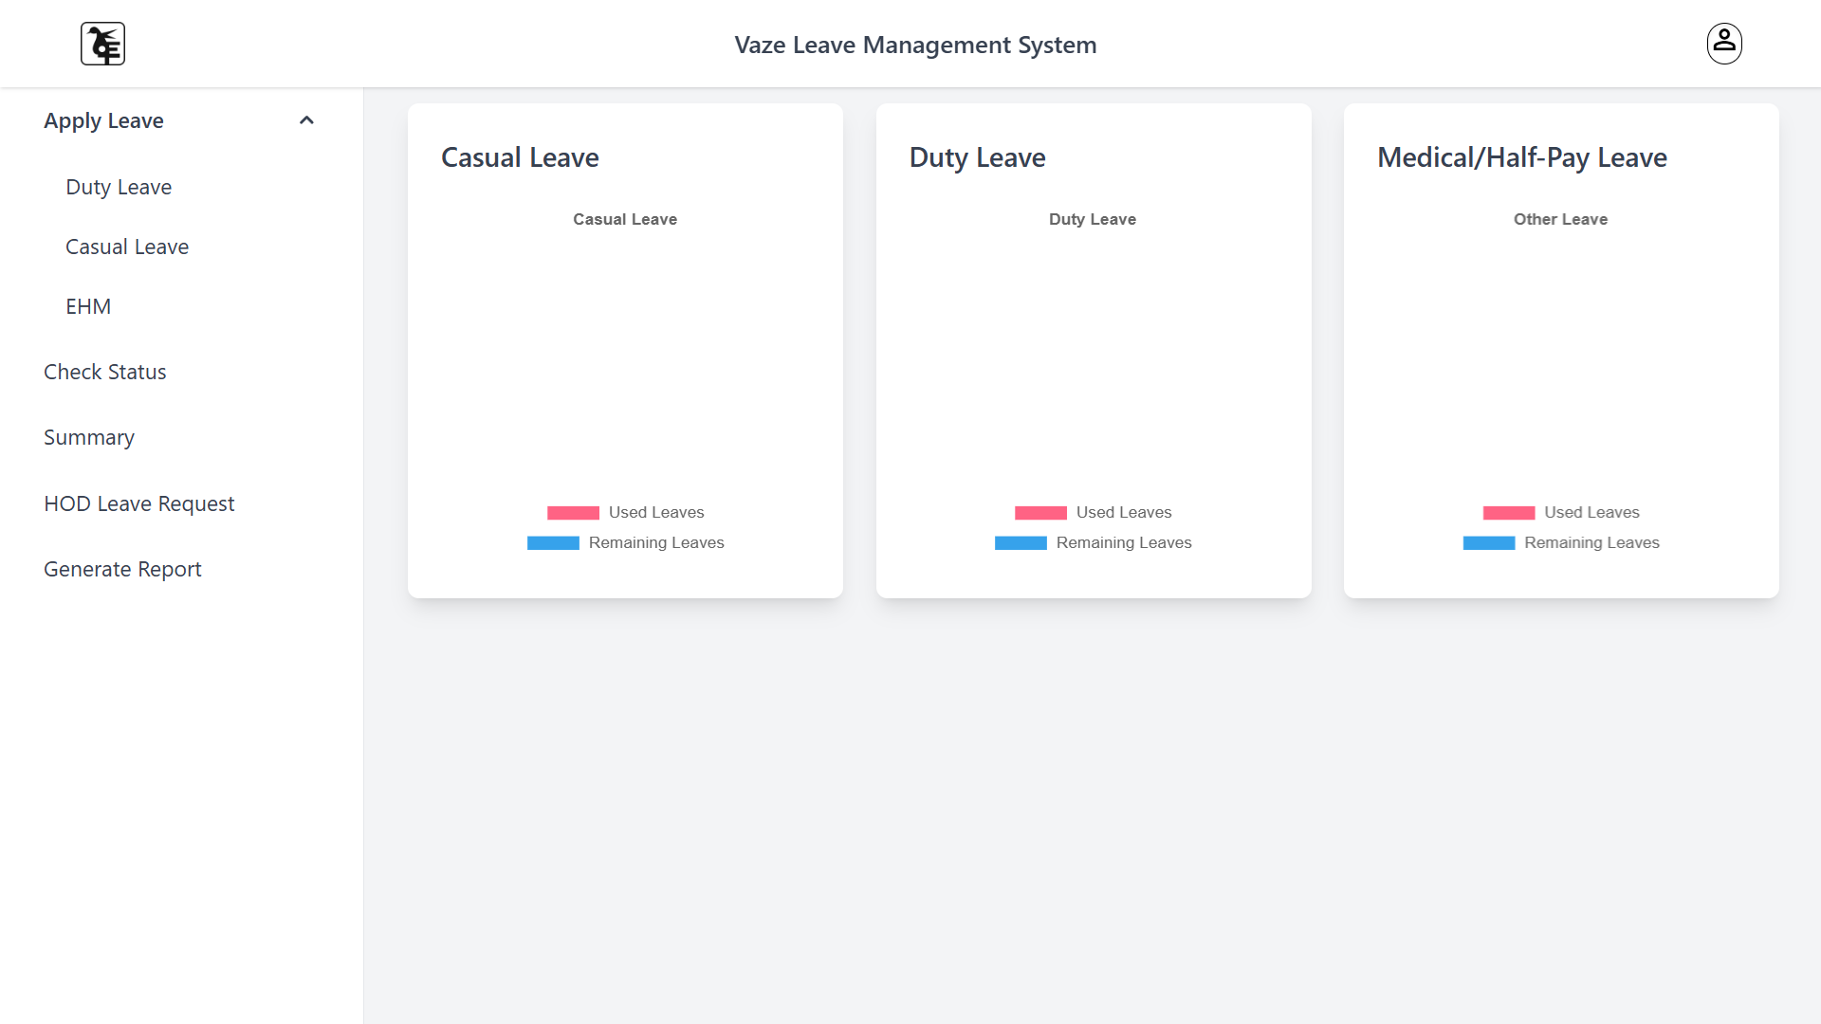

Office Operator

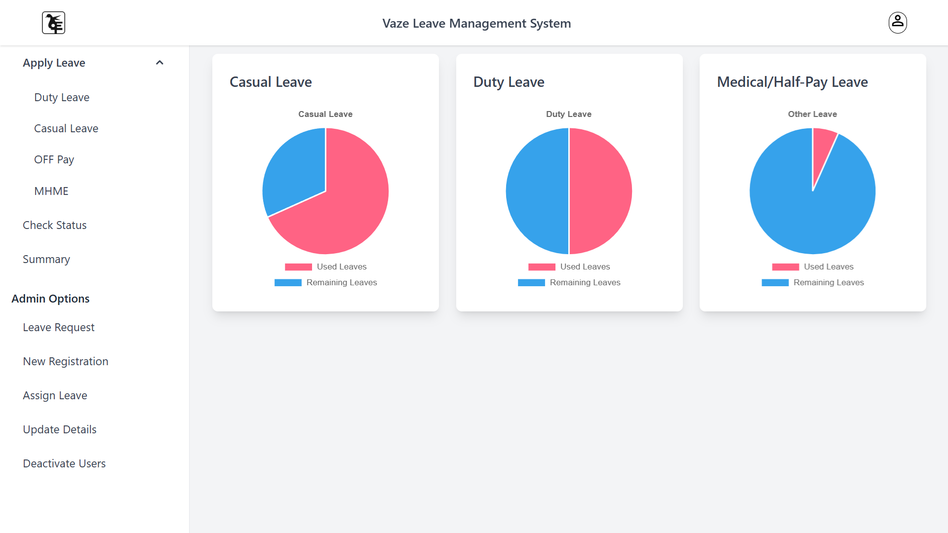

### Staff Registration

Interface for HOD or Admin to register new staff members.

### Assign Leave (Non-Teaching Staff)

Form for assigning leave to non-teaching staff, accessible by authorized users.

### Assign Leave (Teaching Staff)

Form for assigning leave to teaching staff, with options based on leave type.

### Deactivate Users

Interface for deactivating or removing users from the system.

### Report

A downloadable report interface for generating detailed leave data reports.

### Update Staff Details

Update staff information using a dynamic form, with AJAX for real-time updates.

### Apply Leave for CL

Form to apply for Casual Leave (CL) for teaching and non-teaching staff.Check

**Status**

Interface to check the status of leave requests with filter options.

**Remaining and Summary**

Page showing the summary of leaves used and remaining for each staff member.

## Screenshots

Include screenshots of all major pages described above in the provided spaces.