User Manual for Vaze Leave Management System

Introduction
The Vaze College Leave Management System simplifies leave applications for faculty and provides HODs, the Principal, vice principal, and admin staff with tools for efficient review and approval. Key features include streamlined leave submission, multi-level approval processes, and role-based access for secure interactions. The system enhances transparency, reduces paperwork, and ensures efficiency in managing leave records and approvals.

Notations
• TD – Teacher Degree
• TJ – Teacher Junior
• NL – Non-Teaching Laboratory
• NO – Non-Teaching Office
• OO – Office Operator

Pages Overview
• Login Page
• Forgot Password
• Change Password
• Apply Leave
• CL (Casual Leave)
• DL (Duty Leave)
• OFF PAY (Off Pay Leave)
• EMHM (Earned, Medical, Half Pay, Maternity)
• Check Status
• Summary & Remaining
• Leave Request
• New Registration
• Assign Leave
• Update Details
• Deactivate Users
• Report
• User Status Log

Users and Roles

Principal (Super Admin)
- Leave Request
- New Registration
- Assign Leave
- Update Details
- Deactivate Users
- Report
- Principal Leave Request

Office Operator (Sub Admin)
- Leave Request
- New Registration
- Assign Leave
- Update Details
- Deactivate Users
- Report

HOD / Vice Principal (Departmental Admin)
- Leave Request
- New Registration
- Assign Leave
- Update Details
- Deactivate Users
- Report
- HOD Leave Request

Teaching and Non-Teaching Staff
- Login
- Forgot Password
- Change Password
- Apply Leave
- Check Status
- Summary & Remaining

Registrar
- User Status Log

Leave Types and Rules

Leave Types
- DL – Special / Duty Leave
- CL – Casual Leave (Cannot be Carried Forward)
- OFF Pay Leave – Special leave if Worked on an off day
- MHM – Medical, Half Pay, Maternity Leave
- EHM – Earned, Half Pay, Maternity Leave

Academic Year
• Teaching Staff: 1st June – 31st May
• Non-Teaching Staff: 1st January – 31st December
• HOD, Principal, and Office Remarks Cannot be Null.

Important Notes
1. Change Password must be done at the first login.
2. HOD, Principal, and Office Remarks cannot be null.
3. Initially, password for every user is ‘NEW’

Detailed Interface Descriptions

Login Page / Forgot Password / Change Password

New User Login
STEP 1: Enter your registered mail and “NEW” as the password and click the login button.
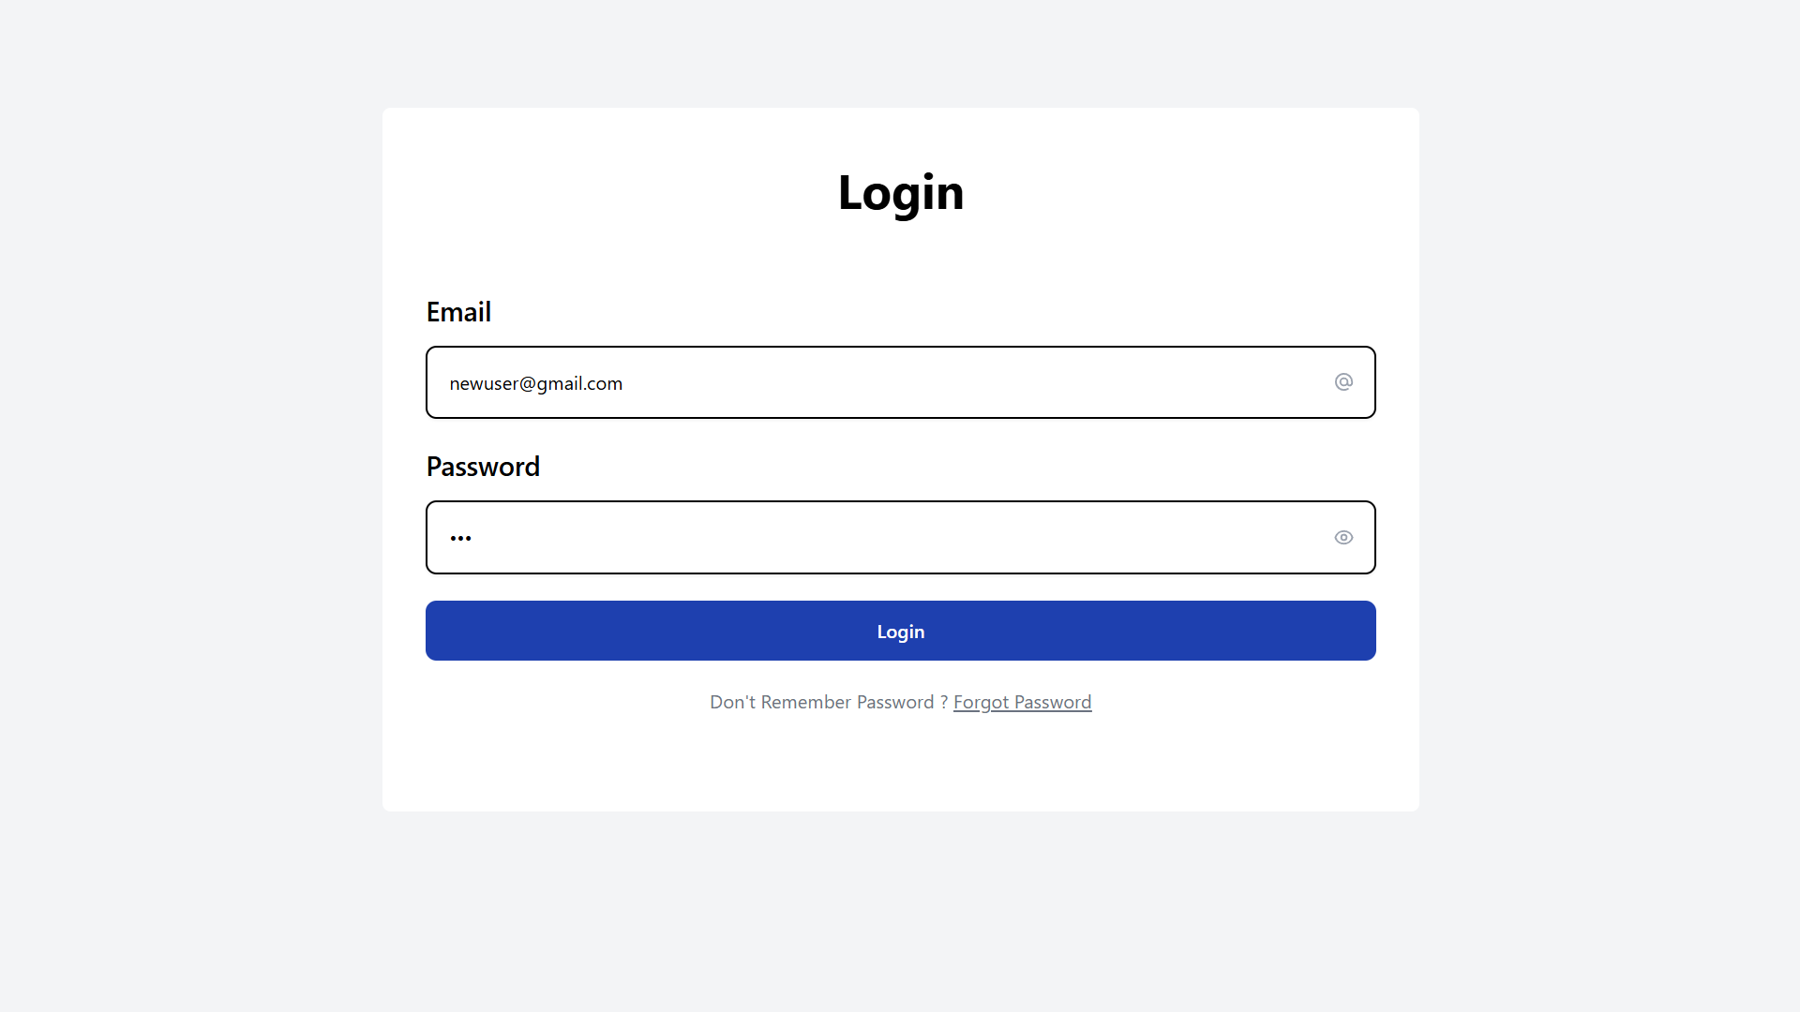
STEP 2: you will be redirected to change password page. Enter “NEW” as the old password, set new password, confirm it and click change password.
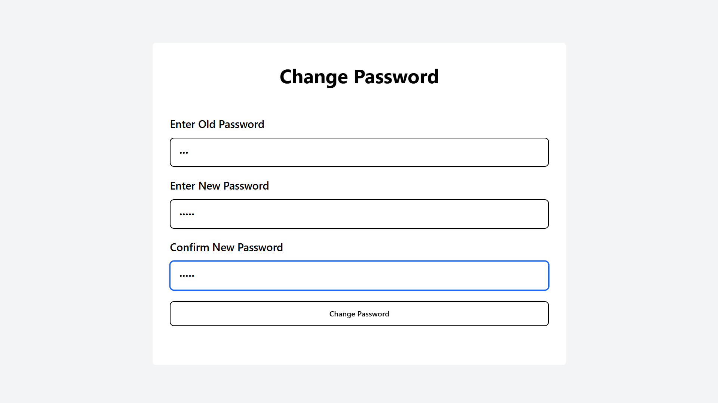
A success popup will appear, and will be redirected to the home page.

Forgot Password
STEP 1: Click on forgot password
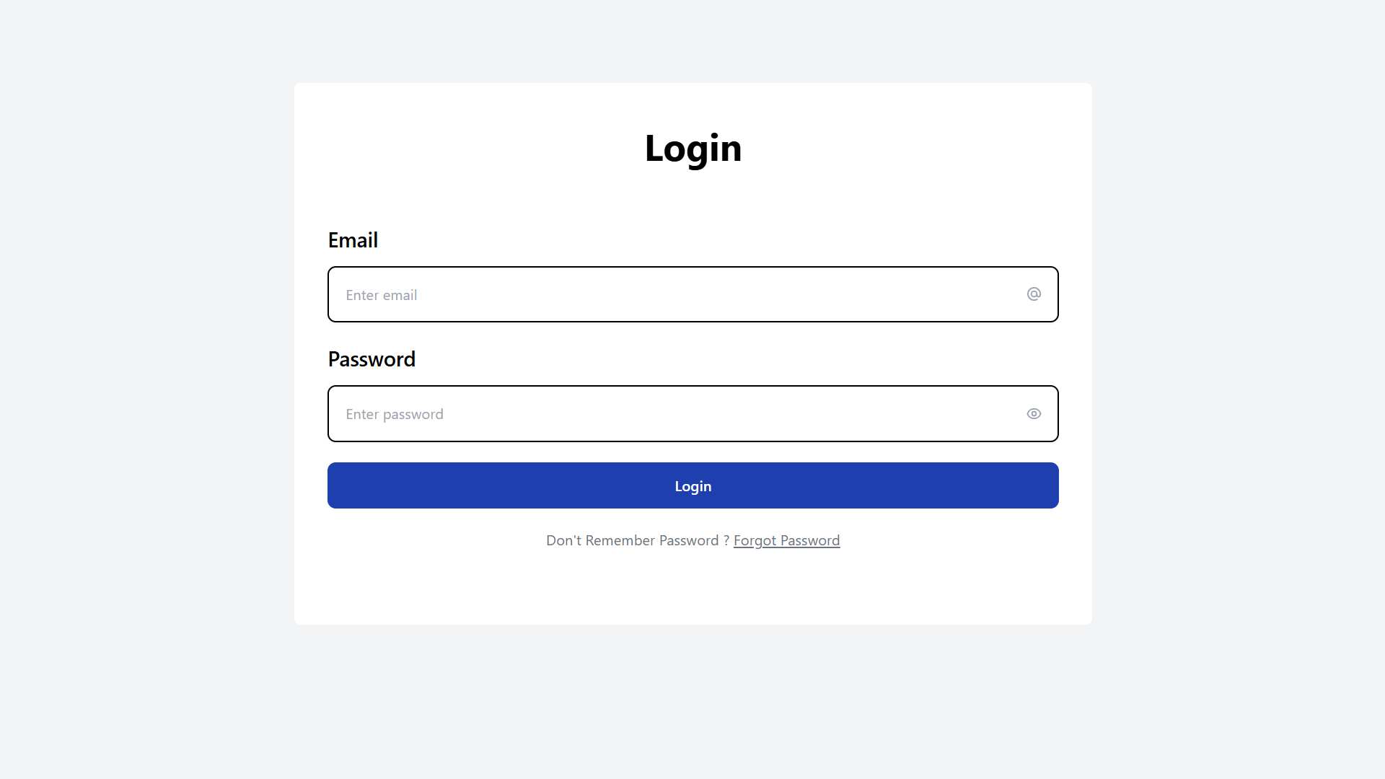
STEP 2: Enter your registered mail
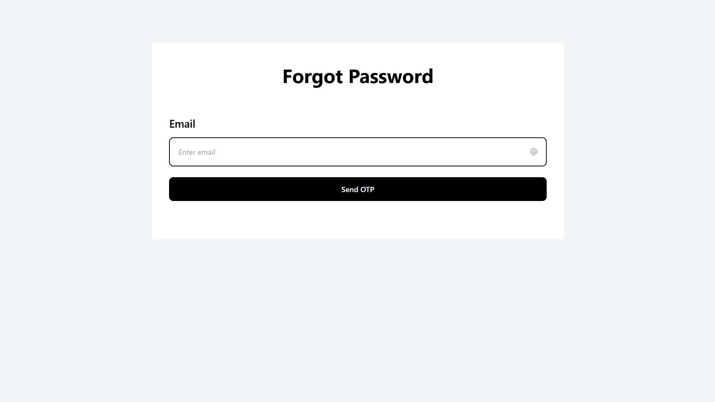
STEP 3: Click send OTP. A success popup will confirm the email has been sent.
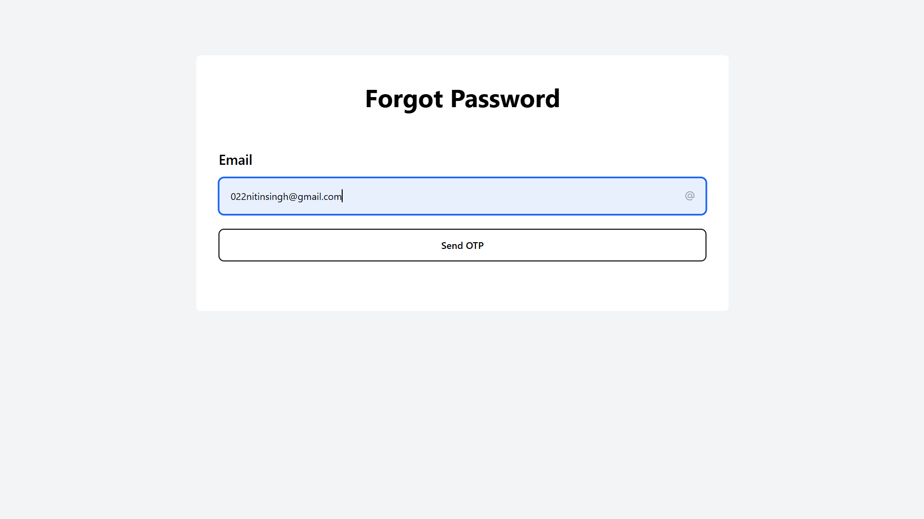

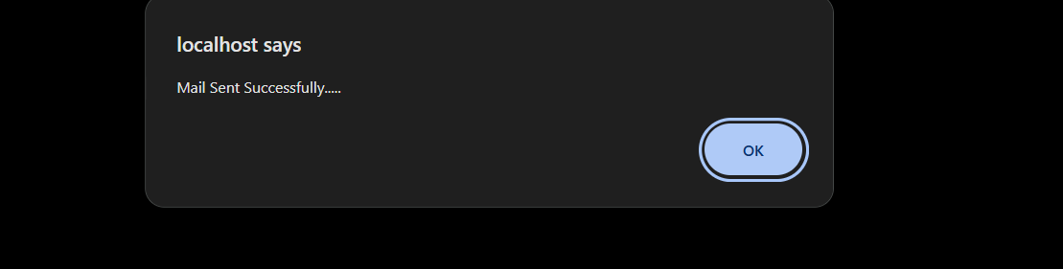
STEP 5: Check your email for OTP
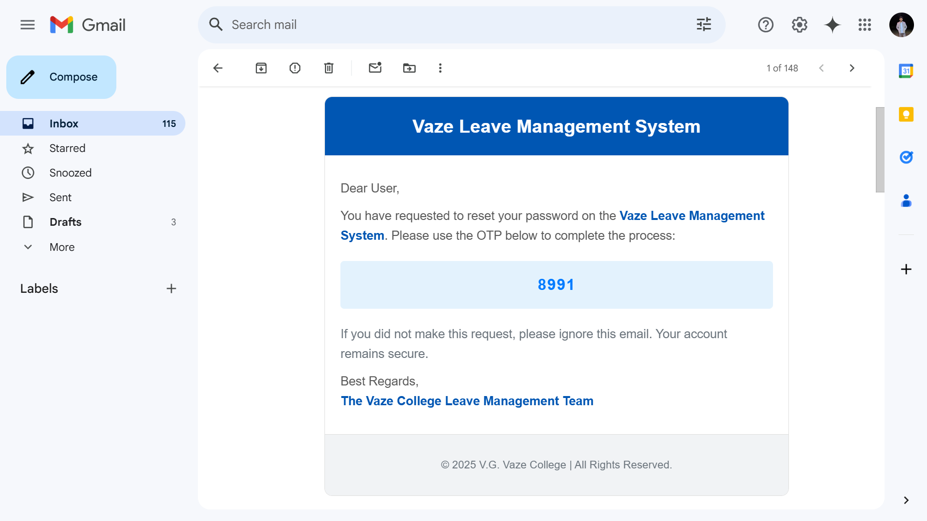
STEP 6: Enter your OTP and click verify OTP
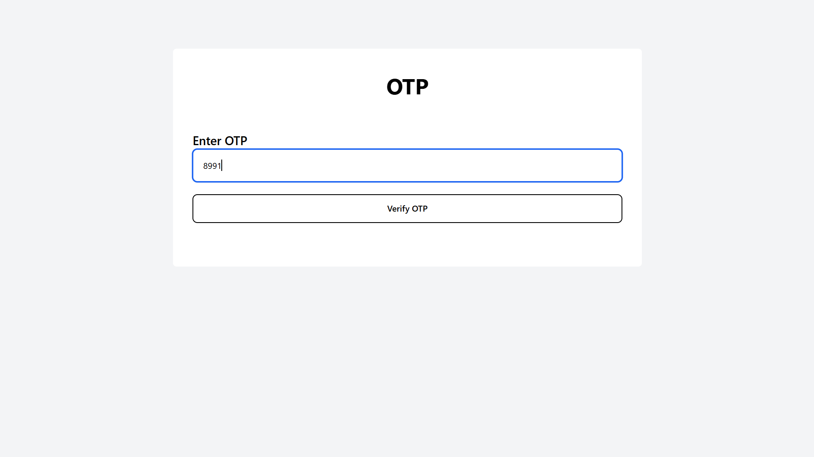
STEP 7: Set a new password, confirm it, and click change password.
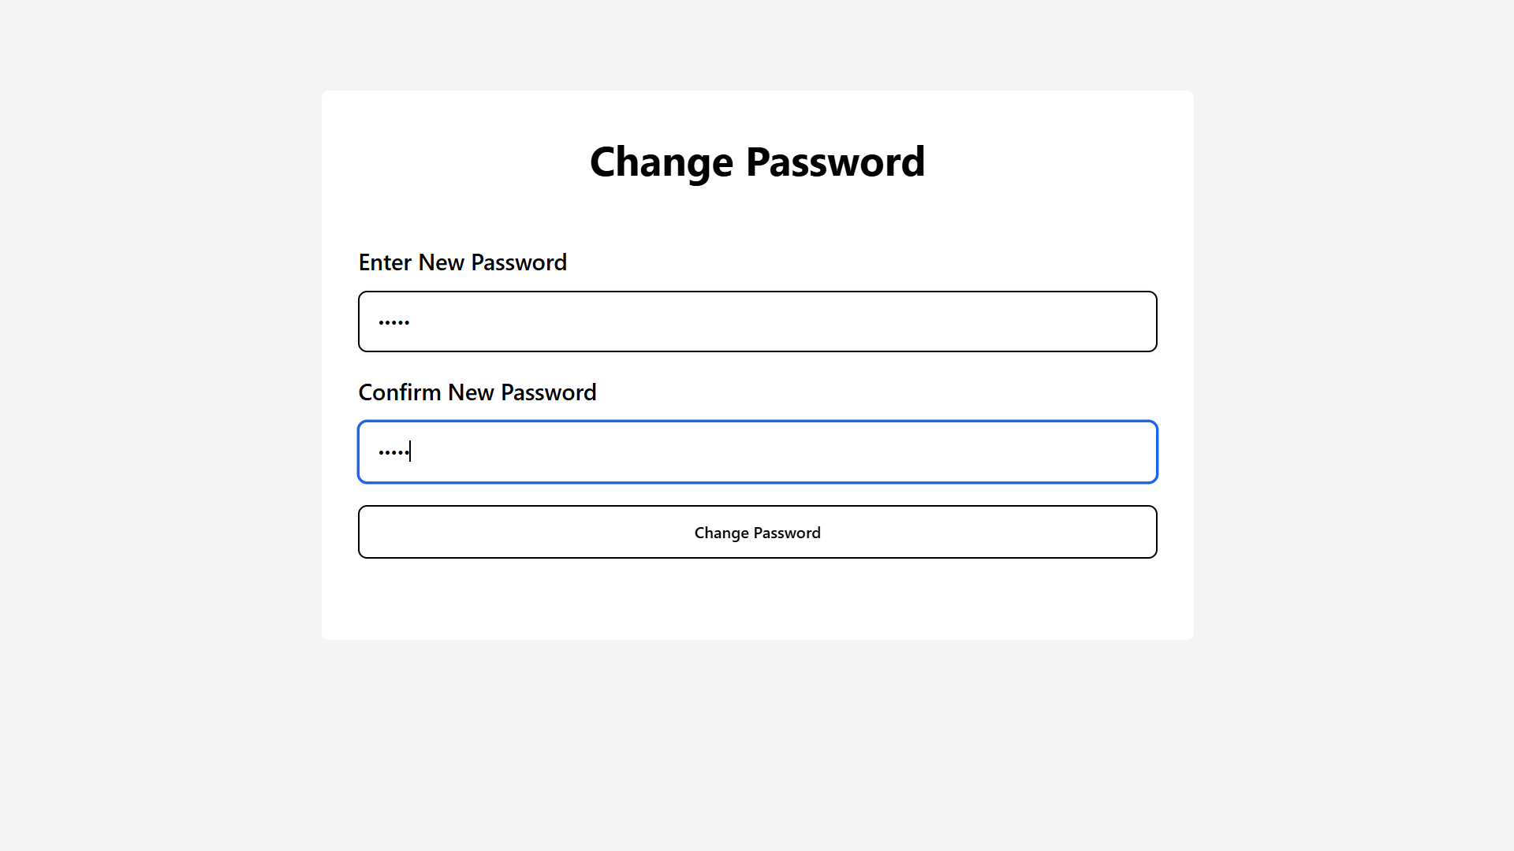
A success popup will appear confirming the password change.

Task Menu
Sidebar displaying the list of available actions based on user role, such as Apply Leave, Check Status, and more.
Principal
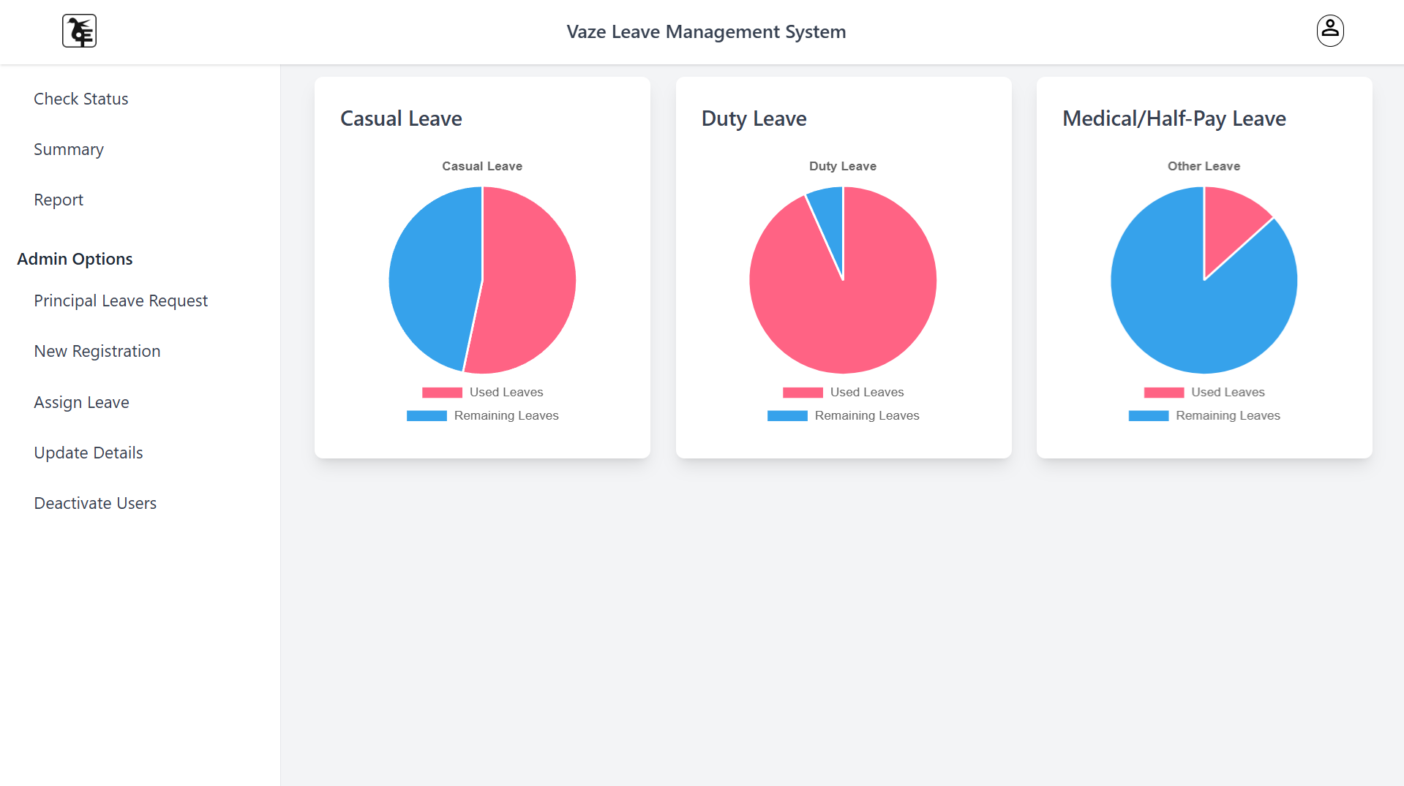

HOD
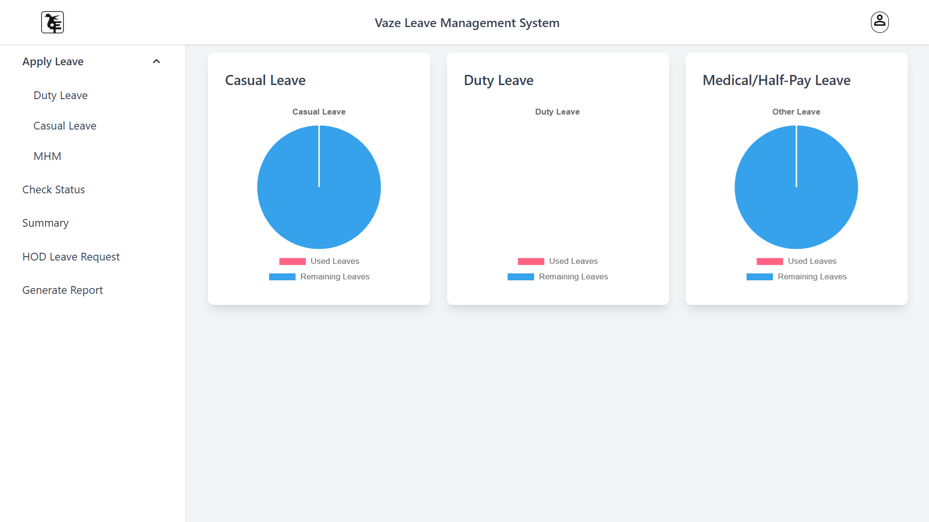

Vice Principal
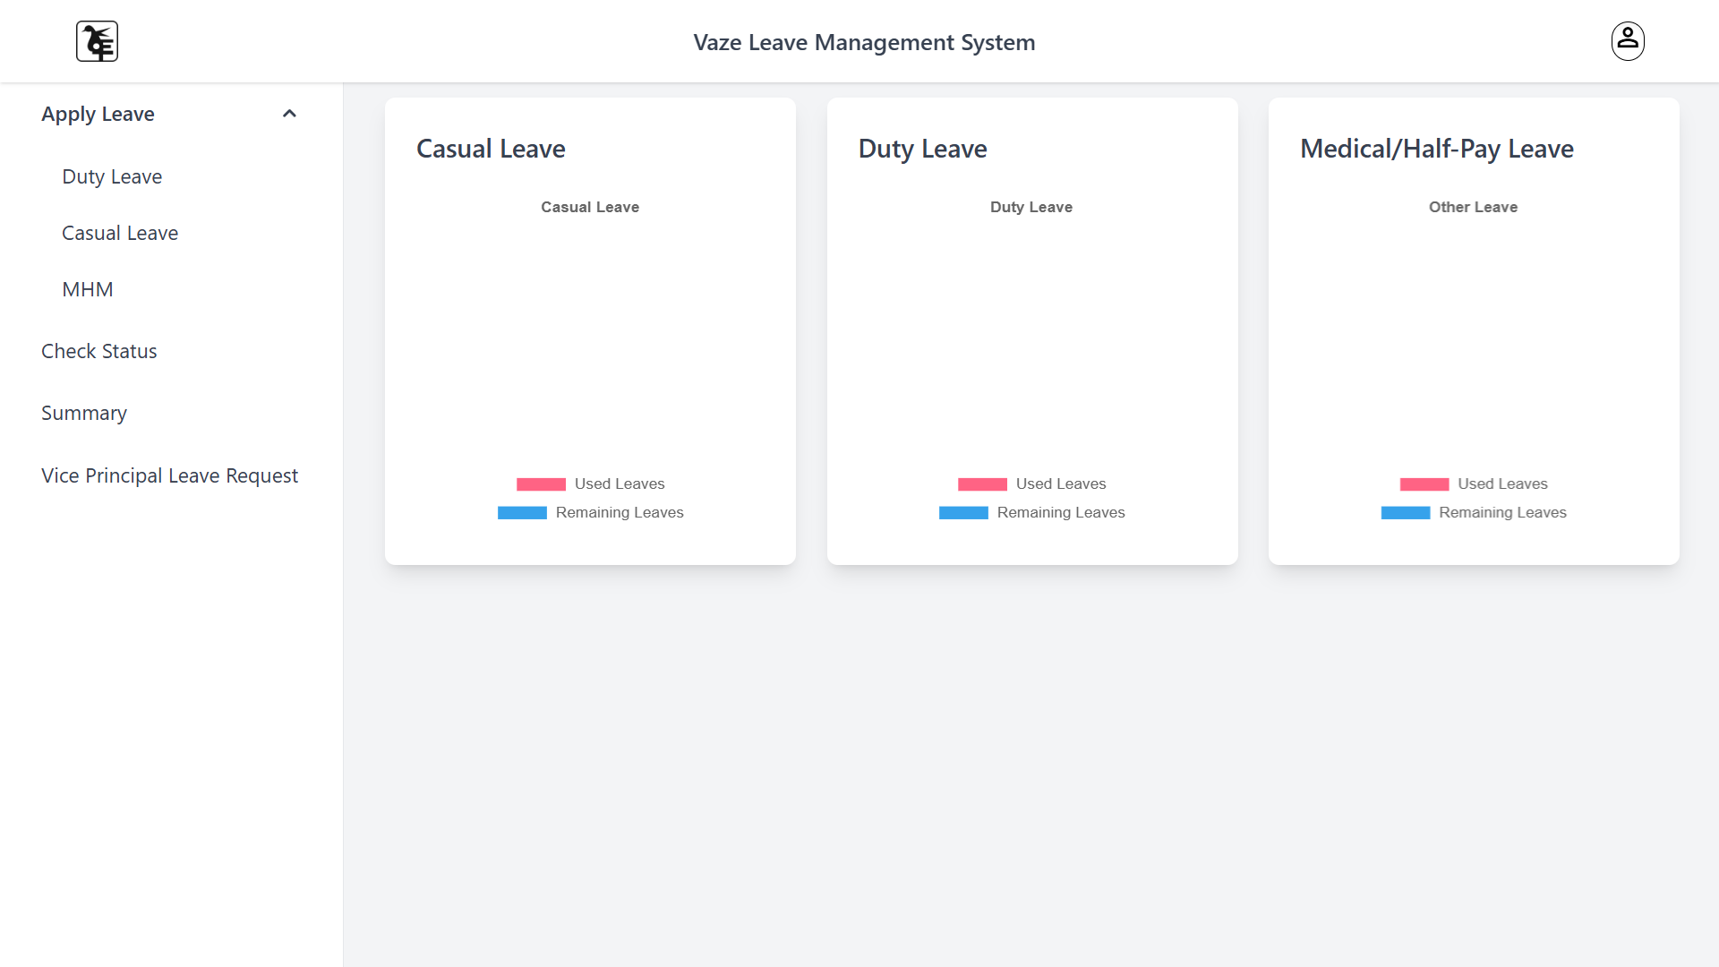

Registror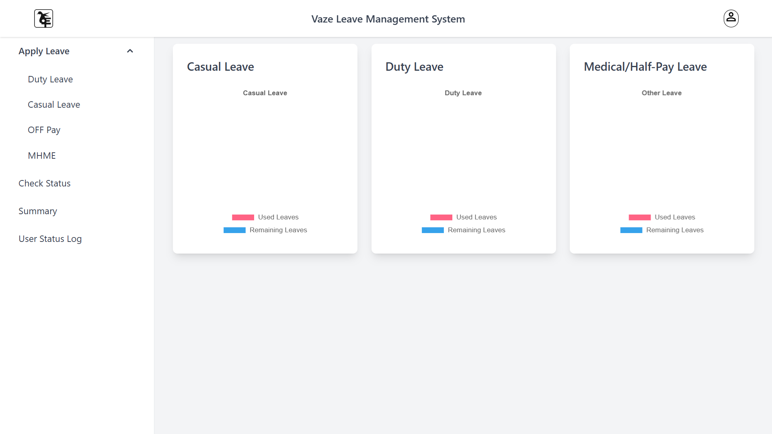
Teacher degree
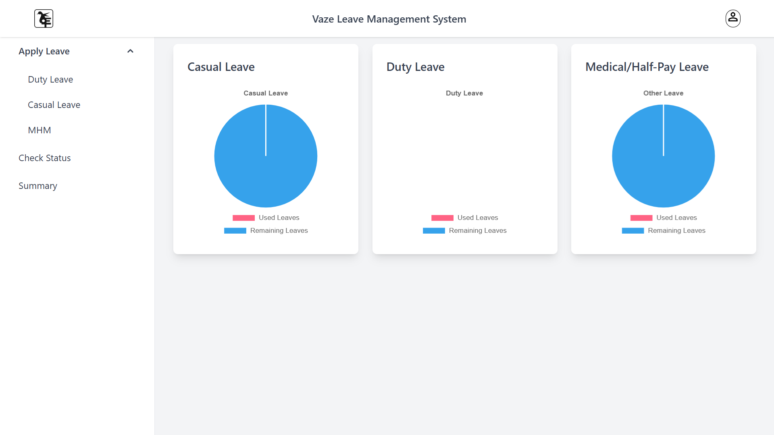

Non Teacher office
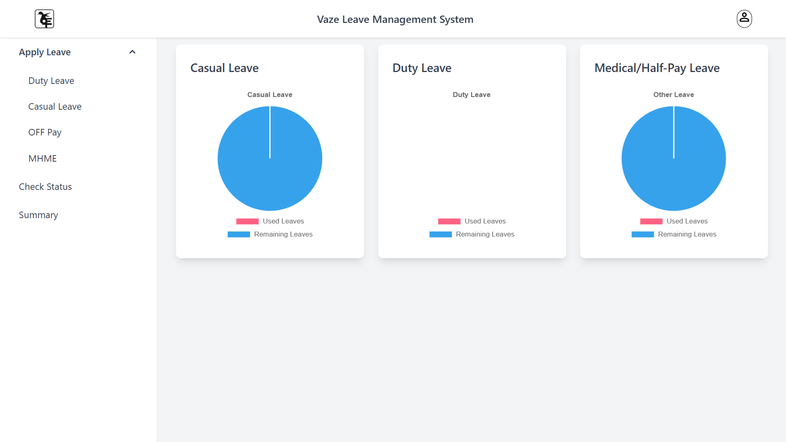

HOD Junior
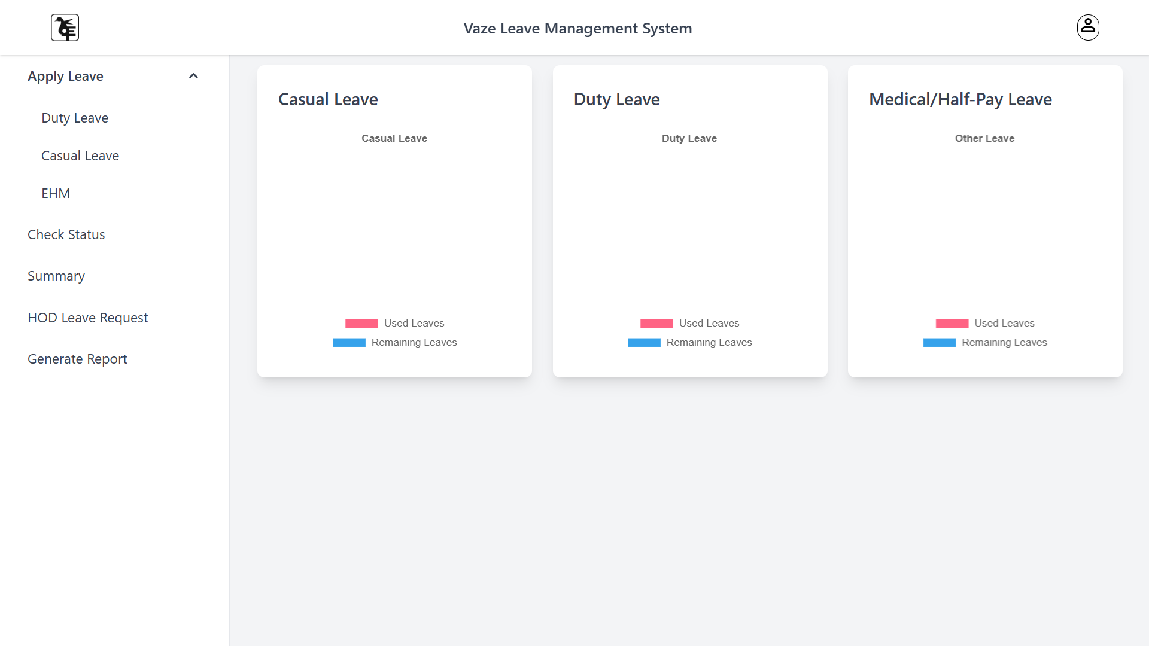

Office Operator
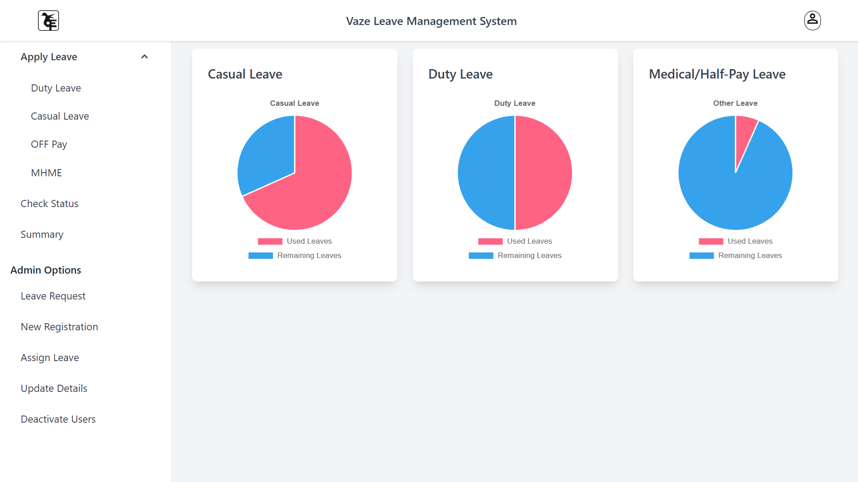

Staff Registration
Interface for HOD or Admin to register new staff members.

Assign Leave (Non-Teaching Staff)
Form for assigning leave to non-teaching staff, accessible by authorized users.

Assign Leave (Teaching Staff)
Form for assigning leave to teaching staff, with options based on leave type.

Deactivate Users
Interface for deactivating or removing users from the system.

Report
A downloadable report interface for generating detailed leave data reports.

Update Staff Details
Update staff information using a dynamic form, with AJAX for real-time updates.

Apply Leave for CL
Form to apply for Casual Leave (CL) for teaching and non-teaching staff.Check
Status
Interface to check the status of leave requests with filter options.
Remaining and Summary
Page showing the summary of leaves used and remaining for each staff member.

Screenshots
Include screenshots of all major pages described above in the provided spaces.

