Automated Identification of Gait Abnormalities
UE24CS352A Machine Learning Mini-Project | Team No. 10
Nishit Suresh (PES2UG24CS326) and Nitin Somisetty (PES2UG24CS327)

1. Problem Statement
Gait abnormalities are early indicators of musculoskeletal and neurological conditions such as cerebral palsy, Parkinson's disease, and hip weakness. Manual clinical gait assessment is subjective, slow, and requires expert observation. This project builds a machine learning classifier that automatically identifies one of six gait patterns from 3D skeleton joint coordinates: normal, antalgic (pain-avoidance limp), stiff-legged (reduced knee flexion), lurching (trunk compensation), steppage (foot drop with high knee lift), and Trendelenburg (pelvic drop from hip weakness). The goal is to enable fast, objective, and portable gait screening.

2. Dataset
We used the Kinect v2 pathological gait skeleton dataset (Jun et al., IEEE Access 2020), selecting 480 walking sequences from 10 subjects across 6 gait classes, with near-balanced class distribution. Each walk consists of frames recorded at ~30 Hz, with 25 body joints tracked in 3D. The raw data contains 75 coordinate columns (25 joints x 3 axes) plus 8 derived biomechanical features (joint angles, segment lengths, symmetry ratios), yielding 83 features per frame. We selected 8 walks per subject per gait type, retaining valid files and excluding those with malformed coordinates (86 files with values around 10^267) or missing data. The abnormal gaits were simulated by healthy volunteers under supervision, which limits generalization to real patients but ensures clean, controlled data.

3. Approach
Feature Engineering. Each walk (hundreds of frames) is converted into one feature vector. We compute bone-segment lengths from joint key points, knee/hip/ankle flexion angles, stride cadence, and left-right symmetry ratios. Each feature is summarized across the walk as mean, min, max, and standard deviation. Features are normalized per-subject to remove scale bias.
Models Compared. Three classical machine learning models (Logistic Regression, Random Forest, Gradient Boosting) plus a Dummy baseline that always predicts the most frequent class. Classical models were chosen because the feature set is already interpretable and the subject count is small (10), so complex models would overfit.
Evaluation. 5-fold Group
KFold cross-validation, grouped by subject, so all walks from one subject stay in the same fold. This prevents the model from learning to recognize individuals instead of gait types. Primary metric is macro F1, which weights all six classes equally. Two subjects were held out as a final test set, never used during model selection.

4. Implementation Overview
The pipeline follows seven stages, shown below: load and validate data, split into train/test by subject, extract features per walk, clean invalid data, train models with cross-validation, select the best model, and predict gait type. All code is in a single Jupyter notebook using scikit-learn, pandas, and NumPy. Raw data and generated files are excluded from version control.


5. Results
Logistic Regression achieved 75.6% accuracy and 74.7% macro F1 on cross-validation, best among the three trained models. The Dummy baseline scored 16.8% accuracy and 4.8% macro F1, so Logistic Regression is 4.5x better on macro F1.
Confusion Matrix. Rows are true labels, columns are predictions. The model correctly classifies most walks. Confusion is concentrated between Antalgic <-> Stiff-legged and Trendelenburg <-> Lurch, both pairs sharing similar compensatory joint-angle signatures. This is clinically plausible, not a model failure.
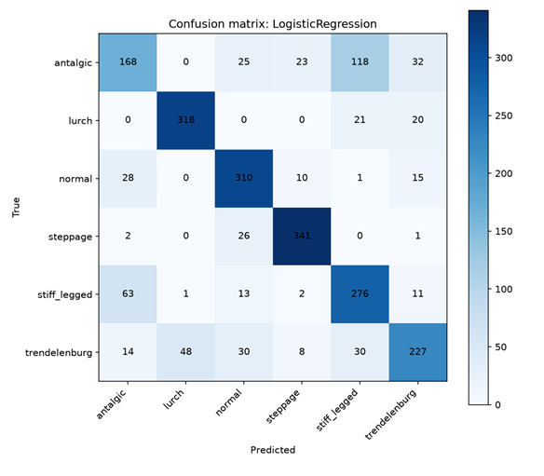
Test Set. On the two held-out subjects (8 and 9), the model generalized well, correctly predicting multiple walks with high confidence (typically >90%), confirming that it learned patterns, not individuals.

6. Conclusions
Gait abnormalities can be classified from skeleton-derived features alone, achieving 75.6% accuracy on six classes with Logistic Regression. Hand-designed features (joint angles, symmetry, cadence) are sufficient to separate most gaits. The main limitations are the small subject count (10), simulated abnormal gaits (not real patients), and some confusion between similar gait types. Future work could include richer temporal features across full stride cycles, data collection on real patients to resolve Antalgic/Stiff-legged and Trendelenburg/Lurch confusion, and comparison against sequence models. The approach is portable and could enable fast, objective gait screening in clinics or at home.

