**Architecture**

**Behavior Diagrams**

**High Level Behavioural Diagram**

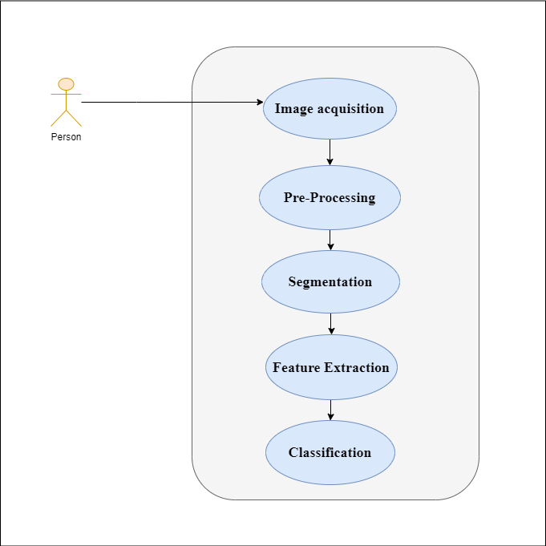

### Low Level Behavioural Diagram

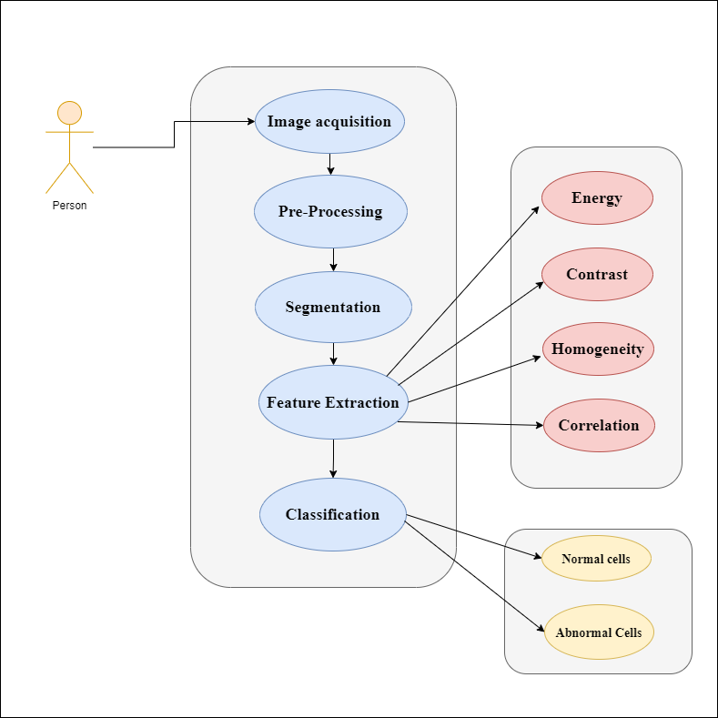

## System Diagrams

### High Level System Diagram

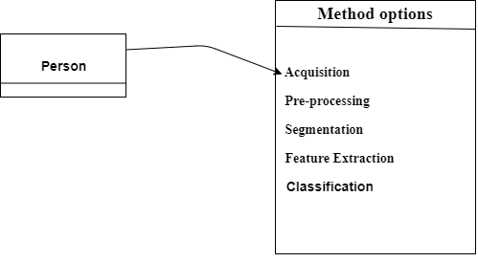

### Low Level System Diagram

