Healthcare Mega-Trend: Investment Note

1. The Trend
India’s healthcare sector is at an inflection point — rising incomes, an ageing population, and post-COVID awareness are pushing millions of first-time patients into hospitals, diagnostic labs, and pharmacies. Healthcare spending as a share of GDP is still well below global peers, meaning the runway for growth is long and structural, not cyclical. This isn’t a short-term trade; it’s a decade-long story.

2. The Proxy Logic
Picking which hospital chain or pharma brand wins is hard — competition is fierce, pricing is regulated, and drug pipelines can disappoint overnight. The smarter play is to back the enablers — the companies that supply the tools, tubes, tests, and infrastructure that every healthcare provider needs, regardless of who wins the market-share battle. Think of it like the Gold Rush: sell the shovels, not the gold.

3. Top Proxy Plays
Rank | Company | Lynch Score | One-Line Thesis
🥇 | POLYMED (Poly Medicure) | 8/10 STRONG | Makes the IV sets, catheters, and disposables every hospital buys daily — clean balance sheet (D/E: 0.08), 31% earnings growth, and a global export kicker.
🥈 | LALPATHLAB (Dr. Lal PathLabs) | 7/10 STRONG | India’s most trusted diagnostics brand with zero meaningful debt, steady 13% earnings growth, and a network that gets stronger as preventive health testing becomes routine.
🥉 | TORNTPHARM (Torrent Pharma) | 7/10 STRONG | Quietly compounding at 24% earnings growth with a focused branded-generics model, strong promoter skin-in-the-game (68%), and manageable debt.
4️⃣ | ZYDUSLIFE (Zydus Lifesciences) | 7/10 STRONG | Explosive 74% earnings CAGR, the lowest PE in the top tier at 18.7x, and promoters holding 75% — rare combination of value and growth in pharma.
5️⃣ | APOLLOHOSP (Apollo Hospitals) | 6/10 MODERATE | The gold-standard hospital brand in India with 24% earnings growth; its digital health platform (Apollo 24/7) is an underappreciated long-term option.

4. Watch Out For
⚠️ Valuation Stretch — Several names here trade at 40–90x earnings. Good businesses at bad prices still make poor investments. Wait for dips or buy in tranches rather than going all-in at once.
⚠️ Earnings Reversals in Diagnostics — THYROCARE and METROPOLIS have seen earnings shrink 14–15% over three years as post-COVID testing volumes normalised. Don’t assume past peak revenues will return quickly.
⚠️ Regulatory & Pricing Risk — The government periodically caps drug prices and hospital procedure costs. A single policy announcement can compress margins overnight, especially for pharma companies with high domestic exposure.

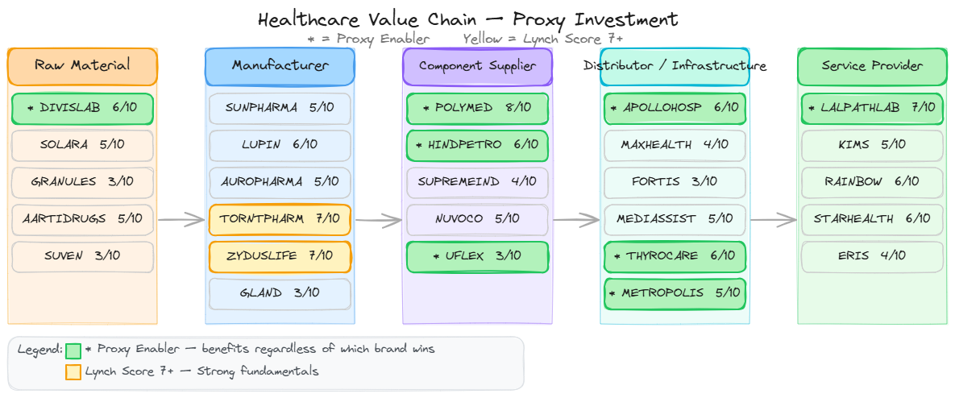
This note is for informational purposes only and does not constitute financial advice. Please do your own due diligence before investing.

