Prototype in Javascript

Prototype is a default property getting attached to the functions or any variables whenever they are created.

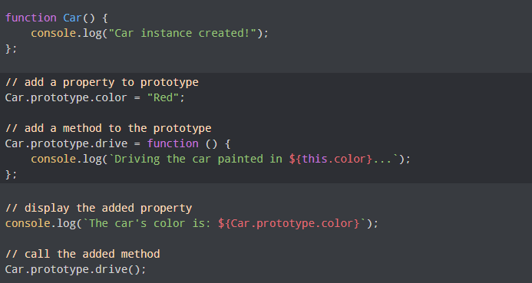

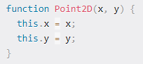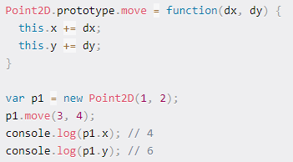

Js engine push all the predefined properties, methods into the Prototype object & attach this prototype object to newly created functions, string, arrays or any custom objects automatically.

Prototype inheritance in Javascript

Newly created object or functions, inherits properties from Prototype object hence called as prototype inheritance.

Inheritance is the passing down characteristics from Parent to its child so that child can reuse those properties & can enhance those properties by his own.

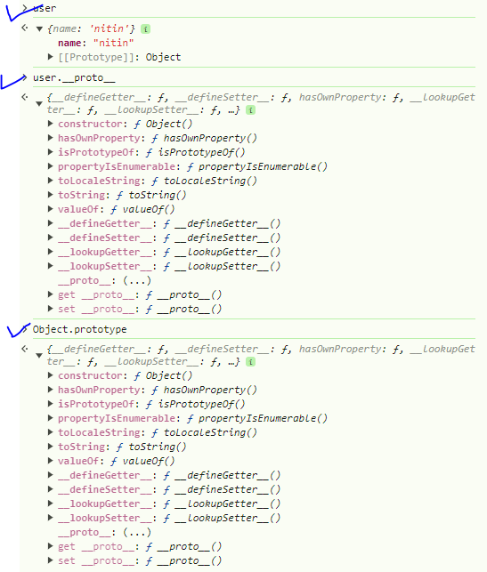

In this ex our user object has __proto__ object attached, which is inherited from Object. prototype.

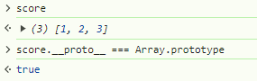

Why everything in js is an Object?

See below ex. Our custom array score has his own __proto__ object which is inherited form Array. Prototype.

Likewise, Array. prototype has its own __proto__ object which is inherited from Object. Prototype.

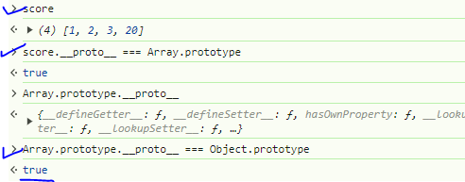

Hence it is called that everything in JavaScript is an object because every variable, function, array, Boolean, strings we use inherits default properties from Object.prototype.

 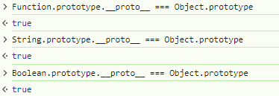

This chaining also called as a Prototype chaining.

