

### PROJECT REPORT

**On**

# Hospital Management System

Submitted in partial fulfilment of the requirement for the Course BEE (22CS026) of

**COMPUTER SCIENCE AND ENGINEERING**

#### B.E. Batch-2022

**In**

**July-Dec 2024**



**Under the Guidance of**

**Submitted By**

**Name of the Project Guide Nitin (2210991997)**

**Ms Aditi Sharma Mam Nitin Goyal (2210992000)**

**Ocean Kajal (2210992006)**

**Prabhdeep Singh(2210992050)**

**DEPARTMENT OF COMPUTER SCIENCE AND ENGINEERING**

# CHITKARA UNIVERSITY

**PUNJAB**



**Certificate**

This is to be certified that the project entitled “Hospital Management System” has been submitted for the Bachelor of Computer Science Engineering at Chitkara University, Punjab during the academic semester July 2024- december-2024 is a bonafide piece of project work carried out by “Nitin (2210991997) Nitin Goyal (2210992000) Ocean (2210992006) Prabhdeep Singh (2210992050)” towards the partial fulfillment for the award of the course Integrated Project (CS 203) under the guidance of “Mr. Rahul” and supervision.

**Sign. of Project Guide** : Name of Project Guide (Designation & Department)



#### (Annexure –D)

### CANDIDATE’S DECLARATION

We, **Nitin(2210991997), Nitin Goyal(2210992000), Ocean** **Kajal(2210992006) , Prabhdeep Singh(2210992050) ,** B.E.-2021 of the Chitkara University, Punjab hereby declare that the Integrated Project Report entitled **“Hospital Management”** is an original work and data provided in the study is authentic to the best of our knowledge. This report has not been submitted to any other Institute for the award of any other course.

|  |  |  |
| --- | --- | --- |
| **Sign. of Student 1** | **Sign. of Student 2** | **Sign. of Student 3** |
| Nitin | Nitin Goyal | Ocean Kajal |
| ID No 2210991997. | ID No 2210992000 | ID No 2210992006 |

|  |
| --- |
| **Sign. of Student 4** |
| Prabhdeep Singh |
| ID No 2210992050 |

**Place:**

**Chitkara University**

**Date:12-09-2024**



### ACKNOWLEDGEMENT

It is our pleasure to be indebted to various people, who directly or indirectly contributed in the development of this work and who influenced my thinking, behavior and acts during the course of study.

We express our sincere gratitude to all for providing me an opportunity to undergo Integrated Project as the part of the curriculum.

We are thankful to “Mr. Rahul ” for his support, cooperation, and motivation provided to us during the training for constant inspiration, presence and blessings.

We also extend our sincere appreciation to ***“Mr. Rahul and Ms.Aditi Sharma”*** who provided his valuable suggestions and precious time in accomplishing our Integrated project report.

Lastly, We would like to thank the almighty and our parents for their moral support and friends with whom we shared our day-to day experience and received lots of suggestions that improve our quality of work.

|  |  |  |
| --- | --- | --- |
| **Nitin** | **Nitin Goyal** | **Ocean** |
| **ID No 2210991997** | **ID No 2210992000** | **ID No 2210992000** |

|  |
| --- |
| **Prabhdeep Singh** |
| **ID No 2210992050** |



**The report must consist of following chapters:**

### Abstract 1:This report presents the development of a Hospital Management System (HMS) utilizing the MERN stack. The system aims to digitize and centralize hospital operations, covering essential functions such as patient registration, appointment scheduling, medical record management, and billing automation. Using MongoDB for data storage, Express.js and Node.js for the backend, and React for the front-end interface, the HMS offers a secure and efficient solution to enhance healthcare management and service delivery.

1. **Keywords**: HMS, healthcare system, MongoDB, Express.js, React, Node.js, patient data, hospital workflow, digital healthcare, medical record system.
2. **Introduction to the project**
   1. **Background:** Hospitals and healthcare facilities traditionally rely on manual or semi-automated systems to manage patient records, appointments, billing, and other crucial administrative tasks. These processes, while functional, often lead to inefficiencies, increased workload, and the risk of human error. As healthcare providers handle increasing patient volumes, there is a growing need for a streamlined, digital solution to enhance operational efficiency, improve service delivery, and ensure the security of sensitive patient data.
   2. **Problem Statement:** Traditional hospital systems are inefficient and error-prone, leading to poor data management, inadequate communication, and fragmented billing and inventory processes. They lack real-time information access and secure data handling, compromising patient care and operational efficiency. A MERN stack-based Hospital Management System is needed to centralize data, streamline operations, and enhance security.
3. **Software and Hardware Requirement Specification**
   1. **Methods:** The Hospital Management System (HMS) follows an agile development approach, starting with requirement gathering and system design. The frontend is built using React.js, while the backend uses Node.js with Express.js and MongoDB for the database. RESTful APIs enable communication.
   2. **Programming/Working Environment:** The programming environment for the Hospital Management System (HMS) includes Visual Studio Code for development, Git for version control, and npm for managing dependencies. MongoDB is used for database management, while Node.js with Express.js handles the backend, and React.js is used for frontend development. Postman facilitates API testing, and cloud platforms **.**
   3. **Requirements to run the application:** To run the Hospital Management System (HMS), you'll need Node.js installed for backend execution and npm for dependency management. MongoDB is required for database management, and a modern browser (e.g., Chrome, Firefox) is needed for accessing the frontend.
4. **Database Analyzing, design and implementation:** The database for the Hospital Management System (HMS) is designed using MongoDB, a NoSQL database, for its flexibility in handling diverse medical records. Patient, doctor, appointment, and billing data are stored as collections. The schema design ensures efficient querying and data retrieval. Relationships between collections are managed using embedded documents and references, ensuring scalability and data integrity.
5. **Program’s Structure Analyzing and GUI Constructing (Project Snapshots)**

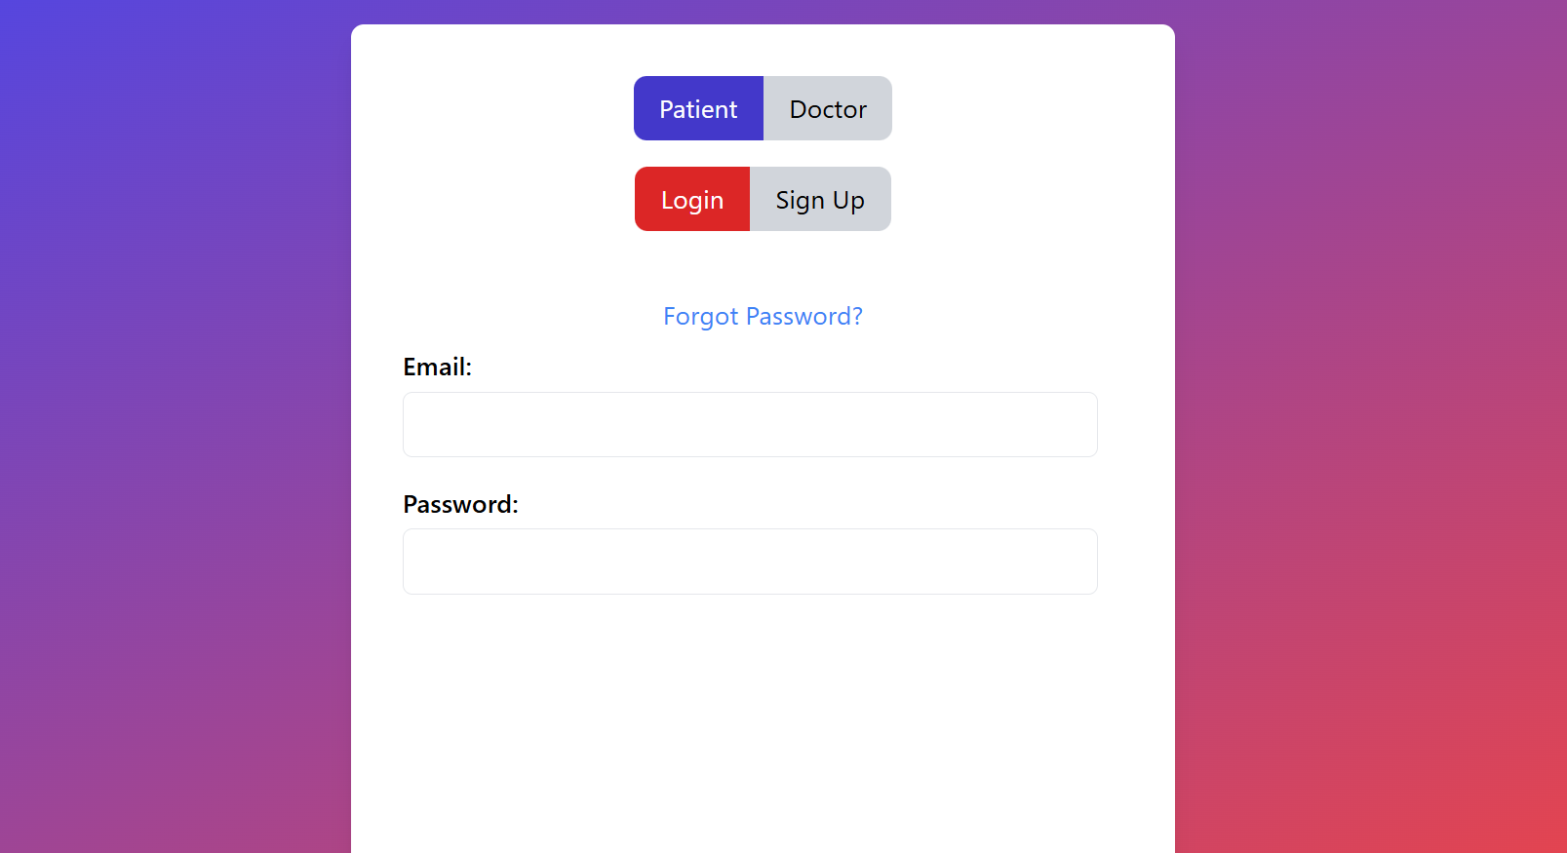

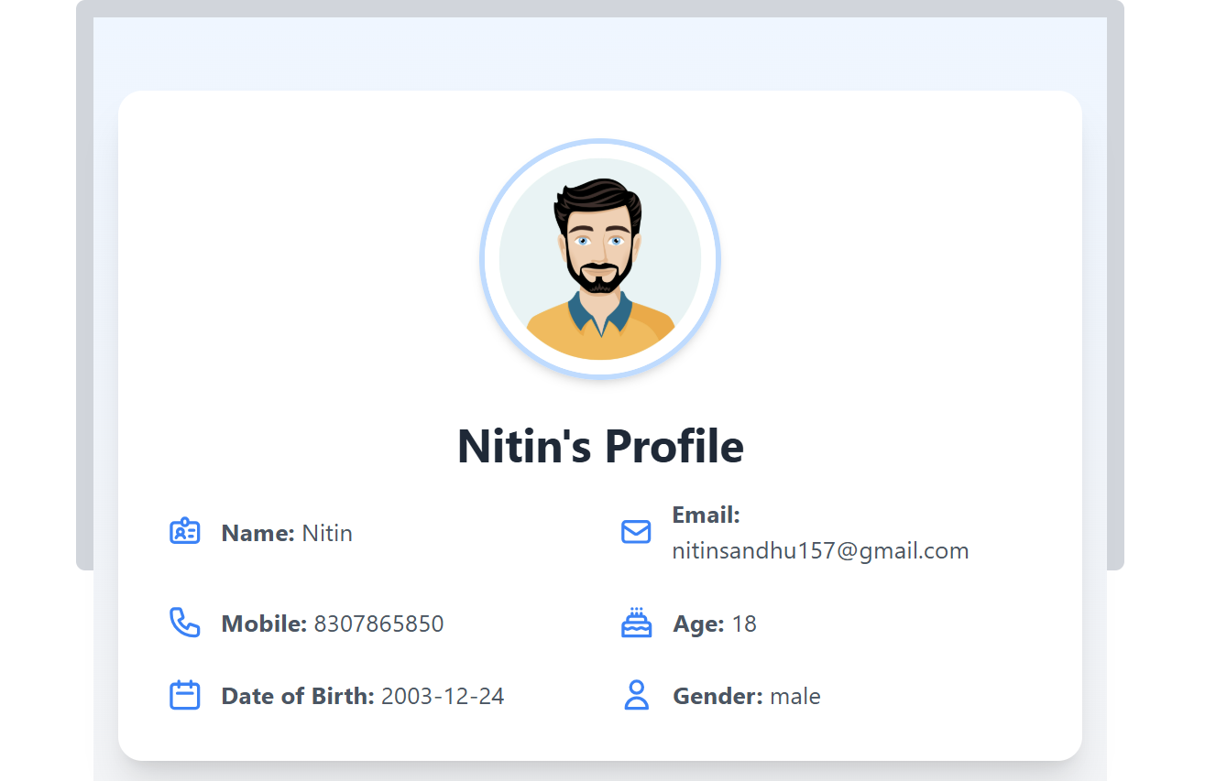

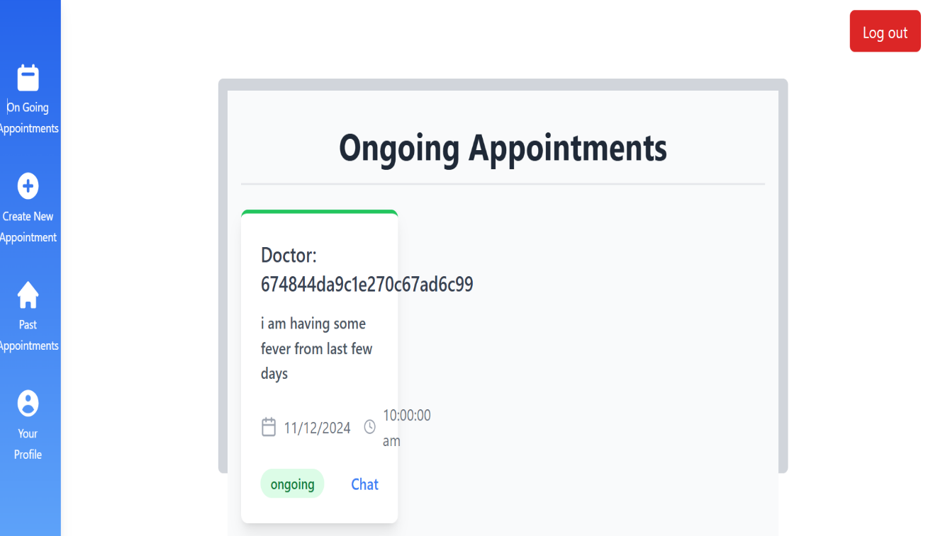

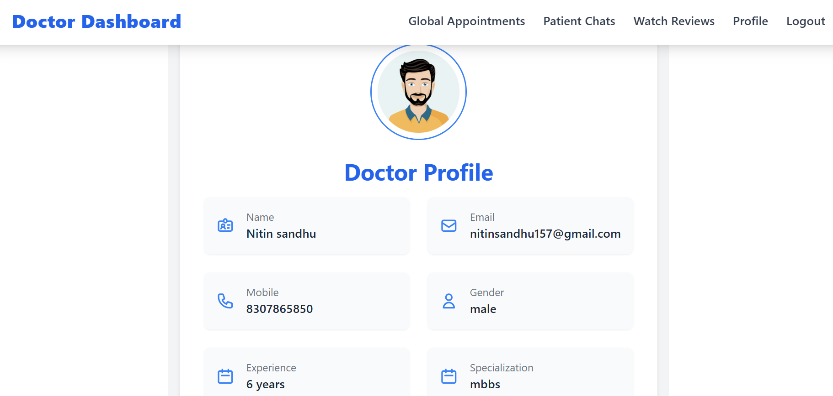

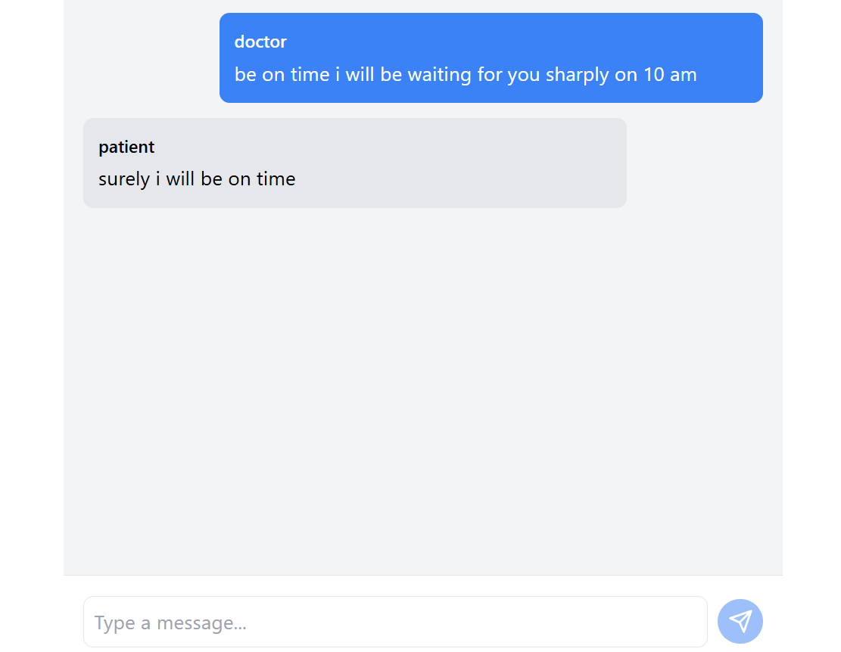

1. **Code-Implementation and Database Connections (If any)**

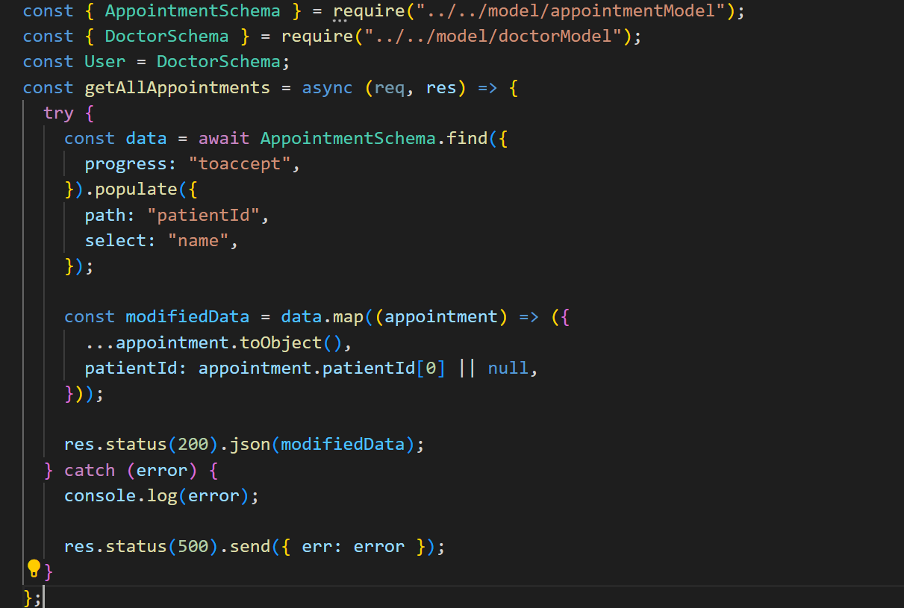

1. **Conclusion**: In conclusion, the Hospital Management System (HMS) built using the MERN stack provides a comprehensive solution for managing hospital operations efficiently. By automating tasks such as patient records, appointments, and billing, the system enhances operational accuracy and reduces manual workload. Its scalability, security, and user-friendly interface ensure improved healthcare service delivery and streamlined hospital management.
2. **Future Scope:** Future enhancements for the Hospital Management System (HMS) include integrating advanced analytics for predictive health insights, incorporating telemedicine features for remote consultations, and expanding mobile support for improved accessibility. Additionally, leveraging machine learning for automated diagnostics and incorporating AI-driven patient care recommendations could further optimize hospital operations and enhance patient outcomes.
3. **Bibliography/References:**

* **React Documentation: React – A JavaScript library for building user interfaces.** [**https://reactjs.org/**](https://reactjs.org/)
* **Node.js Documentation: Node.js – JavaScript runtime built on Chrome's V8 JavaScript engine. https://nodejs.org/en/docs/**
* **Mongoose Documentation: Mongoose – MongoDB object modeling for Node.js. https://mongoosejs.com/docs/**
* **Express Documentation: Express – Fast, unopinionated, minimalist web framework for Node.js.** [**https://expressjs.com/**](https://expressjs.com/)

