Figure: Grad-CAM examples (MobileNetV2, full fine-tuning, seed 0)
Model: MobileNetV2 fine-tuned on EuroSAT, seed 0 (the best model, 98.27% mean test accuracy). Tiles are the real 64 x 64 pixels, enlarged without smoothing. Heat map: red = where the model looked most, blue = least (Grad-CAM, last feature block). Confidence = the model's softmax probability for its predicted class.

A. Correct predictions (one per class)
# | Actual class | Predicted class (confidence) | Original tile | Grad-CAM heat map | Overlay
C1 | AnnualCrop | AnnualCrop (99.9%) |  | 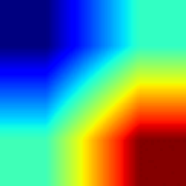 | 
C2 | Forest | Forest (100.0%) |  | 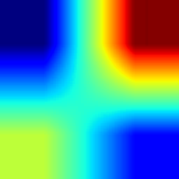 | 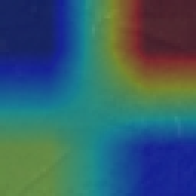
C3 | HerbaceousVegetation | HerbaceousVegetation (99.9%) | 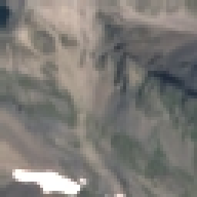 | 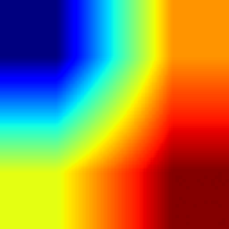 | 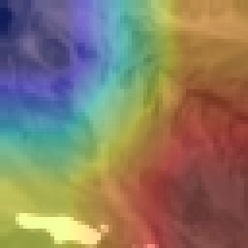
C4 | Highway | Highway (99.9%) | 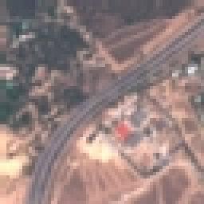 | 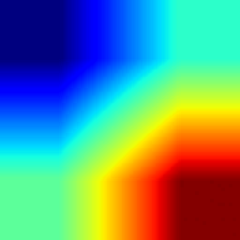 | 
C5 | Industrial | Industrial (100.0%) | 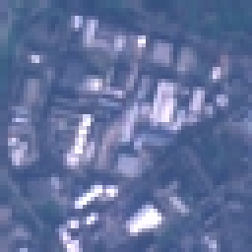 | 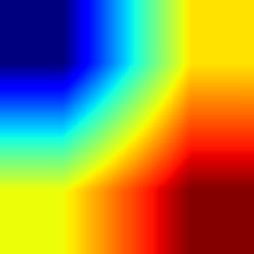 | 
C6 | Pasture | Pasture (100.0%) | 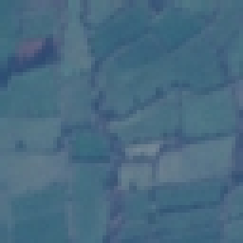 | 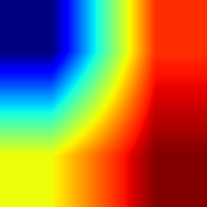 | 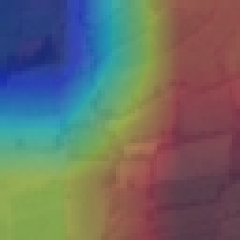
C7 | PermanentCrop | PermanentCrop (99.2%) |  | 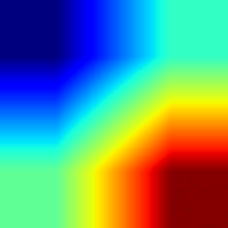 | 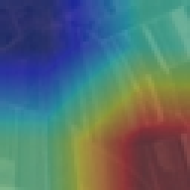
C8 | Residential | Residential (100.0%) |  | 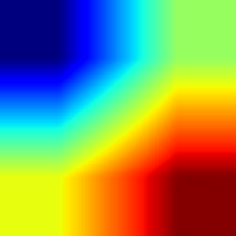 | 
C9 | River | River (96.6%) | 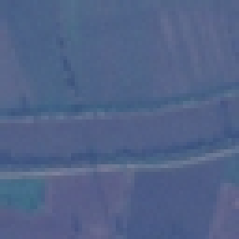 | 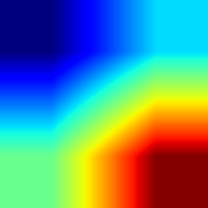 | 
C10 | SeaLake | SeaLake (100.0%) |  | 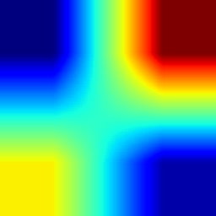 | 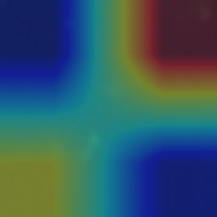

B. Wrong predictions (one from each of the 10 most frequent confusion pairs)
# | Actual class | Predicted class (confidence) | Original tile | Grad-CAM heat map | Overlay
W1 | AnnualCrop | PermanentCrop (61.3%) | 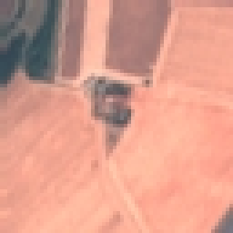 | 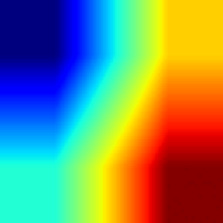 | 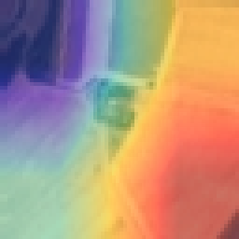
W2 | AnnualCrop | Pasture (99.7%) | 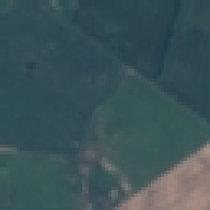 | 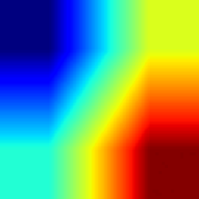 | 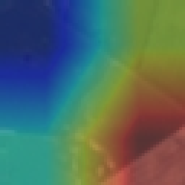
W3 | HerbaceousVegetation | Pasture (54.6%) | 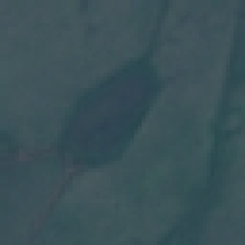 | 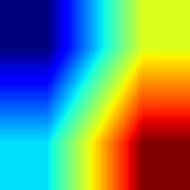 | 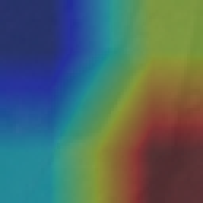
W4 | HerbaceousVegetation | PermanentCrop (80.7%) | 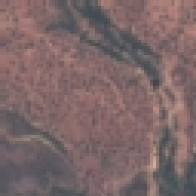 | 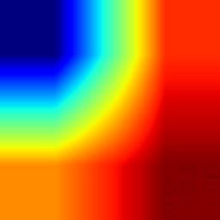 | 
W5 | Highway | River (50.3%) |  | 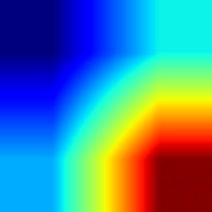 | 
W6 | Pasture | AnnualCrop (85.8%) |  | 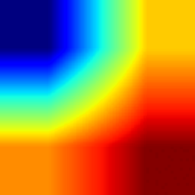 | 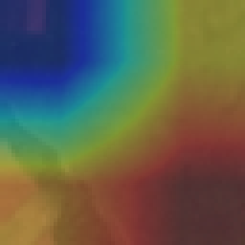
W7 | Industrial | Highway (87.0%) | 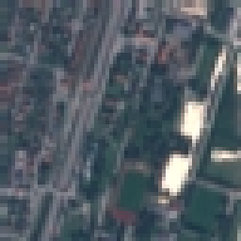 | 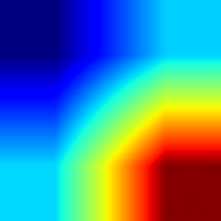 | 
W8 | River | Highway (66.4%) |  | 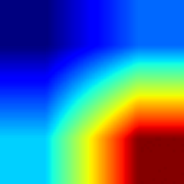 | 
W9 | PermanentCrop | Highway (84.0%) | 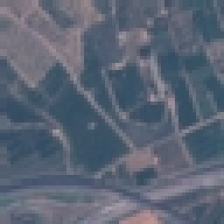 | 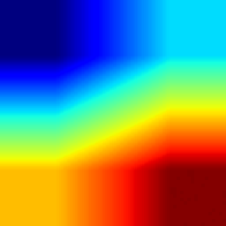 | 
W10 | PermanentCrop | AnnualCrop (93.3%) |  | 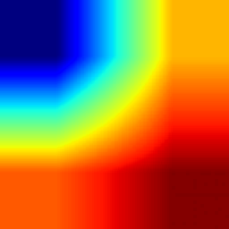 | 
Note: Grad-CAM on a 64 x 64 tile is coarse (the last MobileNetV2 block is 2 x 2 cells). In our control experiment, hiding the hottest 25% of a tile reduced confidence by 0.064, about the same as hiding the coldest 25% (0.061). Treat the heat maps as illustrations, not proof.

