**Bartender :**







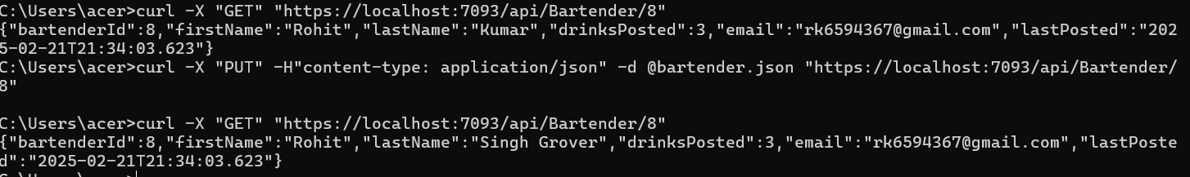



**Category:**



Screenshot 2025-02-21 165119.png





Screenshot 2025-02-21 171320.png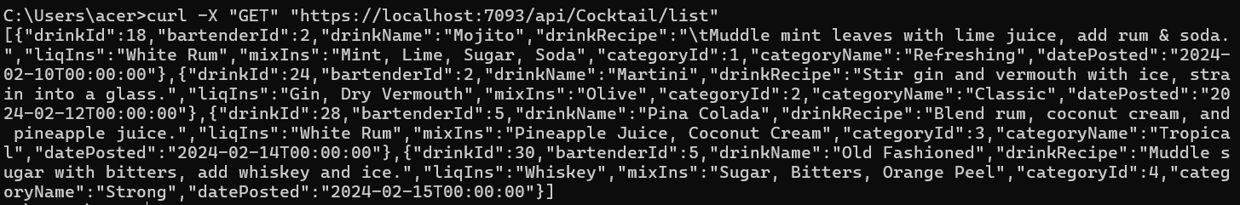

**Cocktail**





