PROJECT REPORT

On

**Learn2Earn**

Seventh Semester

Computer Science & Engineering

**SUBMITTED BY** **GUIDED BY**

Nitish Kumar Ms.Shilpi Gupta Ma’am

University RollNo.:20012004501

anangpuria

**DEPARTMENT OF COMPUTER SCIENCE AND ENGINEERING**

**B.S Anangpuria Institute of Technology & Management Alampur, Faridabad**

# DECLARATION

I hereby declare that the project entitled “**Learn2Earn**” submitted for the partial B.Tech. (CSE) degree is my original work and the project has not formed the basis for the award of any other degree, diploma, fellowship or any other similar titles.

Place: Faridabad

Date: **Signature**

**INDEX:-**

1. **Abstract.**
2. **Introduction.**
3. **Propose Methodlogy**
4. **Flowchart**
5. **Detailed Information**
6. **Results**
7. **Conclusion**
8. **Future Scope**
9. **Refrences**

**ABSTRACT**

* Learn2Earn is premium course selling platform where student can register themselves in order to upskill.
* This application is solution to for all course selling businesses in order to run their venture.
* It provides subscription based model for courses. It simply means that any learner with premium membership credential can access the course.
* It is MERN based web application which is fast in terms of response time.
* Main aim of this system is to provide facility to students that they learn couese easily without any problems that they face while going in the institute.

**Techstack**

**Node.js**

Node.js is an open-source server environment. Node.js is cross-platform and runs on Windows, Linux, Unix, and macOS. Node.js is a back-end JavaScript runtime environment. Node.js runs on the V8 JavaScript Engine and executes JavaScript code outside a web browser.

**Express.js**

Express.js, or simply Express, is a back end web application framework for building RESTful APIs with Node.js, released as free and open-source software under the MIT License. It is designed for building web applications and APIs. It has been called the de facto standard server framework for Node.js.

**React.js**

React is a free and open-source front-end JavaScript library for building user interfaces based on UI components. It is maintained by Meta and a community of individual developers and companies.

**MongoDB**

MongoDB is a source-available cross-platform document-oriented database program. Classified as a NoSQL database program, MongoDB uses JSON-like documents with optional schemas. MongoDB is developed by MongoDB Inc. and licensed under the Server Side Public License which is deemed non-free by several distributions.

**Tools Used**

**Visual Studio Code**

This is IDE which allow us to code efficiently.It provides access to terminal which

make development friendly environment . It has large set of useful extension which

reduces the pain of developer.

**MongoDB Compass**

This is an interactive tool for querying, optimizing, and analyzing your **MongoDB** data.

**POSTMAN**

Postman is an API platform for developers to design, build, test and iterate their APIs.

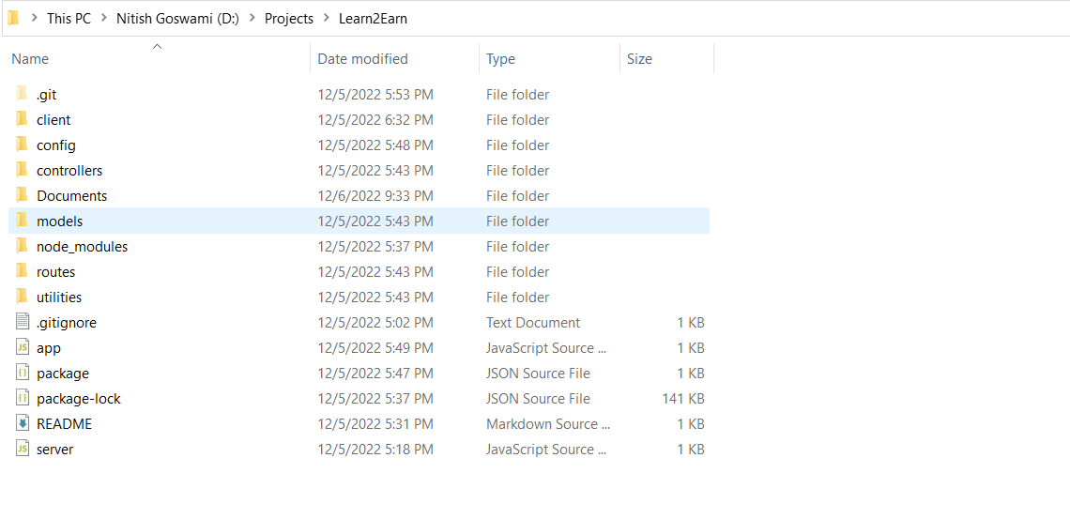

**Flowchart**

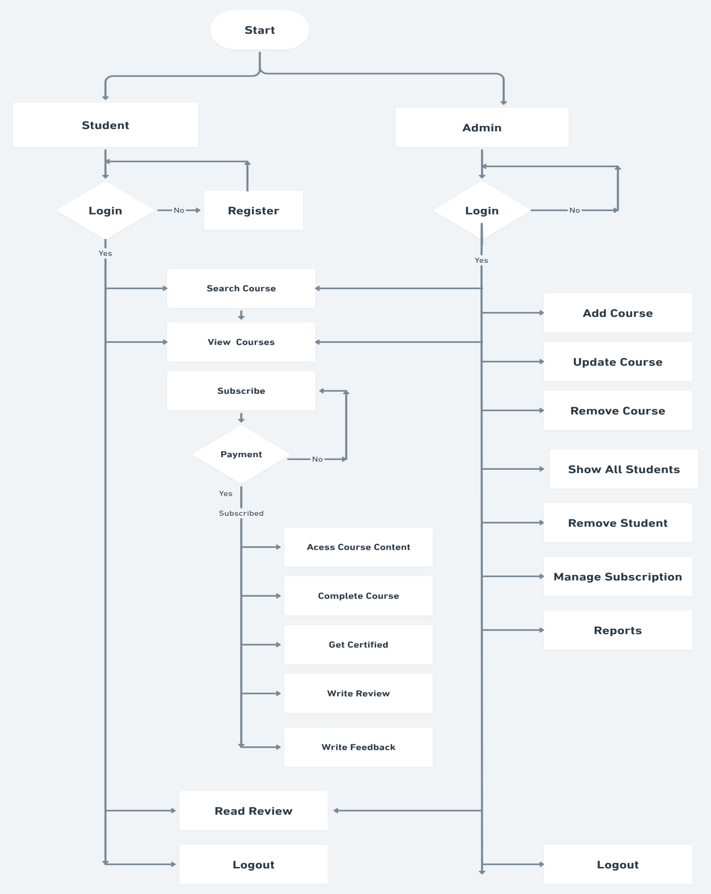

**Results**



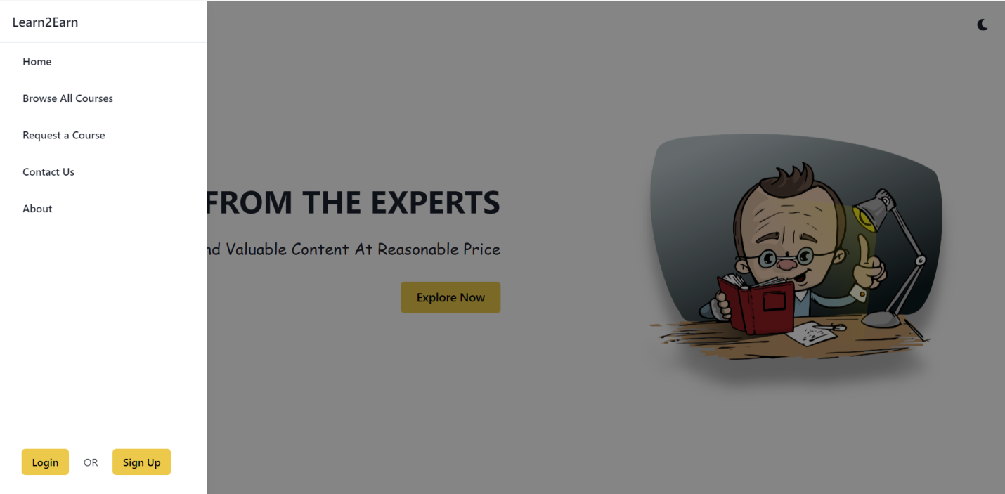

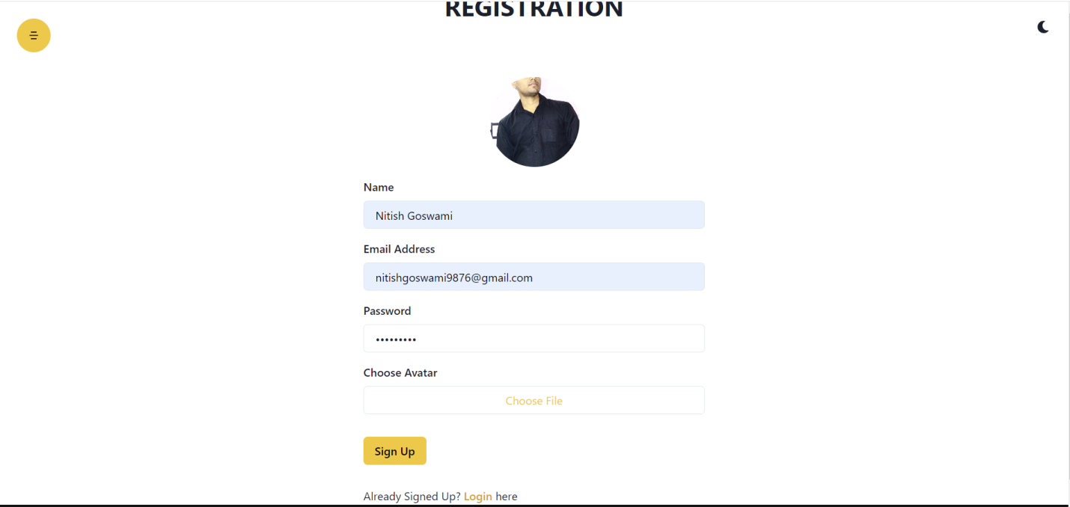

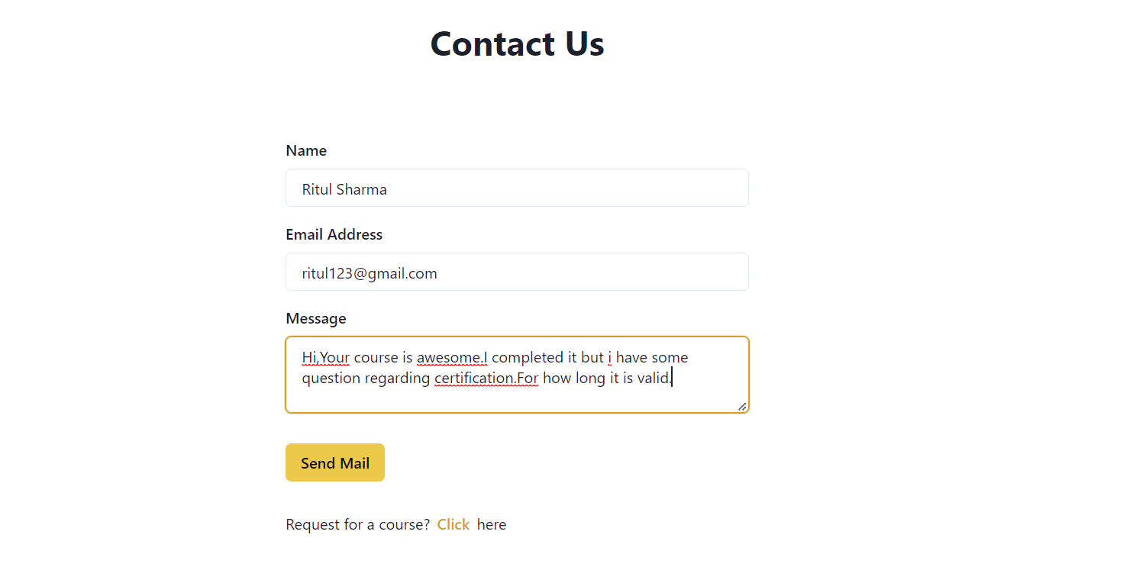

**References**

I learned all used technology through free resources available on internet.Mainly I followed official documentation for technology.

Other than this I used following resources in this project development

Journey

* [Stackoverflow](http://www.stackoverflow.com) (For doubt and error resolution)
* [Geeksforgeeks](https://www.geeksforgeeks.org/) (For understanding some concepts)
* [Pepcoding Web Dev. Course](https://www.youtube.com/watch?v=mrEcfu-ByDw&list=PL-Jc9J83PIiEeD3I4VXETPDmzJ3Z1rWb4) (For learning MERN stack)