ASSAM AI ROADWATCH
AI-Based Assam Road Health & Maintenance Prioritisation Platform
Concept / Technical Proposal Document
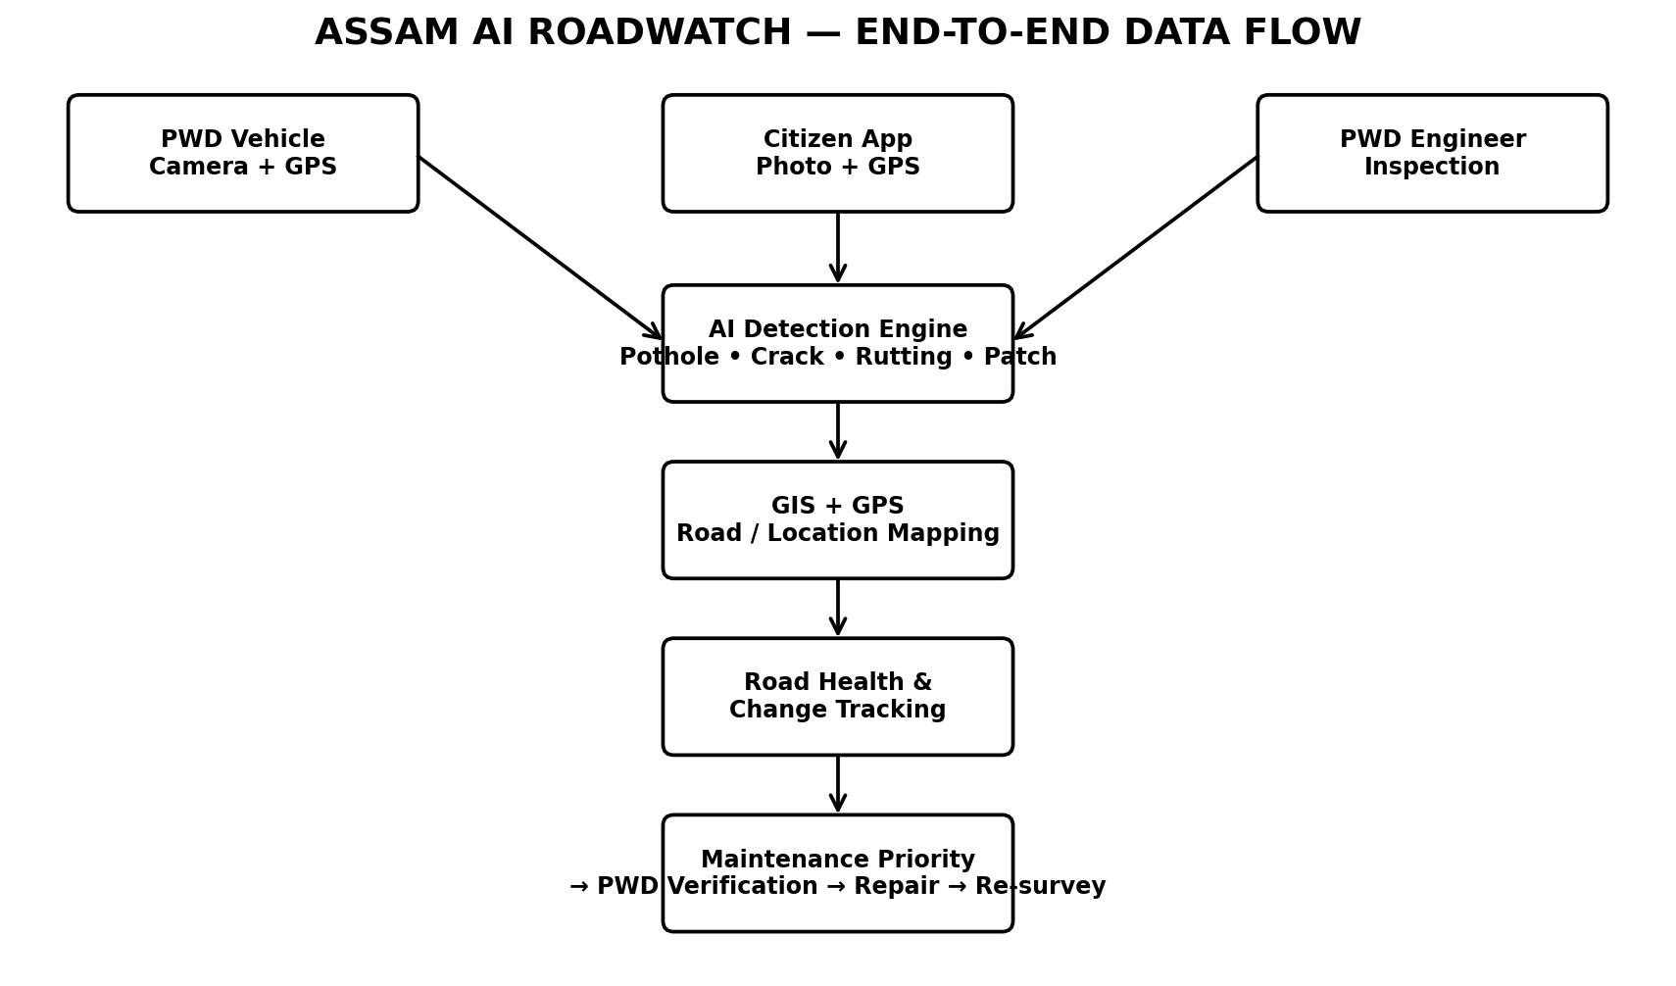

1. Executive Summary
Assam AI RoadWatch is an integrated road-condition intelligence platform combining AI-based road defect detection, GIS/GPS geolocation, citizen reporting, PWD vehicle surveys, engineer verification, road-health monitoring and maintenance prioritisation. The concept supports—not replaces—engineering judgement and departmental approval.

2. Core Concept
The platform should not be limited to a citizen pothole complaint application. Citizen reports are one input source. The core capability is continuous, repeatable road-condition surveying using PWD vehicles and/or survey cameras, followed by AI detection, geospatial mapping, historical comparison and maintenance workflow.

3. Proposed Data Sources
Source | Captured Information | Purpose
PWD survey vehicle | Video/images, GPS, timestamp, optional IMU | Systematic road inspection
Citizen app | Photo/video, GPS, timestamp, optional description | Additional evidence and local reporting
PWD engineer | Inspection result, severity/verification, remarks | Official verification and workflow

4. End-to-End Workflow

5. AI Detection
- Potholes
- Longitudinal/transverse cracks
- Rutting or surface deformation
- Patches / repaired areas
- Other configured road-surface distress categories
Each detection should retain model confidence, image/frame evidence, GPS coordinates, survey timestamp and model/version information. Confidence should be used as a review signal, not as an automatic engineering decision.

6. Citizen Reporting Workflow
- Citizen opens “Report Road Damage”.
- Camera captures road evidence.
- Mobile device requests location permission and records GPS.
- AI performs a preliminary image-quality and defect check.
- The report is stored with evidence and routed for review.
- Nearby/duplicate reports can be grouped with an existing defect record.

7. Duplicate and Same-Defect Tracking
Use GPS proximity, road segment, time window and visual similarity to associate multiple reports with one defect record. This supports a defect life cycle such as PTH-102: first detection → repeat detection → repair → post-repair verification.

8. Road Health and Change Tracking
Roads can be divided into configurable segments. Segment indicators can include defect count, defect density, severity distribution, historical condition and rate of change. A Road Health Index may be implemented as a configurable engineering-supported indicator; its formula should be validated with PWD rather than presented as an official standard.
Road Segment | Defects | Illustrative Health | Illustrative Priority
NH-27 Segment A | 5 | 86/100 | Low
NH-27 Segment B | 21 | 61/100 | Medium
NH-27 Segment C | 48 | 32/100 | High
NH-27 Segment D | 71 | 18/100 | Critical
Illustrative values only; not official PWD scores.

9. Maintenance Prioritisation Workflow
AI Detection → GIS Location → Verified Severity → Historical Deterioration → Road Importance → Priority → PWD Verification → Maintenance → Re-survey.

10. Evidence Pack
Each defect should provide road/segment, coordinates, detection date, defect type, confidence, image/video evidence, previous observations, citizen reports, PWD inspections, verification status, maintenance status and audit history.

11. Four Main Portals
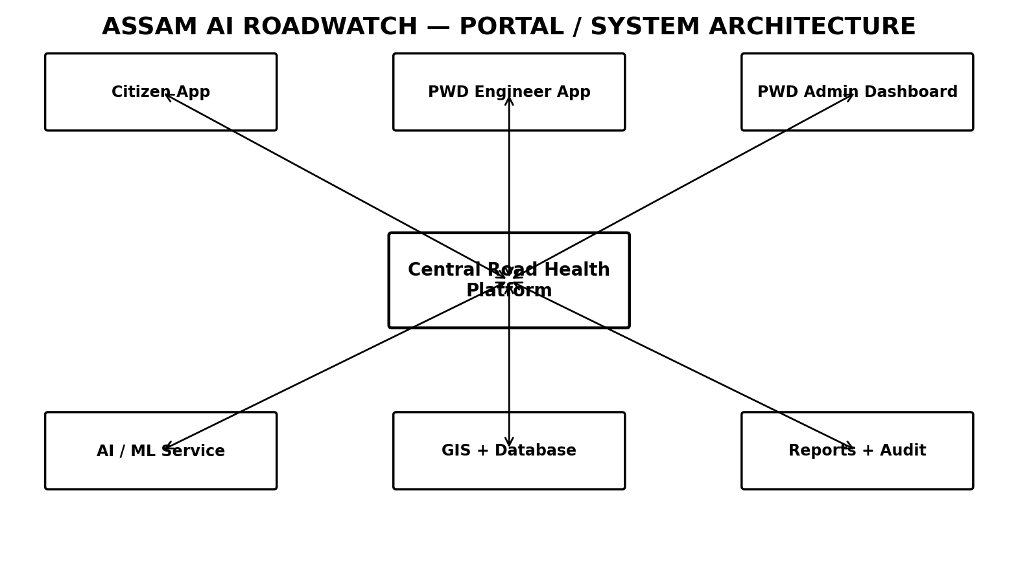
Portal | Main Functions
Citizen App | Report damage, capture evidence, GPS, report tracking
PWD Engineer App | Road survey, inspection, verification, field remarks
PWD Admin Dashboard | GIS map, defects, road health, priorities, maintenance reports
Super Admin | Users, divisions/circles/roads, configuration, AI model settings, audit logs

12. Suggested Technical Architecture
- Frontend: React / Next.js web dashboard; Android/iOS or cross-platform citizen/engineer app.
- Backend: Spring Boot or equivalent REST service.
- Database: PostgreSQL + PostGIS (recommended for geospatial workloads) or an approved government database stack.
- Media: S3-compatible object storage for evidence images/videos.
- AI: Python inference service using a trained object-detection/segmentation model.
- Maps: Government-approved GIS basemap/services; road inventory should remain the authoritative source.
- Security: RBAC, audit logs, encrypted transport, controlled media access and secure API authentication.

13. Core Data Entities
- Road
- Road Segment
- Defect
- Survey
- Survey Evidence
- Citizen Report
- Defect Observation
- Maintenance Action
- User / Role
- AI Model Version
- Audit Log

14. Recommended MVP
- Citizen photo + GPS reporting
- PWD vehicle image/video upload with GPS
- AI pothole and crack detection
- GIS defect map
- Engineer verification workflow
- Duplicate report grouping
- Road-segment dashboard
- Basic historical comparison
- Evidence pack and downloadable reports

15. Future Enhancements
- Automated frame extraction from survey video
- Same-defect visual matching
- Pavement distress severity estimation
- Offline-first field inspection mode
- Road-risk analytics
- Integration with existing road inventory / asset-management systems
- Maintenance work-order and contractor workflow
- Before/after repair verification
- Model monitoring and periodic re-training using verified field data

16. Key Benefits
- Faster and more consistent road-condition surveillance
- Geospatially traceable evidence
- Single view of citizen and departmental observations
- Historical deterioration tracking
- Reduced duplicate reporting
- Evidence-supported maintenance planning
- Better visibility for engineers and administrators
- Foundation for continuous road asset management

17. Governance and Engineering Controls
The system should preserve human review for official defect verification, severity confirmation, maintenance prioritisation and repair closure. AI outputs should be traceable to the model version and source evidence. Road inventory and engineering classifications should follow departmental authoritative data and approved standards.

18. Proposed Demonstration Scenario
For a challenge demo, show one survey route with several defects, one citizen report near a detected pothole, automatic duplicate grouping, a GIS map, a defect evidence pack, a historical change view, engineer verification, and a post-maintenance re-survey.

19. Conclusion
Assam AI RoadWatch positions AI as an intelligence layer over road inspection and asset-management workflows. Its distinguishing value is the combination of systematic survey data, citizen evidence, GIS, repeat observations, defect life-cycle tracking and engineer-controlled maintenance planning.
Prepared as a concept / technical proposal — September 2026

