Pre-request:

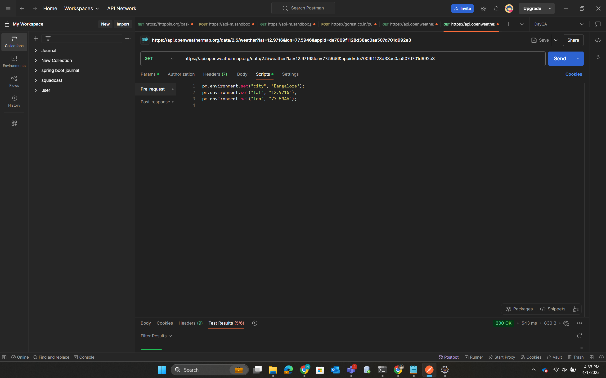

Post-response:

Tests:

