**Fall-2020 Semester**

**Semester**



Submitted by:

Nitish Jaswal (300181850)

BCIS, 2020

Date of Submission:

19-11-2020

Due Date of Submission:

19-11-2020

Submitted to:

Prof. Siddhartha Shyam Vyas

**COMP 155 (Object-Oriented Programming)**

**Java Coding**

**Assignment3**

Table of Contents

CERTIFICATE OF ORIGINALITY i

ACKNOWLEDGEMENT ii

COMPANY OVERVIEW & COMPANY INTERACTIONS iii

1. WAP to declare and initialize a 1-D array and then print it along with their positions / indexes. 1

2. WAP to read a 1-D integer array, printing the array elements with their indexes / positions. Also find the sum of array elements and print the sum: 1

3. WAP to read a 1-D integer array, find maximum element in an array and print it: 1

4. WAP to read two 1-D integer arrays (A[] and B[]) and then merge both in third 1-D integer array (C[]). Then print the third array - C[]. 1

5. WAP to take string as a user input. Use a pre-defined function to convert it to a character array and print that character array. 1

6. WAP to take string as a user input. Then find a maximum character in a string and then print it.: 1

7. WAP to take string as a user input. Then convert it into a 1-D character array without the use of pre-defined function. Then print the reversed character array. 1

8. WAP to take string as a user input, then print the string, then print the characters of string in descending order. 1

9. WAP to count the number of words present in a line. 1

Q10. Write a program to check if a string is palindrome or not.. 1

Q11. Write a program to convert a string to proper case, that is, to capitalize first letter of each word of the string. For example: If the string is: siddhartha shyam vyas, it should output it as: Siddhartha Shyam Vyas 1

Q12. WAP to prfrom a LINEAR SEARCH technique on 1-D integer array. If search successful, then print it else print Search Unsuccessful! 1

Q13. WAP to perfrom a BINARY SEARCH technique on 1-D integer array. If search successful, then print it else print Search Unsuccessful! 1

Q14 WAP to perform SELECTION SORT technique on 1-D integer array. 1

Q15 WAP to perform BUBBLE-SORT technique on 1-D integer array. 1

References 12

# CERTIFICATE OF ORIGINALITY

I hereby declare that:

* I have used my own words
* I have not copied
* I have not plagiarized
* I have cited all the sources from where I have adapted / sourced.

**Nitish Jaswal (300181850)**

**Signature**



# ACKNOWLEDGEMENT

**I want to express my profound gratefulness to Prof. Siddhartha Shyam Vyas, Ph.D**

**Nitish Jaswal (300181850)**

**Signature**



# COMPANY OVERVIEW & COMPANY INTERACTIONS

**Professional Name:** Mr. Himanshu Gusain

**Position:** Freelancer

**The platform of Interaction:** Over WhatsApp messaging app

**Contact :** email – himanshugsn30@gmail.com

Ph no- +91 8800950205

**The Interaction is as follow**:

**Que 1:What framework do you use ?**

Reply:

Well, I am a ruby on rails web developer, currently freelancing, other than that I have worked with coding ninjas.

**Que 2: What is ruby on rails, and how you reachout to clients and manage your code ?**

Reply:

Well, The Rails framework helps developers to build websites and applications, sometimes I go for client hunting online , looking for small businesses whose webstie has security, or User interface flaws and call them directly and tell them that I can improve their website, other than that I do bid on the freelancing websites for the ads posted there, and the organization of code is done on the hosting website, I normally suggest hostinger, however I do use git version control sometimes if the web application has too many devlopment phases.

**Que3: Do you use java as developer?**

Reply:

Yes, I do , sometimes clients ask for a android app to be developed, so I use java for that purpose , however iam shifting toward kotlin , as there not much performace difference between the two languages.

**Que4: Why do you freelance instead of working for a specific company ?**

Ans – what most of the web or mobile application development companies do is that they take contract work in India and assign those projects to employees, so the company takes some part of the money on the application you develop, also sometimes you don’t even get assigned a project. So freelancing increases your knowledge and removes the middleman, if you are a good communicator you can get projects as freelancer easily.

**Professional Name:** Mr. Akshay Tyagi

**Company Name – NorthCorpSoftware**

**Company Overview-**

A delhi based firm which help business automate and make their practices more efficient with help of new technologies like IoT

They serve in telecommunication industry, automobile industry and Fast-Moving Consumer Goods firms

**Position:** Software Developer

**The platform of Interaction:** Instagram chat

**Contact :** email – [akshaytyagi@north.tech](mailto:akshaytyagi@north.tech)

Github - <https://github.com/akshay20t>

**The Interaction is as follow**:

**Que 1: What technologies you have worked on?**

I have worked with framework such as Django and CherryPy for python, and even at work I use these technologies, our company has setup its database connection , with Django ORM.

**Que 2:** **Have you done any system design from scratch?**

Yes, I have developed Database Interface to acces and manipulate database based on python GUI. It is developed using pymysql and tkinter modules. You can see my projects on my github.

# WAP to declare and initialize a 1-D array and then print it along with their positions / indexes.

**FORM 1 : Acc to Que**

public class Que1{

//main function

public static void main(String[] args) {

//creating array and initializing it

int a[] = {10,11,22,13,14,15};

//printing array element with index

for(int i=0; i<a.length; ++i){

System.out.println("at index "+i+" element is :"+a[i]);

}

}

}

**OUTPUT:**

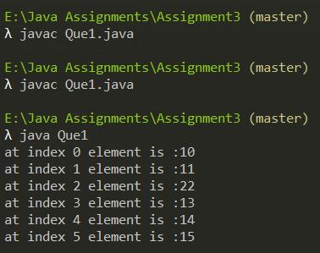

DrawBacks\Improvements -

* Handling Exceptions
* Refactoring the program to make it more adaptive and organized.
* Refractoring would include
  + For keeping our program running
  + creating seprate function for inputting
  + Creating seprate function to convert the string to character array
  + For outputing the output that is our array
  + For Reading multiple input from the file
  + For permanently stroing our output In a file
* Other than refractoring we can Pass many inputs through a CSV ( comma seprated file) is possible and it is good to have huge input processing in program so that user can use a data file to input
* For our analysis we can check the execution time of the program

**Note- we have also used CurrentTime method in System class to measure our execution time**

**Proposed Algorithm**

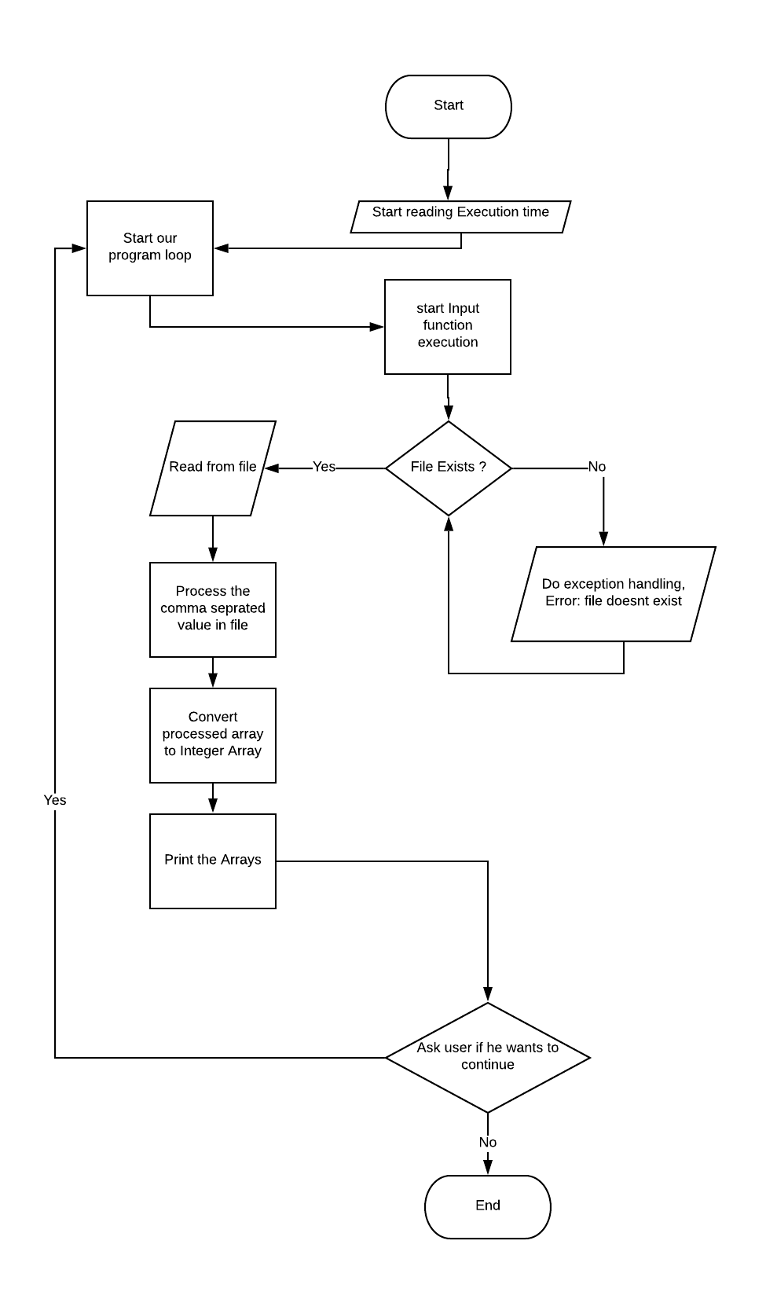

FORM 2: Modified

import java.util.*;//imported util classes for Scanner class

import java.io.*;

public class Que1{

//creting a global static object to scanner class

public static Scanner sc = new Scanner(System.in);

public static Que1 obj = new Que1();

//main function

public static void main(String[] args) {

//Start time

long start = System.currentTimeMillis();

obj.cont(start);

}

public void cont(long start){

int ex=1;

do{

obj.input();

long finish = System.currentTimeMillis();

System.out.println("Time consumed: " + (finish - start) + " ms");

System.out.println("\nDo you want to continue?1.Yes 2.No");

ex=sc.nextInt();

}while(ex==1);

}

public void input(){

try{

File myObj = new File("test.txt");

Scanner myReader = new Scanner(myObj);

while (myReader.hasNextLine()) {

String data = myReader.nextLine();

System.out.print(data);

obj.convertToArray(data);

}

}

catch(IOException|ArrayIndexOutOfBoundsException e){

System.out.println("Either one of the input in file is not correct format or The file doesn't exist!!");

}

}

public void convertToArray(String str){

//seprating our file input into comma seprated array

String[] parts = str.split(",");

int len= parts.length;

//declaring our character array

int[] parsedArry = new int[len];

//filtering the integers in the string with comma sepration

// that is 1 , 2 , 3

for(int i =0; i < len; i++)

{

parsedArry[i] = Integer.parseInt(parts[i]);

}

System.out.print("\nThe Array is : "+ Arrays.toString(parsedArry));

obj.out(parsedArry);

}

public void out(int[] arry){

try{

//initilized file writer method to pass true value to append the output

FileWriter myWriter = new FileWriter("E:\\Java Assignments\\Assignment3\\Output.txt",true);

myWriter.write("\n The Array is : "+ Arrays.toString(arry));

myWriter.close();

System.out.println("Successfully wrote to Output.txt");

}

catch (IOException e) {

System.out.println("An error occurred while writing");

}

}

}

COMPLEXITY

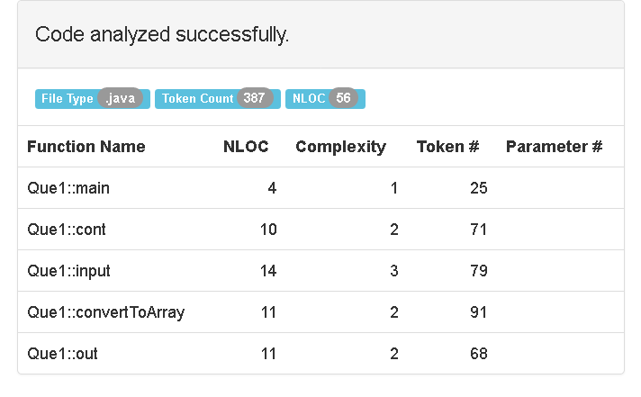

OUTPUT

Text File

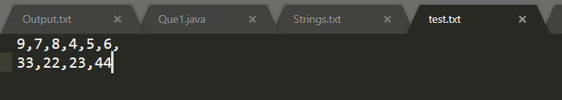

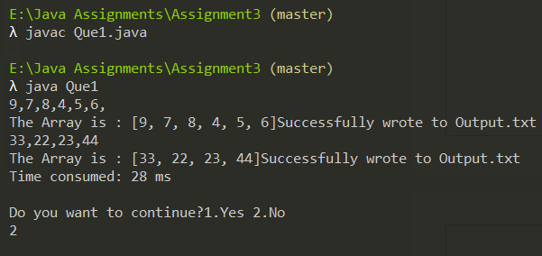

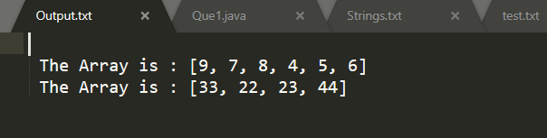



**Drawback**

* **The buffer crashes when the input is larger from the file or there are many inputs , and just throws the exception of TypeMismatch**

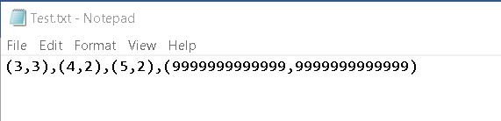

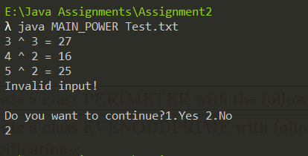

Exception Thrown, However our program didn’t crash which is a good thing, now we handle this issue

**So now we have to improve our current program flow , and data types to handle the large input.**

**NOTE:- For this purpose we are going to use BIGINTEGER class, which can take huge inputs and process them.  
This will make us to do changes in both of our classes as doing arithemetic with biginteger is totally different than doing it with other data types.**

**FORM 3:- Handling larger Inputs**

import java.util.*;

import java.io.*;

import java.math.BigInteger;

public class MAIN_POWER{

public static void main(String[] args) {

//creating obj of scanner class for input

Scanner sc = new Scanner(System.in);

int ex=0;

Our Big Integer variables, we don’t need to initialize them as the class itself does that

BigInteger N,PWR;

do

{

try{

File file = new File(args[0]);

Scanner fs = new Scanner(file);

fs.useDelimiter("\\D+");

while(fs.hasNext()){

Passed them to class constructor

N = fs.nextBigInteger();

PWR = fs.nextBigInteger();

POWER pw = new POWER(N,PWR);

System.out.println(N+" ^ "+PWR+" = "+pw.COMPUTE_POWER());

}

}

catch(InputMismatchException|FileNotFoundException e){

System.out.println("Invalid input!");

}

sc.nextLine();

//asking user if he want to continue

System.out.println("Do you want to continue?1.Yes 2.No");

ex=sc.nextInt();

}while(ex==1);

Note major changes in our POWER class

}

}

class POWER{

private static BigInteger COUNTER,NUM; //declared counter var

//constructor to initialize members

public POWER(BigInteger N,BigInteger PWR){

NUM = N;

COUNTER = PWR;

}

Assigned to the class members,

Note: you might have noticed we have not changed our class members from being static, that is because BigInteger already assigns a huge size of memory in regard to input size so by making our static we save some memory

public BigInteger COMPUTE_POWER(){

BigInteger num=NUM; //storing the value of number

Used equals method to check if the counter is not equal to one

//loop to compute power

BigInteger.ONE , is member of BigInteger class which contain the value 1

while(!COUNTER.equals(BigInteger.ONE)){

NUM=num.multiply(NUM);

COUNTER = COUNTER.subtract(BigInteger.ONE);

**NOTE  
We cant use Increament and Decreament operators with BigIntegers , so there is subtract method for it**

}

//returning the result to main

return NUM;

}

}

OUTPUT

TEXT Input file -

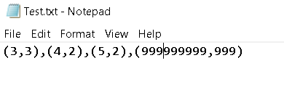

**NOTE - the BIGINTEGER can handle the input large enough in our drawback section, however my computer memory and processing power was not enough to handle such a large input base, further it nearly froze my computer.**

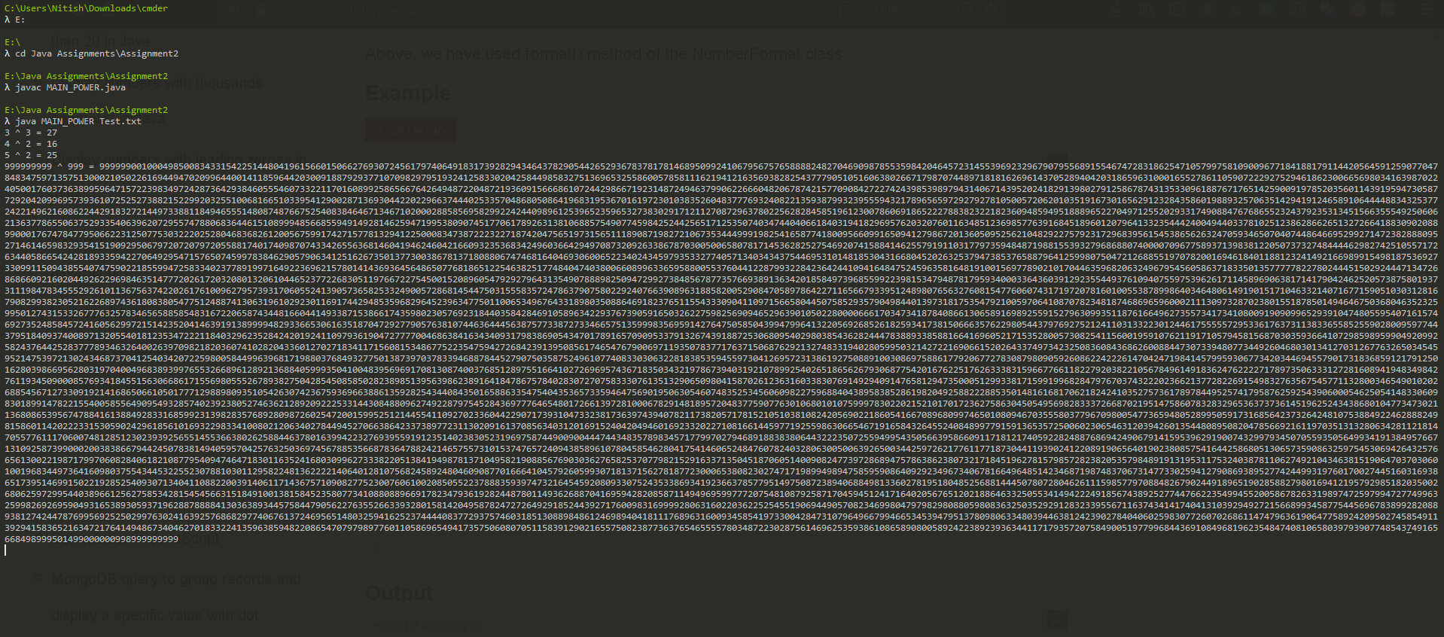 Note – Please Zoom in to see clear output

**NOTE**

**There is still one big drawback our huge output so we format it to scientific notation by adding following code. So what we are doing is using Formatter class in text package to convert our number format into decimal scientific notation that is “0.######E0”   
The statement “**DecimalFormatSymbols.getInstance(Locale.ROOT)**”Returns an array of all locales for which the getInstance methods of this class can return localized instances.**

import java.math.BigDecimal;

Imported our classes

import java.text.NumberFormat;

import java.text.DecimalFormat;

import java.text.DecimalFormatSymbols;

Storing our huge output to string and formatting it

---- code similar ---

//for formatting our huge output

NumberFormat formatter = new DecimalFormat("0.######E0", DecimalFormatSymbols.getInstance(Locale.ROOT));

String str = formatter.format(pw.COMPUTE_POWER());

System.out.println(N+" ^ "+PWR+" = "+str);

**OUTPUT –**

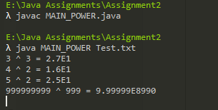

We have formatted our huge output

Got this output on scientific calculator which is similar to ours how ever the formatting of decimal precision is more

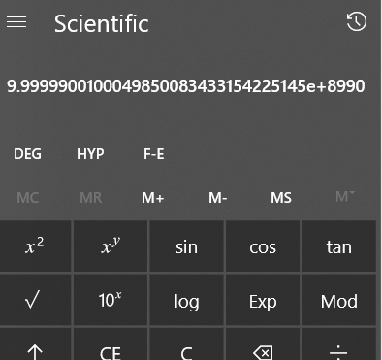

# WAP to read a 1-D integer array, printing the array elements with their indexes / positions. Also find the sum of array elements and print the sum:

**Form1:**Acc to Que

import java.util.*;//imported for scanner class

public class Que2{

//created static scanner object

public static Scanner sc = new Scanner(System.in);

public static void main(String[] args) {

//get array size

System.out.println("Enter The length of the array: ");

int length = sc.nextInt();

//declaring array and sum

int a[] = new int[length];

int sum =0;

//inputting array

for(int i=0; i<length; ++i){

a[i] = sc.nextInt();

}

//adding elements and printing

for(int i=0; i<length; ++i){

System.out.println("at "+i+" element is :"+a[i]);

sum+=a[i];

}

//printing the sum

System.out.println("Sum of the elements of array :"+sum);

}

}

**OUTPUT:**

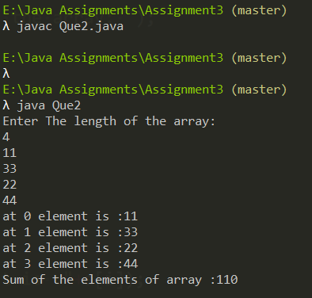

DrawBacks\Improvements -

* Handling Exceptions
* Refactoring the program to make it more adaptive and organized.
* Refractoring would include
  + For keeping our program running
  + creating seprate function for inputting
  + Creating seprate function to convert the string to character array
  + For outputing the output that is our array
  + Finding sum
  + For Reading multiple input from the file
  + For permanently stroing our output In a file
* Other than refractoring we can Pass many inputs through a CSV ( comma seprated file) is possible and it is good to have huge input processing in program so that user can use a data file to input
* For our analysis we can check the execution time of the program

**Note- we have also used CurrentTime method in System class to measure our execution time**

**Proposed Algorithm**

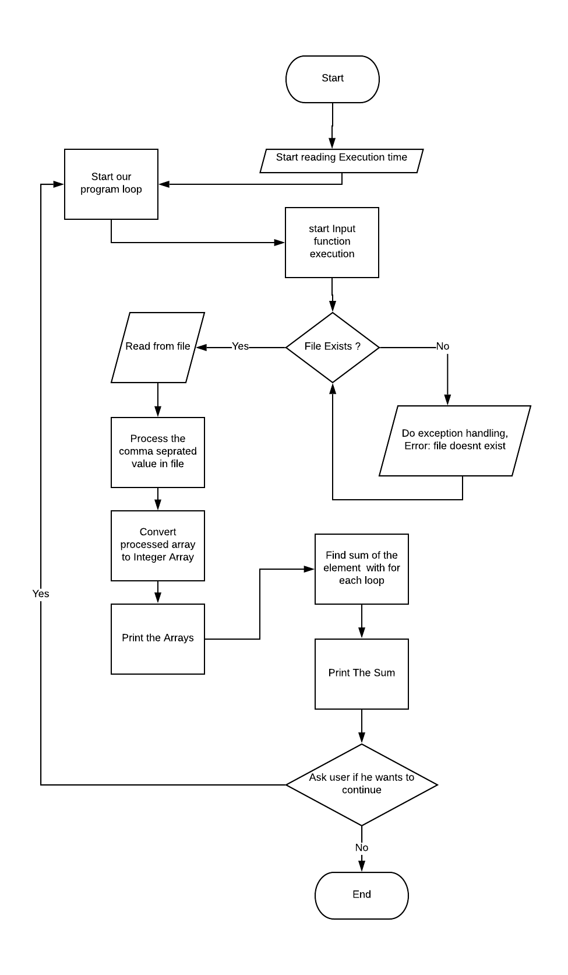

Form 2 - Modified

//WAP to read a 1-D integer array, printing the array elements with their indexes / positions. Also find the sum of array elements and print the sum.

import java.util.*;//imported for scanner class

import java.io.*;

public class Que2{

//created static scanner object

public static Scanner sc = new Scanner(System.in);

public static Que2 obj = new Que2();

public static void main(String[] args) {

//Start time

long start = System.currentTimeMillis();

obj.cont(start);

}

public void cont(long start){

int ex=1;

do{

obj.input();

long finish = System.currentTimeMillis();

System.out.println("Time consumed: " + (finish - start) + " ms");

System.out.println("\nDo you want to continue?1.Yes 2.No");

ex=sc.nextInt();

}while(ex==1);

}

public void input(){

try{

File myObj = new File("test.txt");

Scanner myReader = new Scanner(myObj);

while (myReader.hasNextLine()) {

String data = myReader.nextLine();

System.out.print(data);

obj.convertToArray(data);

}

}

catch(IOException|ArrayIndexOutOfBoundsException e){

System.out.println("Either one of the input in file is not correct format or The file doesn't exist!!");

}

}

public void convertToArray(String str){

//seprating our file input into comma seprated array

String[] parts = str.split(",");

int len= parts.length;

//declaring our character array

int[] parsedArry = new int[len];

//filtering the integers in the string with comma sepration

// that is 1 , 2 , 3

for(int i =0; i < len; i++)

{

parsedArry[i] = Integer.parseInt(parts[i]);

}

System.out.println("\nThe Array is : "+ Arrays.toString(parsedArry));

int sum = obj.sum(parsedArry);

System.out.println("The sum of the elemens is: "+sum);

obj.out(parsedArry,sum);

}

public int sum(int[] arry){

int sum = 0;

for(int i=0; i<arry.length; ++i){

System.out.println("at "+i+" element is :"+arry[i]);

sum+=arry[i];

}

return sum;

}

public void out(int[] arry,int sum){

try{

//initilized file writer method to pass true value to append the output

FileWriter myWriter = new FileWriter("E:\\Java Assignments\\Assignment3\\Output.txt",true);

myWriter.write("\n The Array is : "+ Arrays.toString(arry)+" and the sum of elements is: "+sum);

myWriter.close();

System.out.println("Successfully wrote to Output.txt");

}

catch (IOException e) {

System.out.println("An error occurred while writing");

}

}

}

Complexity

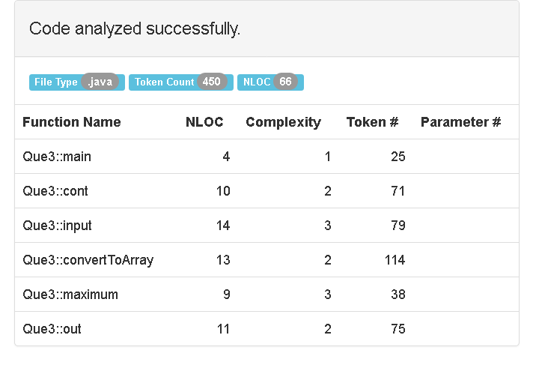

**OUTPUT**

Text File

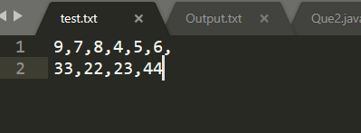

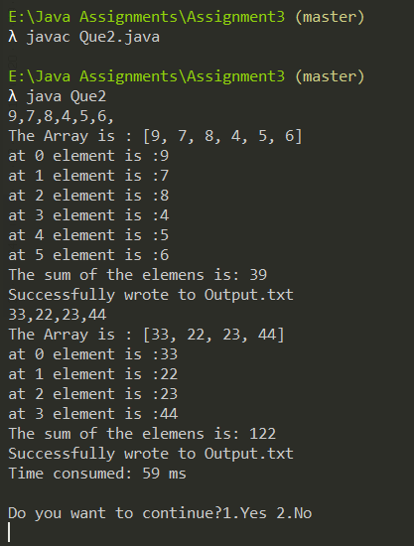

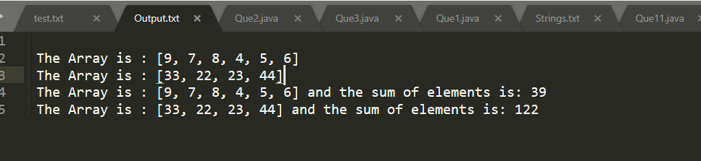



# WAP to read a 1-D integer array, find maximum element in an array and print it:

FORM 1: Acc to Que

import java.util.*; //importing scanner class

public class Que3{

//creating static global object for scanner

public static Scanner sc = new Scanner(System.in);

public static void main(String[] args) {

System.out.println("Enter the length of the array: ");

int length = sc.nextInt();

//declaring array and creating max variable

int a[] = new int[length];

int MAX = 0;

System.out.println("Enter the array: ");

//inputting array

for(int i=0; i<length; ++i){

a[i] = sc.nextInt();

}

//running for each loop to compare elements

for (int i:a) {

if(i>MAX){

MAX = i;

}

}

System.out.println("The maximum in the array is :"+MAX);

}

}

**OUTPUT:**

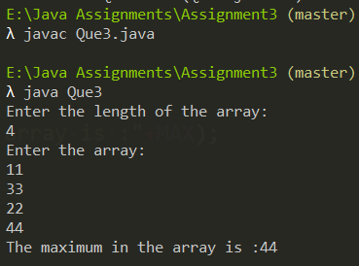

DrawBacks\Improvements -

* Handling Exceptions
* Refactoring the program to make it more adaptive and organized.
* Refractoring would include
  + For keeping our program running
  + creating seprate function for inputting
  + Creating seprate function to convert the string to Integer array
  + For outputing the output that is our array
  + Finding maximum in array
  + For Reading multiple input from the file
  + For permanently stroing our output In a file
* Other than refractoring we can Pass many inputs through a CSV ( comma seprated file) is possible and it is good to have huge input processing in program so that user can use a data file to input
* For our analysis we can check the execution time of the program

**Note- we have also used CurrentTime method in System class to measure our execution time**

**Proposed Algorithm**

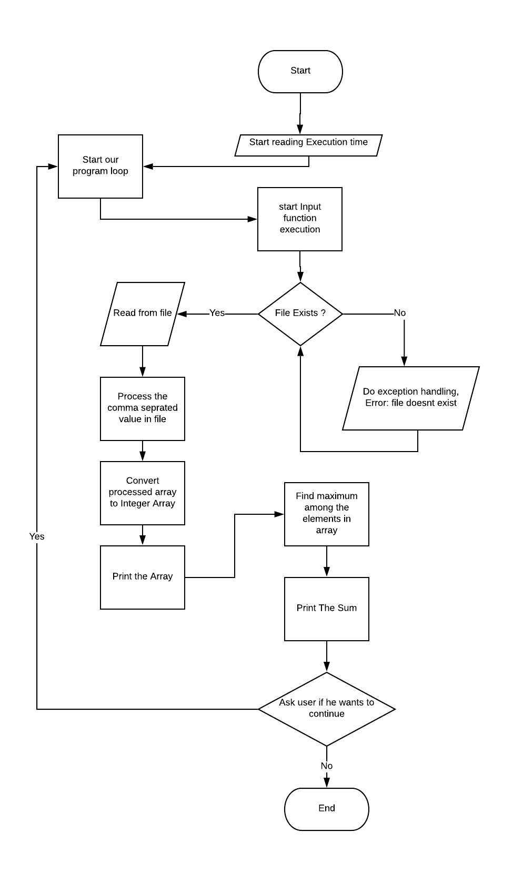

FORM 2: Modified

import java.util.*; //importing scanner class

import java.io.*; //importing io for file input output methods

public class Que3{

//creating static global object for scanner

public static Scanner sc = new Scanner(System.in);

public static Que3 obj = new Que3();

public static void main(String[] args) {

//Start time

long start = System.currentTimeMillis();

obj.cont(start);

}

public void cont(long start){

int ex=1;

do{

obj.input();

long finish = System.currentTimeMillis();

System.out.println("Time consumed: " + (finish - start) + " ms");

System.out.println("\nDo you want to continue?1.Yes 2.No");

ex=sc.nextInt();

}while(ex==1);

}

public void input(){

try{

File myObj = new File("test.txt");

Scanner myReader = new Scanner(myObj);

while (myReader.hasNextLine()) {

String data = myReader.nextLine();

System.out.print(data);

obj.convertToArray(data);

}

}

catch(IOException|ArrayIndexOutOfBoundsException e){

System.out.println("Either one of the input in file is not correct format or The file doesn't exist!!");

}

}

public void convertToArray(String str){

//seprating our file input into comma seprated array

String[] parts = str.split(",");

int len= parts.length;

//declaring our character array

int[] parsedArry = new int[len];

//filtering the integers in the string with comma sepration

// that is 1 , 2 , 3

for(int i =0; i < len; i++)

{

parsedArry[i] = Integer.parseInt(parts[i]);

}

System.out.println("\nThe Array is : "+ Arrays.toString(parsedArry));

int max = obj.maximum(parsedArry);

System.out.println("The greatest elemens is: "+max);

obj.out(parsedArry,max);

}

public int maximum(int[] arry){

int MAX = 0;

for (int i:arry) {

if(i>MAX){

MAX = i;

}

}

return MAX;

}

public void out(int[] arry,int max){

try{

//initilized file writer method to pass true value to append the output

FileWriter myWriter = new FileWriter("E:\\Java Assignments\\Assignment3\\Output.txt",true);

myWriter.write("\n The Array is : "+ Arrays.toString(arry)+" and the greatest among elements is: "+max);

myWriter.close();

System.out.println("Successfully wrote to Output.txt");

}

catch (IOException e) {

System.out.println("An error occurred while writing");

}

}

}

**COMPLEXITY**

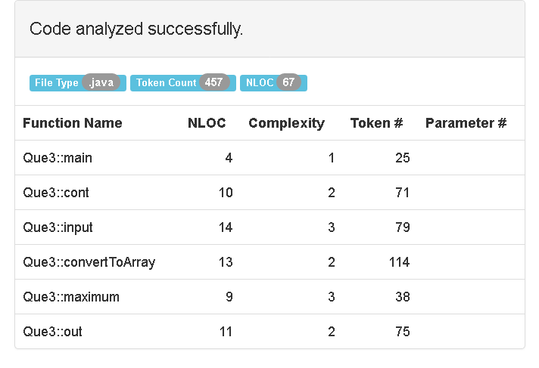

**OUTPUT:**

Text File

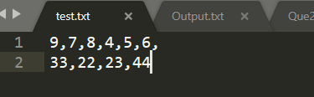

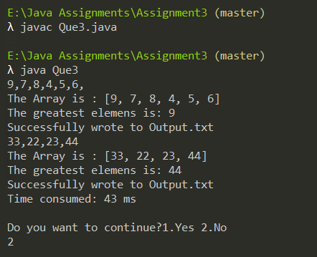

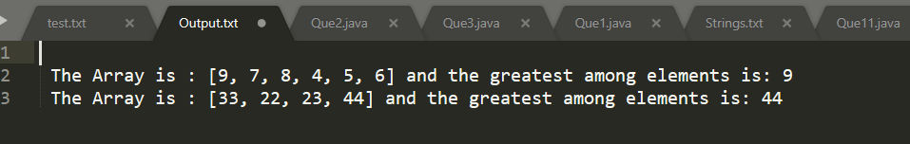



# WAP to read two 1-D integer arrays (A[] and B[]) and then merge both in third 1-D integer array (C[]). Then print the third array - C[].

FORM 1: acc to que

import java.util.*; //importing scanner class

public class Que4{

//creting a global static object to scanner class

public static Scanner sc = new Scanner(System.in);

public static void main(String[] args) {

//inputting length

System.out.println("Enter Length of the first array :");

int len1 = sc.nextInt();

//declaring array

int a[] = new int[len1];

//inputting first array

System.out.println("Enter the first array :");

for(int i=0; i<len1; ++i){

a[i] = sc.nextInt();

}

//inputing second array

System.out.println("Enter Length of the second array :");

int len2 = sc.nextInt();

int b[] = new int[len2];

int sum =0;

System.out.println("Enter the second array :");

for(int i=0; i<len2; ++i){

b[i] = sc.nextInt();

}

//creating third array

int c[] = new int[len1+len2];

//pos variable to keep track of position in the merging array

int pos = 0;

//adding first array A to C

for (int i: a) {

c[pos] = i;

pos++;

}

//Adding second array B to C

for(int i:b){

c[pos] = i;

pos++;

}

//printing combined array

System.out.println("Combined Array is : ");

for(int i=0; i<len1+len2; ++i){

System.out.print(c[i]+" | ");

}

}

}

OUTPUT**:**

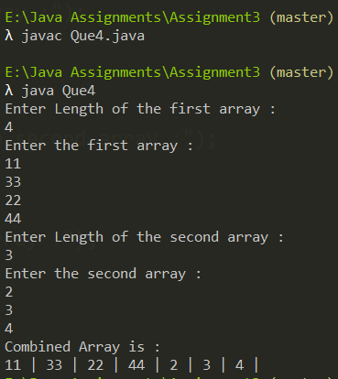

DrawBacks\Improvements -

* Handling Exceptions
* Refactoring the program to make it more adaptive and organized.
* Refractoring would include , having methods for-
  + For keeping our program running
  + creating seprate function for inputting
  + Creating seprate function to convert the string to integer array
  + For outputing both the arrays to be combined
  + For combining the arrays
  + For Reading multiple input from the file
  + For permanently stroing our output In a file
* Other than refractoring we can Pass many inputs through a CSV ( comma seprated file) is possible and it is good to have huge input processing in program so that user can use a data file to input
* For our analysis we can check the execution time of the program

**Note- we have also used CurrentTime method in System class to measure our execution time**

**Proposed Algorithm**

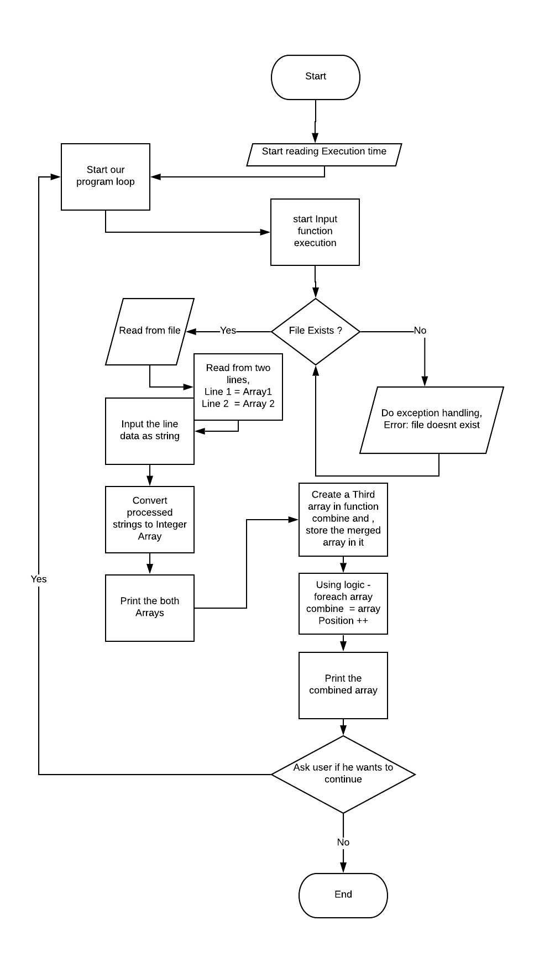

Form 2 - Modified

import java.util.*; //importing scanner class

import java.io.*;

public class Que4{

//creting a global static object to scanner class

public static Scanner sc = new Scanner(System.in);

public static Que4 obj = new Que4();

public static void main(String[] args) {

//Start time

long start = System.currentTimeMillis();

obj.cont(start);

}

public void cont(long start){

int ex=1;

do{

obj.input();

long finish = System.currentTimeMillis();

System.out.println("Time consumed: " + (finish - start) + " ms");

System.out.println("\nDo you want to continue?1.Yes 2.No");

ex=sc.nextInt();

}while(ex==1);

}

public void input(){

int lineindex =0;

try{

File myObj = new File("test.txt");

Scanner myReader = new Scanner(myObj);

while (myReader.hasNextLine()) {

String data1 = myReader.nextLine();

String data2 = myReader.nextLine();

System.out.print("["+data1+"]"+" "+"["+data2+"]\n");

obj.convertToArray(data1,data2);

lineindex++;

}

}

catch(IOException|ArrayIndexOutOfBoundsException e){

System.out.println("Either one of the input in file is not correct format or The file doesn't exist!!");

}

}

public void convertToArray(String str1, String str2){

//seprating our file input into comma seprated array

String[] parts1 = str1.split(",");

String[] parts2 = str2.split(",");

int len1= parts1.length;

int len2= parts2.length;

//declaring our character array

int[] parsedArry1 = new int[len1];

int[] parsedArry2 = new int[len2];

//filtering the integers in the string with comma sepration

// that is 1 , 2 , 3

for(int i =0; i < len1; i++)

{

parsedArry1[i] = Integer.parseInt(parts1[i]);

}

for(int i =0; i < len2; i++)

{

parsedArry2[i] = Integer.parseInt(parts2[i]);

}

System.out.println("\nThe First Array is : "+ Arrays.toString(parsedArry1));

System.out.println("\nThe Second Array is : "+ Arrays.toString(parsedArry2));

int[] combined = obj.combine(parsedArry1,parsedArry2);

System.out.println("The combined array is: "+ Arrays.toString(combined));

obj.out(combined);

}

public int[] combine(int[] arry1,int[] arry2){

//creating third array

int comb[] = new int[arry1.length+arry2.length];

//pos variable to keep track of position in the merging array

int pos = 0;

//adding first array A to C

for (int i: arry1) {

comb[pos] = i;

pos++;

}

//Adding second array B to C

for(int i:arry2){

comb[pos] = i;

pos++;

}

return comb;

}

public void out(int[] arry){

try{

//initilized file writer method to pass true value to append the output

FileWriter myWriter = new FileWriter("E:\\Java Assignments\\Assignment3\\Output.txt",true);

myWriter.write("\n The combined Array is : "+ Arrays.toString(arry));

myWriter.close();

System.out.println("Successfully wrote to Output.txt\n");

}

catch (IOException e) {

System.out.println("An error occurred while writing\n");

}

}

}

OUTPUT -

Text file

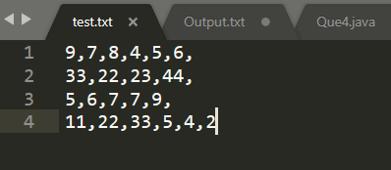

Second Two Arrays

First two arrays

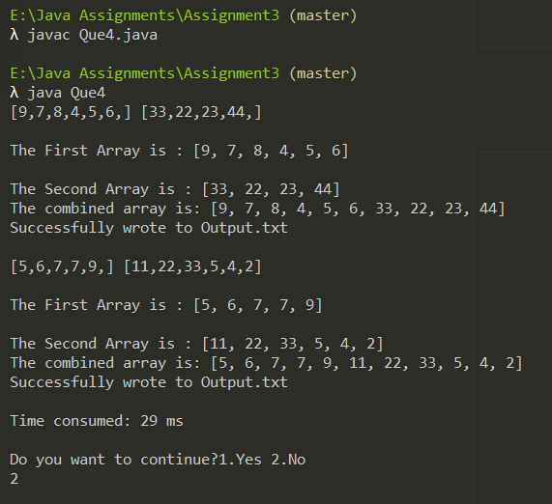

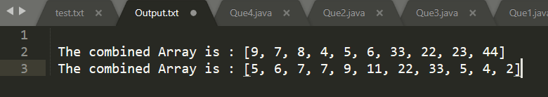



# WAP to take string as a user input. Use a pre-defined function to convert it to a character array and print that character array.

Then take a character as a user input, and search that character in a string. Then print whether search successful or unsuccessful

Form 1: acc to que

import java.util.*; //importing scanner class

public class Que5{

//creting a global static object to scanner class

public static Scanner sc = new Scanner(System.in);

//main function

public static void main(String[] args) {

//inputting string

System.out.println("Enter The String :");

String str= sc.nextLine();

//converting to character array using toCharArray and printing

System.out.println("The Character Array is :");

char c[] = str.toCharArray();

for (int i=0; i<c.length; ++i) {

System.out.print(c[i]+" | ");

}

//linear searching for character

System.out.println("\nEnter Character to find :");

char ch = sc.next().charAt(0);

System.out.println("At following positions "+ ch + " was found");

for(int i=0; i<c.length; ++i){

if(c[i]==ch){

System.out.println(i);

}

}

}

}

OUTPUT –

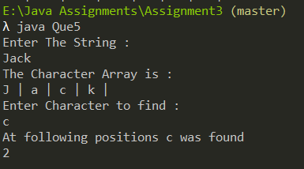

DrawBacks\Improvements -

* Handling Exceptions
* Refactoring the program to make it more adaptive and organized.
* Refractoring would include
  + For keeping our program running
  + creating seprate function for inputting
  + Creating seprate function to convert the string to character array
  + For searching the array
  + For outputing the output
  + For Reading multiple input from the file
  + For permanently stroing our output In a file
* Other than refractoring we can Pass many inputs through a CSV ( comma seprated file) is possible and it is good to have huge input processing in program so that user can use a data file to input
* For our analysis we can check the execution time of the program

**Note- we have also used CurrentTime method in System class to measure our execution time**

**Proposed Algorithm**

# 

FORM 2: Modified

import java.util.*; //importing scanner class

import java.io.*;

public class Que5 {

//creting a global static object to scanner class

public static Scanner sc = new Scanner(System.in);

public static Que5 obj = new Que5();

Main function , more organized

//main function

public static void main(String[] args) {

long start = System.currentTimeMillis();

obj.cont(start);

Program to make execution user-friendly

}

public void cont(long start){

int ex=1;

do{

obj.input();

long finish = System.currentTimeMillis();

System.out.println("Time consumed: " + (finish - start) + " ms");

System.out.println("\nDo you want to continue?1.Yes 2.No");

ex=sc.nextInt();

}while(ex==1);

}

Method to Input from file with taking string input on each line

public void input(){

try{

File myObj = new File("Strings.txt");

Scanner myReader = new Scanner(myObj);

while (myReader.hasNextLine()) {

String data = myReader.nextLine();

System.out.print(data);

convertToArray(data);

}

}

catch(IOException|ArrayIndexOutOfBoundsException e){

System.out.println("Either one of the input in file is not correct format or The file doesn't exist!!");

}

Method to convert to Array

}

public static void convertToArray(String str){

int len= str.length();

//declaring our character array

char[] ch = new char[len];

//inputting string characters in character array

for(int i =0; i < len; i++)

{

ch[i] = str.charAt(i);

}

obj.search(ch);

}

public void search(char[] arry){

System.out.println("\nEnter Character to find :");

char ch = sc.next().charAt(0);

System.out.println("At following positions "+ ch + " was found");

for(int i=0; i<arry.length; ++i){

if(arry[i]==ch){

System.out.print(i+ " ");

out(i,ch);

}

}

Method to Output on File

}

public void out(int ind,char ch){

try{

//initilized file writer method to pass true value to append the output

FileWriter myWriter = new FileWriter("E:\\Java Assignments\\Assignment3\\Output.txt",true);

myWriter.write("\nThe "+ch+" Occur at Index "+ind+" in file ");

myWriter.close();

System.out.println("Successfully wrote to Output.txt");

}

catch (IOException e) {

System.out.println("An error occurred while writing");

}

}

}

**Code Analysis**

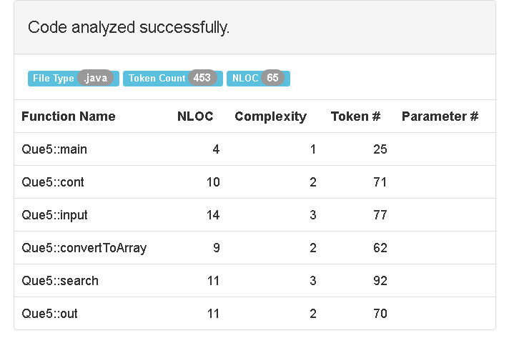

**OUTPUT:**

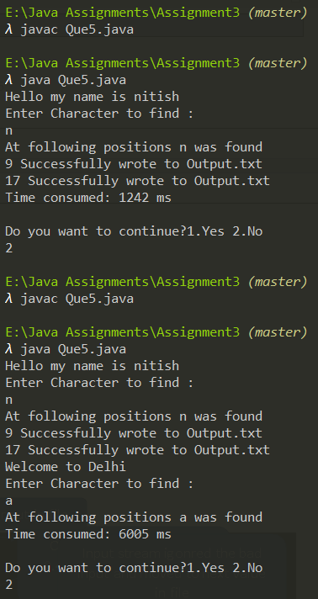

Text File

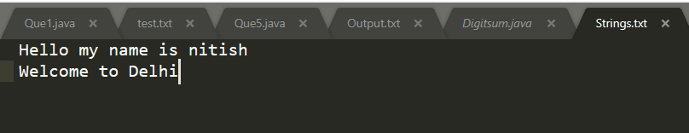

Passing multiple string with line breaks

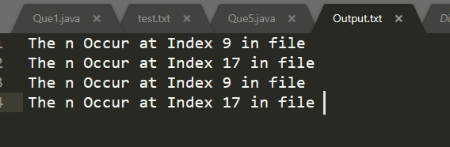

Outputed printed on FIle



Time consumed for execution

# WAP to take string as a user input. Then find a maximum character in a string and then print it.:

Form 1: acc to que

import java.util.*;//importing scanner class

public class Que6 {

//creting a global static object to scanner class

public static Scanner sc = new Scanner(System.in);

//main

public static void main(String[] args) {

//input string

System.out.println("Enter a string : ");

String str = sc.nextLine();

//initialize max to find max character

char max = '\0';

//convert string to character array

char[] c= str.toCharArray();

//loop for finding max

for (int i = 0; i < c.length; i++) {

if (Character.toLowerCase(c[i]) > max) {

max = c[i];

}

}

System.out.println("The maximum in string is: " + max);

}

}

OUTPUT-

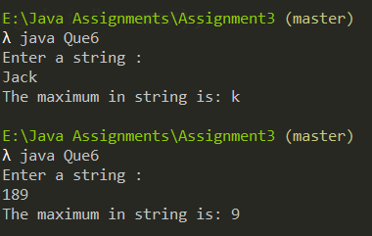

DrawBacks -

* Handling Exceptions
* Refactoring the program to make it more adaptive and organized.
* Refractoring would include
  + For keeping our program running
  + creating seprate function for inputting
  + Creating seprate function to convert the string to character array
  + For searching the array
  + For outputing the output
  + For Reading multiple input from the file
  + For permanently stroing our output In a file
* Other than refractoring we can Pass many inputs through a CSV ( comma seprated file) is possible and it is good to have huge input processing in program so that user can use a data file to input
* For our analysis we can check the execution time of the program

**Note- we have also used CurrentTime method in System class to measure our execution time**

# Proposed Algorithm

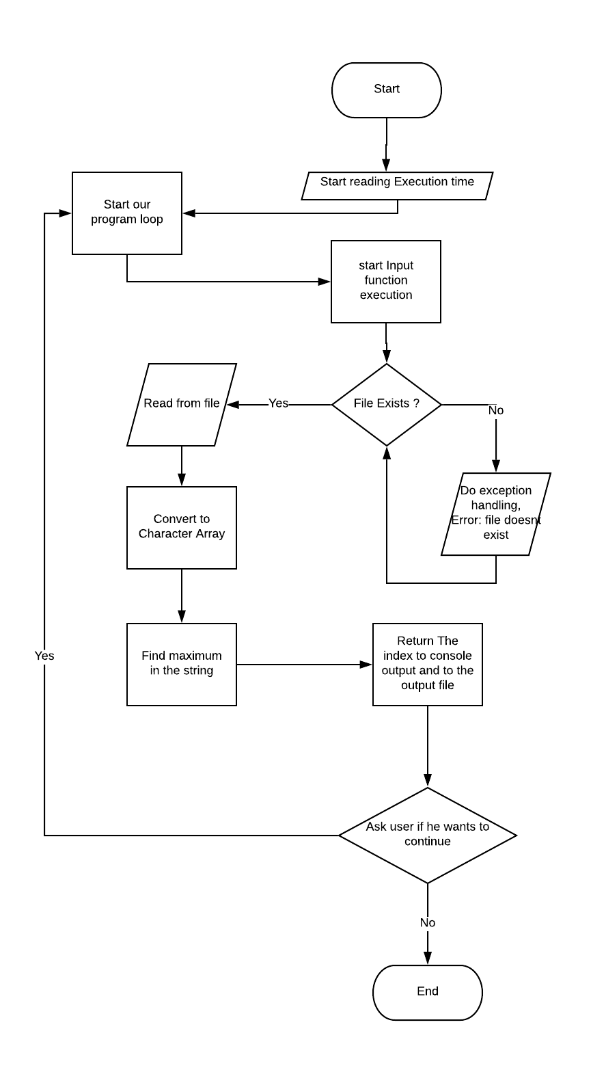

FORM 2: Modified

import java.util.*;//importing scanner class

import java.io.*; //importing io class for file input output and exception handling

public class Que6 {

//creting a global static object to scanner class

public static Scanner sc = new Scanner(System.in);

public static Que6 obj = new Que6();

//main

public static void main(String[] args) {

long start = System.currentTimeMillis();

obj.cont(start);

}

public void cont(long start){

int ex=1;

do{

obj.input();

long finish = System.currentTimeMillis();

System.out.println("Time consumed: " + (finish - start) + " ms");

System.out.println("\nDo you want to continue?1.Yes 2.No");

ex=sc.nextInt();

}while(ex==1);

}

public void input(){

try{

File myObj = new File("Strings.txt");

Scanner myReader = new Scanner(myObj);

while (myReader.hasNextLine()) {

String data = myReader.nextLine();

System.out.print(data);

convertToArray(data);

}

}

catch(IOException|ArrayIndexOutOfBoundsException e){

System.out.println("Either one of the input in file is not correct format or The file doesn't exist!!");

}

}

public static void convertToArray(String str){

int len= str.length();

//declaring our character array

char[] ch = new char[len];

//inputting string characters in character array

for(int i =0; i < len; i++)

{

ch[i] = str.charAt(i);

}

obj.maximum(ch);

}

public void maximum(char[] c){

char max = '\0';

for (int i = 0; i < c.length; i++) {

if (Character.toLowerCase(c[i]) > max) {

max = c[i];

}

}

System.out.println("\nThe maximum in string is: " + max);

obj.out(max);

}

public void out(char ch){

try{

//initilized file writer method to pass true value to append the output

FileWriter myWriter = new FileWriter("E:\\Java Assignments\\Assignment3\\Output.txt",true);

myWriter.write("\n Greatest character in the line is : "+ch);

myWriter.close();

System.out.println("Successfully wrote to Output.txt");

}

catch (IOException e) {

System.out.println("An error occurred while writing");

}

}

}

# Complexity

# 

**OUTPUT:**

Our Text file for taking input -

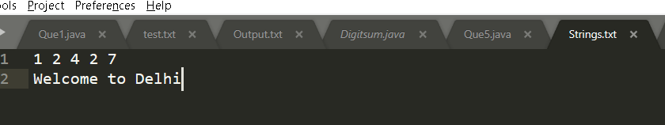

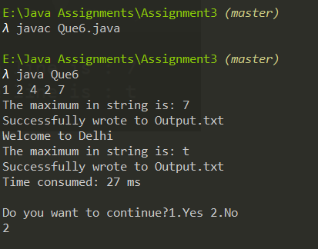

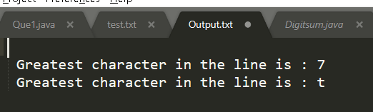



# WAP to take string as a user input. Then convert it into a 1-D character array without the use of pre-defined function. Then print the reversed character array.

FORM 1:-

import java.util.*;//importing scanner class

public class Que7{

//creting a global static object to scanner class

public static Scanner sc = new Scanner(System.in);

public static void main(String[] args)

{

//declaring string and inputting it

String inputString;

System.out.println("Please Enter the String");

inputString = sc.nextLine();

//getting length of string

int len=inputString.length();

//declaring our character array

char[] name = new char[len];

//inputting string characters in character array

for(int i =0; i < len; i++)

{

name[i] = inputString.charAt(i);

}

System.out.println("Character Array is: ");

System.out.println(name);

//printing reversed array

System.out.println("reversed Array is :");

for(int i =len-1; i>=0; i--)

{

System.out.print(name[i]);

}

}

}

OUTPUT-

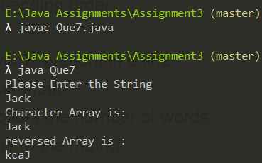

DrawBacks -

* Handling Exceptions
* Refactoring the program to make it more adaptive and organized.
* Refractoring would include creating methods for-
  + For keeping our program running
  + creating seprate function for inputting
  + Creating seprate function to convert the string to character array
  + For reversing the array
  + For outputing the output
  + For Reading multiple input from the file
  + For permanently stroing our output In a file
* Other than refractoring we can Pass many inputs through a CSV ( comma seprated file) is possible and it is good to have huge input processing in program so that user can use a data file to input
* For our analysis we can check the execution time of the program

**Note- we have also used CurrentTime method in System class to measure our execution time**

# Proposed Algorithm

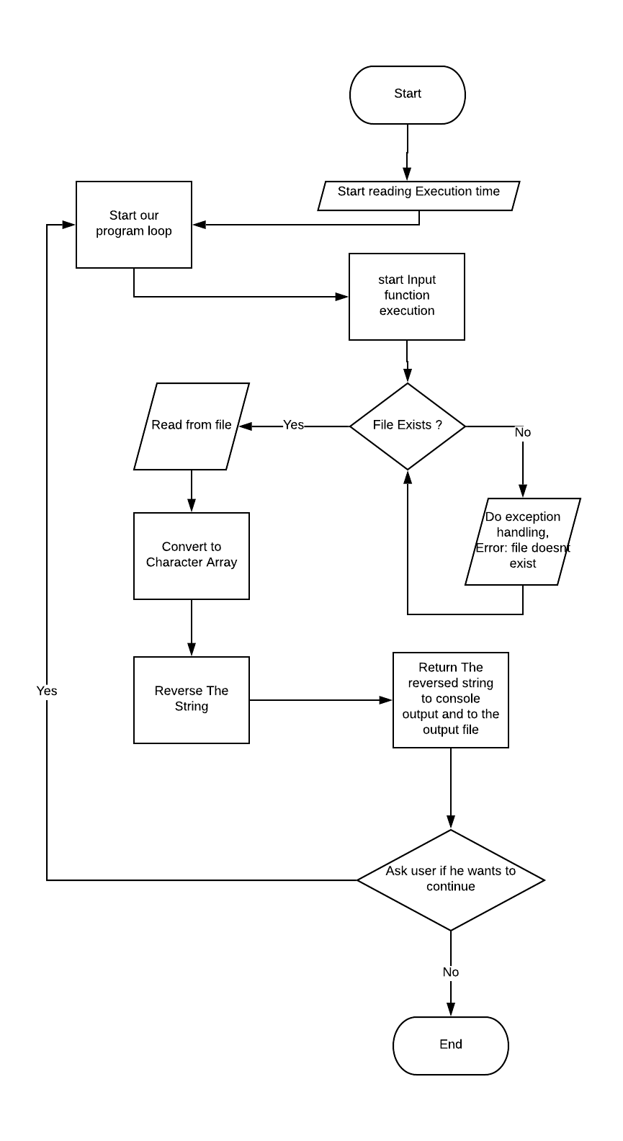

Form 2:

import java.util.*;//importing scanner class

import java.io.*;

public class Que7{

//creting a global static object to scanner class

public static Scanner sc = new Scanner(System.in);

public static Que7 obj = new Que7();

public static void main(String[] args)

{

long start = System.currentTimeMillis();

obj.cont(start);

}

public void cont(long start){

int ex=1;

do{

obj.input();

long finish = System.currentTimeMillis();

System.out.println("Time consumed: " + (finish - start) + " ms");

System.out.println("\nDo you want to continue?1.Yes 2.No");

ex=sc.nextInt();

}while(ex==1);

}

public void input(){

try{

File myObj = new File("Strings.txt");

Scanner myReader = new Scanner(myObj);

while (myReader.hasNextLine()) {

String data = myReader.nextLine();

System.out.print(data);

convertToArray(data);

}

}

catch(IOException|ArrayIndexOutOfBoundsException e){

System.out.println("Either one of the input in file is not correct format or The file doesn't exist!!");

}

}

public static void convertToArray(String str){

int len= str.length();

//declaring our character array

char[] ch = new char[len];

//inputting string characters in character array

for(int i =0; i < len; i++)

{

ch[i] = str.charAt(i);

}

obj.reverse(ch);

}

public void reverse(char[] c){

int len = c.length;

for (int i=0; i < (len/2); i++)

{

char l = c[i];

c[i] = c[len-i-1];

c[len-i-1] = l;

}

System.out.println("\nThe Reversed string is: "+new String(c));

obj.out(c);

}

public void out(char[] rev){

try{

//initilized file writer method to pass true value to append the output

FileWriter myWriter = new FileWriter("E:\\Java Assignments\\Assignment3\\Output.txt",true);

myWriter.write("\n Reversed String is: "+ new String(rev));

myWriter.close();

System.out.println("Successfully wrote to Output.txt");

}

catch (IOException e) {

System.out.println("An error occurred while writing");

}

}

}

**Complexity**

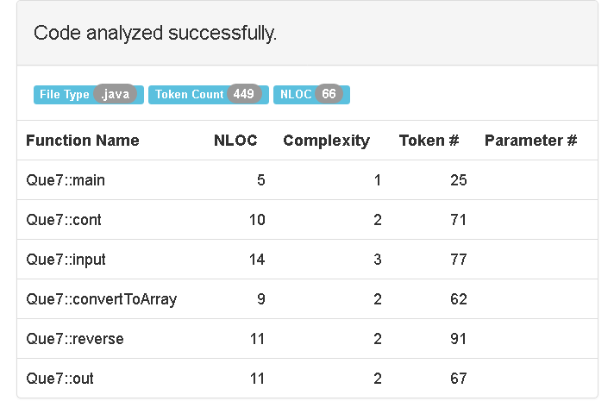

**OUTPUT:**

Our Text file for taking input -

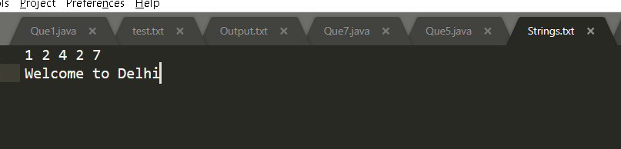

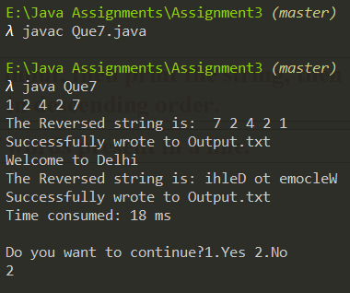

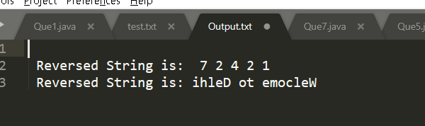



# WAP to take string as a user input, then print the string, then print the characters of string in descending order.

FORM 1:-

import java.util.*;

public class Que8 {

//creting a global static object to scanner class

public static Scanner sc = new Scanner(System.in);

public static void main(String[] args) {

//inputting string

System.out.println("Enter a string : ");

String str = sc.nextLine();

//converting to character array

char[] c = str.toCharArray();

for (int i = 0; i < c.length; i++) {

for (int j = i + 1; j < c.length; j++) {

if (Character.toLowerCase(c[j]) < Character.toLowerCase(c[i])) {

swap(i, j, c);

}

}

}

//printing strings

System.out.println("The orginal string is: " + str);

System.out.println("Sorted string " + String.valueOf(c));

}

private static void swap(int i, int j, char[] c) {

char temp = c[i];

c[i] = c[j];

c[j] = temp;

}

}

OUTPUT-

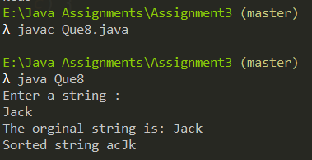

DrawBacks -

* Handling Exceptions
* Refactoring the program to make it more adaptive and organized.
* Refractoring would include creating methods for-
  + For keeping our program running
  + creating seprate function for inputting
  + Creating seprate function to convert the string to character array
  + For sorting and printing the array in ascending order
  + For outputing the output
  + For Reading multiple input from the file
  + For permanently stroing our output In a file
* Other than refractoring we can Pass many inputs through a CSV ( comma seprated file) is possible and it is good to have huge input processing in program so that user can use a data file to input
* For our analysis we can check the execution time of the program

**Note- we have also used CurrentTime method in System class to measure our execution time**

**Proposed Algorithm**

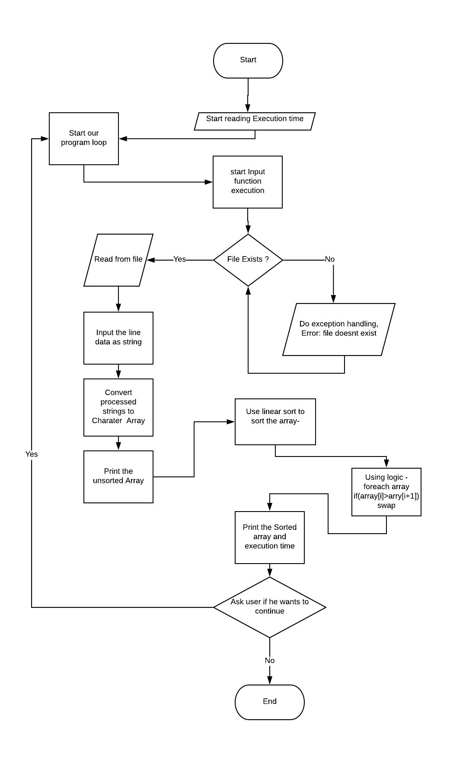

FORM 2: Modified

import java.util.*;

import java.io.*;

public class Que8 {

//creting a global static object to scanner class

public static Scanner sc = new Scanner(System.in);

public static Que8 obj = new Que8();

public static void main(String[] args) {

//starting time

long start = System.currentTimeMillis();

obj.cont(start);

}

public void cont(long start){

int ex=1;

do{

obj.input();

long finish = System.currentTimeMillis();

System.out.println("Time consumed: " + (finish - start) + " ms");

System.out.println("\nDo you want to continue?1.Yes 2.No");

ex=sc.nextInt();

}while(ex==1);

}

public void input(){

try{

File myObj = new File("Strings.txt");

Scanner myReader = new Scanner(myObj);

while (myReader.hasNextLine()) {

String data = myReader.nextLine();

System.out.print("Unsorted String is: "+data);

convertToArray(data);

}

}

catch(IOException|ArrayIndexOutOfBoundsException e){

System.out.println("Either one of the input in file is not correct format or The file doesn't exist!!");

}

}

public static void convertToArray(String str){

int len= str.length();

//declaring our character array

char[] ch = new char[len];

//inputting string characters in character array

for(int i =0; i < len; i++)

{

ch[i] = str.charAt(i);

}

for (int i = 0; i < len; i++) {

for (int j = i + 1; j < len; j++) {

if (Character.toLowerCase(ch[j]) < Character.toLowerCase(ch[i])) {

obj.swap(i, j, ch);

}

}

}

System.out.println("\nSorted string: " + Arrays.toString(ch));

obj.out(ch);

}

private void swap(int i, int j, char[] c) {

char temp = c[i];

c[i] = c[j];

c[j] = temp;

}

public void out(char[] sort){

try{

//initilized file writer method to pass true value to append the output

FileWriter myWriter = new FileWriter("E:\\Java Assignments\\Assignment3\\Output.txt",true);

myWriter.write("\n Reversed String is: "+ Arrays.toString(sort));

myWriter.close();

System.out.println("Successfully wrote to Output.txt");

}

catch (IOException e) {

System.out.println("An error occurred while writing");

}

}

}

**Complexity**

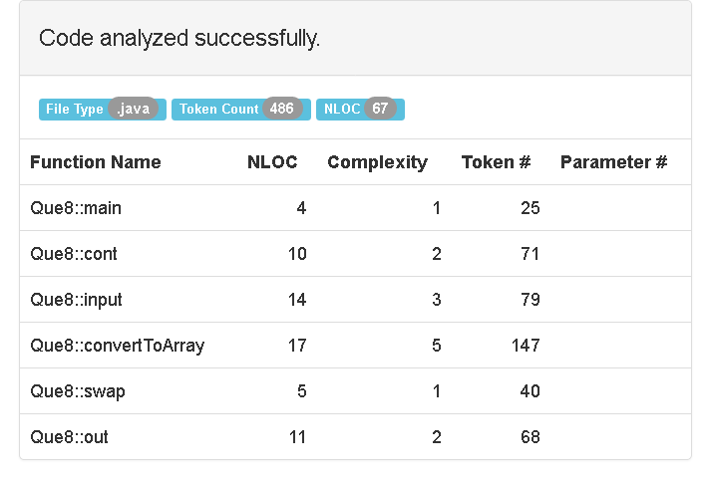

**OUTPUT:**

Our Text file for taking input -

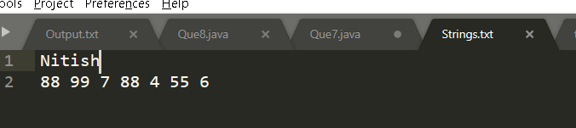

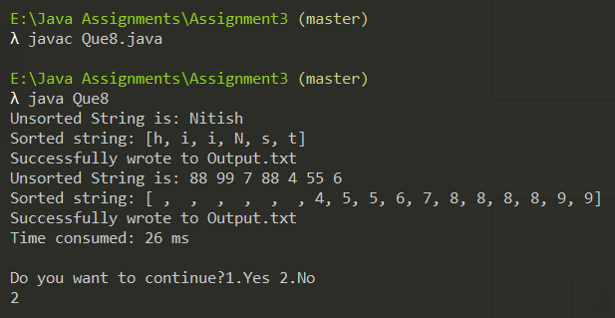

Output FIle

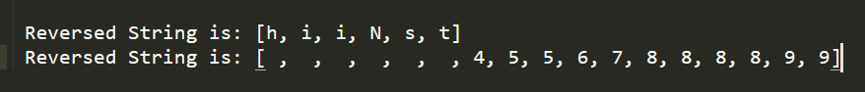



Execution time

# WAP to count the number of words present in a line.

main() must take the string as a user input

wordcount() must put in a logic to count the number of words present in a line and return the value to the main()

main() must further print the number of words found in a line

FORM 1:-

import java.util.*;

public class Que9 {

public static Scanner sc = new Scanner(System.in);

public static Que9 obj = new Que9();

public int wordcount(String N) {

int count = 0;

boolean isWord = false;

int last = N.length() - 1;

char[] characters = N.toCharArray();

for(int i = 0;i<characters.length;i++)

{

if(Character.isLetter(characters[i]) && i != last)

{

isWord = true;

}

else if(!Character.isLetter(characters[i]) && isWord)

{

count++;

isWord = true;

}

else if(Character.isLetter(characters[i]) && i == last)

{

count++;

}

}

return count;

}

public static void main(String[] args) {

String s = "";

System.out.println("Enter a string: ");

s = sc.nextLine();

System.out.println("The Number of words in String are : "+obj.wordcount(s));

}

}

OUTPUT-

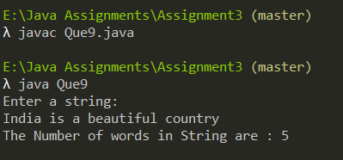

DrawBacks -

* Handling Exceptions
* Refactoring the program to make it more adaptive and organized.
* Refractoring would include creating methods for-
  + For keeping our program running
  + creating seprate function for inputting
  + Creating seprate function to convert the string to character array
  + For Counting the words in array , after each whitespace
  + For Reading multiple input from the file
  + For permanently stroing our output In a file
* Other than refractoring we can Pass many inputs through a CSV ( comma seprated file) is possible and it is good to have huge input processing in program so that user can use a data file to input
* For our analysis we can check the execution time of the program

**Note- we have also used CurrentTime method in System class to measure our execution time**

**Proposed Algorithm**

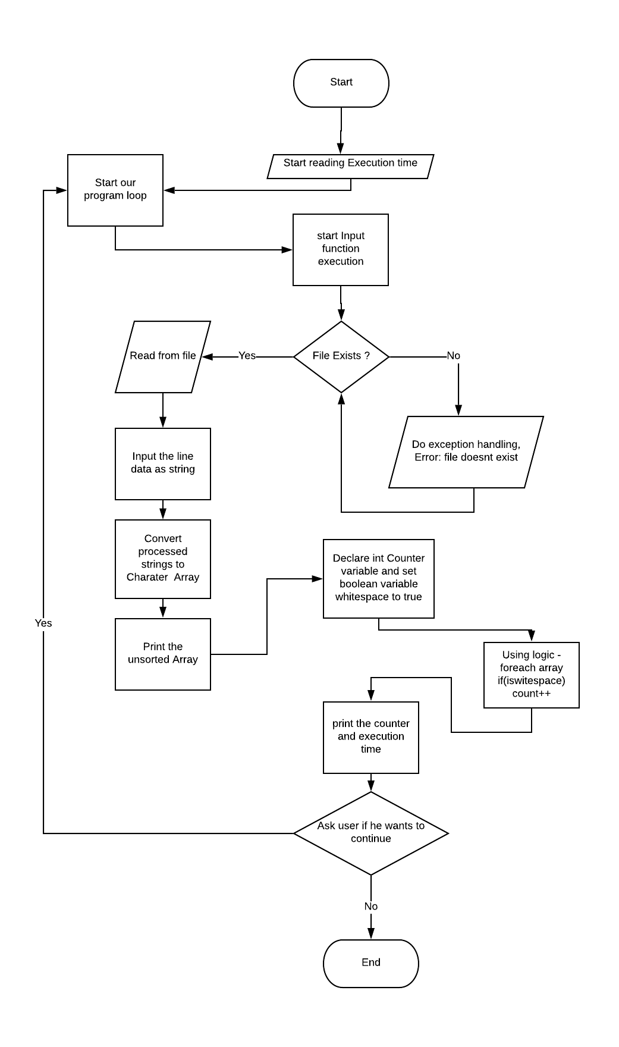

FORM 2: Modified

import java.util.*;

import java.io.*;

public class Que9 {

public static Scanner sc = new Scanner(System.in);

public static Que9 obj = new Que9();

public static void main(String[] args) {

//starting time

long start = System.currentTimeMillis();

obj.cont(start);

}

public void cont(long start){

int ex=1;

do{

obj.input();

long finish = System.currentTimeMillis();

System.out.println("Time consumed: " + (finish - start) + " ms");

System.out.println("\nDo you want to continue?1.Yes 2.No");

ex=sc.nextInt();

}while(ex==1);

}

public void input(){

try{

File myObj = new File("Strings.txt");

Scanner myReader = new Scanner(myObj);

while (myReader.hasNextLine()) {

String data = myReader.nextLine();

System.out.print("Unsorted String is: "+data);

convertToArray(data);

}

}

catch(IOException|ArrayIndexOutOfBoundsException e){

System.out.println("Either one of the input in file is not correct format or The file doesn't exist!!");

}

}

public static void convertToArray(String str){

int len= str.length();

//declaring our character array

char[] ch = new char[len];

//inputting string characters in character array

for(int i =0; i < len; i++)

{

ch[i] = str.charAt(i);

}

System.out.println("\nNumber of words are: " + obj.wordcount(ch));

obj.out(obj.wordcount(ch));

}

public int wordcount(char[] characters) {

int count = 0;

boolean isWord = false;

int last = characters.length - 1;

for(int i = 0;i<characters.length;i++)

{

if(Character.isLetter(characters[i]) && i != last)

{

isWord = true;

}

else if(!Character.isLetter(characters[i]) && isWord)

{

count++;

isWord = true;

}

else if(Character.isLetter(characters[i]) && i == last)

{

count++;

}

}

return count;

}

public void out(int count){

try{

//initilized file writer method to pass true value to append the output

FileWriter myWriter = new FileWriter("E:\\Java Assignments\\Assignment3\\Output.txt",true);

myWriter.write("\n Number of words are: "+ count);

myWriter.close();

System.out.println("Successfully wrote to Output.txt");

}

catch (IOException e) {

System.out.println("An error occurred while writing");

}

}

}

**Complexity**

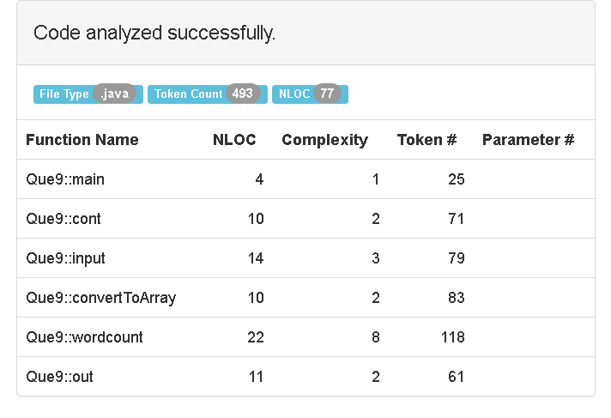

**OUTPUT:**

Our Text file for taking input -

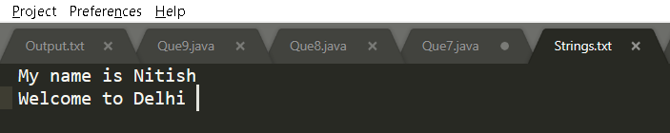

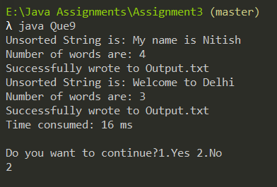

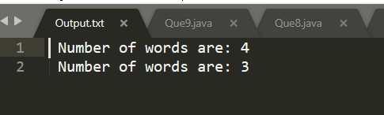



# Q10. Write a program to check if a string is palindrome or not..

main() must take string as a user input, and then print it

palindrome() must put in the logic to check whether the given string is a palindrome or not and return the value to the main()

main() must further print whether the given string is a palindrome or not.

FORM 1:- Acc to the question

import java.util.*; //imported util classes for Scanner class

public class Que10{

//creting a global static object to scanner class

public static Scanner sc = new Scanner(System.in);

//creating a global static object to our Que10 class

public static Que10 obj = new Que10();

//main fucntion

public static void main(String[] args) {

//declaring inputting string

String str = "";

//Entering the string

System.out.println("Enter a string/number to check if it is a palindrome");

str = sc.nextLine();

//inputting length of the string to our length variable

//using length() method

int length = str.length();

System.out.println(str+" "+obj.pallindrom(str,length));

}

//function to check string is pallindrome or not

public String pallindrom(String s,int length){

//for storing reversed string

String reverse="";

//running reverse loop

//with charat function to store characters at those indices

for ( int i = length - 1; i >= 0; i--){

reverse = reverse + s.charAt(i);

}

//Printign reverse

System.out.println("The reverse of string is: "+reverse);

//checking if the reverse string is equal to the original

if((reverse.toLowerCase()).equals(s.toLowerCase())){

return "is pallindrome";

}

else{

return "is not pallindrome";

}

}

}

OUTPUT-

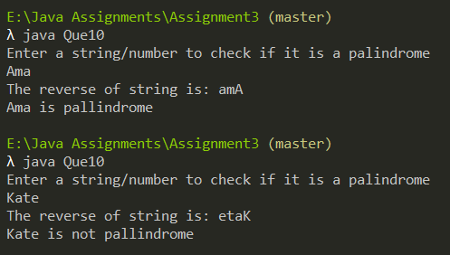

DrawBacks -

* Handling Exceptions
* Refactoring the program to make it more adaptive and organized.
* Refractoring would include creating methods for-
  + For keeping our program running
  + creating seprate function for inputting
  + For reversing and checking if the string is pallindrome or not
  + For outputing the output
  + For Reading multiple input from the file
  + For permanently stroing our output In a file
* Other than refractoring we can Pass many inputs through a CSV ( comma seprated file) is possible and it is good to have huge input processing in program so that user can use a data file to input
* For our analysis we can check the execution time of the program

**Note- we have also used CurrentTime method in System class to measure our execution time**

**Proposed Algorithm**

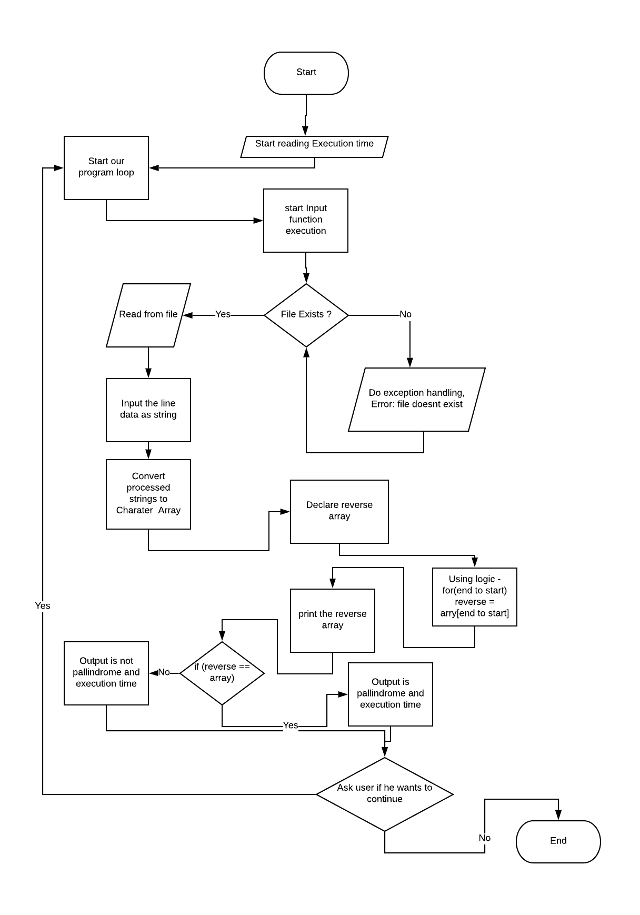

FORM 2: Modified

import java.util.*; //imported util classes for Scanner class

import java.io.*;

public class Que10{

//creting a global static object to scanner class

public static Scanner sc = new Scanner(System.in);

//creating a global static object to our Que10 class

public static Que10 obj = new Que10();

//main fucntion

public static void main(String[] args) {

//starting time

long start = System.currentTimeMillis();

obj.cont(start);

}

public void cont(long start){

int ex=1;

do{

obj.input();

long finish = System.currentTimeMillis();

System.out.println("Time consumed: " + (finish - start) + " ms");

System.out.println("\nDo you want to continue?1.Yes 2.No");

ex=sc.nextInt();

}while(ex==1);

}

public void input(){

try{

File myObj = new File("Strings.txt");

Scanner myReader = new Scanner(myObj);

while (myReader.hasNextLine()) {

String data = myReader.nextLine();

System.out.print("Unsorted String is: "+data);

System.out.println(data+" "+obj.pallindrome(data));

obj.out(data);

}

}

catch(IOException|ArrayIndexOutOfBoundsException e){

System.out.println("Either one of the input in file is not correct format or The file doesn't exist!!");

}

}

//function to check string is pallindrome or not

public String pallindrome(String s){

//for storing reversed string

String reverse="";

int length = s.length();

//running reverse loop

//with charat function to store characters at those indices

for ( int i = length - 1; i >= 0; i--){

reverse = reverse + s.charAt(i);

}

//Printign reverse

System.out.println("\nThe reverse of string is: "+reverse);

//checking if the reverse string is equal to the original

if((reverse.toLowerCase()).equals(s.toLowerCase())){

return "is pallindrome";

}

else{

return "is not pallindrome";

}

}

public void out(String str){

try{

//initilized file writer method to pass true value to append the output

FileWriter myWriter = new FileWriter("E:\\Java Assignments\\Assignment3\\Output.txt",true);

myWriter.write("\n"+str+" "+ obj.pallindrome(str));

myWriter.close();

System.out.println("Successfully wrote to Output.txt");

}

catch (IOException e) {

System.out.println("An error occurred while writing");

}

}

}

COMPLEXITY

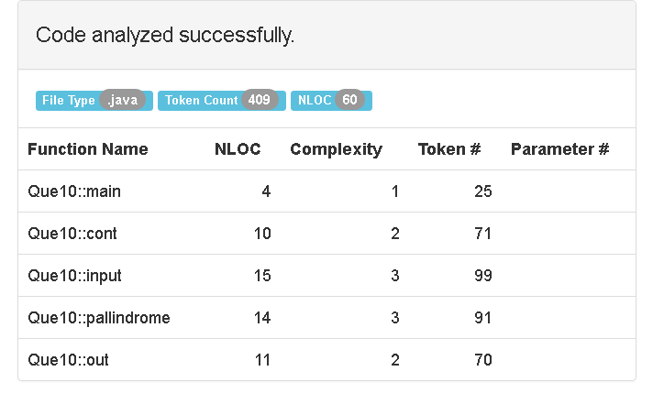

**OUTPUT:**

Our Text file for taking input -

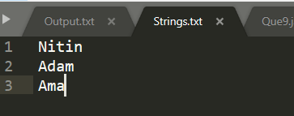

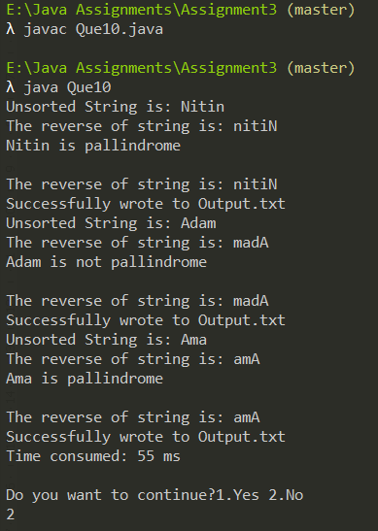

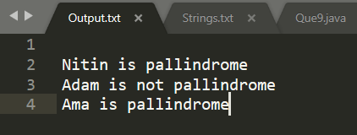



# Q11. Write a program to convert a string to proper case, that is, to capitalize first letter of each word of the string. For example: If the string is: siddhartha shyam vyas, it should output it as: Siddhartha Shyam Vyas

create a user-defined function: capitalize()

main() must take string as a user input

capitalize() must put in the logic to output the first letter of every word to be in capital letters and then print the string

FORM 1:- Acc to the question

import java.util.*; //imported util classes for Scanner class

public class Que11{

//creting a global static object to scanner class

public static Scanner sc = new Scanner(System.in);

//creating a global static object to our Que11 class

public static Que11 obj = new Que11();

//main fucntion

public static void main(String[] args) {

//Entering the string

System.out.println("Enter a string: ");

String str = sc.nextLine();

//inputting length of the string to our length variable

//using length() method

int length = str.length();

//Assigning to character array

char[] charArray = str.toCharArray();

System.out.println("Capitalised string is: "+obj.capitalize(charArray));

}

//function to check string is pallindrome or not

public String capitalize(char[] charArray){

//for checking for space

boolean foundSpace = true;

for(int i = 0; i < charArray.length; i++) {

// if the array element is a letter

if(Character.isLetter(charArray[i])) {

// check space is present before the letter

if(foundSpace){

// change the letter into uppercase

charArray[i] = Character.toUpperCase(charArray[i]);

//make found space false

foundSpace = false;

}

}

else {

// if the new character is not character

foundSpace = true;

}

}

return String.valueOf(charArray);

}

}

OUTPUT-

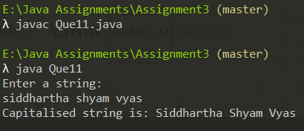

DrawBacks -

* Handling Exceptions
* Refactoring the program to make it more adaptive and organized.
* Refractoring would include creating methods for-
  + For keeping our program running
  + creating seprate function for inputting
  + Creating seprate function to convert the string to character array
  + For Capitalize the first letter of string
  + For outputing the output
  + For Reading multiple input from the file
  + For permanently stroing our output In a file
* Other than refractoring we can Pass many inputs through a CSV ( comma seprated file) is possible and it is good to have huge input processing in program so that user can use a data file to input
* For our analysis we can check the execution time of the program

**Note- we have also used CurrentTime method in System class to measure our execution time**

FORM 2: Modified

import java.util.*; //imported util classes for Scanner class

import java.io.*;

public class Que11{

//creting a global static object to scanner class

public static Scanner sc = new Scanner(System.in);

//creating a global static object to our Que11 class

public static Que11 obj = new Que11();

//main fucntion

public static void main(String[] args) {

long start = System.currentTimeMillis();

obj.cont(start);

}

public void cont(long start){

int ex=1;

do{

obj.input();

long finish = System.currentTimeMillis();

System.out.println("Time consumed: " + (finish - start) + " ms");

System.out.println("\nDo you want to continue?1.Yes 2.No");

ex=sc.nextInt();

}while(ex==1);

}

public void input(){

try{

File myObj = new File("Strings.txt");

Scanner myReader = new Scanner(myObj);

while (myReader.hasNextLine()) {

String data = myReader.nextLine();

System.out.print(data);

convertToArray(data);

}

}

catch(IOException|ArrayIndexOutOfBoundsException e){

System.out.println("Either one of the input in file is not correct format or The file doesn't exist!!");

}

}

public static void convertToArray(String str){

int len= str.length();

//declaring our character array

char[] ch = new char[len];

//inputting string characters in character array

for(int i =0; i < len; i++)

{

ch[i] = str.charAt(i);

}

obj.capitalize(ch);

}

//function to check string is pallindrome or not

public void capitalize(char[] charArray){

//for checking for space

boolean foundSpace = true;

for(int i = 0; i < charArray.length; i++) {

// if the array element is a letter

if(Character.isLetter(charArray[i])) {

// check space is present before the letter

if(foundSpace){

// change the letter into uppercase

charArray[i] = Character.toUpperCase(charArray[i]);

//make found space false

foundSpace = false;

}

}

else {

// if the new character is not character

foundSpace = true;

}

}

String Cap = new String(charArray);

System.out.println("Capitalised string is: "+Cap);

obj.out(Cap);

}

public void out(String Cap){

try{

//initilized file writer method to pass true value to append the output

FileWriter myWriter = new FileWriter("E:\\Java Assignments\\Assignment3\\Output.txt",true);

myWriter.write("\n Capitalized sentence is : "+ Cap);

myWriter.close();

System.out.println("Successfully wrote to Output.txt");

}

catch (IOException e) {

System.out.println("An error occurred while writing");

}

}

}

**OUTPUT:**

Our Text file for taking input -

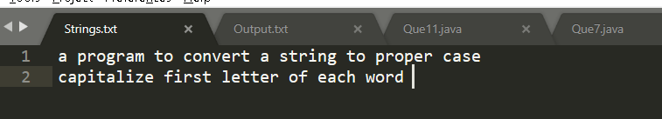

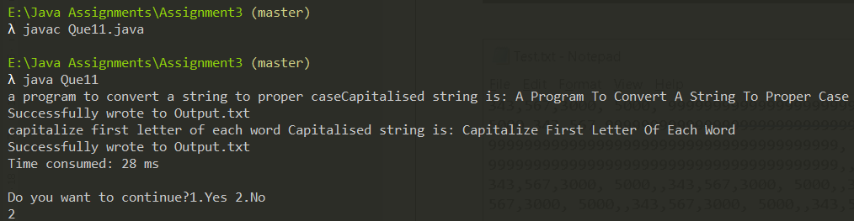

Took 28ms for processing 2 line input from the file

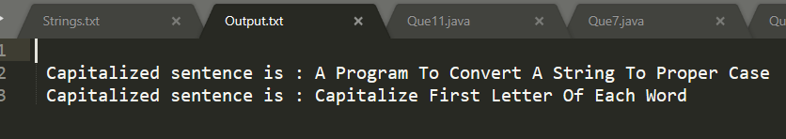



# Q12. WAP to prfrom a LINEAR SEARCH technique on 1-D integer array. If search successful, then print it else print Search Unsuccessful!

FORM 1:- Acc to the question

import java.util.*;//imported util classes for Scanner class

public class Que12{

//creting a global static object to scanner class

public static Scanner sc = new Scanner(System.in);

//main function

public static void main(String[] args) {

//inputting length

System.out.println("Enter Length of the array :");

int length = sc.nextInt();

//creating array

int a[] = new int[length];

System.out.println("Enter the array :");

//inputting array

for(int i=0; i<length; ++i){

a[i] = sc.nextInt();

}

System.out.println("Enter the number ot found :");

int key = sc.nextInt();

//printing array element with index

System.out.println(key+" Found at Positions : ");

for(int i=0; i<length; ++i){

if(a[i]==key){

System.out.print(i+" | ");

}

}

}

}

OUTPUT-

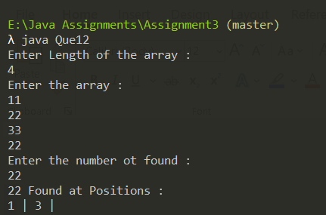

DrawBacks -

* Handling Exceptions
* Refactoring the program to make it more adaptive and organized.
* Refractoring would include creating methods for-
  + For keeping our program running
  + creating seprate function for inputting
  + Creating seprate function to convert the string to character array
  + For Capitalize the first letter of string
  + For outputing the output
  + For Reading multiple input from the file
  + Reading from file would include taking in the string , parsing it into integer array, then manipulating it
  + For permanently stroing our output In a file
* Other than refractoring we can Pass many inputs through a CSV ( comma seprated file) is possible and it is good to have huge input processing in program so that user can use a data file to input
* For our analysis we can check the execution time of the program

**Note- we have also used CurrentTime method in System class to measure our execution time.**

# Proposed Algorithm

# 

FORM 2: Modified

import java.util.*;//imported util classes for Scanner class

import java.io.*;

public class Que12{

//creting a global static object to scanner class

public static Scanner sc = new Scanner(System.in);

public static Que12 obj = new Que12();

//main function

public static void main(String[] args) {

//inputting length

long start = System.currentTimeMillis();

obj.cont(start);

}

public void cont(long start){

int ex=1;

do{

obj.input();

long finish = System.currentTimeMillis();

System.out.println("Time consumed: " + (finish - start) + " ms");

System.out.println("\nDo you want to continue?1.Yes 2.No");

ex=sc.nextInt();

}while(ex==1);

}

public void input(){

try{

File myObj = new File("test.txt");

Scanner myReader = new Scanner(myObj);

while (myReader.hasNextLine()) {

String data = myReader.nextLine();

System.out.print(data);

convertToArray(data);

}

}

catch(IOException|ArrayIndexOutOfBoundsException e){

System.out.println("Either one of the input in file is not correct format or The file doesn't exist!!");

}

}

public static void convertToArray(String str){

//seprating our file input into comma seprated array

String[] parts = str.split(",");

int len= parts.length;

//declaring our character array

int[] parsedArry = new int[len];

//filtering the integers in the string with comma sepration

// that is 1 , 2 , 3

for(int i =0; i < len; i++)

{

parsedArry[i] = Integer.parseInt(parts[i]);

}

obj.search(parsedArry);

}

//function to check string is pallindrome or not

public void search(int[] intArray){

//for checking for space

System.out.println("\nEnter the number to found :");

int key = sc.nextInt();

System.out.println(key+" Found at Positions : ");

for(int i=0; i<intArray.length; ++i){

if(intArray[i]==key){

System.out.print(i+" | ");

obj.out(i);

}

}

}

public void out(int pos){

try{

//initilized file writer method to pass true value to append the output

FileWriter myWriter = new FileWriter("E:\\Java Assignments\\Assignment3\\Output.txt",true);

myWriter.write("\n Key found at positions: "+ pos);

myWriter.close();

System.out.println("Successfully wrote to Output.txt");

}

catch (IOException e) {

System.out.println("An error occurred while writing");

}

}

}

**Complexity**

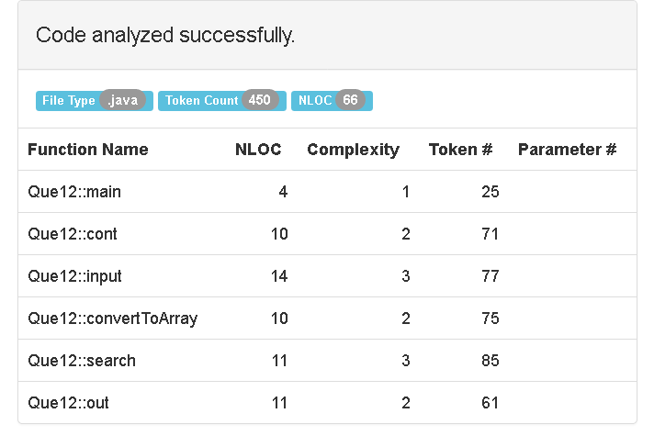

**OUTPUT:**

Our Text file for taking input -

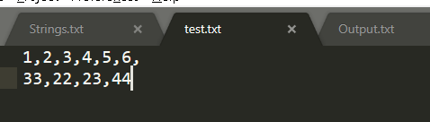

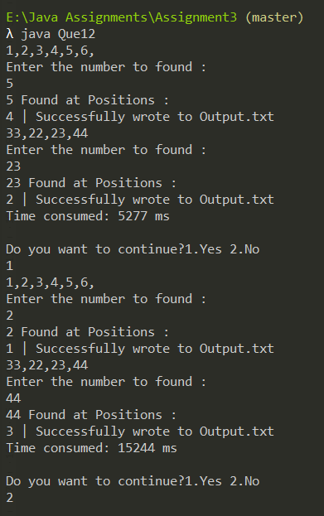

Took 5277ms for the first execution of our program loop

OUTPUT TEXT FILE

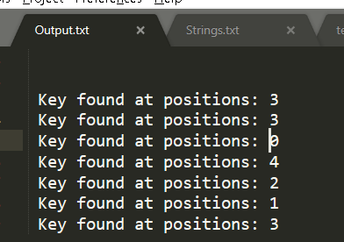

# Q13. WAP to perfrom a BINARY SEARCH technique on 1-D integer array. If search successful, then print it else print Search Unsuccessful!

FORM 1:- Acc to the question

import java.util.*; //imported util classes for Scanner class

public class Que13{

//creting a global static object to scanner class

public static Scanner sc = new Scanner(System.in);

//creating a global static object to our Que13 class

public static Que13 obj = new Que13();

//main fucntion

public static void main(String[] args) {

//declaring inputting string

System.out.println("Enter The length of the array: ");

int length=sc.nextInt();

int[] arry = new int[length];

System.out.println("Enter the array: ");

for (int i=0; i<length; i++){

arry[i]= sc.nextInt();

}

obj.mergeSort(arry,length);

System.out.print("The Sorted Array is : ");

for (int i : arry) {

System.out.print(i+" | ");

}

System.out.println("\nenter element to search:");

int Key = sc.nextInt();

int result = obj.binarySearch(arry,Key);

if (result == -1)

System.out.println("\nElement not present");

else

System.out.println("\nElement found at "

+ "index " + result);

}

public static void mergeSort(int[] a, int n) {

//if array is smaller than 2 then exit

if (n < 2) {

return;

}

int mid = n / 2;

int[] l = new int[mid];

int[] r = new int[n - mid];

for (int i = 0; i < mid; i++) {

l[i] = a[i];

}

for (int i = mid; i < n; i++) {

r[i - mid] = a[i];

}

mergeSort(l, mid);

mergeSort(r, n - mid);

merge(a, l, r, mid, n - mid);

}

public static void merge(

int[] a, int[] l, int[] r, int left, int right) {

int i = 0, j = 0, k = 0;

while (i < left && j < right) {

if (l[i] <= r[j]) {

a[k++] = l[i++];

}

else {

a[k++] = r[j++];

}

}

while (i < left) {

a[k++] = l[i++];

}

while (j < right) {

a[k++] = r[j++];

}

}

public int binarySearch(int arr[], int x)

{

int l = 0, r = arr.length - 1;

while (l <= r) {

int m = l + (r - l) / 2;

// Check if x is present at mid

if (arr[m] == x)

return m;

// If x greater, ignore left half

if (arr[m] < x)

l = m + 1;

// If x is smaller, ignore right half

else

r = m - 1;

}

// if we reach here, then element was

// not present

return -1;

}

}

OUTPUT-

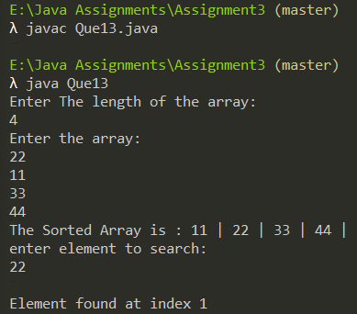

DrawBacks -

* Handling Exceptions
* Refactoring the program to make it more adaptive and organized.
* Refractoring would include creating methods for-
  + For keeping our program running
  + creating seprate function for inputting
  + Creating seprate function to convert the string to integer array
  + For Searching the integer array
  + For outputing the output
  + For Reading multiple input from the file
  + Reading from file would include taking in the string , parsing it into integer array, then manipulating it
  + For permanently storing our output In a file
* Other than refractoring we can Pass many inputs through a CSV ( comma seprated file) is possible and it is good to have huge input processing in program so that user can use a data file to input
* For our analysis we can check the execution time of the program

**Note- we have also used CurrentTime method in System class to measure our execution time.**

**Proposed Algorithm**

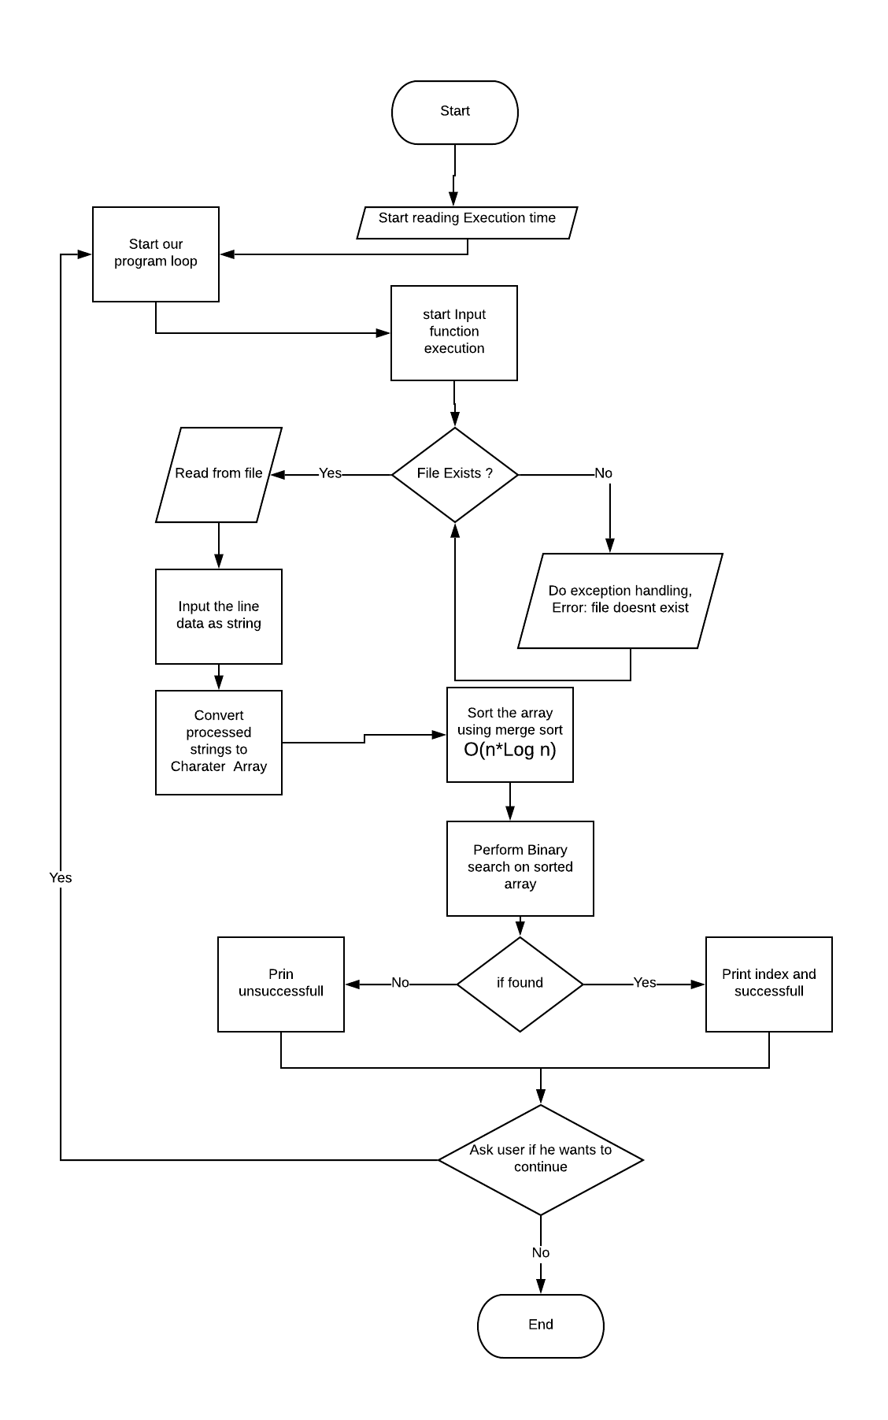

FORM 2: Modified

import java.util.*; //imported util classes for Scanner class

import java.io.*;

public class Que13{

//creting a global static object to scanner class

public static Scanner sc = new Scanner(System.in);

//creating a global static object to our Que13 class

public static Que13 obj = new Que13();

//main fucntion

public static void main(String[] args) {

//Start time

long start = System.currentTimeMillis();

obj.cont(start);

}

public void cont(long start){

int ex=1;

do{

obj.input();

long finish = System.currentTimeMillis();

System.out.println("Time consumed: " + (finish - start) + " ms");

System.out.println("\nDo you want to continue?1.Yes 2.No");

ex=sc.nextInt();

}while(ex==1);

}

public void input(){

try{

File myObj = new File("test.txt");

Scanner myReader = new Scanner(myObj);

while (myReader.hasNextLine()) {

String data = myReader.nextLine();

System.out.print(data);

convertToArray(data);

}

}

catch(IOException|ArrayIndexOutOfBoundsException e){

System.out.println("Either one of the input in file is not correct format or The file doesn't exist!!");

}

}

public static void convertToArray(String str){

//seprating our file input into comma seprated array

String[] parts = str.split(",");

int len= parts.length;

//declaring our character array

int[] parsedArry = new int[len];

//filtering the integers in the string with comma sepration

// that is 1 , 2 , 3

for(int i =0; i < len; i++)

{

parsedArry[i] = Integer.parseInt(parts[i]);

}

obj.mergeSort(parsedArry,len);

System.out.print("\nThe Sorted Array is : ");

for (int i : parsedArry) {

System.out.print(i+" | ");

}

obj.binarySearch(parsedArry);

}

public static void mergeSort(int[] a, int n) {

//if array is smaller than 2 then exit

if (n < 2) {

return;

}

int mid = n / 2;

int[] l = new int[mid];

int[] r = new int[n - mid];

for (int i = 0; i < mid; i++) {

l[i] = a[i];

}

for (int i = mid; i < n; i++) {

r[i - mid] = a[i];

}

mergeSort(l, mid);

mergeSort(r, n - mid);

merge(a, l, r, mid, n - mid);

}

public static void merge(

int[] a, int[] l, int[] r, int left, int right) {

int i = 0, j = 0, k = 0;

while (i < left && j < right) {

if (l[i] <= r[j]) {

a[k++] = l[i++];

}

else {

a[k++] = r[j++];

}

}

while (i < left) {

a[k++] = l[i++];

}

while (j < right) {

a[k++] = r[j++];

}

}

//function to check string is pallindrome or not

public void binarySearch(int arr[])

{

int l = 0, r = arr.length - 1;

System.out.println("\nEnter the number to found :");

int key = sc.nextInt();

System.out.println(key+" Found at Positions : ");

while (l <= r) {

int m = l + (r - l) / 2;

// Check if key is present at mid

if (arr[m] == key){

System.out.print(m+" ");

obj.out(m);

}

// If key greater, ignore left half

if (arr[m] < key){

l = m + 1;

}

// If key is smaller, ignore right half

else{

r = m - 1;

}

}

}

public void out(int pos){

try{

//initilized file writer method to pass true value to append the output

FileWriter myWriter = new FileWriter("E:\\Java Assignments\\Assignment3\\Output.txt",true);

myWriter.write("\n Key found at positions: "+ pos);

myWriter.close();

System.out.println("Successfully wrote to Output.txt");

}

catch (IOException e) {

System.out.println("An error occurred while writing");

}

}

}

**OUTPUT:**

Our Text file for taking input -

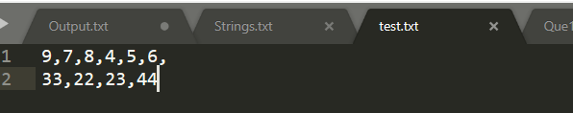

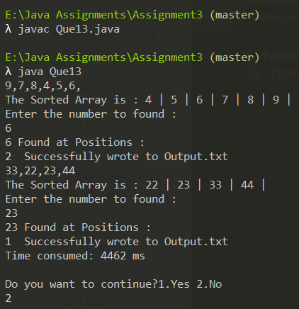

The sorting process increased our execution time

Increasing our input size and checking our time of execution

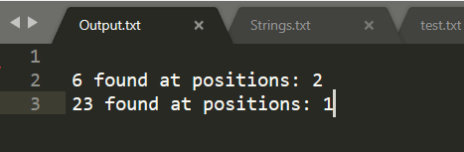



# Q14 WAP to perform SELECTION SORT technique on 1-D integer array.

FORM 1:- Acc to the question

import java.util.*;

public class Que14{

public static Scanner sc = new Scanner(System.in);

public static void main(String[] args) {

//inputting length

System.out.println("Enter Length of the array :");

int length = sc.nextInt();

//creating array

int a[] = new int[length];

System.out.println("Enter the array :");

//inputting array

for(int i=0; i<length; ++i){

a[i] = sc.nextInt();

}

SelectionSort(a);

System.out.println("Sorted array is : ");

for(int i=0; i<length; ++i)

{

System.out.println(a[i]);

}

}

public static void SelectionSort(int[] arr)

{

int lowest, lowestIndex;

for(int i = 0; i < arr.length -1; i++) {

//Find the lowest

lowest = arr[i];

lowestIndex = i;

for(int j = i; j < arr.length; j++) {

if(arr[j] < lowest) {

lowest = arr[j];

lowestIndex = j;

}

}

//Swap

if(i != lowestIndex) {

int temp = arr[i];

arr[i] = arr[lowestIndex];

arr[lowestIndex] = temp;

}

}

}

}

OUTPUT-

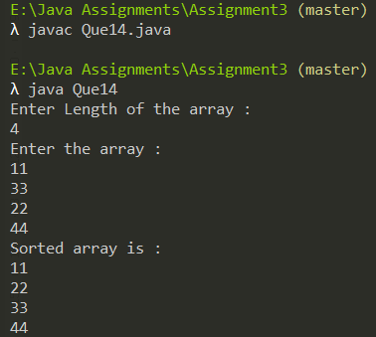

DrawBacks -

* Handling Exceptions
* Refactoring the program to make it more adaptive and organized.
* Refractoring would include creating methods for-
  + For keeping our program running
  + creating seprate function for inputting
  + Creating seprate function to convert the string to integer array
  + For Sorting the integer array
  + For outputing the output
  + For Reading multiple input from the file
  + Reading from file would include taking in the string , parsing it into integer array, then manipulating it
  + For permanently storing our output In a file
* Other than refractoring we can Pass many inputs through a CSV ( comma seprated file) is possible and it is good to have huge input processing in program so that user can use a data file to input
* For our analysis we can check the execution time of the program

**Note- we have also used CurrentTime method in System class to measure our execution time.**

**Proposed Algorithm**

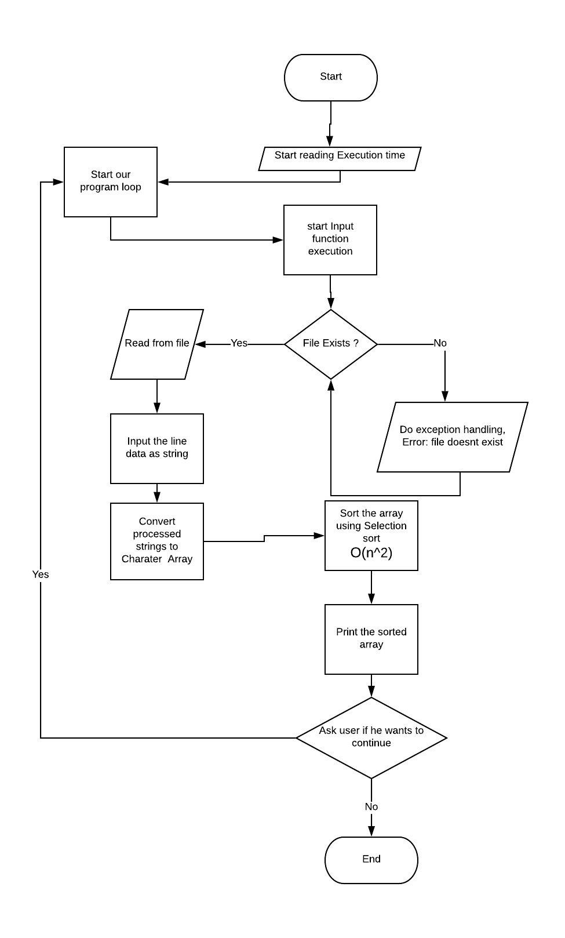

FORM 2: Modified

import java.util.*;

import java.io.*;

public class Que14{

public static Scanner sc = new Scanner(System.in);

public static Que14 obj = new Que14();

public static void main(String[] args) {

//Start time

long start = System.currentTimeMillis();

obj.cont(start);

}

public void cont(long start){

int ex=1;

do{

obj.input();

long finish = System.currentTimeMillis();

System.out.println("Time consumed: " + (finish - start) + " ms");

System.out.println("\nDo you want to continue?1.Yes 2.No");

ex=sc.nextInt();

}while(ex==1);

}

public void input(){

try{

File myObj = new File("test.txt");

Scanner myReader = new Scanner(myObj);

while (myReader.hasNextLine()) {

String data = myReader.nextLine();

System.out.print(data);

obj.convertToArray(data);

}

}

catch(IOException|ArrayIndexOutOfBoundsException e){

System.out.println("Either one of the input in file is not correct format or The file doesn't exist!!");

}

}

public void convertToArray(String str){

//seprating our file input into comma seprated array

String[] parts = str.split(",");

int len= parts.length;

//declaring our character array

int[] parsedArry = new int[len];

//filtering the integers in the string with comma sepration

// that is 1 , 2 , 3

for(int i =0; i < len; i++)

{

parsedArry[i] = Integer.parseInt(parts[i]);

}

SelectionSort(parsedArry);

System.out.print("\nThe Sorted Array is : ");

for (int i : parsedArry) {

System.out.print(i+" | ");

}

obj.out(parsedArry);

}

public static void SelectionSort(int[] arr)

{

int lowest, lowestIndex;

for(int i = 0; i < arr.length -1; i++) {

//Find the lowest

lowest = arr[i];

lowestIndex = i;

for(int j = i; j < arr.length; j++) {

if(arr[j] < lowest) {

lowest = arr[j];

lowestIndex = j;

}

}

//Swap

if(i != lowestIndex) {

int temp = arr[i];

arr[i] = arr[lowestIndex];

arr[lowestIndex] = temp;

}

}

}

public void out(int[] sorted){

try{

String sortA = Arrays.toString(sorted);

//initilized file writer method to pass true value to append the output

FileWriter myWriter = new FileWriter("E:\\Java Assignments\\Assignment3\\Output.txt",true);

myWriter.write("\n Sorted Array is : "+ sortA);

myWriter.close();

System.out.println("Successfully wrote to Output.txt");

}

catch (IOException e) {

System.out.println("An error occurred while writing");

}

}

}

Complexity

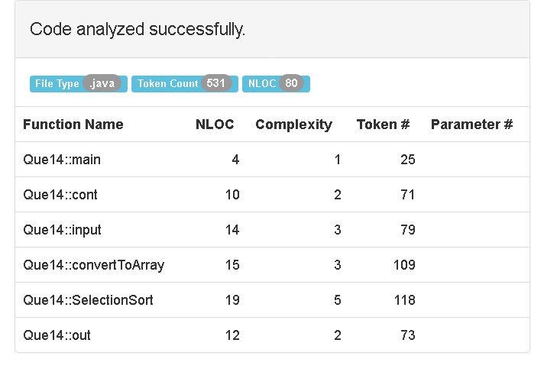

**OUTPUT:**

Our Text file for taking input -



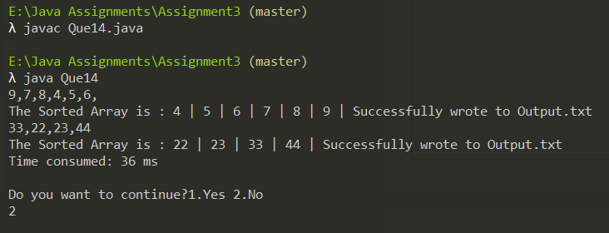

Selection Sort Execution time

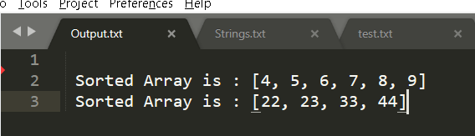



# Q15 WAP to perform BUBBLE-SORT technique on 1-D integer array.

FORM 1:- Acc to the question

import java.util.*;

public class Que15{

public static Scanner sc = new Scanner(System.in);

public static void main(String[] args) {

//inputting length

System.out.println("Enter Length of the array :");

int length = sc.nextInt();

//creating array

int a[] = new int[length];

System.out.println("Enter the array :");

//inputting array

for(int i=0; i<length; ++i){

a[i] = sc.nextInt();

}

bubbleSort(a);

System.out.println("Sorted array is : ");

for(int i=0; i<length; ++i)

{

System.out.println(a[i]);

}

}

static void bubbleSort(int[] arr) {

int n = arr.length;

int temp = 0;

for(int i=0; i < n; i++){

for(int j=1; j < (n-i); j++){

if(arr[j-1] > arr[j]){

//swap elements

temp = arr[j-1];

arr[j-1] = arr[j];

arr[j] = temp;

}

}

}

}

}

OUTPUT-



DrawBacks -

* Handling Exceptions
* Refactoring the program to make it more adaptive and organized.
* Refractoring would include creating methods for-
  + For keeping our program running
  + creating seprate function for inputting
  + Creating seprate function to convert the string to integer array
  + For Sorting the integer array
  + For outputing the output
  + For Reading multiple input from the file
  + Reading from file would include taking in the string , parsing it into integer array, then manipulating it
  + For permanently storing our output In a file
* Other than refractoring we can Pass many inputs through a CSV ( comma seprated file) is possible and it is good to have huge input processing in program so that user can use a data file to input
* For our analysis we can check the execution time of the program

**Note- we have also used CurrentTime method in System class to measure our execution time.**

**Proposed Algorithm**

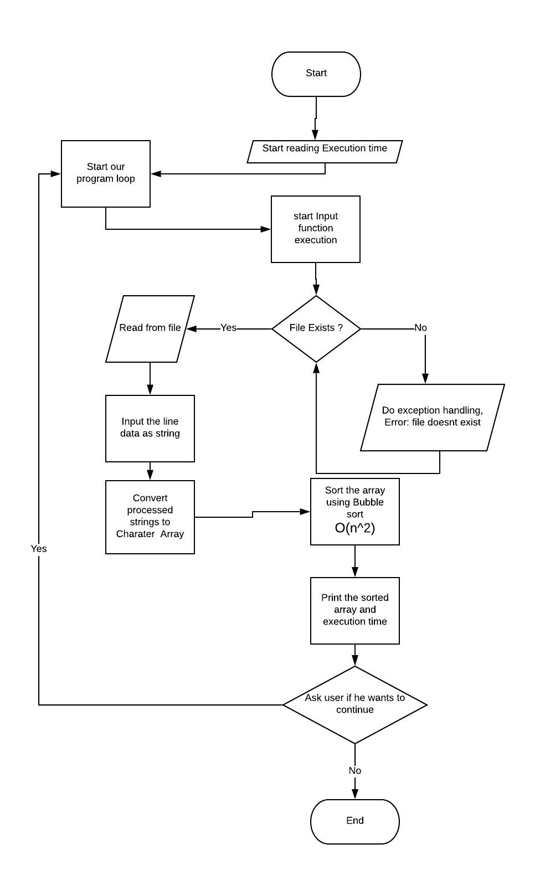

FORM 2: Modified

import java.util.*;

import java.io.*;

public class Que15{

public static Scanner sc = new Scanner(System.in);

public static Que15 obj = new Que15();

public static void main(String[] args) {

//Start time

long start = System.currentTimeMillis();

obj.cont(start);

}

public void cont(long start){

int ex=1;

do{

obj.input();

long finish = System.currentTimeMillis();

System.out.println("Time consumed: " + (finish - start) + " ms");

System.out.println("\nDo you want to continue?1.Yes 2.No");

ex=sc.nextInt();

}while(ex==1);

}

public void input(){

try{

File myObj = new File("test.txt");

Scanner myReader = new Scanner(myObj);

while (myReader.hasNextLine()) {

String data = myReader.nextLine();

System.out.print(data);

obj.convertToArray(data);

}

}

catch(IOException|ArrayIndexOutOfBoundsException e){

System.out.println("Either one of the input in file is not correct format or The file doesn't exist!!");

}

}

public void convertToArray(String str){

//seprating our file input into comma seprated array

String[] parts = str.split(",");

int len= parts.length;

//declaring our character array

int[] parsedArry = new int[len];

//filtering the integers in the string with comma sepration

// that is 1 , 2 , 3

for(int i =0; i < len; i++)

{

parsedArry[i] = Integer.parseInt(parts[i]);

}

bubbleSort(parsedArry);

System.out.print("\nThe Sorted Array is : ");

for (int i : parsedArry) {

System.out.print(i+" | ");

}

obj.out(parsedArry);

}

public void bubbleSort(int[] arr) {

int n = arr.length;

int temp = 0;

for(int i=0; i < n; i++){

for(int j=1; j < (n-i); j++){

if(arr[j-1] > arr[j]){

//swap elements

temp = arr[j-1];

arr[j-1] = arr[j];

arr[j] = temp;

}

}

}

}

public void out(int[] sorted){

try{

String sortA = Arrays.toString(sorted);

//initilized file writer method to pass true value to append the output

FileWriter myWriter = new FileWriter("E:\\Java Assignments\\Assignment3\\Output.txt",true);

myWriter.write("\n Sorted Array is : "+ sortA);

myWriter.close();

System.out.println("Successfully wrote to Output.txt");

}

catch (IOException e) {

System.out.println("An error occurred while writing");

}

}

}

Complexity

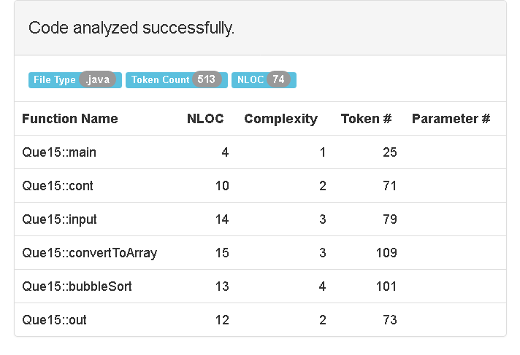

**OUTPUT:**

Our Text file for taking input -



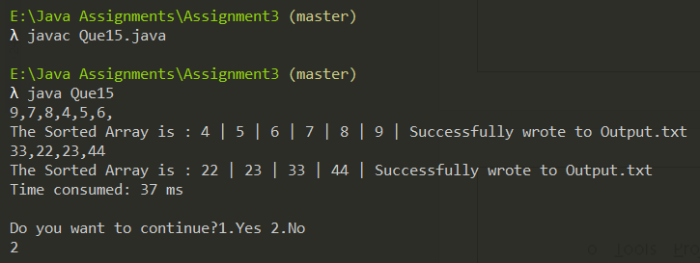

Bubble Sort Execution time





Note -

In Que 14 and 15 both the sorting algorithms have O(n2) complexity, however the selection sort was 1ms faster than the bubble sort which is due to fewer swaps being done in selection sort, this 1ms second difference could increase hugly in case of large inputs.

# References

* LucidChart.(2020). For Creating Algorithm Flowcharts . Retrived from <https://lucid.app/lucidchart/2ad0b638-ad75-44f5-8b1a-80c543902516/edit?page=0_0#?folder_id=home&browser=icon>  
  (18th Nov, 2020)
* LizardComplexityAnalyzer.(2020). For Analyzing the Complexity of The Program . Retrived from <http://www.lizard.ws/>

(18th Nov, 2020)

* GeeksForGeeks.(2020). Selection Sort . Retrived from <https://www.geeksforgeeks.org/selection-sort/>

(18th Nov, 2020)

* GeeksForGeeks.(2020). Merge Sort . Retrived from <https://www.geeksforgeeks.org/merge-sort/>

(18th Nov, 2020)

* GeeksForGeeks.(2020). Bubble Sort . Retrived from <https://www.geeksforgeeks.org/bubble-sort/>

(18th Nov, 2020)

* GeeksForGeeks.(2020). Binary Search. Retrived from <https://www.geeksforgeeks.org/binary-search/>

(18th NOV, 2020)