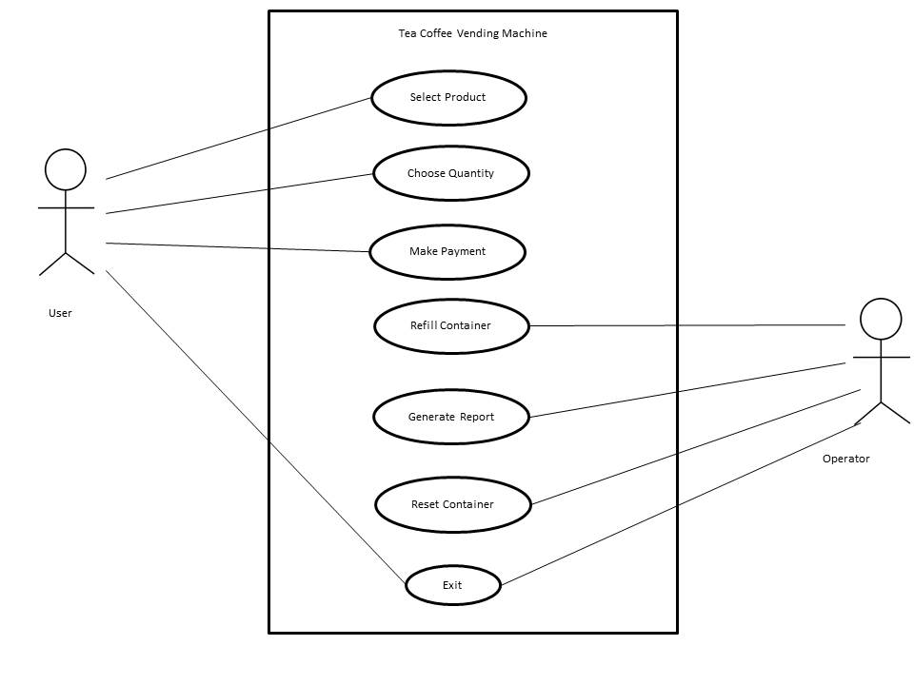 **Usecase Diagram: Tea Coffee Vending Machine** 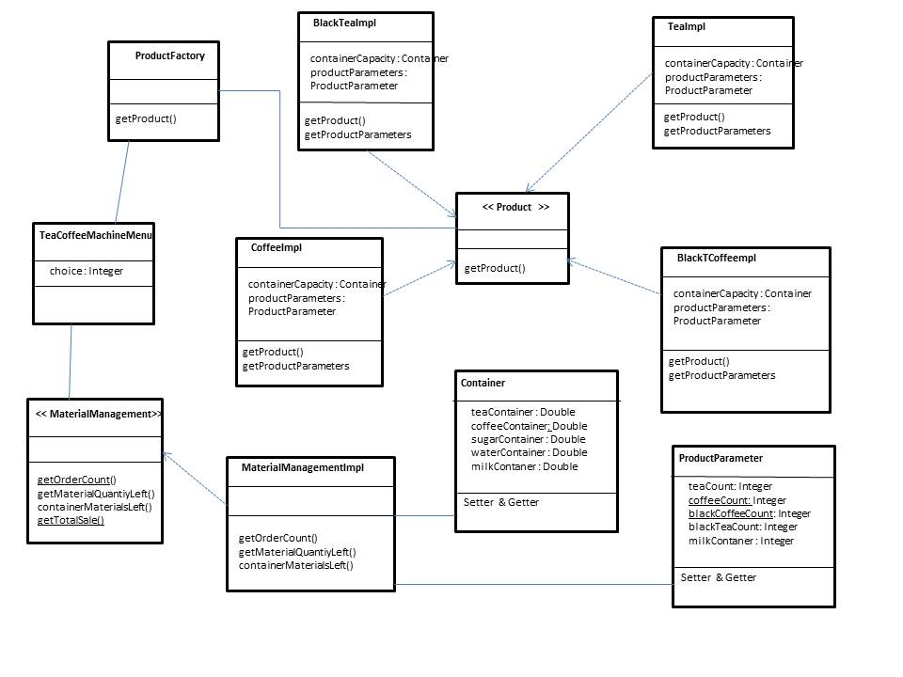

**Class Diagram: Tea Coffee Vending Machine**

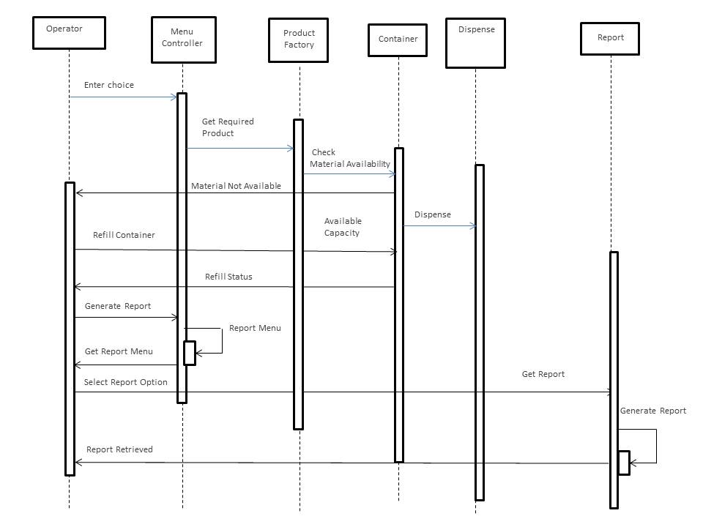

**Sequence Diagram:**  **Tea Coffee Vending Machine**