**B.Tech Project Report**

**Efficient Delivery: Route Planner**

**BACHELOR OF TECHNOLOGY IN**

**INFORMATION TECHNOLOGY**

**Submitted By: Under the Guidance Of:**

**Nitish Kumar (2K19/IT/093) Mrs. Geetanjali Bhola**

**Mehul Jain (2K19/IT/078) Assi. Prof., D.T.U**



**DEPARTMENT OF INFORMATION TECHNOLOGY**

**DELHI TECHNOLOGICAL UNIVERSITY**

**(Formerly Delhi College of Engineering), Bawana Road,**

**Delhi-110042**

**December-2020**

**Github Link** [**https://github.com/Nitish9711/Delivery-Route-Planner**](https://github.com/Nitish9711/Delivery-Route-Planner)

**CANDIDATE’S DECLARATION**

We, hereby declare that the project work entitled “Efficient Delivery: Route Planner” submitted by Nitish Kumar and Mehul Jain to Department Of Information Technology, Delhi Technological University is a record of bonfide Project work carried out by us under the guidance of Mrs. Geetanjali Bhola and this project is submitted in the partial fulfillment of the requirements for the awards of the degree of Bachelor of Technology in Information Technology. The results embodied in this thesis have not been submitted to any other University or Institute for the award of any diploma or degree.

Delhi Mehul Jain

Date: November,16,2020 Nitish Kumar

**CERTIFICATE**

This is to certify that the project entitled, “Efficient Delivery: Route Planner" submitted by Nitish Kumar and Mehul Jain in partial fulfillment of the requirements for the award of Bachelor of Technology in Information Technology under the guidance of Mrs. Geetanjali Bhola is an authentic work carried out by them under my supervision and guidance. To the best of my knowledge all the work has been done on their own and has not been copied from elsewhere without proper citation.

Delhi Geetanjali Bhola

Date: November,16,2020

**ACKNOWLEDGEMENT**

We have taken efforts in this project. However, it would not have been possible without the kind support and help of many individuals and organizations. We would like to extend our sincere thanks to all of them.

We are highly indebted to our professor Mrs. Geetanjali Bhola for their guidance and constant supervision as well as for providing necessary information regarding the project & also for their support in completing the project.

We would like to express our gratitude towards our parents & member of Delhi Technological University for their kind co-operation and encouragement which help us in completion of this project.

We would like to express our special gratitude and thanks to industry persons for giving us such attention and time.

Our thanks and appreciations also go to my colleague in developing the project and people who have willingly helped us out with their abilities.

**ABSTRACT**

**Description:**

This project deals with the **‘Efficient Delivery: Route Planner’**. The software is basically user specific and built for the manager of a corporation to have a look through the work in progress, maintaining the employees’ details, maintaining the order details and how are they being processed at what stage.

**Previous System:**

In the previous system everything had to be processed manually which at times becomes very hectic for the chief management. All the work had to be fed manually and processed manually without the assurance of authenticity and efficiency of the working/processing.

**Existing System:**

Now we have built a platform/software where in the chief managing person has the powers to make changes to employees’ file, orders’ list and also delivery an efficient route which the employees’ will follow for the betterment of the company and the timely execution of the orders. The existing system is not totally automated. Though the system is computerized to a particular extent.

The different processes involved are:

* To maintain details of bookings.
* To maintain details of employees.
* To maintain details of the routes followed by delivery persons.
* Efficiency.

**TABLE OF CONTENTS**

|  |  |
| --- | --- |
| Abstract | 5 |
| Table Of Contents | 6 |
| Chapter 1: Introduction   * 1.1 Introduction To Efficient Delivery: Route Planner   + - 1.1.1 Purpose of the Project     - 1.1.2 Why the new system?     - 1.1.3 Scope of the Project.     - 1.1.4 Bottlenecks of Existing System. | 7  7  8  8  9 |
| Chapter 2: System Development Environment   * + 2.1 HTML     - 2.1.1 What is HTML?     - 2.1.2 Some HTML Tags     - 2.1.3 HTML5   + 2.2 SQL     - 2.2.1 Features of SQL     - 2.2.2 Basic SQL Commands   + 2.3 PYTHON     - 2.3.1 Modules Used     - 2.3.2 OOPS Concepts Used     - 2.3.3 Tkinter   + 2.4 GOOGLE OR TOOLS     - 2.4.1 What is Google OR Tool?     - 2.4.2 Why we used them? | 10  10  11  11  12  12  13  13  13  14 |
| Chapter 3: Graphical User Interface   * 3.1 Login & Registration Window * 3.2 Order Employee Database Updation * 3.3 SQL Servers * 3.4 E-mail Sent * 3.5 Final Routes(Output) | 15  16  17  17  18 |
| Chapter 4: Conclusion | 19 |
| Chapter 5: References | 20 |

Chapter 1: Introduction

**1.1 Introduction To Efficient Delivery : Route Planner**

Well, our route plan holds a lot of weight for your field service business – not only do they impact your employees, but they are critical to providing a positive customer experience.

It can be challenging to build the perfect route that meets all of your requirements while allowing you to run a profitable business.

But yes, with the right technology and processes in place, it can be done!

Our focus is to increase the efficiency and customer satisfaction level.

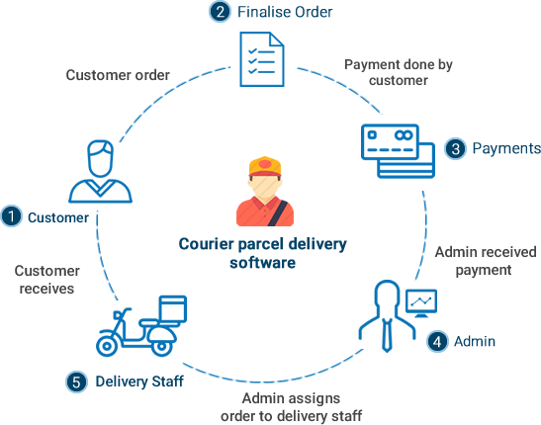

**1.1.1 PURPOSE OF PROJECT:**

This project deals with the ‘Courier management’. The system is used for daily activities such as booking, non delivery, out return, company details, hubr ates, and pickup centers. It is very difficult to do this process manually. Hence it is recommended to computerize the process by developing the relative software as the world is turning into information and technology; computerization becomes necessity in all walks of life.

**1.1.2 Why the New System?**

Nowadays, people are very busy and they don’t find much time to go to a dealer to get products. But they need to buy products. And most of the people are accessing Internet.

Then why don’t we help them in searching & getting products online. Of course this is helpful for company & dealer also to improve the sales.

**1.1.3 SCOPE OF THE PROJECT:**

Courier management computerization is “the incorporate of appropriate technology to help administrator manage information. Technology is considered appropriate, when it utilizes the most abundant domestic resources and conserves capital and skilled personnel”.

This project deals with the maintenance of booking details, incoming courier details, courier non delivery details and courier return details etc; the main aim of this project is to computerize the maintenance of courier management.

**1.1.4 Bottlenecks of the Existing System:**

The existing system has lot of problems such as:

* The entire database is maintained manually which is rather tedious and error prone.
* Time delay is more because of verification of many records for generating reports, answering querier etc.
* Queries are not answered properly due to lack of communication.
* More space is required to keep all the records.
* Improper interface.
* Inefficiency in the whole system.

Chapter 2: System Development Environment

**2.1 HTML**

**2.1.1 What is HTML?**

To publish information for global distribution, one needs a university-understood language, a kind of publishing mother tongue that all computers may potentially understand. The publishing language used by the World Wide Web is HTML (Hyper Text Markup Language).

**HTML Gives Authors The Means To:**

1. Publish online documents with headings, text, tables, list, photos etc.
2. Retrieve online information via hypertext links, at the click of a button
3. Design forms for conducting transactions with remote services, for use in searching information, making reservation, ordering products etc.;
4. Includes spreadsheets, video clips, sound clips, and other applications directly in the documents.

**2.1.2 Some HTML Tags:**

* <HTML> :Starting an HTML tag
* <HEAD> : Creating a web page’s head
* <TITLE> : Giving a web page ‘s body
* </HEAD> : Ending a web pages head
* </BODY> : Ending a web pages body
* </HTML> :Ending a web page
* <FORM> : Creating a HTML forms
* <INPUT TYPE=BUTTON> : Creating a buttons
* <INPUT TYPE=CHECKBOX> : Creating a checkboxes
* <INPUT TYPE=SUBMIT> : Creating a submit button
* <INPUT TYPE=TEXT> : Creating a text fields

**2.1.3 HTML5:**

HTML5 extends with mechanisms for style sheets, scripting, frames embedding objects, improved support for right to left and mixed direction texts, richer tables and enhancements to form, offering improved accessibilities for people with disability.

**2.2 THE SQL LANGUAGE**

SQL is a language for relational database. SQL is a non-procedural i.e., when we use SQL we specify what we want to be done not how to do it.

**2.2.1 Features Of SQL:**

1. SQL is an interactive query language.
2. SQL is a database administration language.
3. SQL is a database programming language.
4. SQL is a client/server language.
5. SQL is a distributed database language.
6. SQL is a database gateway language.

**2.2.2 Basic SQL Commands:**

1. Data Definition Language commands (DDL)
2. Data Manipulation Language commands (DML)
3. Transaction Control Language commands (TCL)
4. Data control Language commands (DCL)

**2.3 PYTHON**

Python is an interpreted, high level and general purpose programming language. Python's design philosophy emphasizes code readability with its notable use of significant whitespaces. Its language constructs and object oriented approach aim to help programmers write clear, logical code for small and large-scale projects.

**2.3.1 Modules Used:**

1. Pymongo 5. Pymysql

2. Pandas 6. Gmplot

3. Pillow 7. Numpy

4. Tkinter

**2.3.2 Object Oriented Programming Concepts Used:**

* Operator Overloading
* Inheritance
* Data Abstraction
* Data Encapsulation
* Const, Static variable and function concepts
* Constructors & Destructors

**2.3.3 Tkinter:**

**Tkinter** is the standard GUI library for **Python**. **Python** when combined with **Tkinter** provides a fast and easy way to create GUI applications. **Tkinter** provides a powerful object-oriented interface to the Tk GUI toolkit. Add one or more of the above-mentioned widgets to the GUI application. It is the base of our Graphical User Interface.

**2.4 GOOGLE OR TOOLS:**

**2.4.1 What is Google OR Tool?**

Google OR-Tools is an open source software suite for optimization, tuned for tackling the world's toughest problems in vehicle routing, flows, integer and linear programming, and constraint programming.

OR-Tools is Google’s software suite for combinatorial optimization. The suite contains:

* A constraint programming solver;
* A simple and unified interface to several linear programming and mixed integer programming solvers, including [CBC](https://projects.coin-or.org/Cbc), [CLP](https://projects.coin-or.org/Clp), [GLOP](https://developers.google.com/optimization/lp/glop), [GLPK](https://www.gnu.org/software/glpk/), [Gurobi](http://www.gurobi.com/), [CPLEX](http://www-01.ibm.com/software/commerce/optimization/cplex-optimizer/), and [SCIP](http://scip.zib.de/);
* Bin packing and knapsack algorithms;
* Algorithms for the Traveling Salesman Problem and Vehicle Routing Problem;
* Graph algorithms (shortest paths, minimum-cost flow, maximum flow, linear sum assignment).

**2.4.2 Why we used them?**

As in our problem statement we had to optimize our route and print the path on a graph, which is the basis of the famous TRAVELLING SALESMAN PROBLEM. As the TSP is a NP Hard problem and due to the efficiency required in the project and the numerous number of iterations it required we had to take up the use case of these tools provided by Google.

Chapter 3: Graphical User Interface

**3.1 LOGIN & REGISTRATION:**

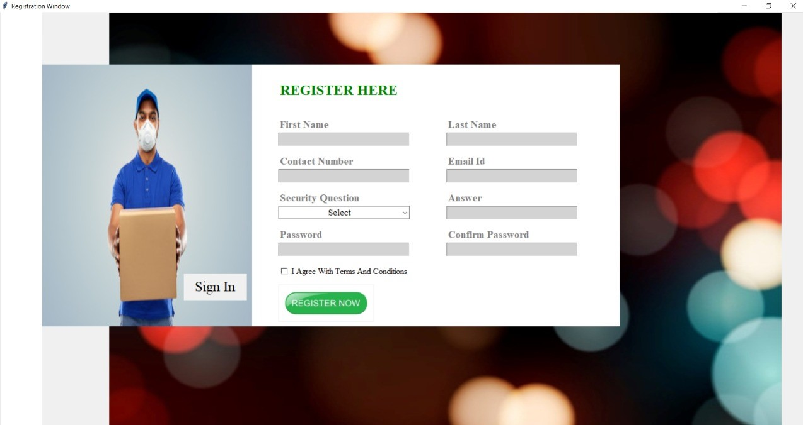

Fig. 3.1: Registration Window

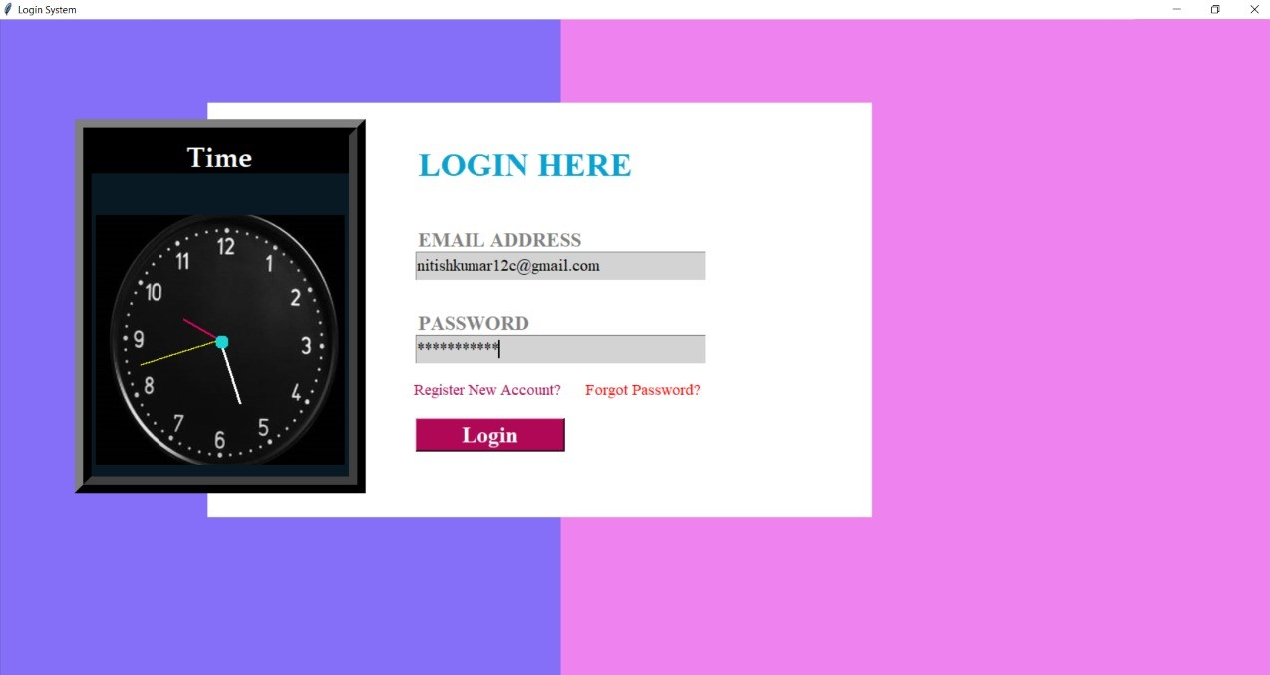

Fig. 3.2: Login Window

**3.2 Update Employees’ & Orders Database:**

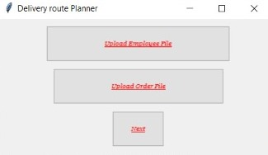

Fig. 3.3: Updation Window

**3.3 SQL Servers:**

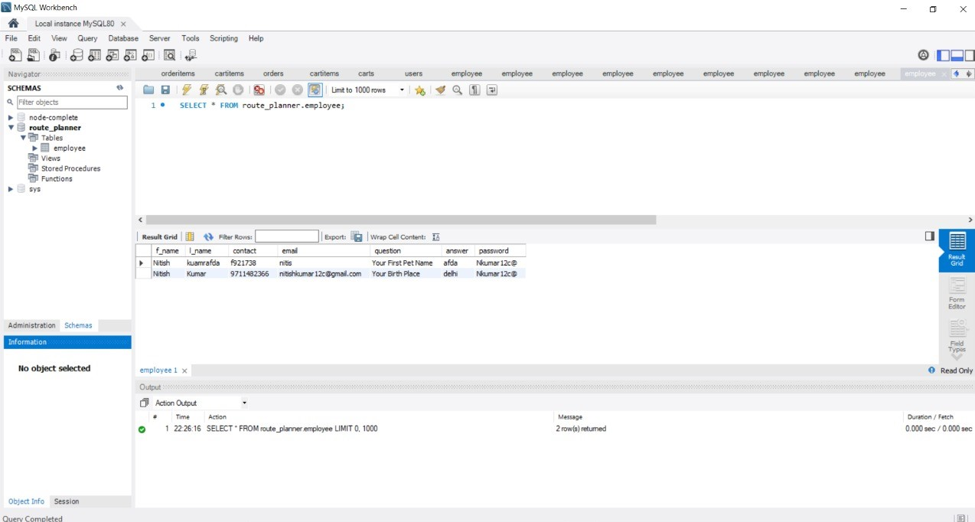

Fig. 3.4: SQL Database Servers

**3.4 Mail sent to employee’s registered Id:**

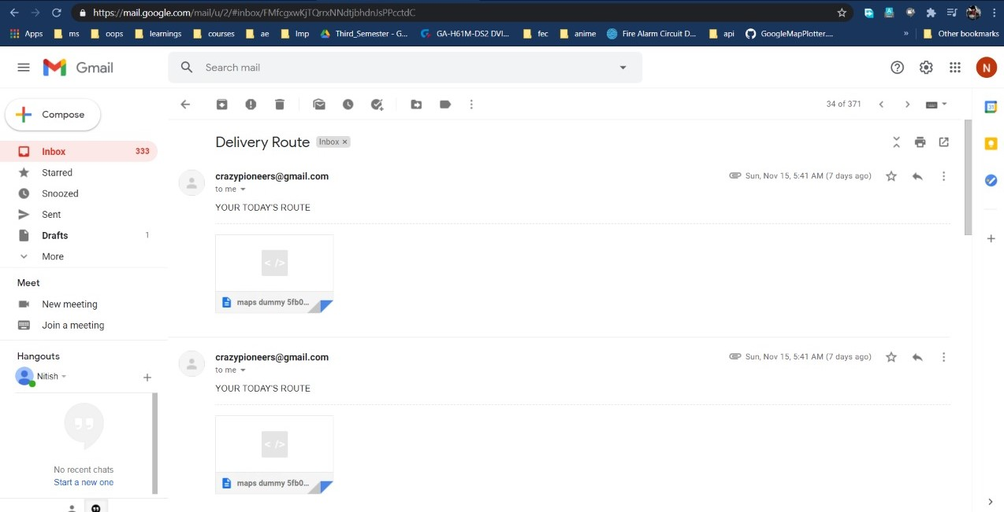

Fig. 3.5: E-mail Sent

**3.5 Routes:**

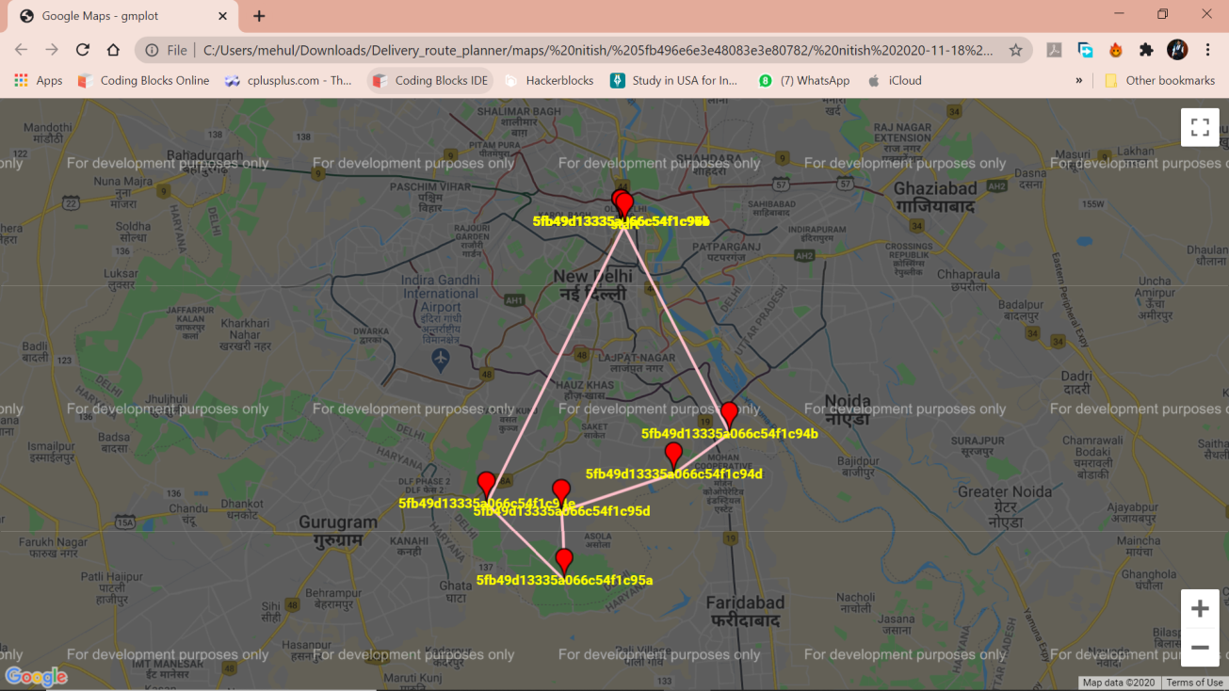

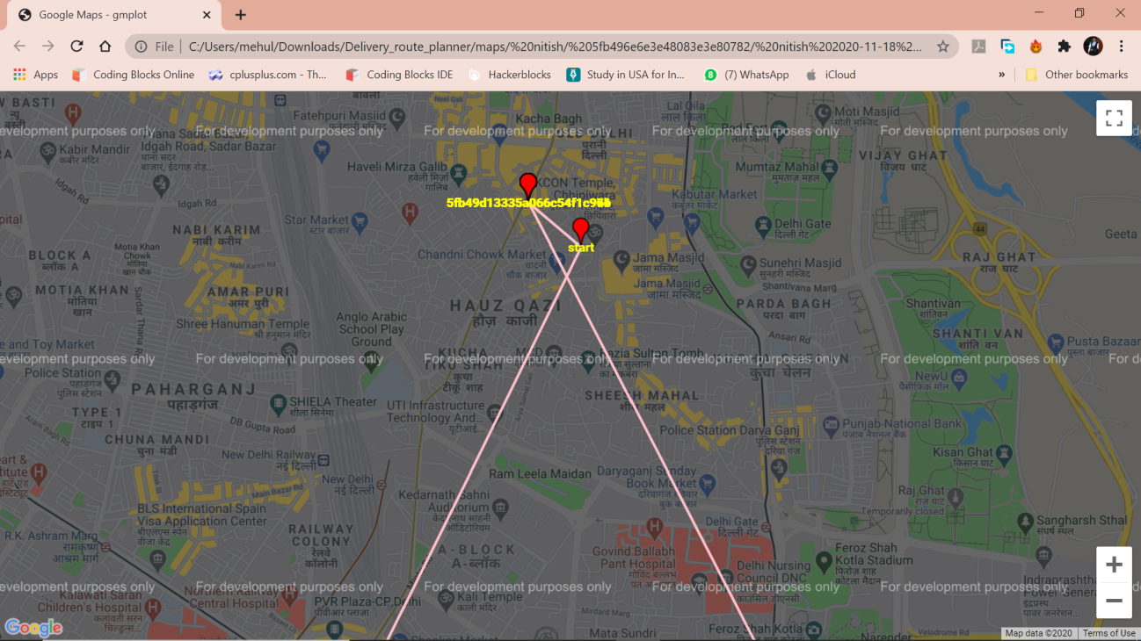

Fig. 3.6: Final Route

Chapter 4

**CONCLUSION**

The entire project has been developed and deployed as per the requirements stated by the user, it is found to be bug free as per the testing standards that is implemented. Any specification-untraced errors will be concentrated in the coming versions, which are planned to be developed in near future. The system at present does not take care off the money payment methods, as the consolidated constructs need SSL standards and are critically to be initiated in the first face, the application of the credit card transactions is applied as a developmental phase in the coming days. The system needs more elaborative technicality for its inception and evolution.

Chapter 5

**REFERENCES**

* <https://www.codementor.io/blog/basic-pathfinding-explained-with-python-5pil8767c1>
* <https://www.codementor.io/blog/basic-pathfinding-explained-with-python-5pil8767c1>
* <https://www.geeksforgeeks.org/python-program-for-dijkstras-shortest-path-algorithm-greedy-algo-7/>
* **Mastering SQL Server 2000 by**

**-Gunderloy, Jorden BPB Publications**

* **Beginning SQL Server 2000 by**

**-Thereon Willis wrox publications**

THANK YOU!