**B.Tech Project Report Automatic Toll System Artificial Intelligence and Expert System**

## Submitted By: Under the Guidance Of:

**Nitish Kumar (2K19/IT/093) Ms. Reena Tripathi**



**DEPARTMENT OF INFORMATION TECHNOLOGY DELHI TECHNOLOGICAL UNIVERSITY**

## (Formerly Delhi College of Engineering), Bawana Road, Delhi-110042

**April - 2022**

**Github:** [**https://github.com/Nitish9711/QuickToll-AIES**](https://github.com/Nitish9711/QuickToll-AIES)

# Introduction To QuickToll

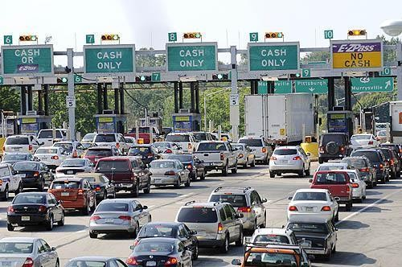The traffic on roads is increasing at a large rate. This traffic leads to high wait times at intersections and toll gates. The wait at toll gates further increases due to various reasons such as the commuters arguing with the employees at the toll gate, further time is lost due to inability to tender exact change and sometimes commuters even ask for directions at toll gates.

Figure 1.1: Traffic caused by a toll booth

Waiting at the toll station queue is a very frustrating experience. Even the vehicle’s that ply for emergency services such as ambulance and fire engines get stuck at the toll station traffic. Some commuters refuse to leave without an argument with the employees, wasting everyone else’s time. Employees are mostly harsh and are rude with the commuters. This behaviour worsens if the commuter does not have exact change to tender. Some commuters try to cut queues at the toll station which leads to minor accidents and also may lead to fights at the toll stations.

Automation of the toll station also benefits the owners of the total stationas it reduces the reliance on human resource. The employer need not employ multiple employees round the clock in different shifts. They all can be replaced by the automated system reducing labour costs and trouble from various workers unions. The only human resource that might be required are for the updating and maintenance of the system.

Automation of the toll gates will reduce all these unnecessary delays. Commuters can pay the amount due online as per their convenience. The available prototypes for automation all require a one time installation of tags on each and every vehicle. They also need human resource to process the vehicles without these tags. The tags installed can be for barcode-based recognition, NFC based recognition or Infrared based recognition. All the alternative prototypes require complex

machinery for implementation. The proposed system requires no such onetime installation and only needs a good quality camera for implementation.

The entire motivation behind developing an automation system for toll collection is from a number of reasons. The existing system using human resources been in use since a long time and is not able to catch up with the requirements of today’s society. There is an urgent need to adopt new methods of toll collection.

Another motivation of this system is to provide an online facility for paying the toll taxes. This online Payment can reduce the waiting time at the toll and can also solve the problem of tender change.

Some of the benefits which the driver has on using automated toll system are:

* No or shorter queues at toll plazas by increasing toll booth service turnaround rates.
* Faster and more efficient service.
* Facility to make online payments
* Other benefits for the motorists include fuel savings and reduced mobile emissions by reducing or eliminating deceleration, waiting time, and acceleration.

And likewise, the toll operator has his benefits too, which include:

* Lowered toll collection costs.
* Better audit control by centralizing user accounts.
* Expand capacity without building more infrastructures

# IMPLEMENTATION DETAILS:

## Automatic Toll System

This chapter gives idea about the design, architecture and working process of the automatic toll system. Automatic toll system is a user-friendly toll system which saves time and reduces traffic conjunction. A camera will capture the image of number plate of the fast-moving vehicle. Using image processing techniques, the registration number of the vehicle is extracted.

This registration is passed on to the central server. At the server, it matches the obtained number against the central database and obtains the vehicle type and the registered owner’s details. A corresponding charge is added against the owner’s name depending upon the type of vehicle as identified from the central database based on the registration number extracted from the captured image.

Explanation of work

The Automatic toll system consists of three parts,

1. Vehicle registration plate extraction
2. Vehicle registration number recognition
3. Website for paying the tax

* Vehicle registration plate extraction

In Automatic toll system a camera module will take the image of the number plate. From this image the registration number of the vehicle isextracted. Using this registration number of the vehicle toll fee is added into the database corresponding vehicle registration number. The user can pay their toll fee using the online system. The requirements in this step are that the camera should be set at an angle from where it can capture an image of the vehicle that contains the registration plate.

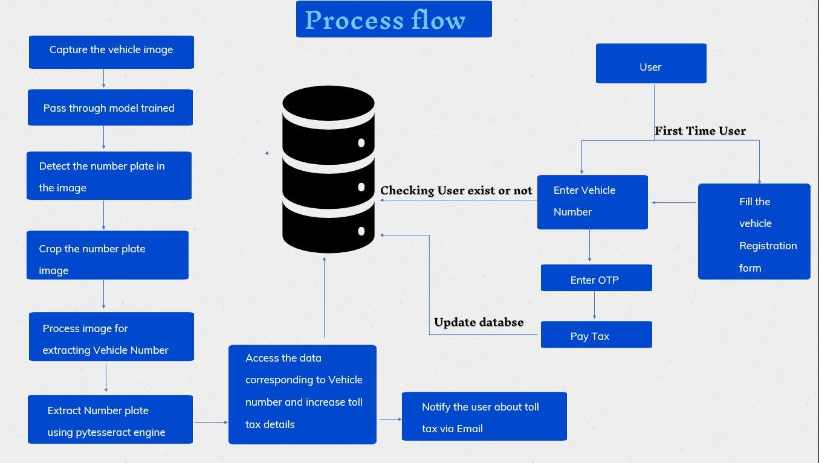

Fig : Overall Process flow

Training of number plate has been done on google colab due to the availability of high power gpu. Overall training has been done on 226 Indian Number Plate Images dataset.

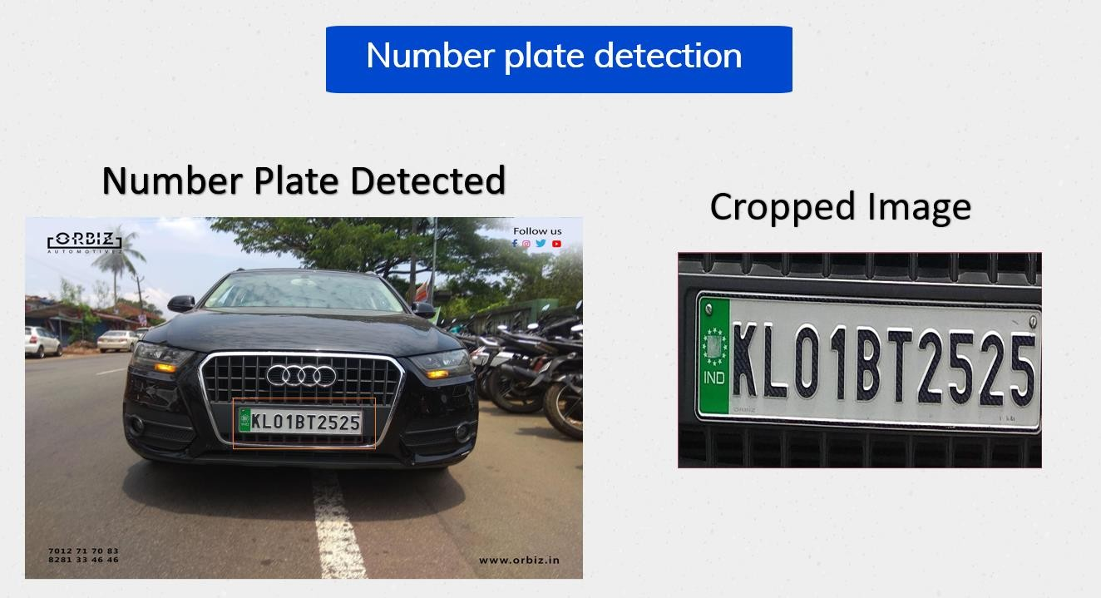

Fig 2.2 Image after passing through Trained model Text extraction

First the Cropped Imageis converted to Grey scale effectively reducing the number of colors present and reducing the complexity of the algorithm that follows.

The image is then subjected to contour mapping to identify the most important contour plain in the image. The identified contour is then retained and the all the remaining areas are blurred. This is done to reduce the importance of the background and also help with noise reduction. The output of this phase will be an image in which the element that is clear will be the vehicle registration plate and all other elements will be blurred.

The blurring ensure that all the regions except the mapped contour region are treated as unwanted and will be excluded from the image in the next phase. This image is then passed through a Gaussian filter that will filter out the image based on threshold values. The threshold value set for this system is 65. All the pixels which after going through the Gaussian filter has a Gaussian value greater than 65 are set to black and all other pixels are set to white. The process thus converts a Grey scale image to black and white.

This will further reduce the difference between the various pixels used to represent the image further reducing the complexity of the algorithm that follows. In the final image the only elements visibly detectable will be the characters of the vehicle registration number.

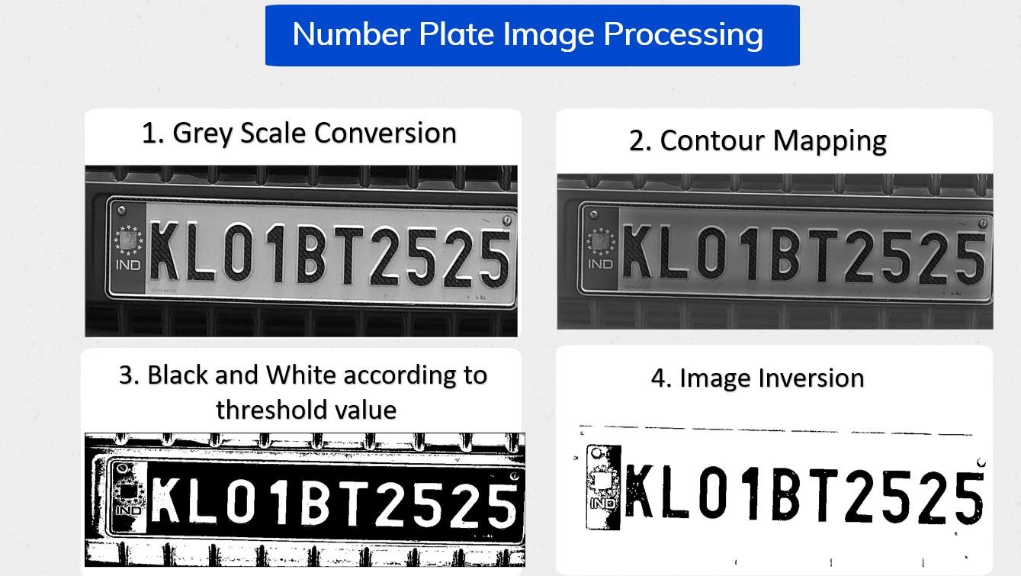

The image will be mostly dark and the characters will be in white. The image thus obtained will have all the prominent details of the image shown in white and the all the associated spaces near it shown in black. This image now needs to inverted in terms of black and white to highlight the regions necessary.

After this the image is ready for text extraction. The text extraction is done using an open source engine called Tesseract Engine.

The engine is capable of identifying many languages and characters. Hence, to improve efficiency we limit the language to English and the character set to a set of 36 characters. The 36 characters being the numbers 0-9 and the alphabets A-Z in capitals. This reduces the domain of optical character recognition functions that the engine may have to perform and will increase the efficiency as the engine now has to look only for a smaller set of characters.

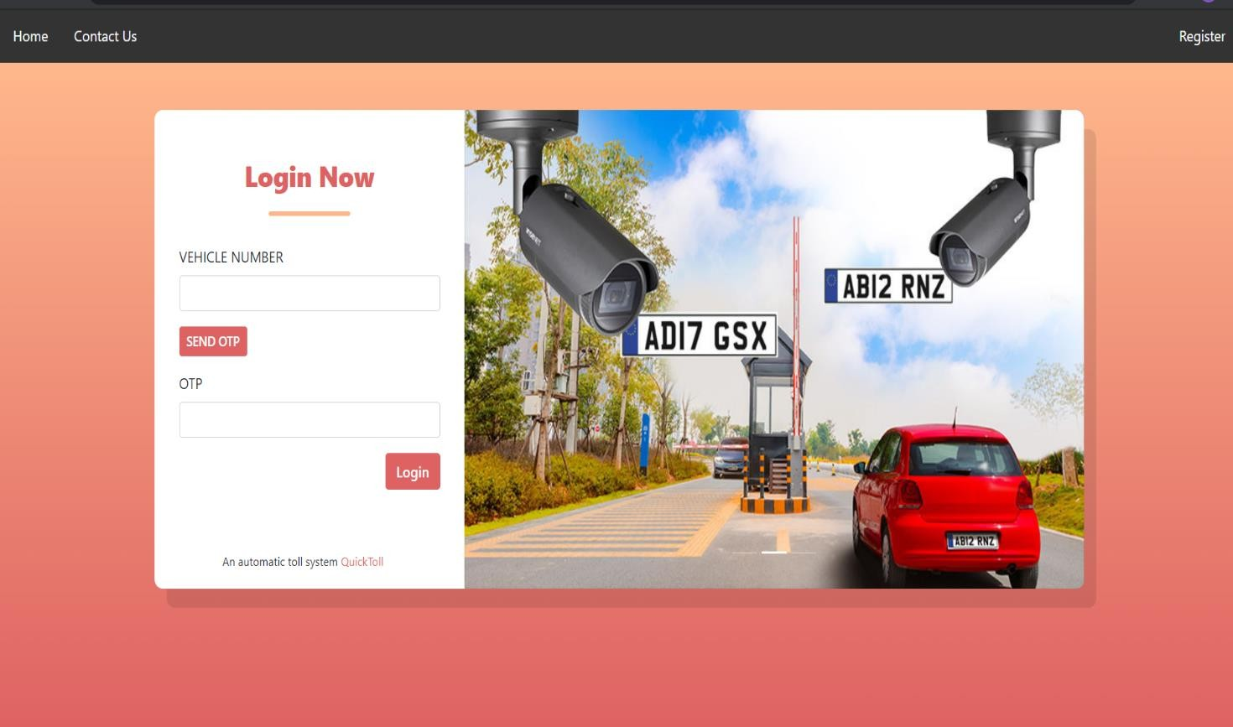

Fig: Website Login page

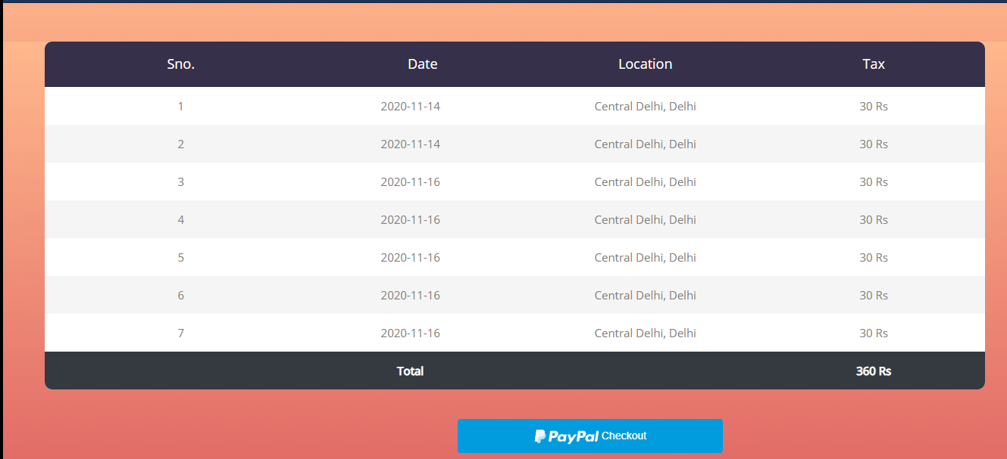

Fig: Website Payment page

# EXPERIMENTAL RESULT AND DISCUSSION:

The implementation of automated toll system will significantly contribute to improve travel conditions by addressing delay caused by both recurring and nonrecurring congestion. People hate the delay at tollbooths. This system collects toll from the vehicles driving on toll roads without making the vehicle stop at Tollbooths. These systems include benefits to both toll authorities and facility users, in terms of time and cost saving, improved security, increased capacity and greater convenience. This system provides a broad overview for collecting toll and thus provides advantage to toll operators and commuters alike.

Thus, a system used as an Automated Toll collection booth, based on image processing saves the time at toll booth, minimizes the fuel consumption during the idle condition of the vehicle. In turn we can save the environment from emission of extra carbon monoxide. Hence, we can save our country. The system helps attain automation of toll stations, the only human resource needed after the implementation of this system will be for updation and maintenance. Also, it serves in providing the tracking system for theft vehicle which is secured and highly reliable can be obtained. It can be used to remove all drawbacks with the current system such as time and human effort and it also doesn’t require any tag to be attached to all the vehicles, the only thing required is a good quality camera and fixed font number plate on each vehicle.

## REFERENCES

1. Kavya.S, Mutturaj Hubballi, Priyanka.B.N , ”Image Processing Based Toll Automation Using ANPR” , International Journal of Emerging Technologies in Computational and Applied Sciences , March-May 2015.
2. Zoe Jeffrey, Xiaojun Zhai1, Faycal Bensaali, Reza Sotudeh , Aladdin Ariyaeeinia , ”Automatic Number Plate Recognition System on an ARMDSP and FPGA Heterogeneous SoC Platforms” ,
3. Tesseract (software) , Wikipedia , 8 March 2016.
4. Rama B. Takbhate , Prof. S. D. Chavan , ”Automated Toll Booth System” , International Journal of Research Studies in Computer Science and Engineering , Volume. 1, Issue 3, July 2014.