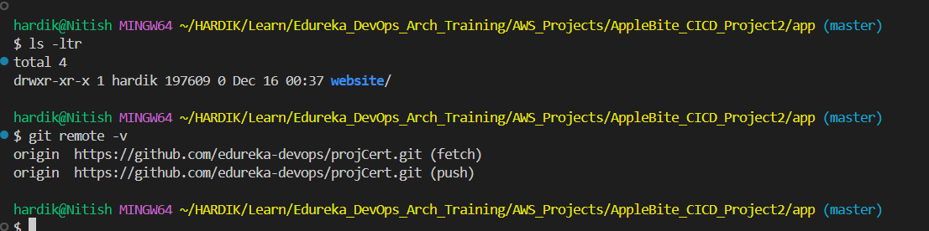
Figure 1Cloned Sample Project
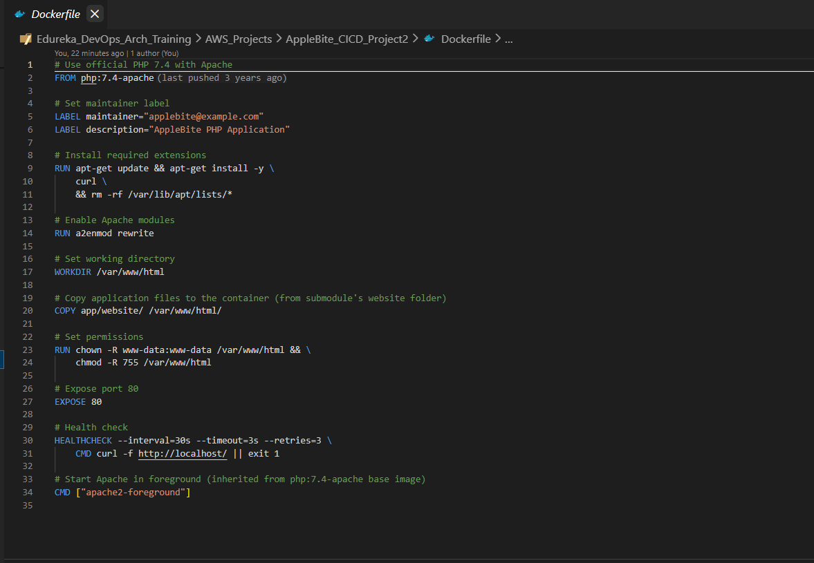
Figure 2 Dockerfile
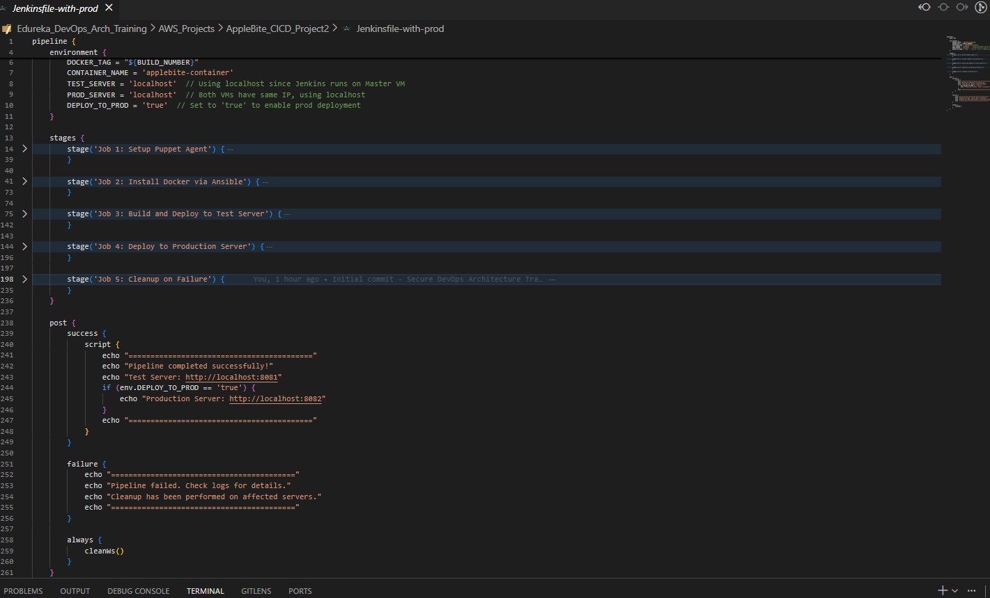
Figure 3 Jenkinsfile
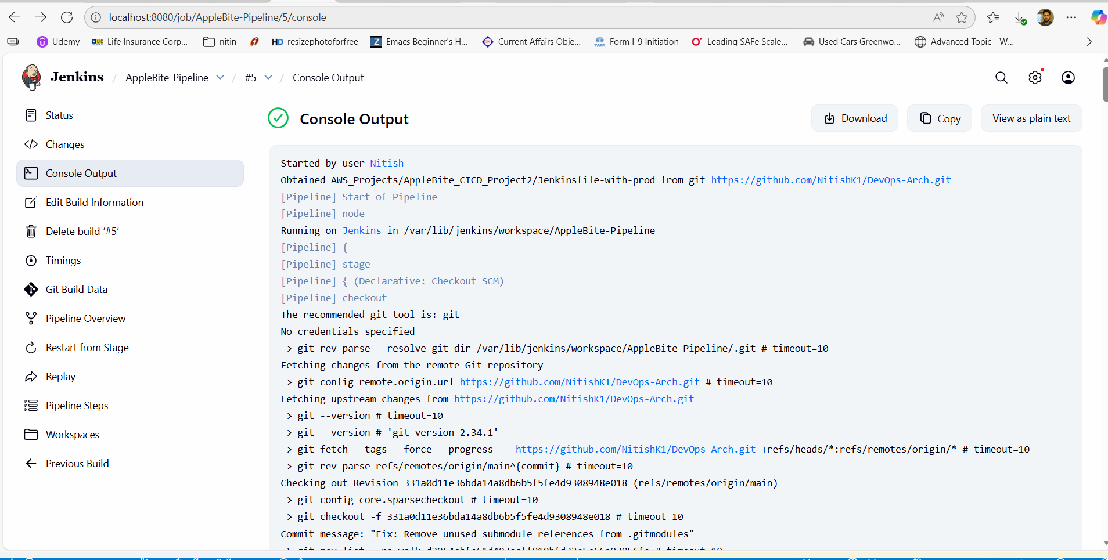
Figure 4 Jenkins Pipeline Successful Run
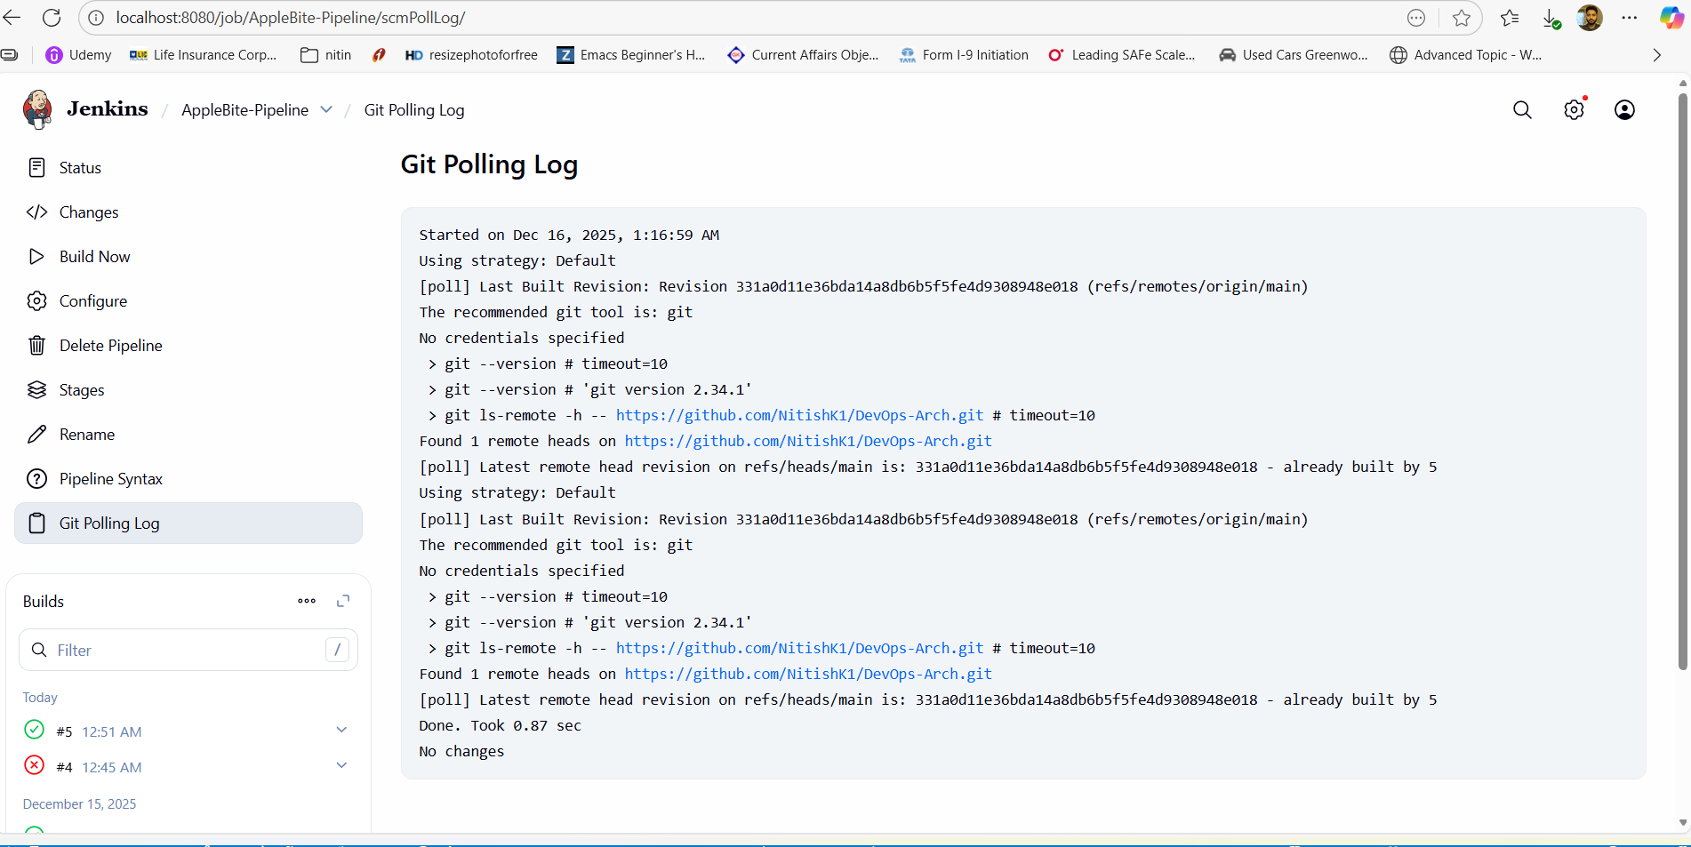
Figure 5 Jenkins Git Polling log
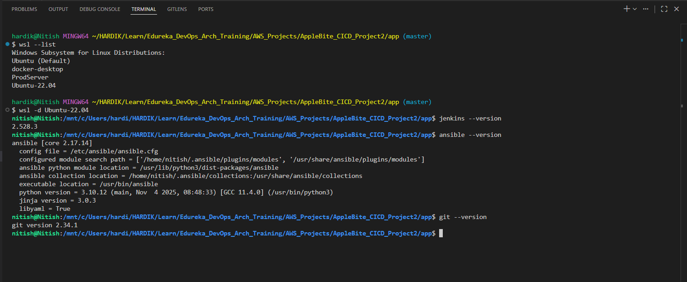
Figure 6 Jenkins, Ansible and Git Installations on Master node
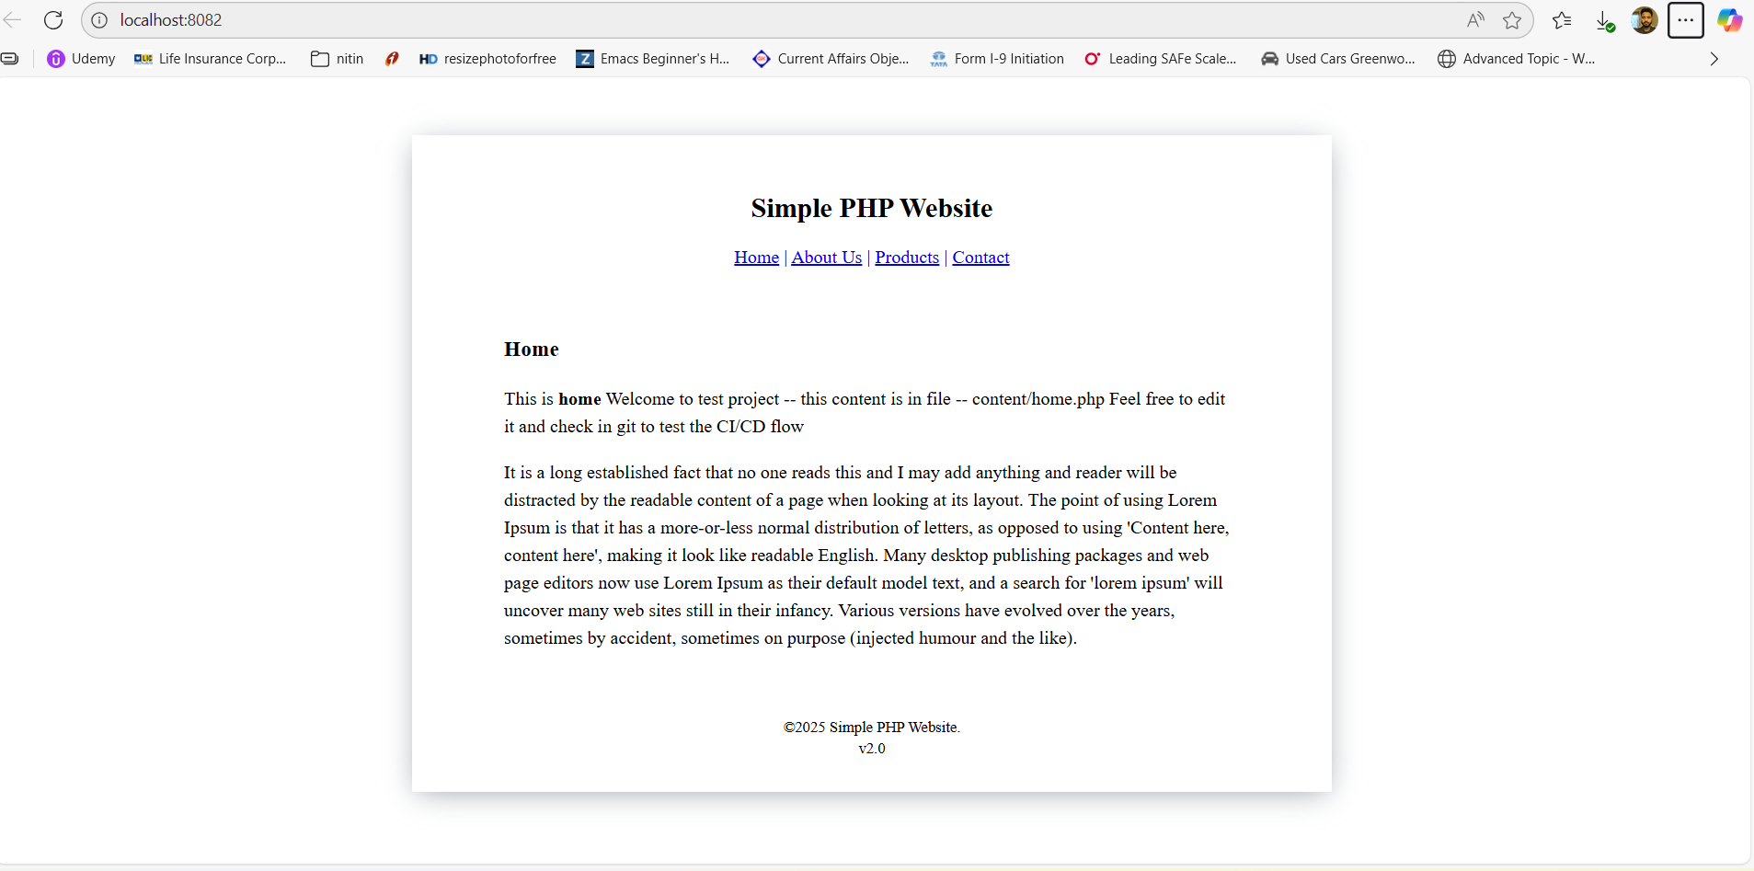
Figure 7 sample Application on Prod Server
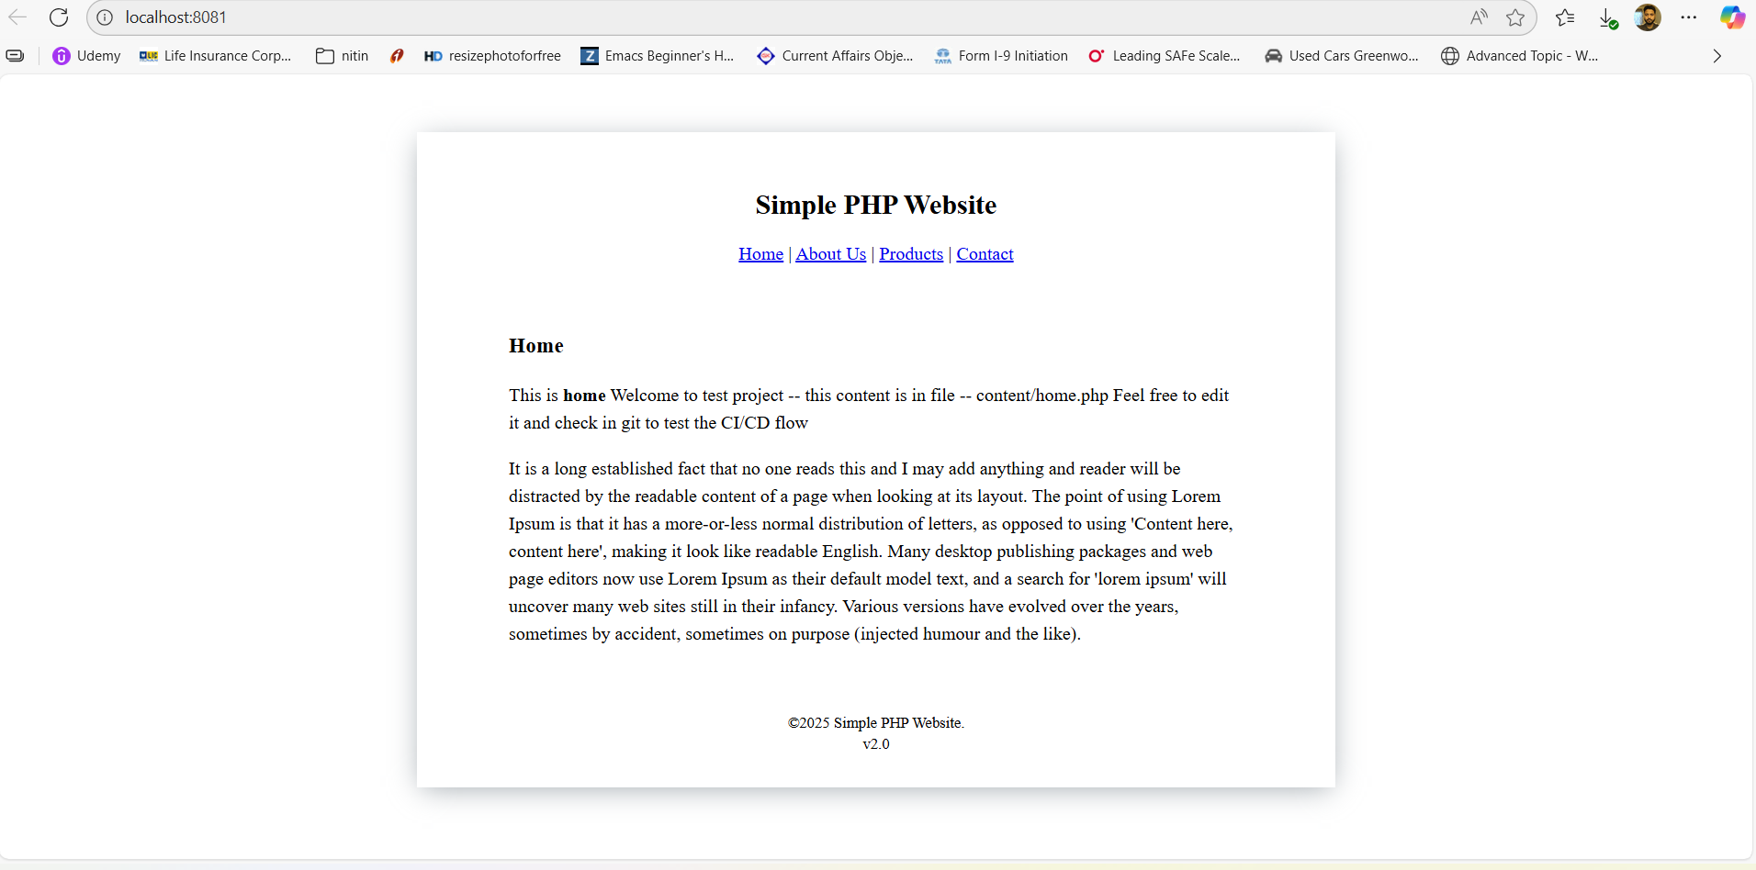
Figure 8 Sample Application on Test Server

