Q. 2.1 - 3

Taking only “yF” as the label for the given dataset

For the feature map x, experienced variance = **0.6753394473758031**

For the feature map [ 1, x, x2 ] , experienced variance = **0.6541188499275538**

Q.2.1 – 4

Experienced Variance vs Dimensions Plot

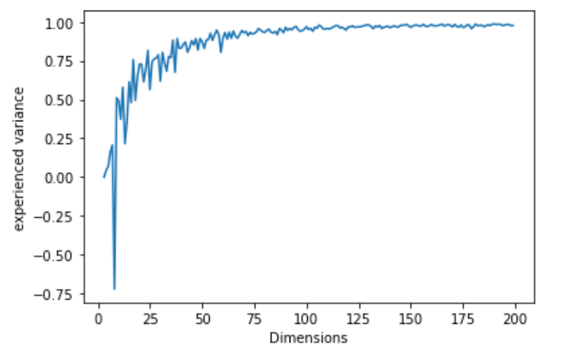

2.2 – 1

For the feature map x :

* Scikit Perceptron Class gives accuracy of **69.84126984126984 %**
* Logistic Regression gives accuracy of **68.25396825396826 %**

For the feature map [1, x, x2] :

* Scikit Perceptron Class gives accuracy of **69.84126984126984 %**
* Logistic Regression gives accuracy of **30.158730158730157 %**

2.3 – 1

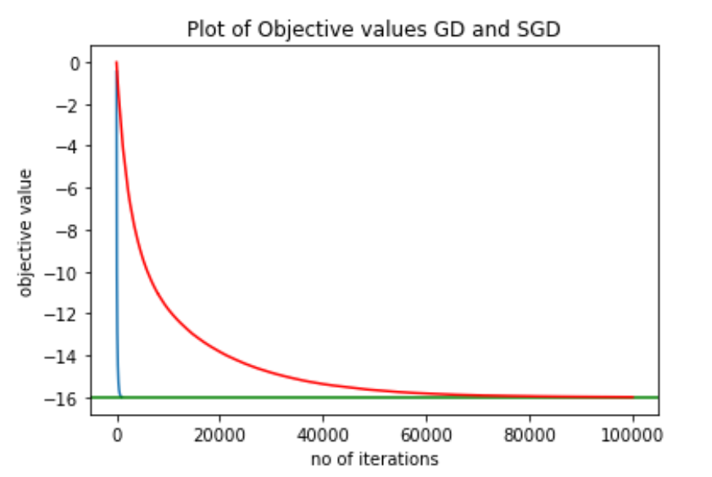

Blue is GD and red is SGD.