***Assignment - 5***

**Question 5.2.1**

1. For the **L2 – Regularized logistic regression model**

* For the feature map **x**, the most suitable value of c is **100** and accuracy score is **70.23%** andfor the unregularized logistic regression accuracy score was **68.25%**
* For the feature map **[1, x, x2]**, the most suitable value of c is **100** and accuracy score is **65.18%** and for the unregularized logistic regression accuracy score was **65.53%**

1. For the **Linear SVC**

* For the feature map **x**, the most suitable value of c is **1** and accuracy score is **63.49%** andfor the unregularized logistic regression accuracy score was **68.25%**
* For the feature map **[1, x, x2]**, the most suitable value of c is **10** and accuracy score is **66.66%** and for the unregularized logistic regression accuracy score was **65.53%**

**Question 5.2.2**

1. For the **Model Ridge – regressor**

* For the feature map **x**, the most suitable value of c is **10** and explained variance is **0.768** and for the unregularized linear regression explained variance was **0.675**
* For the feature map **[1, x, x2]**, the most suitable value of c is **0.01** and explained variance is **0.796** and for the unregularized linear regression explained variance was **0.654**

1. For the **Model SVR**

* For the feature map **x**, the most suitable value of c is **1** and explained variance is **0.754** andfor the unregularized linear regression explained variance was **0.675**
* For the feature map **[1, x, x2]**, the most suitable value of c is **100** and explained variance is **0.587** andfor the unregularized linear regression explained variance was **0.654**

**5.3.3**

**For linear kernel**

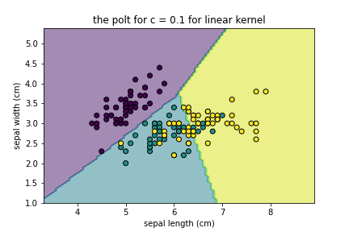 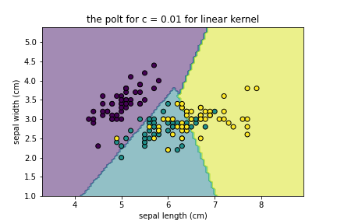

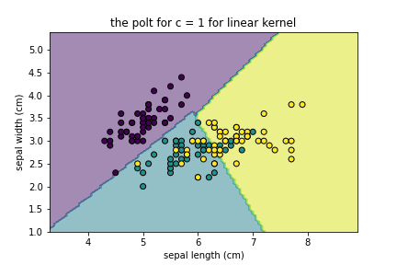 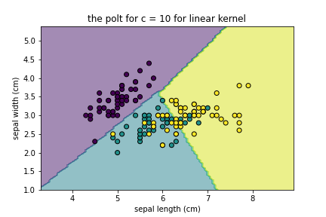

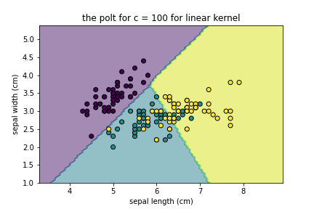

**For Poly kernel**

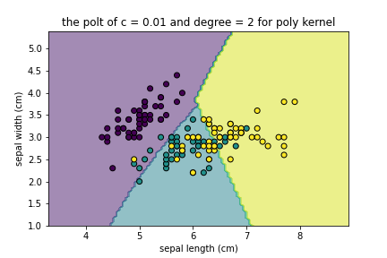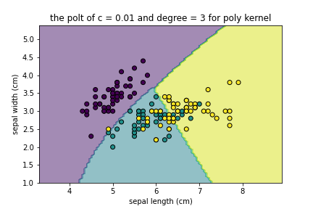

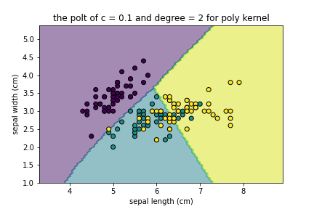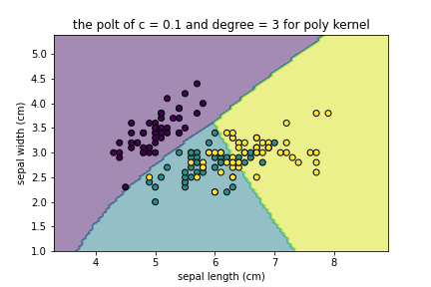

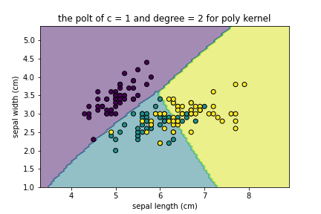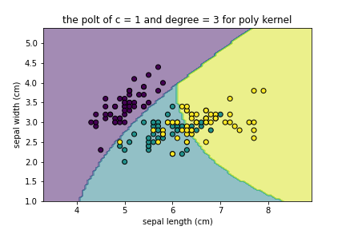

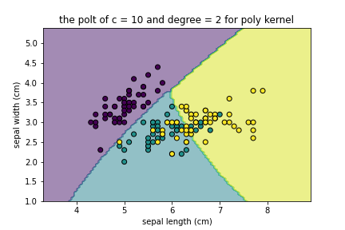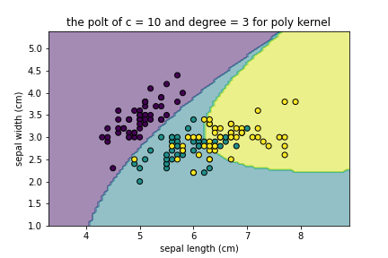

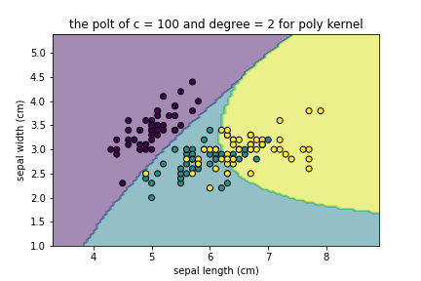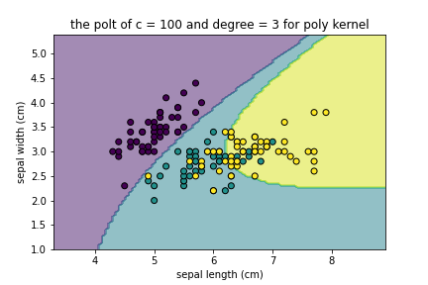

**For ‘rgf’ kernel:**

**For c = 0.01 and gamma in [0.01,0.1,1,10,100]**

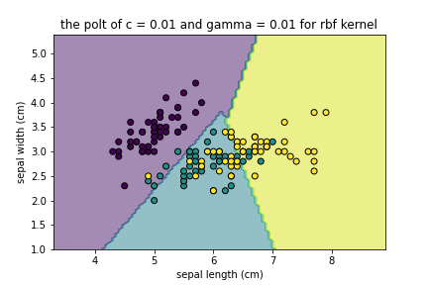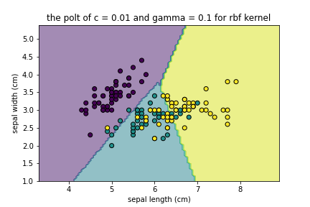

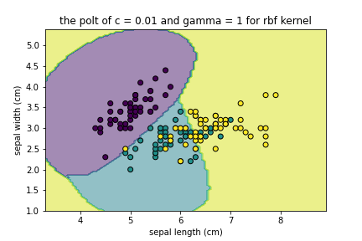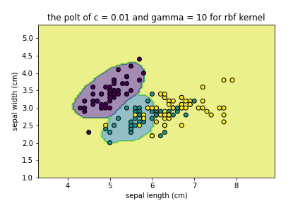

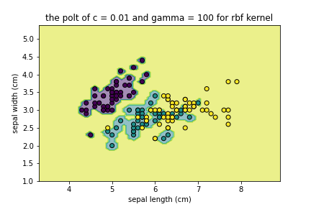

**For c = 0.1 and gamma in [0.01,0.1,1,10,100]**

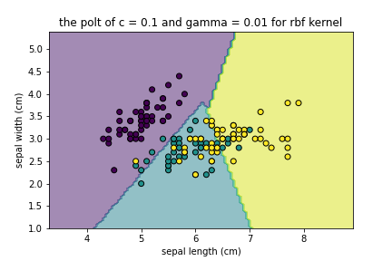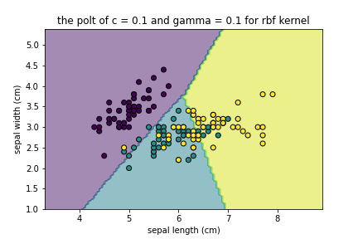

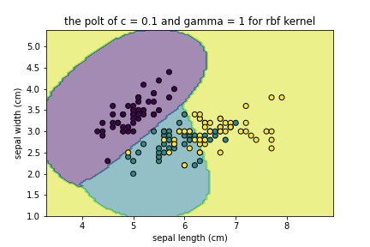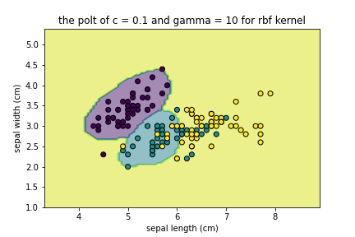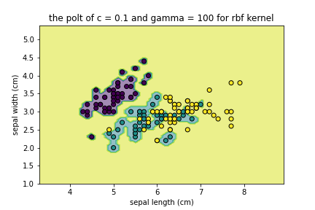

**For c = 1 and gamma in [0.01,0.1,1,10,100]**

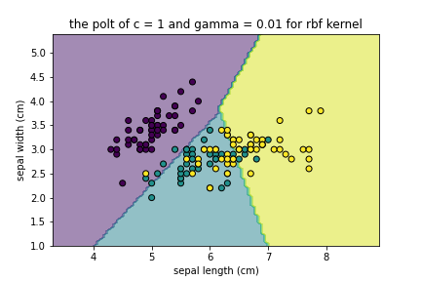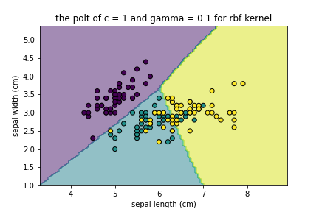

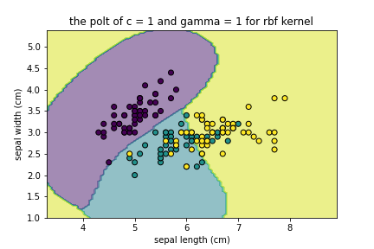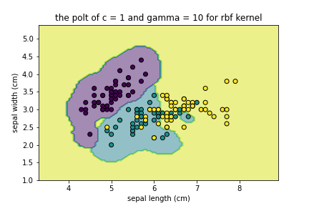

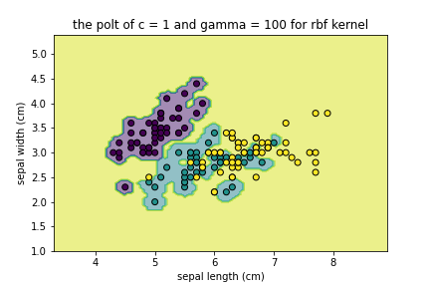

**For c = 10 and gamma in [0.01,0.1,1,10,100]**

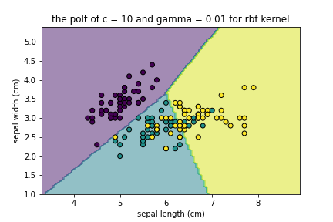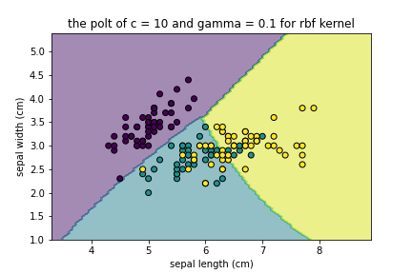

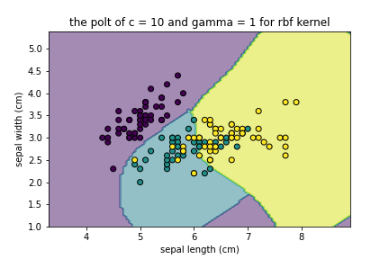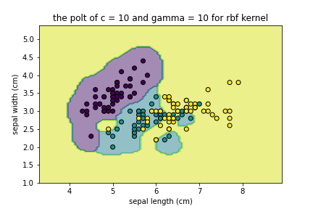

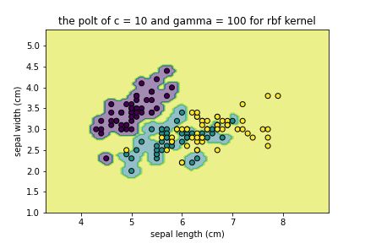

**For c = 100 and gamma in [0.01,0.1,1,10,100]**

