Q .6 .1

Plot for training loss over epochs Depth : 1 , Batch Size : 10

With accuracy : 87.2%

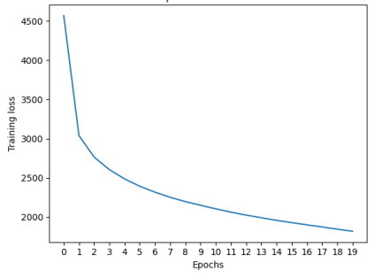

Plot for training loss over epochs Depth : 1 , Batch Size : 100

With accuracy : 87.5%

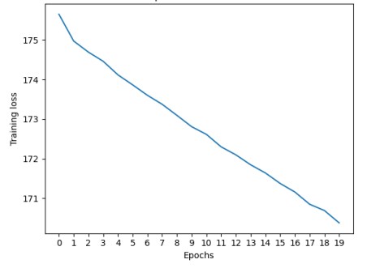

Plot for training loss over epochs Depth : 1 , Batch Size : 1000

With accuracy : 87.61%

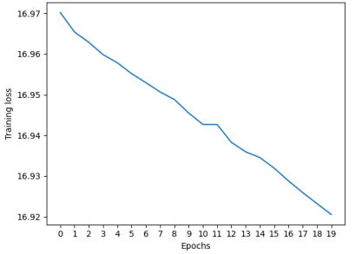

Plot for training loss over epochs Depth : 1 , Batch Size : 10000

Accuracy is : 87.55%

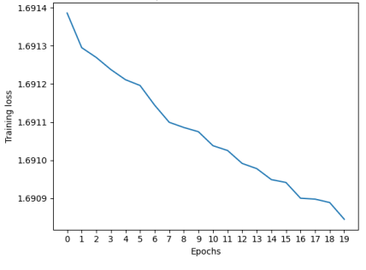

Plot for training loss over epochs Depth : 2 , Batch Size : 10

With accuracy : 87.4%

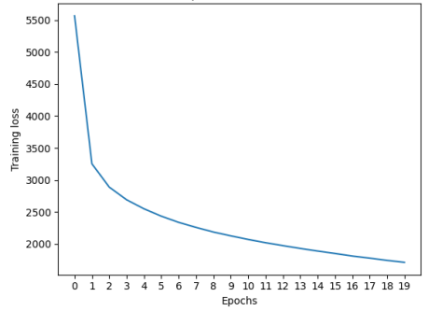

Plot for training loss over epochs Depth : 2 , Batch Size : 100

With accuracy : 88.01%

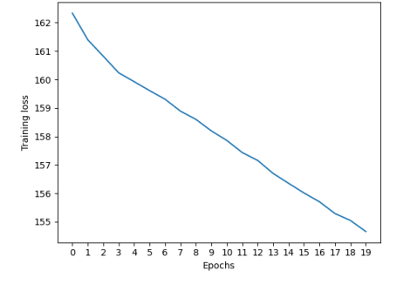

Plot for training loss over epochs Depth : 2 , Batch Size : 1000

With accuracy : 88.04%

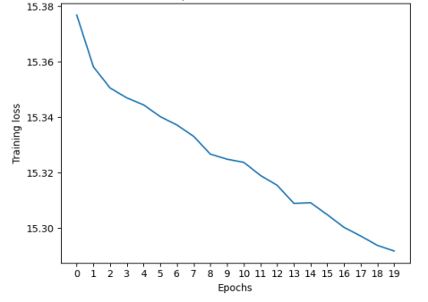

Plot for training loss over epochs Depth : 2 , Batch Size : 10000

With accuracy : 88.12%

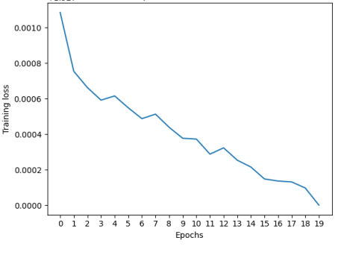

SVM :

Trained SVM: sigma = 0.1, C = 0.01: accuracy = 0.10302734375

Trained SVM: sigma = 0.1, C = 0.1: accuracy = 0.10302734375

Trained SVM: sigma = 0.1, C = 1: accuracy = 0.10302734375

Trained SVM: sigma = 0.1, C = 10: accuracy = 0.10302734375

Trained SVM: sigma = 0.1, C = 100: accuracy = 0.10302734375

Trained SVM: sigma = 1, C = 0.01: accuracy = 0.10302734375

Trained SVM: sigma = 1, C = 0.1: accuracy = 0.10302734375

Trained SVM: sigma = 1, C = 1: accuracy = 0.10302734375

Trained SVM: sigma = 1, C = 10: accuracy = 0.10302734375

Trained SVM: sigma = 1, C = 100: accuracy = 0.10302734375

Trained SVM: sigma = 10, C = 0.01: accuracy = 0.10302734375

Trained SVM: sigma = 10, C = 0.1: accuracy = 0.19921875

Trained SVM: sigma = 10, C = 1: accuracy = 0.8125

Trained SVM: sigma = 10, C = 10: accuracy = 0.82421875

Trained SVM: sigma = 10, C = 100: accuracy = 0.82421875

Trained SVM: sigma = 33.24893569946289, C = 0.01: accuracy = 0.395751953125

Trained SVM: sigma = 33.24893569946289, C = 0.1: accuracy = 0.90869140625

Trained SVM: sigma = 33.24893569946289, C = 1: accuracy = 0.9365234375

Trained SVM: sigma = 33.24893569946289, C = 10: accuracy = 0.945556640625

Trained SVM: sigma = 33.24893569946289, C = 100: accuracy = 0.9448242187

Q . 6.3

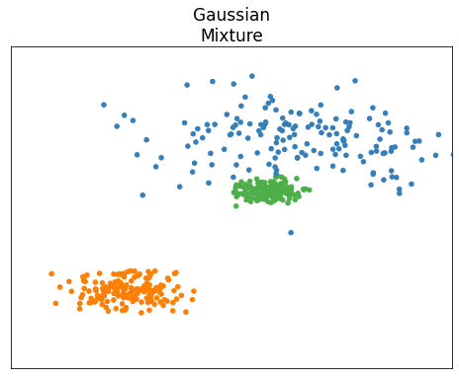

Here 0,1,2 are clusters

True parameters :

Mean of 0 : [-1.174,-1.288]

Mean of 1 : [0.755 , 1.039]

Mean of 2 : [0.409 , 0.2511]

Variance of 0 :

[[ 0.1019269 -0.00029818] [-0.00029818 0.02493694]]

Variance of 1 :

[[ 0.73527736 -0.04720549] [-0.04720549 0.15766104]]

Variance of 2 :

[[0.03158649 0.00019285] [0.00019285 0.00730099]]

MLE Parameters :

Mean of 0 : [-1.174,-1.288]

Mean of 1 : [0.755 , 1.041]

Mean of 2 : [0.422 , 0.2540]

Variance of 0 :

[[ 0.1019279 -0.00029818][-0.00029818 0.02493794]]

Variance of 1 :

[[ 0.74108496 -0.04699152][-0.04699152 0.15890399]]

Variance of 2 :

[[ 0.03092742 0.00041713] [ 0.00041713 0.00753385]]]

The Obtained parameters and the true parameters are almost same