Jindal Steel 2014 doesn’t have the net debt while in 2015 has the net debt and while in 2015 there is the mention of the net debt of 2014.
The Total debt of the Company increased from ` 4,55,265.28 lacs as at March 31, 2015 mentioned this while in the 2015 results net debt shown 4098.54.
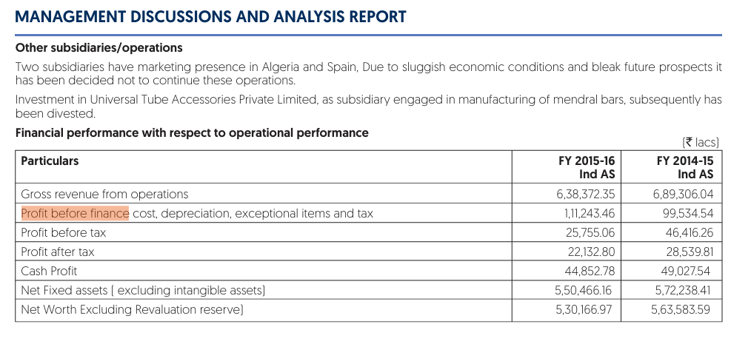

There is no mention of the standalone and all but model is considering this as standalone
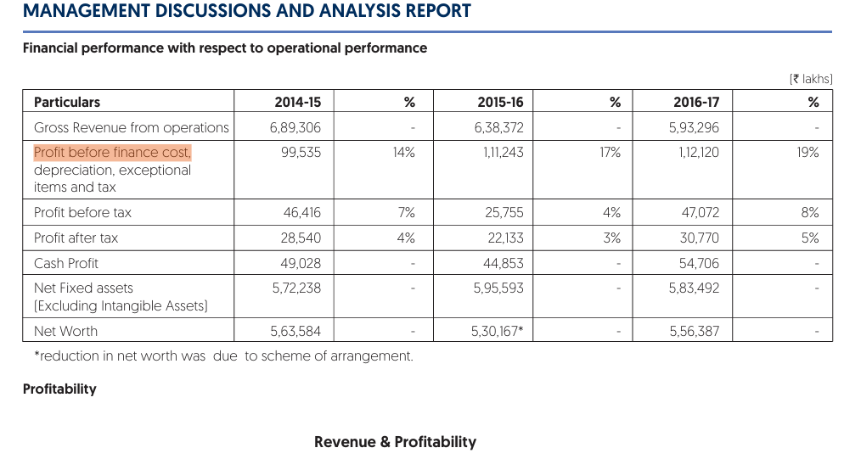
Here in the 2017 there is also considering ebitda as standalone not consolidated
In 2018 it took the Net debt of the standalone while there consolidated is mentioned, so this is a error
2019 again consolidated of net debt but not take the EBITDA
2020 model considering the EBIT and EBITDA same and the verification layer is also saying both are same, and the reasons by the model also same for both. Also here the same amount which was model earlier considering standalone, in this considering this as the Consolidated.
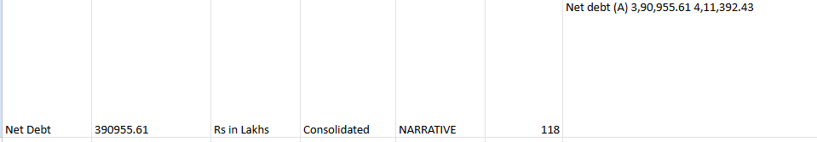
In 2020 model saying it took the consolidated value of the net debt but in actual it took the standalone value of the net debt, also mentioned the page number wrong.
In 2021 only took the net debt of consolidated not EBITDA
In 2022 it again took the EBIT and EBITDA same in verification layer too. In this net debt is mentioned three places standalone, consolidate and management discussion and at every place values are different.

