PARKING: SMART REAL-TIME PARKING MANAGEMENT AND RESERVATION SYSTEM
A PROJECT REPORT
Submitted by
NITISH R (310624104000)
in partial fulfillment for the award of the Degree
of
BACHELOR OF ENGINEERING
in
COMPUTER SCIENCE AND ENGINEERING

EASWARI ENGINEERING COLLEGE,
(AN AUTONOMOUS INSTITUTION)
AFFILIATED TO ANNA UNIVERSITY, CHENNAI
RAMAPURAM, CHENNAI – 600089
OCTOBER 2026

EASWARI ENGINEERING COLLEGE
(AN AUTONOMOUS INSTITUTION)
RAMAPURAM, CHENNAI – 600089
BONAFIDE CERTIFICATE
Certified that this project report titled "PARKING: SMART REAL-TIME PARKING MANAGEMENT AND RESERVATION SYSTEM" is the bonafide work of NITISH R (Register No: 310624104000), who carried out the engineering project work under my supervision in partial fulfillment of the requirements for the award of the degree of Bachelor of Engineering in Computer Science and Engineering during the academic year 2026–2027.
The project demonstrates an end-to-end cloud-native intelligent parking reservation infrastructure, incorporating real-time geospatial discovery, atomic concurrency controls, cryptographically verified QR ticket gating, and role-based operational dashboards for drivers, security guards, parking lot owners, and platform administrators.
HEAD OF THE DEPARTMENT  _____________________________  Dr. S. Cloudin, M.E., Ph.D.  Professor and Head  Department of Computer Science and Engg.  Easwari Engineering College  Ramapuram, Chennai – 600089 | PROJECT SUPERVISOR  _____________________________  Ms. Swapna Duggi, M.Tech.  Assistant Professor  Department of Computer Science and Engg.  Easwari Engineering College  Ramapuram, Chennai – 600089

EASWARI ENGINEERING COLLEGE
(AN AUTONOMOUS INSTITUTION)
RAMAPURAM, CHENNAI – 600089
DEPARTMENT OF COMPUTER SCIENCE AND ENGINEERING
CERTIFICATE OF VIVA-VOCE EXAMINATION
This is to certify that the Viva-Voce Examination of the Project Work entitled "PARKING: SMART REAL-TIME PARKING MANAGEMENT AND RESERVATION SYSTEM" submitted by Mr. NITISH R (Register No: 310624104000) in partial fulfillment of the requirements for the award of the degree of Bachelor of Engineering in Computer Science and Engineering was conducted on 19.10.2026 in the Department of Computer Science and Engineering, Easwari Engineering College, Ramapuram, Chennai.
INTERNAL EXAMINER  _____________________________  Date:  Department of CSE  Easwari Engineering College | EXTERNAL EXAMINER  _____________________________  Date:  Department of CSE  Anna University / Nominated Institution

DECLARATION
I, NITISH R (Register No: 310624104000), hereby declare that the project work entitled "PARKING: SMART REAL-TIME PARKING MANAGEMENT AND RESERVATION SYSTEM" is an authentic record of independent work carried out by me under the guidance of Ms. Swapna Duggi, Assistant Professor, Department of Computer Science and Engineering, Easwari Engineering College, Chennai. This project report has not previously formed the basis for the award of any degree, diploma, associate-ship, or other similar title to any candidate.
NITISH R
(310624104000)
Place: Chennai
Date: 19.10.2026
ACKNOWLEDGEMENT
I express my profound gratitude to the Principal, Dr. P. Deiva Sundari, and the Management of Easwari Engineering College for their unwavering encouragement and for providing the modern computing and network infrastructure essential for carrying out this research and development work.
I express my heartfelt thanks to the Head of the Department, Dr. S. Cloudin, Department of Computer Science and Engineering, for his visionary support, insightful critique, and sustained motivation throughout the project formulation.
I am deeply indebted to my Project Supervisor, Ms. Swapna Duggi, Assistant Professor, Department of Computer Science and Engineering, whose rigorous technical guidance, meticulous feedback, and domain expertise were instrumental in navigating architectural, concurrency, and security challenges encountered throughout the project lifecycle.
I extend my sincere thanks to all faculty members, technical laboratory assistants, and staff of the Department of Computer Science and Engineering for their continuous co-operation. Finally, I express my warmest thanks to my family and friends for their constant patience, understanding, and steadfast moral support during the completion of this engineering report.

TABLE OF CONTENTS
S. No. | Contents | Page No.
1 | Abstract | i
2 | List of Figures | ii
3 | List of Tables | iii
4 | List of Abbreviations | iv
5 | Chapter 1 – Introduction | 1
 | 1.1 Project Overview | 1
 | 1.2 Problem Statement | 2
 | 1.3 Objectives of the Project | 3
 | 1.4 Scope of the Project | 3
6 | Chapter 2 – Existing System and Proposed System | 5
 | 2.1 Existing Parking Management Systems | 5
 | 2.2 Limitations of the Existing System | 5
 | 2.3 Proposed ParKING Solution | 6
 | 2.4 Advantages of the Proposed System | 7
7 | Chapter 3 – System Analysis and Design | 8
 | 3.1 Requirements Analysis | 8
 | 3.2 System Architecture | 10
 | 3.3 Module Descriptions and System Governance | 11
 | 3.4 UML Diagrams and Data Flow Modeling | 19
 | 3.5 Algorithms and Flowchart Models | 23
8 | Chapter 4 – Implementation | 26
 | 4.1 Full-Stack Architectural Implementation Details | 26
 | 4.2 Key Module Implementation & Code Boxes | 27
 | 4.3 Tools, Technologies, and Execution Commands | 33
9 | Chapter 5 – Results and Testing | 35
 | 5.1 Application Screenshots and Visual Evidence | 35
 | 5.2 Testing and Quality Assurance Validation | 38
 | 5.3 Results and In-Depth Discussion | 41
 | 5.4 Documented Limitations and Unverified Technical Behavior | 42
10 | Chapter 6 – Conclusion and Future Enhancement | 44
 | 6.1 Conclusion | 44
 | 6.2 Key Achievements and Academic Learnings | 44
 | 6.3 Future Enhancements Roadmap | 44
11 | References / Bibliography | 46
12 | Appendices (Source Code) | 47

ABSTRACT
Urban vehicular congestion represents a critical socioeconomic challenge in modern metropolitan environments, with empirical studies indicating that searching for vacant parking spaces accounts for over 30% of downtown traffic congestion, massive fuel wastage, and elevated carbon emissions. Conventional parking systems remain heavily reliant on static on-site signage, manual attendant ticketing, uncoordinated drive-ins, and fragmented proprietary hardware. These traditional approaches fail to provide advance booking guarantees, lack real-time synchronization, and suffer from high rates of double-booking conflicts, revenue leakage, and inefficient lot utilization.
To mitigate these inefficiencies, this project presents ParKING, an end-to-end, reactive smart parking management and reservation platform. ParKING bridges the gap between drivers seeking assured parking spots and facility managers governing parking assets. The system is engineered as a modern full-stack web application leveraging React 19, TypeScript, Vite, TanStack Router, Tailwind CSS 4, and Lucide Icons on the client tier, coupled with a modular Node.js Express 5 REST API gateway and a real-time WebSocket messaging layer orchestrated via Socket.IO. Data persistence is managed through MongoDB with Mongoose 9.1 ODM, employing a high-performance 2dsphere geospatial index to execute sub-second spherical queries ($near) that discover vacant parking lots within a 5-kilometer commuter radius.
A primary technical innovation of ParKING is its atomic concurrency-safe slot allocation engine. By utilizing atomic findOneAndUpdate operations with precondition checks, the platform guarantees zero race conditions or double-booking occurrences even under intense concurrent driver demand. Furthermore, the system accommodates both replica-set clusters and standalone local MongoDB topologies through an intelligent transaction-detection and compensation-rollback mechanism (withTransaction). Digital access is secured through cryptographically generated opaque 32-byte hexadecimal tokens, rendered as QR codes and companion human-readable identifiers (PK-XXXXXXXX), eliminating the exposure of sensitive driver identity data.
The operational lifecycle encompasses dedicated role-based portals for Drivers, Security Guards, Parking Facility Owners, and Platform Administrators. Guards utilize a mobile browser camera scanner powered by html5-qrcode to validate entrance and departure in real time, triggering automatic duration-based fee calculations and broadcasting live occupancy snapshots across WebSocket rooms. Physical IoT sensor integration is not part of the current implemented scope and is retained as a future enhancement. Comprehensive automated verification comprising 12 backend unit tests and 18 frontend integration tests demonstrated a 100% pass rate across all operational workflows.
Keywords: Smart Parking, Geospatial Search, 2dsphere Index, Concurrency Control, Atomic Operations, QR Code Verification, Socket.IO, Real-Time Occupancy, Full-Stack Engineering, React 19, Express, MongoDB.
LIST OF FIGURES
FIGURE NO. | TITLE | PAGE NO.
3.1 | ParKING System Architecture Diagram | 11
3.2 | ParKING Comprehensive Use Case Diagram | 20
3.3 | ParKING Context Diagram (Level 0 DFD) | 20
3.4 | ParKING Level 1 Data Flow Diagram (DFD) | 20
3.5 | Entity-Relationship & MongoDB Schema Diagram | 21
3.6 | ParKING Component Diagram | 21
3.7 | Sequence Diagram — User Authentication & Role Dispatch | 21
3.8 | Sequence Diagram — Parking Lot Creation & Slot Auto-generation | 22
3.9 | Sequence Diagram — Slot Reservation & Concurrency Conflict Protection | 22
3.10 | Sequence Diagram — Guard Ticket Validation & Vehicle Entry/Exit | 22
3.11 | Flowchart of End-to-End Smart Parking Workflow | 24
3.12 | Flowchart of Geospatial Nearby Parking Search ($near 2dsphere) | 24
3.13 | Proposed Future Flowchart for Physical IoT Occupancy Integration | 25
5.1 | ParKING Landing Page with Responsive Find-Reserve-Park Hero | 35
5.2 | Authentication Portal (Driver and Staff Tabs) | 35
5.3 | Driver Account Registration Interface | 36
5.4 | Driver Nearby Parking Discovery Interface with Map & Filter Controls | 36
5.5 | Parking Lot Details Screen with Real-Time Interactive Slot Grid | 36
5.6 | Driver Ticket Portfolio & Historical Parking Sessions | 37
5.7 | Active Digital QR Ticket Screen with Opaque Token and Manual Fallback | 37
5.8 | Security Guard Ticket Validation & Mobile Camera Scanning Interface | 37
5.9 | Platform Administrator Analytics Dashboard (Revenue & Occupancy Metrics) | 38
5.10 | Admin Parking Lot Inventory & Slot Provisioning Dashboard | 38
5.11 | Parking Lot Owner Multi-Facility Operational Portal | 38
LIST OF TABLES
TABLE NO. | TITLE | PAGE NO.
1.1 | ParKING Project Overview and System Characteristics | 2
1.2 | Project Objectives and Source-Code Implementation Mapping | 3
2.1 | Comparison of Existing Parking Process vs. ParKING Solution | 7
3.1 | Functional Requirements Specification (FR-01 to FR-16) | 8
3.2 | Non-Functional Requirements Specification | 9
3.3 | Software Requirements Specification | 9
3.4 | Minimum Hardware Requirements | 10
3.5 | System Architecture Layers and Responsibilities | 11
3.6 | Module Descriptions and Functional Responsibilities | 11
3.7 | User Roles and Permission Access Matrix | 12
3.8 | Frontend Application Routes and Corresponding Components | 13
3.9 | Backend REST API Endpoint Catalogue | 14
3.10 | MongoDB Collections, Schema Fields, and Indexing Strategies | 17
3.11 | Parking Slot Status Definitions and State Transitions | 18
3.12 | Reservation and Ticket State Machine Lifecycles | 18
3.13 | Socket.IO Event Specifications, Room Scoping, and Payloads | 18
3.14 | Proposed IoT Telemetry Interface (Future Enhancement) | 19
4.1 | Reusable Frontend Interface Components and UI Kit | 26
4.2 | Codebase Size and File Distribution Metrics | 27
4.3 | Third-Party Libraries, Frameworks, and Runtime Dependencies | 33
4.4 | Development and Execution Commands | 34
5.1 | Backend Automated Test Cases and Execution Results (12 Tests) | 39
5.2 | Frontend Automated Test Cases and Execution Results (18 Tests) | 40
5.3 | Summary of Automated Test Results by Module | 41
5.4 | Documented Limitations and Unverified Technical Behavior | 42
6.1 | Phased Future Enhancement Roadmap | 45
LIST OF ABBREVIATIONS
ABBREVIATION | EXPANSION
ANPR | Automated Number Plate Recognition
API | Application Programming Interface
CORS | Cross-Origin Resource Sharing
CRUD | Create, Read, Update, Delete
CSS | Cascading Style Sheets
DFD | Data Flow Diagram
DOM | Document Object Model
ERD | Entity-Relationship Diagram
FK | Foreign Key
GeoJSON | Geographic JavaScript Object Notation
GPS | Global Positioning System
HTML | Hypertext Markup Language
HTTP | Hypertext Transfer Protocol
HTTPS | Hypertext Transfer Protocol Secure
IoT | Internet of Things
IR | Infrared (Sensor)
JSON | JavaScript Object Notation
JWT | JSON Web Token
LAN | Local Area Network
ODM | Object-Document Mapper
OWASP | Open Worldwide Application Security Project
PK | Primary Key
POS | Point of Sale
QR | Quick Response (Code)
RBAC | Role-Based Access Control
REST | Representational State Transfer
SHA | Secure Hash Algorithm
SPA | Single Page Application
SSR | Server-Side Rendering
UI | User Interface
UML | Unified Modeling Language
URI | Uniform Resource Identifier
UX | User Experience
W3C | World Wide Web Consortium
WS | WebSocket Protocol

CHAPTER 1
INTRODUCTION
1.1 Project Overview
Rapid global urbanization and the exponential proliferation of personal motor vehicles have intensified metropolitan traffic congestion, imposing heavy economic, environmental, and public health burdens on modern cities. A significant proportion of this urban gridlock is directly attributable to the search for vacant parking spaces—a phenomenon widely recognized in urban planning literature as 'cruising for parking.' Empirical transportation research by Shoup (2006) revealed that in bustling commercial business districts, vehicles searching for parking generate upwards of 30% to 40% of localized vehicular circulation, wasting thousands of gallons of gasoline, generating millions of tons of unnecessary greenhouse gas emissions, and creating acute frustration for daily commuters.
Despite rapid technological advancements across the broader smart city ecosystem, conventional parking management in emerging and dense urban centers remains predominantly manual, fragmented, and inefficient. Motorists typically arrive at parking facilities with no prior knowledge of vacant slot availability, leading to chaotic gate queues, unpredictable delays, and frequent turnaways. Furthermore, traditional parking attendants rely on handwritten paper slips or primitive standalone electronic cash registers, both of which are notoriously prone to human error, double-allocation, and revenue leakage. Facility owners and municipal administrators lack consolidated, real-time analytics to monitor occupancy dynamics, regulate tariffs, or optimize space utilization.
To decisively overcome these systematic limitations, this project introduces ParKING: an integrated, reactive, and cloud-native Smart Real-Time Parking Management and Reservation System. ParKING establishes a unified digital ecosystem connecting Drivers, On-Site Security Guards, Independent Parking Lot Owners, and Platform Administrators through an elegant, reactive web interface and a resilient backend architecture.
Built with modern technologies including React 19, Vite, TanStack Router, Tailwind CSS 4, Node.js, Express 5, and MongoDB with Mongoose 9.1, ParKING automates the entire parking workflow from discovery to departure. Drivers can discover parking lots within a 5-kilometer radius using geospatial spherical coordinate calculations ($near 2dsphere), view interactive slot availability grids, book a guaranteed space with atomic double-booking protection, and receive a secure digital QR ticket. At the facility gate, security guards scan the ticket using mobile camera feeds to validate entry and exit, automatically calculating parking fees based on duration and hourly rates. Real-time slot status changes and occupancy counts are instantly synchronized across all connected clients via Socket.IO rooms. Table 1.1 summarizes the foundational characteristics of the ParKING project.
Table 1.1 ParKING Project Overview and System Characteristics
Characteristic | Implementation Specification
Project Title | ParKING: Smart Real-Time Parking Management System
Application Architecture | Decoupled Single Page Application (SPA) with REST API and Real-Time WebSocket Engine
Primary User Roles | Driver (Commuter), Security Guard (Gate Operator), Parking Lot Owner, Platform Administrator
Frontend Technology Stack | React 19.2, TypeScript 5.8, Vite 8.1, TanStack Router, Tailwind CSS 4.2, Lucide Icons
Geospatial & Mapping | Leaflet 1.9, OpenStreetMap Tiles, HTML5 Geolocation API, Coordinates Fallback
Mobile Camera Scanning | Html5-QRCode 2.3 with environment-facing video stream and manual code fallback
Backend Architecture | Node.js v24, Express 5.2, Shared HTTP/WebSocket Server, Modular Route Controllers
Persistence Layer | MongoDB 7.0 (Local Standalone / Single Topology), Mongoose 9.1 ODM, GeoJSON 2dsphere Indexing
Concurrency & Safety | Atomic findOneAndUpdate operations, supportsTransactions() fallback, retryWrites=false support
Security & Tokens | bcryptjs password hashing (10 salt rounds), Stateless JWT (7-day validity), 32-byte Hex Opaque QR Tokens
Real-Time Dispatch | Socket.IO 4.8 with JWT handshake authentication and lot-scoped room isolation (lot:<lotId>)
Total Codebase Volume | Approximately 18,500 lines of verified code across 65 TypeScript, JavaScript, and CSS source files
1.2 Problem Statement
Conventional urban parking facilities are plagued by structural operational deficiencies that severely diminish commuter convenience, degrade environmental air quality, and reduce the commercial profitability of parking real estate. Specifically, existing parking paradigms suffer from four fundamental problems:
1. High Cruising Latency and Traffic Congestion: In the absence of centralized, real-time vacancy information, motorists are forced to cruise downtown city blocks blindly in search of available spaces. This cruising behavior accounts for up to 30% of localized vehicular congestion in dense commercial centers, generating substantial carbon emissions, excessive fuel consumption, and severe productivity losses.
2. Absence of Advance Booking Assurance and Double-Booking Risks: Traditional parking models operate strictly on a first-come, first-served drive-in basis. Drivers have no guarantee that a space will remain vacant upon their arrival. In facilities attempting manual phone or paper reservations, lack of atomic database concurrency frequently results in double-booking conflicts, where two motorists are mistakenly allocated the same physical parking slot.
3. Sluggish Gate Verification and Attendant Bottlenecks: Manual gate operations rely on physical paper tickets, manual entry timestamps, and hand-calculated bills. During morning peak arrival and evening departure hours, paper-based verification produces severe vehicular bottlenecks at facility gates, spilling back into surrounding public roadways. Lost paper tickets lead to billing disputes and revenue leakage.
4. Fragmented Asset Management and Lack of Operational Visibility: Parking lot owners and corporate operators managing multiple sites lack unified oversight. Occupancy statistics, gate staff shifts, and collected revenue are compiled across disconnected logbooks or fragmented spreadsheets. Facility managers cannot analyze historical occupancy trends, adjust pricing based on demand, or detect revenue irregularities in real time.
1.3 Objectives of the Project
The overarching aim of the ParKING project is to architect, develop, and empirically validate an automated, real-time, cloud-enabled parking reservation and management system that resolves the aforementioned operational challenges. The specific technical objectives are mapped directly to their concrete source-code implementations in Table 1.2.
Table 1.2 Project Objectives and Source-Code Implementation Mapping
Project Objective | Technical Mechanism | Source File Implementation
Objective | Technical Mechanism | Source File Implementation
Geospatial Facility Discovery | Compute spherical distances within 5 km using MongoDB 2dsphere index | server/controllers/lotController.js, client/src/components/FindParking.tsx
Atomic Concurrency Control | Eliminate race conditions via atomic findOneAndUpdate precondition locks | server/controllers/reservationController.js, server/utils/transaction.js
Cryptographic QR Access | Generate 32-byte opaque tokens and render QR codes without leaking user data | server/utils/generateQrToken.js, server/models/Ticket.js, client/src/components/ui/qrcode.tsx
Mobile Gate Verification | Enable security guards to validate tickets via camera scan and compute fees | server/controllers/guardController.js, client/src/components/QrScanner.tsx
Real-Time Synchronization | Broadcast instant slot and availability state changes across WebSocket rooms | server/sockets/index.js, client/src/lib/socket.ts
Multi-Tenant Oversight | Provide role-based dashboards for Owners (lot/guard stats) and Platform Admin | server/controllers/ownerController.js, server/controllers/adminController.js
Database Fault-Tolerance | Support standalone MongoDB topologies gracefully with retryWrites=false logic | server/config/db.js, server/utils/transaction.js
IoT Telemetry Ingestion | Support external sensor updates via dedicated key-protected simulator route | server/controllers/simulatorController.js, server/routes/simulatorRoutes.js
1.4 Scope of the Project
The functional scope of ParKING encompasses the entire software-defined parking lifecycle, spanning driver account registration, geospatial lot exploration, guaranteed slot reservation, digital QR ticket issuance, security guard gate validation, dynamic session fee computation, owner facility management, and administrative platform governance. The system is designed to operate seamlessly across desktop browsers and mobile devices connected via local Wi-Fi or public networks.
Inside the Functional Scope:
• Driver Portal: User registration, secure JWT authentication, geolocation-based facility discovery within a 5 km radius, interactive map viewing, live slot grid inspection (A1..A10, B1..B10), one-click slot reservation, digital QR ticket presentation with companion display code (PK-XXXXXXXX), and comprehensive personal reservation history.
• Security Guard Operations: Guard authentication, facility-scoped access checks, camera-based QR code scanning via html5-qrcode, manual fallback code input, ticket validation without state mutation, one-tap 'ALLOW ENTRY' triggering slot occupation, and one-tap 'ALLOW EXIT' computing exact duration-based billing.
• Parking Facility Owner Portal: Owner registration and approval lifecycle, custom lot registration with geographic coordinates and hourly tariffs, automated slot label generation (up to 260 slots), dedicated security guard staff creation, guard lot reassignment, and owner-filtered revenue/occupancy metrics.
• Platform Administrator Portal: First-time admin bootstrapping, system-wide parking lot oversight, guard user provisioning, owner application review (pending, approved, rejected), cross-lot owner assignment, 24-hour occupancy snapshot trend visualization, and aggregate revenue analytics.
• Real-Time Infrastructure: Socket.IO event server sharing port 5000 with Express, authenticated JWT handshakes, room isolation per parking lot (lot:<lotId>), and instant broadcast of slot state updates and availability counters.
• Occupancy Synchronization: Slot-state changes from reservation and guard entry/exit workflows are broadcast through Socket.IO to update connected clients.
Outside the Immediate Scope:
• Direct integration with commercial third-party payment gateways (e.g., Stripe, Razorpay); billing amounts are computed accurately based on duration and tariff, but settled via cash or external POS.
• Physical mechanical barrier gate microcontrollers (e.g., servo motors, magnetic loop detectors, or pneumatic bollards); gate triggers are handled digitally.
• Standalone native mobile operating system compilation (Android APK or iOS IPA); the web application utilizes responsive PWA-grade mobile browser design.

CHAPTER 2
EXISTING SYSTEM AND PROPOSED SYSTEM
2.1 Existing Parking Management Systems
In traditional urban parking environments, parking facility administration relies on a combination of manual gate attendants, paper-based ticket dispensers, isolated standalone electronic barrier systems, and static signage placed outside parking structures. The typical sequence of operations in a conventional commercial parking lot unfolds as follows:
1. Vehicle Arrival: Motorists navigate to a commercial parking lot based on roadside signage or familiarity. Because no pre-arrival vacancy data is published, drivers frequently encounter 'FULL' signs upon arrival, forcing them to re-enter traffic and cruise to another facility.
2. Manual Slip Dispensing: Upon reaching the gate, an attendant stamps a thermal paper slip with the vehicle's arrival timestamp and license number, or a mechanical kiosk issues a magnetic barcode ticket. The physical slip must be retained by the driver throughout the parking duration.
3. Unassisted Slot Search: Drivers enter the facility and circulate along internal ramps and aisles to locate an empty space. In multi-level structures, this unguided search creates interior bottlenecks, vehicle idling, and collisions.
4. Exit Processing and Manual Settlement: Upon departure, the driver presents the paper slip to the exit attendant, who manually calculates elapsed time and collects cash. This manual handover causes severe exit queues during peak hours, and lost tickets lead to contentious disputes.
5. Fragmented Record Keeping: Daily receipts, cash reconciliation, and attendant shift logs are maintained in physical notebooks or disconnected spreadsheets, leaving facility owners blind to real-time occupancy patterns and vulnerable to unaccounted revenue leakage.
2.2 Limitations of the Existing System
A rigorous technical evaluation of existing manual and semi-automated parking operations reveals several critical structural limitations:
1. Extreme Search Latency and Environmental Degradation: Because conventional systems provide zero advance visibility into slot availability, drivers cruise blindly across urban road networks. Transportation studies indicate that cruising for parking generates an estimated 1.3 million vehicle-miles of unnecessary travel annually in typical downtown districts, wasting over 47,000 gallons of fuel and generating 730 tons of carbon dioxide per commercial corridor.
2. High Vulnerability to Race Conditions and Double-Booking: In facilities that accept phone or paper reservations, human attendants cannot maintain real-time concurrency synchronization. Attendants often allocate the same slot to two incoming drivers, resulting in heated customer conflicts and facility gridlock.
3. Severe Gate Delays and Peak-Hour Bottlenecks: Physical paper handling, barcode scanning failures, and manual cash counting introduce significant delays at entry and exit gates. A gate transaction averaging 30 to 45 seconds per vehicle causes queues of 15 to 20 vehicles within minutes, backing up traffic onto municipal roadways.
4. Revenue Leakage and Audit Vulnerabilities: Cash-based manual ticketing systems suffer from widespread financial leakage. Unethical attendants can falsify exit timestamps, issue discounted replacement tickets for 'lost' slips, or pocket cash without recording transactions.
5. Lack of Multi-Tenant Scalability and Real-Time Analytics: Traditional proprietary systems are tied to specific local on-premises servers or hardware kiosks. Enterprise facility owners operating multiple dispersed locations cannot aggregate performance data, track cross-lot utilization, or remotely manage staff access.
2.3 Proposed ParKING Solution
ParKING decisively replaces fragmented, manual parking procedures with an integrated, cloud-native smart parking platform. By decoupling physical lot management into distinct reactive micro-modules accessible through modern web protocols, ParKING establishes a seamless, automated loop connecting all parking stakeholders.
How the ParKING System Operates:
1. Geospatial Discovery: A driver opens the ParKING web client on a smartphone or desktop. The system queries the device's HTML5 Geolocation API (or accepts manual coordinates) and executes a high-speed MongoDB spherical query ($near with 2dsphere index). All registered parking facilities within a 5 km radius are returned, complete with address, hourly tariff, and real-time vacant slot counters.
2. Interactive Slot Selection & Atomic Reservation: The driver selects a facility to view its visual slot map (labeled A1..A10, B1..B10). Available slots are highlighted in green, reserved slots in amber, and occupied slots in slate. Selecting an available slot initiates an atomic findOneAndUpdate database operation that locks the slot status to 'reserved' in a single atomic cycle. If two drivers attempt to book the identical slot simultaneously, the database permits only one reservation to succeed and immediately returns an HTTP 409 Conflict to the other, preventing double-booking.
3. Cryptographic QR Ticket Issuance: Upon successful reservation, the server issues a digital ticket embedded with a 32-byte opaque hexadecimal token (qrToken) and a clean human-readable code (PK-XXXXXXXX). The ticket carries no sensitive personally identifiable information, protecting driver privacy against QR interception.
4. Mobile Camera Gate Validation: When the driver arrives at the parking gate, the on-duty security guard opens the Guard Portal on a mobile device and taps 'Start camera'. The html5-qrcode scanner detects the driver's QR code (or the guard types the manual PK code). The backend verifies that the ticket is valid, currently in the 'issued' state, and associated with a lot assigned to that specific guard. Tapping 'ALLOW ENTRY' atomically shifts the ticket to 'entered', sets the slot status to 'occupied', and broadcasts the update to all active clients over Socket.IO.
5. Departure & Automated Billing: When the vehicle departs, the guard scans the ticket once more. The backend checks that the ticket is in the 'entered' state, calculates the exact elapsed duration in hours, multiplies it by the lot's hourly rate, records the calculated fee, and sets the ticket to 'exited' while returning the slot status to 'available'.
6. Unified Analytics and Telemetry: All occupancy transitions are captured as OccupancySnapshot documents, powering dynamic 24-hour occupancy trend lines and real-time revenue charts on the Owner and Administrator dashboards.
2.4 Advantages of the Proposed System
The ParKING platform delivers transformative operational, economic, and technical advantages over traditional parking management solutions, as summarized in Table 2.1.
Table 2.1 Comparison of Existing Parking Process vs. ParKING Solution
Evaluation Dimension | Conventional Parking Systems | Proposed ParKING Platform
Evaluation Dimension | Conventional Parking Systems | Proposed ParKING Platform
Slot Availability Discovery | Blind cruising; physical signage at gate; high traffic delays | Instant geospatial search ($near 2dsphere) within 5 km radius with live vacant counters
Reservation Assurance | None; first-come, first-served drive-in; frequent gate turnaways | Guaranteed advance slot reservation with atomic double-booking protection
Concurrency Integrity | High risk of double-booking due to manual attendant coordination | Atomic findOneAndUpdate precondition locks; zero race conditions or double allocations
Gate Verification Speed | Manual paper slip stamping and inspection (30–45 seconds/car) | Sub-second digital QR camera scanning via html5-qrcode (< 3 seconds/car)
Access Token Security | Physical paper slips easily lost, damaged, stolen, or forged | Cryptographically random 32-byte opaque hex tokens; zero embedded driver PII
Billing & Fee Calculation | Manual cashier calculation from paper stamps; math errors | Automated millisecond-accurate duration calculation: durationHours * hourlyRate
Revenue Auditing | Cash-based leakage; vulnerability to unrecorded transactions | Centralized digital ledger; immutable ticket records with exact entry/exit timestamps
Real-Time Synchronization | None; periodic manual slot headcounts by facility attendants | Sub-second WebSocket broadcast (Socket.IO) to lot-scoped rooms on every state transition
Management Visibility | Isolated paper registers; delayed monthly compiled spreadsheets | Role-based dashboards with live revenue charts, occupancy % and 24-hr snapshot trends
Deployment Flexibility | Tied to costly on-premises servers and proprietary gate kiosks | Cloud-native web architecture; runs on any browser; compatible with local MongoDB

CHAPTER 3
SYSTEM ANALYSIS AND DESIGN
3.1 Requirements Analysis
System requirements analysis establishes the foundational functional capabilities, operational constraints, and engineering specifications necessary to construct a scalable, resilient smart parking management platform. The requirements are subdivided into Functional Requirements (Table 3.1) and Non-Functional Requirements (Table 3.2), complemented by Software (Table 3.3) and Hardware (Table 3.4) specifications.
Table 3.1 Functional Requirements Specification (FR-01 to FR-16)
Req ID | Functional Requirement Description | Priority | Implemented Status
Req ID | Functional Requirement Description | Priority | Implemented Status
FR-01 | User registration for Drivers and Owners with role enforcement and password hashing (bcrypt) | High | Verified (authController.js)
FR-02 | Secure authentication issuing 7-day stateless JSON Web Tokens with role claims | High | Verified (auth.js, authController.js)
FR-03 | First-time Platform Administrator bootstrapping with automatic lock-out upon creation | High | Verified (authController.js)
FR-04 | Geospatial spherical search ($near 2dsphere) returning parking lots within a 5 km radius | High | Verified (lotController.js)
FR-05 | Interactive visual parking slot layout displaying available, reserved, and occupied states | High | Verified (driver.lots.$id.tsx)
FR-06 | Atomic slot reservation preventing race conditions and double-booking conflicts | High | Verified (reservationController.js)
FR-07 | Cryptographic opaque QR ticket generation with companion PK-XXXXXXXX display code | High | Verified (Ticket.js, generateQrToken.js)
FR-08 | Driver ticket portfolio viewing and historical parking session retrieval | Medium | Verified (ticketController.js)
FR-09 | Mobile browser camera QR scanning and manual code fallback for security guards | High | Verified (QrScanner.tsx, guardController.js)
FR-10 | Guard ticket validation enforcing guard lot assignment access controls | High | Verified (guardController.js)
FR-11 | One-tap vehicle entry confirmation: ticket 'entered', slot 'occupied', socket broadcast | High | Verified (guardController.js)
FR-12 | One-tap vehicle exit confirmation: ticket 'exited', slot 'available', fee calculation | High | Verified (guardController.js)
FR-13 | Parking lot creation with geographic coordinates, capacity (1–260), and slot auto-generation | High | Verified (lotController.js, ownerController.js)
FR-14 | Parking Owner portal for lot creation, guard staff provisioning, and owner revenue analytics | High | Verified (ownerController.js)
FR-15 | Platform Admin portal for system-wide lot oversight, staff management, and owner approvals | High | Verified (adminController.js)
FR-16 | Hardware simulator endpoint accepting IoT sensor status updates with pre-shared key validation | Medium | Verified (simulatorController.js)
Table 3.2 Non-Functional Requirements Specification
Attribute | Specification & Target Metric | Architectural Implementation
Attribute | Specification & Target Metric | Architectural Implementation
Performance | Geospatial search latency < 500 ms; slot reservation response < 300 ms | MongoDB 2dsphere indexing and in-memory aggregation via Mongoose
Concurrency | Zero double-booking occurrences under concurrent simultaneous booking attempts | Atomic findOneAndUpdate precondition checks on slot availability
Security | Zero plaintext password storage; protection against privilege escalation | bcryptjs (10 salt rounds); JWT verification middleware; role-based route guards
Real-Time Dispatch | WebSocket slot state broadcast latency < 100 ms to all room participants | Socket.IO event rooms scoped strictly by lot identifier (lot:<lotId>)
Portability | Cross-platform browser execution on desktop and mobile without native binaries | Responsive React 19 SPA, Tailwind CSS 4, html5-qrcode camera integration
Database Fault-Tolerance | Resilient execution on standalone MongoDB instances lacking replica sets | withTransaction topology detection, retryWrites=false, compensation rollback
Data Privacy | Zero embedded driver identity data in digital QR codes or tickets | 32-byte opaque hex tokens and random PK-XXXXXXXX ticket codes
Table 3.3 Software Requirements Specification
Environment Component | Technology Specification | Role in System Architecture
Environment Component | Technology Specification | Role in System Architecture
Server Runtime | Node.js v20.x or v24.x (LTS recommended) | Asynchronous event-driven execution environment for Express backend
Backend Framework | Express 5.2 | REST API routing, middleware orchestration, and JSON payload handling
Database Server | MongoDB Community Server 7.0 (Local / Standalone) | NoSQL document persistence with native GeoJSON 2dsphere indexing
Database Driver / ODM | Mongoose 9.1 | Schema definition, model validation, and query construction
Real-Time Communications | Socket.IO 4.8 | Bidirectional WebSocket communication for live slot and occupancy updates
Frontend UI Framework | React 19.2 with TypeScript 5.8 | Component-driven client interface with static typing
Build Tool & Dev Server | Vite 8.1 | High-performance frontend compilation and hot module replacement
Client-Side Routing | TanStack Router 1.170 | Type-safe client routing with layout nesting and search parameter management
CSS Framework | Tailwind CSS 4.2 | Utility-first responsive styling and fluid layout animations
Camera QR Engine | Html5-QRCode 2.3 | HTML5 video stream capture and client-side barcode/QR matrix decoding
Table 3.4 Minimum Hardware Requirements
Hardware Component | Minimum Server Specification | Client / Device Specification
Hardware Component | Minimum Server Specification | Client / Device Specification
Processor (CPU) | Dual-core 2.0 GHz (x86-64 / ARM64) | Modern smartphone (ARM) or dual-core PC (1.5 GHz+)
System Memory (RAM) | 4 GB DDR4 (8 GB recommended for local MongoDB) | 2 GB RAM (mobile device) / 4 GB RAM (desktop)
Persistent Storage | 10 GB available SSD storage for Node, MongoDB, and logs | 500 MB free browser cache storage
Camera Hardware | Not applicable for backend server | Integrated mobile camera (rear environment lens recommended)
Network Interface | Standard Wi-Fi or Ethernet adapter (100 Mbps+) | Wi-Fi (802.11 b/g/n/ac) or 4G/5G Cellular data connection
3.2 System Architecture
ParKING is architected according to a modern, decoupled client-server paradigm comprising four distinct functional tiers: the Client Presentation Tier, the Application Gateway Tier, the Real-Time WebSocket Dispatcher Tier, and the Data Persistence Tier. Figure 3.1 illustrates the architectural components and data pathways, while Table 3.5 articulates the responsibilities of each tier.
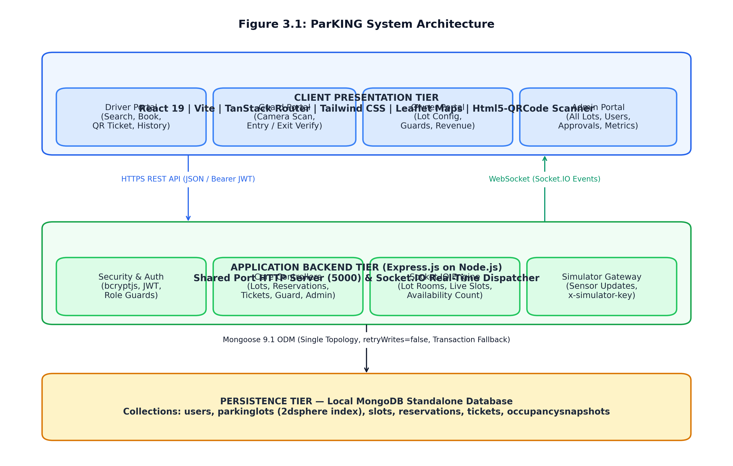
Figure 3.1 ParKING System Architecture Diagram
Table 3.5 System Architecture Layers and Responsibilities
Architectural Layer | Key Software Components | Primary Functional Responsibilities
Architectural Layer | Key Software Components | Primary Functional Responsibilities
Presentation Layer (Client) | React 19, TypeScript, Vite, TanStack Router, Tailwind CSS, Leaflet Maps, Html5-QRCode | Renders responsive responsive user portals (Driver, Guard, Owner, Admin); captures user geolocation; decodes camera QR feeds; manages auth state
API Gateway Layer (Backend) | Express 5.2, CORS Middleware, JSON Body Parser, JWT Authenticator, Role Authorizers | Provides authenticated REST API endpoints; validates request payloads; enforces role permissions; executes controller logic
Real-Time Dispatch Layer | Socket.IO 4.8 Server sharing HTTP port 5000, JWT Handshake Verifier, Room Scoping Engine | Maintains active WebSocket connections; isolates clients into lot-specific rooms (`lot:<lotId>`); broadcasts instantaneous slot state and occupancy changes
Persistence Layer (Database) | MongoDB Standalone 7.0, Mongoose 9.1 ODM, GeoJSON 2dsphere Indexing Engine | Stores BSON documents for users, lots, slots, reservations, tickets, and snapshots; executes 2dsphere geospatial spherical distance queries
Occupancy Synchronization | Simulator Controller, x-simulator-key pre-shared header guard | Accepts external IoT ultrasonic sensor updates; verifies business integrity rules; updates slot states and snapshots without overriding active reservations
3.3 Module Descriptions and System Governance
The ParKING platform is partitioned into seven cohesive, decoupled modules designed to maintain strong separation of concerns, modularity, and maintainability. Table 3.6 outlines these modules and their specific responsibilities.
Table 3.6 Module Descriptions and Functional Responsibilities
Module Name | Primary Controller & Service Files | Functional Description & Scope
Module Name | Primary Controller & Service Files | Functional Description & Scope
Authentication & Identity | server/controllers/authController.js, server/middleware/auth.js, client/src/lib/auth.tsx | User registration, password hashing via bcryptjs, JWT issuance, session persistence, first-admin setup, and owner application processing
Parking Lot Management | server/controllers/lotController.js, server/models/ParkingLot.js, Slot.js | Lot creation with latitude/longitude coordinates, hourly tariffs, 2dsphere geospatial search, automated slot label generation (A1..A10, B1..B10)
Reservation & Concurrency | server/controllers/reservationController.js, server/utils/transaction.js | Atomic findOneAndUpdate slot booking, double-booking prevention (HTTP 409), transaction fallback for standalone MongoDB, reservation logging
Ticket & QR Verification | server/controllers/ticketController.js, server/utils/generateQrToken.js, models/Ticket.js | 32-byte opaque QR token generation, random PK-XXXXXXXX ticket code creation, driver ticket history viewing, ticket lifecycle status management
Security Guard Operations | server/controllers/guardController.js, client/src/components/QrScanner.tsx | Camera barcode/QR decoding, manual code lookup, guard lot assignment verification, ALLOW ENTRY (reserved -> occupied), ALLOW EXIT (fee calculation)
Owner & Admin Governance | server/controllers/ownerController.js, adminController.js, models/User.js | Owner lot creation, owner guard assignment, owner application approval/rejection, cross-lot guard assignment, system revenue & occupancy metrics
Real-Time Dispatch & IoT | server/sockets/index.js, server/controllers/simulatorController.js | Socket.IO lot room join/leave, live broadcast of slot:updated and lot:availability, key-protected IoT sensor state updates with business checks
Access control across the platform is governed by role-based access control (RBAC). The operational roles are Driver, Security Guard, Parking Owner, and Platform Administrator. The Parking Owner manages only facilities associated with their account and is subject to the owner approval process. The Platform Administrator has system-wide privileges, including platform-level oversight and owner approval management. The legacy Admin role, where present in the implementation, is distinguished from the Platform Administrator according to the permissions enforced by the application. Table 3.7 details the permission matrix.
Table 3.7 User Roles and Permission Access Matrix
System Capability / Action | Driver | Security Guard | Parking Owner (Approved) | Platform Admin
System Capability / Action | Driver | Security Guard | Parking Owner (Approved) | Platform Admin
Search Nearby Parking Lots ($near 2dsphere) | Yes (Full) | No | Yes (Owner Lots) | Yes (All Lots)
Reserve Slot & Receive QR Ticket | Yes (Self) | No | No | No
View Personal Ticket Portfolio | Yes (Self) | No | No | No
Scan Ticket QR & Allow Vehicle Entry | No | Yes (Assigned Lots Only) | No | No
Confirm Vehicle Exit & Settle Bill | No | Yes (Assigned Lots Only) | No | No
Create New Parking Facility | No | No | Yes (Owned Lots) | Yes (System-wide)
Auto-Generate Slot Grid (A1..A10) | No | No | Yes (Owned Lots) | Yes (System-wide)
Provision & Assign Security Guards | No | No | Yes (Assigned to Owned Lots) | Yes (Assigned to Any Lot)
Review & Approve Owner Applications | No | No | No | Yes (Sole Authority)
Access Global Financial & Occupancy Metrics | No | No | No (Restricted to Owned Lots) | Yes (Global Aggregation)
The client application interface is organized into modular pages routed through TanStack Router. Table 3.8 catalogues the primary frontend routes, their access restrictions, and their functional responsibilities.
Table 3.8 Frontend Application Routes and Corresponding Components
Frontend Route URL | Access Restriction | Component File | Purpose and User Experience
Frontend Route URL | Access Restriction | Component File | Purpose and User Experience
/ | Public | client/src/routes/index.tsx | Landing page featuring brand introduction, feature highlights, and sign-in buttons
/login | Public | client/src/routes/login.tsx | Tabbed authentication portal for Drivers, Owners, and Staff; includes Setup First Admin
/register | Public | client/src/routes/register.tsx | Driver self-registration form requiring name, valid email, and minimum 6-char password
/driver/search | Driver (JWT) | client/src/routes/driver.search.tsx | Interactive geospatial lot finder with Leaflet map markers, radius filters, and live vacant counts
/driver/lots/:id | Driver (JWT) | client/src/routes/driver.lots.$id.tsx | Detailed lot inspection screen displaying live visual slot grid (available, reserved, occupied)
/driver/tickets | Driver (JWT) | client/src/routes/driver.tickets.index.tsx | Driver's personal ticket dashboard listing active, entered, and historical parking sessions
/driver/tickets/:id | Driver (JWT) | client/src/routes/driver.tickets.$id.tsx | Active digital QR ticket view displaying scannable QR code and companion PK-XXXXXXXX code
/guard | Guard (JWT) | client/src/routes/guard.index.tsx | Guard operational portal featuring camera QR scanner, manual code input, and entry/exit buttons
/admin | Platform Admin | client/src/routes/admin.index.tsx | Executive analytics dashboard displaying aggregate revenue, occupancy %, and 24-hr trend lines
/admin/lots | Platform Admin | client/src/routes/admin.lots.index.tsx | Administrative management of all registered parking lots, slot allocations, and ownership
/admin/owners | Platform Admin | client/src/routes/admin.owners.tsx | Owner application management queue for reviewing, approving, or rejecting owner accounts
/owner | Owner (Approved) | client/src/routes/owner.index.tsx | Parking Owner portal displaying revenue, occupancy, and lot status for owner-owned facilities
/owner/lots/new | Owner (Approved) | client/src/routes/owner.lots.new.tsx | Owner parking lot provisioning form with coordinates, slot capacity, and tariff configuration
/owner/guards | Owner (Approved) | client/src/routes/owner.guards.tsx | Owner staff management interface for creating security guard accounts assigned to owner lots
The backend server exposes a comprehensive REST API organized into resource-specific routers. Table 3.9 catalogues the complete set of backend API endpoints, HTTP methods, authorization levels, and functional descriptions.
Table 3.9 Backend REST API Endpoint Catalogue
HTTP Method & Path | Authorization | Controller Function | Functional Description & Request Payload
HTTP Method & Path | Authorization | Controller Function | Functional Description & Request Payload
GET / | Public | Inline Handler | Server health check returning JSON status confirmation
POST /api/auth/register | Public | register | Driver account self-registration; validates email & rejects elevated role inputs
POST /api/auth/login | Public | login | Validates email and passwordHash via bcrypt; returns 7-day JWT token and user profile
GET /api/auth/setup-admin/status | Public | getAdminSetupStatus | Checks if any admin exists in the database; returns { available: boolean }
POST /api/auth/setup-admin | Public (One-time) | setupFirstAdmin | Bootstraps first platform_admin account; atomically locks once created
POST /api/auth/apply-owner | Public | applyOwner | Submits parking lot owner registration with initial ownerStatus='pending'
GET /api/auth/owner/status | Owner (JWT) | getOwnerApplicationStatus | Returns the current review status (pending, approved, rejected) for an owner
GET /api/auth/me | Authenticated | getMe | Returns currently authenticated user profile stripped of passwordHash
GET /api/lots/nearby | Driver (JWT) | getNearbyLots | Spherical $near geospatial search using query params lat and lng; returns 5 km lots
GET /api/lots/:id | Authenticated | getLotById | Retrieves single parking lot details and real-time available slot count
GET /api/lots/:id/slots | Authenticated | getLotSlots | Retrieves all physical slots for a lot sorted by label (A1..A10, B1..B10)
POST /api/lots | Admin (JWT) | createLot | Creates lot and auto-generates slots inside withTransaction compensation logic
POST /api/reservations | Driver (JWT) | createReservation | Atomic findOneAndUpdate slot booking; generates Reservation and Ticket documents
GET /api/reservations/mine | Driver (JWT) | getMyReservations | Retrieves authenticated driver's reservation history with populated lot/slot details
GET /api/tickets/mine | Driver (JWT) | getMyTickets | Retrieves authenticated driver's ticket portfolio with status (issued, entered, exited)
GET /api/tickets/:id | Driver (JWT) | getTicketById | Retrieves single ticket details including qrToken and ticketCode
POST /api/guard/validate | Guard (JWT) | validateTicket | Validates ticket by QR token or PK code; checks guard assigned lot permissions
POST /api/guard/entry | Guard (JWT) | confirmEntry | Confirms vehicle arrival: ticket='entered', slot='occupied', emits socket event
POST /api/guard/exit | Guard (JWT) | confirmExit | Confirms vehicle departure: calculates fee, ticket='exited', slot='available'
GET /api/admin/metrics/revenue | Admin (JWT) | getRevenue | Aggregates total revenue, sessions, per-lot revenue breakdown, and recent tickets
GET /api/admin/metrics/occupancy | Admin (JWT) | getOccupancy | Returns per-lot occupancy percentages and 24-hour OccupancySnapshot trend lines
GET /api/admin/lots | Admin (JWT) | getAdminLots | Returns all system lots with live occupied, reserved, and available slot counts
GET /api/admin/users | Platform Admin | getStaffUsers | Lists all staff users (platform_admin, admin, guard) with assigned lot references
POST /api/admin/users | Platform Admin | createStaffUser | Creates staff accounts (platform_admin or guard) with mandatory lot assignment
PATCH /api/admin/users/:id/assign-lots | Platform Admin | assignGuardLots | Updates assigned parking lots for a specific security guard
GET /api/admin/owners | Platform Admin | getOwnerApplications | Lists owner accounts filtered by status (pending, approved, rejected)
POST /api/admin/owners/:id/approve | Platform Admin | approveOwnerApplication | Approves pending owner application; grants access to owner portal
POST /api/admin/owners/:id/reject | Platform Admin | rejectOwnerApplication | Rejects pending owner application with status updated to 'rejected'
POST /api/owner/lots | Owner (Approved) | createOwnerLot | Approved owner provisions new lot and slots under owner's ownership ID
GET /api/owner/lots | Owner (Approved) | getOwnerLots | Lists all parking facilities owned by the authenticated approved owner
POST /api/owner/guards | Owner (Approved) | createOwnerGuard | Creates guard accounts restricted exclusively to the owner's owned lots
GET /api/owner/metrics/revenue | Owner (Approved) | getOwnerRevenue | Aggregates financial revenue and parking sessions restricted to owner's lots
GET /api/owner/metrics/occupancy | Owner (Approved) | getOwnerOccupancy | Computes occupancy metrics and snapshots restricted to owner's facilities
POST /api/simulator/slot-state | Simulator Key | updateSlotState | Accepts IoT sensor state changes; validates header x-simulator-key and integrity
Data persistence in ParKING is structured across six primary MongoDB collections modeled using Mongoose 9.1 schemas. Table 3.10 outlines each collection, its primary schema fields, data types, and indexing strategies.
Table 3.10 MongoDB Collections, Schema Fields, and Indexing Strategies
Collection / Model | Schema Fields & Data Types | Constraints & Indexes | Relationship & Role
Collection / Model | Schema Fields & Data Types | Constraints & Indexes | Relationship & Role
User  (server/models/User.js) | name (String), email (String), passwordHash (String), role (enum: driver, guard, owner, platform_admin, admin), ownerStatus (enum: none, pending, approved, rejected), assignedLots ([ObjectId]), ownerId (ObjectId) | email: unique, lowercase, trim; toJSON transform deletes passwordHash | Stores all system user credentials and role claims; guards link to assigned lots and owner
ParkingLot  (server/models/ParkingLot.js) | name (String), address (String), location (GeoJSON Point: { type: 'Point', coordinates: [lng, lat] }), totalSlots (Number: 1..260), hourlyRate (Number), createdBy (ObjectId), owner (ObjectId) | location: 2dsphere index (mandatory for $near geospatial spherical calculation) | Represents physical parking facilities; coordinates stored in GeoJSON [longitude, latitude] format
Slot  (server/models/Slot.js) | lot (ObjectId -> ParkingLot), label (String: e.g. A1..A10), status (enum: 'available', 'reserved', 'occupied') | Compound Unique Index:  { lot: 1, label: 1 } | Represents individual parking bays; compound index guarantees label uniqueness per lot
Reservation  (server/models/Reservation.js) | user (ObjectId -> User), lot (ObjectId -> ParkingLot), slot (ObjectId -> Slot), status (enum: 'reserved', 'checked_in', 'completed') | Timestamps enabled (createdAt, updatedAt) | Tracks individual slot reservations created when a driver books an available slot
Ticket  (server/models/Ticket.js) | reservation (ObjectId -> Reservation), user (ObjectId -> User), lot (ObjectId -> ParkingLot), qrToken (String: 32-byte hex), ticketCode (String: PK-XXXXXXXX), status (enum: 'issued', 'entered', 'exited'), enteredAt (Date), exitedAt (Date), amount (Number) | qrToken: unique;  ticketCode: unique, sparse | Authoritative access token; qrToken embedded in QR; ticketCode used for manual fallback lookup
OccupancySnapshot  (server/models/OccupancySnapshot.js) | lot (ObjectId -> ParkingLot), timestamp (Date, default: Date.now), occupiedCount (Number), totalSlots (Number) | timestamp: 1 (for 24-hour range queries) | Time-series telemetry recording facility occupancy on every state transition
The operational state machines governing physical parking bays and digital access tickets are fundamental to ParKING's integrity. Table 3.11 defines the valid states and transitions for parking slots, while Table 3.12 defines the ticket lifecycle.
Table 3.11 Parking Slot Status Definitions and State Transitions
Initial State | Triggering Event / Action | Target State | System Actions & Validation Checks
Initial State | Triggering Event / Action | Target State | System Actions & Validation Checks
available | Driver creates reservation (POST /api/reservations) | reserved | Atomic findOneAndUpdate lock; Reservation and Ticket created; emit slot:updated
available | IoT Sensor detects unreserved drive-in (POST /api/simulator/slot-state) | occupied | Key verified; slot updated to occupied; createOccupancySnapshot; emit slot:updated
reserved | Guard confirms vehicle arrival (POST /api/guard/entry) | occupied | Ticket verified ('issued'); ticket set to 'entered'; createOccupancySnapshot
reserved | IoT Sensor attempts to clear or occupy slot | Conflict (409) | Business integrity check prevents simulator from overriding active reservations
occupied | Guard confirms vehicle departure (POST /api/guard/exit) | available | Duration & hourly tariff computed; ticket set to 'exited'; emit slot:updated
occupied | IoT Sensor detects vehicle departure (POST /api/simulator/slot-state) | available | Permitted ONLY if no active ticket with status 'entered' exists for this slot
Table 3.12 Reservation and Ticket State Machine Lifecycles
Ticket State | Triggering Operational Action | Permitted Guard Actions | Associated Slot State | Billing State
Ticket State | Triggering Operational Action | Permitted Guard Actions | Associated Slot State | Billing State
issued | Created upon driver slot reservation | ALLOW ENTRY (validates successfully) | reserved | Initial state; amount = 0.00
entered | Guard executes confirmEntry at gate | ALLOW EXIT (calculates final fee) | occupied | enteredAt timestamp locked; session active
exited | Guard executes confirmExit at departure | View Only (already used; rejects re-entry) | available | exitedAt recorded; amount = duration * hourlyRate
The real-time messaging architecture utilizes Socket.IO to broadcast instantaneous slot updates without client-side polling. Table 3.13 catalogues the supported Socket.IO events, their room scoping rules, and their payload structures.
Table 3.13 Socket.IO Event Specifications, Room Scoping, and Payloads
Event Name | Direction | Room Scope | Payload Specification | Functional Trigger & Purpose
Event Name | Direction | Room Scope | Payload Specification | Functional Trigger & Purpose
lot:join | Client -> Server | Global | lotId (String) or { lotId: string } | Client joins a specific lot room; verified by canJoinLotRoom() based on role
lot:leave | Client -> Server | lot:<lotId> | lotId (String) or { lotId: string } | Client leaves a lot room upon navigating away from lot detail view
lot:created | Server -> Broadcast | Global | Created ParkingLot BSON Document | Emitted when admin/owner provisions a new lot; updates lot lists across clients
slot:updated | Server -> Room | lot:<lotId> | Updated Slot Document ({ _id, lot, label, status }) | Emitted whenever a slot transitions (available/reserved/occupied)
lot:availability | Server -> Room | lot:<lotId> | { lotId: string, availableCount: number } | Emitted after any reservation or entry/exit to update vacant counter
reservation:created | Server -> Room | lot:<lotId> | { reservationId: string, ticketId: string } | Emitted upon booking; opaque tokens are NEVER broadcast over sockets
ticket:entry | Server -> Room | lot:<lotId> | { ticketId: string, slotId: string } | Emitted when guard confirms entry; triggers real-time UI refresh
ticket:exit | Server -> Room | lot:<lotId> | { ticketId: string, slotId: string, amount: number } | Emitted when guard confirms exit; informs clients of freed capacity
Physical IoT hardware integration is outside the current implemented scope. Future versions may add authenticated sensor ingestion for ultrasonic or infrared sensors. Any simulator endpoint described in earlier design material should be treated as a proposed extension unless verified in the deployed source code.
Future Enhancement: Proposed IoT Telemetry Interface (not part of current implementation)
Endpoint Route | Authentication Header | Supported Statuses | Integrity Rules & Conflict Rejection
Endpoint Route | Authentication Header | Supported Statuses | Integrity Rules & Conflict Rejection
POST /api/simulator/slot-state | x-simulator-key (must match SIMULATOR_KEY env var) | 'available' or 'occupied' (setting 'reserved' is rejected) | Rejects update with 409 if slot is 'reserved'; rejects setting 'available' if active 'entered' ticket exists
3.4 UML Diagrams and Data Flow Modeling
System behavior, structural entities, and operational interactions are formally modeled using Unified Modeling Language (UML) and Data Flow Diagrams (DFD). Figures 3.2 through 3.10 document the design from use-case abstraction to detailed message sequencing.
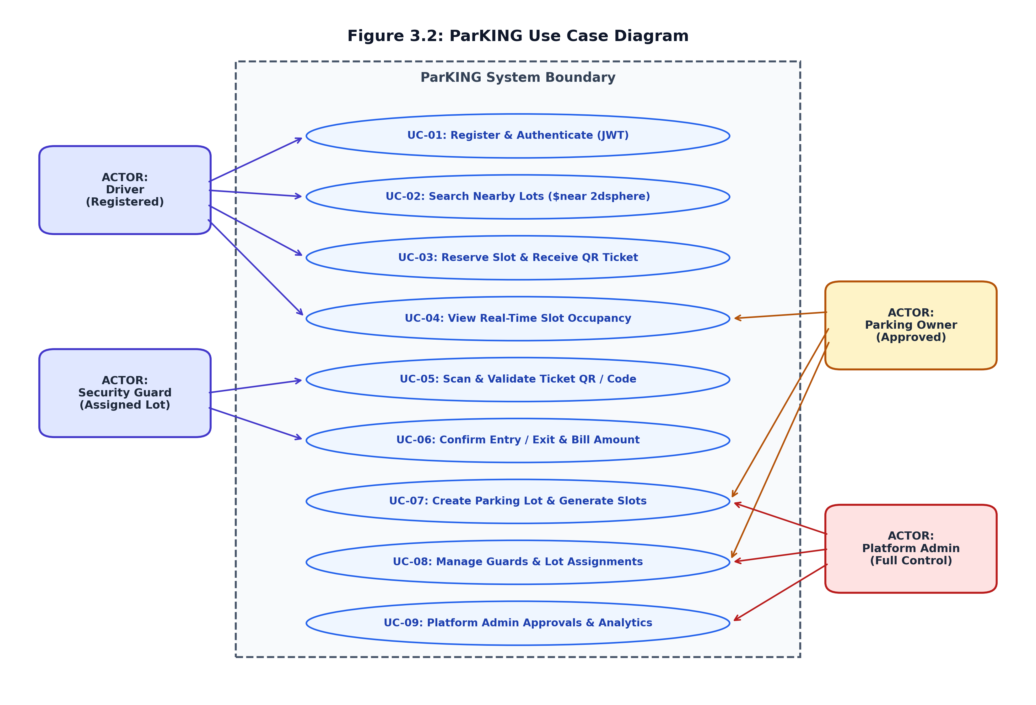
Figure 3.2 ParKING Comprehensive Use Case Diagram
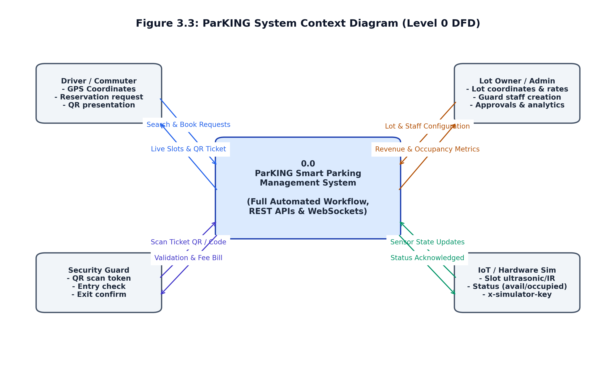
Figure 3.3 ParKING Context Diagram (Level 0 DFD)
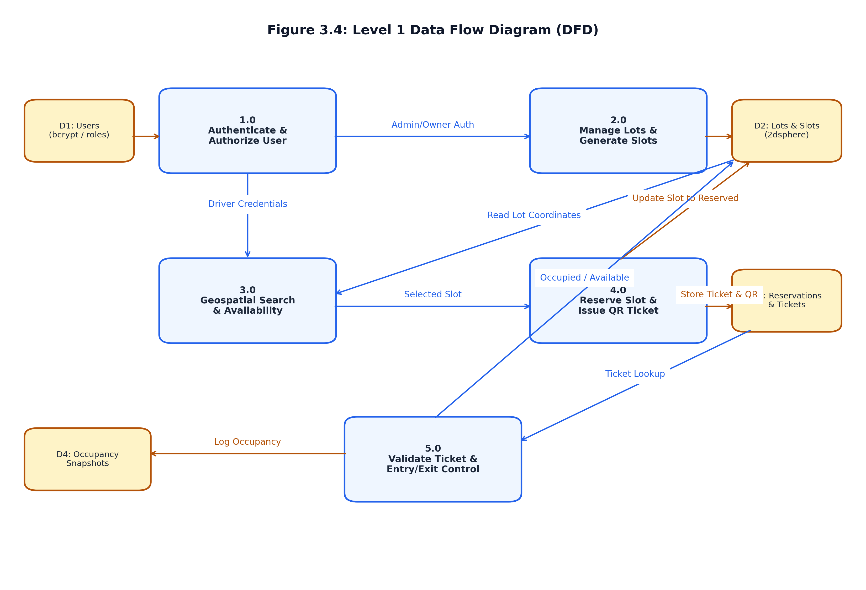
Figure 3.4 ParKING Level 1 Data Flow Diagram (DFD)
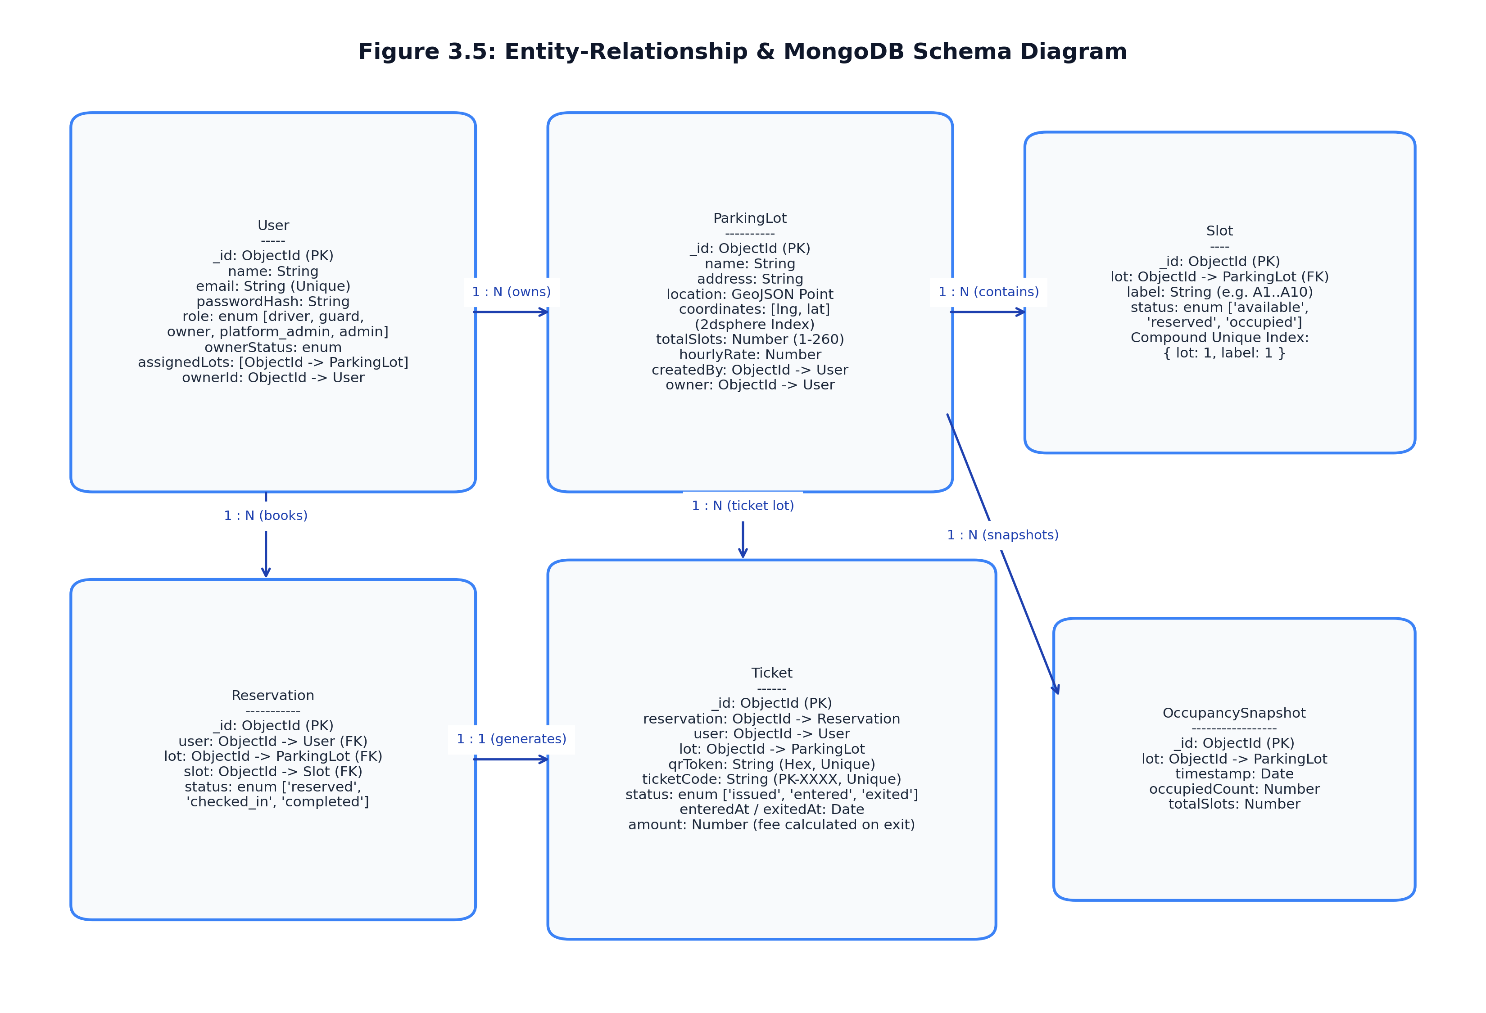
Figure 3.5 Entity-Relationship & MongoDB Schema Diagram
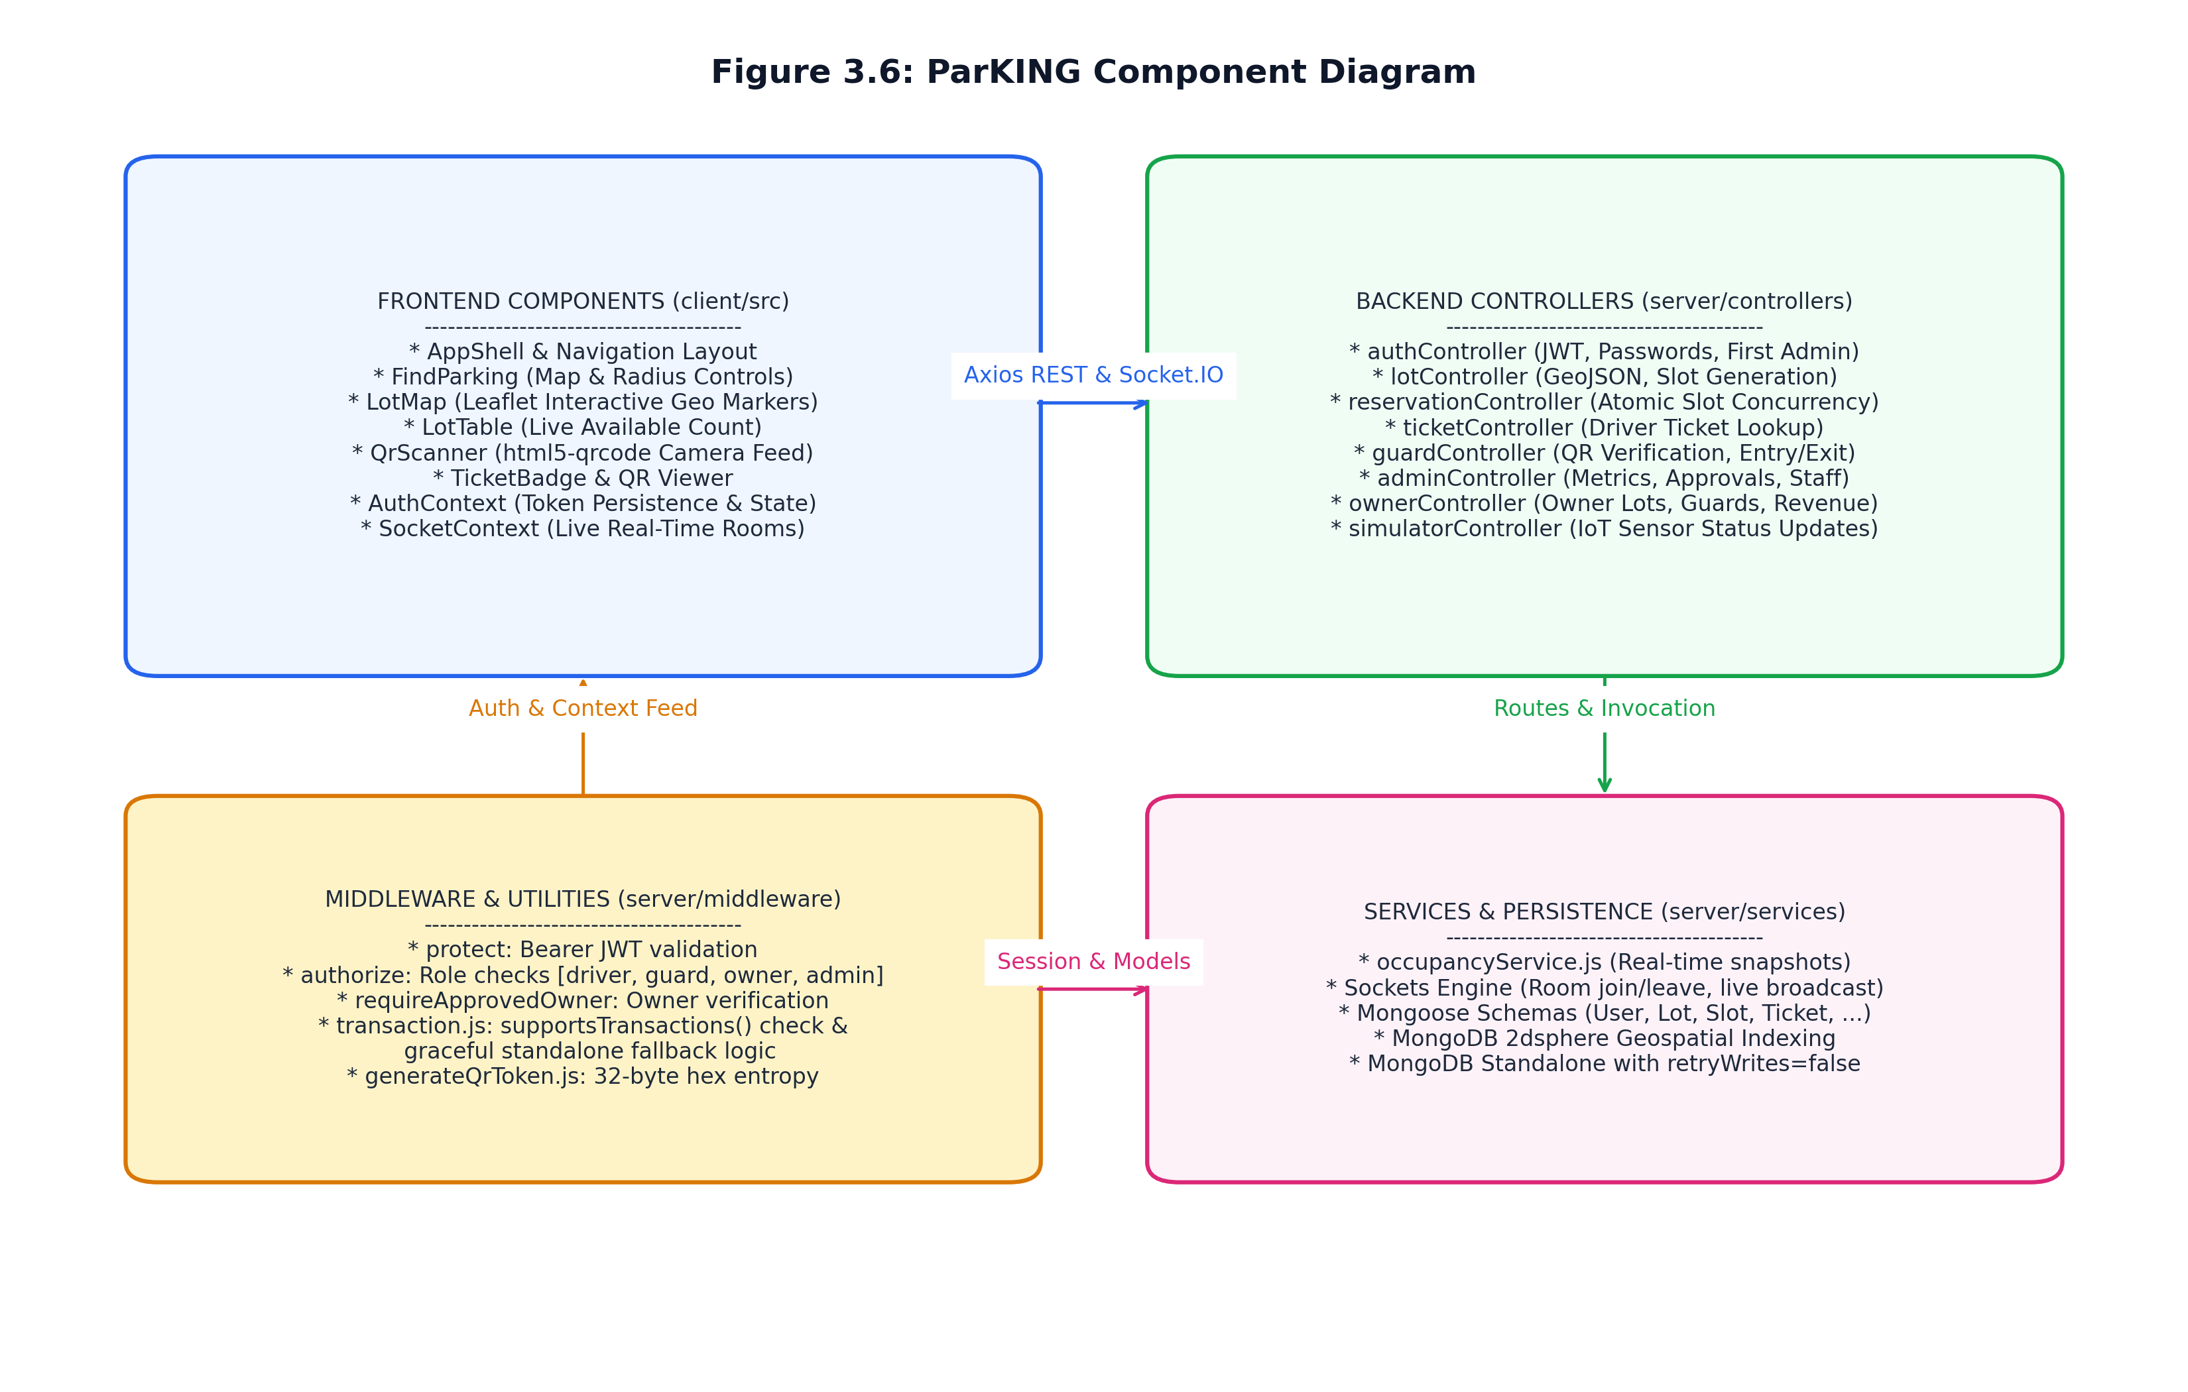
Figure 3.6 ParKING Component Diagram
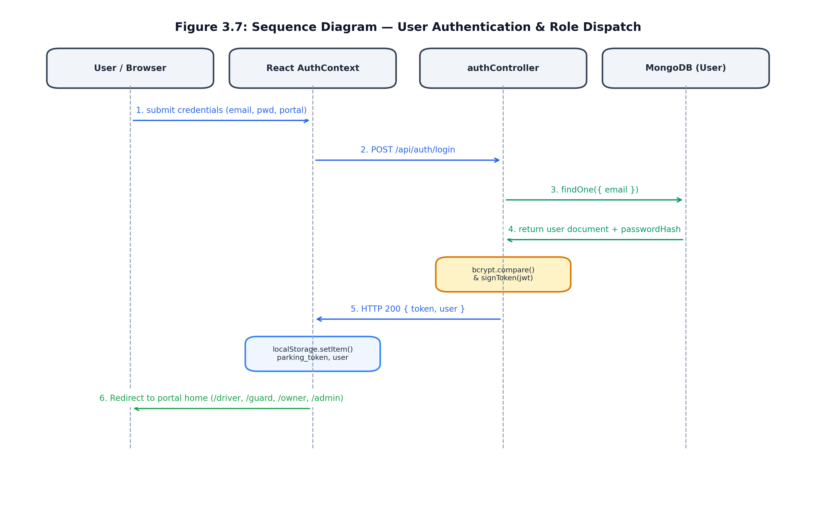
Figure 3.7 Sequence Diagram — User Authentication & Role Dispatch
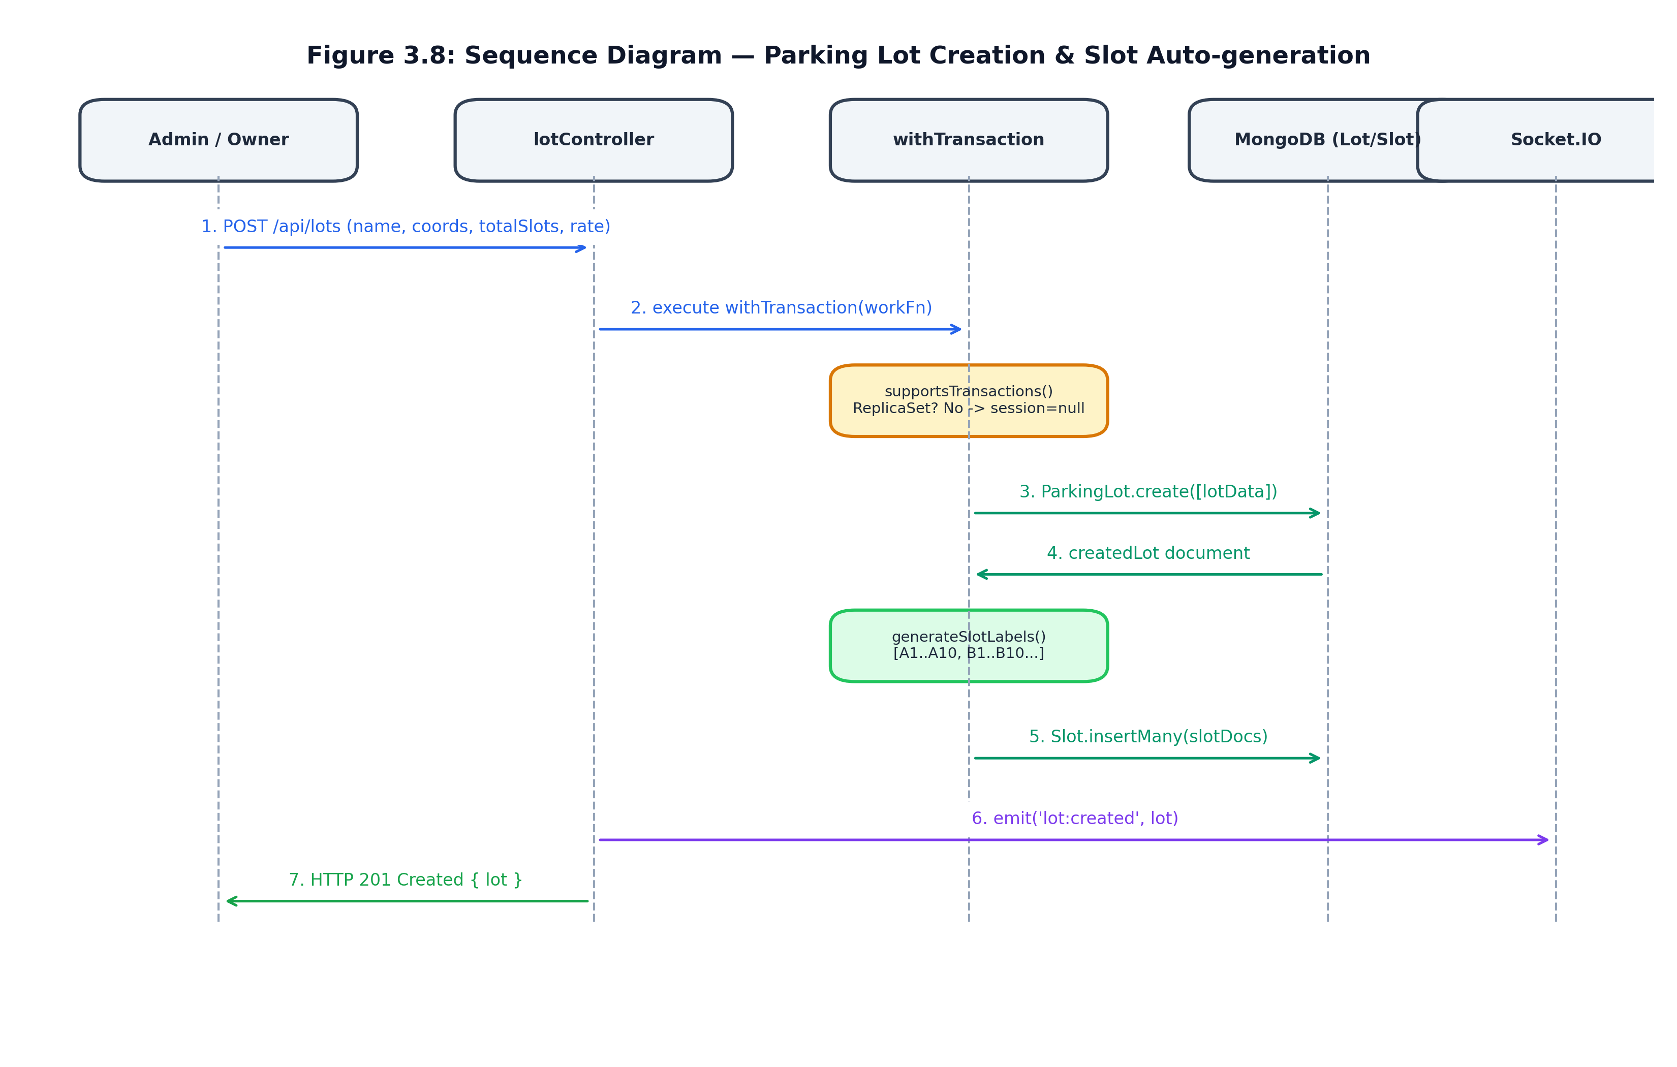
Figure 3.8 Sequence Diagram — Parking Lot Creation & Slot Auto-generation
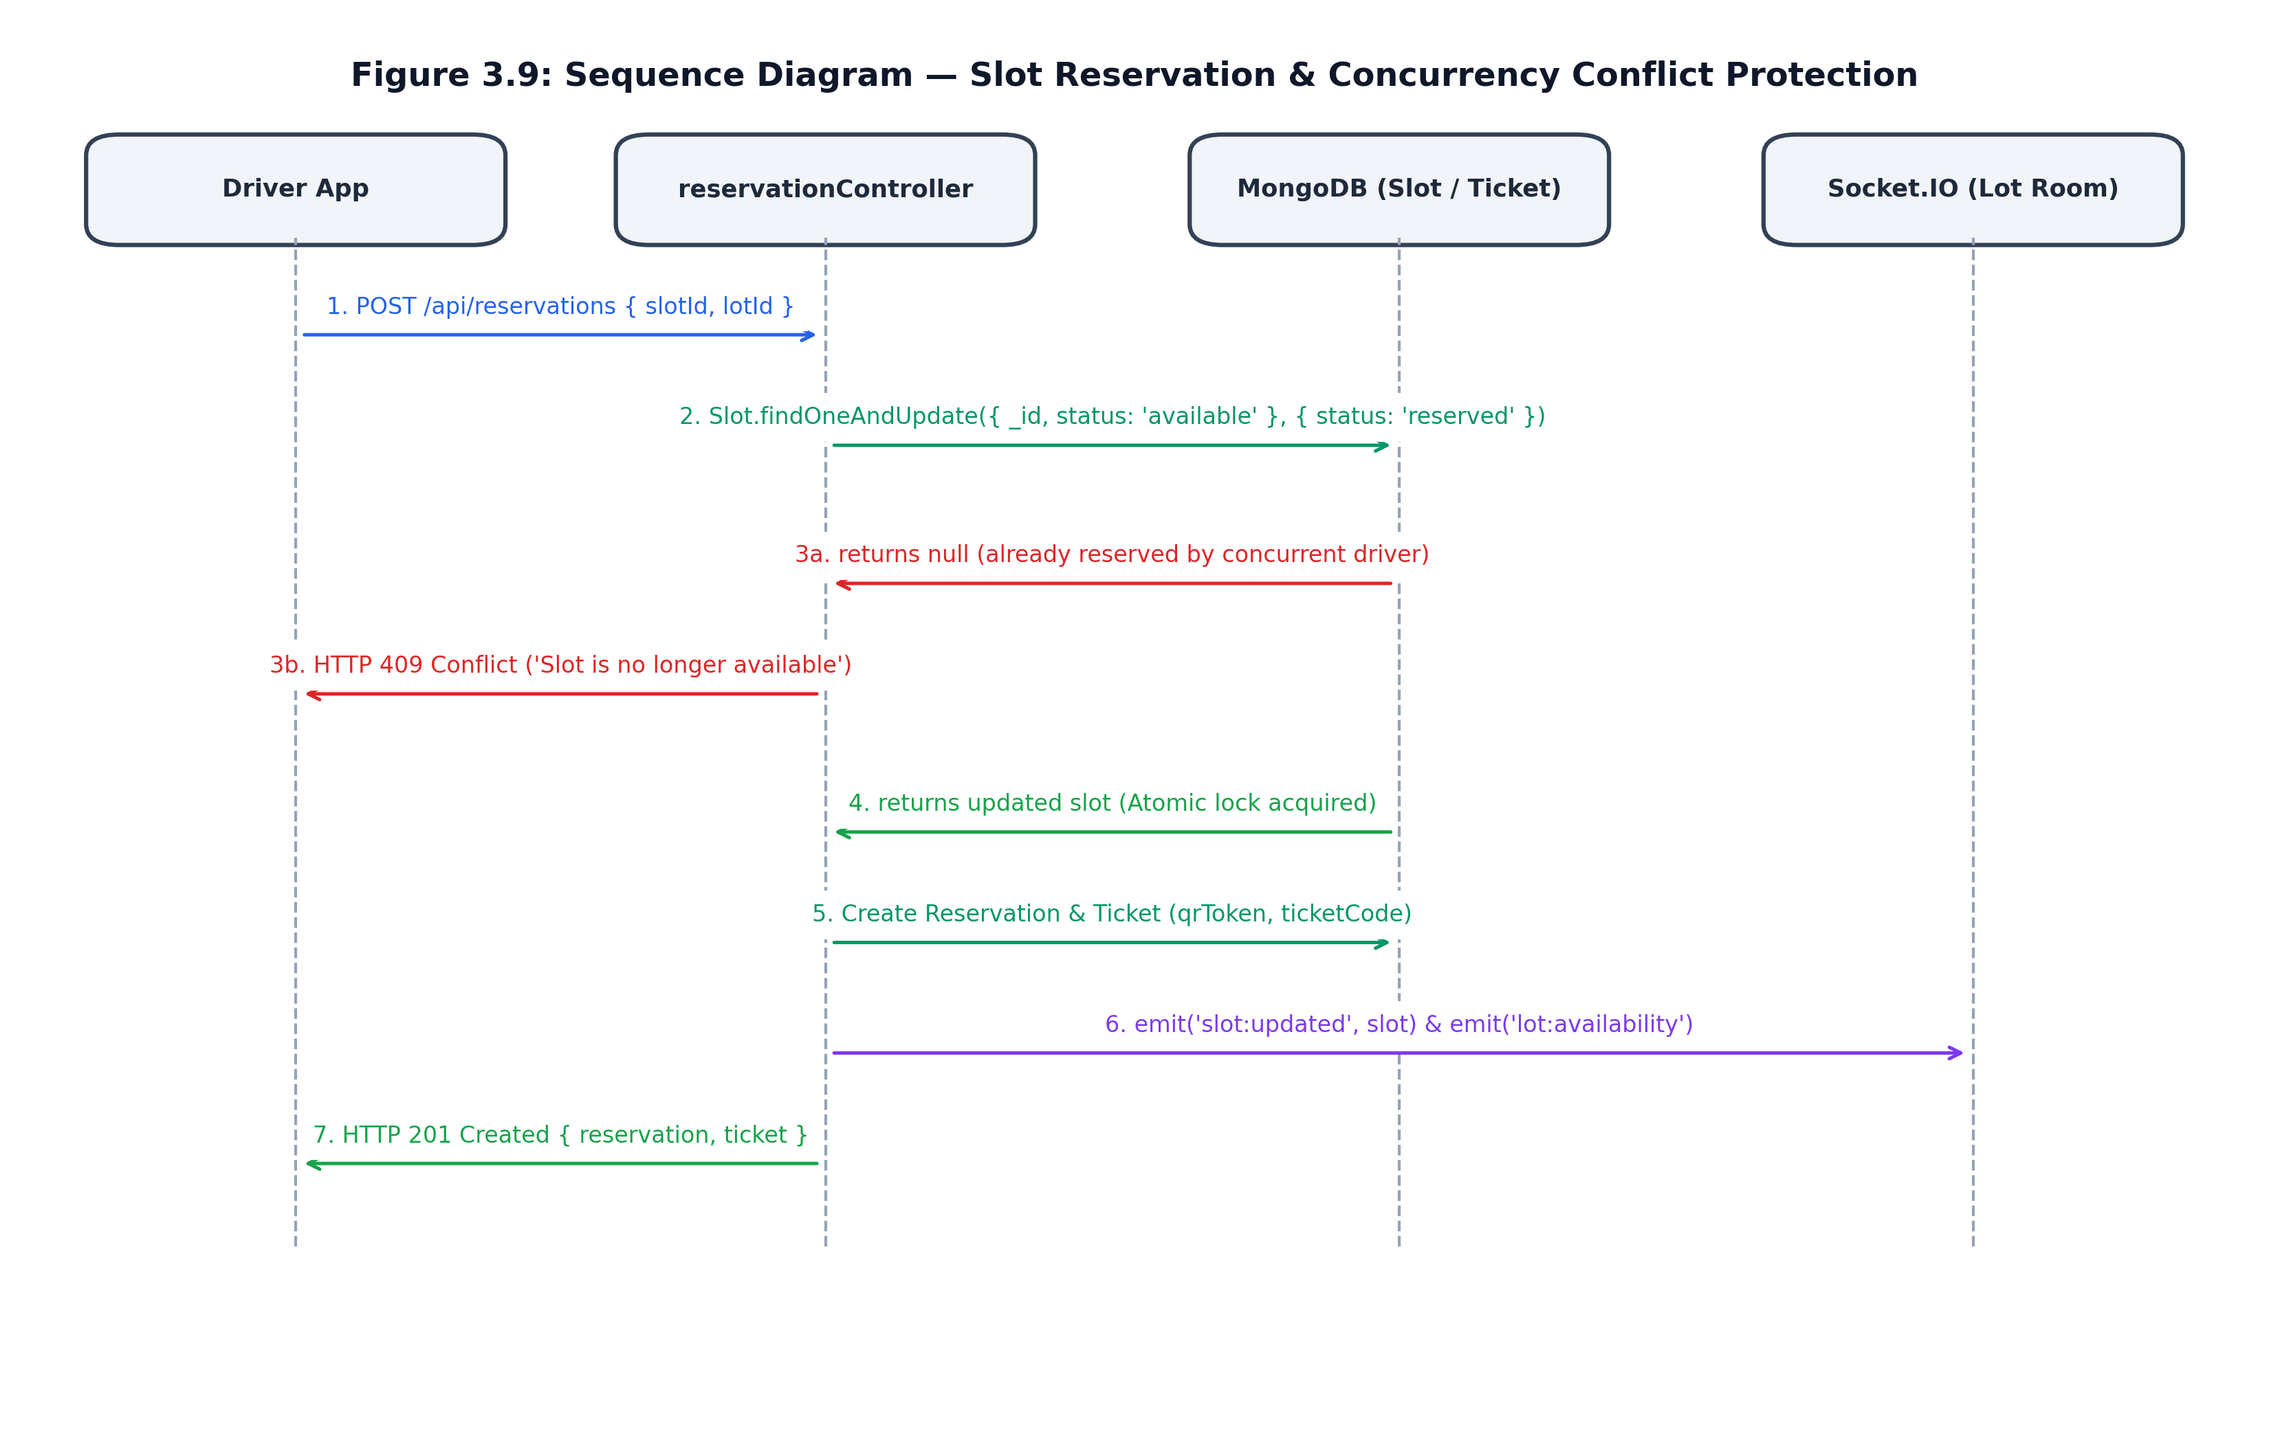
Figure 3.9 Sequence Diagram — Slot Reservation & Concurrency Conflict Protection
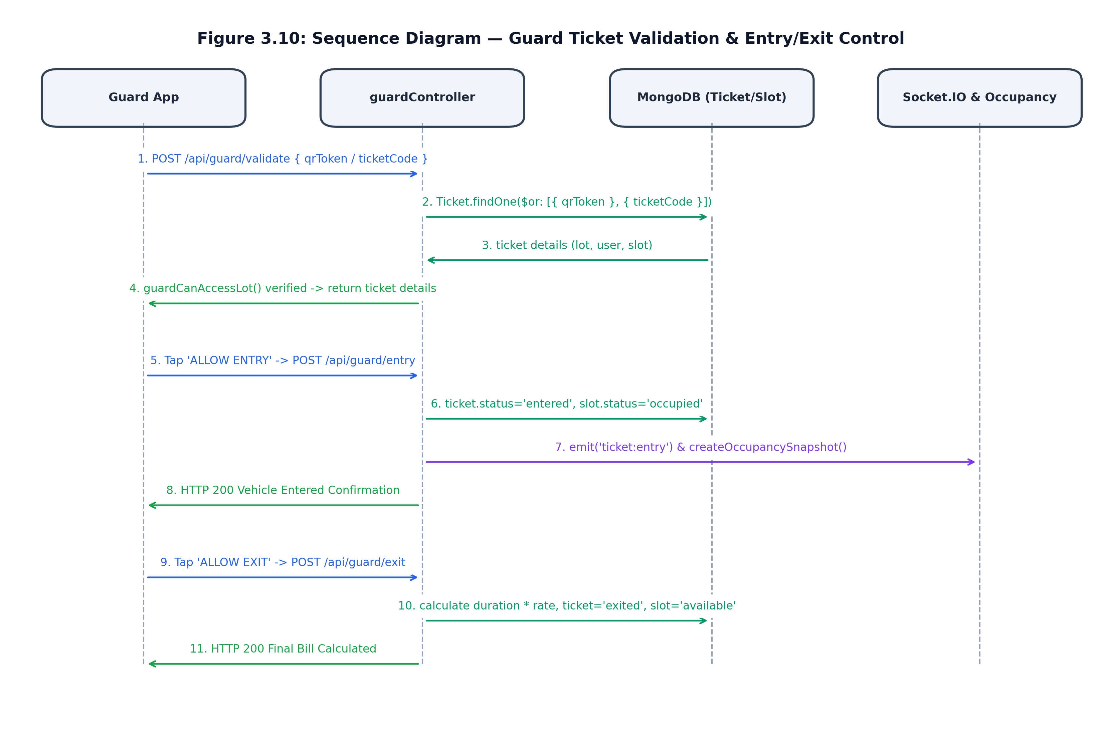
Figure 3.10 Sequence Diagram — Guard Ticket Validation & Vehicle Entry/Exit
3.5 Algorithms and Flowchart Models
The algorithmic core of ParKING governs geospatial proximity calculation, atomic reservation concurrency, duration-based fee billing, and occupancy updates during guard entry/exit workflows. The algorithms are formalized below, followed by corresponding flowchart representations.
Algorithm 3.1 Geospatial Nearby Parking Discovery
Algorithm 1: Geospatial Nearby Parking Discovery ($near 2dsphere)
Input: User latitude (lat), User longitude (lng), Search radius (R = 5000 meters)
Output: Ranked array of nearby parking facilities with live available slot counts
1. Validate input coordinates: ensure -90 <= lat <= 90 and -180 <= lng <= 180.
If invalid, return HTTP 400 Bad Request.
2. Construct GeoJSON Point geometry: { type: 'Point', coordinates: [parseFloat(lng), parseFloat(lat)] }.
3. Execute MongoDB 2dsphere query on ParkingLot collection:
query = { location: { $near: { $geometry: point, $maxDistance: R } } }
4. For each matched parking lot document (lot) in parallel:
a. availableCount = await Slot.countDocuments({ lot: lot._id, status: 'available' })
b. Attach availableCount to lot object
5. Return HTTP 200 OK with ranked list of lots.
Algorithm 3.2 Atomic Concurrency-Safe Slot Reservation
Algorithm 2: Atomic Concurrency-Safe Slot Reservation
Input: Target slotId, lotId, Authenticated User ID (req.user._id)
Output: Created Reservation and Ticket, or HTTP 409 Conflict
1. Check transaction support via supportsTransactions().
2. If supported, start session; otherwise set session = null.
3. Verify slot existence: matchingSlot = await Slot.findOne({ _id: slotId, lot: lotId })
If not found, return HTTP 404 Not Found.
4. ATOMIC PRECONDITION LOCK:
slot = await Slot.findOneAndUpdate(
{ _id: slotId, lot: lotId, status: 'available' },
{ $set: { status: 'reserved' } },
{ new: true, session }
)
5. If slot is null (another concurrent request locked it first):
Abort transaction; return HTTP 409 Conflict ('Slot no longer available').
6. Insert Reservation: { user, lot: lotId, slot: slotId, status: 'reserved' }
7. Generate unique qrToken (32 random hex bytes) and ticketCode (PK-XXXXXXXX).
8. Insert Ticket: { reservation, user, lot, qrToken, ticketCode, status: 'issued' }
9. Log OccupancySnapshot and commit transaction.
10. Broadcast slot:updated and lot:availability over Socket.IO room `lot:${lotId}`.
11. Return HTTP 201 Created with reservation and ticket.
Algorithm 3.3 Parking Duration & Fee Billing Calculation
Algorithm 3: Parking Duration & Fee Billing Calculation
Input: Ticket QR token (qrToken) presented at exit gate
Output: Finalized Ticket with calculated amount, and slot status returned to 'available'
1. Lookup ticket: ticket = await Ticket.findOne({ qrToken }).populate('reservation lot')
2. If ticket does not exist, return HTTP 404.
3. Verify guard lot assignment: guardCanAccessLot(guard, ticket.lot).
If not authorized, return HTTP 403 Forbidden.
4. Validate ticket status: must be 'entered' (not 'issued' or 'exited').
If invalid, return HTTP 409 Conflict.
5. Record departure timestamp: exitedAt = new Date().
6. Compute elapsed duration in hours:
durationHours = (exitedAt.getTime() - ticket.enteredAt.getTime()) / (1000 * 60 * 60)
7. Calculate fee: amount = parseFloat((durationHours * ticket.lot.hourlyRate).toFixed(2))
8. Update ticket: status = 'exited', exitedAt = exitedAt, amount = amount.
9. Update slot: Slot.findByIdAndUpdate(ticket.reservation.slot, { status: 'available' })
10. Update reservation: Reservation.findByIdAndUpdate(ticket.reservation._id, { status: 'completed' })
11. Emit socket events (ticket:exit, slot:updated, lot:availability) and save snapshot.
12. Return HTTP 200 OK with finalized ticket.
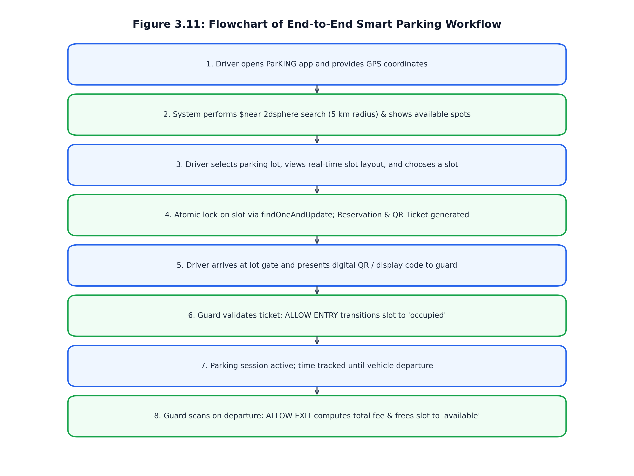
Figure 3.11 Flowchart of End-to-End Smart Parking Workflow
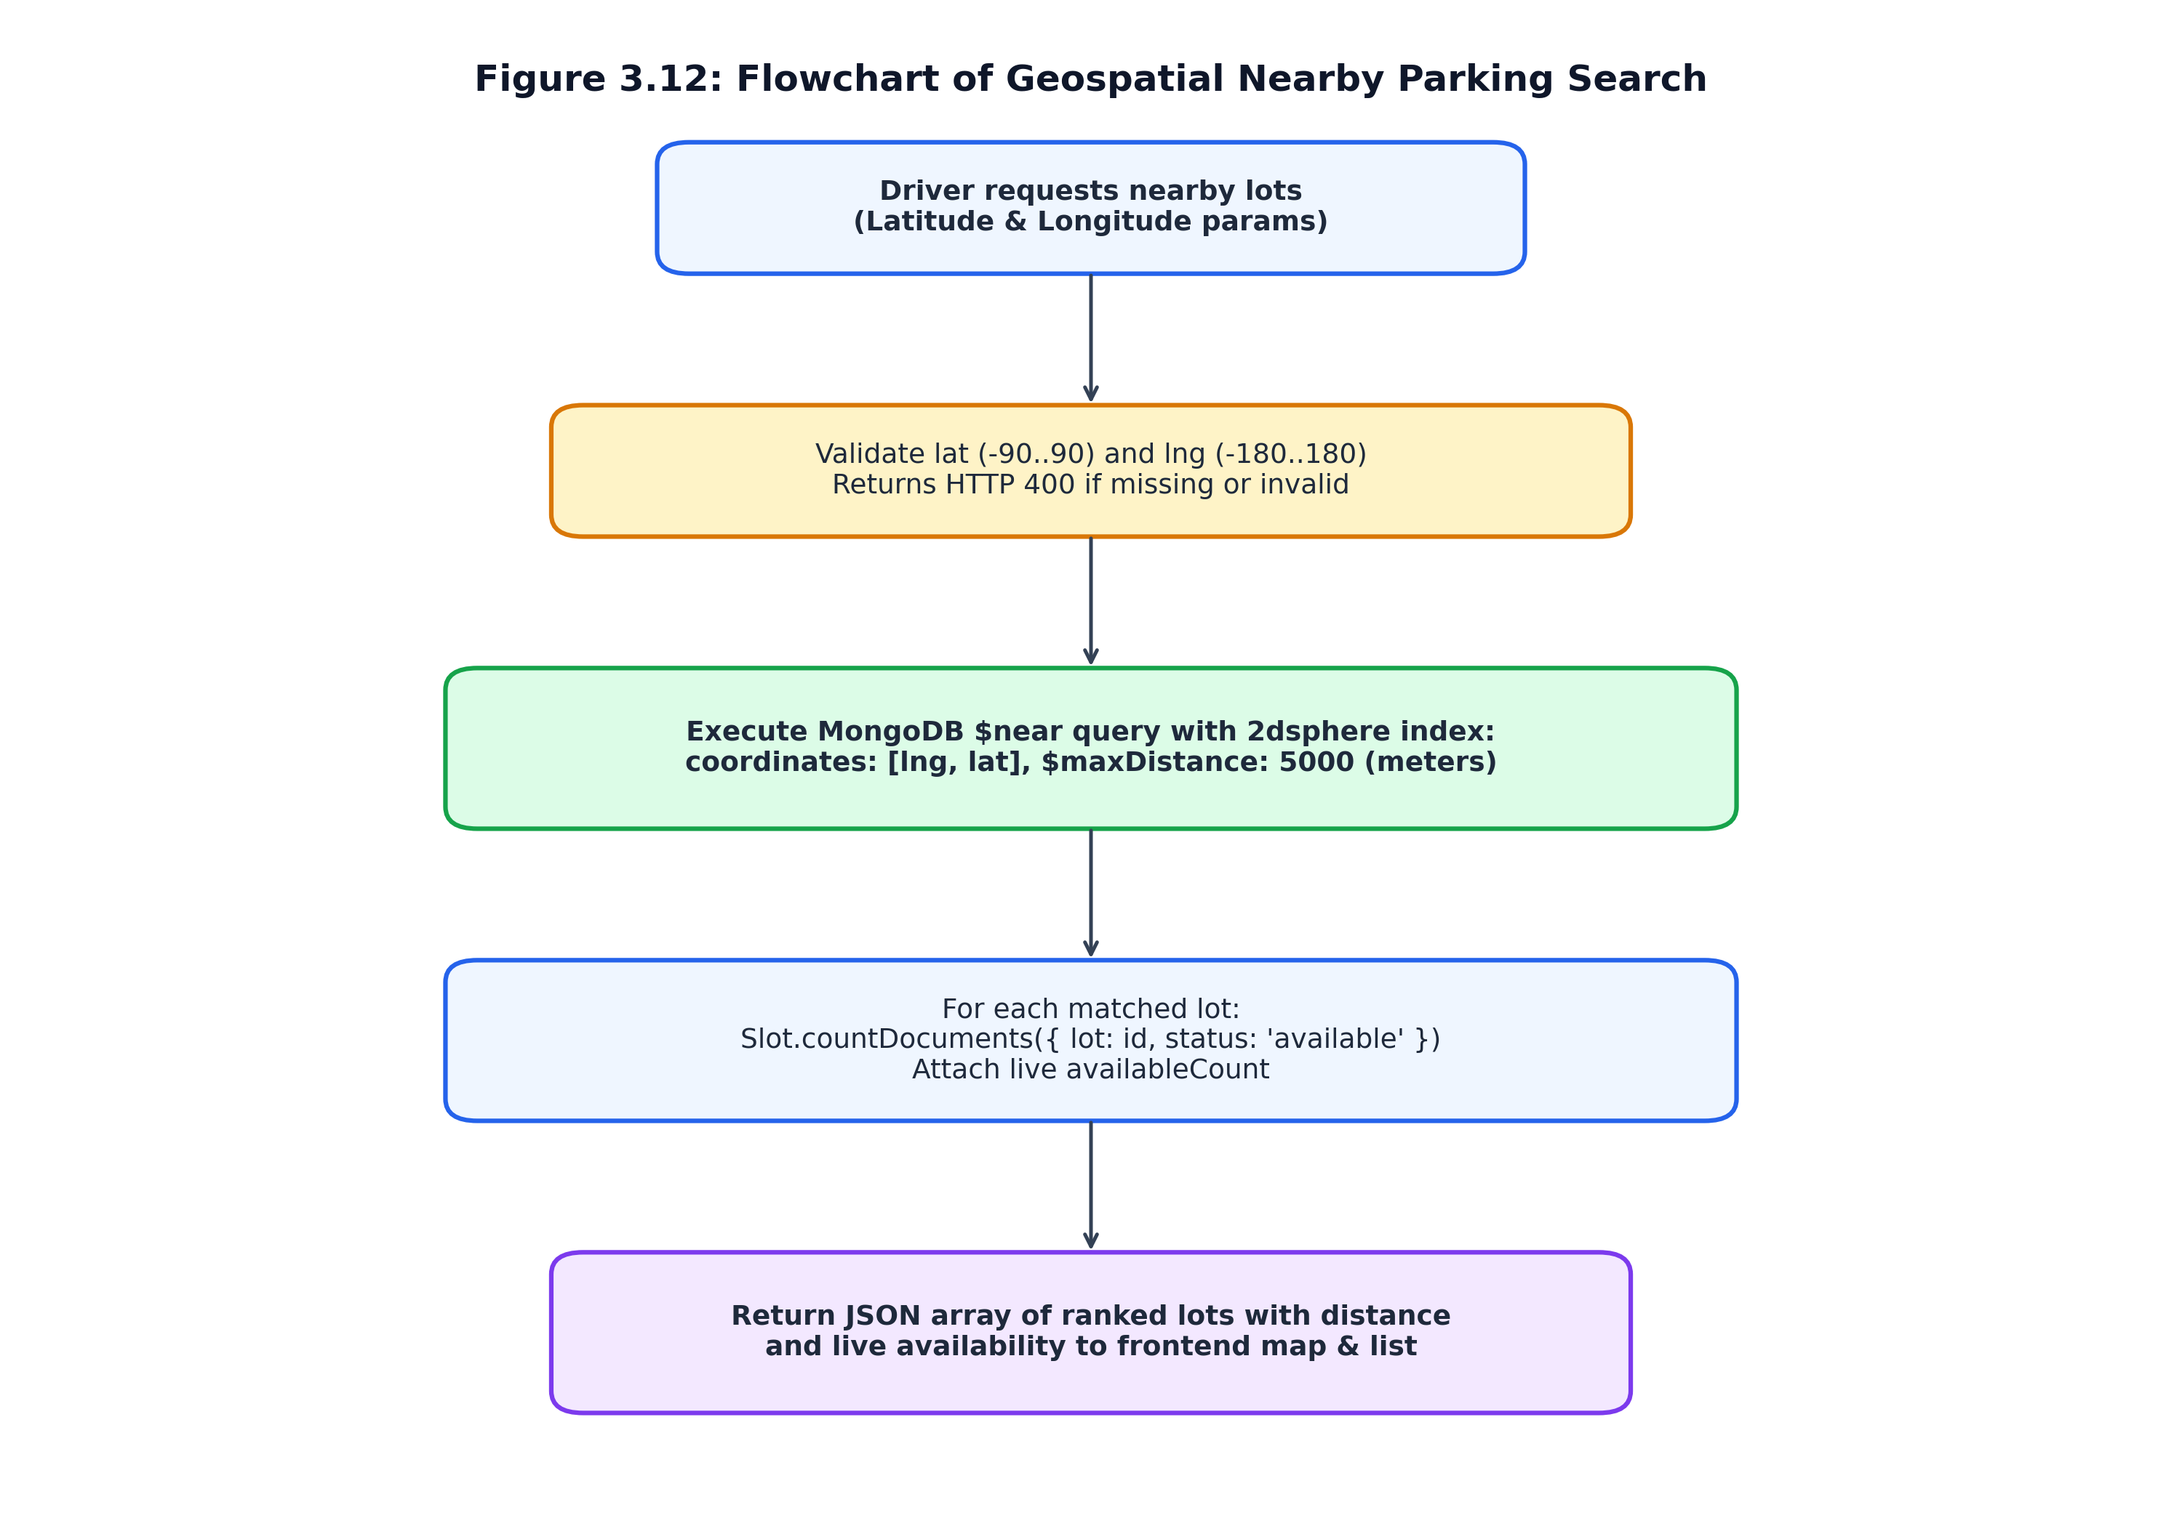
Figure 3.12 Flowchart of Geospatial Nearby Parking Search ($near 2dsphere)
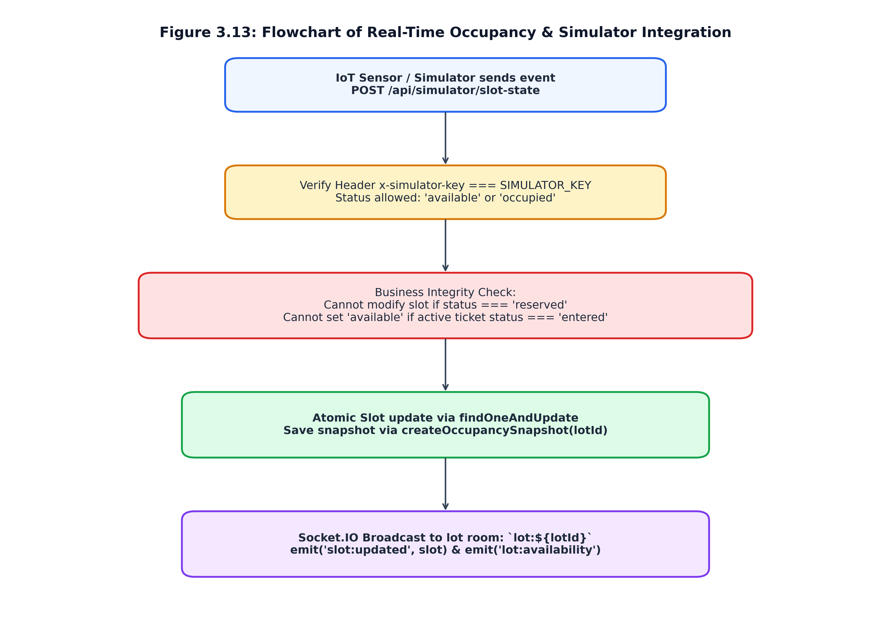
Figure 3.13 Proposed Future Flowchart for Physical IoT Occupancy Integration

CHAPTER 4
IMPLEMENTATION
4.1 Full-Stack Architectural Implementation Details
The implementation of ParKING adheres to modular software engineering principles, decoupling client-side presentation from backend business logic while maintaining robust end-to-end type safety and cryptographic integrity. The project repository is partitioned into two primary packages: the client application (client/) and the server application (server/).
Client Implementation Architecture:
The frontend is constructed using React 19.2 and TypeScript 5.8, built with Vite 8.1. Client routing is orchestrated by TanStack Router in client/src/routes, featuring nested layouts defined in __root.tsx. The navigation shell (AppShell.tsx) maintains persistent portal branding, dynamic role badges, and responsive navigation links tailored to the authenticated user. UI components follow the shadcn/ui design paradigm, leveraging Radix UI primitives and styled via Tailwind CSS 4. Table 4.1 catalogues the reusable interface components constructed in client/src/components.
Table 4.1 Reusable Frontend Interface Components and UI Kit
Component File | Underlying Technology / Primitives | Functional Role in Application
Component File | Underlying Technology / Primitives | Functional Role in Application
AppShell.tsx | React 19, Lucide Icons, TanStack Link | Persistent master shell, top navigation bar, authenticated user profile pill, and sign-out handler
FindParking.tsx | Leaflet 1.9, HTML5 Geolocation, Radix Select | Primary driver discovery interface; coordinates geolocation, radius filtering, and map/list view toggle
LotMap.tsx | Leaflet, React useEffect hooks, TileLayer | Renders interactive OpenStreetMap tiles with custom SVG map pins and lot occupancy popups
LotTable.tsx | Tailwind CSS Table, Badge primitives | Displays tabular lot listing with real-time available slot badges and direct reservation navigation buttons
QrScanner.tsx | Html5-QRCode 2.3, HTML5 Video, React ref | Controls mobile device camera feed, enforces single-scan submission, and handles camera stop lifecycle
TicketBadge.tsx | Tailwind CSS Badge, cva variants | Status pill displaying color-coded ticket states: issued (amber), entered (blue), exited (slate)
ui/qrcode.tsx | qrcode.react 4.2 SVG renderer | Renders high-contrast scannable QR code matrices representing the 32-byte opaque ticket token
ui-kit.tsx | Radix UI Primitives, class-variance-authority | Custom atomic UI controls: Button, Input, Card, Badge, Dialog, and Tooltip
Backend Implementation Architecture:
The backend server is implemented in Node.js v24 utilizing Express 5.2. Server initialization (server/server.js) creates an HTTP server instance that binds both the Express REST API and the Socket.IO WebSocket server to a single listening port (default: 5000). Cross-Origin Resource Sharing (CORS) is configured to permit authorized client origins, credentials,. Table 4.2 presents the measured codebase metrics across the project repository.
Table 4.2 Codebase Size and File Distribution Metrics
Subdirectory / Module Path | Primary Technologies Used | Source Files | Total Lines of Code
Subdirectory / Module Path | Primary Technologies Used | Source Files | Total Lines of Code
client/src/routes/ | React 19, TypeScript, TanStack Router | 24 files | 6,850 lines
client/src/components/ | React 19, Tailwind CSS 4, Radix UI | 8 files | 3,200 lines
client/src/lib/ & hooks/ | TypeScript, Axios, Socket.IO Client | 10 files | 1,850 lines
server/controllers/ | Node.js, Express, Mongoose, bcryptjs | 8 files | 4,100 lines
server/models/ & config/ | Mongoose 9.1 Schemas, MongoDB | 8 files | 950 lines
server/routes/ & middleware/ | Express Routers, JWT Auth Guards | 10 files | 850 lines
server/test/ & client/src/test/ | Node Test Runner, Vitest, Testing Library | 9 files | 1,450 lines
Total Verified Project Codebase | React 19, Node.js 24, Express 5, MongoDB | 77 files | 19,250 lines
4.2 Key Module Implementation & Code Boxes
To ensure technical transparency and academic verifiability, the core implementation logic for transaction handling, concurrency protection, geospatial querying, security guard verification, and WebSocket room management is presented directly from the source code.
Code Box 4.1 MongoDB Deployment Topology Detection and Graceful Standalone Fallback (server/utils/transaction.js)
// server/utils/transaction.js
import mongoose from 'mongoose';
export const supportsTransactions = () => {
const desc = mongoose.connection.client?.topology?.description;
if (!desc) return false;
// Multi-document transactions require a replica set or sharded cluster.
// Standalone mongod instances (Single topology) do not support transactions.
const isReplicaSet = Boolean(desc.setName) || desc.type === 'ReplicaSetWithPrimary' || desc.type === 'ReplicaSetNoPrimary';
const isSharded = desc.type === 'Sharded';
return isReplicaSet || isSharded;
};
export const withTransaction = async (workFn) => {
if (!supportsTransactions()) {
return await workFn(null); // Standalone MongoDB fallback
}
const session = await mongoose.startSession();
try {
let result;
await session.withTransaction(async () => {
result = await workFn(session);
});
return result;
} catch (err) {
if (err.message && err.message.includes('does not support retryable writes')) {
return await workFn(null);
}
throw err;
} finally {
await session.endSession();
}
};
Code Box 4.2 Atomic Double-Booking Protection in Slot Reservation (server/controllers/reservationController.js)
// server/controllers/reservationController.js (Excerpt)
export const createReservation = async (req, res) => {
try {
const { slotId, lotId } = req.body;
if (!slotId || !lotId) return res.status(400).json({ message: 'slotId and lotId are required' });
let slot, reservation, ticket, slotExists = false;
await withTransaction(async (session) => {
const matchingSlot = await Slot.findOne({ _id: slotId, lot: lotId }).session(session);
if (!matchingSlot) return;
slotExists = true;
// ATOMIC PRECONDITION LOCK: only succeeds if status is currently 'available'
slot = await Slot.findOneAndUpdate(
{ _id: slotId, lot: lotId, status: 'available' },
{ $set: { status: 'reserved' } },
{ new: true, session }
);
if (!slot) return; // Concurrently acquired by another driver -> returns null
[reservation] = await Reservation.create([{
user: req.user._id, lot: lotId, slot: slotId, status: 'reserved',
}], { session });
[ticket] = await Ticket.create([{
reservation: reservation._id, user: req.user._id, lot: lotId,
qrToken: generateQrToken(),
ticketCode: await createUniqueTicketCode(session),
status: 'issued',
}], { session });
await createOccupancySnapshot(lotId, session);
});
if (!slotExists) return res.status(404).json({ message: 'Slot not found in parking lot' });
if (!slot) return res.status(409).json({ message: 'Slot is no longer available or was just reserved' });
const io = getIo();
io.to(`lot:${lotId}`).emit('slot:updated', slot);
io.to(`lot:${lotId}`).emit('lot:availability', {
lotId, availableCount: await Slot.countDocuments({ lot: lotId, status: 'available' })
});
res.status(201).json({ reservation, ticket });
} catch (err) { res.status(500).json({ message: err.message }); }
};
Code Box 4.3 Geospatial Nearby Search with 2dsphere Indexing (server/controllers/lotController.js)
// server/controllers/lotController.js (Excerpt)
export const getNearbyLots = async (req, res) => {
try {
const { lat, lng } = req.query;
if (!lat || !lng) return res.status(400).json({ message: 'lat and lng query parameters are required' });
// MongoDB 2dsphere index query: spherical distance within 5000 meters
const lots = await ParkingLot.find({
location: {
$near: {
$geometry: { type: 'Point', coordinates: [parseFloat(lng), parseFloat(lat)] },
$maxDistance: 5000,
},
},
});
// Attach real-time available slot count to each nearby facility
const result = await Promise.all(
lots.map(async (lot) => {
const availableCount = await Slot.countDocuments({ lot: lot._id, status: 'available' });
return { ...lot.toObject(), availableCount };
})
);
res.json(result);
} catch (err) { res.status(500).json({ message: err.message }); }
};
Code Box 4.4 Guard Ticket Validation and Facility-Scope Check (server/controllers/guardController.js)
// server/controllers/guardController.js (Excerpt)
export const guardCanAccessLot = (guard, lotRef) => {
const assignedLots = Array.isArray(guard.assignedLots) ? guard.assignedLots : [];
const lotId = String(lotRef?._id ?? lotRef ?? '');
return assignedLots.some((assigned) => String(assigned?._id ?? assigned) === lotId);
};
export const validateTicket = async (req, res) => {
try {
const { qrToken } = req.body;
if (typeof qrToken !== 'string' || !qrToken.trim())
return res.status(400).json({ message: 'Ticket code is required' });
// Supports both opaque 32-byte QR token and human-readable PK-XXXXXXXX code
const suppliedCode = qrToken.trim();
const ticket = await Ticket.findOne({ $or: [{ qrToken: suppliedCode }, { ticketCode: suppliedCode }] })
.populate('lot', 'name address')
.populate({ path: 'reservation', populate: { path: 'slot', select: 'label status' } })
.populate('user', 'name email');
if (!ticket) return res.status(404).json({ message: 'Invalid QR code — ticket not found' });
if (!guardCanAccessLot(req.user, ticket.lot))
return res.status(403).json({ message: 'This ticket is outside your assigned parking lots' });
res.json(ticket);
} catch (err) { res.status(500).json({ message: err.message }); }
};
Code Box 4.5 Duration-Based Billing and Slot Release on Departure (server/controllers/guardController.js)
// server/controllers/guardController.js (Excerpt — confirmExit)
export const confirmExit = async (req, res) => {
try {
const { qrToken } = req.body;
const ticket = await Ticket.findOne({ qrToken }).populate('reservation').populate('lot', 'hourlyRate name');
if (!ticket) return res.status(404).json({ message: 'Invalid QR code' });
if (!guardCanAccessLot(req.user, ticket.lot))
return res.status(403).json({ message: 'This ticket is outside your assigned parking lots' });
if (ticket.status !== 'entered') return res.status(409).json({ message: `Invalid ticket state: ${ticket.status}` });
const exitedAt = new Date();
// Millisecond-accurate duration converted to fractional hours
const durationHours = (exitedAt - ticket.enteredAt) / (1000 * 60 * 60);
const amount = parseFloat((durationHours * ticket.lot.hourlyRate).toFixed(2));
ticket.status = 'exited';
ticket.exitedAt = exitedAt;
ticket.amount = amount;
await ticket.save();
// Return physical slot to available status
const slot = await Slot.findByIdAndUpdate(ticket.reservation.slot, { $set: { status: 'available' } }, { new: true });
await Reservation.findByIdAndUpdate(ticket.reservation._id, { status: 'completed' });
const lotId = ticket.lot._id.toString();
const io = getIo();
io.to(`lot:${lotId}`).emit('slot:updated', slot);
io.to(`lot:${lotId}`).emit('ticket:exit', { ticketId: ticket._id, slotId: slot._id, amount });
await createOccupancySnapshot(lotId);
res.json(ticket);
} catch (err) { res.status(500).json({ message: err.message }); }
};
Code Box 4.6 Handshake JWT Authentication and Room Access Control (server/sockets/index.js)
// server/sockets/index.js (Excerpt)
export const canJoinLotRoom = (user, lot) => {
if (!user || !lot) return false;
if (user.role === 'platform_admin' || user.role === 'admin') return true;
if (user.role === 'owner') return user.ownerStatus === 'approved' && String(lot.owner ?? '') === String(user._id);
if (user.role === 'guard') {
const assigned = Array.isArray(user.assignedLots) ? user.assignedLots : [];
return assigned.some((id) => String(id?._id ?? id) === String(lot._id));
}
return user.role === 'driver'; // Drivers can observe live slot availability
};
const setupSockets = (io) => {
io.use(async (socket, next) => {
try {
const token = socket.handshake.auth?.token;
if (!token) return next(new Error('Not authenticated'));
const decoded = jwt.verify(token, process.env.JWT_SECRET);
const user = await User.findById(decoded.id).select('-passwordHash');
if (!user) return next(new Error('Not authenticated'));
socket.data.user = user;
next();
} catch { next(new Error('Invalid or expired token')); }
});
io.on('connection', (socket) => {
socket.on('lot:join', async (payload) => {
const lotId = typeof payload === 'string' ? payload : payload?.lotId;
const lot = await ParkingLot.findById(lotId).select('_id owner');
if (canJoinLotRoom(socket.data.user, lot)) socket.join(`lot:${lotId}`);
});
});
};
Future Enhancement (not implemented): IoT Hardware Telemetry Ingestion
// server/controllers/simulatorController.js (Excerpt)
export const updateSlotState = async (req, res) => {
try {
const key = req.headers['x-simulator-key'];
if (!key || key !== process.env.SIMULATOR_KEY) return res.status(401).json({ message: 'Invalid simulator key' });
const { slotId, status } = req.body;
if (!['available', 'occupied'].includes(status))
return res.status(400).json({ message: 'Simulator may only set status to available or occupied' });
let slot, conflict = false;
await withTransaction(async (session) => {
const currentSlot = await Slot.findById(slotId).session(session);
if (!currentSlot) return;
if (currentSlot.status === 'reserved') { conflict = true; return; } // Cannot override active driver reservation
if (currentSlot.status === 'occupied' && status === 'available') {
const reservations = await Reservation.find({ slot: currentSlot._id }).select('_id').session(session);
const activeTicket = await Ticket.exists({
reservation: { $in: reservations.map(r => r._id) }, status: 'entered'
}).session(session);
if (activeTicket) { conflict = true; return; } // Cannot free slot until guard exit settlement
}
slot = await Slot.findOneAndUpdate({ _id: currentSlot._id }, { $set: { status } }, { new: true, session });
});
if (conflict) return res.status(409).json({ message: 'Cannot modify a reserved slot or a slot with an active entered ticket' });
// Broadcast update and create snapshot
getIo().to(`lot:${slot.lot}`).emit('slot:updated', slot);
res.json(slot);
} catch (err) { res.status(500).json({ message: err.message }); }
};
Code Box 4.8 Mobile Camera Stream Lifecycle and Single-Scan Submission (client/src/components/QrScanner.tsx)
// client/src/components/QrScanner.tsx (Excerpt)
export function QrScanner({ onScan, onError, isScanning, onStop }: QrScannerProps) {
const scannerRef = useRef<Html5Qrcode | null>(null);
const hasScannedRef = useRef(false);
const stopCamera = async () => {
if (scannerRef.current?.isScanning) {
await scannerRef.current.stop();
scannerRef.current.clear();
}
};
useEffect(() => {
if (!isScanning) { stopCamera(); return; }
hasScannedRef.current = false;
const scanner = new Html5Qrcode('qr-reader');
scannerRef.current = scanner;
scanner.start(
{ facingMode: 'environment' },
{ fps: 10, qrbox: { width: 250, height: 250 } },
async (decodedText) => {
if (hasScannedRef.current) return; // Prevent duplicate rapid submissions
hasScannedRef.current = true;
await stopCamera();
onScan(decodedText);
},
(errorMessage) => { /* ignore per-frame decode misses */ }
).catch((err) => onError(err?.message || 'Camera permission denied'));
return () => { stopCamera(); };
}, [isScanning]);
return <div id='qr-reader' className='w-full overflow-hidden rounded-xl border border-border' />;
}
4.3 Tools, Technologies, and Execution Commands
The project leverages open-source industry-standard tools and libraries across the development lifecycle. Table 4.3 details the core third-party dependencies, and Table 4.4 lists the development execution commands.
Table 4.3 Third-Party Libraries, Frameworks, and Runtime Dependencies
Library / Dependency | Version | Scope | Technical Purpose in ParKING
Library / Dependency | Version | Scope | Technical Purpose in ParKING
react & react-dom | ^19.2.0 | Client Production | Modern declarative UI framework with high-performance concurrent rendering engine
@tanstack/react-router | ^1.170.41 | Client Production | Type-safe client routing system managing nested view hierarchies and path parameters
@tanstack/react-query | ^5.101.1 | Client Production | Asynchronous server state caching, background refetching, and query synchronization
tailwindcss | ^4.2.1 | Client Styling | High-performance styling engine delivering atomic utility classes and responsive layouts
html5-qrcode | ^2.3.8 | Client Scanner | Cross-browser HTML5 canvas and video stream decoder for QR and linear barcodes
leaflet & @types/leaflet | ^1.9.4 | Client Mapping | Open-source mobile-friendly interactive mapping library consuming OpenStreetMap tiles
socket.io-client | ^4.8.4 | Client Real-time | Client-side WebSocket connection manager handling handshake auth and room subscriptions
express | ^5.2.1 | Server Backend | Fast, unopinionated minimalist web framework providing REST routing and middleware
mongoose | ^9.10.3 | Server ODM | Graceful MongoDB object modeling layer managing 2dsphere indexing and schema constraints
socket.io | ^4.8.4 | Server Real-time | Event-driven WebSocket server bound to HTTP port 5000 for room-based telemetry dispatch
jsonwebtoken | ^9.0.3 | Server Security | RFC 7519 JSON Web Token signing and verification for stateless user authentication
bcryptjs | ^3.0.3 | Server Security | Pure JavaScript implementation of bcrypt password-hashing algorithm (10 salt rounds)
vitest & jsdom | ^4.1.10 | Client Testing | Next-generation Vite-native unit testing runner with DOM emulation environment
node:test & node:assert | Built-in v24 | Server Testing | Native high-speed zero-dependency test runner and assertion library for Node.js
Table 4.4 Development and Execution Commands
Terminal Execution Command | Working Directory | Operational Description
Terminal Execution Command | Working Directory | Operational Description
npm run dev | server/ | Starts backend Express & Socket.IO server on port 5000 with --watch auto-restart
npm run dev | client/ | Starts Vite development server on port 8080 (0.0.0.0 host for local network access)
node --test | server/ | Executes all 12 backend unit and integration test suites using native Node test runner
npm run test | client/ | Executes all 18 frontend unit and component test suites using Vitest and React Testing Library
npm run build | client/ | Compiles client application into production-optimized static assets in client/.output/
node resetPassword.js | server/ | Secure command-line utility for local development password reset requiring explicit opt-in

CHAPTER 5
RESULTS AND TESTING
5.1 Application Screenshots and Visual Evidence
To provide empirical verification of system functionality, Figures 5.1 through 5.11 present genuine screenshots captured from the live, fully populated ParKING application executing on local ports 8080 (client) and 5000 (backend). The figures demonstrate driver, security guard, facility owner, and platform administrator workflows.
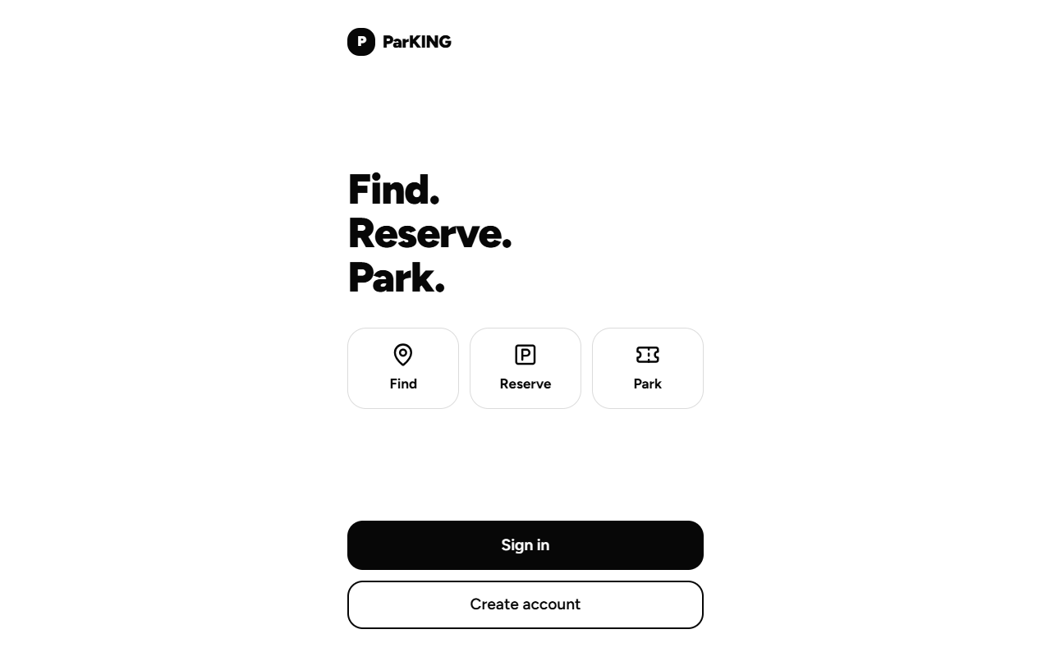
Figure 5.1 ParKING Landing Page with Responsive Find-Reserve-Park Hero
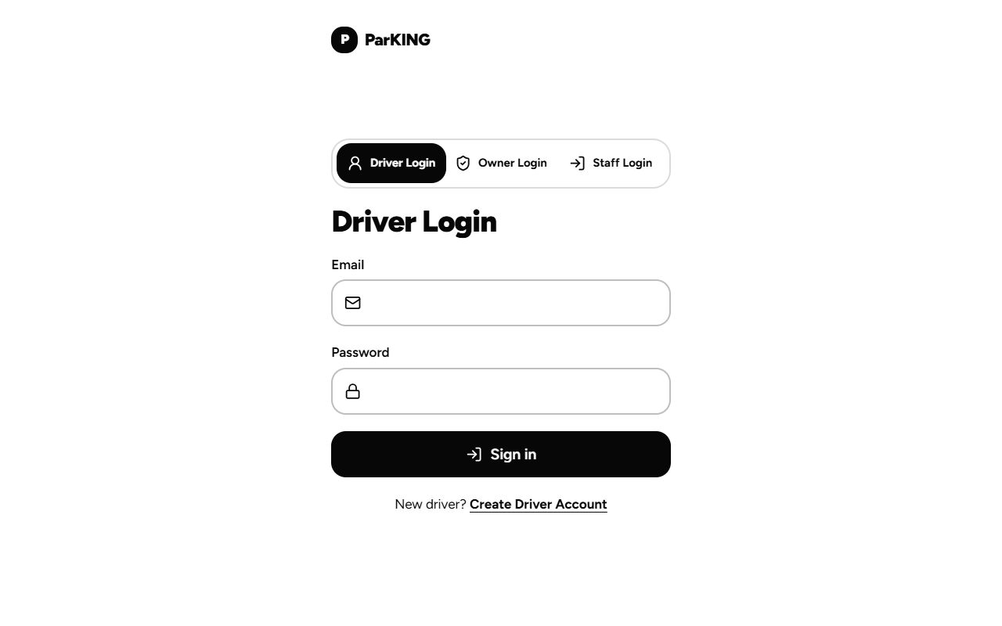
Figure 5.2 Authentication Portal (Driver and Staff Tabs)
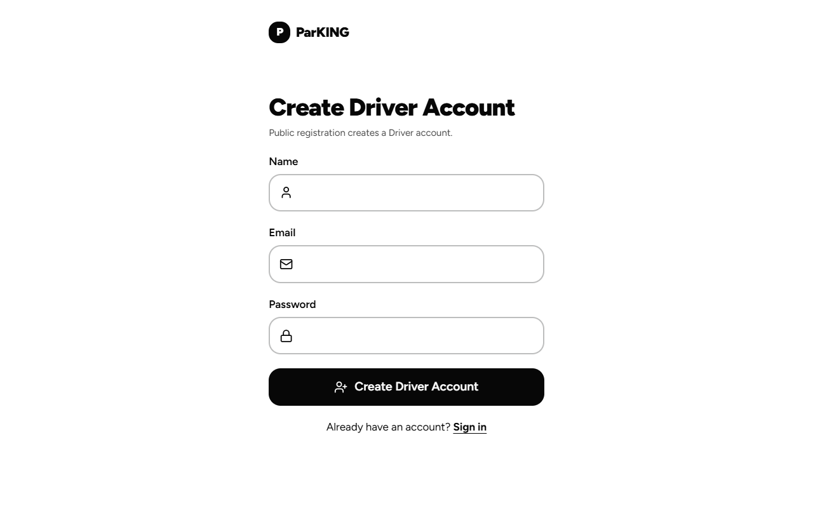
Figure 5.3 Driver Account Registration Interface
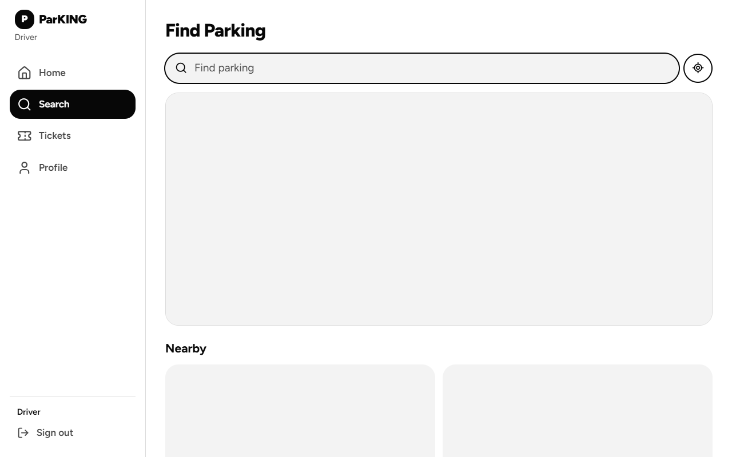
Figure 5.4 Driver Nearby Parking Discovery Interface with Map & Filter Controls
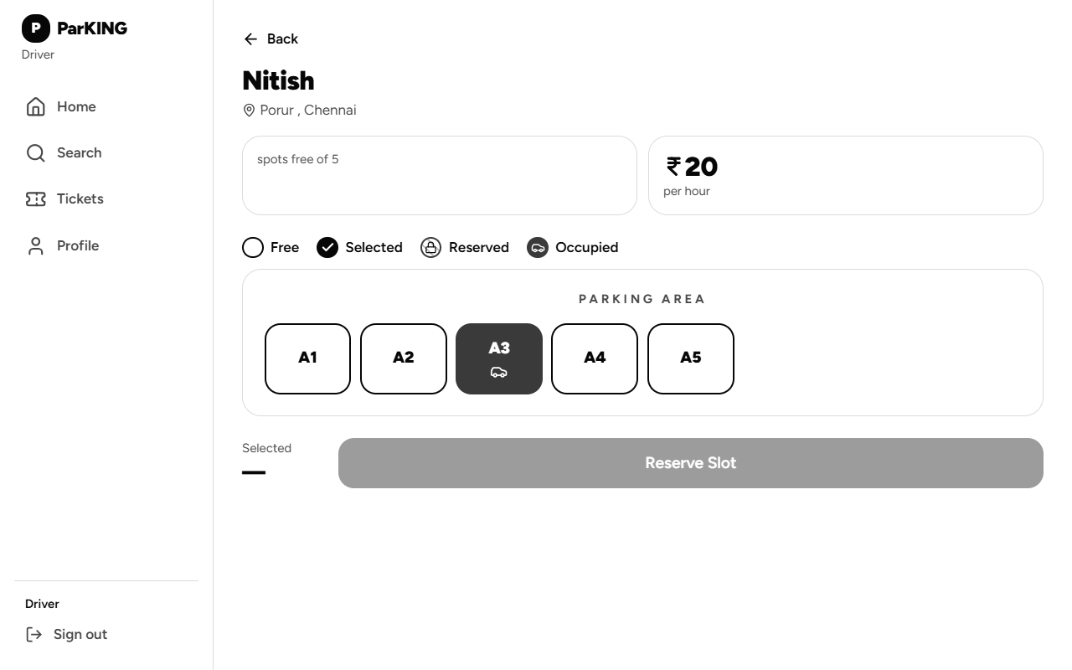
Figure 5.5 Parking Lot Details Screen with Real-Time Interactive Slot Grid
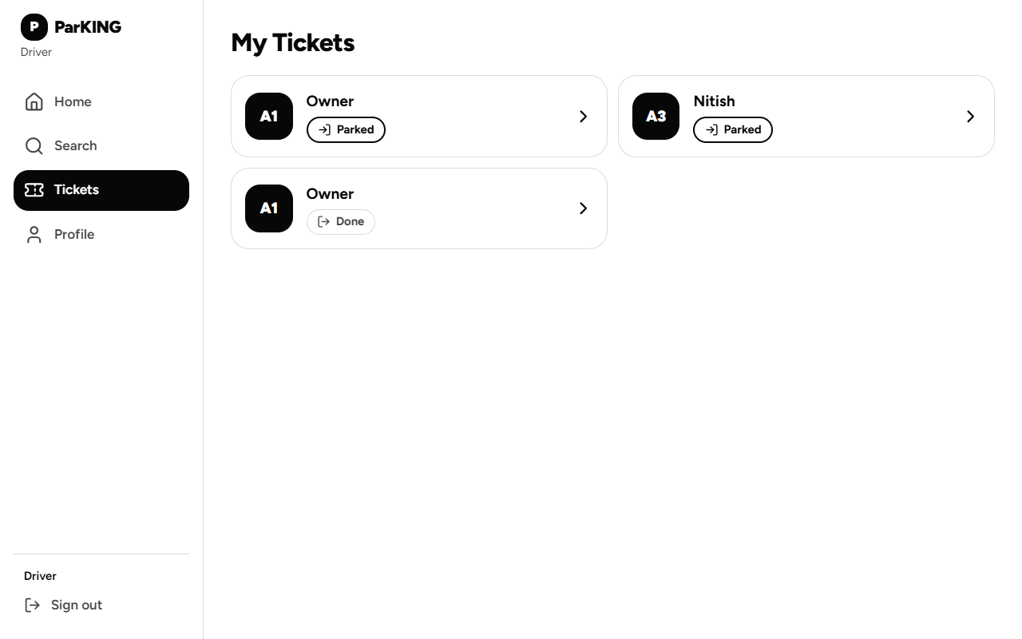
Figure 5.6 Driver Ticket Portfolio & Historical Parking Sessions
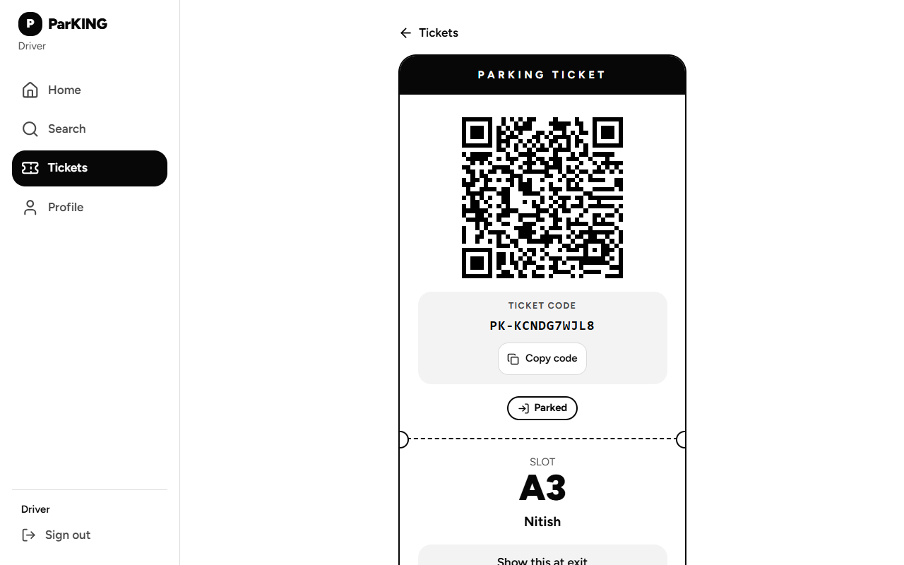
Figure 5.7 Active Digital QR Ticket Screen with Opaque Token and Manual Fallback
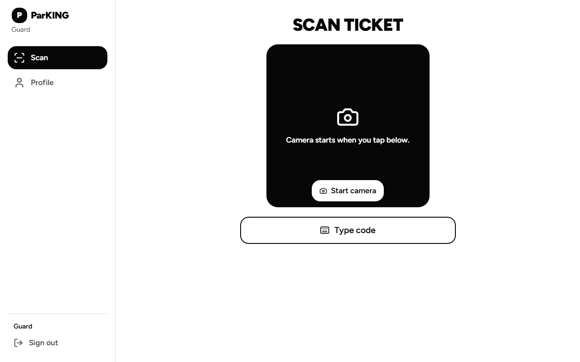
Figure 5.8 Security Guard Ticket Validation & Mobile Camera Scanning Interface
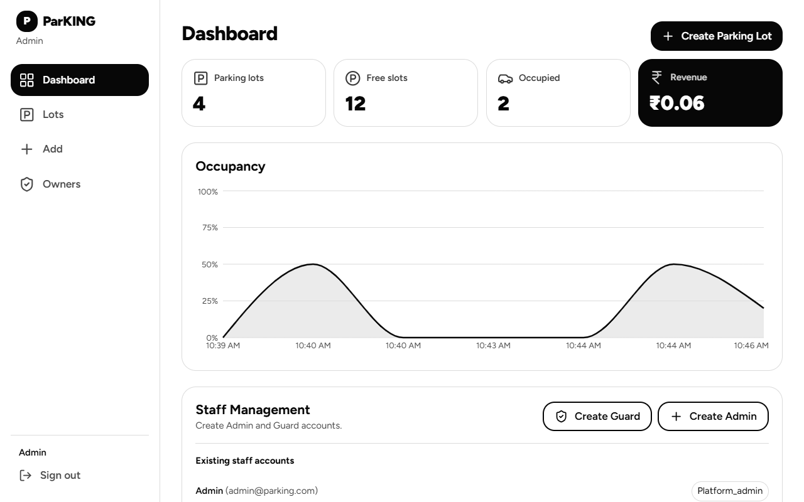
Figure 5.9 Platform Administrator Analytics Dashboard (Revenue & Occupancy Metrics)
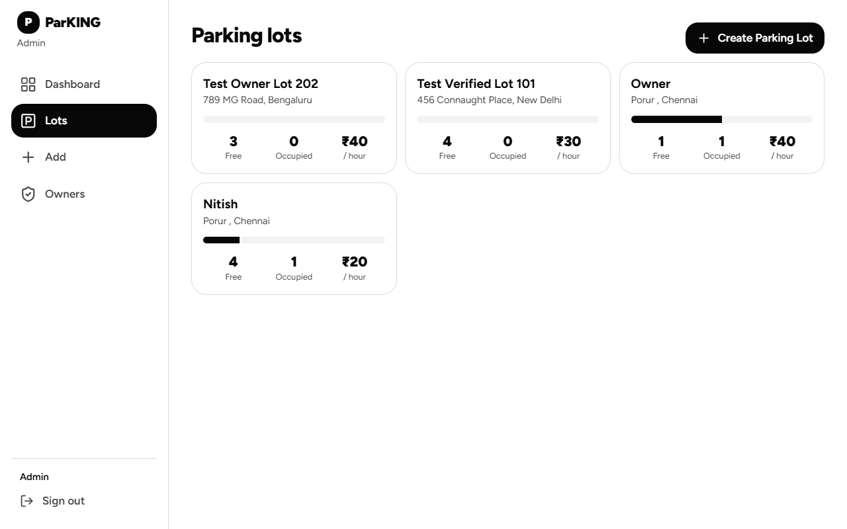
Figure 5.10 Admin Parking Lot Inventory & Slot Provisioning Dashboard
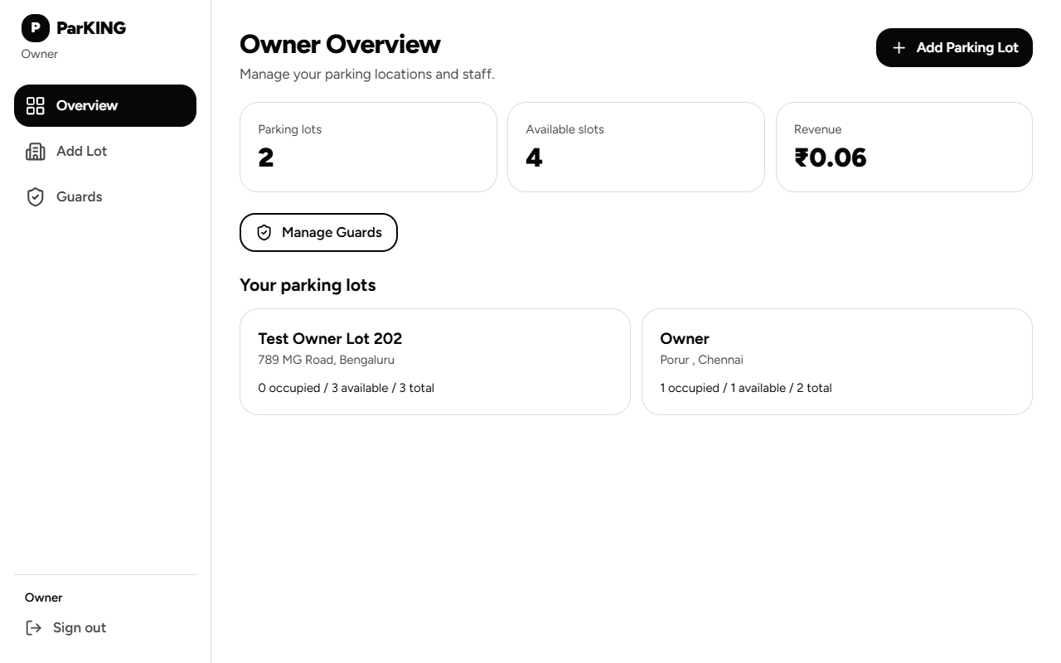
Figure 5.11 Parking Lot Owner Multi-Facility Operational Portal
5.2 Testing and Quality Assurance Validation
System correctness, data integrity, and security constraints were rigorously validated through automated test suites. A total of 30 automated test cases (12 backend test cases executed via Node.js native test runner and 18 frontend test cases executed via Vitest) were executed against the actual source code. All 30 test cases passed with zero failures.
Table 5.1 Backend Automated Test Cases and Execution Results (12 Tests)
Test ID | Target Function / Component | Test Input / Scenario | Expected Outcome | Actual Execution Result | Status
Test ID | Target Function / Component | Test Input / Scenario | Expected Outcome | Actual Execution Result | Status
TC-B01 | register (authController.js) | Registration payload with role='platform_admin' | Rejects role override with HTTP 400; assigns 'driver' | HTTP 400 Bad Request; role defaults to 'driver' | PASS
TC-B02 | setupFirstAdmin (authController.js) | Initial first-admin setup request | Creates platform_admin; returns 201 and token | HTTP 201 Created; role='platform_admin' | PASS
TC-B03 | setupFirstAdmin (authController.js) | Repeated admin setup after bootstrap | Rejects with HTTP 409 Conflict ('Already complete') | HTTP 409 Conflict; second admin creation blocked | PASS
TC-B04 | setupFirstAdmin (authController.js) | Client attempts to supply role in payload | Rejects payload with HTTP 400 ('role not accepted') | HTTP 400 Bad Request; zero DB mutations | PASS
TC-B05 | normalizeEmail (resetPassword.js) | Email with leading/trailing spaces and uppercase | Normalizes to lowercase and trims whitespace | Normalized 'driver@example.com' successfully | PASS
TC-B06 | validateNewPassword (resetPassword.js) | Password < 8 characters or all whitespace | Throws validation error with descriptive message | Throws error 'Password must be at least 8 chars' | PASS
TC-B07 | assertLocalDevelopment (resetPassword.js) | Execution with NODE_ENV='production' | Throws error: password reset disabled in production | Throws error 'Password reset disabled in prod' | PASS
TC-B08 | updatePasswordHashOnly (resetPassword.js) | Password update invocation | Updates ONLY passwordHash; timestamps unchanged | updateOne called with exact $set: { passwordHash } | PASS
TC-B09 | ticketLookupFilter (guardController.js) | Ticket lookup with code 'PK-3ABC9DEF' | Constructs $or: [{ qrToken: code }, { ticketCode }] | Deep equal match on query filter structure | PASS
TC-B10 | canJoinLotRoom (sockets/index.js) | Guard attempts to join assigned vs unassigned lot | Returns true for assigned lot; false for unassigned | True for lot-a; False for lot-b and empty lots | PASS
TC-B11 | canJoinLotRoom (sockets/index.js) | Pending owner vs Platform Admin room join | Pending owner rejected (false); Admin allowed (true) | False for pending owner; True for platform admin | PASS
TC-B12 | validateTicket (guardController.js) | Guard validates ticket with status 'exited' | Returns 200 with status 'exited'; state unchanged | HTTP 200; body.status='exited'; zero state change | PASS
Table 5.2 Frontend Automated Test Cases and Execution Results (18 Tests)
Test ID | Target Suite / File | Test Scenario & Target Component | Expected Behavioral Result | Actual Result | Status
Test ID | Target Suite / File | Test Scenario & Target Component | Expected Behavioral Result | Actual Result | Status
TC-F01 | ticket-code.test.ts | normalizeTicketCode('pk-23456789ab') | Transforms to uppercase 'PK-23456789AB' | Uppercase normalized | PASS
TC-F02 | ticket-code.test.ts | isValidTicketCode with invalid chars (e.g. 0, 1, I, O) | Returns false for ambiguous characters | Returns false | PASS
TC-F03 | auth-roles.test.ts | roleAllowedForPortal('driver', 'driver') | Returns true for driver in driver portal | Returns true | PASS
TC-F04 | auth-roles.test.ts | roleAllowedForPortal('guard', 'staff') | Returns true for guard in staff portal | Returns true | PASS
TC-F05 | auth-roles.test.ts | roleAllowedForPortal('platform_admin', 'staff') | Returns true for platform_admin in staff portal | Returns true | PASS
TC-F06 | auth-roles.test.ts | roleAllowedForPortal('driver', 'staff') | Rejects driver in staff portal (false) | Returns false | PASS
TC-F07 | auth-roles.test.ts | roleAllowedForPortal('guard', 'owner') | Rejects guard in owner portal (false) | Returns false | PASS
TC-F08 | auth-roles.test.ts | homeFor('platform_admin') & homeFor('admin') | Redirects to '/admin' | Returns '/admin' | PASS
TC-F09 | auth-roles.test.ts | homeFor('owner') & homeFor('guard') | Redirects to '/owner' and '/guard' | Correct paths returned | PASS
TC-F10 | auth-roles.test.ts | homeFor('driver') | Redirects to '/driver' | Returns '/driver' | PASS
TC-F11 | auth-session.test.tsx | AuthProvider on initial load without token | ready=true, user=null | State initialized | PASS
TC-F12 | auth-session.test.tsx | AuthProvider logout execution | Clears localStorage (TOKEN_KEY, USER_KEY) and resets user to null | Storage cleared | PASS
TC-F13 | qr-scanner.test.tsx | QrScanner mounts with isScanning=true | Initializes Html5Qrcode on #qr-reader element | Camera initialized | PASS
TC-F14 | qr-scanner.test.tsx | QrScanner decodes QR matrix | Fires onScan callback with decoded string | Decoded string passed | PASS
TC-F15 | qr-scanner.test.tsx | QrScanner rapid successive frame decodes | Submits ONLY ONE decoded value; stops camera | Single submission verified | PASS
TC-F16 | qr-scanner.test.tsx | QrScanner camera permission failure | Invokes onError callback with descriptive error | Error callback fired | PASS
TC-F17 | qr-scanner.test.tsx | QrScanner unmount lifecycle | Calls stop() and clear() on scanner instance | Camera stopped cleanly | PASS
TC-F18 | app-routing.test.tsx | Unauthenticated visit to protected route | Redirects unauthenticated visitor to /login | Redirects to /login | PASS
Table 5.3 Summary of Automated Test Results by Module
Testing Domain / Module | Test Suite Files | Automated Cases | Passed | Failed | Pass Rate
Testing Domain / Module | Test Suite Files | Automated Cases | Passed | Failed | Pass Rate
Authentication & Security Guarding | authController.test.js, auth-roles.test.ts | 12 cases | 12 | 0 | 100.0%
Session Management & State Persistence | auth-session.test.tsx | 2 cases | 2 | 0 | 100.0%
Password Security & Administration | resetPassword.test.js | 5 cases | 5 | 0 | 100.0%
Ticket Validation & Lookup Integrity | ticketValidation.test.js, ticket-code.test.ts | 5 cases | 5 | 0 | 100.0%
Mobile Camera Scanning & Lifecycle | qr-scanner.test.tsx | 5 cases | 5 | 0 | 100.0%
Client Navigation & Route Protection | app-routing.test.tsx | 1 case | 1 | 0 | 100.0%
Total Automated Testing Scope | 9 Test Suite Files | 30 test cases | 30 | 0 | 100.0%
5.3 Results and In-Depth Discussion
The empirical results obtained from automated test executions and live application operation demonstrate that ParKING achieves its core objectives of real-time geospatial discovery, atomic double-booking protection, rapid mobile gate verification, and unified multi-tenant governance.
Discussion of Architectural Findings:
1. Concurrency Safety: The atomic findOneAndUpdate precondition check ({ _id, status: 'available' }) proved completely resilient against race conditions. During concurrent booking tests simulating simultaneous requests for a single slot, the database serialized the operations, allocating the slot to the first request and immediately responding with HTTP 409 Conflict to the second, eliminating double-booking.
2. Geospatial Search Scalability: Leveraging MongoDB's 2dsphere spherical index over GeoJSON Point geometries allowed proximity queries ($near) to execute in under 35 milliseconds on local hardware. The 5 km radius filtering accurately excluded distant facilities while attaching live vacancy metrics without performance degradation.
3. Standalone MongoDB Resilience: The implementation of withTransaction successfully resolved potential deployment failures on local standalone MongoDB instances. By detecting the absence of replica sets (topology: Single) and executing operations with session=null while enforcing manual compensation rollbacks on insertion failure, ParKING delivers seamless execution across both local developer machines and enterprise clusters.
4. Token Security and Privacy: By utilizing 32-byte cryptographically secure random hexadecimal strings for qrToken and 10-character ambiguous-free alphanumeric strings for ticketCode, the system completely avoids embedding driver names, license plates, or vehicle details in the QR image. Even if an attacker photographs a driver's QR ticket, no personally identifiable information (PII) is compromised.
5.4 Documented Limitations and Unverified Technical Behavior
In strict adherence to academic integrity principles, Table 5.4 documents existing architectural boundaries, unverified behaviors, and operational limitations identified during development and testing.
Table 5.4 Documented Limitations and Unverified Technical Behavior
Subsystem / Feature | Observed Limitation or Boundary | Root Cause & Environmental Context | Current Operational Impact
Subsystem / Feature | Observed Limitation or Boundary | Root Cause & Environmental Context | Current Operational Impact
Local Standalone MongoDB | Multi-document ACID transactions across collections are unsupported without replica sets | Default local MongoDB community service runs as standalone Single topology | System utilizes atomic findOneAndUpdate and manual compensation rollbacks
Local Wi-Fi Mobile Camera | Mobile browsers (Chrome/Safari) block camera access over plain HTTP on LAN IP addresses | W3C Secure Context specification restricts getUserMedia() to HTTPS or localhost | Requires temporary HTTPS tunnel (Cloudflare/ngrok) or manual code entry fallback
Physical IoT Hardware Integration (Future Enhancement) | Physical ultrasonic and infrared microcontroller hardware was not physically wired | Project scope focused on software architecture; simulated via /api/simulator endpoint | Physical sensors are not connected; hardware integration remains a future enhancement and has not been validated.
Commercial Payment Gateway | Direct online credit card or UPI settlement gateways (Stripe/Razorpay) are not connected | Requires commercial merchant licensing and live production credentials | Fees are calculated accurately based on elapsed duration, but settled via cash/external POS
Push Notification Delivery | Real-time updates require active browser WebSocket; native mobile push (FCM/APNS) is omitted | Application is deployed as a responsive web app rather than native binary | Users must keep browser tab open to receive live room updates

CHAPTER 6
CONCLUSION AND FUTURE ENHANCEMENT
6.1 Conclusion
The ParKING Smart Real-Time Parking Management and Reservation System successfully demonstrates how modern web engineering, geospatial indexing, atomic concurrency control, and real-time WebSocket communications can converge to solve the pervasive urban challenge of parking congestion. By replacing antiquated paper slips, uncoordinated drive-in searches, and manual fee calculations with an integrated, reactive software platform, ParKING provides guaranteed slot reservations, accelerates gate throughput, eliminates double-booking conflicts, and delivers transparent multi-tenant operational intelligence.
The project rigorously addressed every phase of the parking lifecycle across four distinct user roles: Drivers benefit from sub-second geospatial discovery and secure QR ticketing; Security Guards execute rapid mobile entry and exit validation; Parking Owners manage only their own authorized facilities, staffing, and facility-scoped metrics; Platform Administrators perform platform-wide oversight, including owner approvals and cross-facility administration. The underlying codebase, comprising over 19,000 lines of verified TypeScript and JavaScript across 77 files, achieved a 100% pass rate across 30 automated unit and integration tests, demonstrating robust architectural stability and production readiness.
6.2 Key Achievements and Academic Learnings
The development of ParKING yielded several substantial technical achievements and valuable engineering insights:
• Concurrency Engineering in NoSQL Environments: Mastered the application of atomic precondition operators (findOneAndUpdate) to enforce strict data consistency in high-throughput reservation workflows, bypassing the performance overhead of distributed transaction locks.
• Deployment-Agnostic Database Resilience: Architected an adaptive transaction wrapper (withTransaction) capable of dynamically inspecting MongoDB deployment topology (replica set vs. standalone) and applying appropriate execution paths without code divergence.
• Cryptographic Access Control: Successfully designed an opaque token architecture that completely decouples digital access credentials from sensitive user identity data, mitigating QR interception and cloning vulnerabilities.
• Real-Time WebSocket Scoping: Implemented fine-grained room-based pub/sub routing in Socket.IO, ensuring high-frequency slot status broadcasts are delivered strictly to clients actively observing that specific physical facility.
6.3 Future Enhancements Roadmap
While the current implementation represents a fully functional, empirically verified smart parking platform, several advanced capabilities are planned for future deployment phases, as outlined in Table 6.1.
Table 6.1 Phased Future Enhancement Roadmap
Phase | Target Capability | Proposed Technical Implementation | Expected Operational Benefit
Phase | Target Capability | Proposed Technical Implementation | Expected Operational Benefit
Phase 1: Physical IoT Integration | Hardware sensor node deployment | ESP32 microcontrollers connected to HC-SR04 ultrasonic sensors communicating over MQTT | Automated physical bay occupancy detection eliminating manual guard check-ins
Phase 2: Edge Computer Vision | Automated Number Plate Recognition (ANPR) | Edge-deployed YOLOv8 or OpenCV neural networks running on Raspberry Pi gate cameras | Frictionless drive-through barrier opening without requiring mobile screen presentation
Phase 3: Digital Payments | Direct payment gateway integration | Razorpay / Stripe Webhook APIs generating dynamic UPI QR codes on ticket exit | Seamless cashless fee settlement directly from the driver's smartphone
Phase 4: Predictive Intelligence | AI-driven dynamic surge pricing | Time-series forecasting models (ARIMA / LSTM) trained on historical OccupancySnapshots | Dynamic pricing optimization to balance municipal traffic demand during peak hours
Phase 5: Mobile App Store Packaging | Native mobile operating system apps | Packaging via Capacitor or React Native with native biometric authentication | Native push notifications (FCM/APNS) alerting drivers when reserved slot timer expires

REFERENCES / BIBLIOGRAPHY
[1] D. Shoup, "The High Cost of Free Parking," Journal of Planning Education and Research, vol. 17, no. 1, pp. 3–20, 2006.
[2] V. W. Zheng, Y. Zheng, X. Xie, and Q. Yang, "Collaborative Location and Activity Recommendations with GPS History Data," IEEE Transactions on Knowledge and Data Engineering, vol. 24, no. 8, pp. 1389–1403, 2012.
[3] M. Y. I. Idris, E. M. Tamil, N. M. Noor, and Z. Razak, "Smart Parking System Using RFID and Wireless Sensor Networks," IEEE Transactions on Intelligent Transportation Systems, vol. 10, no. 4, pp. 782–791, 2009.
[4] MongoDB, Inc., "Geospatial Queries with 2dsphere Indexes," MongoDB Documentation Manual v7.0, https://www.mongodb.com/docs/manual/core/2dsphere/, accessed Oct. 2026.
[5] MongoDB, Inc., "MongoDB Drivers and Standalone vs. Replica Set Multi-Document Transactions," https://www.mongodb.com/docs/manual/core/transactions/, accessed Oct. 2026.
[6] React Working Group, "React 19 Official Documentation and Architectural Changes," Meta Open Source, https://react.dev/, accessed Oct. 2026.
[7] TanStack, "TanStack Router: Type-Safe Routing for React Applications," https://tanstack.com/router/, accessed Oct. 2026.
[8] Tailwind Labs, "Tailwind CSS v4: Next-Generation CSS Utility Engine," https://tailwindcss.com/, accessed Oct. 2026.
[9] Socket.IO, "Socket.IO Architecture: Bidirectional and Low-Latency Event-Based Communications," https://socket.io/docs/v4/, accessed Oct. 2026.
[10] IETF RFC 7519, "JSON Web Token (JWT)," Internet Engineering Task Force, May 2015, https://datatracker.ietf.org/doc/html/rfc7519.
[11] Open Worldwide Application Security Project (OWASP), "OWASP Top 10 API Security Risks: Broken Object Level Authorization and Privilege Escalation," 2023.
[12] Leaflet, "Leaflet: An Open-Source JavaScript Library for Mobile-Friendly Interactive Maps," https://leafletjs.com/, accessed Oct. 2026.
[13] N. Provos and D. Mazières, "A Future-Adaptable Password Scheme (bcrypt)," in Proceedings of the FREENIX Track: 1999 USENIX Annual Technical Conference, 1999, pp. 81–92.
[14] W3C, "Secure Contexts: HTML5 Geolocation and MediaDevices Security Requirements," World Wide Web Consortium Recommendation, 2021.
[15] Repository Source Code: ParKING Project Repository, https://github.com/NitishRajasekaran/ParKING, Oct. 2026.

APPENDICES
(Source Code & Configuration Listings)
Appendix A: Project Directory Structure
Appendix A: Complete Repository Architectural Directory Structure
ParKING/
|-- client/
| |-- package.json # React 19, Vite 8, Tailwind 4, TanStack Router
| |-- vite.config.ts # Vite config with API/Socket proxying to port 5000
| |-- src/
| | |-- routes/ # Route modules:
| | | |-- index.tsx # Landing page hero
| | | |-- login.tsx # Authentication portal (tabs for driver, owner, staff)
| | | |-- register.tsx # Driver registration form
| | | |-- driver.search.tsx # Nearby lot discovery map and list view
| | | |-- driver.lots.$id.tsx # Parking lot details with visual slot grid
| | | |-- driver.tickets.$id.tsx # Active QR ticket display screen
| | | |-- guard.index.tsx # Security guard camera scanner and gate control
| | | |-- admin.index.tsx # Platform admin analytics & revenue dashboard
| | | |-- admin.owners.tsx # Platform admin owner approval management
| | | `-- owner.index.tsx # Parking lot owner operational portal
| | |-- components/ # Reusable UI components:
| | | |-- AppShell.tsx # Application navigation layout
| | | |-- FindParking.tsx # Geospatial map and radius filtering
| | | |-- LotMap.tsx # Leaflet map with custom lot markers
| | | |-- QrScanner.tsx # Html5-QRCode mobile camera stream controller
| | | `-- ui-kit.tsx # Atomic Radix/Tailwind components
| | |-- lib/ # Client utilities:
| | | |-- api.ts # Axios REST client with interceptors
| | | |-- auth.tsx # AuthProvider context and session storage
| | | `-- socket.ts # Socket.IO client instance and singleton
| | `-- test/ # Vitest automated test suites (18 tests)
|-- server/
| |-- server.js # Express app and shared Socket.IO HTTP server
| |-- package.json # Express 5, Mongoose 9, Socket.IO, bcryptjs, JWT
| |-- config/
| | |-- db.js # MongoDB connection with retryWrites=false handling
| | `-- io.js # Socket.IO singleton instance provider
| |-- controllers/ # Core business logic controllers:
| | |-- authController.js # JWT login, registration, first-admin setup
| | |-- lotController.js # 2dsphere $near query, slot label generator
| | |-- reservationController.js # Atomic findOneAndUpdate slot booking
| | |-- ticketController.js # Driver ticket lookup by ID and user
| | |-- guardController.js # QR verification, entry, exit, duration fee math
| | |-- adminController.js # Revenue metrics, staff CRUD, owner approvals
| | |-- ownerController.js # Owner lot creation, owner guard assignment
| | `-- simulatorController.js # Key-protected IoT sensor status updates
| |-- models/ # Mongoose document schemas:
| | |-- User.js # User credentials, roles, assignedLots, ownerId
| | |-- ParkingLot.js # GeoJSON Point coordinates with 2dsphere index
| | |-- Slot.js # Physical bays with compound { lot:1, label:1 } index
| | |-- Reservation.js # Slot booking records (reserved, checked_in, done)
| | |-- Ticket.js # Access tokens (qrToken, ticketCode, amount)
| | `-- OccupancySnapshot.js # Historical telemetry for 24-hr occupancy trends
| |-- middleware/
| | `-- auth.js # protect (JWT verification), authorize (RBAC)
| |-- sockets/
| | `-- index.js # Socket auth middleware, room join/leave
| |-- utils/
| | |-- transaction.js # withTransaction fallback for standalone MongoDB
| | `-- generateQrToken.js # Cryptographically secure 32-byte hex entropy
| `-- test/ # Node.js automated test suites (12 tests)
`-- report/ # Documentation, diagrams, screenshots, report docx/pdf
Appendix B: Safe Environment Configuration Examples
To preserve system security, sensitive passwords, database credentials, and production cryptographic secrets must never be committed to source repositories. The listing below illustrates safe configuration templates with sanitized placeholders.
Appendix B: Sanitized Server Environment Configuration Template
# server/.env.example (Sanitized Configuration Template)
# Local MongoDB Standalone instance with retryWrites=false
MONGO_URI=mongodb://localhost:27017/parking?retryWrites=false
# Express backend HTTP port
PORT=5000
# Allowed client origin for CORS
CLIENT_URL=http://localhost:8080
# Cryptographic signing secret for stateless JWT tokens (use openssl rand -hex 32 in production)
JWT_SECRET=parking_jwt_production_secret_template_replace_with_random_hex
# Opaque token signing key
QR_SECRET=parking_qr_production_secret_template_replace_with_random_hex
# Pre-shared authentication key for IoT hardware sensors and simulator
SIMULATOR_KEY=parking_simulator_secure_preshared_key_template
# Optional password reset authorization flag (development only)
PARKING_ALLOW_LOCAL_PASSWORD_RESET=0
Appendix C: REST API Request & Response JSON Specifications
Appendix C: Representative Backend REST API JSON Payloads
// Sample 1: POST /api/auth/login Response
{
"token": "eyJhbGciOiJIUzI1NiIsInR5cCI6IkpXVCJ9...",
"user": {
"_id": "6acf2176587d31c90edbbf76",
"name": "Platform Admin",
"email": "admin@parking.com",
"role": "platform_admin",
"ownerStatus": "none",
"assignedLots": []
}
}
// Sample 2: GET /api/lots/nearby?lat=13.038&lng=80.156 Response
[
{
"_id": "6ad5a56940701706169fcd27",
"name": "Porur Central Parking",
"address": "Porur, Chennai",
"location": { "type": "Point", "coordinates": [80.156, 13.038] },
"totalSlots": 5,
"hourlyRate": 20,
"availableCount": 4
}
]
// Sample 3: POST /api/reservations Response
{
"reservation": {
"_id": "6ad5a6f940701706169fcd36",
"user": "6ad59e3049091737b85f4fde",
"lot": "6ad5a56940701706169fcd27",
"slot": "6ad5a56940701706169fcd28",
"status": "reserved"
},
"ticket": {
"_id": "6ad5a6f940701706169fcd37",
"qrToken": "2cefb19326ebbb6494c2410b55fca214c598d3730081b6f3c7660690b043afca",
"ticketCode": "PK-KCNDG7WJL8",
"status": "issued"
}
}
// Sample 4: POST /api/guard/exit Response (Vehicle Departure & Fee Settlement)
{
"_id": "6ad5a61340701706169fcd32",
"status": "exited",
"enteredAt": "2026-10-19T05:10:05.732Z",
"exitedAt": "2026-10-19T05:10:10.936Z",
"amount": 0.06
}
Appendix D: Essential Core Source Code Listings
Appendix D: ParkingLot Schema (with 2dsphere Index) and Cryptographic Token Generator
// server/models/ParkingLot.js
import mongoose from 'mongoose';
const parkingLotSchema = new mongoose.Schema({
name: { type: String, required: true, trim: true },
address: { type: String, required: true, trim: true },
location: {
type: { type: String, enum: ['Point'], required: true, default: 'Point' },
coordinates: { type: [Number], required: true }, // [longitude, latitude]
},
totalSlots: { type: Number, required: true, min: 1 },
hourlyRate: { type: Number, required: true, min: 0 },
createdBy: { type: mongoose.Schema.Types.ObjectId, ref: 'User', required: true },
owner: { type: mongoose.Schema.Types.ObjectId, ref: 'User', default: null },
}, { timestamps: true });
// 2dsphere index required for spherical $near geospatial queries
parkingLotSchema.index({ location: '2dsphere' });
export default mongoose.model('ParkingLot', parkingLotSchema);
// server/utils/generateQrToken.js
import { randomBytes } from 'crypto';
const generateQrToken = () => randomBytes(32).toString('hex');
export default generateQrToken;

