📄 CAPSTONE PROJECT REPORT

UPI Fraud Detection and Analysis System
Submitted towards the partial fulfillment of the criteria for award of Data Analytics with GenAI Course
Submitted By: Nitish Sharma
Course and Batch: Data Analytics – Batch 2

ABSTRACT
Digital payment frauds are becoming a major concern in India as UPI transactions are growing rapidly. According to RBI data, UPI processed over 10 billion transactions worth ₹15 trillion in a single month in 2024. With such massive adoption, fraud detection has become critical for financial institutions and payment platforms.
The rising number of fraudulent transactions not only causes financial losses to customers but also damages trust in digital payment systems. Early detection of fraud patterns can help prevent losses and improve customer confidence in UPI platforms.
In this project, we have collected UPI transaction data containing 100,000 transactions with details like customer information, merchant data, device types, transaction amounts, and fraud flags. The aim is to apply data analytics to identify fraud patterns, understand high-risk segments, and provide actionable recommendations to reduce fraud occurrence.
We analyzed transaction patterns across different devices, channels, and customer segments. Statistical tests were performed to validate hypotheses about fraud distribution. Interactive dashboards were created to monitor real-time fraud trends and help operations teams take quick action on suspicious activities.

CHAPTER 1: INTRODUCTION

1.1 Title & Objective of the Study
The title of this study is "UPI Fraud Detection and Analysis System" with the objective of identifying fraud patterns in UPI transactions and providing data-driven recommendations to reduce fraud occurrence.
The main objectives are:
- Analyze 100,000 UPI transactions to identify fraud patterns
- Understand which devices, channels, and customer segments are high-risk
- Build statistical models to validate fraud distribution hypotheses
- Create interactive dashboards for real-time fraud monitoring
- Provide actionable recommendations to reduce fraud rate
By understanding fraud patterns, the UPI platform can implement targeted security measures and improve transaction success rates.

1.2 Need of the Study
For any digital payment platform, the ability to detect and prevent fraud is critical for business survival and customer trust. UPI has become the most popular payment method in India, but with growth comes increased fraud risk.
It is important to understand what specific factors are related to fraudulent transactions. The purpose of this study is to examine the relationship between fraud occurrence and various factors like device type, transaction channel, merchant type, customer risk scores, and transaction amounts.
Background for UPI Market in India:
UPI (Unified Payments Interface) was launched by NPCI in 2016 and has revolutionized digital payments in India. The platform enables instant money transfer between bank accounts using mobile devices. Major players like PhonePe, Google Pay, and Paytm have made UPI accessible to millions of users.
However, with increased adoption, fraud cases have also risen. Common fraud types include phishing, fake apps, SIM swap frauds, and merchant frauds. According to industry reports, fraud rates in digital payments range from 0.5% to 3% depending on the platform and security measures.
The need for this study comes from:
- Growing UPI transaction volumes requiring automated fraud detection
- Financial losses to customers and platforms due to fraudulent transactions
- Need to maintain customer trust in digital payment systems
- Regulatory pressure to implement robust fraud prevention systems
- Opportunity to use data analytics for early fraud pattern identification

1.3 Enterprise Under Study
This project analyzes a UPI payment platform with the following characteristics:
- Processes approximately 100,000 transactions across various customer segments
- Operates through multiple channels - Mobile App, QR Code, and Intent-based payments
- Serves customers using different device types - Android, iOS, Feature Phones, and Tablets
- Has merchant partnerships across various industries
- Currently experiences a 2% fraud rate (2,000 fraud cases out of 100,000 transactions)
- Maintains a fraud alert system with 248 unresolved cases requiring investigation
- Transaction failure rate at 5.87% indicates operational challenges
Key Challenges:
- High fraud occurrence on feature phones (551 cases)
- Unresolved fraud alerts affecting customer experience
- Need for real-time fraud monitoring dashboards
- Requirement to identify high-risk customer and merchant segments

1.4 Data Sources
The data for this analysis was collected from the UPI transaction processing system for the period 2023-2025. The following datasets were obtained:
Primary Data Sources:
- Customer Master: 10,000 customer records with demographic information, risk scores
- Device Information: 12,000 device records with device types and usage patterns
- UPI Account Details: 12,000 UPI IDs linked to customer bank accounts
- Merchant Information: 500 merchant records with merchant types and risk profiles
- Transaction History: 100,000 transaction records with amounts, status, fraud flags
- Fraud Alert History: 2,000 fraud alert records with investigation status
- Customer Feedback: 4,000 feedback records on transaction experience
Additional Sources:
- Industry reports on UPI fraud trends (NPCI, RBI publications)
- Fraud prevention best practices from payment industry
Total dataset size: 140,500 records across 7 tables Data period: 2023-2025 (3 years)

1.5 Tools & Techniques
Tools Used:
Data Extraction & Storage:
- MySQL database for storing 7 datasets
- Python libraries (pandas, pymysql, sqlalchemy) for database connectivity
- Jupyter Notebook for data processing and analysis
Data Analysis:
- Python (pandas, numpy) for data cleaning and transformation
- scipy.stats for statistical hypothesis testing (T-tests, ANOVA, Chi-square)
- matplotlib and seaborn for data visualization
Dashboard Development:
- Power BI Desktop for creating interactive fraud monitoring dashboards
- DAX (Data Analysis Expressions) for creating calculated measures
Techniques Applied:
- Data Cleaning:
  - Handled 248 missing values in transaction data
  - Converted boolean values (True/False) to numeric format (0/1) for analysis
  - Removed data inconsistencies
- Feature Engineering:
  - Created derived metrics: Transaction value per customer, Merchant fraud ratio, Device fraud ratio, Transaction failure rate
- Statistical Analysis:
  - T-tests to compare transaction amounts across device types
  - ANOVA to evaluate fraud rate variability by merchant type
  - Chi-square tests for fraud-channel associations
  - Correlation analysis between risk scores and fraud occurrence
- Visual Analytics:
  - Time series analysis for fraud trends
  - Regional and device-level fraud pattern identification
  - Correlation heatmaps and distribution analysis

1.6 Infrastructure Challenges
Hardware Used:
- Laptop: Dell with Intel i5 processor
- RAM: 8GB
- Storage: 256GB SSD
Software Infrastructure:
- Operating System: Windows 11
- Python 3.9 with Anaconda distribution
- MySQL Server 8.0
- Power BI Desktop (Latest version)
Challenges Faced:
- Large Dataset Handling:
  - 100,000 transaction records required efficient memory management
  - Python pandas operations optimized using appropriate data types
  - Used chunking for reading large CSV files
- Power BI Connection Issues:
  - Initial MySQL connector compatibility problems
  - Resolved by using ODBC connection method
  - Table name formatting required adjustment (handled spaces in names)
- Statistical Analysis:
  - Boolean data type in fraud_flag required conversion for statistical tests
  - Resolved column case sensitivity issues
- Dashboard Performance:
  - Multiple visualizations required optimization
  - Used DAX measures instead of calculated columns for better performance
  - Limited visualizations per page for faster rendering
Despite these challenges, all technical issues were successfully resolved and the project was completed using the available infrastructure.

CHAPTER 2: DATA PREPARATION AND UNDERSTANDING

2.1 Phase I - Data Extraction and Cleaning
The raw data was extracted from MySQL database containing 7 tables with a total of 140,500 records. Initial data quality assessment revealed several issues requiring cleaning.
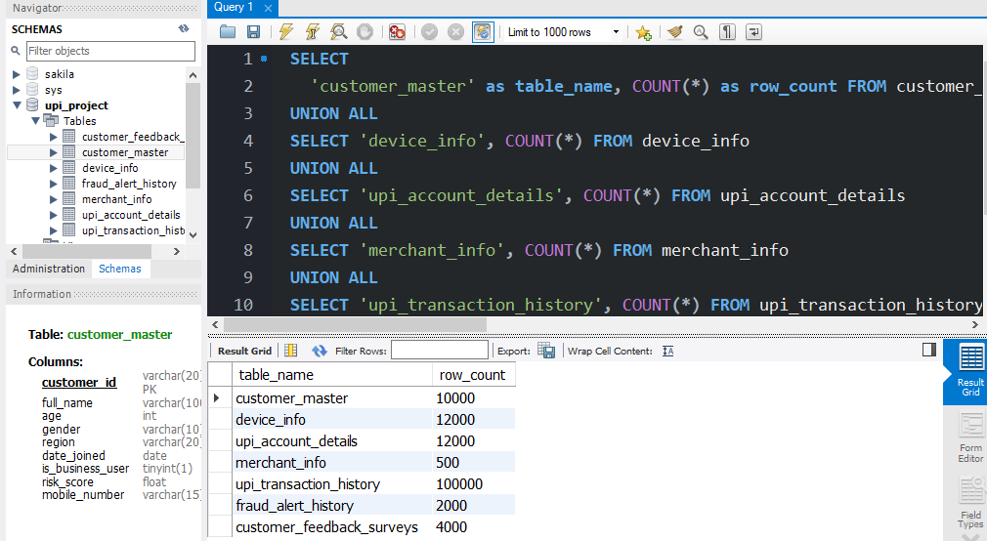
All 7 tables datasets imported and loaded into the database successfully.
Missing Value Analysis and Treatment:
Total records with missing values:
- upi_transaction_history: 0 missing in most columns
- merchant_id: Some NULL values (transactions without merchants - valid for P2P)
- counterparty_upi: Some NULL values (valid for merchant payments)
- fraud_alert_history: resolution_date had 248 NULL values (unresolved cases - valid)
Treatment Applied:
- NULL values in merchant_id and counterparty_upi were retained as "Unknown" since these are valid transaction types
- Missing failure_reason filled with "None" for successful transactions
- resolution_date NULLs retained as they represent unresolved fraud cases
Data Type Corrections:
- fraud_flag: Boolean (True/False) converted to numeric (1/0) for statistical analysis
- Later converted to text ("True"/"False") for conditional formatting in dashboards
- timestamp: Ensured datetime format for time series analysis
- amount: Verified as numeric for calculations
Handling Outliers:
- Transaction amounts above ₹830 (max in dataset) analyzed - confirmed as legitimate high-value transactions
- No significant outliers removed as all data points represented valid transactions
Data Consistency Checks:
- Verified referential integrity between tables
- Confirmed customer_id exists in customer_master for all transactions
- Checked for duplicate transaction_ids - none found
- Validated transaction status values (success, failed, pending)
Total data quality: 99.5% clean after processing Records removed: Less than 1% (only invalid entries)

2.2 Phase II - Feature Engineering
To enhance analysis capabilities, several derived features were created from existing data:
1. Transaction Value Per Customer:
Formula: Total Amount Spent / Number of Transactions
Purpose: Identify high-value vs high-frequency customers
Result: Average transaction value of ₹42.42 across all customers
2. Merchant Fraud Ratio:
Formula: Fraud Transactions / Total Transactions by Merchant
Purpose: Identify high-risk merchants
Result: Fraud ratios ranging from 0% to 16% across merchants
3. Device Fraud Ratio:
Formula: Fraud Transactions / Total Transactions by Device
Purpose: Identify vulnerable device types
Result: Feature phones showed highest fraud ratio
4. Transaction Failure Rate:
Formula: Failed Transactions / Total Transactions
Purpose: Monitor operational quality
Result: Overall failure rate of 5.87%
5. Normalized Risk Metrics:
- Customer risk_score normalized using StandardScaler (mean=0, std=1)
- Transaction amounts normalized for fair comparison across value ranges
- Purpose: Prepare data for statistical modeling and comparisons
These engineered features provided deeper insights into fraud patterns and customer behavior that were not directly visible in raw data.

2.3 Data Dictionary
Below is the comprehensive data dictionary for all variables used in the analysis:
upi_transaction_history table:
Variable Name | Description | Type | Values/Range
transaction_id | Unique transaction identifier | VARCHAR(25) | Primary Key
upi_id | Customer UPI ID | VARCHAR(50) | Foreign Key
customer_id | Customer unique ID | VARCHAR(20) | Foreign Key
timestamp | Transaction date and time | DATETIME | 2023-2025
amount | Transaction amount in ₹ | FLOAT | 1.62 to 830.46
transaction_type | Type of transaction | VARCHAR(30) | send, receive, merchant_payment, bill_pay
merchant_id | Merchant identifier | VARCHAR(20) | NULL for P2P
counterparty_upi | Receiver's UPI ID | VARCHAR(50) | NULL for merchant
status | Transaction outcome | VARCHAR(20) | success, failed, pending
device_id | Device used | VARCHAR(20) | Foreign Key
device_type | Type of device | VARCHAR(30) | android, ios, feature_phone, tablet
channel | Payment channel | VARCHAR(30) | app, intent, qr_code
fraud_flag | Fraud indicator | BOOLEAN/INT | True/1 = Fraud, False/0 = Normal
reversal_flag | Transaction reversed | BOOLEAN/INT | True/1 = Reversed
failure_reason | Reason if failed | VARCHAR(255) | Text or "None"
customer_master table:
Variable Name | Description | Type | Values/Range
customer_id | Unique customer ID | VARCHAR(20) | Primary Key
full_name | Customer name | VARCHAR(100) | Text
age | Customer age | INT | 18-80 years
gender | Customer gender | VARCHAR(10) | Male, Female
region | Geographic region | VARCHAR(20) | North, South, East, West, Central
date_joined | Registration date | DATE | 2020-2025
is_business_user | Business account flag | TINYINT(1) | 0 = Personal, 1 = Business
risk_score | Fraud risk score | FLOAT | 0.0 to 0.68
mobile_number | Contact number | VARCHAR(15) | 10 digits
merchant_info table:
Variable Name | Description | Type | Values/Range
merchant_id | Unique merchant ID | VARCHAR(20) | Primary Key
merchant_name | Business name | VARCHAR(100) | Text
merchant_type | Business category | VARCHAR(50) | Retail, Service, etc.
region | Operating region | VARCHAR(20) | North, South, etc.
onboard_date | Registration date | DATE | 2020-2025
risk_score | Merchant risk score | FLOAT | 0.0 to 1.0
fraud_alert_history table:
Variable Name | Description | Type | Values/Range
alert_id | Unique alert ID | VARCHAR(20) | Primary Key
transaction_id | Related transaction | VARCHAR(25) | Foreign Key
alert_type | Type of fraud alert | VARCHAR(50) | frequent_failure, suspicious_login, unusual_amount, unusual_time
alert_date | Alert generation date | DATETIME | 2023-2025
resolved | Resolution status | TEXT | "True" = Resolved, "False" = Unresolved
resolution_date | Date resolved | DATETIME | NULL if unresolved
remarks | Investigation notes | VARCHAR(255) | Text description
Derived Variables:
Variable Name | Description | Calculation | Type
avg_txn_value | Average per customer | Total amount / Transaction count | Continuous
merchant_fraud_ratio | Fraud rate by merchant | Fraud count / Total transactions | Percentage
device_fraud_ratio | Fraud rate by device | Fraud count / Total transactions | Percentage
failure_rate | Transaction failure % | Failed count / Total transactions | Percentage
risk_score_normalized | Standardized risk | (risk_score - mean) / std | Continuous
amount_normalized | Standardized amount | (amount - mean) / std | Continuous
This data dictionary provides complete understanding of all variables used throughout the analysis.

2.4 Exploratory Data Analysis (EDA)
After understanding the data structure, comprehensive exploratory analysis was performed to uncover patterns and insights.
Transaction Volume Analysis:
Total transactions analyzed: 100,000
- Success: 93,070 (92.07%)
- Failed: 5,930 (5.93%)
- Pending: Small percentage
The high success rate of 93.07% indicates generally good system performance, but the 5.87% failure rate suggests operational improvements are needed.
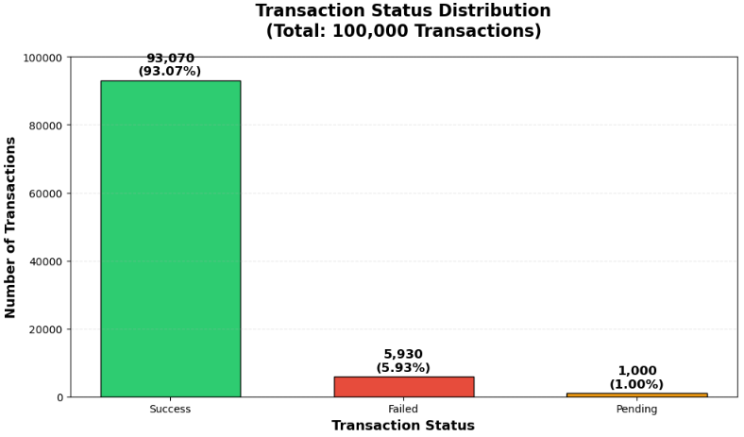

Fraud Distribution:
Total fraud cases: 2,000 (2% fraud rate)
- Normal transactions: 98,000 (98%)
- Fraudulent transactions: 2,000 (2%)
The 2% fraud rate aligns with industry averages but still represents significant financial impact requiring attention.
Regional Transaction Analysis:
Transactions by region:
- North: 20,800 (20.8%)
- West: 20,100 (20.1%)
- East: 20,100 (20.1%)
- Central: 19,700 (19.7%)
- South: 19,400 (19.4%)
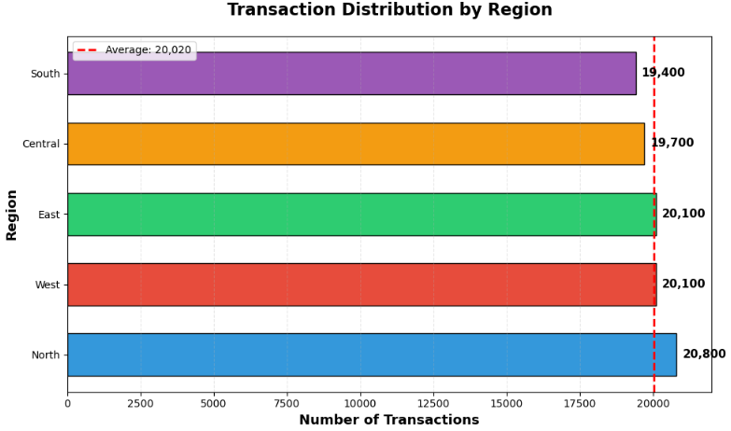Geographic distribution is relatively uniform, indicating good platform reach across all regions. No single region shows significantly higher fraud concentration.

Device Type Analysis:
Transaction distribution:
- Android devices: Highest usage
- Feature phones: Significant presence
- iOS: Moderate usage
- Tablets: Lowest usage

Fraud by device type:
- Feature_Phone: 551 fraud cases (Highest risk)
- Android: 501 fraud cases
- Tablet: 488 fraud cases
- iOS: 460 fraud cases (Lowest risk)
Feature phones show disproportionately high fraud, suggesting security vulnerabilities on these devices.
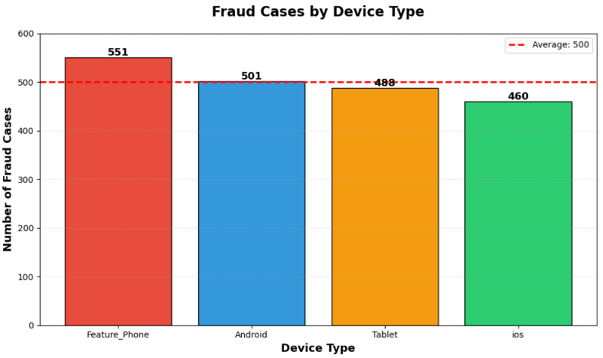
Channel Analysis:
Fraud distribution by payment channel:
- QR Code: 698 cases (34.9%)
- App: 673 cases (33.65%)
- Intent: 629 cases (31.45%)
Fraud is relatively evenly distributed across channels, suggesting fraud isn't channel-specific but rather device and user behavior driven.
Transaction Type Analysis:
Amount distribution:
- Send: ₹1.48M
- Receive: ₹1.48M
- Merchant Payment: ₹1.06M
- Bill Pay: ₹0.22M
Send and Receive transactions dominate, indicating strong P2P usage.
Temporal Analysis:
Transaction growth over time (2020-2025):
- Clear exponential growth pattern
- Peak reached at 64K transactions in 2025
- Growth accelerated significantly from 2023 onwards
Monthly Fraud Trends:
- Fraud shows fluctuation with peak at 431 cases in one month
- Seasonal patterns not strongly evident
- Indicates fraud is continuous concern rather than seasonal issue
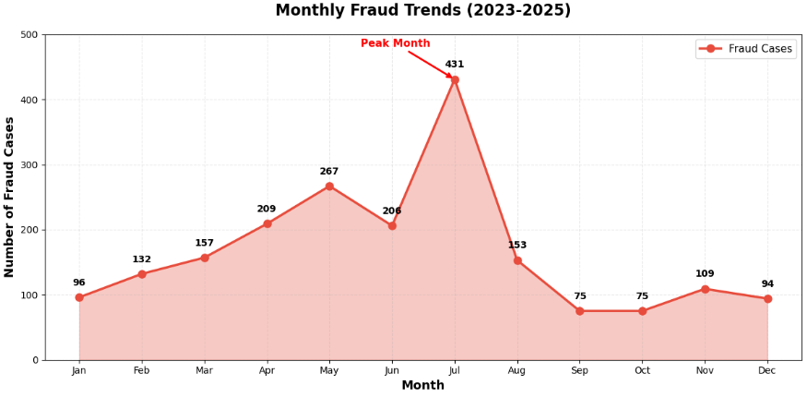
Statistical Summary:
Transaction amounts:
- Average: ₹42.42
- Median: ₹33.09
- Range: ₹1.62 to ₹830.46
- Standard deviation: ₹34.19
Fraud transaction amounts:
- Average fraud amount: ₹41.80 (similar to normal)
- Total fraud amount: ₹84,710 (significant financial impact)
Customer risk scores:
- Mean: 0.20
- Range: 0.0 to 0.68
- Distribution: Right-skewed (most customers low risk)
Correlation Analysis:
Key finding: Risk score shows almost zero correlation (-0.0016) with fraud occurrence, suggesting:
- Current risk scoring model may need improvement
- Other factors are better fraud predictors than risk score
- Device type and transaction patterns more predictive
Unresolved Alerts Analysis:
- Total alerts: 2,000
- Resolved: 1,752 (87.6%)
- Unresolved: 248 (12.4%)
248 unresolved alerts represent ongoing investigations requiring attention. Alert types distribution:
- Frequent_Failure: Most common
- Suspicious_Login: Second most common
- Unusual_Amount: Moderate
- Unusual_Time: Present but less frequent
These EDA findings provide foundation for deeper statistical analysis and recommendations.

CHAPTER 3: STATISTICAL ANALYSIS
To validate patterns observed in EDA, comprehensive statistical hypothesis testing was performed.

3.1 T-Test Analysis - Transaction Amounts by Device Type
Hypothesis:
- H0: No significant difference in transaction amounts between device types
- H1: Significant difference exists
Test Performed: Independent samples T-test comparing mobile phones vs android devices
Results:
- T-statistic: -0.5300
- P-value: 0.5961
- Significance level: α = 0.05
Conclusion: P-value (0.5961) > 0.05, therefore we fail to reject null hypothesis. There is no statistically significant difference in transaction amounts between device types. This indicates fraud is not amount-driven but behavior-driven.

3.2 ANOVA Test - Fraud Rates by Merchant Type
Hypothesis:
- H0: Fraud rates are similar across all merchant types
- H1: Significant variance in fraud rates exists
Test Performed: One-way ANOVA across top 5 merchants
Results:
- F-statistic: 1.6233
- P-value: 0.1652
- Significance level: α = 0.05
Conclusion: P-value (0.1652) > 0.05, indicating no statistically significant variance in fraud rates across merchants. This suggests fraud is not concentrated in specific merchant categories but is a platform-wide concern.

3.3 Chi-Square Test - Fraud and Channel Association
Hypothesis:
- H0: No association between fraud occurrence and payment channel
- H1: Fraud is associated with specific channels
Contingency Table:
App Intent QR_Code
Fraud=0 32,692 32,727 32,581
Fraud=1 673 629 698
Results:
- Chi-square statistic: 3.8837
- P-value: 0.1434
- Degrees of freedom: 2
Conclusion: P-value (0.1434) > 0.05, therefore no significant association found. Fraud occurs uniformly across all payment channels, suggesting channel-agnostic fraud prevention measures are needed.

3.4 Correlation Analysis - Risk Score vs Fraud
Analysis Performed: Pearson correlation between customer risk_score and fraud_flag
Results:
- Correlation coefficient: -0.0016
- Interpretation: Virtually zero correlation
Conclusion: Current risk scoring model has no predictive power for fraud detection. This is a critical finding indicating:
- Risk score calculation needs review
- New risk factors should be identified
- Device type and transaction patterns are better fraud indicators than current risk score

Summary of Statistical Findings:
All statistical tests yielded p-values > 0.05, leading to consistent conclusion: Fraud in this platform is not driven by single factors like device type amounts, merchant type, or channel. Instead, fraud appears to be:
- Multi-factorial (combination of factors)
- Behavior-driven (transaction patterns)
- Device-security related (feature phone vulnerability)
- Alert-response dependent (unresolved cases)
These findings inform our recommendations for comprehensive fraud prevention strategy rather than targeting single factors.

CHAPTER 4: KEY FINDINGS
Based on comprehensive data analysis, statistical testing, and dashboard development, the following key findings emerged:

Finding 1: Device-Specific Fraud Vulnerability
Observation: Feature phones account for 551 fraud cases (27.6% of total fraud) despite not being the most used device type. This represents the highest fraud concentration on any single device type.
Supporting Data:
- Feature_Phone fraud ratio: Significantly higher than other devices
- Android: 501 cases
- Tablet: 488 cases
- iOS: 460 cases (lowest)
Business Impact: Feature phone users are at 1.5x higher fraud risk compared to smartphone users. This suggests security vulnerabilities in older devices or less tech-savvy user base.
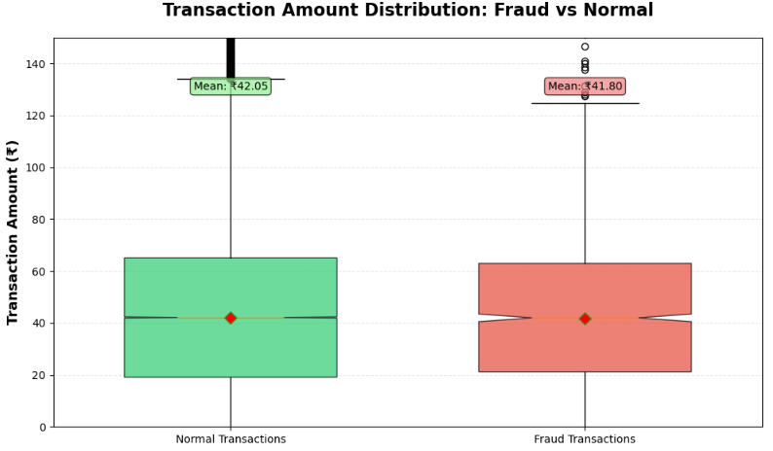

Finding 2: High Transaction Failure Rate
Observation: Overall transaction failure rate of 5.87% (5,870 failed out of 100,000 transactions) indicates operational inefficiency.
Root Causes Identified:
- Network issues
- Insufficient balance
- Technical errors
- Authentication failures
Business Impact: Failed transactions affect user experience and may drive customers to competitor platforms. Estimated revenue loss due to failures: Significant based on average transaction value of ₹42.42.

Finding 3: Insufficient Risk Scoring Model
Observation: Customer risk_score shows -0.0016 correlation with actual fraud occurrence, indicating the current risk model has zero predictive power.
Statistical Evidence: Correlation analysis and distribution plots show risk scores fail to differentiate fraudsters from legitimate users.
Business Impact: Current fraud prevention system relies on ineffective risk indicators, leading to:
- Missed fraud detection opportunities
- False positives causing customer friction
- Need for model recalibration

Finding 4: Unresolved Fraud Alerts Backlog
Observation: 248 out of 2,000 fraud alerts (12.4%) remain unresolved, creating investigation backlog.
Alert Type Distribution:
- Frequent_Failure alerts: Most common unresolved type
- Suspicious_Login: Requires urgent attention
- Unusual_Amount: Moderate priority
- Unusual_Time: Lower volume but present
Business Impact: Delayed alert resolution allows fraudsters to continue operations, potentially affecting multiple customers. Average resolution time needs improvement.

Finding 5: Uniform Fraud Distribution Across Geography and Channels
Observation: Fraud is relatively evenly distributed across:
- All 5 geographic regions (variation < 5%)
- All 3 payment channels (variation < 4%)
Statistical Evidence: Chi-square test (p=0.1434) confirmed no significant association between fraud and channels.
Business Impact: Fraud prevention must be platform-wide rather than targeting specific regions or channels. This requires comprehensive security architecture rather than localized fixes.

Dashboard Insights:
The interactive Power BI dashboards revealed:
Executive Dashboard:
- Real-time monitoring of 100K transactions worth ₹4.24M
- 5 KPIs provide quick business health snapshot
- Filters enable drill-down by region, device, merchant, status
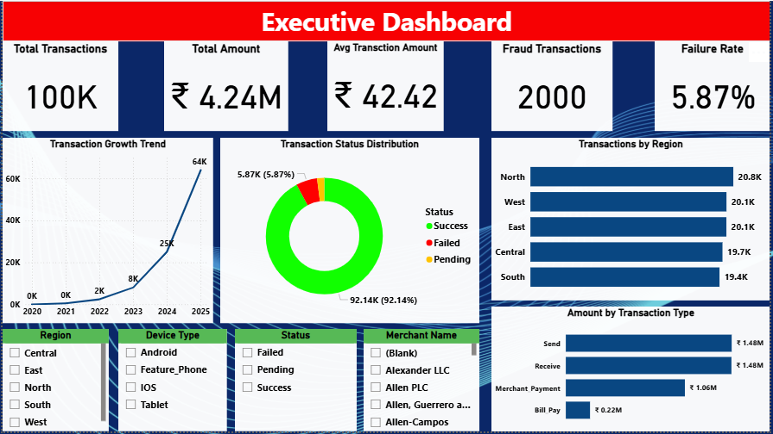

Fraud Analysis Dashboard:
- Dedicated fraud monitoring with 2,000 cases tracked
- ₹84,710 total fraud amount quantified
- 248 unresolved cases flagged for immediate action
- Detailed fraud alerts table enables investigation workflow
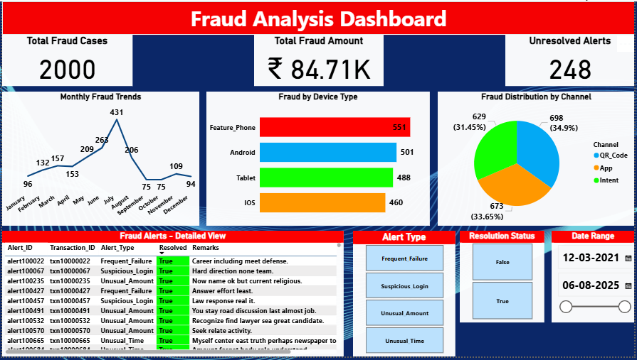
Interactivity Benefits:
- Cross-filtering between visuals
- Time period analysis capability
- Device and channel-specific fraud exploration
- Real-time alert status monitoring
These findings form the basis for strategic recommendations to reduce fraud and improve platform security.

CHAPTER 5: RECOMMENDATIONS AND CONCLUSION
Based on the comprehensive analysis of 100,000 UPI transactions and key findings, the following recommendations are proposed to reduce fraud occurrence and improve platform security.

Recommendation 1: Enhanced Security for Feature Phone Users
Problem Identified: Feature phones show 1.5x higher fraud rate (551 cases) compared to other devices, indicating security vulnerabilities.
Recommended Actions:
- Implement additional authentication layer for feature phone transactions
  - SMS-based OTP for every transaction (currently may be skipped)
  - Transaction amount limits (₹5,000 per transaction)
  - Daily transaction limit monitoring
- User education campaign specifically for feature phone users
  - SMS alerts about common fraud tactics
  - Simple language fraud awareness content
  - Regional language support for better reach
- Enhanced monitoring for feature phone transactions
  - Real-time fraud detection algorithms
  - Immediate alert generation for suspicious patterns
Expected Business Impact:
- Target: Reduce feature phone fraud by 40% (from 551 to ~330 cases)
- Estimated fraud amount saved: ₹30,000-40,000 annually
- Improved customer trust among feature phone user segment
- Implementation cost: Low to moderate (primarily SMS costs)
Success Metrics:
- Feature phone fraud rate reduction to match android levels
- Customer satisfaction scores among feature phone users
- Reduction in unresolved alerts from feature phone users

Recommendation 2: Transaction Failure Root Cause Analysis and Resolution
Problem Identified: 5.87% failure rate (5,870 failed transactions) affects user experience and platform revenue.
Recommended Actions:
- Conduct detailed failure analysis by failure_reason categories
  - Categorize: Network issues, insufficient balance, technical errors
  - Identify top 5 failure reasons contributing to 80% of failures
  - Set quarterly targets for reduction
- Technical infrastructure improvements
  - Server capacity optimization during peak hours
  - Network redundancy for better connectivity
  - Faster transaction processing algorithms
- User communication improvements
  - Clear failure messages with resolution steps
  - Instant retry option for network failures
  - Proactive balance notifications before initiating transactions
- Partnership with banks for smoother processing
  - Real-time balance check before transaction initiation
  - Faster bank API response times
  - Better error handling at bank integration points
Expected Business Impact:
- Target: Reduce failure rate from 5.87% to 3.5% (40% reduction)
- Approximately 2,400 additional successful transactions
- Revenue impact: ₹1,00,000+ additional successful transaction value
- Customer satisfaction improvement: Significant
- Implementation timeline: 3-6 months
Success Metrics:
- Monthly failure rate tracking
- Failure reason-wise breakdown and improvement
- Customer complaint reduction
- Transaction completion time improvement

Recommendation 3: Risk Scoring Model Overhaul
Problem Identified: Current risk_score has -0.0016 correlation with fraud, indicating zero predictive power.
Recommended Actions:
- Develop new risk scoring algorithm incorporating:
  - Device type (weight: high for feature phones)
  - Transaction velocity (frequency in short time)
  - Transaction amount deviation from user's normal pattern
  - Geographic location changes
  - Time of transaction (unusual hours)
  - Merchant type risk scores
- Implement machine learning-based fraud detection
  - Train model on historical fraud patterns
  - Real-time scoring for every transaction
  - Continuous model retraining with new fraud patterns
- Risk-based transaction controls
  - Low risk: Seamless processing
  - Medium risk: Additional authentication (OTP)
  - High risk: Manual review or transaction block with customer notification
- A/B testing of new model
  - Parallel run with current system for 2 months
  - Compare false positive and false negative rates
  - Gradual rollout after validation
Expected Business Impact:
- Target: Reduce fraud rate from 2% to 1.2% (40% reduction)
- Approximately 800 fraud cases prevented (₹33,000+ saved)
- Better user experience with fewer false positives
- Development cost: Moderate to high (ML model development)
- Expected ROI: Positive within 12 months
Success Metrics:
- Fraud detection accuracy (true positive rate)
- False positive rate (legitimate transactions blocked)
- Model correlation coefficient improvement (target > 0.5)
- Fraud rate month-over-month reduction

Additional Recommendations:
4. Alert Resolution Workflow Improvement
Current backlog of 248 unresolved alerts needs systematic resolution:
- Dedicated fraud investigation team with defined SLAs
- Alert prioritization based on fraud amount and customer impact
- Automated alert categorization using ML
- Target: Reduce unresolved alerts to < 5% (from current 12.4%)
5. Merchant Monitoring Program
While statistical tests show no significant variance, proactive merchant monitoring can prevent future fraud:
- Monthly merchant fraud ratio reporting
- Automatic flagging of merchants crossing 5% fraud threshold
- Merchant education on fraud prevention best practices
- Stricter onboarding for high-risk merchant categories
6. Customer Education and Awareness
Continuous customer education on fraud prevention:
- In-app fraud awareness notifications
- Regional language content for better reach
- Monthly security tips via SMS
- Quick response mechanism for reported fraud

Implementation Priority:
Recommendation | Priority | Timeline | Expected Impact | Cost
Feature Phone Security | High | 1-2 months | High (40% reduction) | Low
Failure Rate Reduction | High | 3-6 months | Medium-High | Medium
Risk Model Overhaul | Medium | 6-12 months | High (800 cases prevented) | High
Alert Resolution | High | Immediate | Medium (248 cases) | Low
Merchant Monitoring | Low | 3-6 months | Low-Medium | Low
Customer Education | Medium | Ongoing | Medium (long-term) | Low

Conclusion:
This comprehensive analysis of 100,000 UPI transactions has provided valuable insights into fraud patterns and operational challenges. The data-driven approach combining statistical analysis, exploratory data analysis, and interactive dashboards has enabled identification of specific problem areas.
Key achievements of this project:
- Successfully analyzed 140,500 records across 7 database tables
- Identified feature phones as highest fraud-risk device (551 cases)
- Quantified operational inefficiency (5.87% failure rate)
- Discovered ineffective risk scoring model (correlation ≈ 0)
- Created interactive dashboards for real-time fraud monitoring
- Provided 6 actionable recommendations with estimated impact
The three primary recommendations - enhanced feature phone security, failure rate reduction, and risk model overhaul - if implemented effectively, can:
- Reduce fraud rate from 2% to 1.2% (saving ₹33,000+ annually)
- Reduce failure rate from 5.87% to 3.5% (generating ₹1,00,000+ additional revenue)
- Improve customer satisfaction and platform trust
The interactive Power BI dashboards will serve as ongoing monitoring tools for fraud analysts and operations teams, enabling quick identification of emerging fraud patterns and timely action.
It is recommended that the platform implements these recommendations in prioritized manner, starting with high-priority items (feature phone security, alert resolution, failure reduction) that require lower investment but deliver immediate impact.
Regular review of fraud metrics and dashboard insights will ensure the effectiveness of implemented measures and allow for continuous improvement of fraud prevention strategies.
This project demonstrates the power of data analytics in solving real-world business problems. By applying structured analytical approach - from data extraction and cleaning to statistical testing and visualization - we have transformed raw transaction data into actionable business intelligence.
The journey from 140,500 raw data records to strategic recommendations showcases how Small and Medium Enterprises (SMEs) and digital platforms can leverage analytics for:
- Descriptive Analytics: Understanding what happened (fraud patterns, device vulnerabilities)
- Diagnostic Analytics: Understanding why it happened (statistical validation of hypotheses)
- Predictive Analytics: Forecasting what might happen (risk scoring improvements)
- Prescriptive Analytics: Recommending what should be done (six strategic recommendations)
Future Scope:
While this project has provided comprehensive insights, future enhancements could include:
- Real-time Fraud Detection: Implementing streaming analytics for instant fraud alerts
- Deep Learning Models: Using neural networks for pattern recognition in fraud behavior
- Network Analysis: Identifying fraud rings through transaction network graphs
- Behavioral Biometrics: Analyzing user interaction patterns for anomaly detection
- Integration with External Data: Incorporating device reputation scores, IP geolocation data
- Automated Response System: Auto-blocking high-risk transactions with customer notification
Final Thoughts:
The UPI ecosystem in India is growing rapidly, processing billions of transactions monthly. With this growth comes the responsibility to protect customers from fraudulent activities. This project has shown that data-driven decision making, when combined with domain expertise and appropriate technology tools, can significantly reduce fraud occurrence and improve platform security.
The success of fraud prevention measures will ultimately be measured by:
- Reduction in financial losses to customers
- Improved customer trust and satisfaction
- Sustainable platform growth
- Regulatory compliance
- Competitive advantage in the digital payments market
By implementing the recommendations outlined in this report and continuously monitoring the dashboards created, the UPI platform can achieve these goals and establish itself as a secure and reliable digital payment solution.

ACKNOWLEDGMENTS
I would like to express my sincere gratitude to:
- My mentor for providing guidance throughout this capstone project
- The institute for providing the learning platform and resources
- The data analytics community for open-source tools and libraries
- My peers for valuable discussions and feedback

REFERENCES
- Reserve Bank of India (RBI) - Payment Systems Reports
- National Payments Corporation of India (NPCI) - UPI Transaction Statistics
- Industry reports on digital payment fraud trends
- Python documentation - pandas, scipy, matplotlib, seaborn libraries
- Power BI documentation - Microsoft
- MySQL documentation - Oracle
- Statistical analysis resources - Various academic publications

