# ASSIGNMENT -3

# INFORMATION GATHERING ON WEBSITES USING KALI LINUX

In this assignment we need to gather information on websites. Here are few steps and task we have performed to reach goal.

Find the ip address of windows machine. For finding ip address go to command prompt type ipconfig and we can see the ip address.

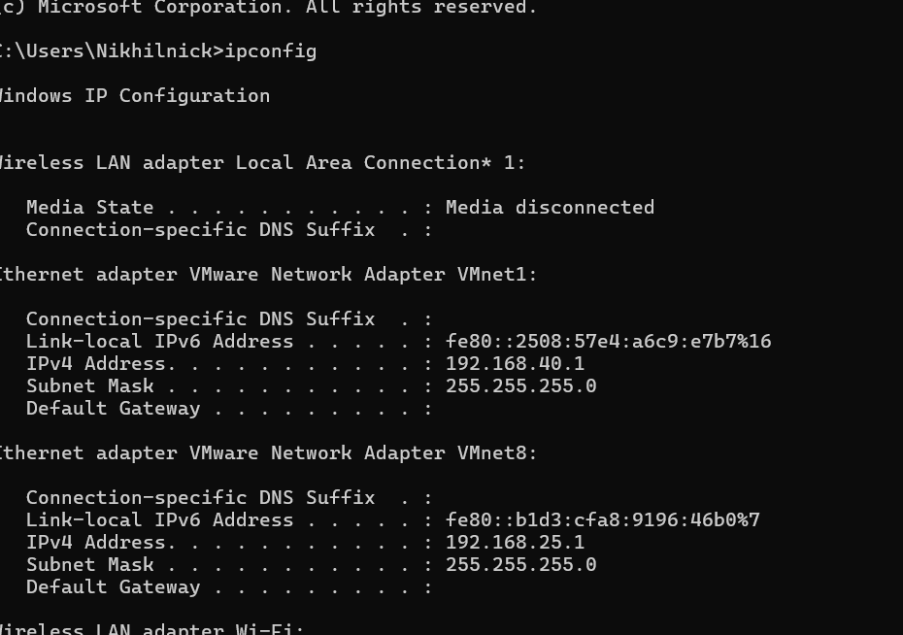

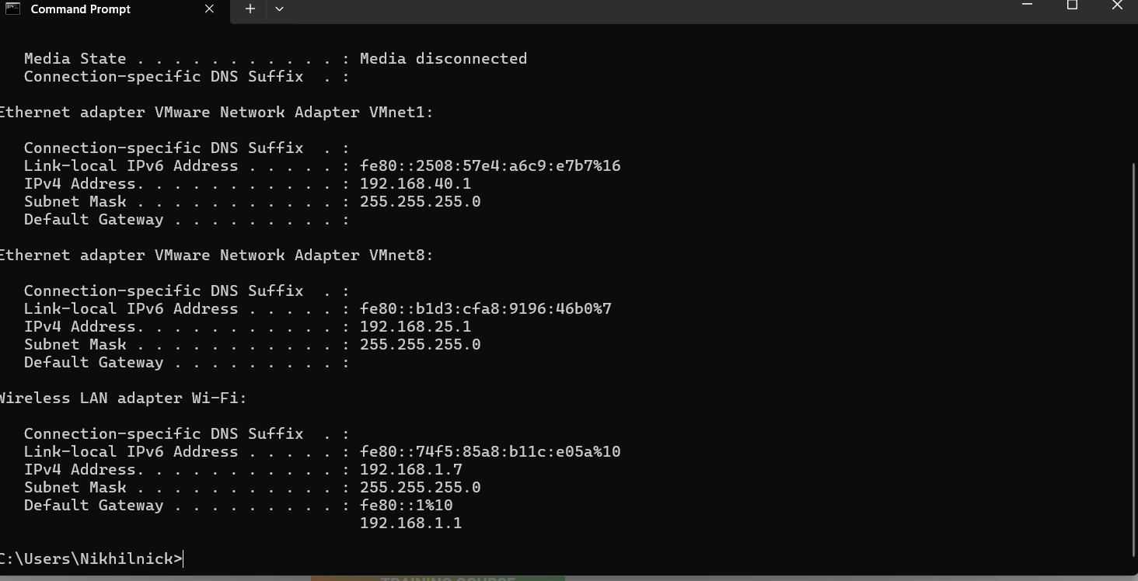

After getting the ip address use the command nmap for gathering information such as os details, ports, service details

Sudo nmap -v -A 192.168.1.7

Here -A gives all the os details, ports, service details .

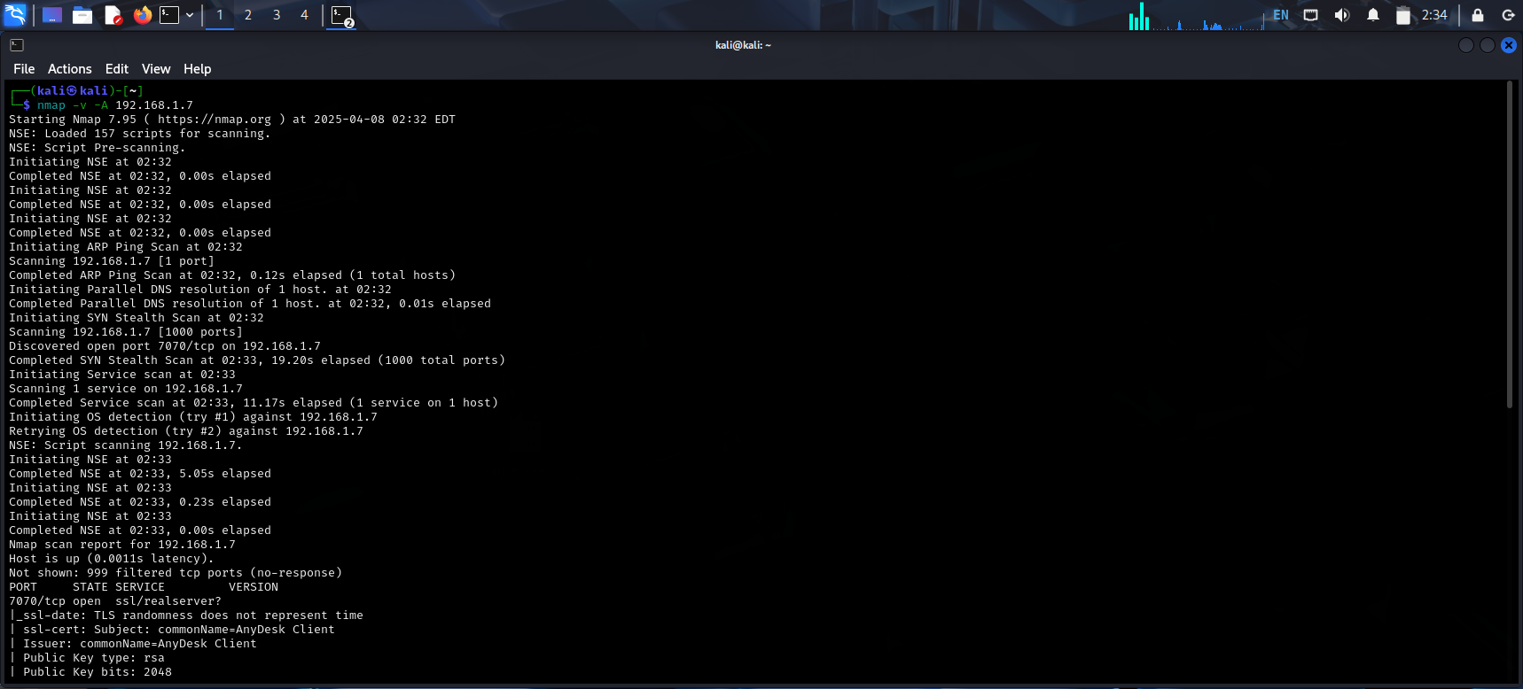

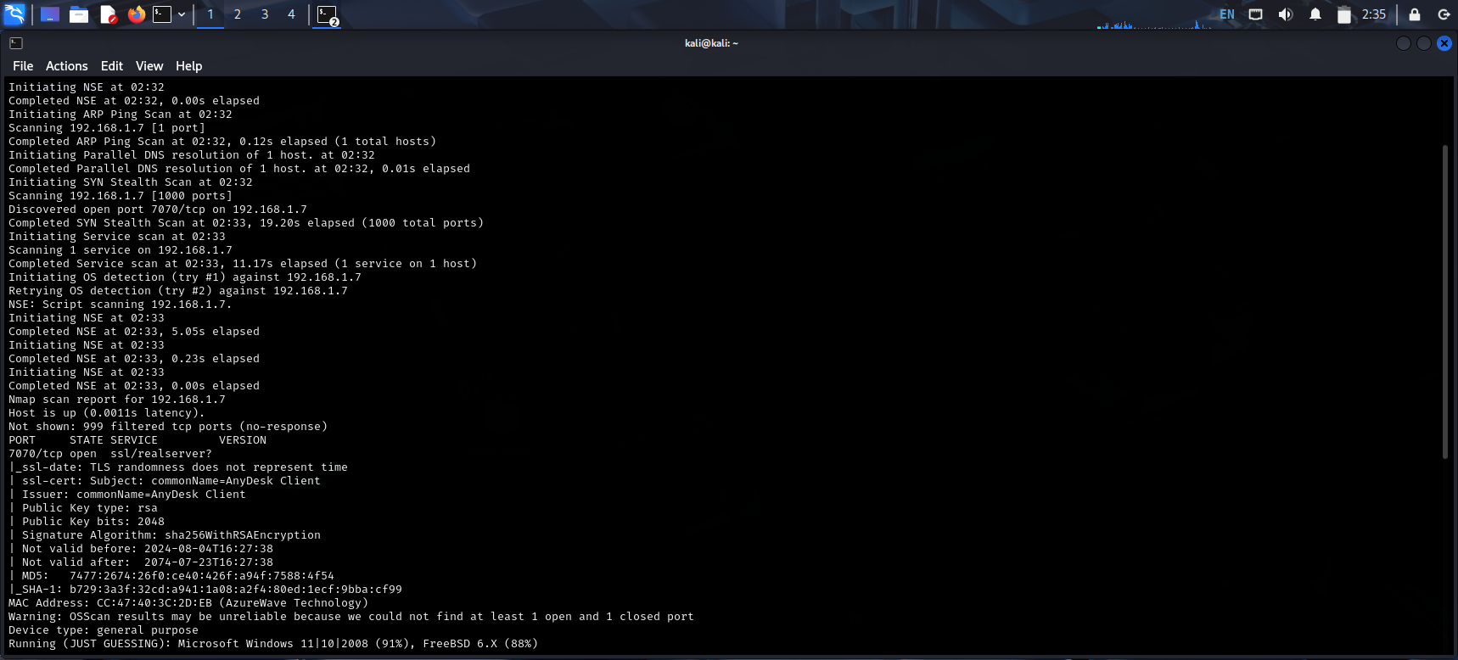

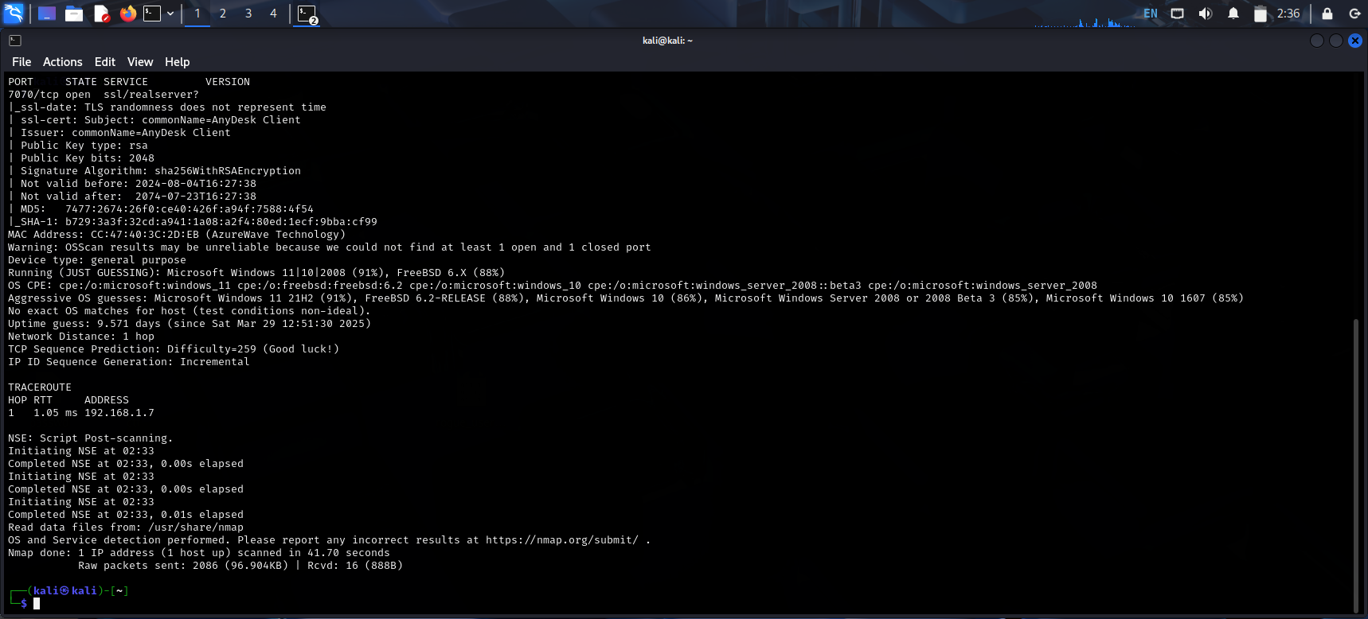

TASK 2

In this task we need to change the mac address to any random address ,for that we can use the command macchanger -r eth0 for random mac address.

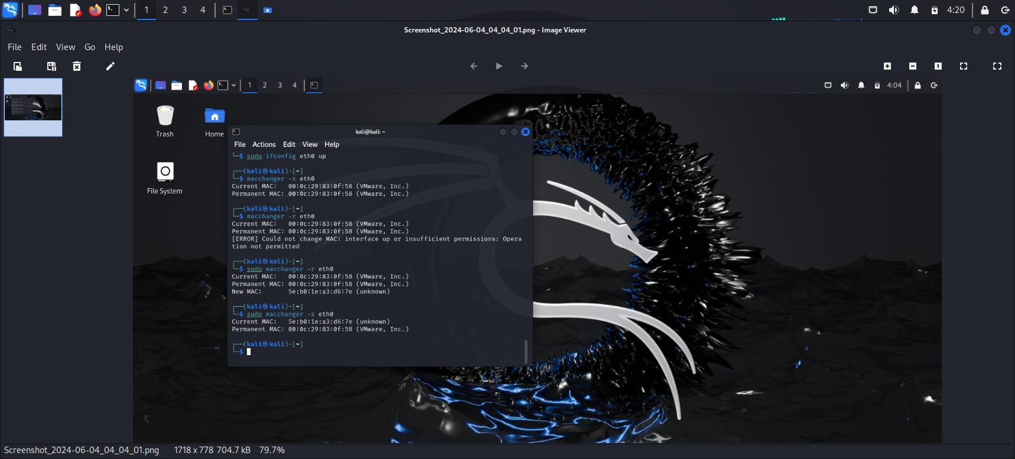

TASK 3

We need to enumerate all the ports in window machine for this go to command prompt type netsat -an it will display all the information.

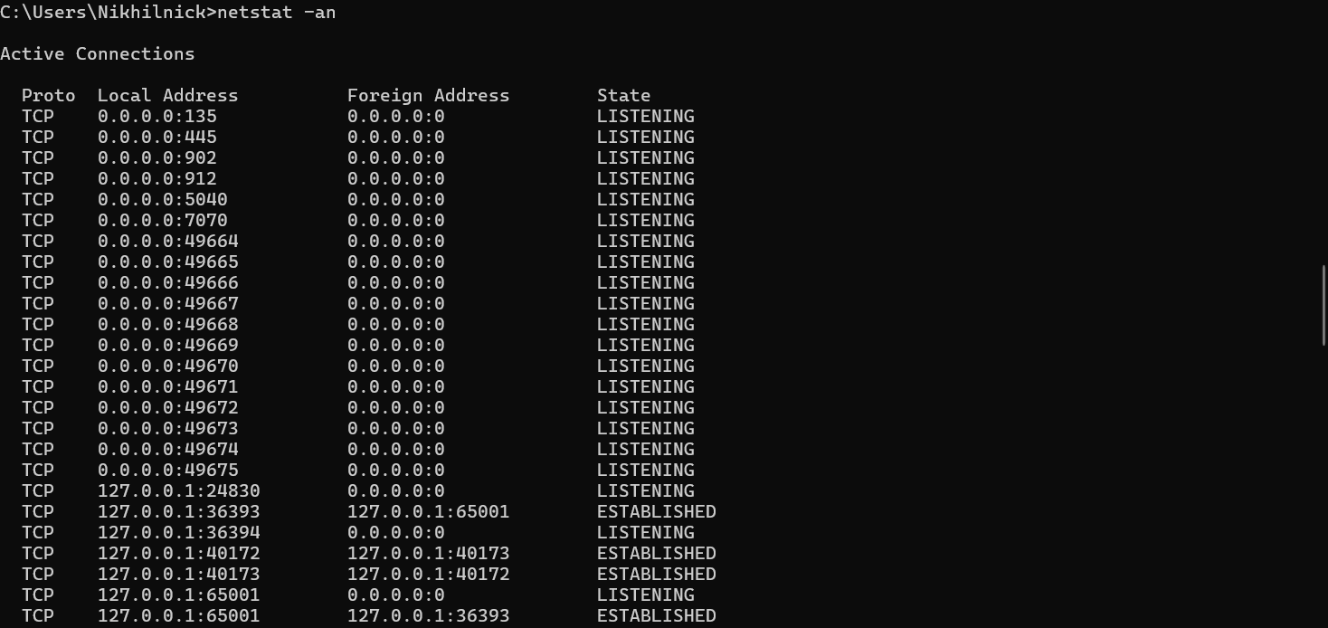

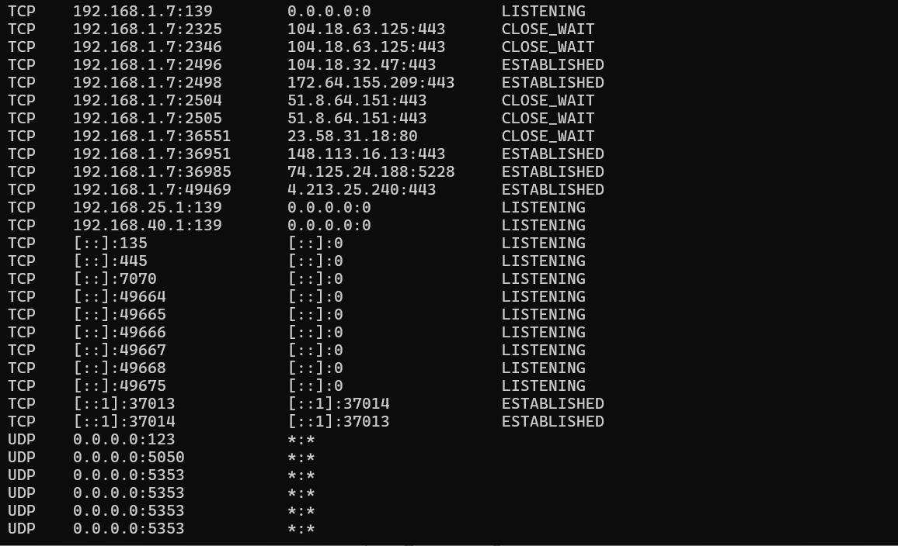

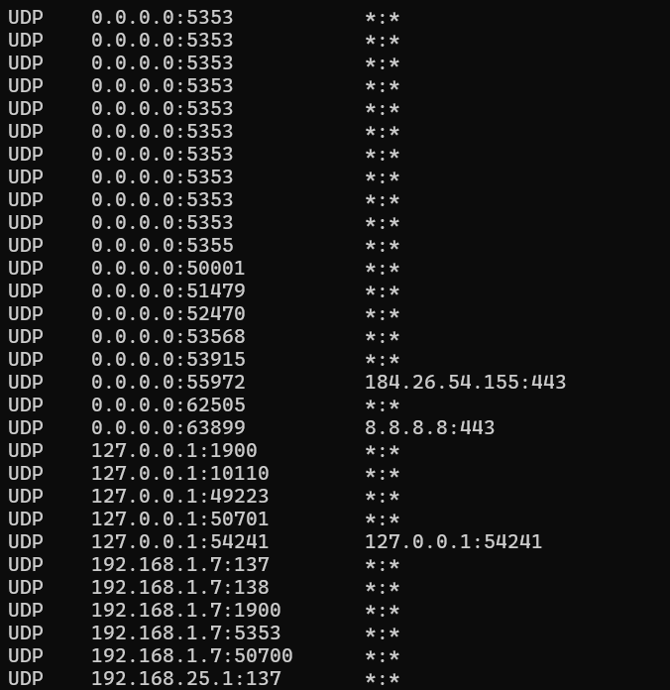

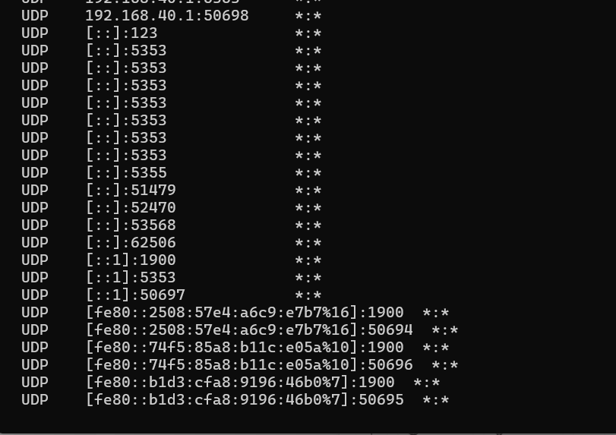

To find the routing table type route print in command prompt to get the tables.

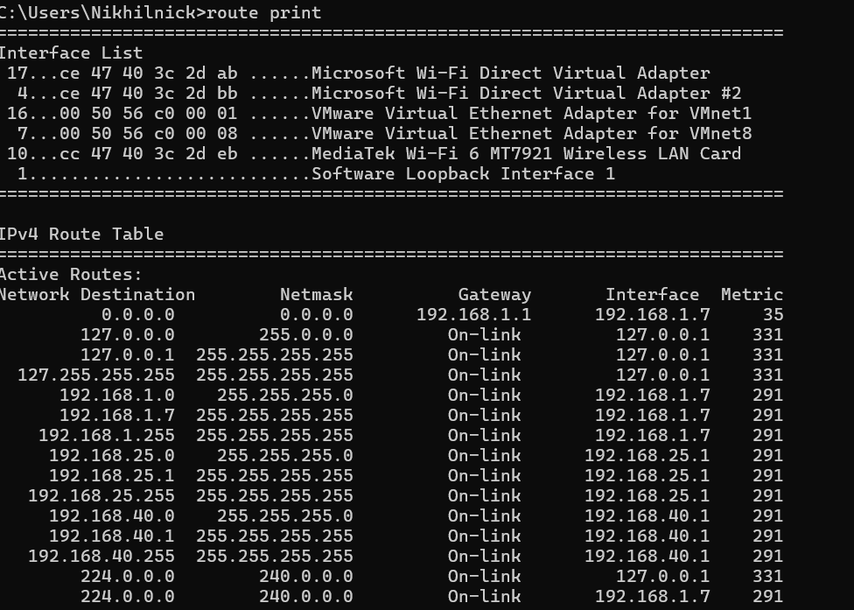

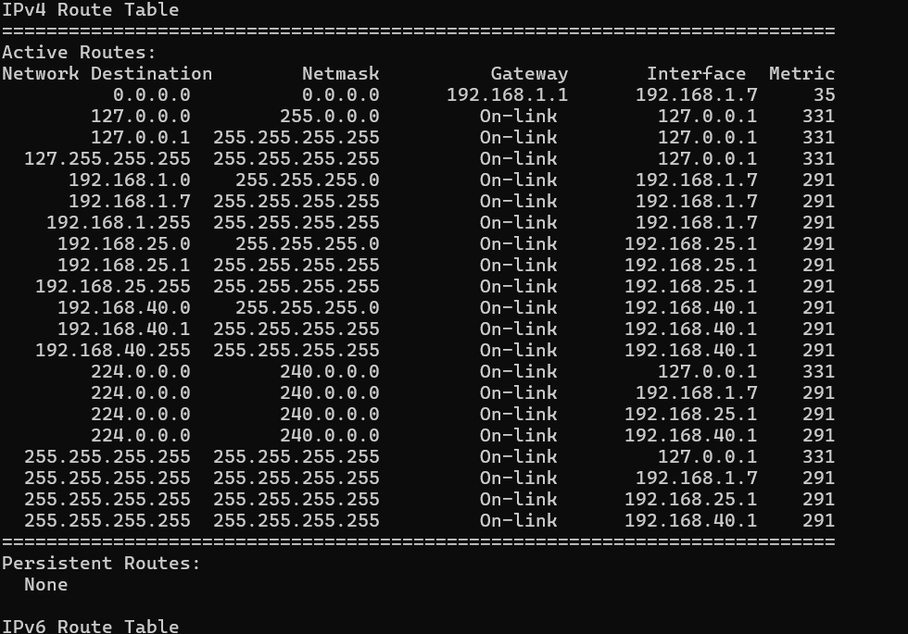

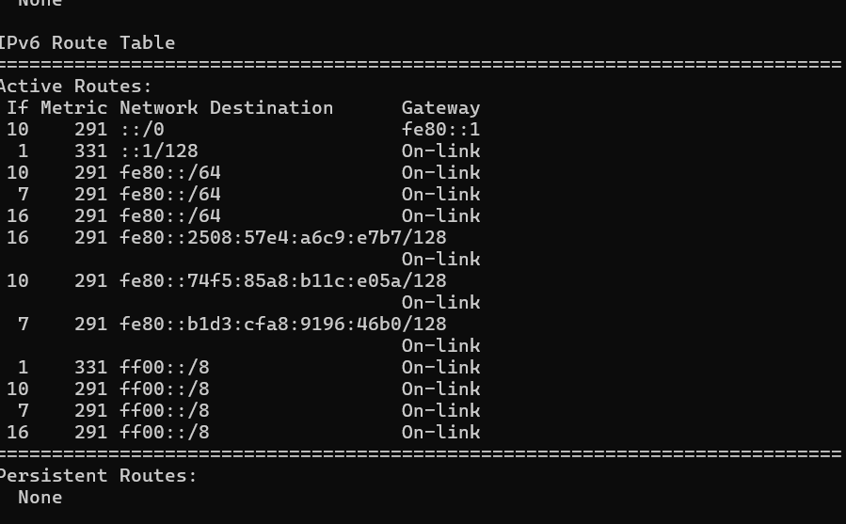

Task 4

We need to have oracle virtualbox vmware .

Download oracle virtualbox vmware and go to settings click on network then change the network to bridge network which keeps windows and kali machine in same local network.

Next step is to type wireshark in kali linux and click on eth0

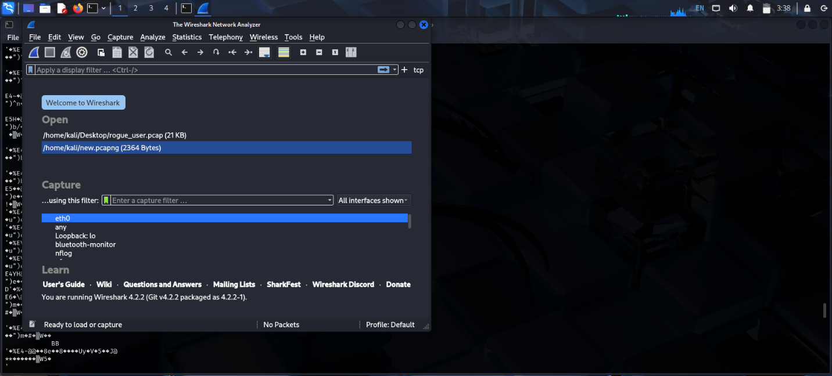

Now download the file rogue_user.pcap file to desktop and copy it to kali linux change the permissions to acess the files if needed.

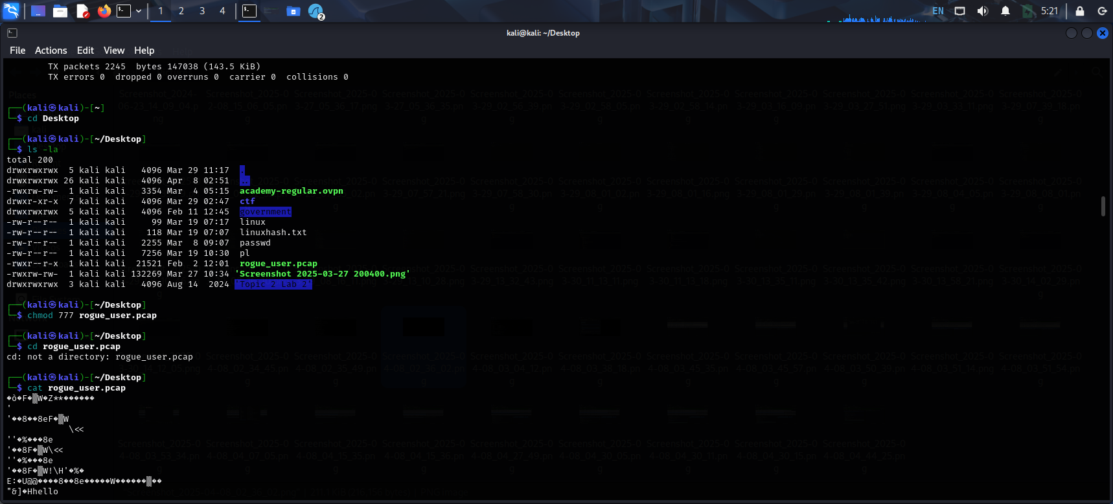

Open the file in wireshark and find the all the main protocols which are present like tcp, upd ,telnet etc.

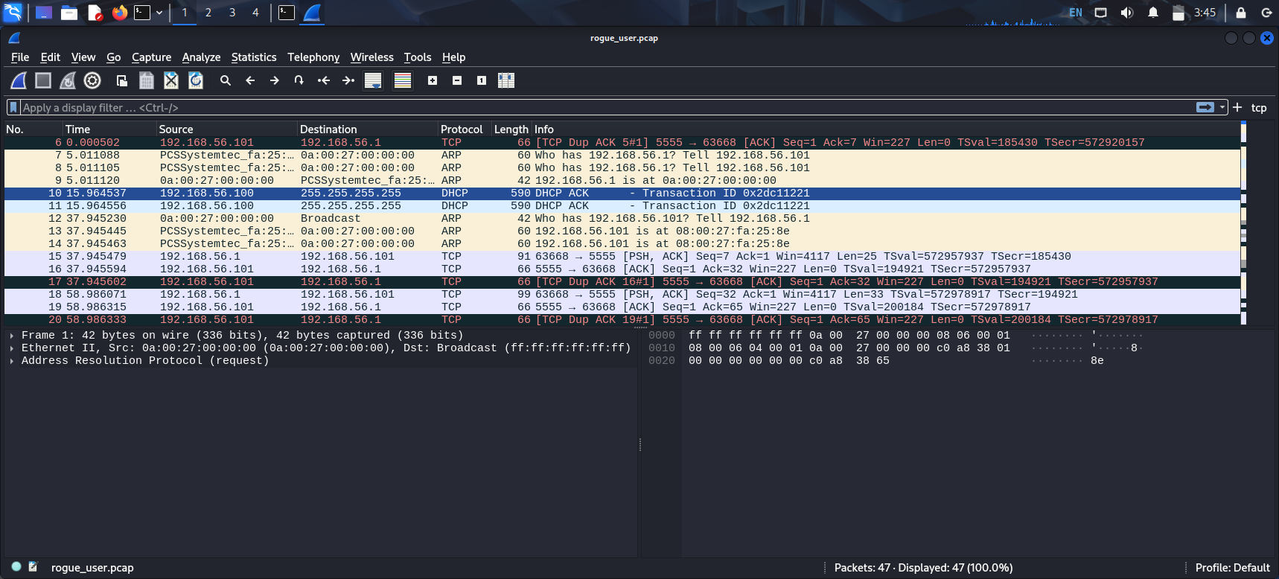

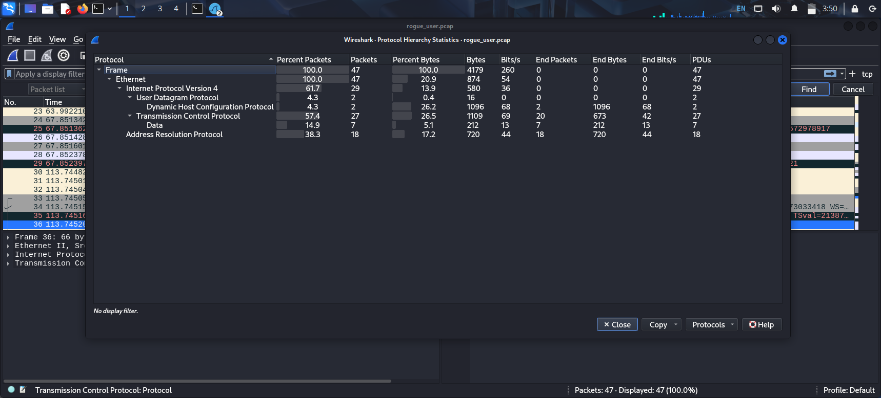

We can find tcp protocol to display column tap on any of the packets of tcp and you will find the option add to column click it.

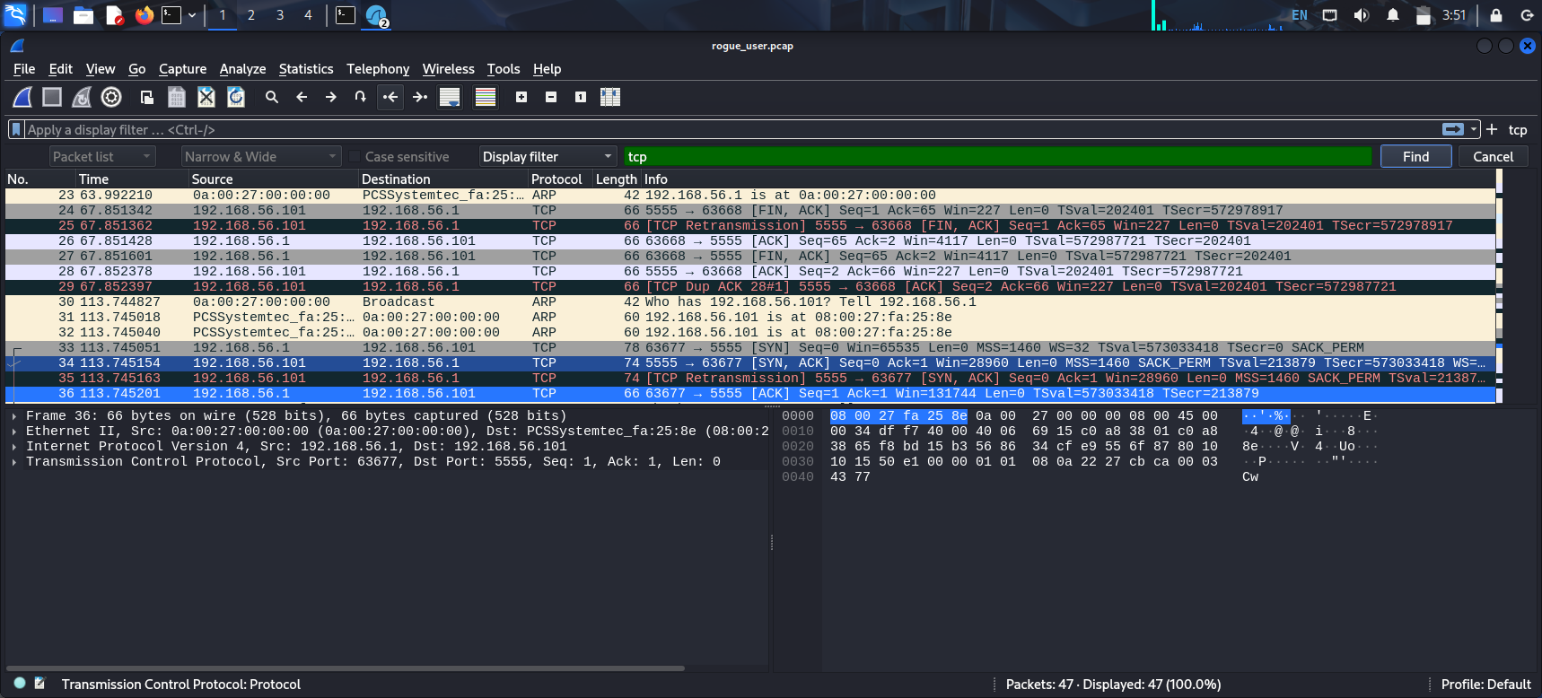We can details like segment, acknowledgment ,destination port ,source port etc details at the bottom of the pane.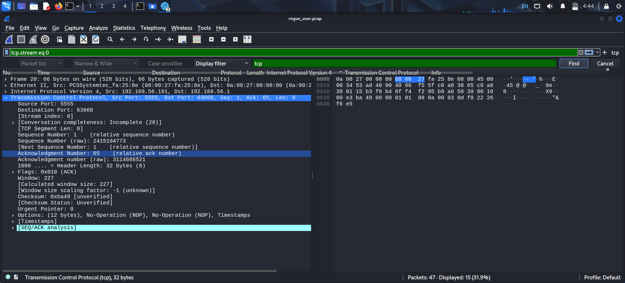

We have achieved all the information .