#SKILL - 4 -Spring Dependency Injection – Constructor & Setter Injection
-2400033340
Prerequisites: • Basic knowledge of Java
• General Idea on Spring Framework
• Basic Idea on DI & IoC
Tasks:
1. Create a Java class named Student with fields: studentId, name, course, year.
2. Create a Constructor that accepts all fields and assigns values.
3. Create Setter methods for at least two fields (example: course, year).
4. Configure the Student bean using: a. XML Configuration - The student should take: • a POJO class • an XML configuration file • a main class to load the container b. Annotation Configuration - The student should take: • a POJO class • a Java class with necessary annotations • a main class to load the container 5. Create a Spring configuration file (XML or Java-based).
6. Write a main class to load the Spring IoC container.
7. Retrieve the Student bean and print the injected values.
8. Push the Spring (core) project to GitHub.

Solution :
Java main method file :
package com.training.main;

import org.springframework.context.ApplicationContext;
import org.springframework.context.support.ClassPathXmlApplicationContext;
import com.training.model.Student;

public class Main {

public static void main(String[] args) {

ApplicationContext context =
new ClassPathXmlApplicationContext("exp4-SKILL.xml");

Student student = context.getBean("student", Student.class);
student.display();
}
}
Student.java (POJO class):
package com.training.model;

public class Student {

private int studentId;
private String name;
private String course;
private int year;

public Student(int studentId, String name, String course, int year) {
this.studentId = studentId;
this.name = name;
}

public void setCourse(String course) {
this.course = course;
}

public void setYear(int year) {
this.year = year;
}

public void display() {
System.out.println("Student ID : " + studentId);
System.out.println("Name : " + name);
System.out.println("Course : " + course);
System.out.println("Year : " + year);
}
}
XML file :
<?xml version="1.0" encoding="UTF-8"?>
<beans xmlns="http://www.springframework.org/schema/beans"
xmlns:xsi="http://www.w3.org/2001/XMLSchema-instance"
xsi:schemaLocation="
http://www.springframework.org/schema/beans
http://www.springframework.org/schema/beans/spring-beans.xsd">

<bean id="student" class="com.training.model.Student">

<!-- Constructor Injection -->
<constructor-arg value="101"/>
<constructor-arg value="Nitisha"/>
<constructor-arg value="CSE"/>
<constructor-arg value="2"/>

<!-- Setter Injection -->
<property name="course" value="Spring Framework"/>
<property name="year" value="3"/>

</bean>

</beans>
Application properties:
spring.application.name=exp4-SKI

Output :
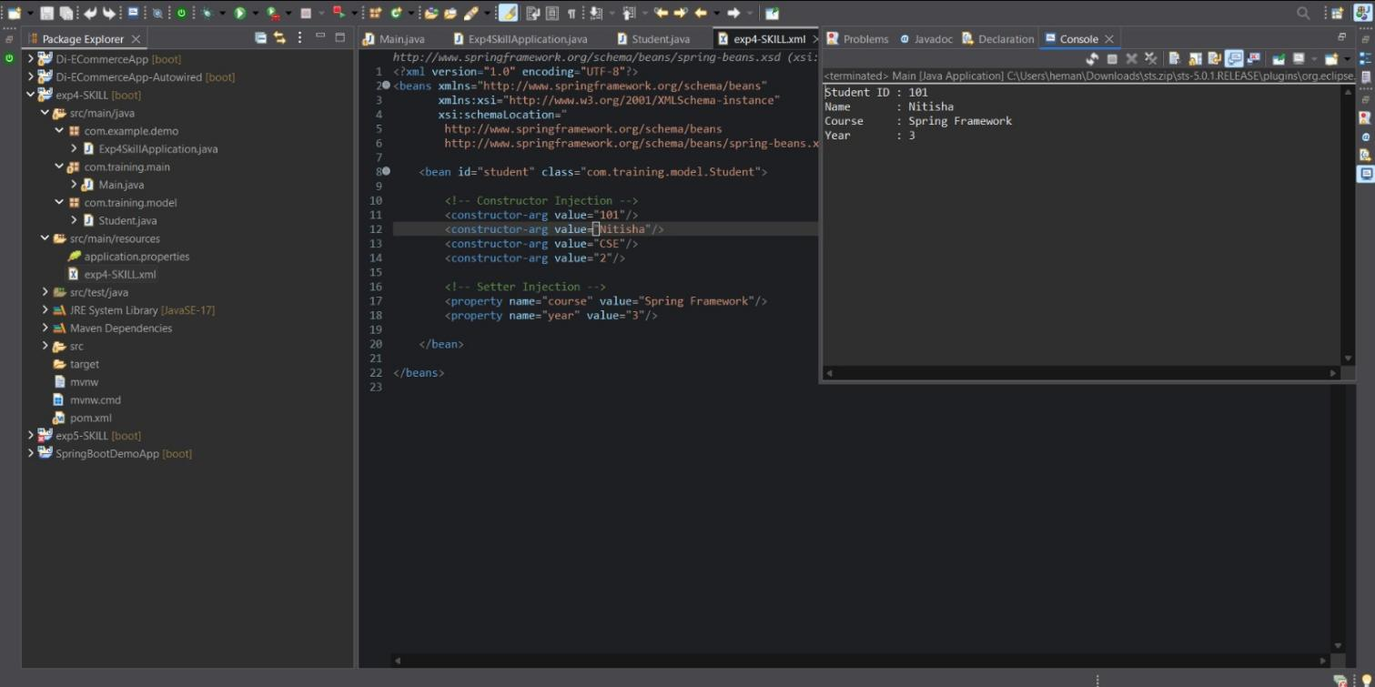

Project Structure:
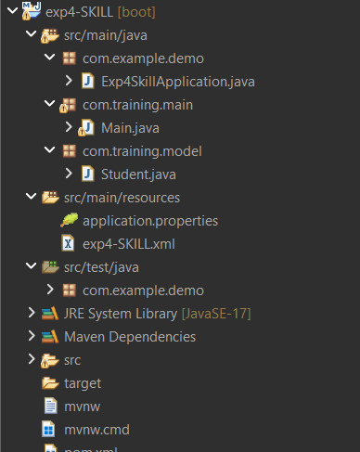

VIVA QUESTIONS:
- What is Dependency Injection (DI) in Spring?
2. What is the difference between Constructor DI and Setter DI?
3. What is the purpose of the IoC container?
4. Why is DI preferred over manual object creation? 5. Can Constructor Injection and Setter Injection be used together?
Answers:
- Dependency Injection (DI) is a design pattern in Spring where an object does not create its own dependencies. Instead, the Spring IoC container creates the required objects and injects them into the class.
This helps in achieving loose coupling between classes.
- Constructor Dependency Injection injects dependencies through a constructor, whereas Setter Dependency Injection injects dependencies through setter methods. Constructor DI is used when dependencies are mandatory and ensures the object is fully initialized at the time of creation.
Setter DI is used when dependencies are optional and allows changing dependencies after object creation.

- The IoC container is responsible for creating, managing, and configuring objects in a Spring application.
It controls the lifecycle of beans and injects dependencies as required, instead of the programmer manually creating objects.

- DI is preferred because it reduces tight coupling between classes, improves maintainability, supports easy testing, and makes applications more flexible.
Manual object creation makes the code rigid and difficult to modify or extend.

- Yes, both Constructor Injection and Setter Injection can be used together in the same class.
Constructor Injection is typically used for mandatory dependencies, while Setter Injection is used for optional dependencies.

