-2400333340

#SKILL - 5 Spring Autowiring Demo using @Autowired
Prerequisites:
• General Idea on Spring Framework
• Modules of Spring Framework
• Understanding of Autowiring concepts
Tasks: 1. Create a Certification class with fields such as id, name, and dateOfCompletion.
2. Create a Student class with fields such as id, name, gender, and a Certification object.
3. Annotate both classes with @Component to enable Spring detection.
4. Use @Autowired on a field, constructor, or setter inside the Student class to inject the Certification object.
5. Configure component scanning using either: a. An XML configuration file b. A Java configuration class with @Configuration and @ComponentScan
6. Load the Spring IoC container using ApplicationContext.
7. Retrieve the Student bean and print all details, including the injected Certification object. 8. Push the Spring project to GitHub.

Solution:

Appconfig.java
package com.klu.config;

import org.springframework.context.annotation.ComponentScan;
import org.springframework.context.annotation.Configuration;

@Configuration
@ComponentScan("com.klu")
public class Appconfig {
}

MainApp.java:
package com.klu.main;

import org.springframework.context.ApplicationContext;
import org.springframework.context.annotation.AnnotationConfigApplicationContext;

import com.klu.config.Appconfig;
import com.klu.model.Student;

public class MainApp {

public static void main(String[] args) {

ApplicationContext context =
new AnnotationConfigApplicationContext(Appconfig.class);

Student student = context.getBean(Student.class);
student.display();
}
}
Certification.java:
package com.klu.model;

import org.springframework.stereotype.Component;

@Component
public class Certification {

private int id;
private String name;
private String dateOfCompletion;

public Certification() {
this.id = 201;
this.name = "Java Full Stack";
this.dateOfCompletion = "15-Jan-2025";
}

public void display() {
System.out.println("Certification ID : " + id);
System.out.println("Certification Name : " + name);
System.out.println("Completion Date : " + dateOfCompletion);
}
}
Student.java:
package com.klu.model;

import org.springframework.beans.factory.annotation.Autowired;
import org.springframework.stereotype.Component;

@Component
public class Student {

private int id;
private String name;
private String gender;

@Autowired
private Certification certification;

public Student() {
this.id = 101;
this.name = "Nitisha";
this.gender = "Female";
}

public void display() {
System.out.println("Student ID : " + id);
System.out.println("Name : " + name);
System.out.println("Gender : " + gender);
certification.display();
}
}
Application.properties:
spring.application.name=exp5-SKILL

Output:
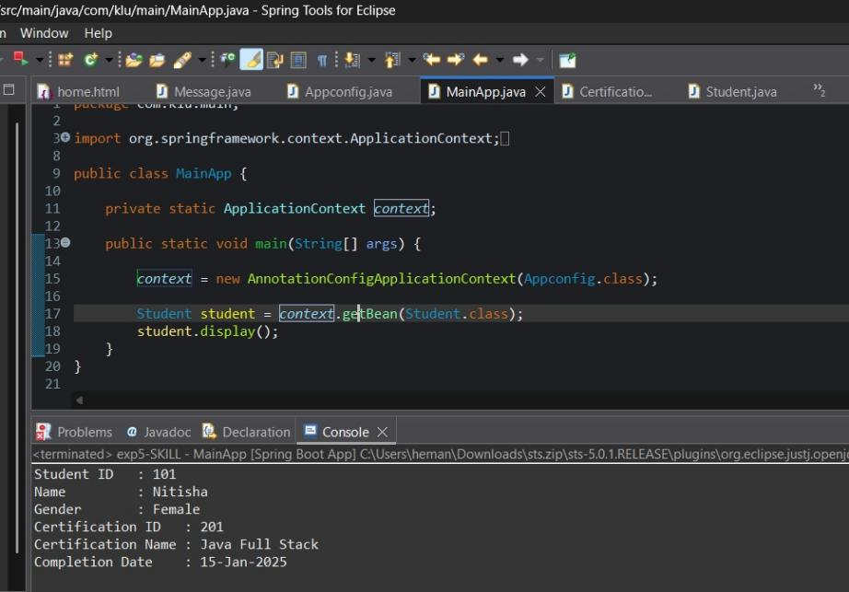
Project Structure:
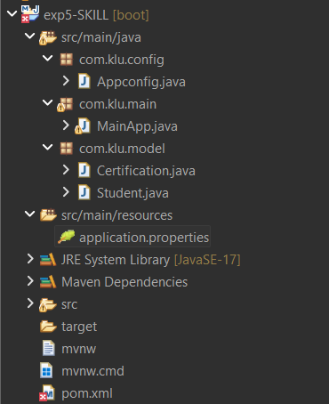
VIVA QUESTIONS: 1. What is autowiring in Spring?
2. What is the purpose of the @Autowired annotation?
3. How does Spring choose which bean to inject?
4. What is component scanning in Spring?
5. What happens if more than one bean matches the dependency type?
Answers :
- Autowiring in Spring is a feature that automatically injects dependent objects into a bean without explicitly defining them in the configuration. Spring resolves and injects the required dependency at runtime.

- The @Autowired annotation is used to tell Spring to automatically inject a required dependency into a class. It can be applied on constructors, setters, or fields to enable automatic dependency injection.
- Spring first looks for a bean that matches the required dependency type.
If only one matching bean is found, it is injected automatically.
If multiple beans exist, Spring uses qualifiers or bean names to decide which one to inject.
- Component scanning is a mechanism in Spring where the framework automatically searches for classes annotated with stereotypes such as @Component, @Service, @Repository, and @Controller, and registers them as beans in the IoC container
- If more than one bean matches the dependency type, Spring throws an exception due to ambiguity.
This can be resolved by using @Qualifier, @Primary, or by specifying the bean name explicitly.

