PROJECT DOCUMENTATION

REAL-TIME AI POWERED SALES INTELLIGENCE TOOL

Project Overview
The Real-Time AI Sales Intelligence Tool is designed to assist sales teams by providing negotiations by analyzing buyer behavior and providing real-time insights. It enhances decision-making through sentiment analysis, intent detection, dynamic deal recommendations, and post-call insights.

Objectives

Dynamic Deal Recommendation System
- Analyze buyer signals (e.g., tone, sentiment, intent) in real-time.
- Recommend optimal deal terms based on CRM data and competitor benchmarks.

Post-Call Insights Hub
- Generate summaries and actionable insights from call transcripts.
- Provide follow-up strategies to improve future engagements.

Software and Hardware Requirements

Software
- Operating System: Windows 10/11, macOS, or Linux
- Python Version: Python 3.9+
- Libraries:
  - pyaudio
  - google-cloud-speech
  - transformers (Hugging Face)
  - cohere
  - gspread
  - oauth2client
- APIs:
  - Google Speech-to-Text API
  - Google Sheets API
  - Cohere API

Hardware
- Processor: Intel i5/i7 or equivalent
- Memory: Minimum 8 GB RAM
- Storage: 100 GB free disk space
- Microphone: For recording audio during calls

Key Features
- Real-Time Sentiment and Intent Analysis: Converts live audio to text, detects sentiment, and identifies buyer intent.
- Dynamic Deal Recommendation: Suggests deal terms based on buyer behavior.
- Post-Call Insights Hub: Summarizes calls and provides actionable insights.
- CRM Integration: Accesses historical data for personalized recommendations.

System Architecture
- Input: Live microphone input and transcript uploads.
- Processing: Speech recognition, NLP models for sentiment and intent analysis, recommendation engine.
- Output: Real-time analysis and sentiment display with recommendation terms
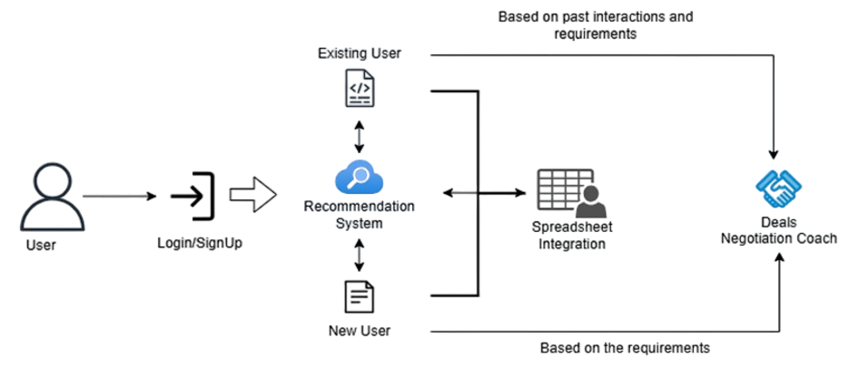

Technology Stack
- Frontend: Streamlit
- Backend: Python
- Speech Recognition: SpeechRecognition, PyAudio
- NLP and LLMs: Hugging Face Transformers, Cohere Models, Sentiment Analysis (RoBERTa), Summarization (Transformer), NLG
- Integration Modules: speech_recognition, gspread, Streamlit

SDLC Steps
1. Planning
- Define project scope: Real-time analysis of buyer-seller interactions.
- Identify tools: Python, Jupyter Notebook, PyAudio, APIs.
- Set milestones: Recording audio, transcribing, sentiment/intent analysis, recommendation ,negotiation terms generation.
2. Analysis
- Identify user requirements for real-time call analysis.
- Evaluate APIs for transcription, sentiment detection, intent analysis, recommendations, negotiation coach and data storage.
3. Design
- Modular design for components:
  - Audio recording module.
  - Transcription module.
  - Analysis modules (sentiment and intent).
  - Data storage module.
4. Development
- Implement functionality in Python.
- Ensure smooth integration of APIs and libraries.
5. Testing
- Unit testing for each module.
- End-to-end testing for the complete system.
6. Deployment
- Deploy on local systems or cloud.
7. Maintenance
Periodic updates for API changes and bug fixes.

API Integrations
- Google APIs: Enable Drive, Sheets, and Speech-to-Text.
- Hugging Face: Use pre-trained sentiment and classification models.
- Cohere API: Generate answer to the input, recommendations and negotiation coach dynamically.
- GROQ API: Summarizes the conversation.

Testing and Evaluation
- Unit Testing: Verify individual components.
- Integration Testing: Ensure seamless interaction among modules.
- Performance Testing: Test for latency during real-time calls.

Future Enhancements
- Multi-Language Support: Extend NLP models for non-English languages.
- Predictive Analytics: Enhance deal success prediction capabilities.

Conclusion
The Real-Time AI Sales Intelligence Tool empowers sales teams with actionable insights and recommendations, enhancing negotiation strategies and improving customer relationships.

References
- PyAudio Documentation
- Google Cloud Speech-to-Text API
- Hugging Face Transformers
- Cohere API Documentation
- Google Sheets API

