DS2 4x4 Port-Feature Temporal GCN Results Report
NoC DoS Detection and Attacker-Router Localization
GNN-2d project checkpoint document
Headline result
Placement split, 24-feature port/directional dataset, fixed threshold 0.50:
Graph F1 = 0.9990; Node F1 = 0.9572; Exact localization = 0.7798; TopK exact = 0.8934.
Main takeaway: aggregate features detect attacks, but directional per-port features are needed for accurate localization.

1. Executive summary
This document summarizes the DS2 4x4 port-feature Temporal GCN experiment. The previous aggregate-feature baseline could detect the presence of NoC DoS attacks well, but localization was weak because each router only had total input/output behavior. The new 24-feature dataset adds local/north/east/south/west directional traffic information, which allows the same Temporal GCN architecture to distinguish attacker routers from forwarding or congested neighbor routers.
The central result is that the bottleneck was feature representation, not the GNN architecture. With per-port directional features, node localization improved substantially while graph-level detection remained strong.

2. Dataset evolution
Dataset | Shape | Features | Role
paper1_temporal_graphs_full.npz | (42809, 16, 8, 2) | ifd_in_norm, ifd_out_norm | Original IFD-only baseline
paper1_temporal_graphs_full_4feat.npz | (42809, 16, 8, 4) | IFD + aggregate flit counts | Aggregate traffic baseline
paper1_temporal_graphs_ds2_4x4_portfeat.npz | (42809, 16, 8, 24) | Aggregate + per-port directional counts/IFDs | Final localization dataset

The old datasets only described total router behavior. The 24-feature dataset adds directional behavior for local, north, east, south, and west ports. This gives the model path information rather than only congestion intensity.

3. Model architecture
The same Temporal GCN architecture was used across the aggregate and port-feature experiments.
Input tensor: x = [samples, routers, time_window, features]
For DS2 port features: x = (42809, 16, 8, 24)
router temporal features
↓
1D temporal convolution per router
↓
router embeddings
↓
2-layer GCN over 4x4 mesh
↓
graph head + node head
The temporal encoder is a 1D convolution over the 8-step time window for each router independently. Spatial information is modeled by graph convolution over the 4x4 NoC mesh adjacency.

4. Why the 24 features helped
Aggregate features tell the model that a router has high traffic or changed inter-flit delay, but not where that traffic came from or where it is going. In a mesh NoC, congestion spreads spatially, so an attacker router and its neighbors can look similar if direction is missing.
Aggregate feature view | Port/directional feature view
Router X has high input traffic. | Traffic entered from west and exited east.
Router X has high output traffic. | Local injection increased at router X.
Router X has changed inter-flit delay. | North or south port became congested along a path.
Cannot separate source and forwarding behavior clearly. | Can distinguish attacker, forwarding neighbor, and victim-side congestion.

5. Main result comparison
Feature set | Split | Threshold | Graph F1 | Node precision | Node recall | Node F1 | Exact loc. | TopK exact
Aggregate 4-feature | Prototype | Tuned | 0.9996 | 0.2366 | 0.7857 | 0.3637 | 0.1141 | 0.1763
Port 24-feature | Prototype | 0.50 | 0.9525 | 0.7856 | 0.9980 | 0.8792 | 0.5871 | 0.9431
Port 24-feature | Prototype | Tuned 0.90 | 0.9526 | 0.8983 | 0.9745 | 0.9349 | 0.7677 | 0.9431
Port 24-feature | Placement | 0.50 | 0.9990 | 0.9287 | 0.9875 | 0.9572 | 0.7798 | 0.8934
Port 24-feature | Placement | Tuned 0.10 | 0.9990 | 0.8760 | 0.9979 | 0.9330 | 0.6520 | 0.8934

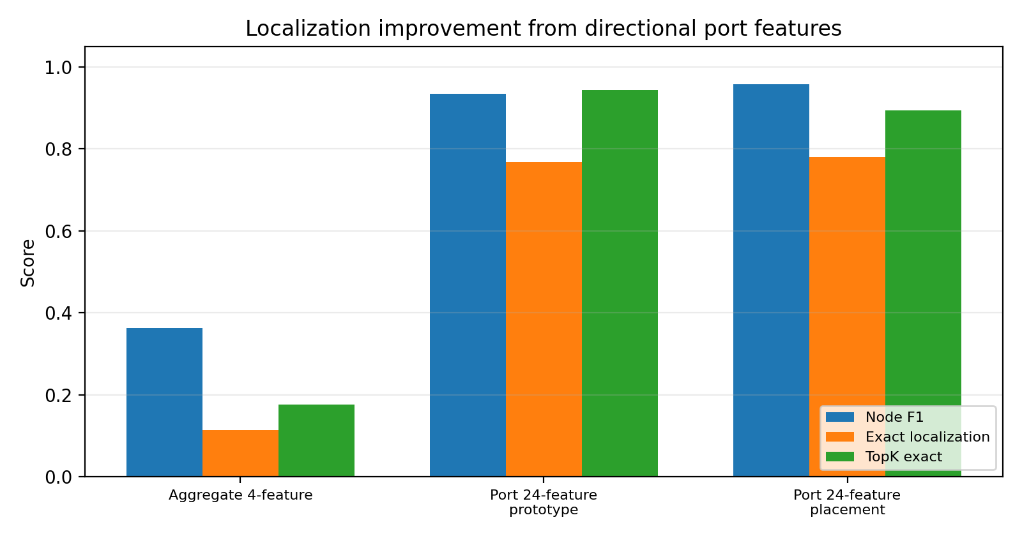
Figure 1. Node-localization metrics improve sharply after adding directional port features.

6. Prototype split results
The prototype split is useful as a sanity/proof-of-concept split. It verifies that the model can learn from the feature representation.
Metric | Fixed 0.50 | Validation-tuned 0.90
Graph accuracy | 0.9159 | 0.9161
Graph precision | 0.9961 | 0.9961
Graph recall | 0.9125 | 0.9126
Graph F1 | 0.9525 | 0.9526
Graph FPR | 0.0424 | 0.0424
Node precision | 0.7856 | 0.8983
Node recall | 0.9980 | 0.9745
Node F1 | 0.8792 | 0.9349
Exact localization | 0.5871 | 0.7677

Prototype top-k metric | Value
Overall top1_any | 0.9816
Overall topK_exact | 0.9431
Overall top4_all | 0.9998
1 attacker topK_exact | 0.9773
2 attacker topK_exact | 0.9545
3 attacker topK_exact | 0.8975

7. Placement split results
The placement split is more meaningful than prototype because it evaluates attacker placements held out from training.
Metric | Fixed 0.50 | Validation-tuned 0.10
Graph accuracy | 0.9982 | 0.9982
Graph precision | 0.9991 | 0.9991
Graph recall | 0.9989 | 0.9989
Graph F1 | 0.9990 | 0.9990
Graph FPR | 0.0121 | 0.0121
Node precision | 0.9287 | 0.8760
Node recall | 0.9875 | 0.9979
Node F1 | 0.9572 | 0.9330
Exact localization | 0.7798 | 0.6520

Placement top-k metric | Value
Top1_any | 0.9885
TopK_exact / top3 exact | 0.8934
Top4_all | 0.9953
Average worst rank | 3.12

Placement headline
The fixed 0.50 placement result is the cleanest headline result: Graph F1 = 0.9990, Node F1 = 0.9572, Exact localization = 0.7798, TopK exact = 0.8934.
The validation-tuned threshold is also reported because it is methodologically useful, but the placement validation/test attacker distributions are mismatched.

8. Placement split caveat
The current placement split is not perfectly balanced by attacker count. Validation contains one 1-attacker run and one 2-attacker run, while test contains two 3-attacker runs. Because of this, validation-selected threshold 0.10 improves validation F1 but is not necessarily optimal for exact localization on the 3-attacker-only test set. Therefore, both fixed 0.50 and validation-tuned results should be reported.

9. Interpretation
The aggregate 4-feature model achieved excellent graph-level detection but poor localization. Its node F1 was 0.3637 and exact localization was 0.1141. This means aggregate traffic features can detect that the NoC is under attack but cannot reliably identify source routers.
After adding directional/per-port features, localization improved substantially. On the placement split with fixed threshold 0.50, node F1 reached 0.9572 and exact localization reached 0.7798. TopK exact localization on unseen 3-attacker placement cases was 0.8934, and all true attackers appeared within the top-4 routers in 0.9953 of test windows.
The key scientific interpretation is that directional NoC features are essential for localization. The GNN architecture was capable, but the original aggregate feature representation was insufficient.

10. Hardware implication
The 24-feature dataset is effective, but it is not necessarily the final hardware-friendly feature set. The next hardware-facing question is whether similar localization accuracy can be preserved with fewer counters or fewer per-port statistics. This matters because a future security engine or accelerator should minimize monitor area, storage, sideband bandwidth, and inference input size.
Future feature set | Question
Port counts only | Are directional volume counters enough?
Port IFD only | Are directional timing features enough?
Reduced 10-12 feature set | Can hardware cost be reduced without losing localization?
All 24 features | Upper-bound localization baseline for the current frontend.

11. Code and artifact references
Category | Path
Training script | scripts/train_temporal_gcn.py
Threshold evaluation | scripts/eval_temporal_gcn_thresholds.py
Top-k evaluation | scripts/eval_temporal_gcn_topk.py
4-feature dataset creation | scripts/add_count_features_to_graph_dataset.py
Final dataset | data/processed/graph_dataset/paper1_temporal_graphs_ds2_4x4_portfeat.npz
Prototype model | models/temporal_gcn_float_prototype_ds2_4x4_portfeat
Placement model | models/temporal_gcn_float_placement_ds2_4x4_portfeat

12. Reproduction commands

12.1 Prototype training
python scripts/train_temporal_gcn.py \
--data data/processed/graph_dataset/paper1_temporal_graphs_ds2_4x4_portfeat.npz \
--out-dir models/temporal_gcn_float_prototype_ds2_4x4_portfeat \
--split-mode prototype \
--epochs 40 \
--batch-size 256 \
--lr 1e-3 \
--temporal-dim 8 \
--gcn-hidden 16 \
--gcn-out 8 \
--node-loss-weight 1.0 \
| tee logs/train_temporal_gcn_prototype_ds2_4x4_portfeat.log

12.2 Placement training
python scripts/train_temporal_gcn.py \
--data data/processed/graph_dataset/paper1_temporal_graphs_ds2_4x4_portfeat.npz \
--out-dir models/temporal_gcn_float_placement_ds2_4x4_portfeat \
--split-mode placement \
--epochs 60 \
--batch-size 256 \
--lr 1e-3 \
--temporal-dim 8 \
--gcn-hidden 16 \
--gcn-out 8 \
--node-loss-weight 1.0 \
| tee logs/train_temporal_gcn_placement_ds2_4x4_portfeat.log

12.3 Threshold and top-k evaluation
python scripts/eval_temporal_gcn_thresholds.py \
--data data/processed/graph_dataset/paper1_temporal_graphs_ds2_4x4_portfeat.npz \
--model-dir models/temporal_gcn_float_placement_ds2_4x4_portfeat \
--batch-size 512 \
| tee logs/eval_thresholds_placement_ds2_4x4_portfeat.log
python scripts/eval_temporal_gcn_topk.py \
--data data/processed/graph_dataset/paper1_temporal_graphs_ds2_4x4_portfeat.npz \
--model-dir models/temporal_gcn_float_placement_ds2_4x4_portfeat \
--batch-size 512 \
| tee logs/eval_topk_placement_ds2_4x4_portfeat.log

13. Next steps
- Run a balanced placement split where validation and test both contain 1-, 2-, and 3-attacker cases.
- Perform feature ablation: aggregate only, port counts only, port IFD only, and all 24 features.
- Perform error analysis to identify hard placements and whether failures occur near victims or along forwarding paths.
- Explore hardware-friendly feature reduction to test whether 10-12 features can preserve most of the localization gain.
- Run multiple random seeds before making final paper-quality numerical claims.

14. Final conclusion
Aggregate router-level temporal features are sufficient for graph-level DoS detection, but insufficient for precise malicious-router localization. Per-port directional temporal features significantly improve localization. The strongest current result is the 24-feature placement split with fixed threshold 0.50: graph F1 = 0.9990, node F1 = 0.9572, exact localization = 0.7798, and topK exact localization = 0.8934.
Therefore, the project direction is validated: temporal modeling plus graph message passing works, but localization requires directional NoC features.

Appendix A. Exact saved summary values
Model | Best epoch | Graph F1 | Node F1 | Exact localization
Prototype port-feature model | 37 | 0.9524646340 | 0.8791665122 | 0.5871017871
Placement port-feature model | 58 | 0.9990129831 | 0.9572213501 | 0.7798333569

Prototype summary file:
models/temporal_gcn_float_prototype_ds2_4x4_portfeat/summary.json
Placement summary file:
models/temporal_gcn_float_placement_ds2_4x4_portfeat/summary.json

