Summary
Submitted by Nitish kumar jha

- Overview Dashboard
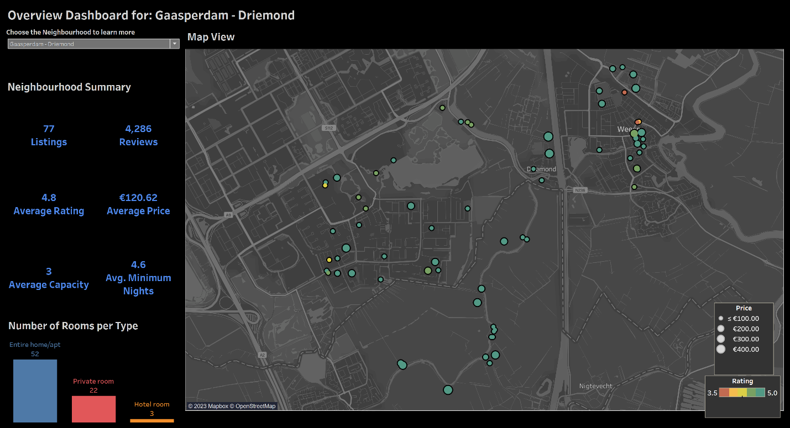
This dashboard provides an overview of Airbnb listings in Amsterdam and allows users to select different neighbourhoods to analyze the same. It highlights the listings in the chosen neighbourhood, along with summary metrics such as the number of listings, total reviews, average rating, average price, average capacity, and the average minimum nights. The distribution of different types of rooms available in the neighbourhood is also displayed, providing insights into traveller preferences and potential trends in the Airbnb landscape. The map displays the geographic location of the listing with the size of the dot indicating price and the colour indicating overall rating.

- Growth and Analysis Dashboard
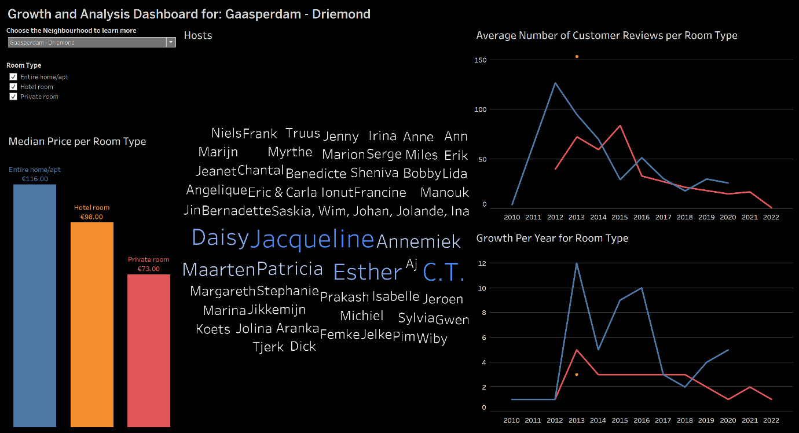
This dashboard builds upon the previous dashboard by delving deeper into the characteristics of the Airbnb listings in Amsterdam. The user can select a neighbourhood for further analysis. The user also can filter across room types. The dashboard displays a chart showing the growth of Airbnb listings across different years in the neighbourhood as well as a chart showing the average number of customer reviews per room type across different years in the neighbourhood, providing insights into trends and seasonality. It also displays an overview of the top hosts in the neighbourhood. Finally, the dashboard displays a pricing distribution chart across different room types in the neighbourhood, allowing users to identify areas with the highest demand for Airbnb rentals.

- Python Visualizations
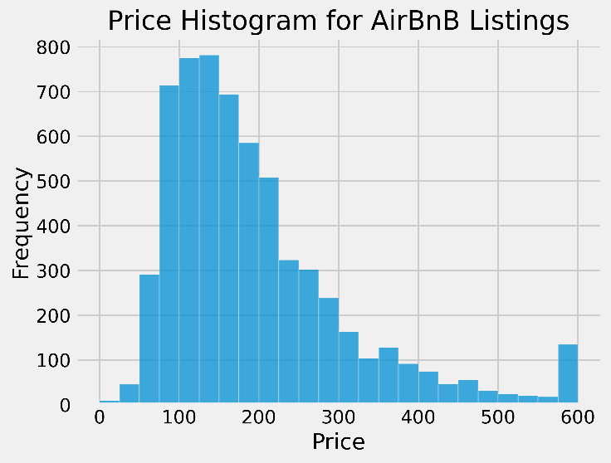
The majority of listings are falling in between €50 and €300. An overflow bin was created at €600 meaning all the data above €600 was clubbed at €600 to improve visualization.
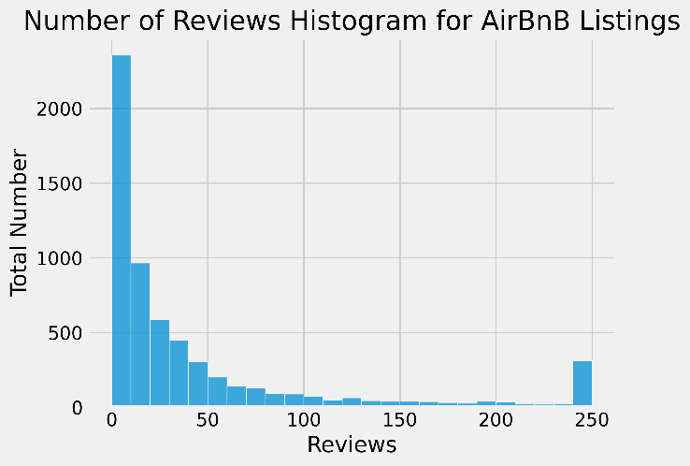
Not everyone using AirBnB are leaving reviews, since the distribution shows the data is mainly below 50. An overflow bin was created at 250 meaning all the data above 250 was clubbed at 250 to improve visualization.
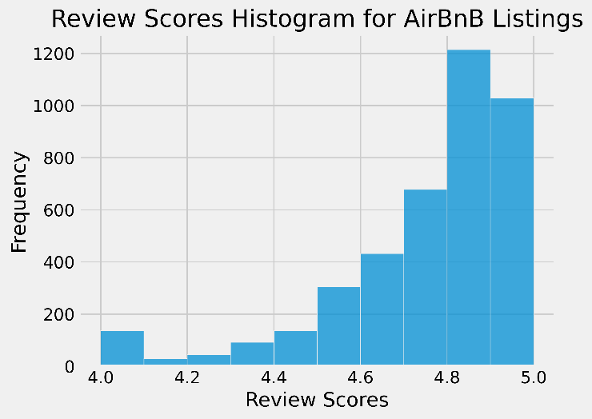
The absolute majority of Review Score Ratings are in between 4 and 5 stars. An underflow bin was created at 4.0 meaning all the data below 4.0 was clubbed at 4.0 to improve visualization.
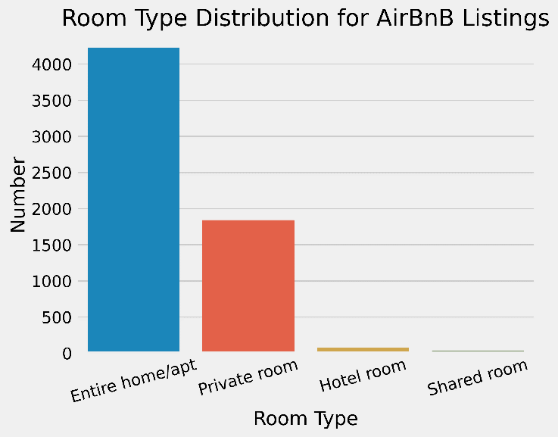
The types of room are mainly either Entire Home/Apartment or a Private Room.
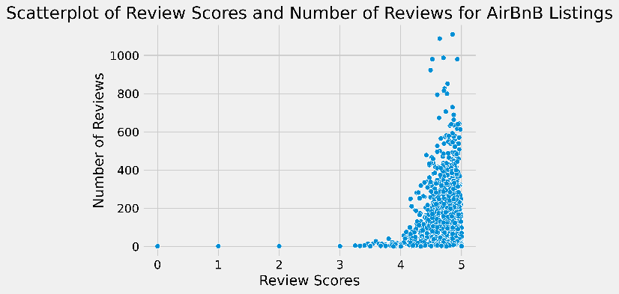
A large number of reviewers are leaving ratings above 4 stars
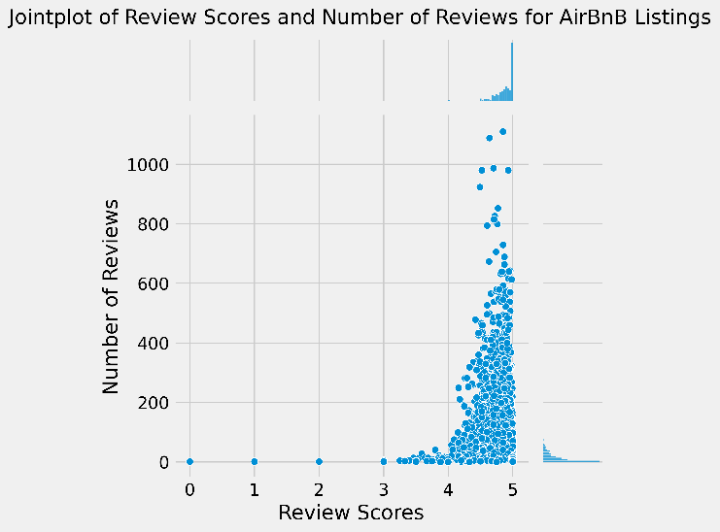
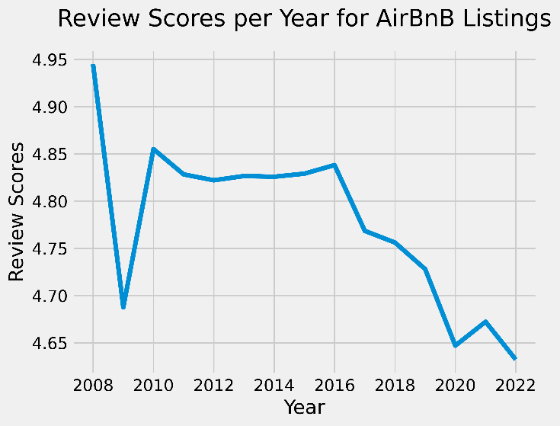
The average rating is seen to be in a decline with respect to time.
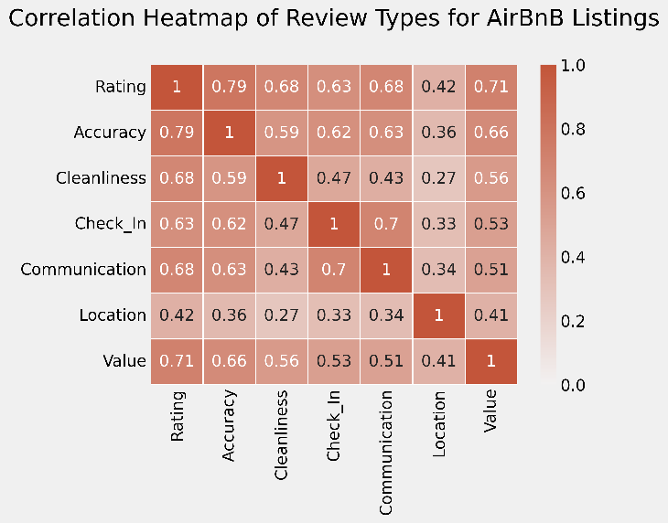
Except for Location, the rest of the review types seem to be highly correlated.
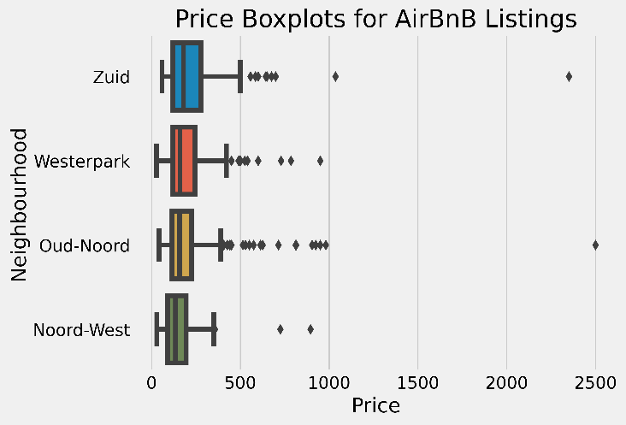
Median prices seem be below €200 for these neighbourhoods.
Also, any price above €500 is a definite outlier.

- Summary
The Tableau dashboards analyze AirBnB listings in Amsterdam. The first offers an overview of listings by neighbourhood, showing metrics such as the number of listings and Room types distribution. The map displays the geographic data with Price and Ratings data shown. The second provides a deeper analysis of top hosts and listing growth over the years. Overall median prices seem to be below €200 with most reviews and ratings above 4 stars. Room types mainly consist of Entire Home/Apartment or Private Rooms. Review types are highly-correlated excluding Location.
These insights obtained from both dashboards are intended to advise the decision-making process related to the Airbnb rental business in Amsterdam by providing valuable information to enhance user experience for hosts and guests.

