System Requirements Analysis and
Block Diagram Design
Week 1 Task Report – Embedded Systems Internship
Selected Application: Smart Asset Safety & Data Logging Unit
Submitted by: Nitish Krishna M H
B.E. Electronics and Communication Engineering
Sri Ramakrishna Engineering College, Coimbatore

1. Introduction
Embedded systems today are expected to do far more than a single fixed task — they sense their environment, make time-critical decisions on their own, and communicate that information to a remote user, often while running continuously and unattended. This report works through the planning stage of one such system before any hardware is touched or a single line of firmware is written.
For this task, a Smart Asset Safety and Data Logging Unit has been chosen as the embedded application to analyse. This is a device intended to be fixed onto a movable or stationary asset (for example, a vehicle, a machine on a factory floor, or a piece of transported cargo) to continuously watch its physical condition, detect anything abnormal, and record and report that information without needing a person to be present. The choice reflects a realistic, industry-relevant scenario rather than a purely academic example, since it brings in sensing, real-time decision-making, non-volatile storage and two independent communication links all in one design.
The sections that follow define what the system must do and how well it must do it (Section 2), present a block-diagram-level architecture of the hardware and the FreeRTOS software structure that ties it together (Section 3), justify why each component was chosen (Section 4), and close with a short conclusion on how the design meets its objectives (Section 5).

2. System Requirements Analysis

2.1 Intended Functionality and Performance Expectations
The unit is meant to sit on the asset and, without any manual intervention, keep track of the asset's temperature, the current being drawn by its motor/load, its physical location, and any sudden or abnormal movement. If any of these readings crosses a safe limit, the system must record the event with an exact time, send an alert to a remote party along with the current GPS location, and, if the condition is serious enough, cut power to the load to prevent further damage. Because a fault such as a crash or an over-current condition can develop in a fraction of a second, the response to it cannot wait behind routine, lower-priority work — this is what makes the system a real-time design rather than a simple polling loop.

2.2 Functional and Non-Functional Requirements
The table below separates what the system must do (functional) from the qualities that behaviour must have (non-functional), and ties each requirement to the hardware block or software mechanism responsible for it.
Requirement Type | Description | Related Module
Functional | Acquire real-time GPS location of the asset | GPS (UART)
Functional | Continuously monitor temperature and current drawn by the asset | ADC channels
Functional | Detect abnormal motion, tilt or crash conditions | MPU6050 (I2C)
Functional | Log every sensor event with an accurate timestamp | RTC (I2C) + SPI Flash
Functional | Send alert messages to a registered number/server during a fault | GSM (UART)
Functional | Disable the load/motor automatically under critical fault conditions | GPIO + PWM
Non-Functional | Fault response within a bounded time (hard real-time constraint) | FreeRTOS priority scheduling
Non-Functional | Continuous 24x7 unattended operation | Power management unit
Non-Functional | Data must survive power loss | External SPI Flash (non-volatile)
Non-Functional | Low power draw in idle/monitoring state | MCU sleep modes

2.3 Input / Output Specification
Every signal that crosses the boundary of the microcontroller has been listed below along with the interface it uses and whether it is data coming into the system or an action/output going out of it.
Signal | Type | Interface | Direction
Temperature reading | Analog | ADC | Input
Current reading | Analog | ADC | Input
Acceleration / tilt data | Digital | I2C | Input
Real-time clock value | Digital | I2C | Input
GPS coordinates | Serial data | UART | Input
Alert / SMS message | Serial data | UART | Output
Logged event record | Serial data | SPI | Output
Load ON/OFF control | Digital + PWM | GPIO/PWM | Output

2.4 Communication Interfaces
Three serial interfaces and one bus-style interface are used, each chosen to match what it is connecting. UART is used twice, once for the GPS receiver and once for the GSM module, because both are standard serial-output devices and giving them separate UART lines means a busy GPS read never blocks an urgent GSM alert. I2C is used for the RTC and the MPU6050 accelerometer since both are low-speed, low-pin-count devices that can comfortably share one two-wire bus. SPI is reserved for the external flash memory because logging needs a faster, dedicated link to write data without stalling other tasks.

2.5 Power Management
As the unit is expected to run continuously, often on battery or on the asset's own supply line, a dedicated power management block regulates the raw input down to the 3.3 V and 5 V rails the MCU and peripherals need, filters supply noise from the motor/load line, and allows the MCU to drop into a low-power state between sensor polls to extend battery life where the asset is not mains-powered.

2.6 Real-Time Constraints
The fault-detection path is the hard real-time element of this design: once a sensor value or accelerometer reading crosses its threshold, the load must be disabled and the alert dispatched within a bounded, predictable time, independent of how busy the logging or communication tasks are. This is why the requirements analysis explicitly separates functional behaviour from the timing guarantee around it, and why the architecture in Section 3 assigns fault handling the highest scheduling priority.

3. System Architecture and Block Diagram
Figure 1 shows the system at the block level: sensing peripherals on the left feed the STM32 core, the core is backed by its own power supply block, and outward-facing communication and actuation modules sit on the right. Arrows show the direction of data or control flow between blocks.
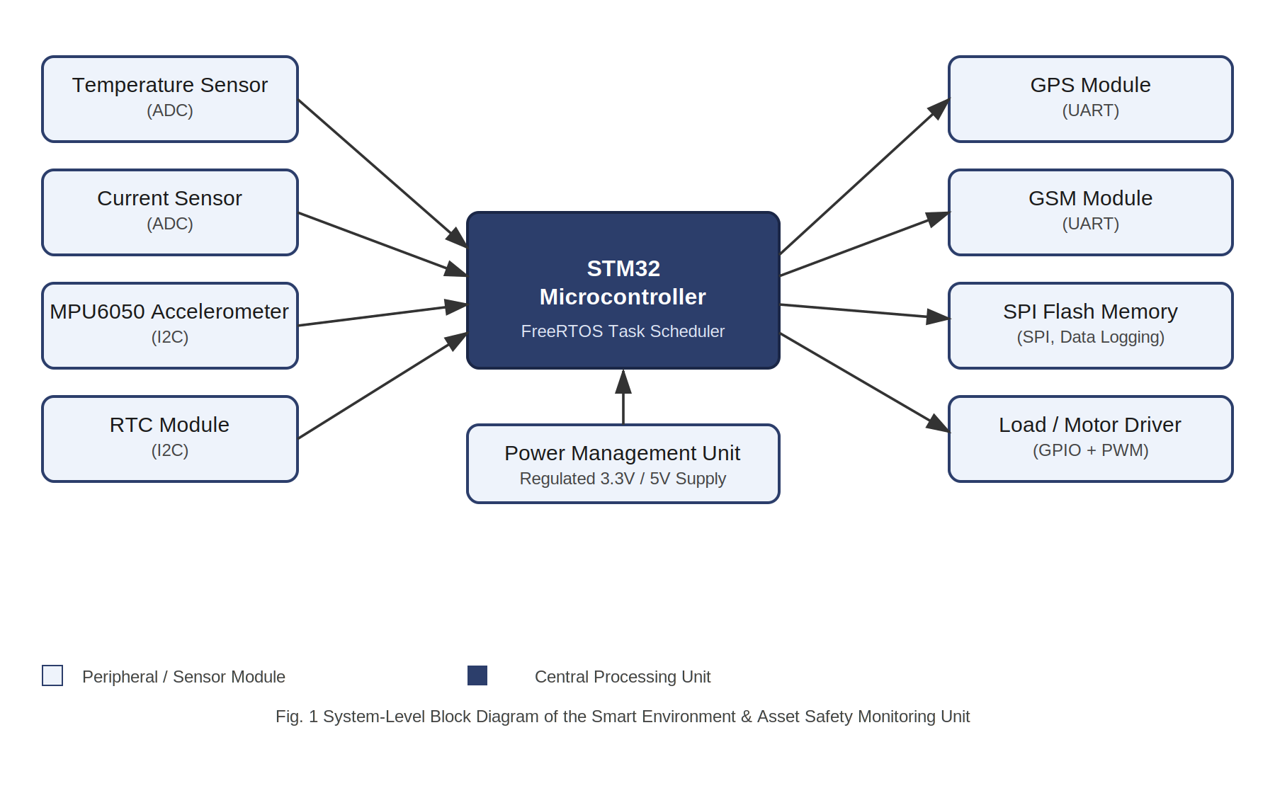
Figure 1: Block Diagram of the Smart Asset Safety & Data Logging Unit

3.1 Software / RTOS Task View
Underneath this hardware layout, FreeRTOS organises the work into five tasks that run on the same core: a Sensor Task that periodically reads the ADC and I2C peripherals, a Fault Task that evaluates the latest readings against safe limits and is given the highest priority, a Logger Task that timestamps and writes accepted events to SPI flash, a Communication Task that formats and sends GPS/GSM alerts, and a Control Task that switches the load through GPIO/PWM. Structuring the firmware this way means a slow operation, such as writing a log entry, never delays the fault check that protects the asset.

4. Component Selection and Design Justification
Each hardware and software choice in Section 3 was made against the requirements defined in Section 2, as summarised below.
Component | Justification
STM32 Microcontroller (Core) | Offers enough peripheral blocks (ADC, I2C, UART, SPI, GPIO/PWM) on a single die to interface every sensor and communication module without extra bridging hardware, and its Cortex-M core is fast enough to run FreeRTOS with room for future tasks.
FreeRTOS | The system has several activities that must run at once (reading sensors, checking faults, logging, sending alerts) with different urgencies. A pre-emptive RTOS lets the Fault Task interrupt lower-priority work so a critical condition is never delayed behind routine logging.
Temperature & Current Sensors (ADC) | Analog sensing is the simplest and most reliable way to get continuous physical readings; the internal ADC removes the need for an external converter chip.
MPU6050 Accelerometer (I2C) | I2C keeps the wiring to two lines and lets the RTC share the same bus, which simplifies the board layout while still giving motion data fine enough to catch a crash or an abnormal tilt.
RTC Module (I2C) | A dedicated RTC keeps accurate time even if the MCU resets, which is essential because every logged event must carry a trustworthy timestamp.
GPS Module (UART) | UART is the standard interface for GPS receivers and is simple to parse in firmware, giving the location needed for the alert message.
GSM Module (UART) | A second UART channel lets the system send SMS/data alerts independently of the GPS link, so location and alert paths don't compete for the same bus.
External SPI Flash | Event logs must survive a reset or power cut; SPI flash is inexpensive, fast enough for periodic writes, and keeps the log external to the MCU's limited internal memory.
GPIO + PWM Load Driver | Lets the Control Task cut power to the motor/load immediately during a critical fault, and PWM allows a soft, controlled shutdown rather than an abrupt one where that is preferable.
Power Management Unit | Regulates the raw supply to the 3.3 V / 5 V rails each module needs and protects the electronics from voltage spikes, which is necessary for an asset that may run unattended for long periods.

5. Conclusion
This task shows how a working embedded product is planned before implementation: requirements are pulled apart into functional and non-functional needs, every signal is mapped to a concrete interface, and only then is a block diagram drawn to represent the hardware. Applying this process to the Smart Asset Safety and Data Logging Unit produced an architecture where the STM32 core, running FreeRTOS, ties together four sensing inputs, two communication outputs, one logging path and one control output, with the fault-detection path given the highest scheduling priority to satisfy the system's real-time safety requirement. The same requirements-first approach used here will carry directly into the later phases of hardware bring-up and firmware development for this internship project.

