**COMPUTER GRAPHICS PRACTICAL FILE**

**SUBMITTED TO-** Mr. ARUN AGARWAL

**SUBMITTED BY -** NITISH KUMAR

**ROLL.N0.-**  20201453

**UNIVERSITY ROLL.NO.-**  20016570016

**COURSE-**  B.Sc.(HONS.) COMPUTER SCIENCE

**SEMESTER-** 6

|  |  |
| --- | --- |
| **S.No.** | **CONTENTS** |
| 1 | **BRESENHAM’S LINE DRAWING ALGORITHM** |
| **2** | **MID POINT CIRCLE DRAWING ALGORITHM** |
| **3** | **COHEN AND SUTHERLAND LINE CLIPPING ALGORITHM** |
| **4** | **SUTHERLAND HODGEMAN POLYGON CLIPPING ALGORITHM** |
| **5** | **POLYGON SCAN LINE FILLING ALGORITHM** |
| **6** | **APPLYING 2D TRANSFORMATIONS 2D OBJECT** |
| **7** | **APPLYING 3D TRANSFORMATIONS 3D OBJECT** |
| **8** | **HERMITE AND BEZIER CURVE** |

**Q1 Write a program to implement Bresenham’s line drawing algorithm.**

**Code:-**

#include<bits/stdc++.h> #include<graphics.h> using namespace std;

//Function to implement Bresenham's line drawing algorithm void bresline(int x1,int y1,int x2,int y2)

{

int dx,dy,P,x,y;

int xmid=getmaxx()/2; int

ymid=getmaxy()/2;

dx=x2-x1; dy=y2-y1;

x=x1; y=y1;

P=2*dy-dx;

while(x<=x2)

{

if(P>=0)

{

putpixel(x,y,YELLOW); y=y+1; P=P+2*dy-2*dx; } else {

putpixel(x,y,YELLOW);

P=P+2*dy;} x=x+1;

}

}

int main()

{

int gdriver = DETECT,gmode;

initgraph(&gdriver,&gmode,"C:\\Dev-Cpp\\lib"); setbkcolor(BLACK); cleardevice(); int x1,x2,y1,y2;

cout<<" Bresenham's Line Drawing Algorithm \n\n"; cout<<" Enter

the x co-ordinate of point 1: ";

cin>>x1;

cout<<"\n Enter the y co-ordinate of point 1: "; cin>>y1;

cout<<"\n Enter the x co-ordinate of point 2: "; cin>>x2;

cout<<"\nEnter the y co-ordinate of point 2: "; cin>>y2;

cleardevice();

int xmid = getmaxx()/2;

int ymid = getmaxy()/2; line(xmid , 0 , xmid ,

getmaxy()); line(0 , ymid , getmaxx() , ymid); bresline(x1+xmid,ymid-y1,x2+xmid,ymid-y2); getch();

closegraph();

return 0;

}

### OUTPUT

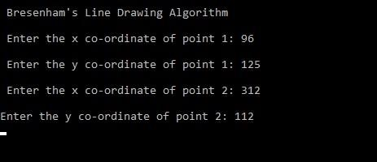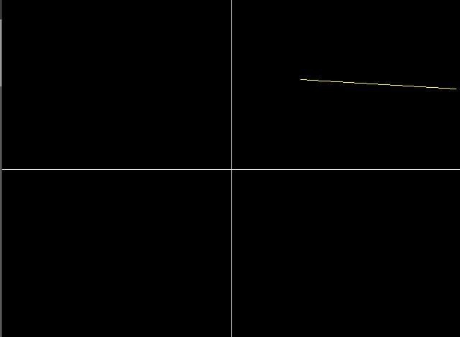

**Q2.Write a program to implement mid-point circle drawing algorithm.**

**Code:-**

#include<iostream>

#include<graphics.h>

#include<math.h>

using namespace std;

void circlePlotPoints (int, int, int, int); int xmid,

ymid;

void circleMidpoint(int xCenter, int yCenter, int radius)

{

int x = 0; int y =

radius; int p = 1 - radius;

//circlePlotPoints (x, y, xCenter, yCenter);

while (x <= y) {

circlePlotPoints (x, y, xCenter, yCenter);

if (p < 0)

{

p += (2*x)+1;

}

else

{ p +=(2*(x-y))+1;

y--;

} x++ ;

}

}

void circlePlotPoints(int x, int y, int xCenter, int yCenter){ putpixel (xCenter + x, yCenter + y, YELLOW); putpixel

(xCenter - x, yCenter + y, YELLOW); putpixel (xCenter + x, yCenter - y, YELLOW); putpixel (xCenter - x, yCenter - y, YELLOW); putpixel (xCenter + y, yCenter + x, YELLOW); putpixel (xCenter - y, yCenter + x, YELLOW); putpixel (xCenter + y, yCenter - x, YELLOW); putpixel (xCenter - y, yCenter - x, YELLOW);

}

int main()

{

int x , y;

float r;

int gd = DETECT , gm; initgraph(&gd, &gm, (char*)"");

cout<<" Mid-point Circle Algorithm \n\n";

cout<<" Enter the x co-ordinate of centre : "; cin>>x;

cout<<"\n Enter the y co-ordinate of centre : "; cin>>y;

cout<<"\n Enter the radius : "; cin>>r;

xmid = getmaxx()/2; ymid =

getmaxy()/2; line(xmid , 0 , xmid , getmaxy()); line(0 , ymid , getmaxx() , ymid); circleMidpoint(x + xmid , ymid

- y , r);

getch(); closegraph();

return 0;

}

### OUTPUT

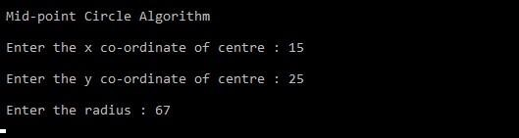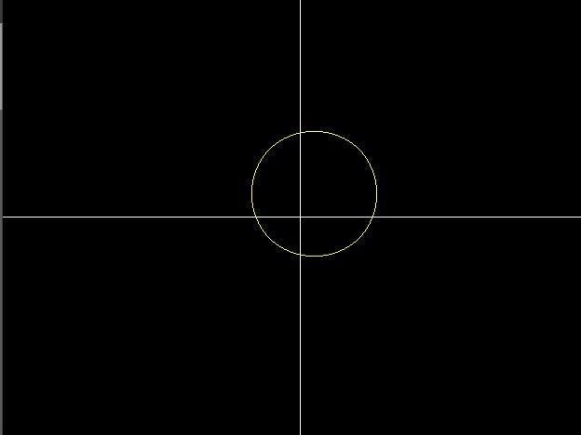

**Q3 Write a program to implement Cohen-Sutherland Line Clipping algorithm.**

**Code:-**

#include <iostream>

#include<graphics.h> #include<math.h> using namespace std;

float x_mid, y_mid;

// Defining region codes const int TOP =

1; // 0001 const int BOTTOM = 2; // 0010 const int RIGHT = 4; // 0100 const int LEFT = 8; // 1000

// Defining x_max, y_max and x_min, y_min for clipping rectangle.

const int x_max = 300; const int

y_max = 300; const int x_min = 80; const int y_min = 80;

// Function to compute region code for a point(x, y).

int ComputeOutCode(double x, double y)

{

// Point initialized as being inside the clipping window.

int code = 0;

if (y > y_max) code |= TOP;

else if (y < y_min) code |= BOTTOM; if (x > x_max) code |= RIGHT; else if (x < x_min) code |= LEFT;

return code;

}

// Implementing Cohen-Sutherland algorithm.

void CohenSutherlandLineClipAndDraw(double x1, double y1, double x2, double y2)

{

// Initialize line as outside the clipping window.

bool accept = false, done = false;

// Compute region codes for P1, P2. int code1 =

ComputeOutCode(x1, y1); int code2 =

ComputeOutCode(x2, y2);

do

{

if (!(code1 | code2))

{

// Trivial accept and exit. accept = true; done =

true; break;

}

else if (code1 & code2)

{

// If both endpoints are outside clipping window, so trivial reject. break;

} else

{

/* Failed both tests, so calculate the line segment to clip: from an outside point to an intersection with clip edge.

*/

double x, y;

int code_out;

// At least one endpoint is outside the clip rectangle, pick it.

code_out =(code1 != 0)? code1 : code2;

// Now, find intersection point.

// Using formulas: y = y1 + slope * (x - x1), x = x1 + (1 / slope) * (y - y1).

if (code_out & TOP)

{

// Point is above the clipping window. x = x1 + (x2 - x1) * (y_max - y1) / (y2 - y1); y = y_max;

}

else if (code_out & BOTTOM)

{

// Point is below the clipping window. x = x1 + (x2 - x1) * (y_min - y1) / (y2 - y1); y = y_min;

}

else if (code_out & RIGHT)

{

// Point is to the right of clipping window. y

= y1 + (y2 - y1) * (x_max - x1) / (x2 - x1); x = x_max;

}

else if (code_out & LEFT)

{

// Point is to the left of clipping window. y = y1 + (y2 - y1) * (x_min - x1) / (x2 - x1); x = x_min;

}

// Now we move outside point to intersection point to clip.

if (code_out == code1)

{

x1 = x; y1 =

y;

code1 = ComputeOutCode(x1, y1);

} else

{

x2 = x; y2 =

y;

code2 = ComputeOutCode(x2, y2);

}

}

} while(done == false); if (accept)

{

// Drawing the clipped line.

cout << "Line accepted from (" << x1 << ", " << y1 << ") to (" << x2

<< ", " << y2 << ")" << endl; setcolor(RED);

line(x1, y1, x2, y2);

} else

cout << "Line rejected" << endl;

}

// Driver code int main()

{

int gd = DETECT, gm; initgraph(&gd, &gm,

(char*)"");

float X = getmaxx(), Y = getmaxy(); float

x_mid = X / 2; float y_mid = Y / 2;

setcolor(WHITE);

outtextxy(30, 30, "Cohen-Sutherland Line Clipping Algorithm");

// Drawing Window using Lines setcolor(YELLOW); line(x_min, y_min, x_max, y_min); line(x_max, y_min,

x_max, y_max); line(x_max, y_max, x_min, y_max); line(x_min, y_max, x_min, y_min);

setcolor(GREEN);

// First Line segment

// P1 = (250, 320), P2 = (330, 270) line(250, 320, 330, 270);

CohenSutherlandLineClipAndDraw(250, 320, 330, 270);

// Second Line segment

// P1 = (80, 80), P2 = (150, 150) CohenSutherlandLineClipAndDraw(100, 100, 150, 150);

// Third Line segment

// P1 = (290, 310), P2 = (320, 500) setcolor(GREEN); line(290, 310, 300, 400);

CohenSutherlandLineClipAndDraw(290, 310, 320, 400);

// Fourth Line segment

// P1 = (450, 450), P2 = (500, 500) setcolor(GREEN); line(350, 150, 450, 250);

CohenSutherlandLineClipAndDraw(350, 150, 450, 250);

getch(); closegraph();

return 0;

}

### OUTPUT

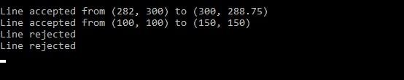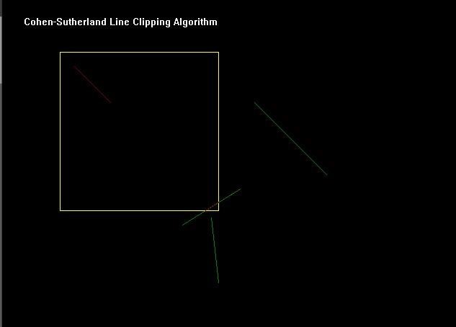

**Q4 Write a program to implement Sutherland Hodgeman Clipping program.**

**Code:-**

#include<iostream>

#include<conio.h> #include<graphics.h> using namespace std; #define round(a)

((int)(a+0.5)) int k;

float xmin,ymin,xmax,ymax,arr[20],m; void clipl(float x1,float y1,float x2,float y2) { if(x2-x1) m=(y2y1)/(x2-x1); else m=100000; if(x1 >= xmin

&& x2 >= xmin)

{

arr[k]=x2; arr[k+1]=y2; k+=2;

}

if(x1 < xmin && x2 >= xmin)

{

arr[k]=xmin; arr[k+1]=y1+m*(xmin-x1); arr[k+2]=x2; arr[k+3]=y2; k+=4;

}

if(x1 >= xmin && x2 < xmin)

{

arr[k]=xmin; arr[k+1]=y1+m*(xminx1); k+=2;

}

}

void clipt(float x1,float y1,float x2,float y2)

{ if(y2-y1) m=(x2-x1)/(y2-y1); else m=100000; if(y1 <= ymax && y2 <= ymax)

{

arr[k]=x2; arr[k+1]=y2; k+=2;

}

if(y1 > ymax && y2 <= ymax)

{

arr[k]=x1+m*(ymax-y1); arr[k+1]=ymax; arr[k+2]=x2; arr[k+3]=y2; k+=4;

}

if(y1 <= ymax && y2 > ymax)

{

arr[k]=x1+m*(ymax-y1); arr[k+1]=ymax; k+=2;

}

}

void clipr(float x1,float y1,float x2,float y2) { if(x2-x1) m=(y2-y1)/(x2-x1); else m=100000; if(x1 <= xmax && x2 <= xmax)

{

arr[k]=x2; arr[k+1]=y2; k+=2;

}

if(x1 > xmax && x2 <= xmax)

{

arr[k]=xmax; arr[k+1]=y1+m*(xmax-x1); arr[k+2]=x2; arr[k+3]=y2; k+=4;

}

if(x1 <= xmax && x2 > xmax)

{

arr[k]=xmax; arr[k+1]=y1+m*(xmax-x1); k+=2;

}

}

void clipb(float x1,float y1,float x2,float y2)

{ if(y2-y1) m=(x2-x1)/(y2-y1); else m=100000; if(y1 >= ymin && y2 >= ymin)

{

arr[k]=x2; arr[k+1]=y2;

k+=2;

}

if(y1 < ymin && y2 >= ymin)

{

arr[k]=x1+m*(ymin-y1);

arr[k+1]=ymin; arr[k+2]=x2; arr[k+3]=y2; k+=4;

}

if(y1 >= ymin && y2 < ymin)

{

arr[k]=x1+m*(ymin-y1);

arr[k+1]=ymin; k+=2;

}

}

int main()

{

int gd=DETECT,gm,n,poly[20]; initgraph(&gd,&gm,(char*)""); float

xi,yi,xf,yf,polyy[20];

cout<<"Coordinates of rectangular clip window :\nxmin,ymin :"; cin>>xmin>>ymin; cout<<"xmax,ymax :"; cin>>xmax>>ymax;

cout<<"\n\nPolygon to be clipped :\nNumber of sides :"; cin>>n; cout<<"Enter the coordinates :"; int i; for(i=0;i < 2*n;i++)

cin>>polyy[i];

polyy[i]=polyy[0]; polyy[i+1]=polyy[1]; for(i=0;i <

2*n+2;i++) poly[i]=round(polyy[i]); setcolor(RED);

rectangle(xmin,ymax,xmax,ymin);

cout<<"\t\tUNCLIPPED POLYGON"; setcolor(WHITE); fillpoly(n,poly);

getch();

cleardevice(); k=0;

for(i=0;i < 2*n;i+=2)

clipl(polyy[i],polyy[i+1],polyy[i+2],polyy[i+3]); n=k/2; for(i=0;i <

k;i++)

polyy[i]=arr[i];

polyy[i]=polyy[0]; polyy[i+1]=polyy[1]; k=0; for(i=0;i < 2*n;i+=2)

clipt(polyy[i],polyy[i+1],polyy[i+2],polyy[i+3]); n=k/2; for(i=0;i <

k;i++)

polyy[i]=arr[i]; polyy[i]=polyy[0]; polyy[i+1]=polyy[1]; k=0; for(i=0;i < 2*n;i+=2)

clipr(polyy[i],polyy[i+1],polyy[i+2],polyy[i+3]); n=k/2; for(i=0;i <

k;i++)

polyy[i]=arr[i];

polyy[i]=polyy[0]; polyy[i+1]=polyy[1]; k=0; for(i=0;i < 2*n;i+=2)

clipb(polyy[i],polyy[i+1],polyy[i+2],polyy[i+3]); for(i=0;i < k;i++)

poly[i]=round(arr[i]); if(k)

fillpoly(k/2,poly);

setcolor(RED);

rectangle(xmin,ymax,xmax,ymin); cout<<"\tCLIPPED POLYGON";

getch(); closegraph();

}

### OUTPUT

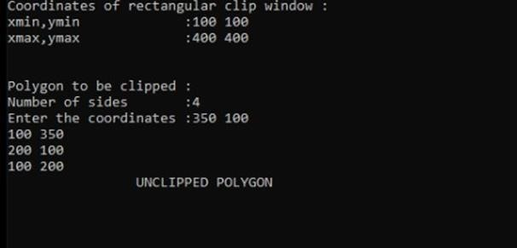

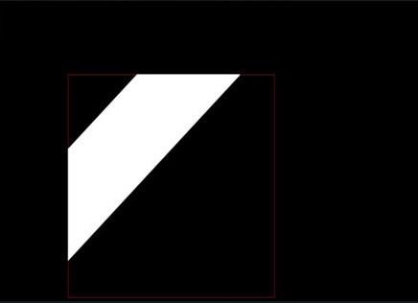

**Q5 Write a program to implement Scan-Line Polygon fill algorithm.**

**Code:-**

#include<iostream>

#include<graphics.h> #include<math.h> using namespace std;

const int WINDOW_HEIGHT = 1000;

typedef struct tdcPt

{

int x; int y;

}dcPt;

typedef struct tEdge

{

int yUpper;

float xIntersect, dxPerScan; struct tEdge

*next;

}Edge;

// Vertices: Array of structures.

dcPt vertex[5] = {{200, 500}, {300, 250}, {270, 230}, {320, 200}, {360, 290}};

void insertEdge(Edge *list, Edge *edge)

{

Edge *p, *q = list; p = q->next;

while (p != NULL)

{

if (edge->xIntersect < p->xIntersect)

p = NULL; else

{ q = p;

p = p->next;

}

}

edge->next = q->next; q->next = edge;

}

int yNext(int k, int cnt, dcPt *pts)

{

int j;

if ((k + 1) > (cnt - 1)) j = 0; else

j = k + 1; while(pts[k].y == pts[j].y)

{

if ((j + 1) > (cnt - 1))

j = 0;

else j++;

}

return (pts[j].y);

}

void makeEdgeRec(dcPt lower, dcPt upper, int yComp, Edge *edge, Edge *edges[])

{

edge->dxPerScan = (float) (upper.x - lower.x) / (upper.y - lower.y); edge>xIntersect = lower.x; if (upper.y < yComp) edge->yUpper = upper.y -

1; else

edge->yUpper = upper.y; insertEdge(edges[lower.y], edge);

}

void buildEdgeList(int cnt, dcPt *pts, Edge *edges[])

{

Edge *edge; dcPt v1,

v2; int i, yPrev = pts[cnt - 2].y;

v1.x = pts[cnt - 1].x; v1.y = pts[cnt - 1].y; for(int i = 0; i <

cnt; i++)

{

v2 = pts[i];

if (v1.y != v2.y) // nonhorizontal line

{

edge = (Edge *) malloc (sizeof(Edge));

if (v1.y < v2.y) // upgoing edge

makeEdgeRec(v1, v2, yNext(i, cnt, pts), edge, edges); else // down-going edge

makeEdgeRec(v2, v1 , yPrev, edge, edges);

}

yPrev = v1.y;

v1 = v2;

}

}

void buildActiveList(int scan, Edge *active, Edge *edges[])

{

Edge *p, *q;

1. = edges[scan]->next; while (p)

{

1. = p->next; insertEdge(active, p);

p = q;

}

}

void fillScan(int scan, Edge *active)

{

Edge *p1, *p2 ; int i;

p1 = active->next; while (p1)

{

p2 = p1->next;

for(i = p1->xIntersect; i < p2->xIntersect; i++) putpixel((int) i, scan, GREEN); p1 = p2->next;

}

}

void deleteAfter(Edge *q)

{

Edge *p = q->next;

q->next = p->next; free(p);

}

void updateActiveList(int scan, Edge *active)

{

Edge *q = active, *p = active->next;

while (p)

{

if (scan >= p->yUpper)

{

p = p->next; deleteAfter(q);

} else

{

p->xIntersect = p->xIntersect + p->dxPerScan; q = p; p = p->next;

}

}

}

void resortActiveList(Edge *active)

{

Edge *q, *p = active->next; active-

>next = NULL; while (p)

{

q = p->next;

insertEdge(active, p); p = q;

}

}

void scanFill(int cnt, dcPt *pts)

{

Edge *edges[WINDOW_HEIGHT], *active; int i, scan;

for (i = 0; i < WINDOW_HEIGHT; i++)

{

edges[i] = (Edge *) malloc (sizeof(Edge));; edges[i]->next = NULL;

}

buildEdgeList(cnt, pts, edges); active = (Edge *) malloc

(sizeof(Edge));; active->next = NULL;

for (scan = 0; scan < WINDOW_HEIGHT; scan++) {

buildActiveList(scan, active, edges); if (active->next)

{

fillScan(scan, active); updateActiveList(scan, active) ; resortActiveList(active);

}

}

free(edges[WINDOW_HEIGHT]); free(active);

}

int main()

{

int gd = DETECT, gm; initgraph(&gd, &gm,

(char*)"");

float X = getmaxx(), Y = getmaxy(); float x_mid = X / 2; float y_mid = Y / 2;

cleardevice(); scanFill(5,

vertex);

getch();

closegraph(); return 0;

}

**OUTPUT:-**

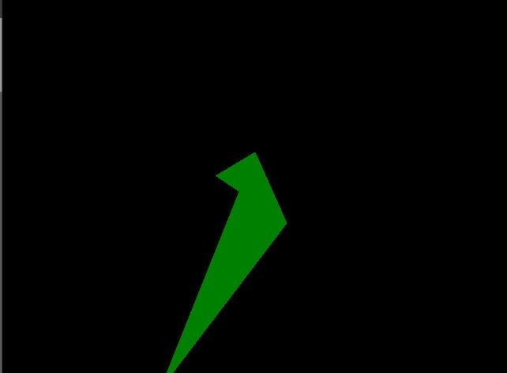

**Q6 Write a program to apply various 2D transformations on 2D object (use homogeneous objects).**

**Code:-**

#include<graphics.h>

#include<stdlib.h>

#include<stdio.h>

#include<iostream>

#include<conio.h> #include<math.h> using namespace std;

int mat[3][3];

void dda_line(int x1 , int y1 , int x2 , int y2 , int col){ int dx , dy , st; dx = x2 - x1; dy = y2 - y1; float y , x , xinc , yinc; int xmid , ymid; xmid = getmaxx()/2; ymid = getmaxy()/2; if(abs(dx) > abs(dy)){ st = abs(dx);

}

else{ st = abs(dy);

}

xinc = dx / st; yinc = dy / st; x =

x1; y = y1; for(int i=0 ; i<st ; i++){ x += xinc; y += yinc;

putpixel(ceil(x) + xmid , ymid - ceil(y),col);

}

}

void rotate(){ int xmid , ymid; xmid =

getmaxx()/2; ymid = getmaxy()/2; line(xmid , 0 , xmid , getmaxy()); line(0 , ymid , getmaxx() , ymid); int c[3][2] ,l , m, i

, j , k;

int a[3][2]={{200,200},{200,100},{100,200}}; int

t[2][2]={{0,1},{-1,0}}; for( i = 0 ; i < 3 ; i++){ for(j=0 ; j<2 ; j++){ c[i][j]=0;

}

}

dda_line(a[0][0],a[0][1],a[1][0],a[1][1],YELLOW);

dda_line(a[1][0],a[1][1],a[2][0],a[2][1],YELLOW);

dda_line(a[2][0],a[2][1],a[0][0],a[0][1],YELLOW); for ( i=0;i<3;i++){ for ( j=0;j<2;j++){ for ( k=0;k<2;k++){ c[i][j]=c[i][j]+(a[i][k]*t[k][j]);

} }

}

dda_line(c[0][0],c[0][1],c[1][0],c[1][1],GREEN); dda_line(c[1][0],c[1][1],c[2][0],c[2][1],GREEN); dda_line(c[2][0],c[2][1],c[0][0],c[0][1],GREEN);

}

void reflection(){ int xmid , ymid; xmid = getmaxx()/2; ymid = getmaxy()/2; line(xmid , 0 , xmid , getmaxy()); line(0 , ymid , getmaxx() , ymid); int c[3][2] ,l , m, i

, j , k;

int a[3][2]={{200,200},{200,100},{100,200}}; int

t[2][2]={{0,-1},{-1,0}}; for( i = 0 ; i < 3 ; i++){ for(j=0 ; j<2 ; j++){ c[i][j]=0;

}

} dda_line(a[0][0],a[0][1],a[1][0],a[1][1],YELLOW); dda_line(a[1][0],a[1][1],a[2][0],a[2][1],YELLOW); dda_line(a[2][0],a[2][1],a[0][0],a[0][1],YELLOW); for ( i=0;i<3;i++){ for ( j=0;j<2;j++){ for ( k=0;k<2;k++){ c[i][j]=c[i][j]+(a[i][k]*t[k][j]);

} }

}

dda_line(c[0][0],c[0][1],c[1][0],c[1][1],GREEN); dda_line(c[1][0],c[1][1],c[2][0],c[2][1],GREEN); dda_line(c[2][0],c[2][1],c[0][0],c[0][1],GREEN);

}

void scaling(){ int xmid , ymid; xmid =

getmaxx()/2; ymid = getmaxy()/2; line(xmid , 0 , xmid , getmaxy()); line(0 , ymid , getmaxx() , ymid); int c[3][2] ,l , m, i , j , k; int a[3][2]={{20,20},{20,10},{10,20}}; int t[2][2]={{5,0},{0,5}}; for( i = 0 ; i < 3 ; i++){ for(j=0 ; j<2 ; j++){ c[i][j]=0;

}

}

dda_line(a[0][0],a[0][1],a[1][0],a[1][1],YELLOW);

dda_line(a[1][0],a[1][1],a[2][0],a[2][1],YELLOW); dda_line(a[2][0],a[2][1],a[0][0],a[0][1],YELLOW); for ( i=0;i<3;i++){ for ( j=0;j<2;j++){ for ( k=0;k<2;k++){ c[i][j]=c[i][j]+(a[i][k]*t[k][j]);

}

}

}

dda_line(c[0][0],c[0][1],c[1][0],c[1][1],GREEN); dda_line(c[1][0],c[1][1],c[2][0],c[2][1],GREEN); dda_line(c[2][0],c[2][1],c[0][0],c[0][1],GREEN); }

void multi(int a[3][3] , int b[3][3] ){ int i , j ,k; int c[3][3]; for( i = 0 ; i < 3 ; i++){ for(j=0 ; j< 3 ; j++){ c[i][j]=0;

}

}

for ( i=0;i<3;i++){ for ( j=0;j<3;j++){ for ( k=0;k<3;k++){ c[i][j]=c[i][j]+(a[i][k]*b[k][j]);

} }

}

for( i = 0 ; i < 3 ; i++){ for(j=0 ; j< 3 ;

j++){ mat[i][j]=c[i][j];

} }

}

void reflection_arbitrary(){ int xmid , ymid; xmid = getmaxx()/2; ymid = getmaxy()/2; line(xmid , 0 , xmid , getmaxy()); line(0 , ymid , getmaxx() , ymid); int a[3][3]={{200,200,1},{200,100,1},{100,200,1}}; int t[3][3]={{1,0,0},{0,1,0},{0,0,1}}; int r[3][3]={{-1,0,0},{0,1,0},{0,0,1}}; int ref[3][3]={{1,0,0},{0,-1,0},{0,0,1}}; int rinv[3][3]={{-1,0,0},{0,-1,0},{0,0,1}}; int tinv[3][3]={{1,0,0},{0,1,0},{0,1,1}}; dda_line(a[0][0],a[0][1],a[1][0],a[1][1],YELLOW); dda_line(a[1][0],a[1][1],a[2][0],a[2][1],YELLOW); dda_line(a[2][0],a[2][1],a[0][0],a[0][1],YELLOW); multi(t,r); multi(mat,ref); multi(mat,rinv); multi(mat,tinv); multi(a,mat);

dda_line(mat[0][0],mat[0][1],mat[1][0],mat[1][1],GREEN); dda_line(mat[1][0],mat[1][1],mat[2][0],mat[2][1],GREEN); dda_line(mat[2][0],mat[2][1],mat[0][0],mat[0][1],GREEN);

}

void rotation_arbitrary(){ int xmid , ymid; xmid = getmaxx()/2; ymid = getmaxy()/2; line(xmid , 0 , xmid , getmaxy()); line(0 , ymid , getmaxx() , ymid);

int c[3][3] , i , j , k; int l[1][3]={{200,200,1}};

int a[3][3]={{200,200,1},{200,100,1},{100,200,1}}; int t[3][3]={{1,0,0},{0,1,0},{-133,-133,1}}; int r[3][3]={{-

1,0,0},{0,-1,0},{0,0,1}}; int tinv[3][3]={{1,0,0},{0,1,0},{133,133,1}}; dda_line(a[0][0],a[0][1],a[1][0],a[1][1],YELLOW); dda_line(a[1][0],a[1][1],a[2][0],a[2][1],YELLOW); dda_line(a[2][0],a[2][1],a[0][0],a[0][1],YELLOW); multi(t,r); multi(mat,tinv); for( i = 0 ; i < 3 ; i++){ for(j=0 ; j<3 ;

j++){ c[i][j]=0;

}

}

for ( i=0;i<3;i++){ for ( j=0;j<3;j++){ for ( k=0;k<3;k++){

c[i][j]=c[i][j]+(a[i][k]*mat[k][j]);

}

}

}

dda_line(c[0][0],c[0][1],c[1][0],c[1][1],GREEN); dda_line(c[1][0],c[1][1],c[2][0],c[2][1],GREEN); dda_line(c[2][0],c[2][1],c[0][0],c[0][1],GREEN);

}

int main()

{

int gdriver = DETECT , gmode , errorcode; initgraph(&gdriver,

&gmode, "C:\\TURBOC3\\BGI"); int n , m; cout<<" 1.Rotation \n 2.Reflection \n 3.Scaling \n 4.Reflection about an arbitrary axis \n"; cout<<" 5.Rotation about an arbitrary point\n";

cout<<"Enter your choice : "; cin>>n; switch(n){ case 1 : rotate();

break; case 2 : reflection(); break; case 3 : scaling(); break;

case 4 : reflection_arbitrary(); break; case 5 : rotation_arbitrary(); break; default : cout<<"Invalid Choice\n";

}

getch();

}

### OUTPUT

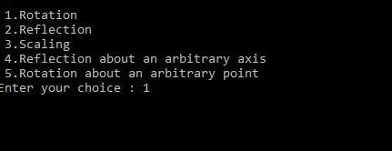

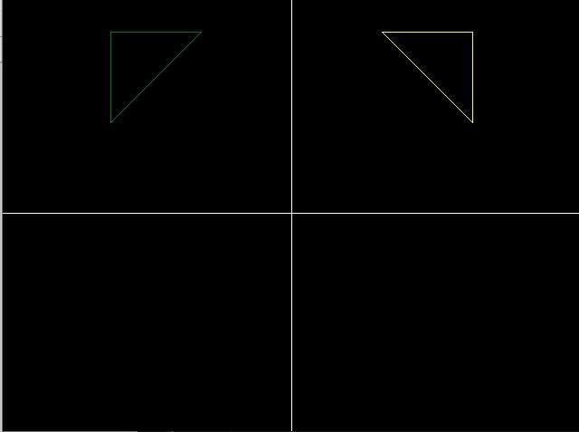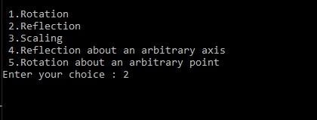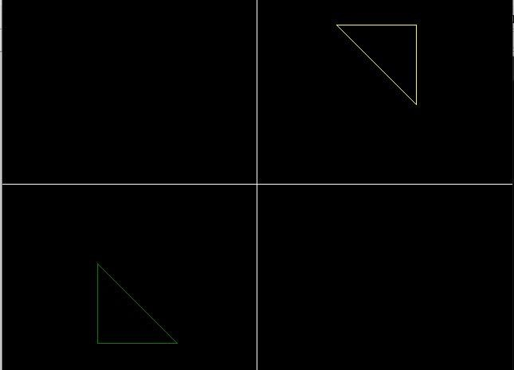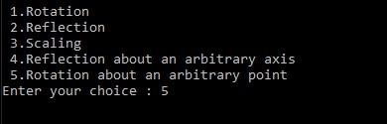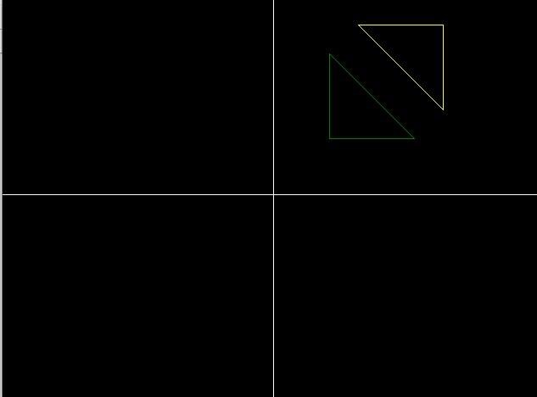

**Q7 Write a program to apply various 3D transformations on a 3D object and then apply parallel and perspective projection on it.**

**Code:-**

#include<iostream>

#include<dos.h>

#include<stdio.h>

#include<math.h>

#include<conio.h>

#include<graphics.h> #include<process.h> double x1,x2,y1,y2; void draw_cube(double edge[20][3]){

int i;

cleardevice(); for(i=0;i<19;i++){

x1=edge[i][0]+edge[i][2]*(cos(2.3562)); y1=edge[i][1]-

edge[i][2]*(sin(2.3562)); x2=edge[i+1][0]+edge[i+1][2]*(cos(2.3562)); y2=edge[i+1][1]-edge[i+1][2]*(sin(2.3562)); line(x1+320,240-y1,x2+320,240-y2);

}

line(320,240,320,25); line(320,240,550,240); line(320,240,150,410);

}

void translate(double edge[20][3]){ int a,b,c; int i;

cout<<"Enter the Translation Factors : "; cin>>a>>b>>c; cleardevice(); for(i=0;i<20;i++){ edge[i][0]+=a; edge[i][0]+=b; edge[i][0]+=c;

}

draw_cube(edge);

}

void rotate(double edge[20][3]){ int n; int i; double temp,theta,temp1; cleardevice(); cout<<" 1.X-Axis \n 2.Y-Axis \n 3.Z-Axis \n"; cout<<"Enter your choice : "; cin>>n; switch(n){ case 1: cout<<" Enter The Angle "; cin>>theta; theta=(theta*3.14)/180; for(i=0;i<20;i++){ edge[i][0]=edge[i][0]; temp=edge[i][1]; temp1=edge[i][2];

edge[i][1]=temp*cos(theta)-temp1*sin(theta); edge[i][2]=temp*sin(theta)+temp1*cos(theta);

}

draw_cube(edge); break;

case 2: cout<<" Enter The Angle "; cin>>theta; theta=(theta*3.14)/180; for(i=0;i<20;i++){ edge[i][1]=edge[i][1]; temp=edge[i][0]; temp1=edge[i][2];

edge[i][0]=temp*cos(theta)+temp1*sin(theta); edge[i][2]=temp*sin(theta)+temp1*cos(theta);

}

draw_cube(edge); break;

case 3: cout<<" Enter The Angle "; cin>>theta; theta=(theta*3.14)/180; for(i=0;i<20;i++){ edge[i][2]=edge[i][2]; temp=edge[i][0]; temp1=edge[i][1];

edge[i][0]=temp*cos(theta)-temp1*sin(theta); edge[i][1]=temp*sin(theta)+temp1*cos(theta);

}

draw_cube(edge); break;

}

}

void reflect(double edge[20][3]){ int n; int i; cleardevice();

cout<<" 1.X-Axis \n 2.Y-Axis \n 3.Z-Axis \n"; cout<<" Enter Your Choice : "; cin>>n; switch(n){ case 1: for(i=0;i<20;i++){ edge[i][0]=edge[i][0]; edge[i][1]=edge[i][1]; edge[i][2]=-edge[i][2];

}

draw_cube(edge); break; case 2: for(i=0;i<20;i++){ edge[i][1]=edge[i][1]; edge[i][0]=edge[i][0]; edge[i][2]=-edge[i][2]; }

draw_cube(edge); break; case 3: for(i=0;i<20;i++){

edge[i][2]=edge[i][2]; edge[i][0]=edge[i][0]; edge[i][1]=-edge[i][1];

}

draw_cube(edge); break;

}

}

void perspect(double edge[20][3]){ int n; int i; double p,q,r; cleardevice();

cout<<" 1.X-Axis \n 2.Y-Axis \n 3.Z-Axis\n"; cout<<" Enter Your Choice : "; cin>>n; switch(n){ case 1: cout<<" Enter P : "; cin>>p; for(i=0;i<20;i++){ edge[i][0]=edge[i][0]/(p*edge[i][0]+1); edge[i][1]=edge[i][1]/(p*edge[i][0]+1); edge[i][2]=edge[i][2]/(p*edge[i][0]+1);

}

draw_cube(edge); break; case 2: cout<<" Enter Q

: "; cin>>q; for(i=0;i<20;i++){ edge[i][1]=edge[i][1]/(edge[i][1]*q+1); edge[i][0]=edge[i][0]/(edge[i][1]*q+1); edge[i][2]=edge[i][2]/(edge[i][1]*q+1);

}

draw_cube(edge); break; case 3: cout<<" Enter R : "; cin>>r;

for(i=0;i<20;i++){

edge[i][2]=edge[i][2]/(edge[i][2]*r+1); edge[i][0]=edge[i][0]/(edge[i][2]*r+1);

edge[i][1]=edge[i][1]/(edge[i][2]*r+1);

}

draw_cube(edge); break;

}

}

void main(){ clrscr();

int gdriver = DETECT , gmode , errorcode; initgraph(&gdriver,

&gmode, "C:\\TURBOC3\\BGI"); int n; double

edge[20][3]={100,0,0,100,100,0,0,100,0,0,100,100,0,0,100,0,0,0,100,

0,0,

100,0,100,100,75,100,75,100,100,100,100,75,100,100,0,100,100,75,

100,75,100,75,100,100,0,100,100,0,100,0,0,0,0,0,0,100,100,0,100}; cout<<"

1.Draw Cube \n 2.Rotation \n 3.Reflection \n"; cout<<" 4.Translation \n 5.Perspective Projection \n"; cout<<" Enter Your Choice : "; cin>>n; switch(n){ case 1: draw_cube(edge); break; case 2: rotate(edge); break; case 3: reflect(edge); break; case 4: translate(edge); break; case 5: perspect(edge); break; default:

cout<<" Invalid Choice\n ";

}

getch();

}

### OUTPUT

**ORIGINAL CUBE:**

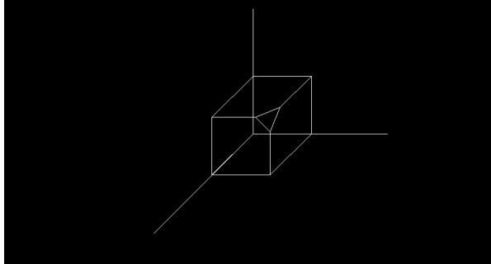

**ROTATION ABOUT Y-AXIS BY AN ANGLE OF 45 DEGREE:**

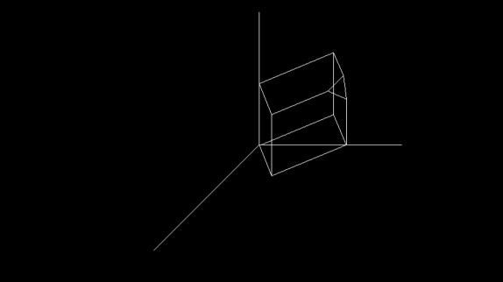

**TRANSLATION FACTORS AS 20, 30, 40:**

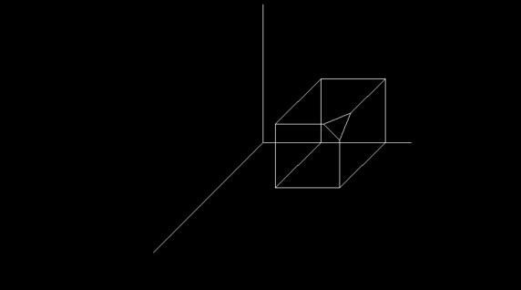

**PERSPECTIVE PROJECTION ABOUT X-AXIS WHEN P=50:**

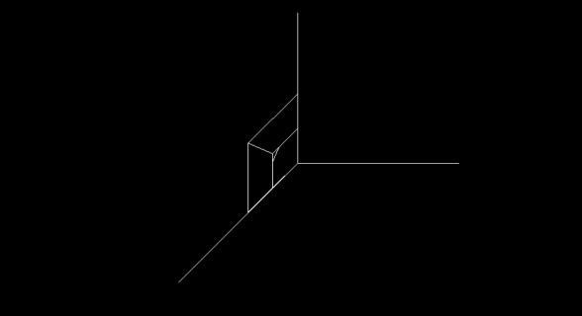

**REFLECTION ABOUT Z-AXIS:**

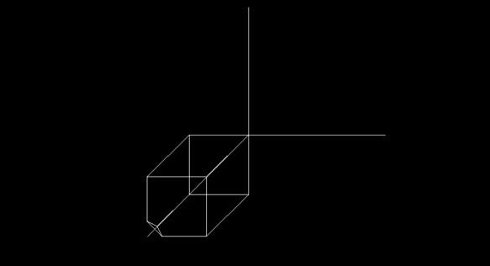

**Q8 Write a program to draw Hermite/Bezier curve.**

**Code:-**

#include<iostream>

#include<conio.h>

#include<graphics.h> #include<math.h> void bezier_curve(int x[4],int y[4]){ double t; for(t=0.0;t<1.0;t=t+0.0005){ double xt=pow(1t,3)*x[0]+3*t*pow(1- t,2)*x[1]+3*pow(t,2)*(1-

t)*x[2]+pow(t,3)*x[3]; double yt=pow(1t,3)*y[0]+3*t*pow(1- t,2)*y[1]+3*pow(t,2)*(1-

t)*y[2]+pow(t,3)*y[3]; putpixel(xt,yt,YELLOW);

}

for(int i=0;i<3;i++){ line(x[i],y[i],x[i+1],y[i+1]);

}

}

void hermite_curve(int x1,int y1,int x2,int y2,double t1,double t4){ float

x,y,t; for(t=0.0;t<=1.0;t+=0.001){

x=(2*t*t*t-3*t*t+1)*x1+(-2*t*t*t+3*t*t)*x2+(t*t*t-

2*t*t+t)*t1+(t*t*t-t*t)*t4;

y=(2*t*t*t-3*t*t+1)*y1+(-2*t*t*t+3*t*t)*y2+(t*t*t-

2*t*t+1)*t1+(t*t*t-t*t)*t4; putpixel(x,y,YELLOW);

}

putpixel(x1,y1,GREEN); putpixel(x2,y2,GREEN);

line(x1,y1,x2,y2);

}

voidmain()

{ clrscr();

int gdriver=DETECT,gmode,errorcode; int x1,y1,x2,y2,n; double t1,t4;

initgraph(&gdriver,&gmode,"C:\\TURBOC3\\BGI"); int x[4],y[4];

int i;

cout<<"1.BezierCurve\n2.HermiteCurve\n";

cout<<"Enteryourchoice:"; cin>>n; if(n==1){ cout<<"Enterxandycoordinates\n";

for(i=0;i<4;i++){ cout<<"x"<<i+1<<":"; cin>>x[i]; cout<<"y"<<i+1<<":"; cin>>y[i]; cout<<endl;

}

bezier_curve(x,y);

}

elseif(n==2){

cout<<"Enterthexcoordinateof1sthermitepoint:"; cin>>x1; cout<<"Entertheycoordinateof1sthermitepoint:"; cin>>y1; cout<<"Enterthexcoordinateof4thhermitepoint:"; cin>>x2; cout<<"Entertheycoordinateof4thhermitepoint:"; cin>>y2;

cout<<"Entertangentatp1:"; cin>>t1; cout<<"Entertangentatp4:"; cin>>t4; hermite_curve(x1,y1,x2,y2,t1,t4);

}

else{

cout<<"\nInvalidChoice";

}

getch();

}

### OUPUT

