**Online Mobile Store**

This**project aims to develop**a**web application**that**presents online shopping mobile**from**the largest online selection.**

**INDEX**

* **Objective**
* **Modules**
* **Technology Used**
* **Dependencies Installed**
* **Registration Page**
* **Data Stored**
* **Login Page**
* **Home Page**
* **Scope Of The Project**
* **Objective**

This software helps **customers easily** find different **phones,** their **features, and new updates.** It is designed **to allow you to** view all **updates**of**your phone from anywhere via the internet. This software helps** the **administrator easily maintain** and **update the** products **on the website.** Also, **a**quick and easy comparison of different products for **customers**

* **Modules**
* **Registration –** This module is for users who do not have their own account. Here the user can create a login account. Account creation is done by filling out a registration form with user data such as name and email address.
* **Login -** In this module, registered users can log in with the correct email address and password. If a user enters an incorrect email address, a pop-up appears stating that the email address could not be found. If the user enters an incorrect password, the "Invalid Password" popup appears. You will be redirected to the main page with the correct email address and password.
* **Contact Us -** Users can provide feedback or contact us. Provided details will be stored in Express.
* **Logout -** User will be Redirected to Login Page
* **Technology Used**

1. **Front – End**

HTML, CSS, JAVASCRIPT, BOOTSTRAP 5.2.0

1. **Back – End**

NodeJS

1. **Database**

Express

**IDE Used - VS Code**

* **Dependencies Installed**
* express
* ejs
* bcrypt
* express-flash
* express-session
* method-override
* passport
* passport-local
* **Registration Page**

New Users first register on website then only they can access on website

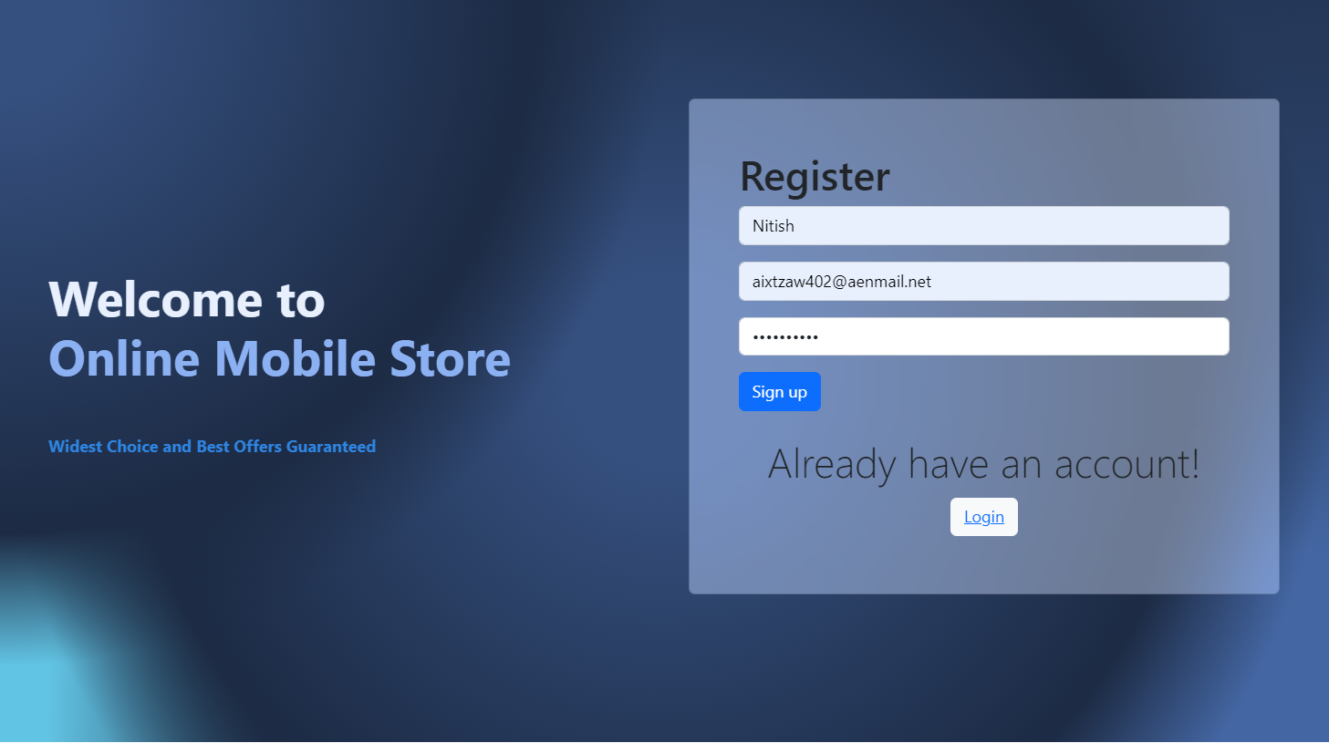

* **Data Store**

Registered user data stored in Express

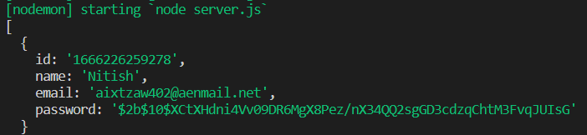

After Successful Registration User Redirected to Login Page

* **Login Page**

Registered User Login with Credentials

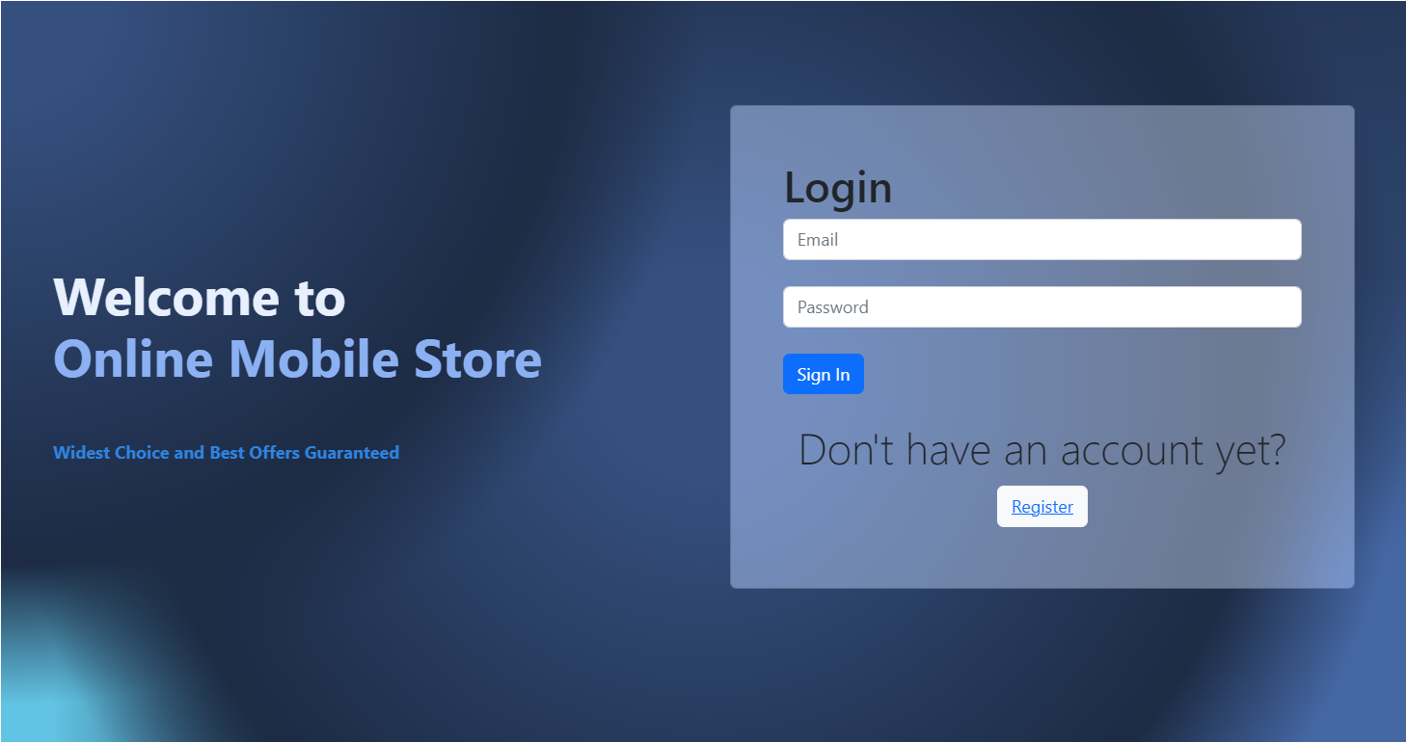

* If User Tries to enter with Wrong Email

Pop-up Will show – No User found with that email

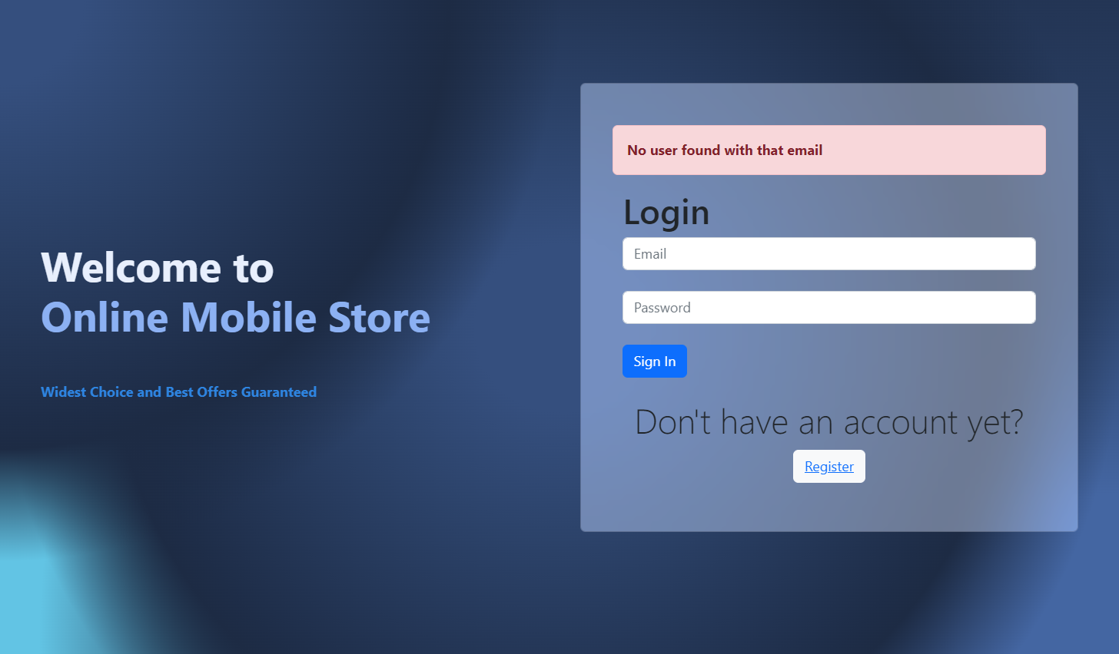

* If User Entered Wrong Password

Pop-up Will show – Password Incorrect

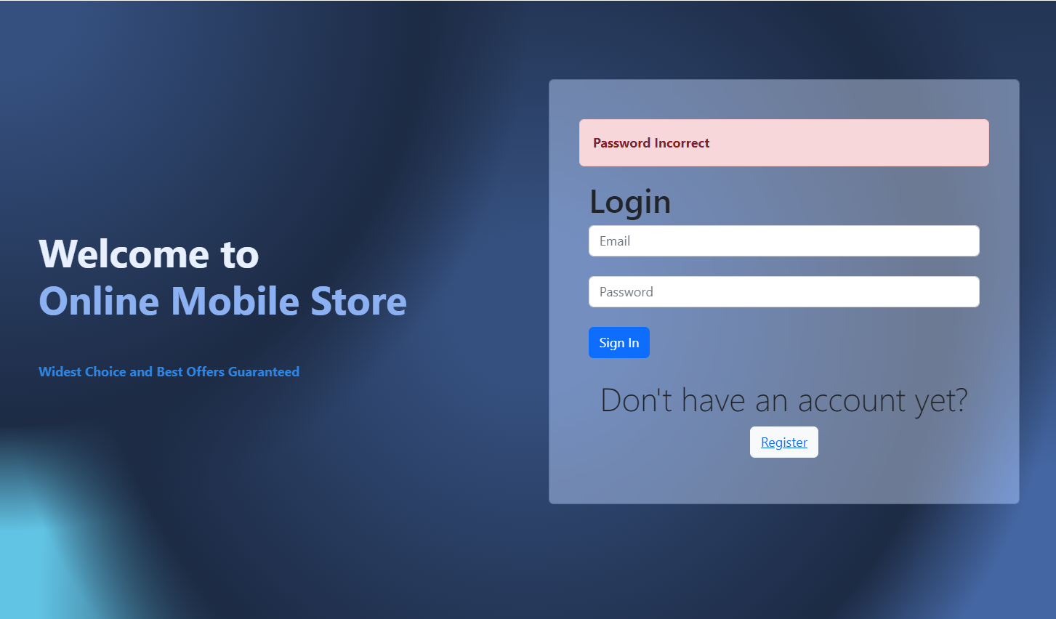

After Successful Login – In

User will Be Able to see Home Page

* **Home Page**

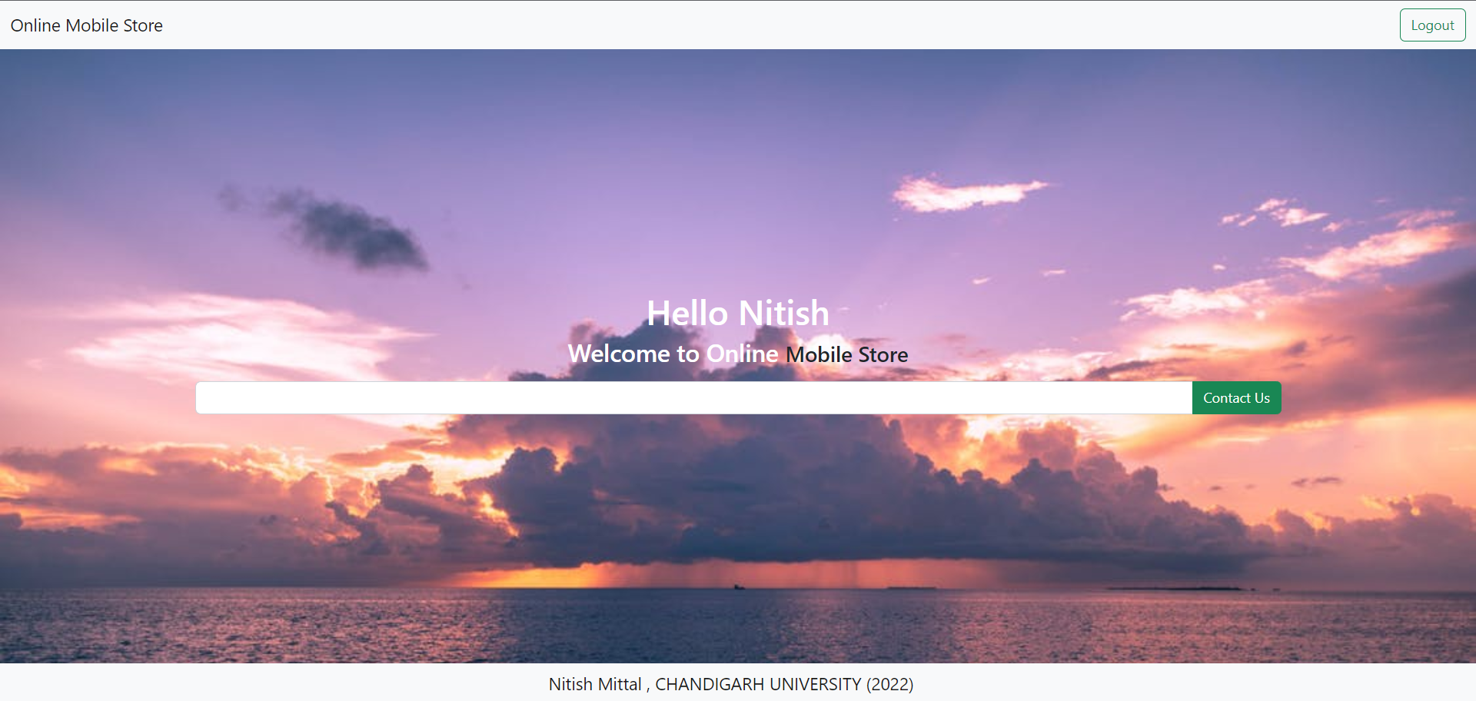

In Home Page we Have Two Options

* Contact Us – Users can provide feedback or contact us. Provided details will be stored in Express.
* Logout – User will be Redirected to Login Page
* **Scope of the Project**

This system reduces the amount of manual work required to keep a record of all booking information. It also generates various reports for analysis. The main concept of the project is to enter transaction reports and maintain customer records. So this software can be used to record easily on any mobile phone.