





#### Team ID :LTVIP2023TMID06621

**Team Leader :** Rampilla Chandrsekhar

**Team member :** Guna Ramarao **Team member :** Koneru Manohar **Team member :** Setikam Nitish

**Team member :** Bongu Syamasundarareddi

# Step 1:

**Creating Developer Org by using Developer Edition Link**

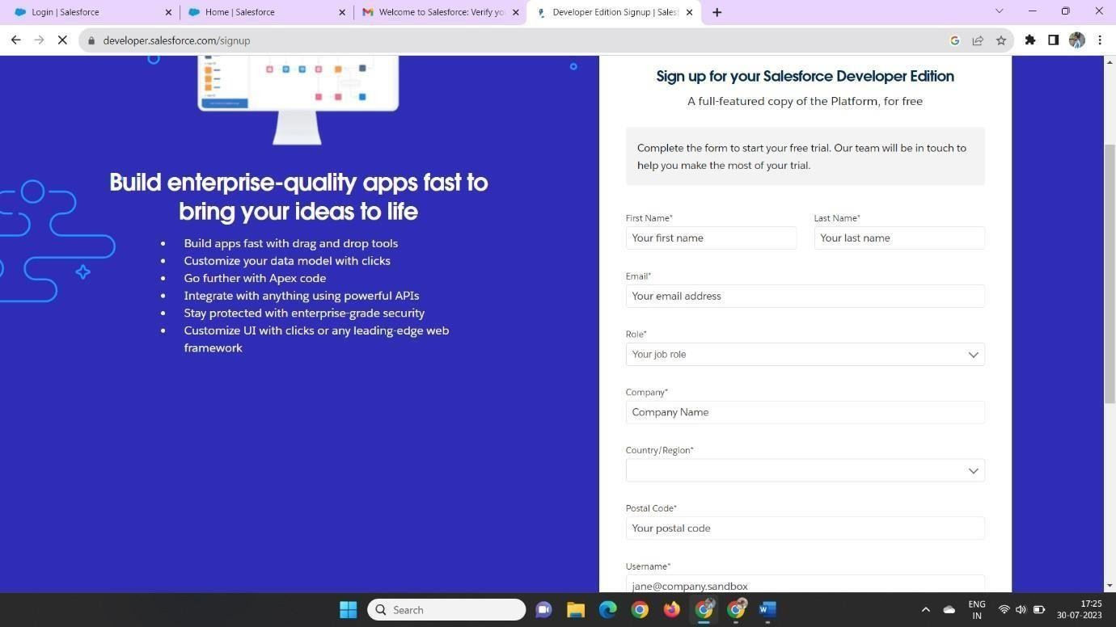

**Step 2:**

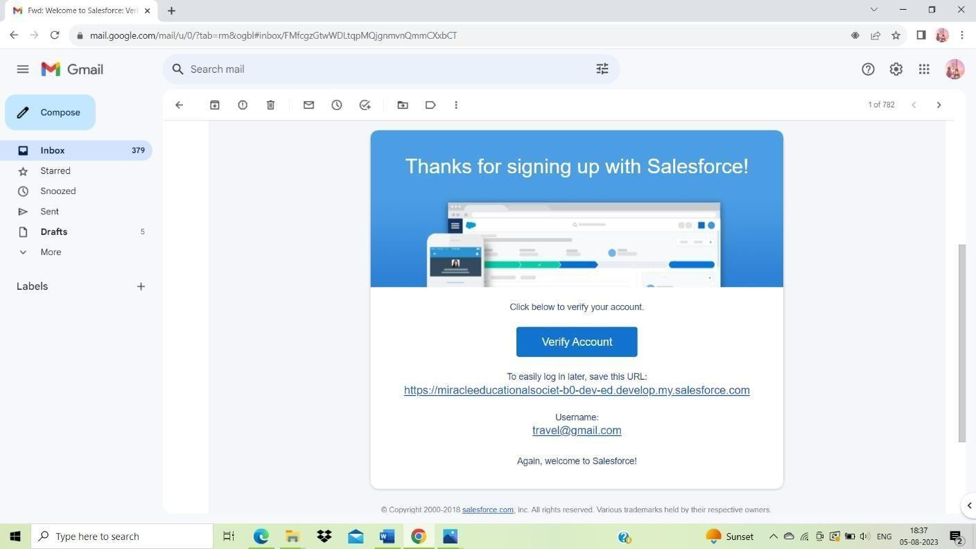**Account Activation**

**We can create password by clicking verify Account then we can directly login to salesforce Account**

**Step 3:**

# Creation Of Semester Object For Candidate Internal Result Card

We Can Create Developer Object in Object Manager by clicking on create – Custom Object and follow the steps in the guide

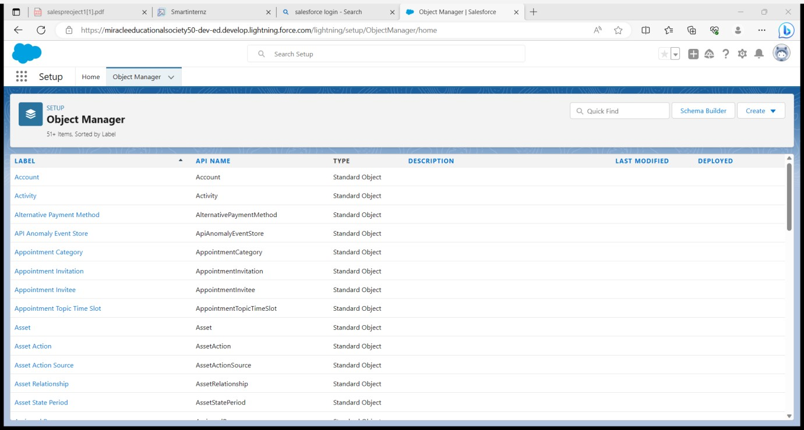

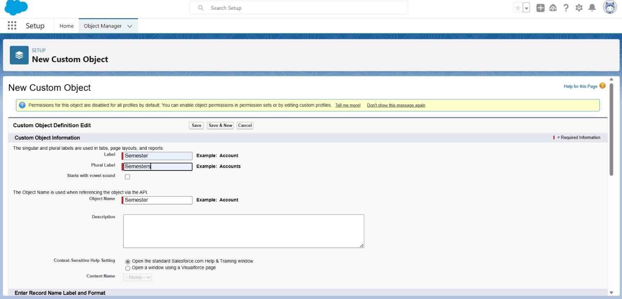

In The Same Manner We have to Create Employee details , Expense,Expense items and Travel Approval Objects.

**Step 4:**

### Creation Of Semester Tab For Candidate Internal Result Card

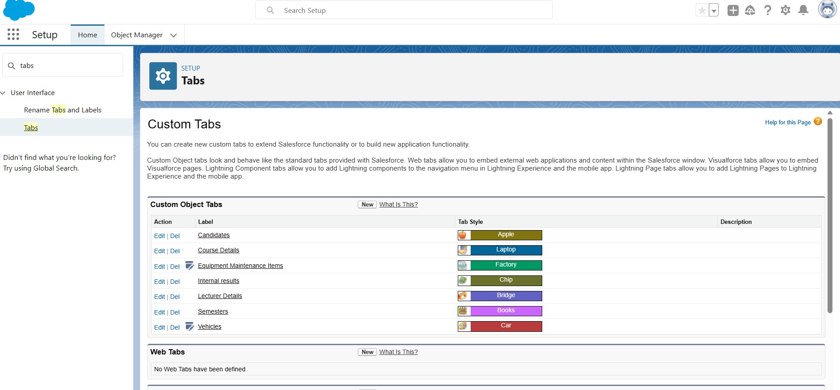

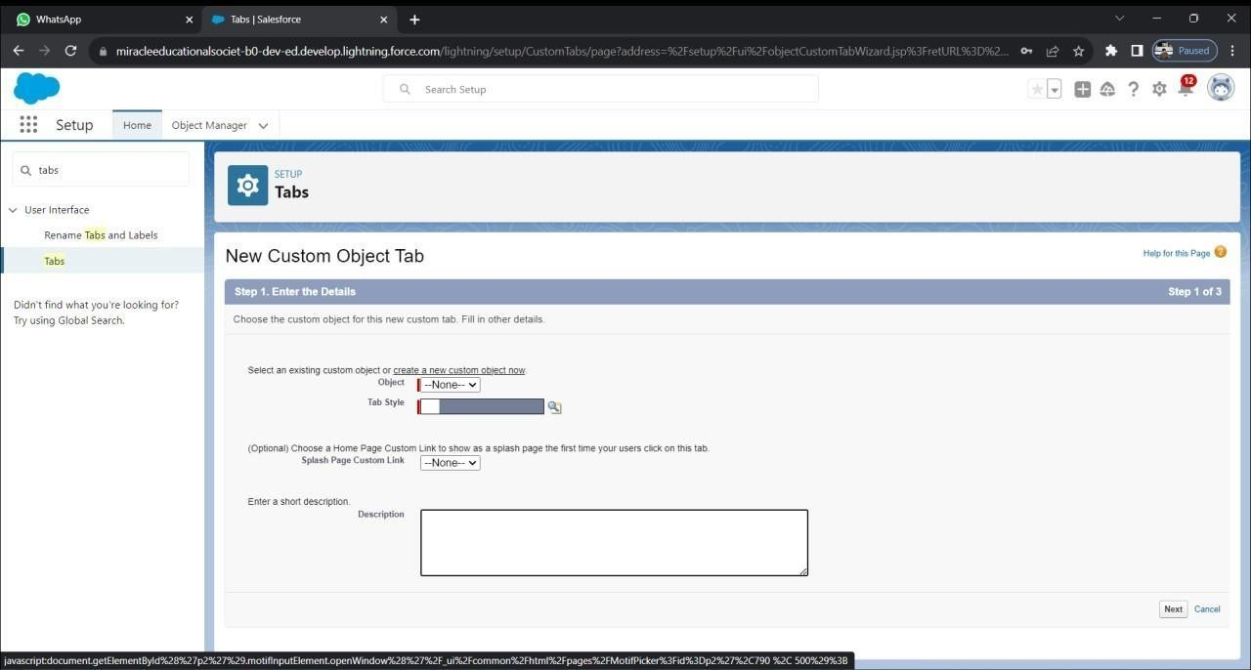

Here We can create Tabs for our objects which we created earlier

**Step 5:**

### Create The Candidate Internal Result Card App (Lighting App)

Now We Can Create a New Lightning App by Using App Manager

Click New Lighting app

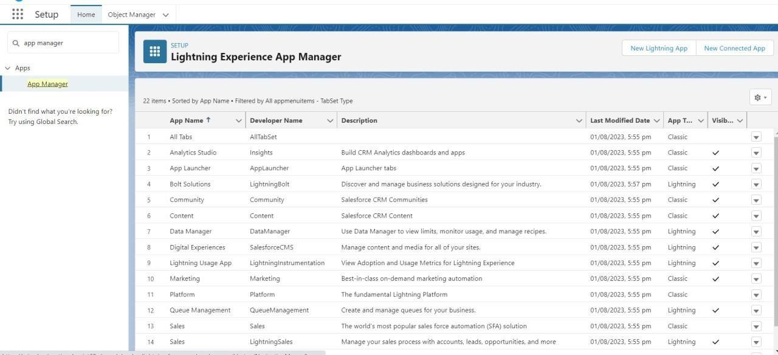

In those we Can Create a New lighting App

We have to give the app name as Candidate Internal Result Card Leave the default items and click next until we find Available items

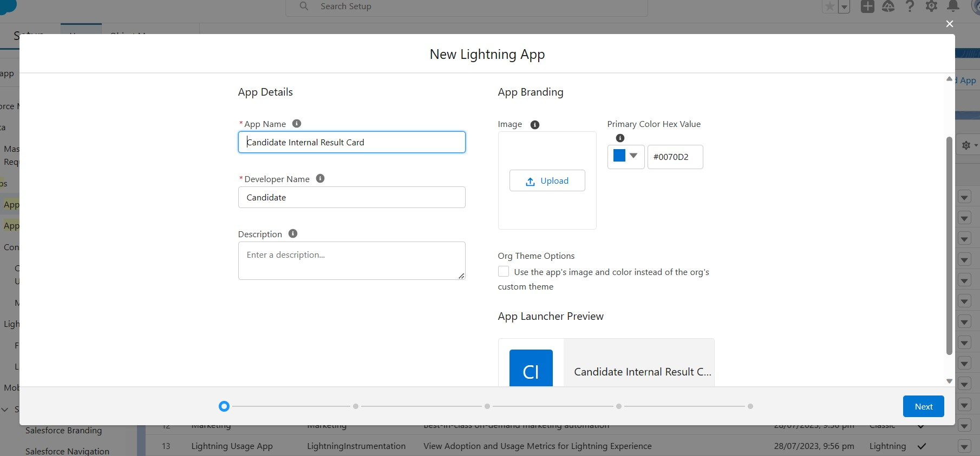

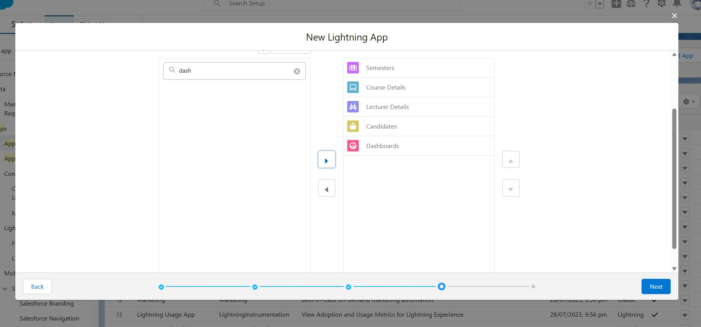

After moving the items to Selected items from Available Profile Move the System Administrator into Selected Profiles and save

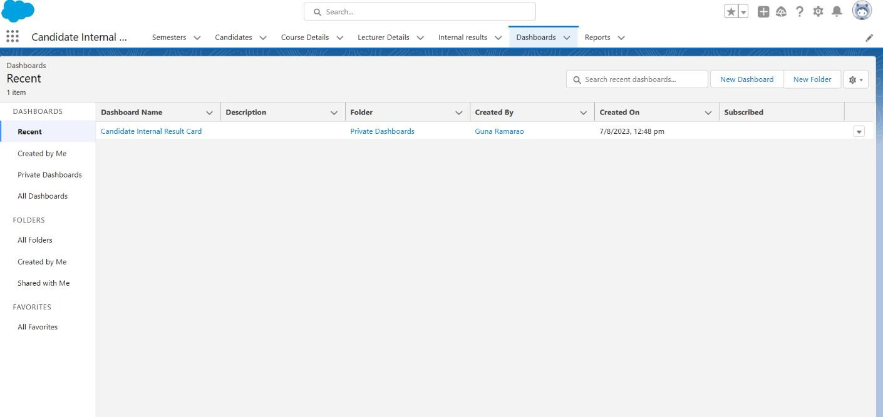

**Step 6:**

**Fields And Relationship**

#### Creation Of Text Field On "Lecturer Details" & Look Up Field For The “Candidate” Object

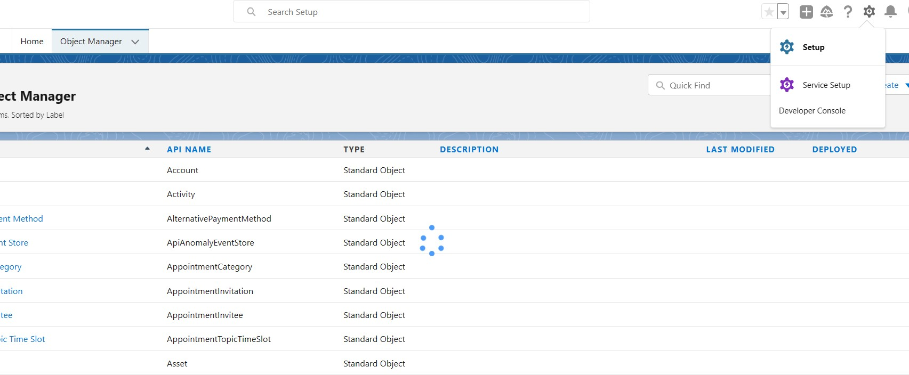

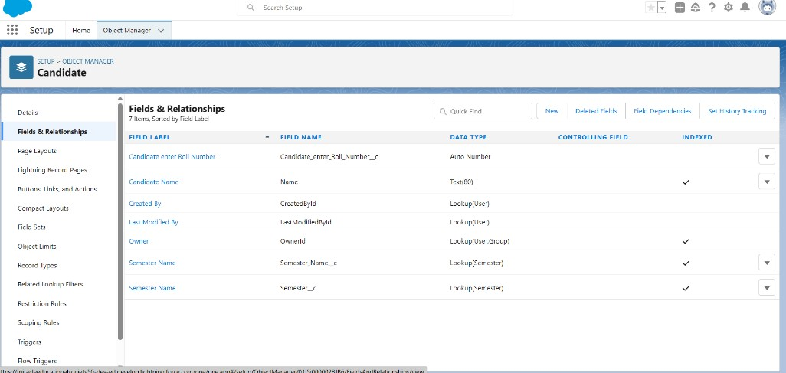

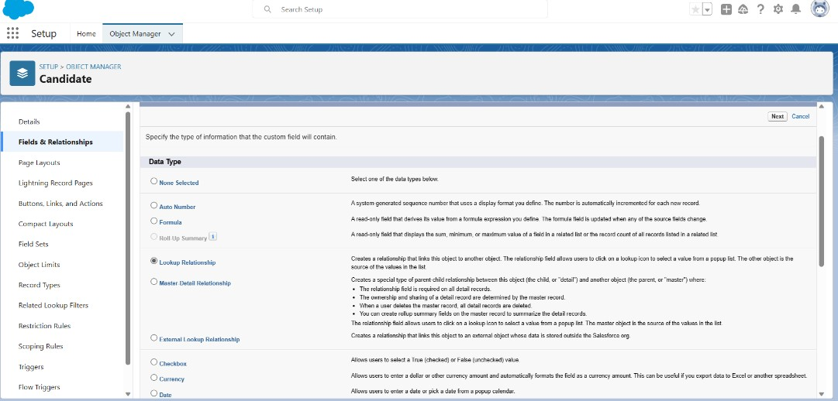

Now take Data Type as a lookup click next.

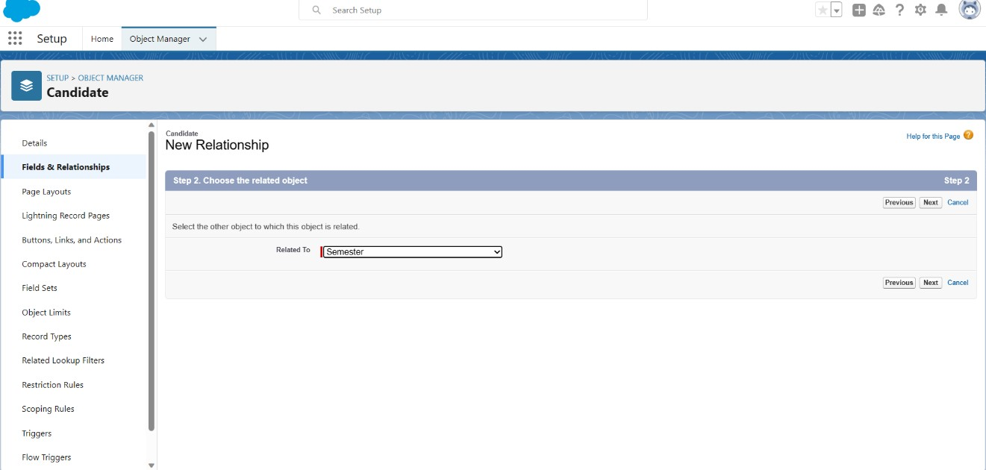

Choose the related object as Semester and click next.

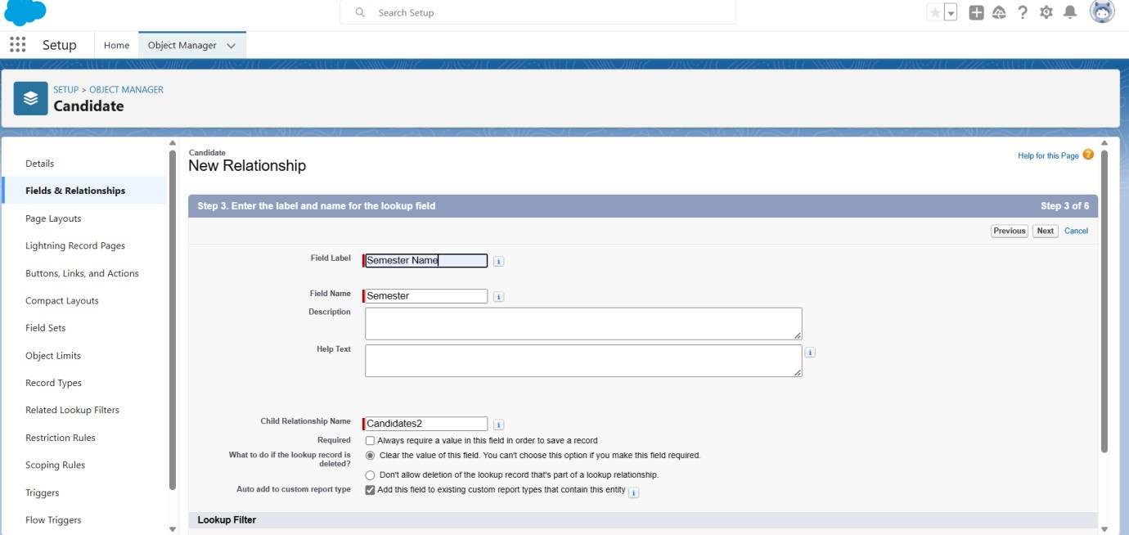

Now enter Field Label as Semester Name Click next, Save and new.

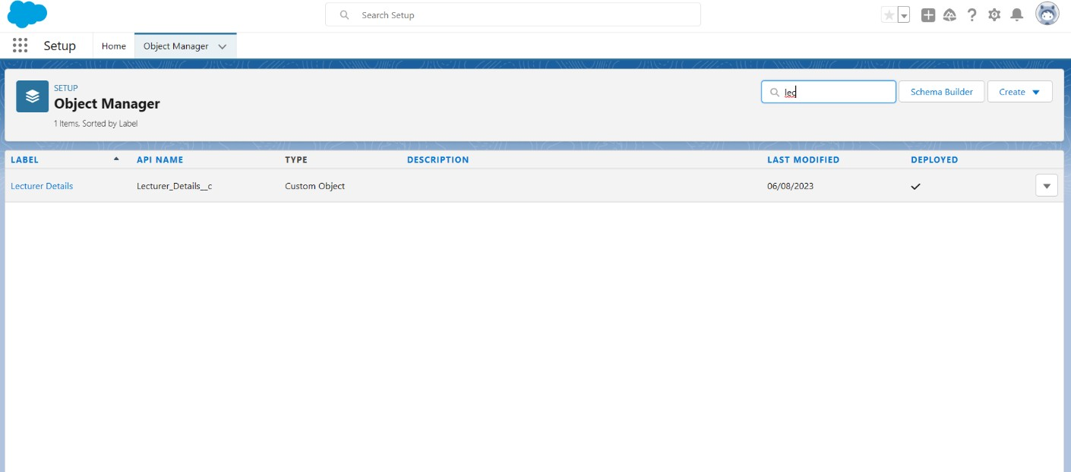In Those Manner We Can Create a Lecturer Details Field Data

In Lecturer Details object fields and Relationships click on new Select Datatype this field is of text type and click next

Fill the field Label as Lecturer Role and length as 40 Later we can click next, next & save

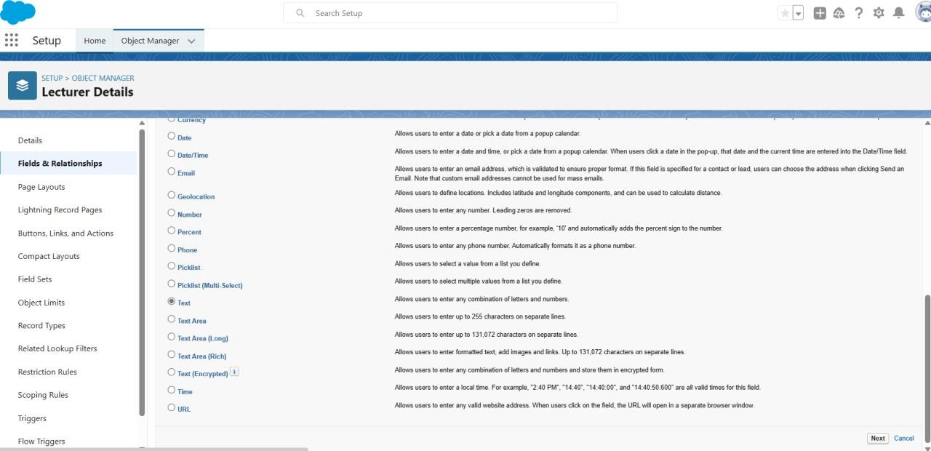

Click next and enter Field Label as Lecturer Role and Enter Length 40 and click next.

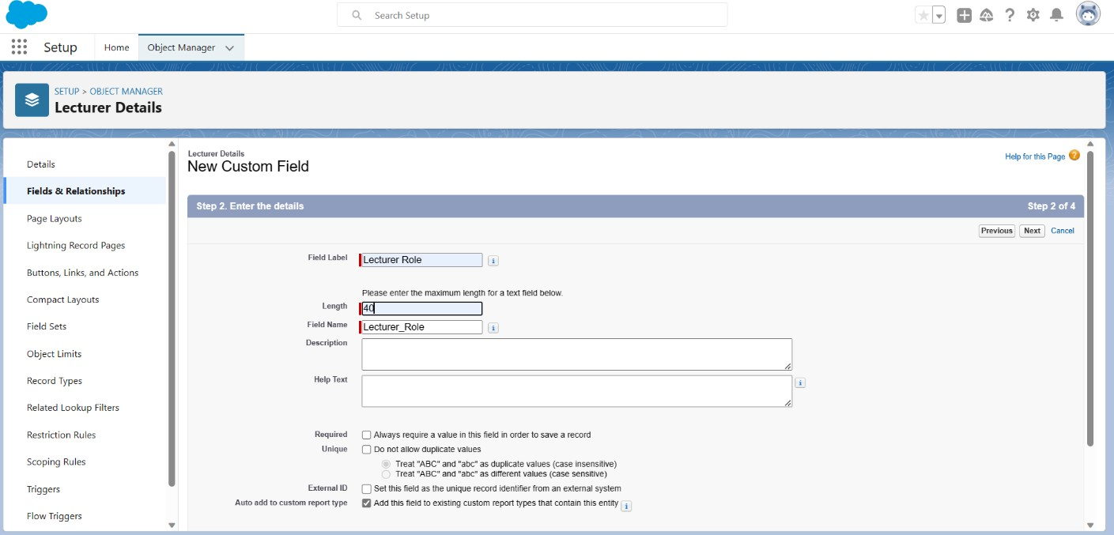

Click next , Save&new

Now we can Similarly create all lookup fields on their respective objects.

* **Creation Of Auto Number Field On Candidate Object, Number Field On Course Details Object & Formula Field Course Details Object**

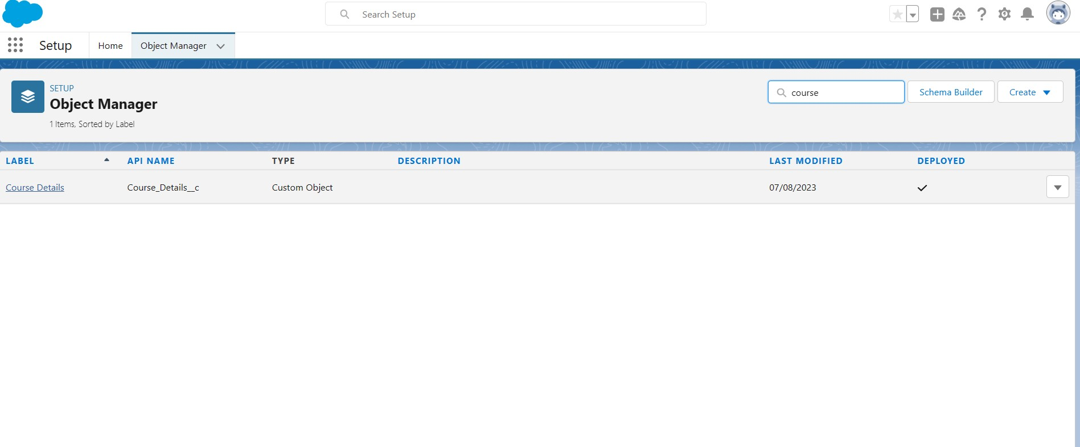Click on object manager tab and select Course Details

Now select Fields & Relationships

Click new tab and select field as a number and click next

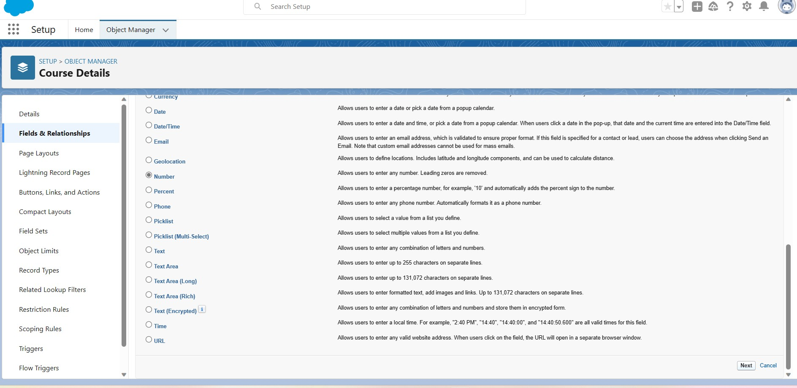

Enter Field label name as Duration and take help text as Enter Course duration value in years

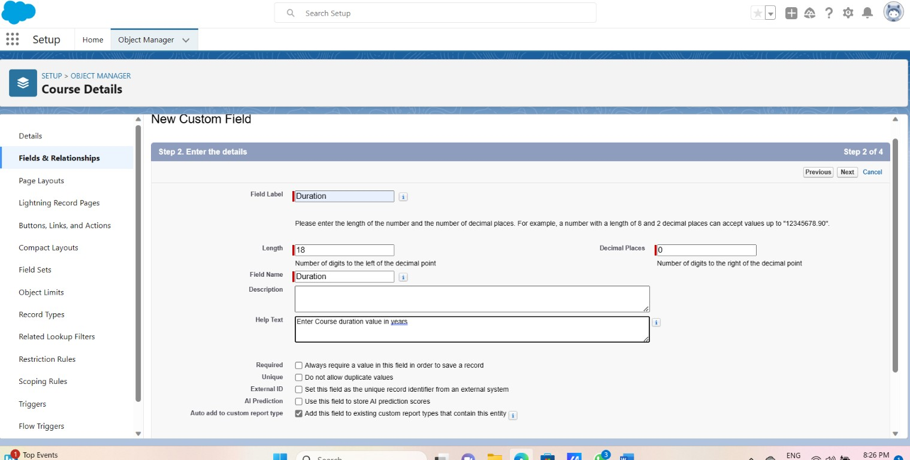Click next, save & New

Click Object Manager tab and select Internal Results

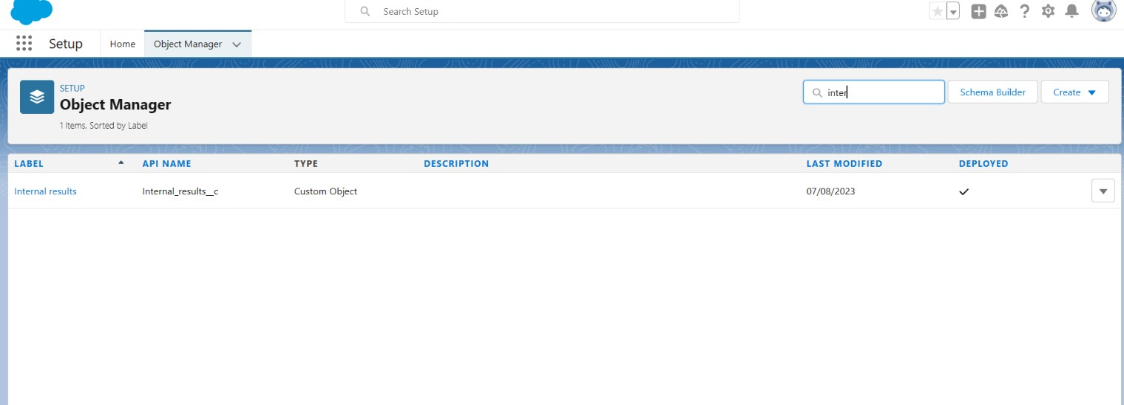

Select Fields & Relationships and click new Take data type as a Formula and Click next

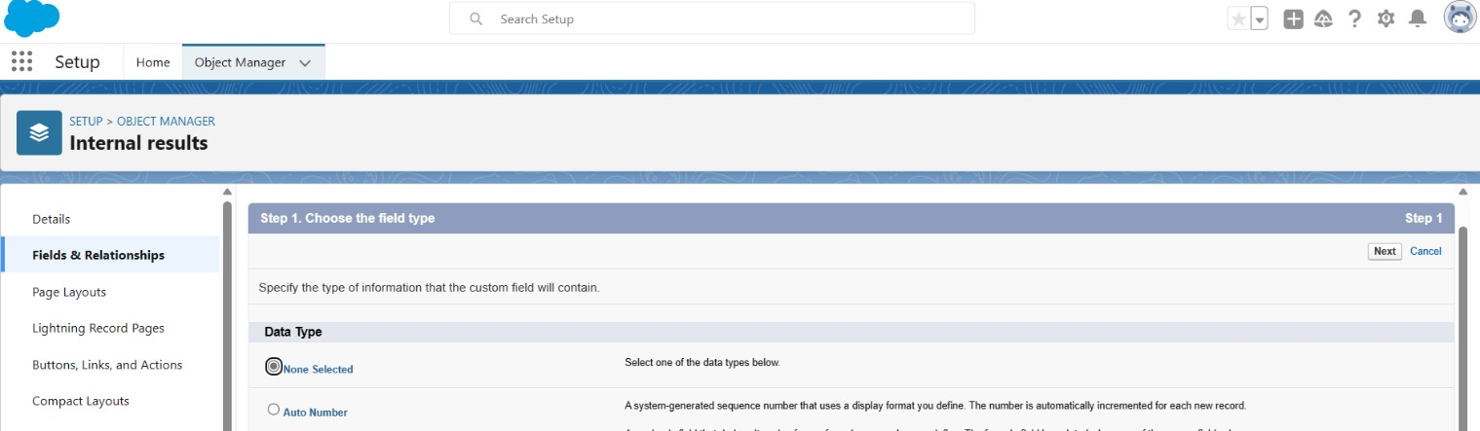

Enter Field Label as Candidate Roll Number and select Formula retuen type as text and click next & save

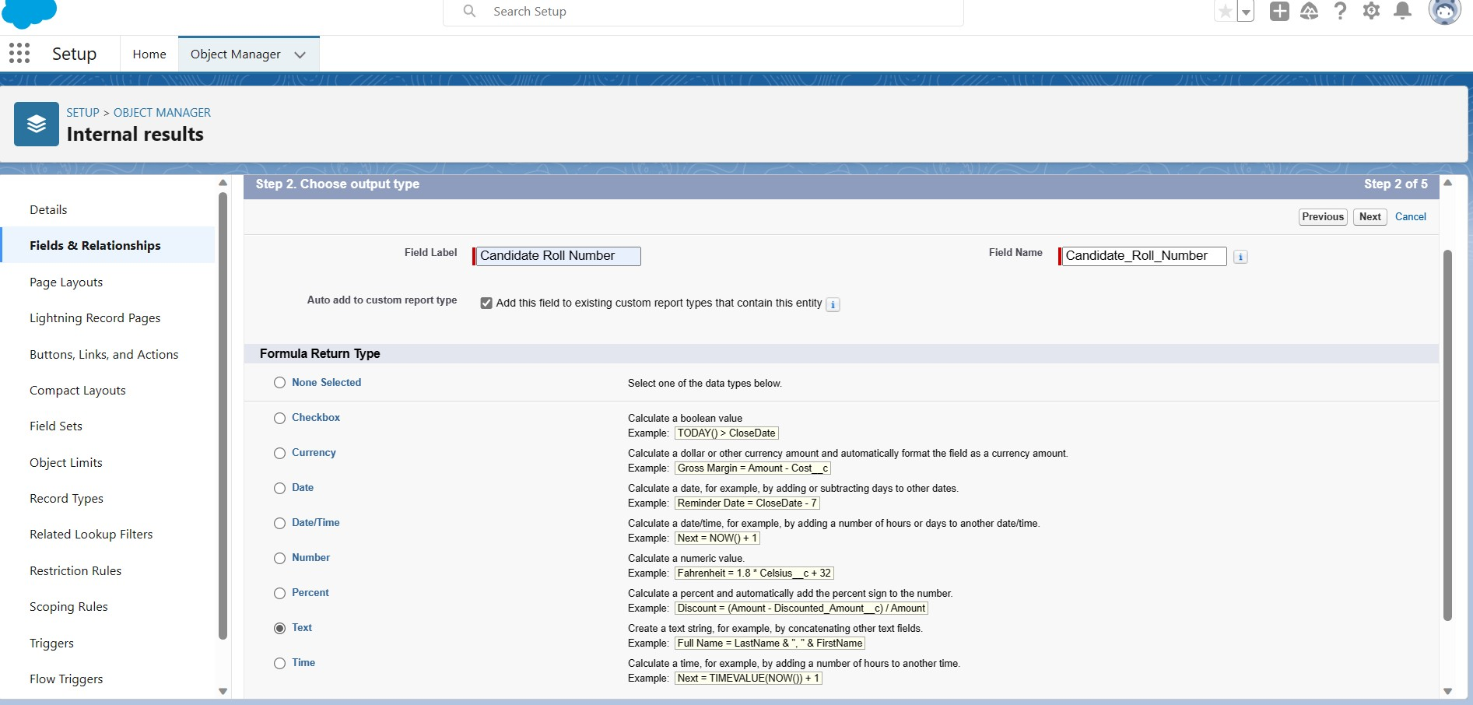

Now click insert field and create Insert candidate roll number Then Click and save.

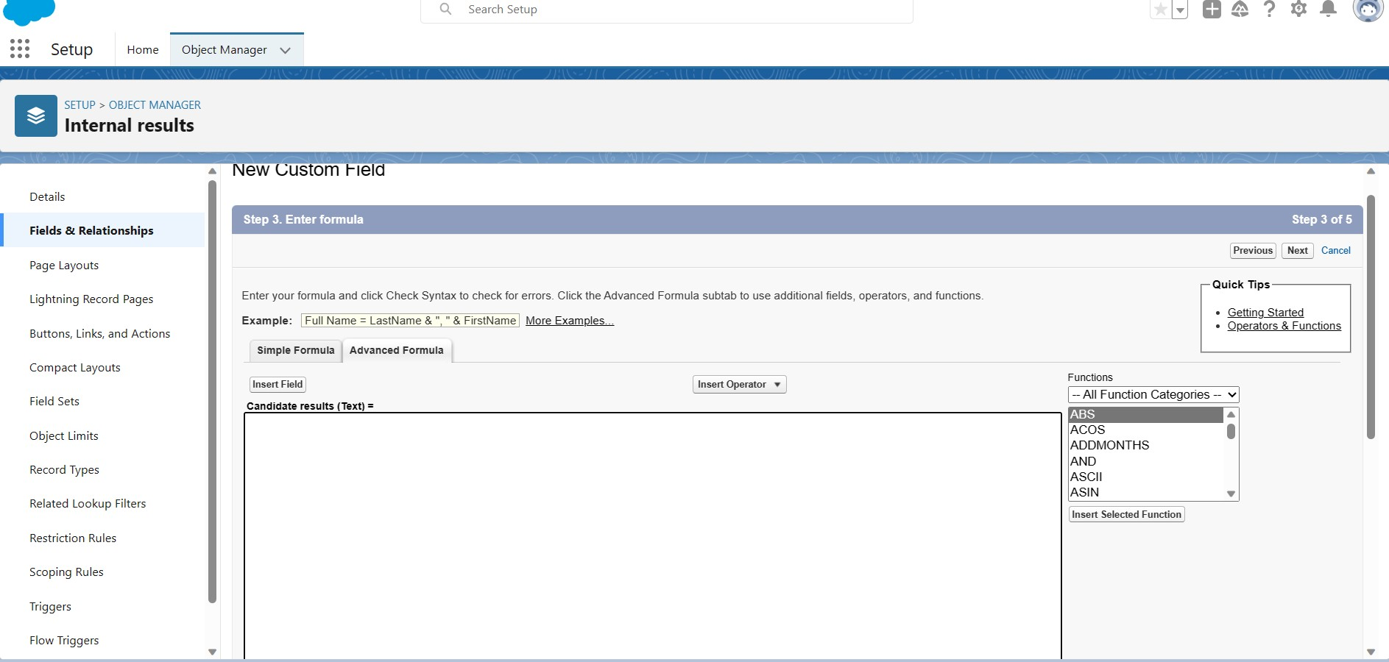

**Step 7:**

# Users

* **Creating A User**

Click on quick find search user Select Users tab and Click new users

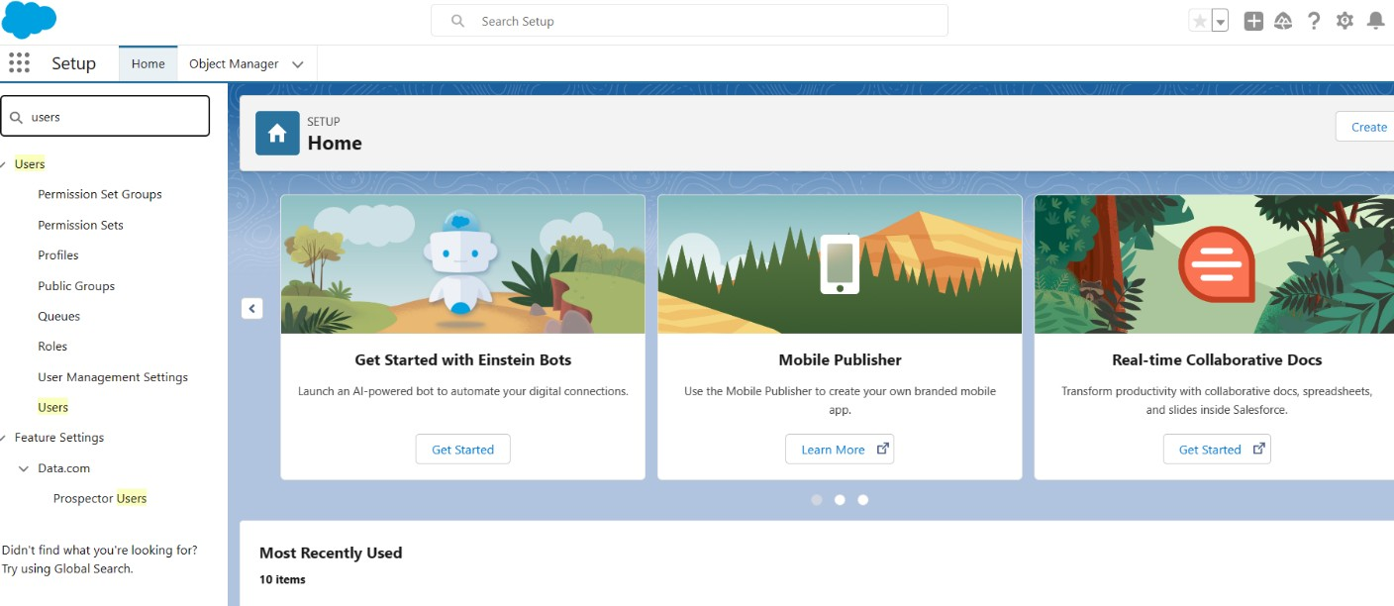

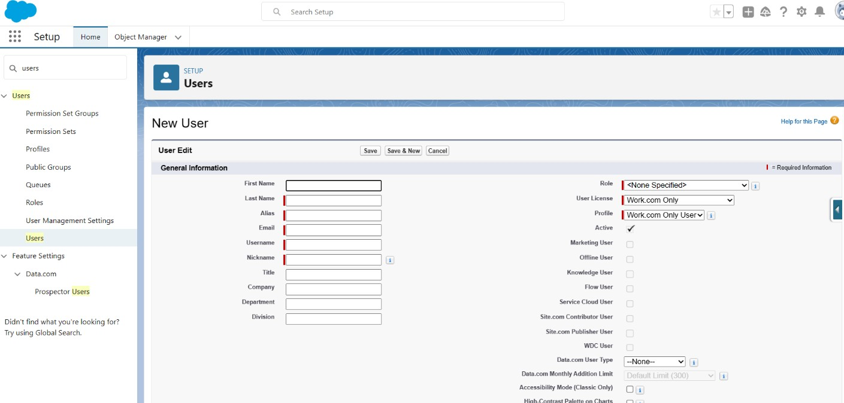

Enter first name as Class,last name as teacher ,email and unique user name Click on the user licence as salesforce and profile as standard user

Click save.

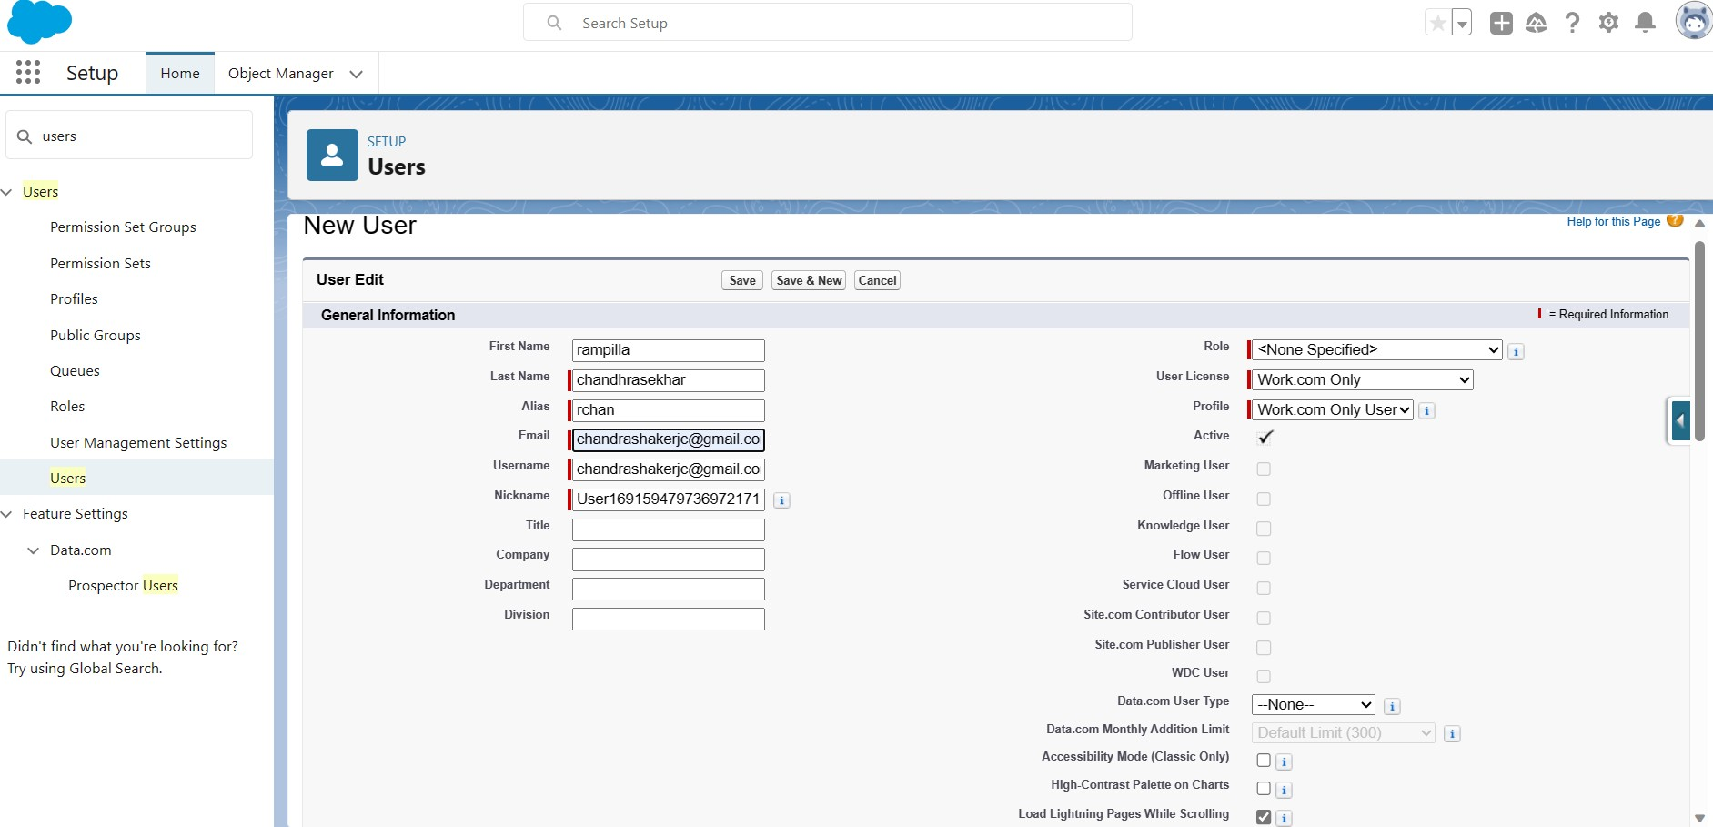

And click on the generate new password for login users of the data

**Step 8:**

**User Adoption**

### Create Record (Course Details)

Click on App Launcher and search Candidate internal result card app and click it.

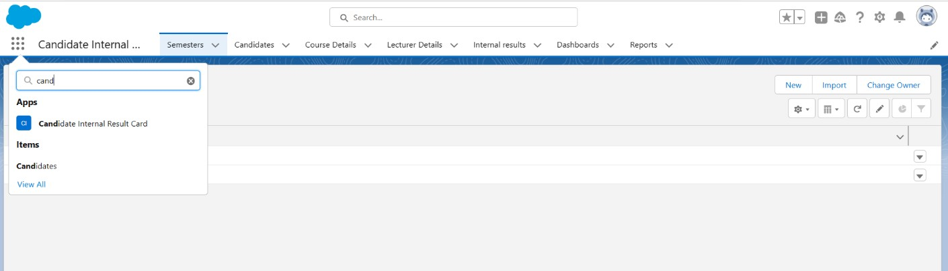

Click course details tab and click new course details and enter new course details record.

Click on save button

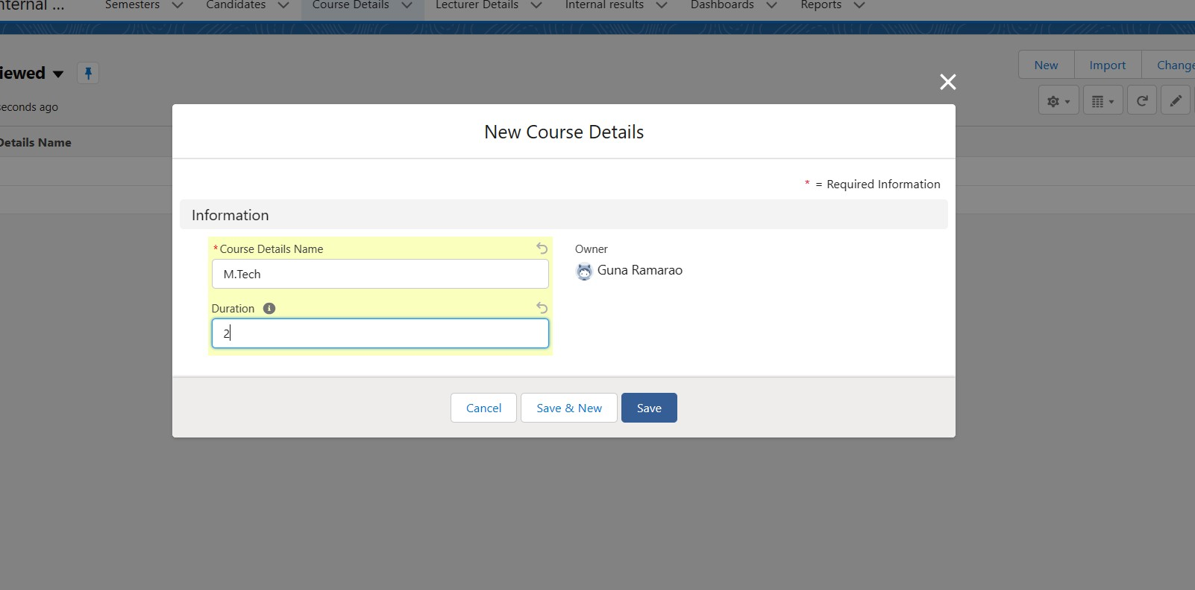

### View Record (Course Details)

Click app launcher and select candidate internal result card and click Course Details tab you can see the details of the Driver.

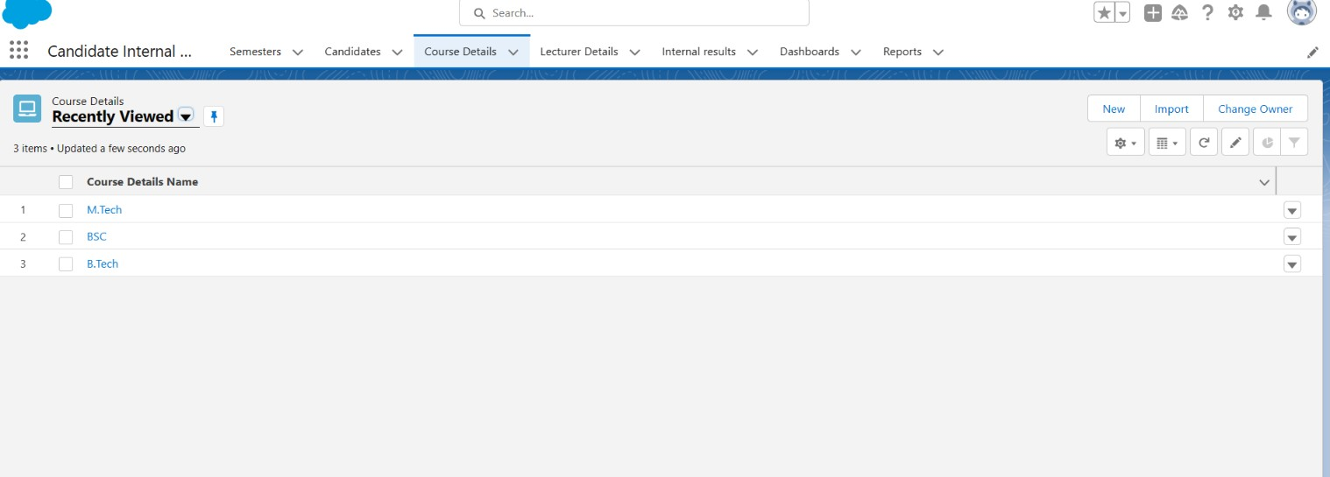

### Delete Record (Course Details)

Similarly click app launcher and select Candidate Internal Result card and click Course Details tab and click right corner arrow and delete the course

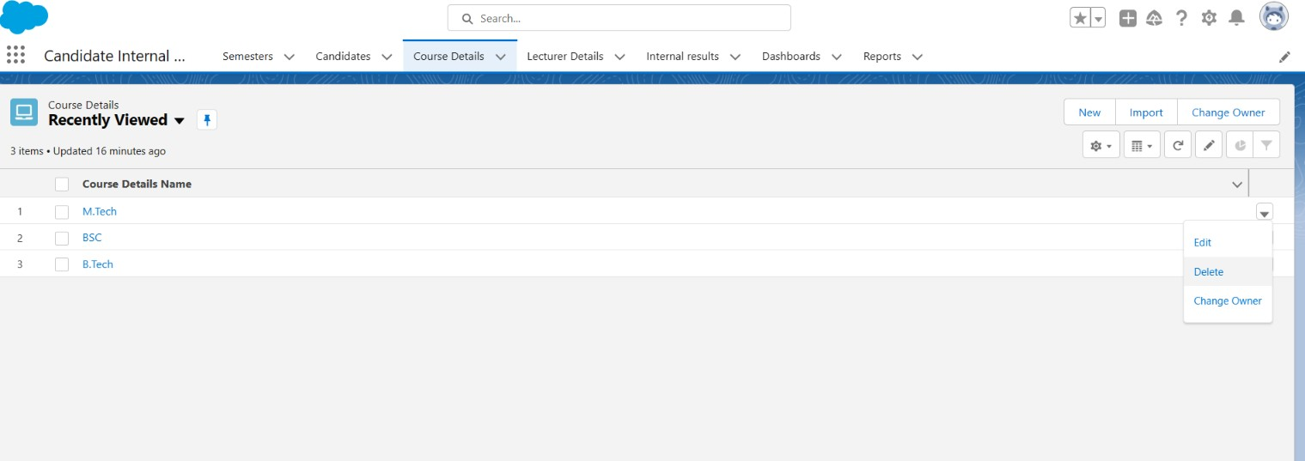

**Step 9:**

**What Are Reports**

Reports in Salesforce is a list of records that meet a particular criterion which gives an answerto a particular question. These records are displayed as a table that can be filtered or grouped based on any field.

There are 4 types of report formats in Salesforce: 1.Tabular Reports

1. Summary Reports 3.Matrix Reports and 4.Joined Reports.

### Create Report

Click on app manager tab and select candidate internal result card And click on reports tab and click new report

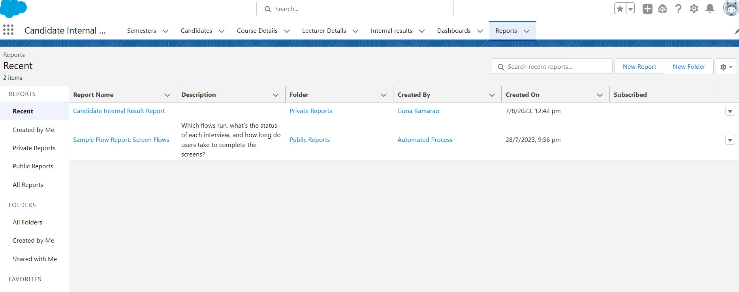

Click on new report tab and click return type as semester with course

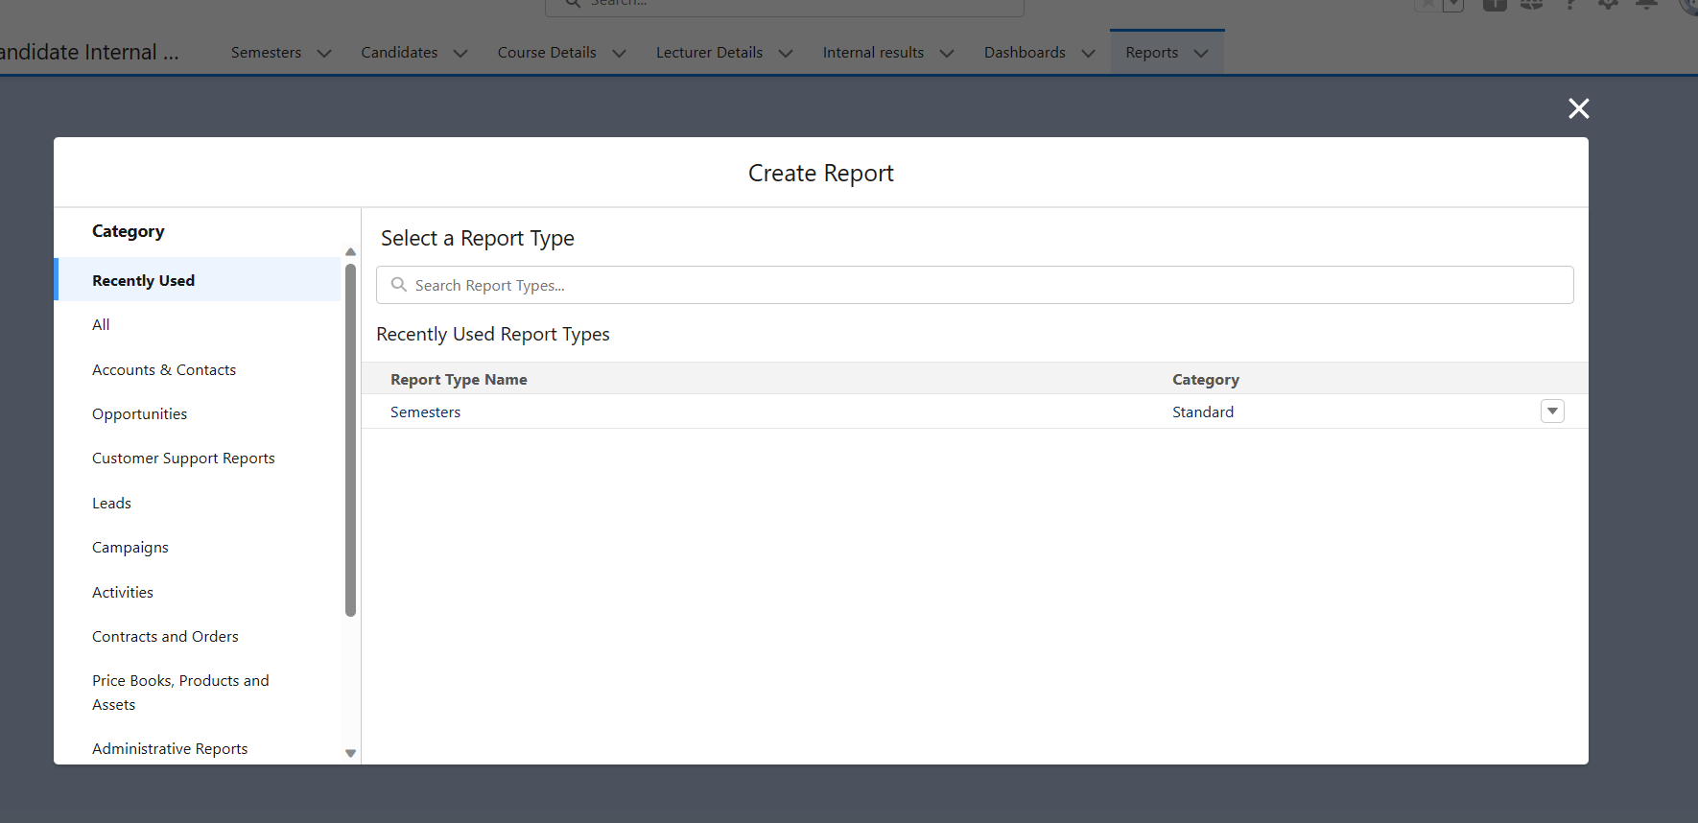

Give the report name as Candidate Internal Result Report And click save

In this report you can see your all record of the object you selected for reporting

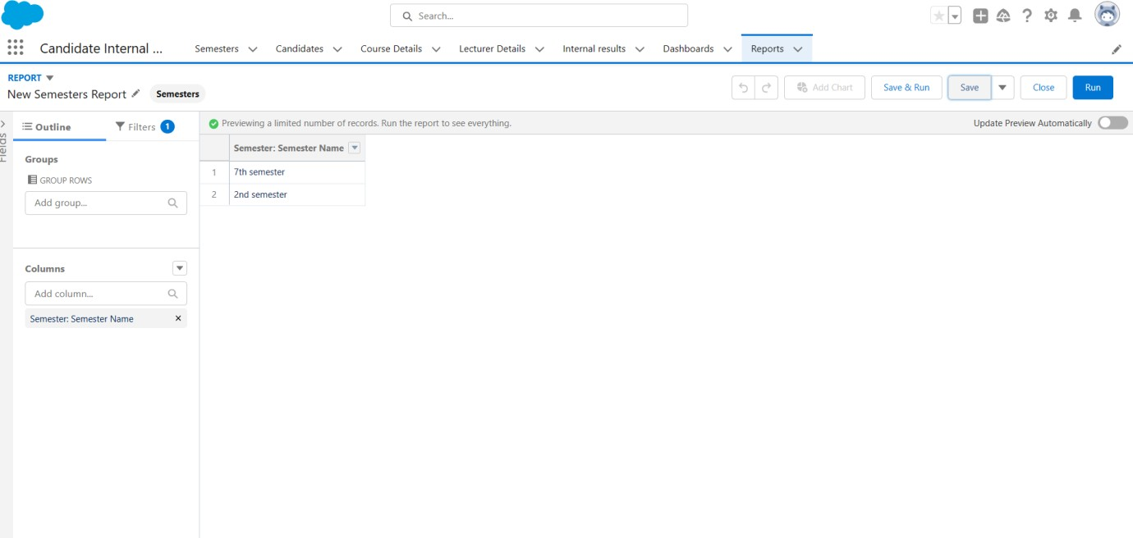

Give the report name as Candidate Internal Result Card And click save

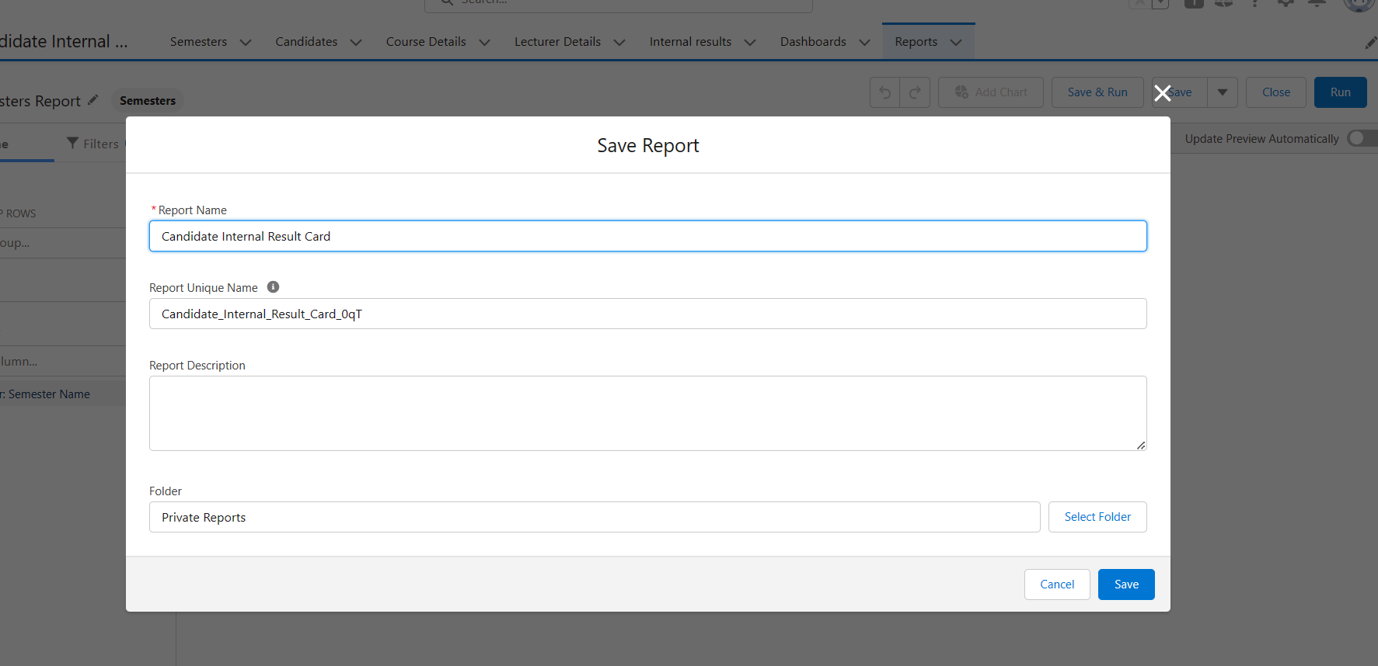

### View Report

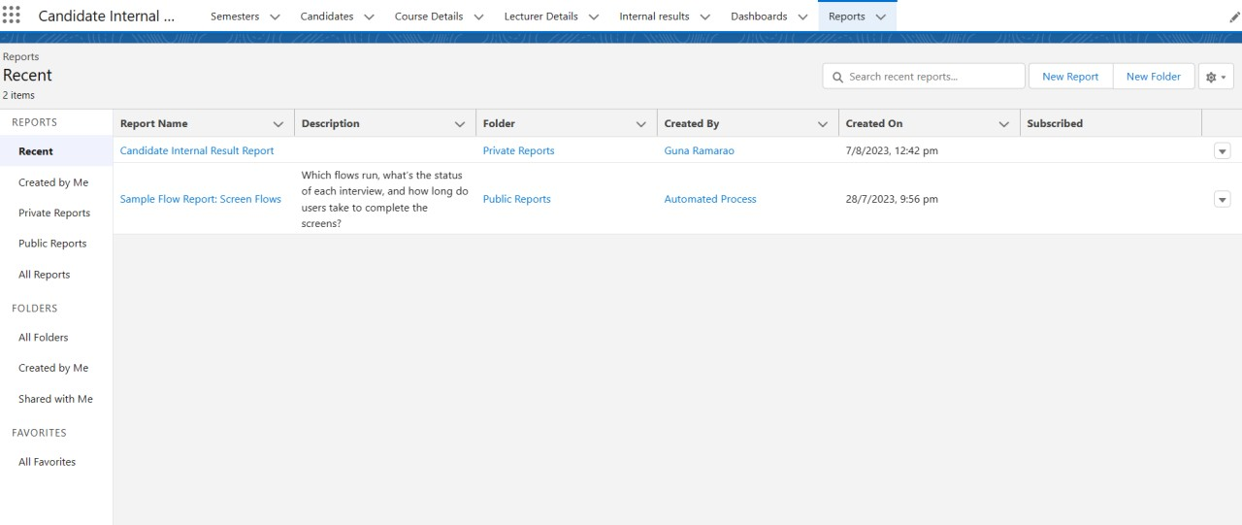click on the app launcher and search as Travel Approval App on the reports tab

we can check the reports tab



## Step 10 :

### Create Dashboard

click on the app launcher and search as Candidate Internal Result Card we click on the dashboard and create a new dashboard with the name of Candidate Internal Result Report.

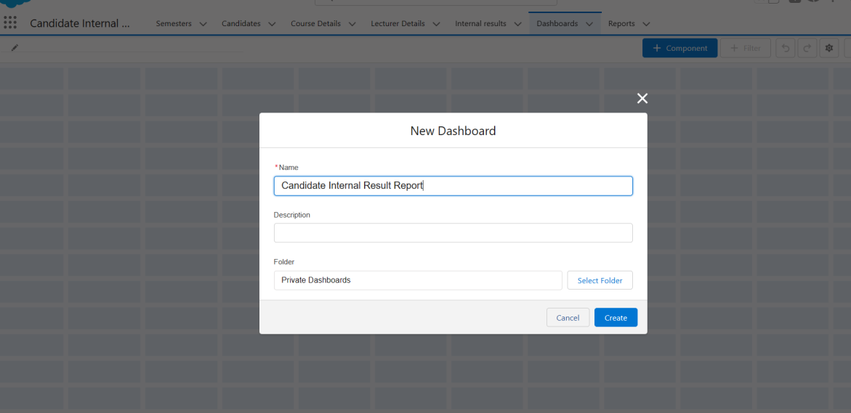

Then we can click on the + component and create a dashboard data

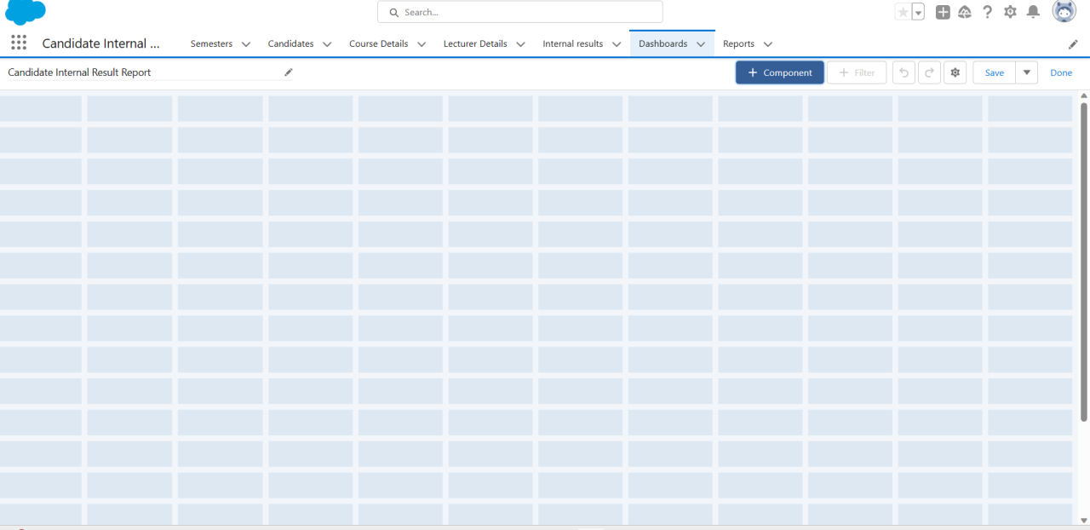

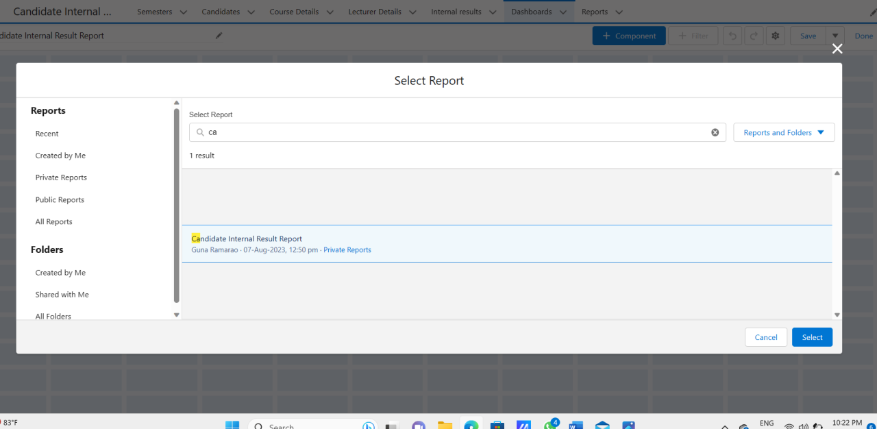Select Candidate Internal Result Report that you created

Later we click on the report we select the data on the field

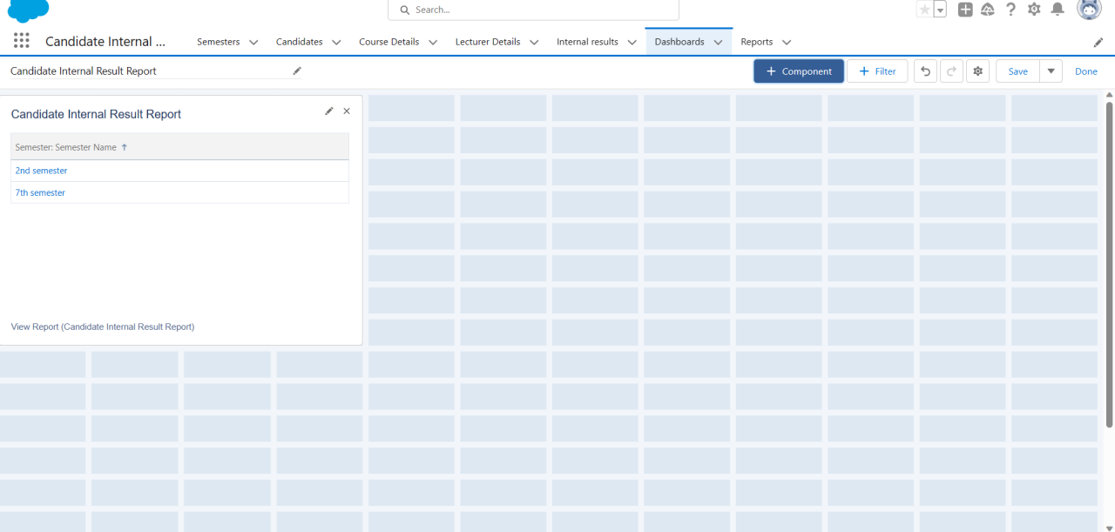

Then click on the finish it will be created

### View Dashboards

click on the app launcher and search as Candidate Internal Result Report click on the dashboard tab and we can check the dashboards click on Candidate Internal Result Report and See graph view of records