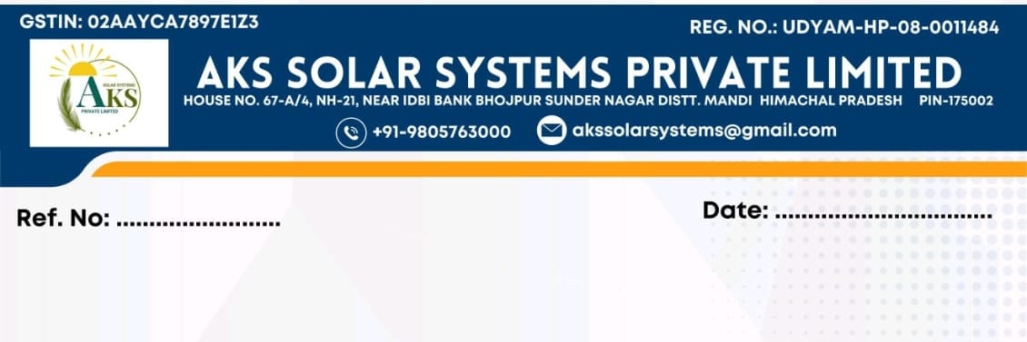
{{RegularizationNumber}} DATE: {{RegularizationDate}}
Regularization of Service
To,
Mr./Ms. {{EmployeeName}}
Address: {{Address}}
Subject: Confirmation / Regularization of Service
Dear Mr./Ms. {{EmployeeName}},
With reference to your Appointment Letter Ref. No. {{AppointmentLetterNumber}} dated {{AppointmentLetterDate}}, and your joining on {{JoiningDate}}, we are pleased to inform you that you have successfully completed your probation period of {{ProbationPeriod}} with the company.
Based on your performance, conduct, and overall contribution during the probation period, the management is satisfied with your services. Accordingly, your employment is hereby confirmed, and your services are regularized with AKS Solar Systems Private Limited with effect from {{EffectiveDate}}.
All other terms and conditions as mentioned in your appointment letter shall remain unchanged and continue to be applicable.
We look forward to your continued dedication, sincerity, and contribution to the growth of the organization.
Kindly acknowledge receipt of this letter.
Wishing you continued success with the company.
Warm regards,
For AKS Solar Systems Pvt. Ltd.
Authorized Signatory

Employee Acknowledgement
I, {{EmployeeName}}, hereby acknowledge and accept the above terms of confirmation of my services.
Signature: __________________
Date: ______________________

