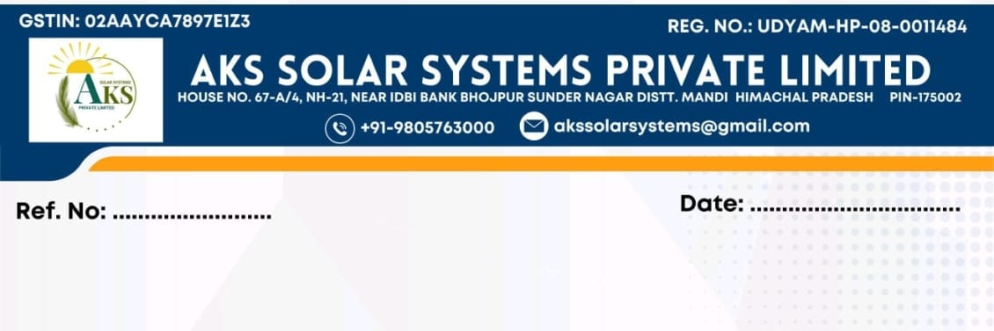
{{RelievingNumber}} Date: {{RelievingDate}}
Relieving Letter

To,
Mr./Ms. {{EmployeeName}}
S/O Sh. {{FatherName}}
{{AddressLine1}}
{{AddressLine2}}
Designation: {{Designation}}

Subject: Relieving Letter
This is to inform that Mr./Ms. {{EmployeeName}} was employed with AKS Solar Systems private Limited from {{JoiningDate}} to {{LastWorkingDate}}.
His/her employment with the company stands relieved effective from the close of working hours on {{LastWorkingDate}}.
All dues payable to him/her have been settled, and the Full & Final settlement has been completed by the company.
This letter is issued for record purposes.

For AKS Solar Systems Private Limited
Authorized Signatory

