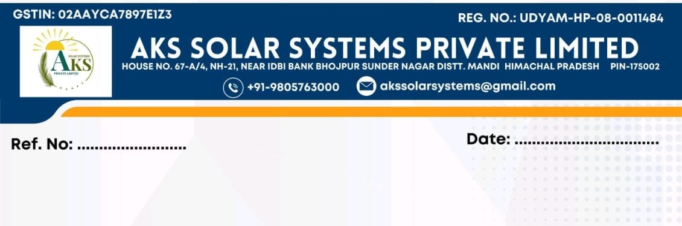
{{OfferNumber}} Date:{{OfferDate}}
OFFER LETTER
Subject: Offer of Employment – {{Designation}}
To,
Mr. {{CandidateName}},
S/O {{FatherName}}
{{AddressLine1}}
{{AddressLine2}}

We are pleased to offer you the position of {{Designation}} at M/S AKS Solar Systems Private Limited at REGD. OFF. H.NO. 67-A/4, NH-21, NEAR IDBI BANK, BHOJPUR TEHSIL SUNDER NAGAR, DISTRICT MANDI (H.P.) PIN-175002

1. Date of Joining:
Your joining date will be {{JoiningDate}}

2. Salary:
You will be paid a monthly salary of ₹{{SalaryNumeric}}/- (Rupees {{SalaryWords}} Only).
Salary will be subject to statutory deductions if applicable.

3. Report to: (On {{JoiningDate}})
{{ReportingManagerName}}
{{ReportingManagerDesignation}}
Contact: {{ReportingManagerContact}}
Reporting Time: 9 AM Sharp
Documents: At the time of joining, you are required to bring the original copies of all educational certificates and mark sheets for verification. Candidate must also carry original experience certificates from previous employers, relieving letter, last salary proof (if applicable), and all other supporting documents related to previous employment and professional experience.
Additionally, candidate is required to submit three recent passport-size photographs at the time of joining for official records and documentation purposes.

4. Job Responsibilities:
1. Site Survey & Technical Assessment
- Conduct detailed pre-installation site surveys for residential, commercial, and industrial solar projects.
- Assess roof suitability, shadow analysis, load-bearing capacity, and available installation area.
- Verify electrical infrastructure including existing panels, earthing system, transformer capacity, and connectivity requirements.
- Prepare survey reports including system feasibility, proposed capacity, module layout, inverter location, cable routing, and BOQ requirements.
- Coordinate with the design team for preparation and finalization of layouts and Single Line Diagrams (SLD).
- Identify site risks and recommend technical solutions prior to project execution.
2. Project Execution & Installation
- Supervise complete installation activities from project handover to commissioning.
- Ensure installation of modules, structures, inverters, ACDB, DCDB, earthing, lightning arresters, and associated equipment as per approved drawings and standards.
- Ensure adherence to project timelines, quality standards, and budget requirements.
- Coordinate daily site activities and ensure smooth project execution.
- Monitor project progress and submit daily and weekly progress reports.
3. PM Surya Ghar Muft Bijli Yojana Projects
- Execute residential rooftop projects under PM Surya Ghar Muft Bijli Yojana.
- Ensure compliance with MNRE and DISCOM guidelines.
- Coordinate net-metering activities, inspections, and subsidy-related processes.
- Support customers during documentation and approval procedures.
4. Commercial & Industrial (C&I) Projects
- Manage execution of commercial and industrial rooftop solar installations.
- Coordinate shutdown planning and electrical integration activities.
- Ensure proper synchronization and commissioning as per project requirements.
- Maintain minimum disruption to client operations during execution.
5. Testing, Commissioning & Handover
- Conduct pre-commissioning checks and testing of complete systems.
- Perform commissioning and performance verification activities.
- Ensure all safety and quality parameters are met before handover.
- Prepare handover documents and obtain customer sign-off.
6. Complaint Handling & After-Sales Support
- Attend customer complaints related to system performance, equipment malfunction, generation issues, leakage, loose connections, communication failures, and other technical concerns.
- Conduct root cause analysis and implement corrective actions within the defined timeline.
- Coordinate with OEMs and vendors for warranty claims and replacement activities.
- Maintain complaint records and closure reports.
- Ensure timely resolution of complaints to maintain customer satisfaction and company reputation.
- Provide technical support to service teams and customers whenever required.
7. Team Management
- Supervise site engineers, technicians, electricians, and subcontractors.
- Allocate work responsibilities and monitor productivity.
- Ensure proper utilization of manpower and materials.
- Conduct toolbox talks and technical guidance sessions for field teams.

8. Quality Assurance & Safety Compliance
- Ensure compliance with company quality standards and installation SOPs.
- Conduct quality inspections and maintain installation checklists.
- Ensure proper use of PPE and adherence to safety protocols.
- Maintain zero tolerance towards unsafe work practices.
9. Documentation & Reporting
- Maintain daily site reports, survey reports, commissioning reports, and material records.
- Prepare snag lists and closure reports.
- Maintain project photographs and installation documentation.
- Coordinate with internal departments for project updates and status reporting.
10. Customer & Stakeholder Coordination
- Act as the primary site-level point of contact for customers.
- Coordinate with clients, DISCOM officials, vendors, and internal teams.
- Provide regular project updates to customers and management.
- Ensure high levels of customer satisfaction throughout project execution and post-installation support.

5. Working Hours:
You will follow company working hours 9am-6pm (or as per work/field requirement).

6. Probation Period:
You will be on a probation period of 3 months, which can be extended based on performance.

7. Leave Policy:
You will be entitled to 1 earned leave per month after completion of probation period as per company policy.

8. Terms & Conditions:
- You are required to maintain confidentiality of company data.
- You shall follow all company rules, discipline, and reporting structure.
- This offer is subject to satisfactory verification of your documents and experience.

9. Acceptance of Offer:
Please sign and return a copy of this letter as a token of your acceptance.

We look forward to welcoming you to our team and wish you a successful career with us.

Warm Regards,
For AKS Solar Systems Private Limited
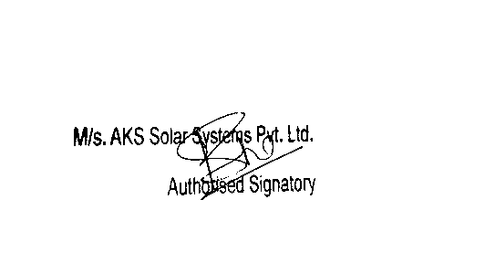
[Authorized Signatory]
SR. Manager (HR & Social Media)

Employee Acceptance
I, {{CandidateName}} accept the above offer and agree to the terms and conditions.
Signature: ____________
Date: ____________

