So, before starting the practicals we have some requirements that needs to be met:

* Hardware requirments:
1) A Raspberry Pi Model A/B/B+
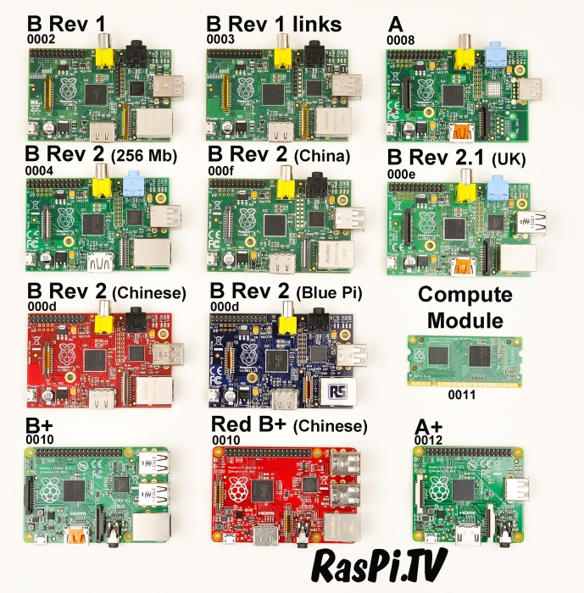

2) A good quality, micro USB power supply that can provide at least 700mA at 5v

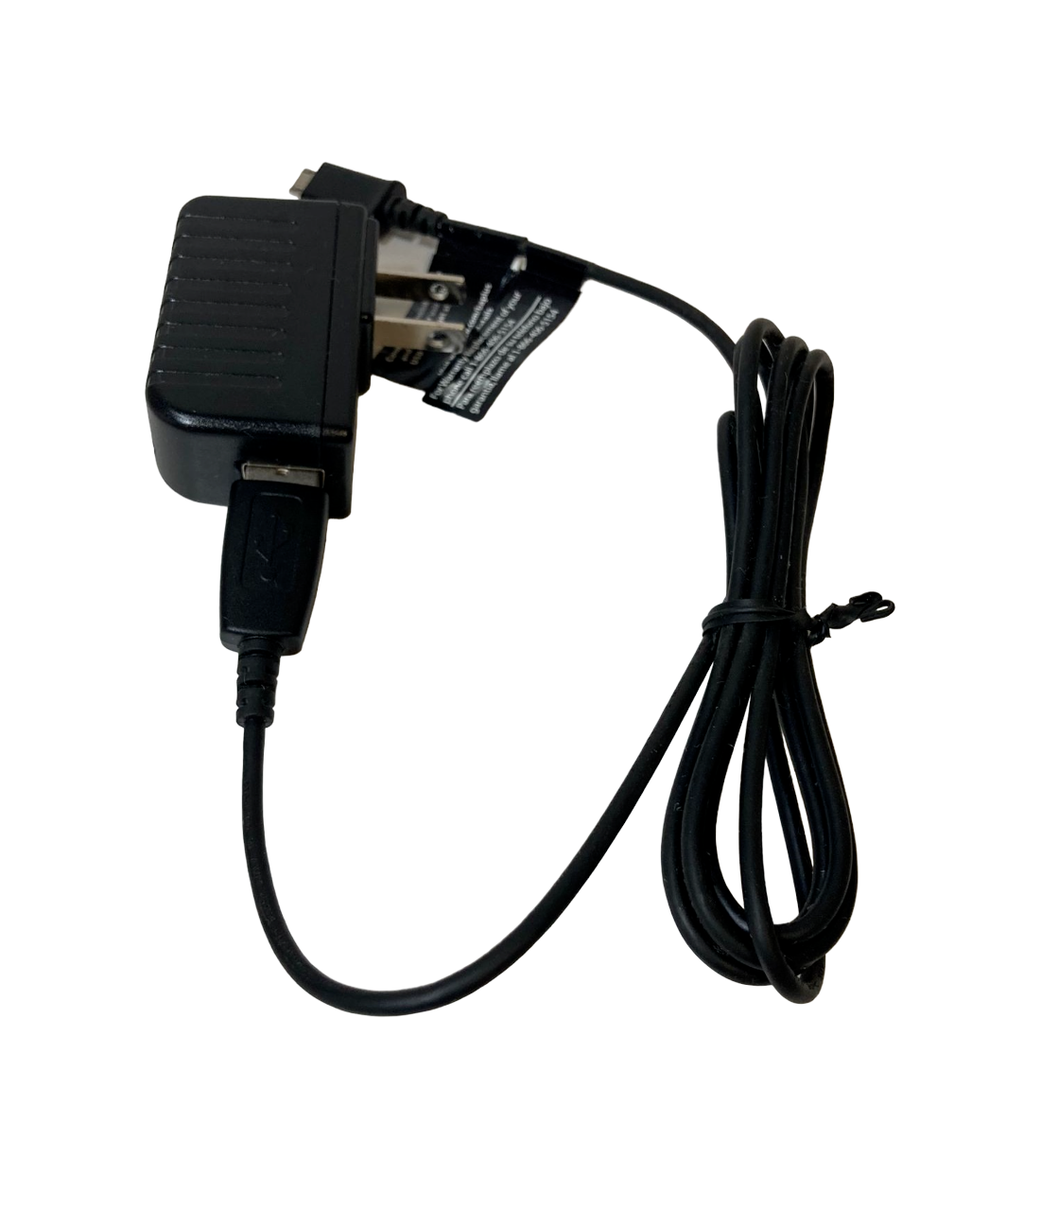

3) 4GB Class 4 SD Card (or Better) and a Card Reader (To read and write the raspbian OS on it from the laptop)
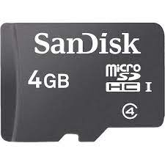

4) An ethernet cable (To connect to the the PC, network connectivity)
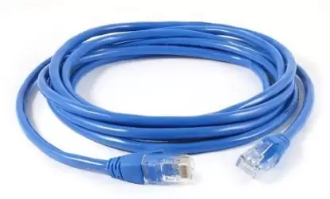

5) USB Keyboard and Mouse
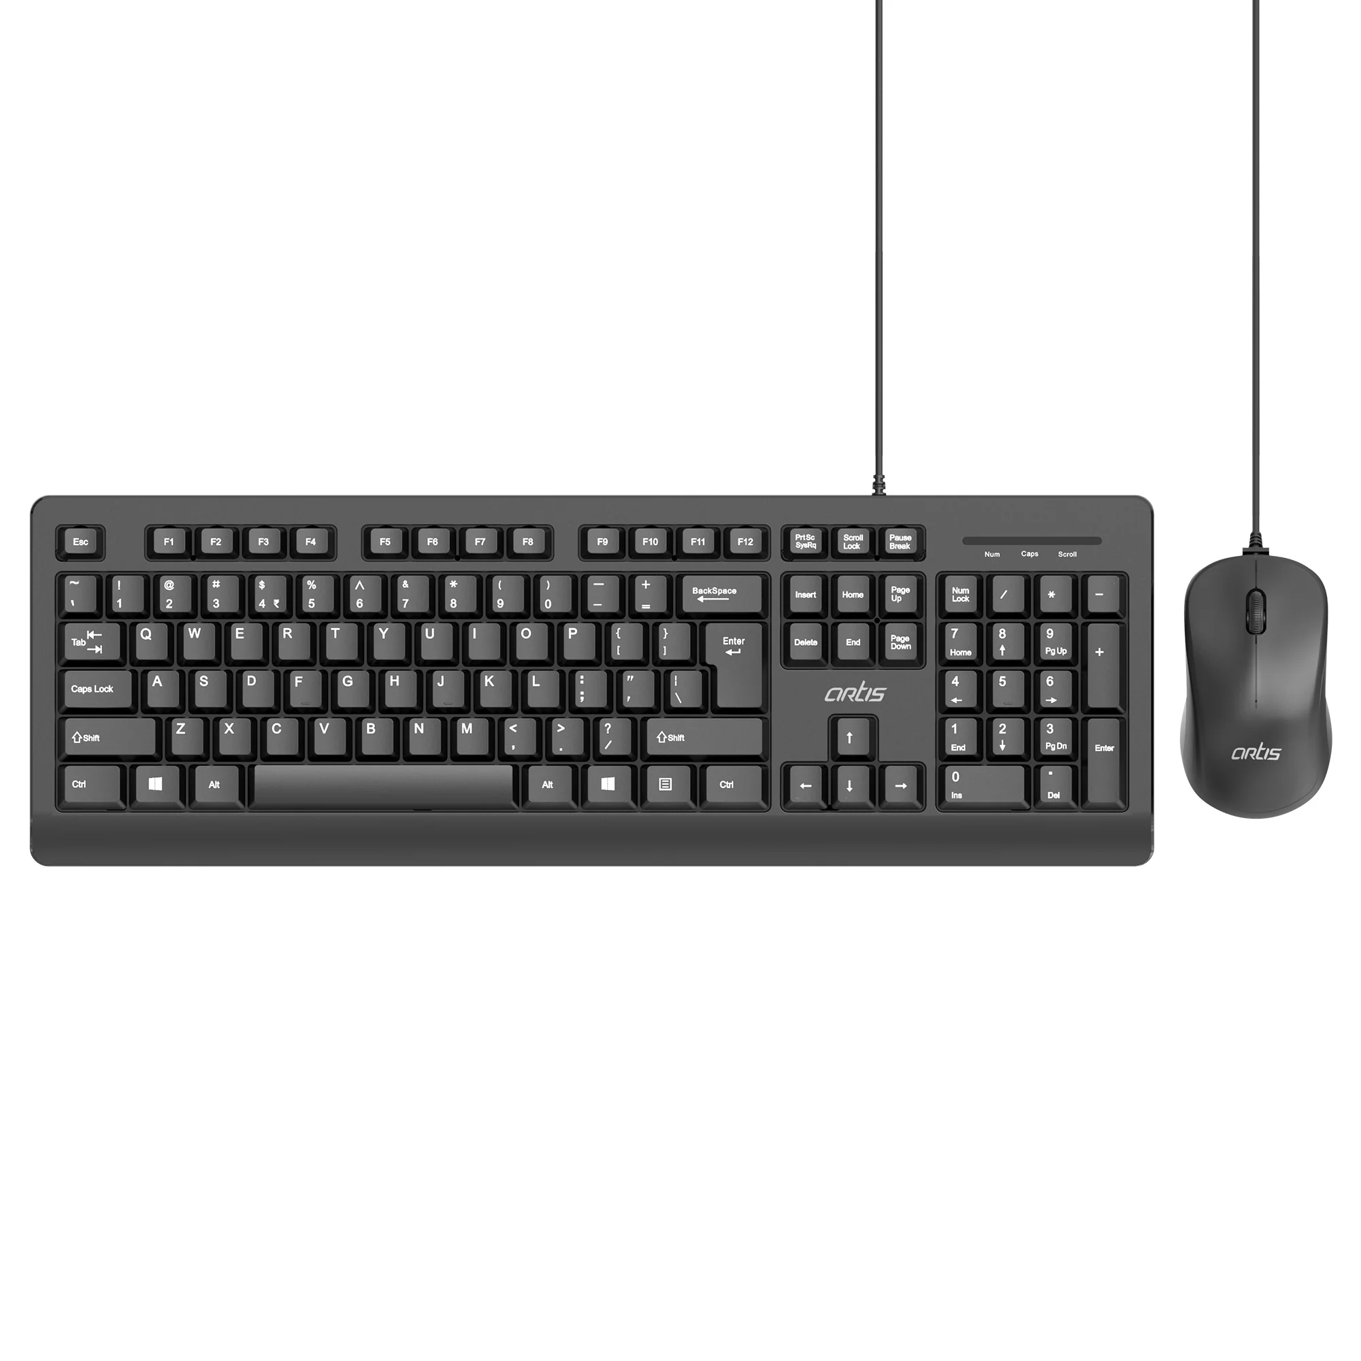

6) HDMI video cable to connect with HDMI-Capable monitor/television
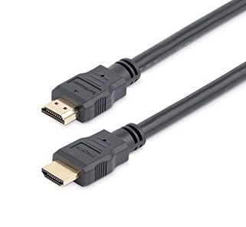

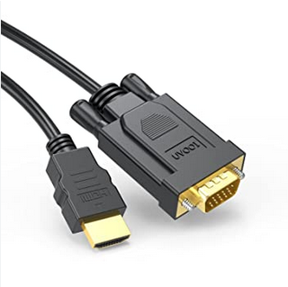
Or 7) HDMI to VGA connector to Connect with VGA-capable monitor

* Software Requirements:
****** 1) Rasbian image:
Raspbian is an operating system (OS) image that is specifically designed for the Raspberry Pi computer. It is a free and open-source operating system based on the popular Linux distribution, Debian. The Raspbian image is available for download from the Raspberry Pi Foundation website.
The Raspbian image includes a variety of pre-installed software packages, including a graphical user interface (GUI) based on the LXDE desktop environment, a web browser, and programming tools such as Python, Scratch, and Node-RED. It also includes a range of software tools and utilities for configuring and managing the Raspberry Pi, such as the Raspberry Pi Configuration tool, the Raspi-Config tool, and the Raspberry Pi Software tool.
Raspbian is the recommended OS for the Raspberry Pi due to its optimized performance and compatibility with the Raspberry Pi's hardware. It is regularly updated with bug fixes, security updates, and new features, and is supported by a large community of developers and users.

2) SD Card Formatter:
An SD card formatter is a software tool used to format SD (Secure Digital) memory cards. Formatting an SD card erases all data on the card and prepares it for use. The SD card formatter tool ensures that the SD card is properly formatted to work with a specific device, such as a camera, mobile phone, or Raspberry Pi.
Formatting an SD card can also be useful to fix certain issues that might occur, such as corrupted data or a damaged file system. In such cases, formatting the SD card can often resolve the problem and restore the card to working order.
The SD card formatter tool can be downloaded from various sources, including the website of the SD Association, the organization responsible for developing and maintaining the SD card standard. The tool is available for both Windows and Mac operating systems, and is typically free to download and use.
It's important to note that formatting an SD card will erase all data on the card, so it's important to backup any important files before proceeding with the format.

3) Windows 32 Disk Image:
Windows 32 Disk Imager is a free and open-source software tool for creating disk images from removable storage devices, such as USB drives or SD cards. It is commonly used to create bootable images of operating systems, such as Raspbian for the Raspberry Pi.
Windows 32 Disk Imager allows users to read and write disk images in various formats, including ISO, IMG, and raw disk images. It can also write disk images to removable storage devices, creating a bootable image that can be used to install an operating system or run a live version of an OS directly from the removable storage device.
Windows 32 Disk Imager is a Windows-based tool that is compatible with various versions of the Windows operating system, including Windows XP, Vista, 7, 8, and 10. It is widely used in the maker community for projects that involve the use of single-board computers, such as the Raspberry Pi or Arduino, as well as for general-purpose disk imaging tasks.

Starting Raspbian OS, Familiarising with Raspberry Pi Components and interface, Connecting to ethernet, Monitor, USB.

* Preparing SD Card:

1) Download the latest raspbian and unzip the .img file
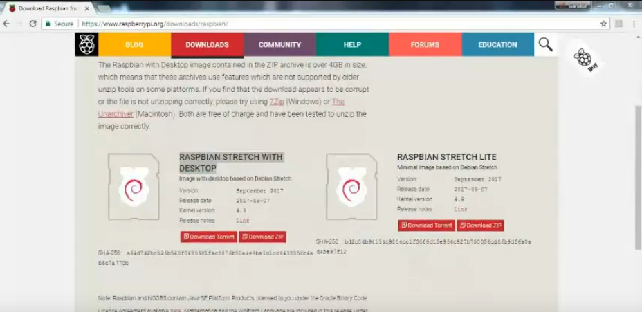

2) Format SD Card using SD card formatter software
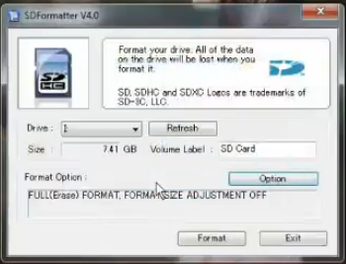

3) Make bootable image for rasbian os using Win32DiskImager software (It takes some time)
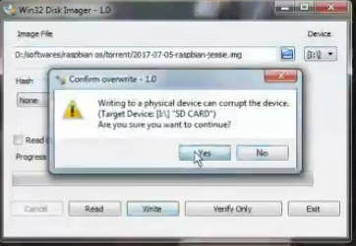

* Powering up Raspberry PI

1) Insert bootable memory card in to Raspberry PI.
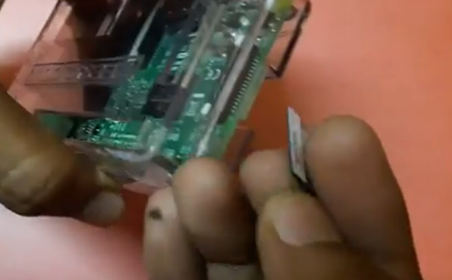

2) Connect all devices:

USB Keyboard & Mouse

Ethernet Cable

HDMI Cable or HDMI to VGA Port

Power Supply (Charger)

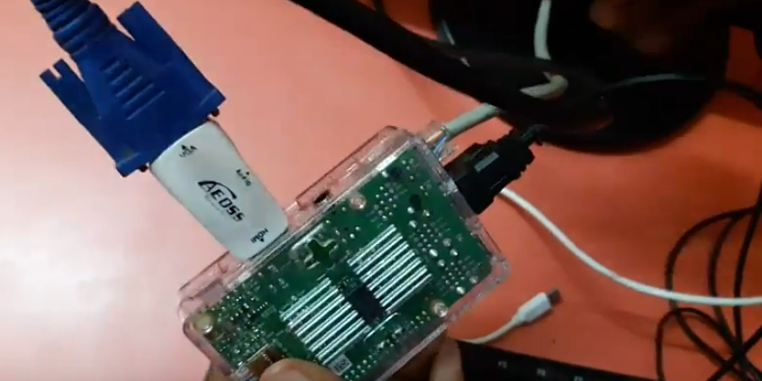

3) Power on Switch Button.

To switch on a Raspberry Pi, you can follow these steps:
- Connect the Power Supply: The first step is to connect the Raspberry Pi to a power source. The most common way to do this is by using a micro-USB power supply. The power supply plugs into the micro-USB port on the Raspberry Pi and provides the necessary voltage and current to power the device.
- Press the Power Button (if available): Some Raspberry Pi models, such as the Raspberry Pi 4, have a power button on the board. You can simply press this button to power on the device.
- Auto Power On: By default, the Raspberry Pi is configured to power on automatically when it is connected to a power source. So, if you have connected the power supply correctly, the Raspberry Pi should power on automatically.
- Wait for the Boot Process: Once the Raspberry Pi is powered on, it will go through a boot process, during which it will load the operating system and any installed applications. The boot process can take a few seconds to a few minutes, depending on the Raspberry Pi model and the complexity of the OS.
- Access the Raspberry Pi: Once the Raspberry Pi has finished booting up, you can access it using a keyboard, mouse, and monitor, or through a remote connection, such as SSH or VNC, depending on your needs.

Notes on Booting PI:
No, you cannot start a Raspberry Pi first and then insert the operating system (OS) on the SD card.
The Raspberry Pi needs an operating system installed on its SD card in order to boot up and operate properly. When the Raspberry Pi is powered on, it looks for the boot files on the SD card, which contain the operating system and the necessary software to start the device.
To install the operating system on the Raspberry Pi, you need to prepare an SD card with the appropriate OS image using a computer. Once the SD card is prepared, it needs to be inserted into the Raspberry Pi before powering it on.
It's important to note that you should also take care to properly shut down the Raspberry Pi before removing the SD card or powering it off, as abruptly removing power or removing the SD card while the device is running could cause data corruption or other issues.

(DONE)
Before The Next Practical Know this:

What are GPIO Pins?
GPIO (General Purpose Input Output) pins on the Raspberry Pi are the set of pins that can be programmed to either input or output digital signals. The GPIO pins are used to communicate with external devices, such as sensors, motors, LEDs, and other electronic components.
The Raspberry Pi has a set of 40 GPIO pins (for the latest Raspberry Pi models) arranged in a header along the top edge of the board. These pins are numbered from 1 to 40 and are grouped in two rows, with odd-numbered pins on one row and even-numbered pins on the other row.
The functions of the GPIO pins can be configured in software using programming languages such as Python or C, using libraries like RPi.GPIO. Each GPIO pin can be set to either input mode or output mode and can be used to read or write digital signals.
In addition to the standard GPIO pins, some of the pins on the Raspberry Pi header have special functions, such as providing power or ground, supporting communication protocols such as I2C, SPI, or UART, or providing analog input/output capabilities through the PWM (Pulse Width Modulation) pins.
It's important to note that the GPIO pins on the Raspberry Pi are not designed to handle high voltages or currents, so it's important to use appropriate external circuitry or protection measures when working with external devices.
But what if we want to access raspberry PI through a laptop instead of using it directly on a monitor, how can we connect it to laptop? Not just use it directly. Here are some methods:
- Remote Desktop Protocol (RDP): You can use the built-in RDP client in Windows to remotely access a Raspberry Pi that has RDP enabled. To do this, you need to install an RDP server on the Raspberry Pi, such as xrdp, and configure it to allow remote connections.
- SSH (Secure Shell): SSH is a secure protocol that allows you to remotely access the command-line interface of a Raspberry Pi. You can use a tool like PuTTY on Windows to establish an SSH connection with the Raspberry Pi by specifying the IP address of the Pi and the port number used for SSH (which is usually 22).
- Virtual Network Computing (VNC): VNC is a cross-platform protocol that allows you to access the graphical user interface of a Raspberry Pi remotely. You can install a VNC server on the Raspberry Pi, such as RealVNC or TightVNC, and use a VNC client on Windows, such as VNC Viewer, to connect to the Raspberry Pi and access its desktop environment.
- Samba file sharing: Samba is a protocol that allows you to share files and directories between Linux and Windows machines. You can install a Samba server on the Raspberry Pi and configure it to share files or directories with your Windows machine.
Overall, the method you choose will depend on your specific needs and the type of access you require.

So we will discuss two methods to access Raspberry PI and its GUI:
1) SSH Method using PuTTY and Xming:
* Requirements:
1) The Bootable Rasbian Image SD Card. (This is described in the starting of this manual)
2) The Card Reader
3) Just Power Supply and Ethernet Cable are required as we don’t require a monitor (we will be using laptop or computer as viewer) So, No HDMI, No USB Keyboard and Mouse required.
* Procedure:
1) Insert the SD card into laptop using the Card Reader.
2) Open the SD Card and save a file with the name “ssh” without any name.
The "ssh" file in Raspbian is used to enable SSH (Secure Shell) access to the Raspberry Pi. By default, SSH is disabled in Raspbian for security reasons, as it allows remote access to the Raspberry Pi's command-line interface, which could potentially be a security risk if left open to the public Internet.
To enable SSH access, you need to create a blank file named "ssh" in the boot partition of the SD card before inserting it into the Raspberry Pi and powering it on. This file signals to the Raspbian operating system that SSH access should be enabled on boot.
When the Raspberry Pi boots up, the Raspbian operating system checks for the presence of the "ssh" file in the boot partition of the SD card. If it finds the file, it enables the SSH server and allows remote access to the command-line interface over SSH.
It's important to note that once SSH access is enabled, you should take appropriate security measures, such as changing the default password, to prevent unauthorized access to the Raspberry Pi. Additionally, you should avoid enabling SSH access on a public network unless you have taken appropriate security precautions.
3) Remove the SD Card and Insert it back to Raspberry PI.
4) Connect the power supply and ethernet Cable to PI
5) Switch on Power Supply. Let Raspberry PI boot.
6) Remember the ethernet Cable should be connected on the same network as the Laptop or PC you are using.
Yes, you can directly connect the Ethernet cable from a Raspberry Pi to a laptop's Ethernet port so that both devices share the same network and use SSH (Secure Shell) to communicate.
To do this, you will need to connect one end of an Ethernet cable to the Ethernet port on the Raspberry Pi, and the other end to the Ethernet port on the laptop. Once the connection is established, the Raspberry Pi should be assigned an IP address on the same network as the laptop.
To find the IP address of the Raspberry Pi, you can use a tool like "arp" or "nmap" on the laptop's command line interface to scan for devices on the network. Once you have the IP address of the Raspberry Pi, you can use SSH to connect to it from the laptop by opening a terminal window and entering the command "ssh pi@[IP address]", where [IP address] is the IP address of the Raspberry Pi.
It's important to note that for this setup to work, both devices must be on the same network and have compatible network settings, such as IP address, subnet mask, and default gateway. You may need to manually configure the network settings on the Raspberry Pi if they are not automatically assigned by your network's DHCP server. Additionally, you should take appropriate security measures, such as changing the default password and disabling password-based SSH authentication, to prevent unauthorized access to the Raspberry Pi.
7) If you have connected the Laptop and Raspberry PI on the same network using a router, you can go to the router page and find the IP Address(Important informatio for SSH connection) of Raspberry PI.
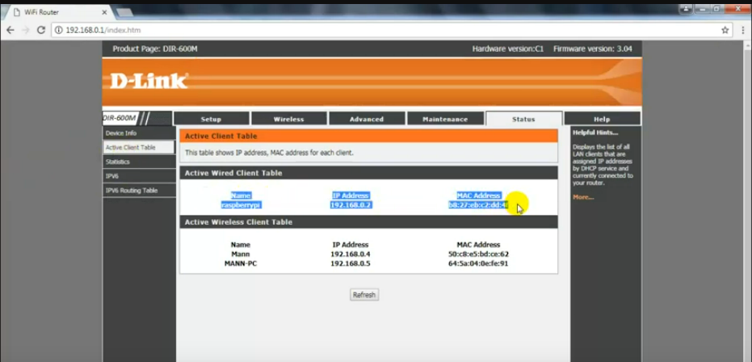
8) Now testing a connection of Raspberry PI with Putty on the laptop or PC:
Here we have entered the IP address we found in the previous step and the port 22 (which is the default SSH port) and selected the protocol as SSH.
Then we clicked on OPEN button.
Then a terminal opens up prompting for User ID and Password:
The default ID is “pi” and password is “raspberry” (Without the quotes), if you have never changed your id and password.
Enter the credentials, accordingly and you enter the ssh mode. Now you can run commands on the raspberry PI. But the next step is to get access to its GUI.
Run some linux commands like Cd, Mkdir, Touch, Ls, if the working if fine, it means we have successfully able to connect to Raspberry PI.
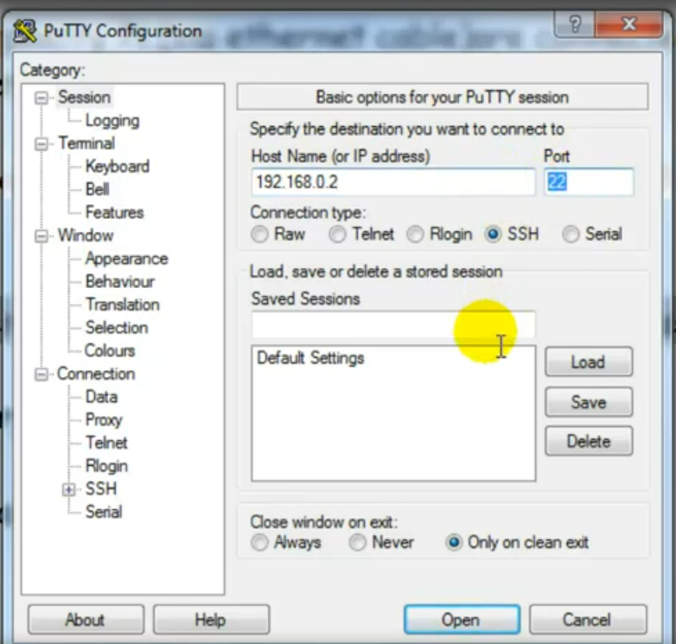
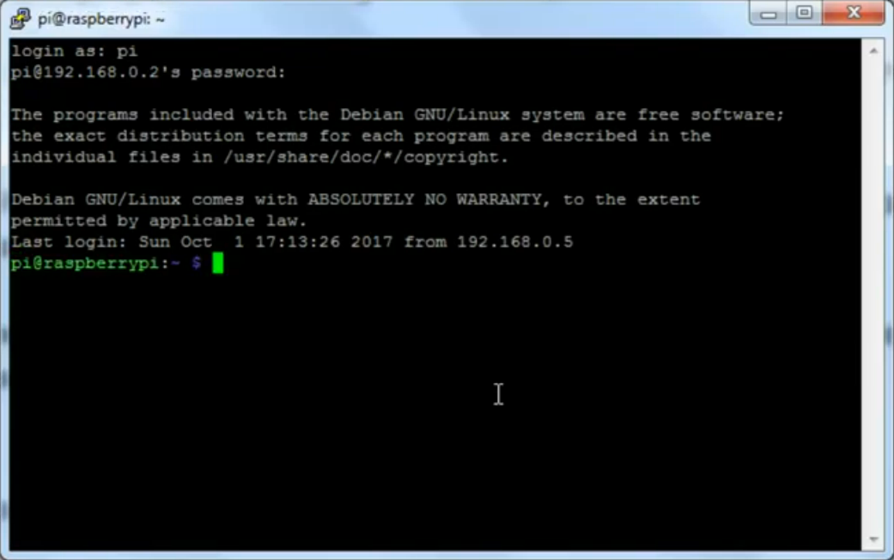
9) Now we have to use Xming (Download it if you don’t have it on the laptop)
Xming can be used with or without Putty, depending on how you want to establish the SSH connection to the remote server.
Putty is a popular SSH client for Windows that provides a secure way to connect to a remote Linux or Unix server over the network. If you are using Putty to connect to a remote server, you can configure it to use X11 forwarding, which allows you to run X11-based applications on the remote server and display them on your local Windows desktop using Xming.
To use Xming with Putty, you need to install both Xming and Putty on your Windows machine, configure Putty to enable X11 forwarding, and then start an SSH session to the remote server using Putty. When you run X11-based applications on the remote server, they will be displayed on your local Windows desktop using Xming.
However, if you prefer to use another SSH client, you can still use Xming to display X11-based applications on your local Windows desktop. To do this, you need to establish an SSH connection to the remote server using your preferred SSH client, and then configure the SSH connection to forward X11 traffic to your local Windows machine. Once the SSH connection is established, you can run X11-based applications on the remote server, and they will be displayed on your local Windows desktop using Xming.

Displaying different LED patterns with Raspberry Pi.

* Speacial Hardware requirements for this practical:
1) Breadboard
2) LED
3) 10k Ohm Resistor
4) 2 Jumper Wires
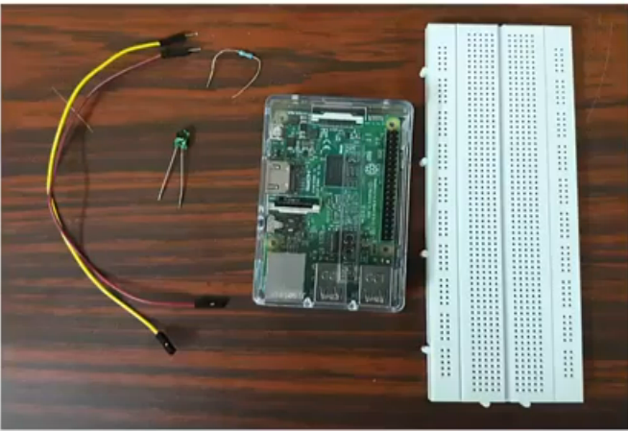
* Making the connections:
1) Connect Positive Terminal of LED with GPIO Physical Pin No. 7 using jumper wire
Displaying Time over 4-Digit 7-Segment Display using Raspberry Pi

Raspberry Pi Based Oscilloscope

Controlling Raspberry Pi with WhatsApp.

