Analysis using new logic
The volume of MQLs has been steady but the SQLs are observed to be going down.

Are we getting bad quality of MQLs?
We can observe the distribution of MQLs across different parameters. We observe a drop in the MQLs requesting >= 20 licenses. Focusing on the cohort with license request of greater than 20 licenses, no differences observed by region. Although we observe a dip from Lvl4:Prospect. Further restricting our cohort to Lvl4 only and >= 20 licenses, we observe the MQLs by region and sub region. It is noted that biggest drops are coming from APAC and North America in APEJ and ROW region respectively.
[CHECK FOR LESS THAN 20 WHERE THE INCREASE CAME FROM?: Lvl4-> North America]
The MQLs by account classification looks fine.

Analysis Details based on old logic used on the dashboard

- Match numbers displayed on the dashboard. Remember to choose MQL Source as ‘P1 VLP’ to identify the pricing requests.
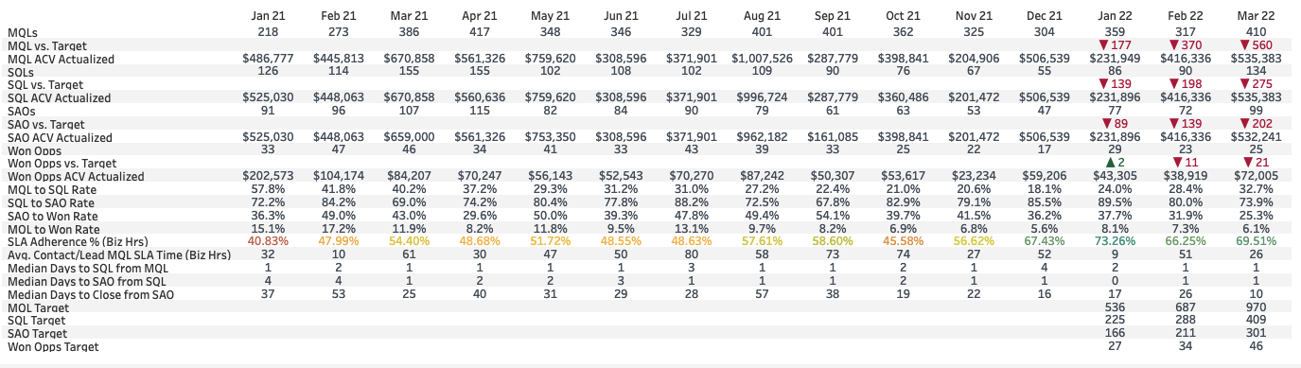
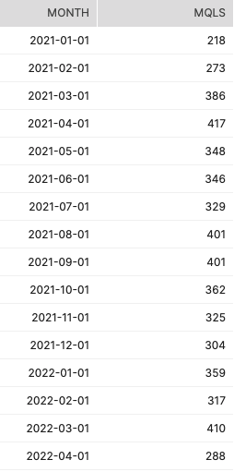
- It is noted that due to join nature there are MQLs that are double counted. This needs to be fixed. If we take only unique MQLs based on LEADORCONTACTID we obtain the following. I have provided the difference in the numbers also.
Suggestion: Count distinct LEADORCONTACTID rather than the number of rows. To check with Stephen which makes more sense: individual lead or volume leads.
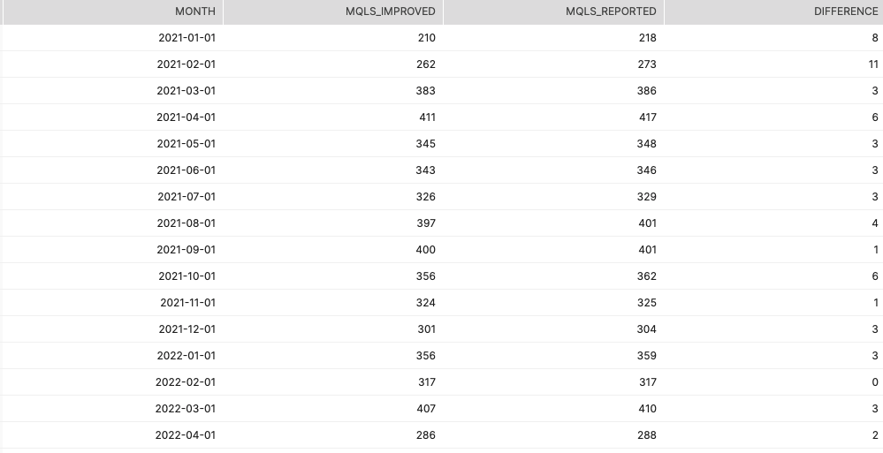
- Validate if SUBMISSION_TIMESTAMP__C is right field to use to show the timeline. For this I am observing its difference from CONTACT_LEAD_MQL_DATE_TIME__C. In theory CONTACT_LEAD_MQL_DATE_TIME__C should be very close or exactly same to SUBMISSION_TIMESTAMP__C. We are looking to understand if there are any discrepancies in the month reported on the dashboard vs when MCL was recorded as MQL on the system. There are 229 MQLs where it doesn’t match.
Suggestion to use CONTACT_LEAD_MQL_DATE_TIME__C more source of truth. Based on that numbers are as below.
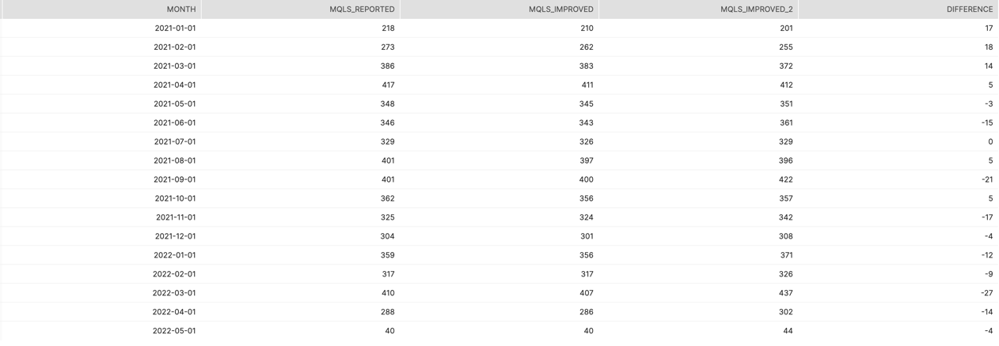
- Validate CONTACT_SQL_DATE__C to be after CONTACT_LEAD_MQL_DATE_TIME__C and understand what is the difference. Note that the numbers are different from what is reported on the dashboard.
Suggestion to add additional condition when counting SQLs CONTACT_SQL_DATE__C > CONTACT_LEAD_MQL_DATE_TIME__C 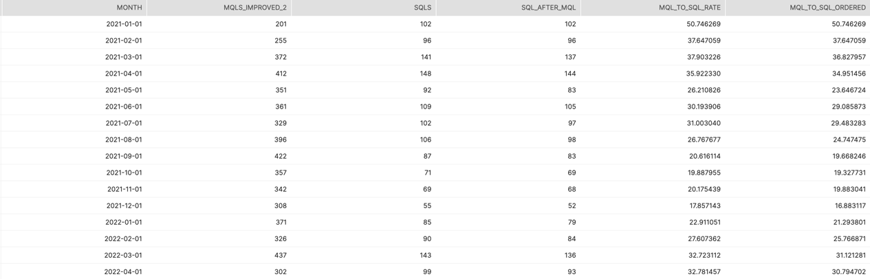
- Distribution of time between CONTACT_SQL_DATE__C and CONTACT_LEAD_MQL_DATE_TIME__C to determine if there are SQLs feeding in for older months. It is noted that there are large number MQLs that become SQLs in 41+ days. Therefore, to make a sound judgment on whether there is fall in the MQL to SQL rate we should be giving same amount of time to all MQLs.
Suggestion to add time window to ensure that each month MQLs get same time frame to transition to SQLs
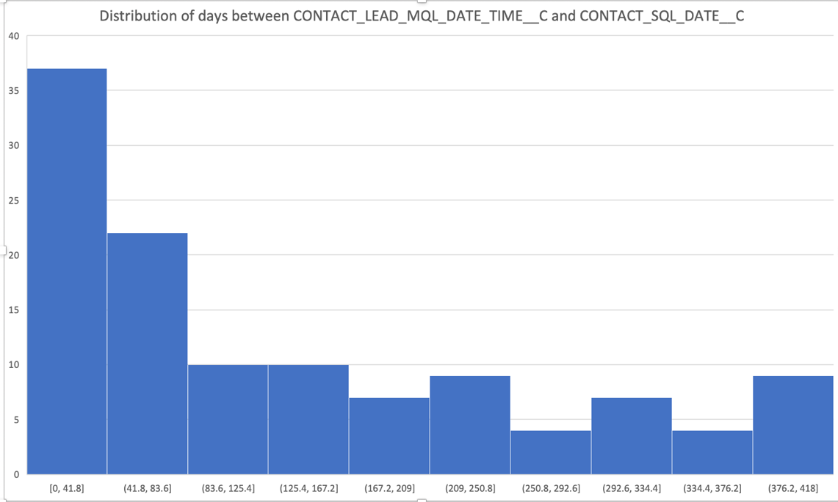

- I constrained SQLs within 60 days of CONTACT_LEAD_MQL_DATE_TIME__C. We observe a sharp decline in MQL to SQL rate from July 2021 till Dec 2021. It started picking up since Dec 2021.

- Let’s observe the distribution of the time between CONTACT_SQL_DATE__C and CONTACT_LEAD_MQL_DATE_TIME__C. It is noted that in most of months the MQLs become SQLs within 30 days, however in Jul 2021, August 2021 and Jan 2022 this pattern seems to be changed.
Was there any change in operations?
[Check SAO and other timestamp if they are serving as lookup in Contacts?]
[map journey and which timestamp is best to use]
- Breakdown using the time window of 60 days
  - Distribution of the number of licenses requested. It is noted that there are lot of invalid values when we are considering MQLs. These are growing over time. From data it is observed that they contain negative values and 0.
Why will we have negative values? Wouldn’t it impact in any of the processes where we based decision on REQ_LICENSES__C ?
It is further noted that the proportion of <=20 licenses and >20 licenses has reversed. We are getting more MQLs with <= 20 licenses now as compared to prior months where more volume was coming from >20 licenses.
We further breakdown these buckets to see where this growth is coming from.
MQL to SQL rate is dropping across both buckets.
  - By employee size CONTACT_LEAD_EMPLOYEES_M__C
Suggestion to correct the condition CONTACT_LEAD_EMPLOYEES__C to exclude with 0 value.
We observe the biggest drop in SQLs from less than 200.

