FULL STACK PROJECT REPORT

**On**

**“FOOPERS”**

**Submitted by**

**Shubh Purwar**

**(191500795)**

**Rishabh Garg**

**(191500649)**

**Sneha Banga**

**(191500813)**

Department of Computer Engineering & Applications

**Institute of Engineering & Technology**



**GLA University**

**Mathura- 281406, INDIA**

**2021-2022**

**Department of computer Engineering and Applications**

**GLA University, Mathura**

**17 km. Stone NH#2, Mathura-Delhi Road, P.O. – Chaumuha,**

**Mathura – 281406**



**Declaration**

We hereby declare that the work which is being presented in the Full Stack Project “**FOOPERS”,** in partial fulfillment of the requirements for Full Stack Project viva voce, is an authentic record of our own work carried by the team members under the supervision of our mentor Mr. Pankaj Kapoor.

Group Members: Shubh Purwar (191500795)

Rishabh Garg (191500649)

Sneha Banga (191500813)

Course: B.Tech (Computer Science and Engineering)

Year: 3rd

Semester: 5th

## Supervised By:

Mr. Pankaj Kapoor, Assistant Professor,

GLA University, Department of Computer Engineering & Application

**Department of computer Engineering and Applications**

**GLA University, Mathura**

**17 km. Stone NH#2, Mathura-Delhi Road, P.O. – Chaumuha,**

**Mathura – 281406**



**Certificate**

This is to certify that the above statements made by the candidates are correct to the best of my/our knowledge and belief.

_______________________

Supervisor

Mr. Pankaj Kapoor

Technical Trainer

Dept of CEA, GLA University

____________________ ____________________________ Project Coordinator Program Coordinator

(Mr. Mayank Srivastava) (Mr. Shashi Shekar)

**About the Project**

Our full stack project “Foopers” is an online food donation NGO website . Bridge for the necessitous to the gainers of world making a connection between hotels, rich people, and the helpers to donate food and other necessities to famishing , starving people of our society. It is a platform that helps to utilizes the waste food and other daily things from the hotels, common people to the NGO’s that ultimately enhance their moto of service to furnish and grow the poor peoples. It acts as a bridge from the one who want to donate called helpers to the NGO’s. Hotels simply find location to the nearest NGO in their area, their contact and all other detail necessary for the verification of true NGO. But NGO’s that are listed on footers are already verified so there is no need for the provider to check further but this is always a option. We provide to those who are in need and from those who want to donate. We are in direct contact with the famous restaurants and hotels all over the country, who want to share the basic necessity of living, food, with everyone. We support food banks, food pantries, and meal programs with food, funds, and advocacy. We are filling the gap between the poor ones and the people who want to contribute for humanity. We are providing food from hotels and restaurants, who would like to donate food to other NGOs , social organizations and poor people.

**Motivation**

“Sharing food with another human being is an intimate act that should not be indulged lightly.”

The rapid onset and spread of the novel coronavirus (COVID-19) pandemic sent shockwaves through the global food system, exposing and exacerbating deeply entrenched challenges. We aim to provide food to the needy ones so that no one has to sleep starving. Giving is not just about the donation but it’s about making a difference. We aim for a Hunger Free India where every individual should have access to healthy food. We support food banks, food pantries, and meal programs with food, funds, and advocacy. We are filling the gap between the poor ones and the people who want to contribute for humanity. We are providing food from hotels and restaurants, who would like to donate food to other NGO’s , social organizations and poor people. We aim for a country where no one dies due to hunger.

**Requirements**

**a). Software Requirements:**

* Technology Implemented: Full Stack Web Development
* Languages/Technologies Used: HTML, CSS, JavaScript, jQuery, Bootstrap
* IDE Used: Visual Studio Code
* Web Browser: Google Chrome/Firefox
* GitHub: GitHub is a code hosting platform for version control and collaboration. It lets you and others work together on projects from anywhere. GitHub Repository: A GitHub repository can be used to store a development project. It can contain folders and any type of files (HTML, CSS, JavaScript, Documents, Data, Images). A GitHub repository should also include a license file and a README file about the project. A GitHub repository can also be used to store ideas, or any resources that you want to share.
* Visual Studio Code: Visual Studio Code is a free source-code editor made by Microsoft for Windows, Linux and macOS. [7] Features include support for debugging, syntax highlighting, intelligent code completion, snippets, code refactoring, and embedded Git. Users can change the theme, keyboard shortcuts, preferences, and install extensions that add additional functionality. Microsoft has released Visual Studio Code's source code on the VS Code repository of GitHub.com, under the permissive MIT License, while the compiled binaries are freeware.

**b). Hardware Requirements:**

* Processor Required: Ryzen 5
* Operating System: Windows 10
* RAM: 4GB
* Hardware Devices: Computer System
* Hard Disk: 256GB

**Acknowledgement**

We thank the almighty for giving us the courage and perseverance in completing the project. This project itself is an acknowledgement for all those people who have given us their heartfelt co-operation in making this project a grand success. We extend our sincere thanks to Mr. Pankaj Kapoor, Assistant Professor at “GLA University, Mathura” for providing his valuable guidance at every stage of this project work. We are profoundly grateful towards the unmatched services rendered by him. And last but not least, we would like to express our deep sense of gratitude and earnest thanks giving to our dear parents for their moral support and heartfelt cooperation in doing the main project.

**FOOPERS**

**Abstract**

Foopers is a hunger relief organization which is founded and run by young minds who have changes the track of their life by only to help the underserved. We aim to provide help to the needy ones, so that no one has to sleep starving. We are in direct contact with hotels, restaurants and people who want to donate food to other NGO’s, social working organizations, poor people. Foopers is an online platform where an individual can connect to thousands of hotels and restaurants in their location to male a step towards humanity. It contains client page where one can access the record of previous clients who made a sweet gesture to mankind. It has login page so that one can connect with our platform and made donations. One can made online payments for charity works. We support food banks, food pantries, and meal programs with food, funds, and advocacy. We are filling the gap between the poor ones and the people who want to contribute for humanity. We are providing food from hotels and restaurants, who would like to donate food to other NGO’s , social organizations and poor people.

**Contents**

**Acknowledgment…………………………………….........**08

**Abstract…………………………………………………**09

1. **Introduction:**

Introduction to Front End Technologies........…......12-13

Pre-requisites…………………………..14

1. **Technologies Used:**

HTML……………………………….15

CSS……………………......................16

JavaScript………………………………..............17-18

Bootstrap...............................................................19

**3. List of Figures...……………………………………**20-26

**4. Software Testing..............................................................**27-31

**5.Conclusion……………………………………………**32

**6.Bibliography………………………………………….**33

**Chapter 1**

**Introduction**

Web programming, also known as web development, is the creation of dynamic web applications. Examples of web applications are social networking sites like Facebook or e-commerce sites like Amazon. Web development is a specific field of software engineering that focuses on building web pages. Web pages, or web apps, are codebases that are downloaded and run in our web browser (e.g., Google Chrome) each time a user navigates to the website address. This differs from other software which is usually downloaded once and run as a standalone application on your computer or phone. Web development makes for an exciting career, as a web development cycle is usually much shorter and you get to iterate over your software at a much faster rate.

The major building blocks of the web are HTML, CSS, and JavaScript. We will be talking about all three languages. We can also think of web development as being split into two main categories: front end and back end. We will discuss what each entails. Everything you have ever seen on the web is considered ‘front end’. Front end is what we see when we open a web page or app. Code is downloaded from a server and is rendered to the screen by a web browser. What happens when we interact with the code is also considered front end. This is often referred to as the ‘Presentation Layer’ or ‘Client’ in software development terms.

The front end is built out of three languages: HTML, CSS, and JavaScript. HTML allows us to put content on our page: text, headers, images, buttons, links, and etc. CSS is used to style our page. It allows the contents to have different text colors, background colors, as well as dealing with the positioning of the content on the page. JavaScript makes our page dynamic. It allows for the content to change on a mouse hover or click and also lets us submit data and have data rendered on our page (such as submitting a new blog post or having your feed populated when you open Facebook).

Real world web development relies heavily on the use of frameworks. Frameworks aren’t exactly new languages, but are more like add-ons to existing languages. These frameworks slightly change the rules and syntax of a language, but save us a lot of time and effort in writing web development code.

For example, a CSS framework like Bootstrap will require us to write our CSS using slightly different rules than regular (vanilla) CSS. It will also limit the level of customization we can do using CSS. But the drawbacks are often worth it, because Bootstrap makes styling our sites far easier and allows us to create mobile-friendly pages with minimal effort.

**Pre-requisite**

Hands-on knowledge of HTML, CSS, JavaScript is essential before working on the concepts for making of webpages. Make sure that you have the browser or chrome installed and running before opening website. You should have a GitHub account where every team member will be contributing in the project by pushing their codes in a separate branches. General knowledge of Bootstrap will be helpful while making the project.

**Chapter 2**

**Technologies Used**

**HTML**

The HyperText Markup Language, or HTML is the standard markup language for documents designed to be displayed in web browser. As name suggests, it is used to markup the content of page with certain tags. It can be assisted by technologies like Cascading style Sheets (CSS) and scripting languages such as JavaScript. It is used to create a basic skeleton of a web page. It is used to structured the web page.Hypertext refers to the ways the pages are connected to one another, either within the single website or between the websites.

Web browsers receive HTML documents from a web server or from local storage and render the documents into multimedia web pages. HTML describes the structure of a web page semantically and originally included cues for the appearance of the document.

HTML Elements are the building blocks of HTML pages. With HTML constructs, images and other objects such as interactive forms may be embedded into the rendered page. HTML provides a means to create structured documents by denoting structural semantics for text such as headings, paragraphs, lists, links , quotes and other items. HTML elements are delineated by tags, written using angle brackets.

Tags such as <img /> and <input /> directly introduce content into the page. Other tags such as <p> surround and provide information about document text and may include other tags as sub-elements.

Browsers do not display the HTML tags, but use them to interpret the content of the page.

**Why to use HTML:**

* It is easy to learn and use. It is the first and foremost language that the person will go through for the one who is learning web development.
* It is free and supported by all browsers.
* It is the most friendy search engine.
* It can easily interact with other languages.
* It is lightweight and simple to edit.
* It is user friendly.
* It is used to create the basic structure of a web page.

**CSS**

Cascading Style Sheets (CSS) is a stylesheet language used to describe the presentation of a document written in HTML or XML (including XML dialects such as SVG, MathML or XHTML). CSS describes how elements should be rendered on screen, on paper, in speech, or on other media.

CSS is among the core languages of the open web and is standardized across Web browsers according to W3C specifications. Previously, development of various parts of CSS specification was done synchronously, which allowed versioning of the latest recommendations. You might have heard about CSS1, CSS2.1, CSS3. However, CSS4 has never become an official version.

From CSS3, the scope of the specification increased significantly and the progress on different CSS modules started to differ so much, that it became more effective to debelop and release recommendations specifically per module. Instead of versioning the CSS specification, W3C now periodically takes a snapshot of the latest stable state of CSS specification. CSS has gone through several changes over the years, and the latest version is CSS3. Most web browsers likely support the CSS3 standard. With this latest version, CSS designers have more tools at their disposal. The advantages of using a separate CSS file rather than embedding the CSS code inside the HTML file include:

* The layout of a web page is better controlled
* Style (CSS) kept separate from structure (HTML), means smaller file size

Another way to increase bandwidth is to decrease the size of a CSS file with compressor tools. CSS compressors eliminate blank spaces, indentations, and even comments to boost performance. Another best practice for CSS designers is to combine separate CSS files into one file for multiple webpages to reduce the amount of HTTP requests (cleancss.com).

**Why use CSS ?**

* CSS compressors
* Vendor prefixes and post processors
* Reset
* Variations
* CSS Validators
* Cross Browser Compatibility

CSS is a powerful tool as long as you know certain tips, best practices, and avoid problematic issues. With CSS web design, you can adjust the layout of a webpage. Without having to define the appearance for every single element, table, or block of text in the HTML file itself.

**JavaScript**

JavaScript (JS) is a lightweight, interpreted, or just-in-time compiled programming language with first class functions. While it is most well-known as the scripting language for Web pages, many non-browser environment also use it, such as Node.js, Apache CouchPD and Adobe Acrobat. JavaScript is a prototype-based, multi-paradigm, single-threaded, dynamic language, supporting object-oriented, imperative, and declarative (e.g. functional programming) styles. Read more about JavaScript.

This section is dedicated to the JavaScript language itself, and not the parts that are specific to Web pages or other host environments. For information about API specifics to Web pages, please see Web APIs and DOM.

The standards for JavaScript are the ECMA Script language specification (ECMA-262) and the ECMAScript Internationalization API Specification(ECMA-402). The JavaScript documentation throughout MDN is based on the latest draft versions of ECMA-262 and ECMA-402. And in cases where some proposals for new ECMA Script features have already been implemented in browsers, documentation and examples in MDN articles may use some of those new features.

Do not confuse JavaScript with the Java programming language. Both "Java" and "JavaScript" are trademarks or registered trademarks of Oracle in the U.S. and other countries. However, the two programming languages have very different syntax, semantics, and use. avaScript frameworks are an essential part of modern front-end web development, providing developers with proven tools for building scalable, interactive web applications.

**Why use JavaScript?**

* Speed. Client-side JavaScript is very fast because it can be run immediately within the client-side browser. Unless outside resources are required, JavaScript is unhindered by network calls to a backend server.
* Simplicity. JavaScript is relatively simple to learn and implement.
* Popularity. JavaScript is used everywhere on the web.
* Interoperability. JavaScript plays nicely with other languages and can be used in a huge variety of applications.
* Server Load. Being client-side reduces the demand on the website server.
* Gives the ability to create rich interfaces.

**BootStrap**

**Bootstrap** is a free and open source CSS framework directed at responsive, mobile-first front end development. It contains CSS and (optionally) Javascript based design templates for typography, forms, buttons, navigation, and other interface components.

Bootstrap, originally named Twitter Blueprint, was developed by Mark Otto and Jacob Thornton at Twitter as a framework to encourage consistency across internal tools. Before Bootstrap, various libraries were used for interface development, which led to inconsistencies and a high maintenance burden. According to Twitter developer Mark Otto:

A super small group of developers and I got together to design and build a new internal tool and saw an opportunity to do something more. Through that process, we saw ourselves build something much more substantial than another internal tool. Months later, we ended up with an early version of Bootstrap as a way to document and share common design patterns and assets within the company.

After a few months of development by a small group, many developers at Twitter began to contribute to the project as a part of Hack Week, a hackathon style week for the Twitter development team. It was renamed from Twitter Blueprint to Bootstrap, and released as an open source project on August 19, 2011. It has continued to be maintained by Mark Otto, Jacob Thornton, and a small group of core developers, as well as a large community of contributors.

The primary purpose of adding it to a web project is to apply Bootstrap's choices of color, size, font and layout to that project. As such, the primary factor is whether the developers in charge find those choices to their liking. Once added to a project, Bootstrap provides basic style definitions for all HTML elements. The result is a uniform appearance for prose, tables and form elements across web browsers. In addition, developers can take advantage of CSS classes defined in Bootstrap to further customize the appearance of their contents

**Chapter 3**

**List of Figures**

**1. SignUp Page**

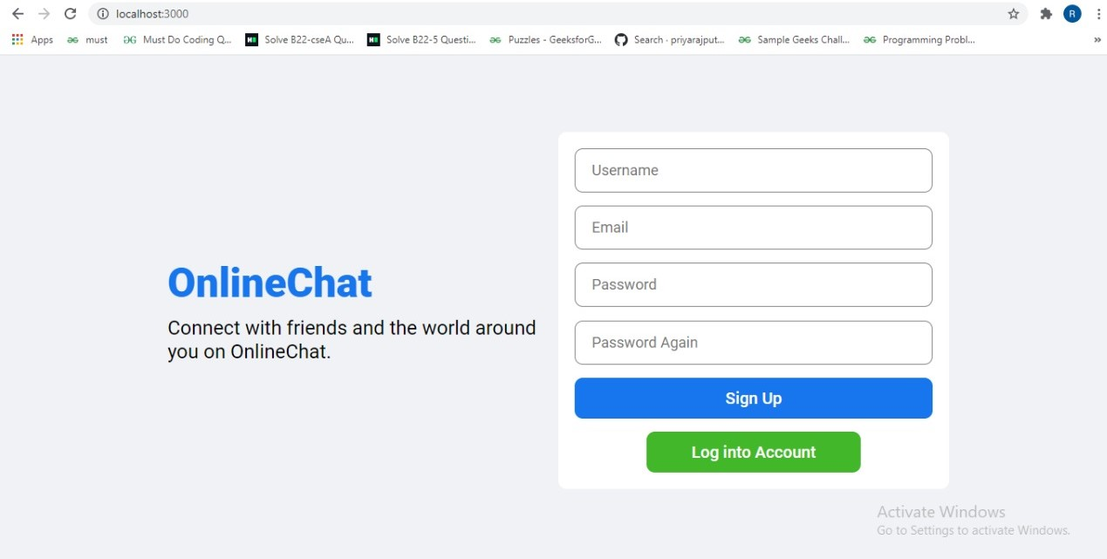

**2. Login Page**

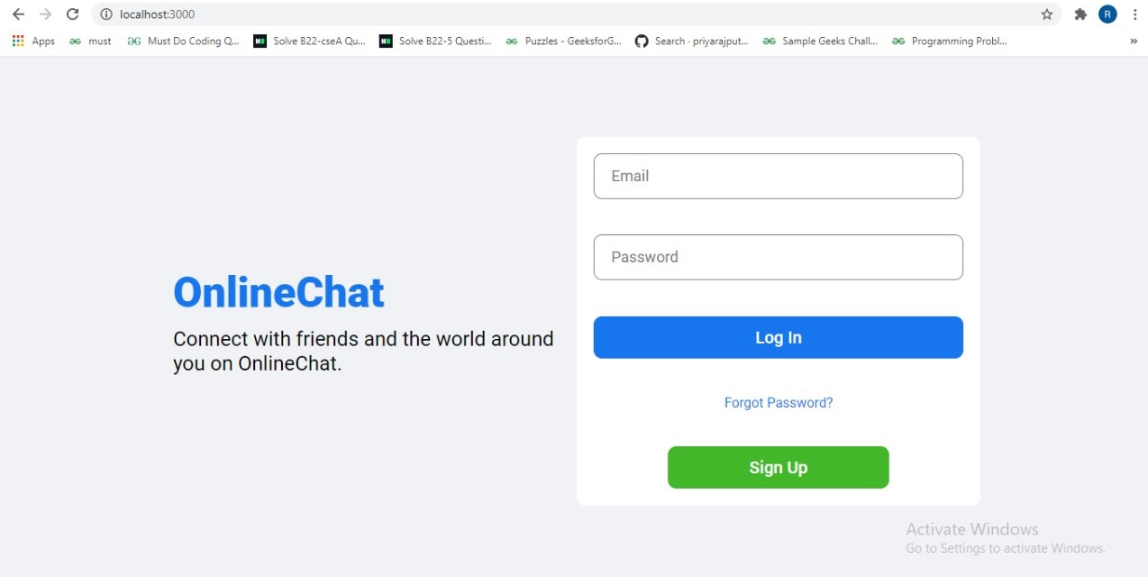

**3. Searching someone’s profile**

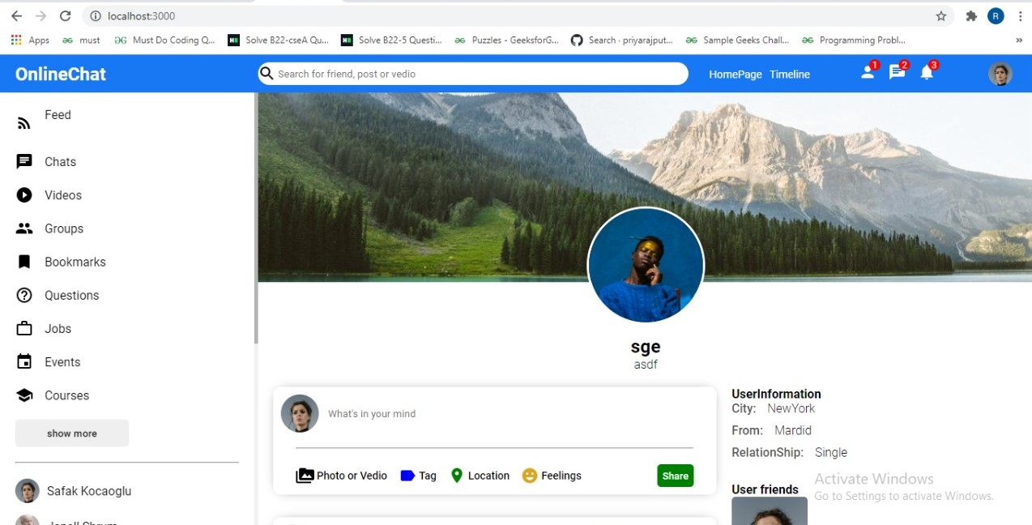

**4. Home Page**

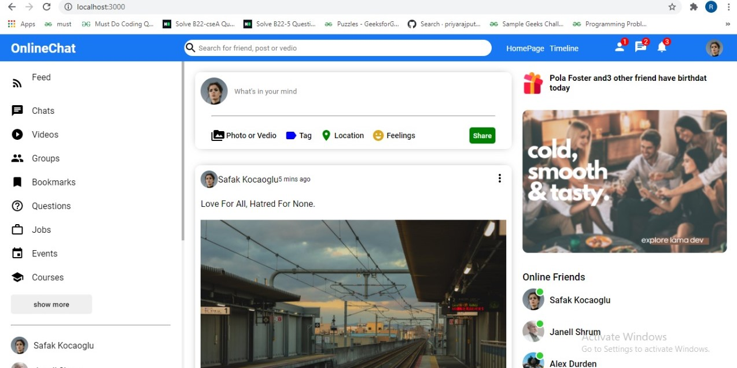

**5.**

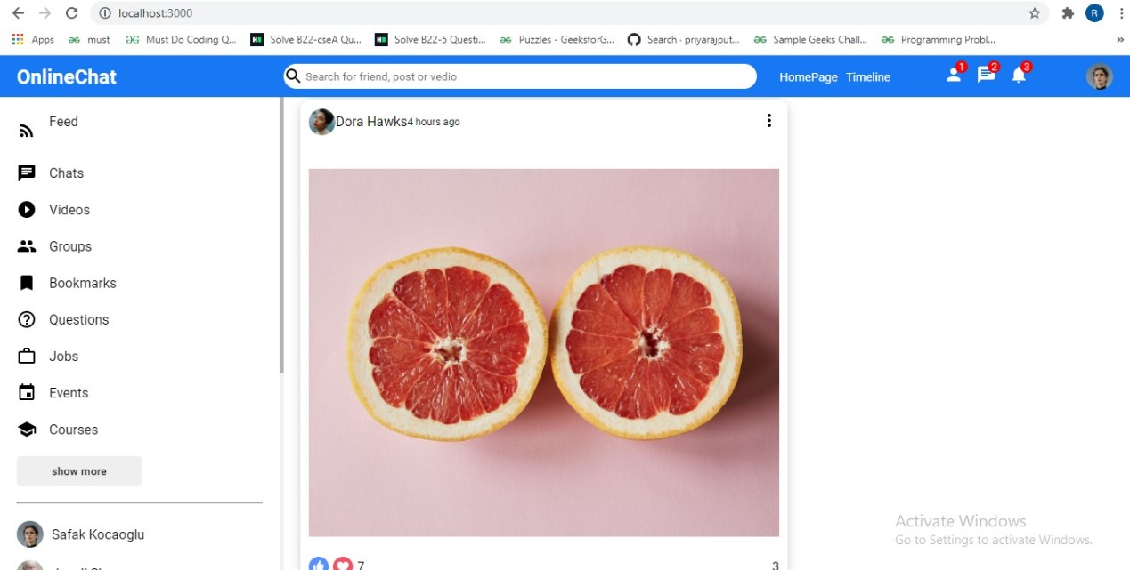

**6.**

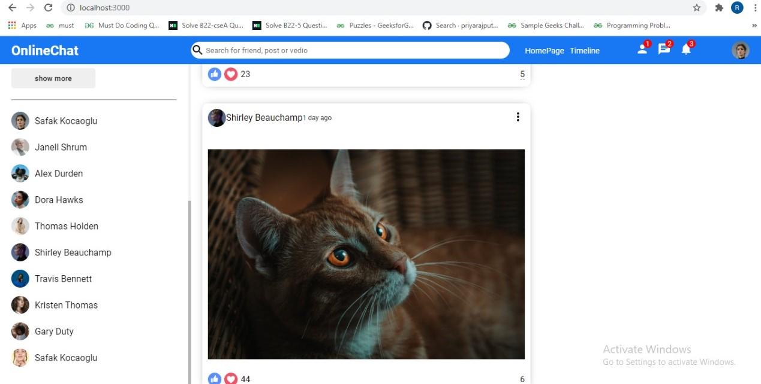

**7.**

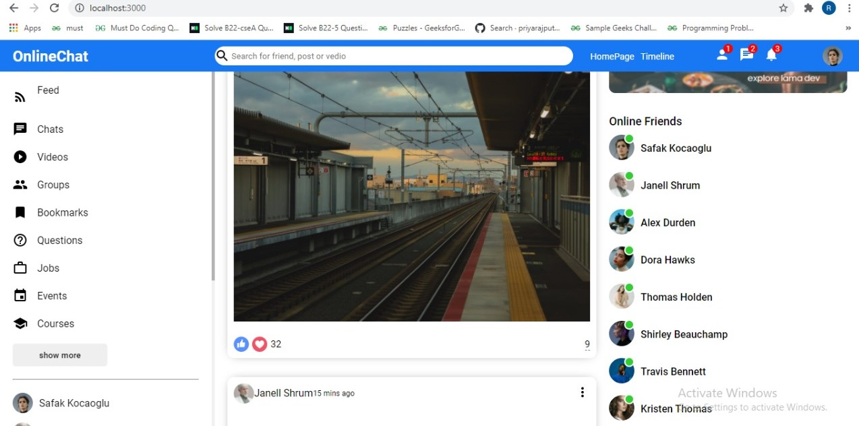

**Chapter 4**

**Software Testing**

Once source code has been generated, software must be tested to uncover as many errors as possible before delivery. It is very important to work the system successfully and achieve high quality of software. Testing include designing a series of test cases that have a high likelihood of finding errors by applying software-testing techniques. System testing makes logical assumptions that if all the parts of the system are correct, the goal will be successfully achieved. The system should be checked logically. Validations and cross checks should be there. Avoid duplications of record that cause redundancy of data. In other Words, Testing is the process of evaluating a system or its component(s) with the intent to find whether it satisfies the specified requirements or not. It is executing a system in order to identify any gaps, errors, or missing requirements in contrary to the actual requirements.

The preliminary goal of implementation is to write source code and internal documentation so that conformance of the code to its specifications can be easily verified, and so that debugging, testing and modifications are eased. This goal can be achieved by making the source code as clear and straightforward as possible. Simplicity, clarity and elegance are the hallmark of good programs, obscurity, cleverness, and complexity are indications of inadequate design and misdirected thinking. Source code clarity is enhanced by structured coding techniques, by good coding style, by, appropriate supporting documents, by good internal comments, and by feature provided in modern programming languages. The implementation team should be provided with a well-defined set of software requirement, an architectural design specification, and a detailed design description. Each team member must understand the objectives of implementation.

4.1 TERMINOLOGY

Error The term error is used in two ways. It refers to the difference between the actual output of software and the correct output, in this interpretation, error is essential a measure of the difference between actual and ideal. Error is also to used to refer to human action that result in software containing a defect or fault.

Fault is a condition that causes to fail in performing its required function. A fault is a basic reason for software malfunction and is synonymous with the commonly used term Bug.

Failure is the inability of a system or component to perform a required function according to its specifications. A software failure occurs if the behavior of the software is the different from the specified behavior. Failure may be caused due to functional or performance reasons.

4.2 TYPES OF TESTING

**a. Unit Testing** The term unit testing comprises the sets of tests performed by an individual programmer prior to integration of the unit into a larger system. A program unit is usually small enough that the programmer who developed it can test it in great detail, and certainly in greater detail than will be possible when the unit is integrated into an evolving software product. In the unit testing the programs are tested separately, independent of each other. Since the check is done at the program level, it is also called program teasing.

**b. Module Testing** A module and encapsulates related component. So can be tested without other system module.

**c. Subsystem Testing** Subsystem testing may be independently design and implemented common problems are sub-system interface mistake in this checking we concenton it. There are four categories of tests that a programmer will typically perform on a program unit.

i Functional test

ii Performance test

iii Stress test

iv Structure test

**Functional Test** Functional test cases involve exercising the code with Nominal input values for which expected results are known; as well as boundary values (minimum values, maximum values and values on and just outside the functional boundaries) and special values.

**Performance Test** Performance testing determines the amount of execution time spent in various parts of the unit, program throughput, response time, and device utilization by the program unit. A certain amount of avoid expending too much effort on fine-tuning of a program unit that contributes little to the overall performance of the entire system. Performance testing is most productive at the subsystem and system levels.

**Stress Test** Stress test are those designed to intentionally break the unit. A great deal can be learned about the strengths and limitations of a program by examining the manner in which a program unit breaks.

**Structure Test** Structure tests are concerned with exercising the internal logic of a program and traversing particular execution paths. Some authors refer collectively to functional performance and stress testing as “black box” testing. While structure testing is referred to as “white box” or “glass box” testing. The major activities in structural testing are deciding which path to exercise, deriving test date to exercise those paths, determining the test coverage criterion to be used, executing the test, and measuring the test coverage achieved when the test cases are exercised.

**Chapter 5**

**Conclusion**

We have completed our project within time limit with the coordination of our team members under the supervision of our mentor Mr. Pankaj Kapoor.

Our project repository is available at

<https://github.com/ritikaAgrawal123/OnlineChat>

**Chapter 6**

**Bibliography**

[**www.google.com**](http://www.google.com)

**https://www.geeksforgeeks.org/**

[**www.youtube.com**](http://www.youtube.com)

**www.w3schools.com**

**www.beta-labs.in**