**CSR2-HUB database PRE-update manual (last update 19.07.2025)**

Please follow the instructions carefully to avoid mistakes and complete the database update as quickly as possible.For example, update 5.8.0 OTA2 will be shown, new cars: *- AstonMartin_DBR22_2023   
- Bugatti_W16MistralWRE_2024  
- DeTomaso_PanteraGT5S_1984  
- Mazda_RX7F2_1993  
- Porsche_911TurboFlachbauC_1987  
- Porsche_911STReward_2024  
- Porsche_911STRewardRecycled_2024*

1. ***Preparing and adding data from data/data space***
   1. ***Icons update***

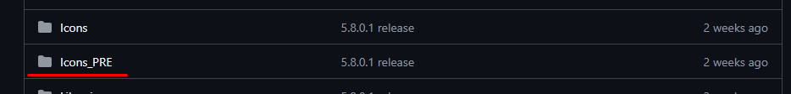

***To update icons, the hub has a special folder Icons_PRE. Please use only this folder for updating!***

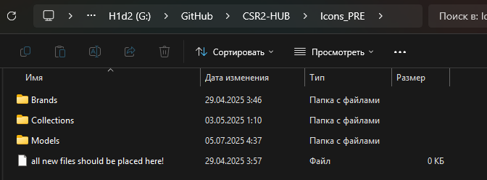

***Like the base folder, it has three additional folders:*** *- Brands: here are all car manufacturers, add a new manufacturer icon if a new one appears, or need update to new design  
- Collections: these are special icons that are used for collections and other things. It only updates when the hub app itself is updated, so skip this folder.  
- Models: here are icons of all cars. Update when new cars appear.*

In this case we have new cars and a new brand: DeTomaso + Mercedes update.

1. Open root/data/data/com.naturalmotion.customstreetracer2/files/NativeDownload/AssetBundles/ASTC
2. Search for _icon and sort by name:

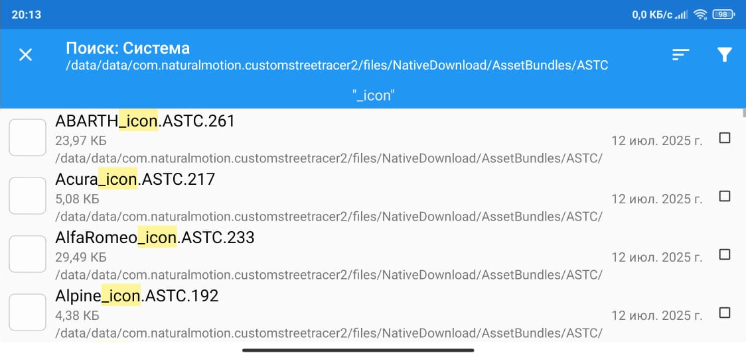

1. Find all the new cars you need, as well as the new manufacturer, copy them to a convenient location and then send them to your computer:

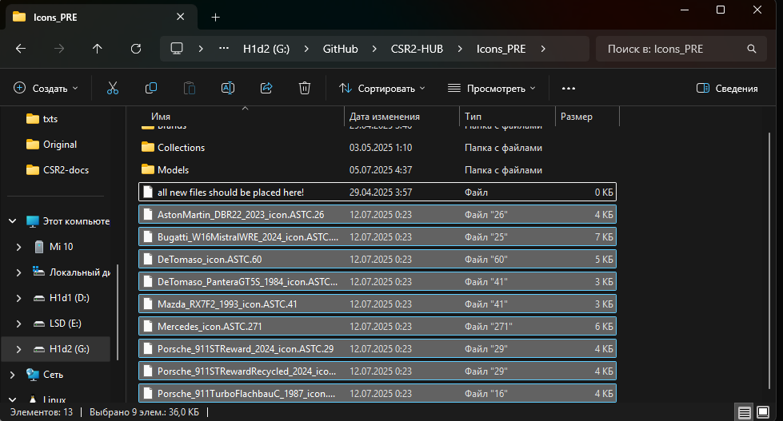

1. Open brand files in AssetStudio (AS) and filter by texture2d:

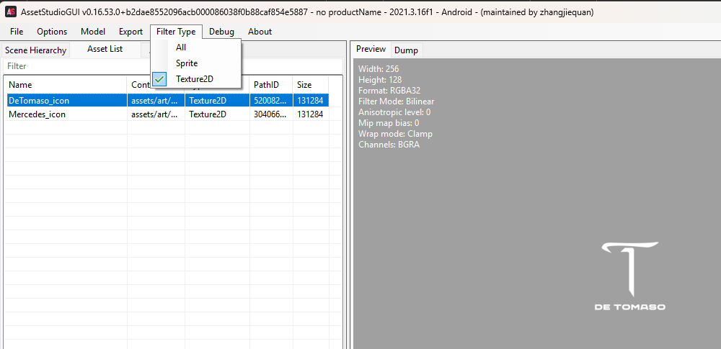

1. Export icons to Brands folder: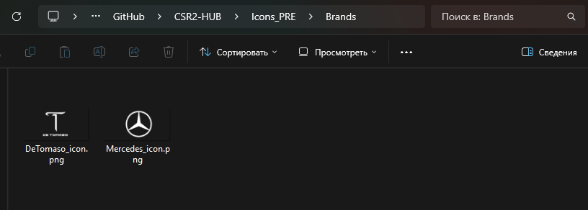
2. Open the remaining files in AS and filter by texture2d :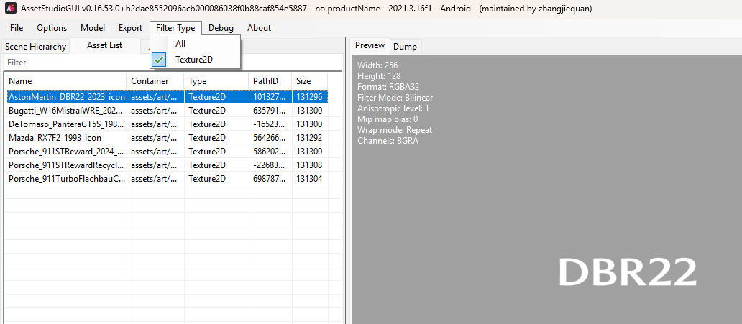
3. Export icons to Models folder :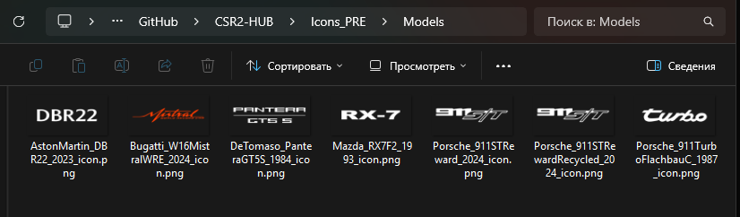
4. Delete ASTC files, they are no longer needed
   1. ***CarVisualData update***

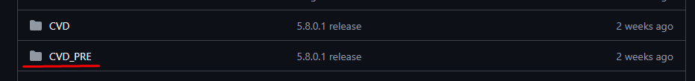

***To update CVDs, the hub has a special folder CVD_PRE. Please use only this folder for updating!***

Now we need to add CVD files for all new cars.

1. Open root/data/data/com.naturalmotion.customstreetracer2/files/NativeDownload/AssetBundles/ASTC
2. Search for _common.ASTC and sort by date :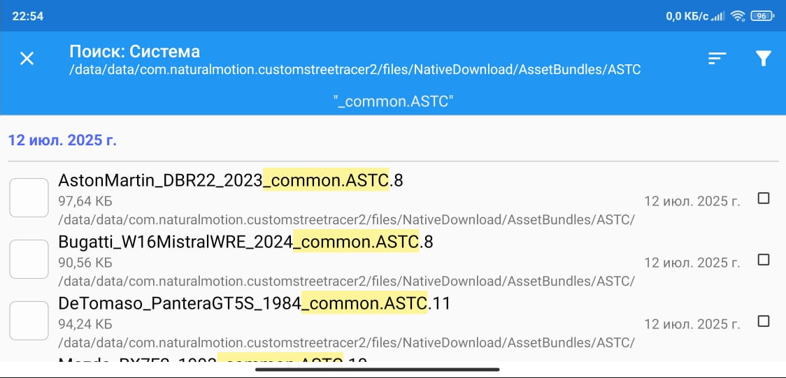
3. Find all the new cars you need and copy them to a convenient location and then send them to CVD_PRE folder :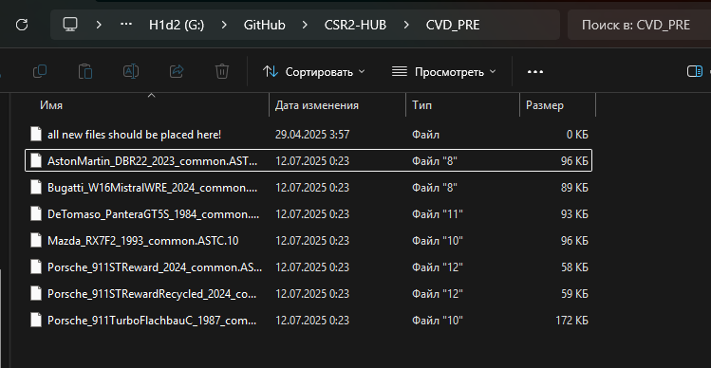
4. Rename the files so that there is only the name car-crdb :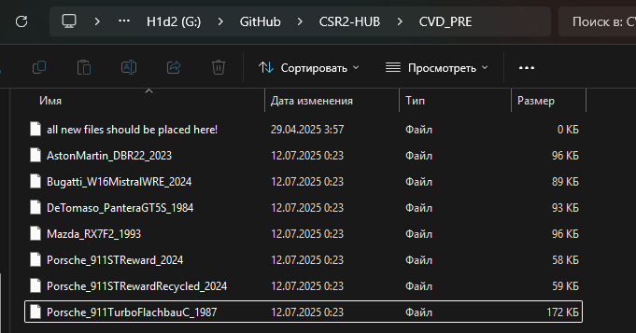
   1. ***CarConfigs update***



***To update CarConfigs, the hub has a special folder Libraries_PRE. Please use only this folder for updating!***

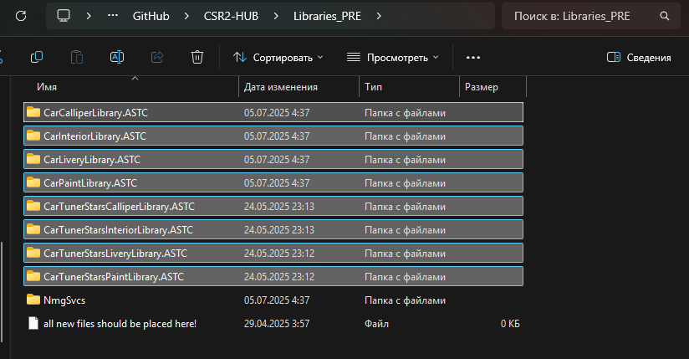

***Like the base folder, it has additional folders:*** *- Each has a file name that is needed for updating.*

Now we need to load new version files.

1. Open root/data/data/com.naturalmotion.customstreetracer2/files/NativeDownload/AssetBundles/ASTC
2. Search for Car and sort by date:

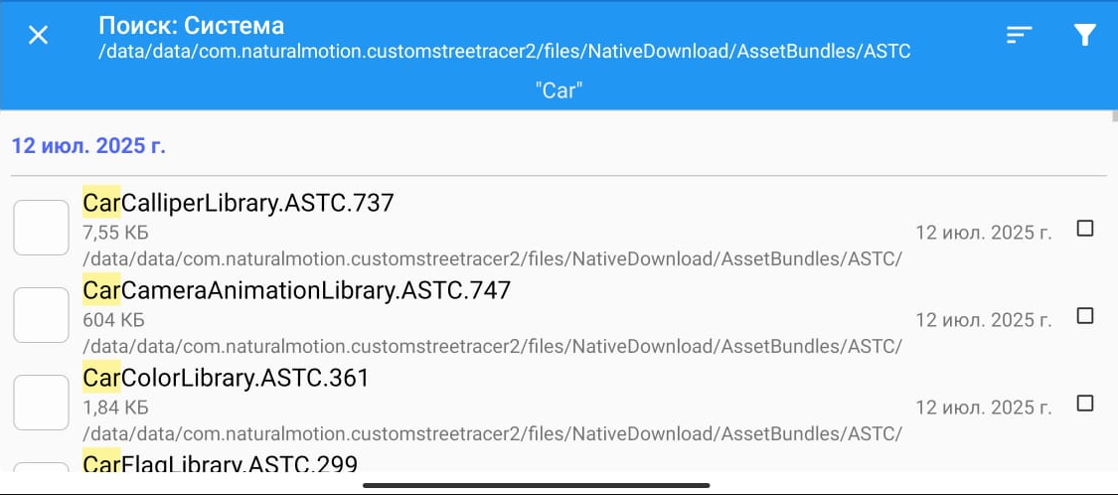

1. Find all the new files you need and copy them to a convenient location, then send them to each designated folder:

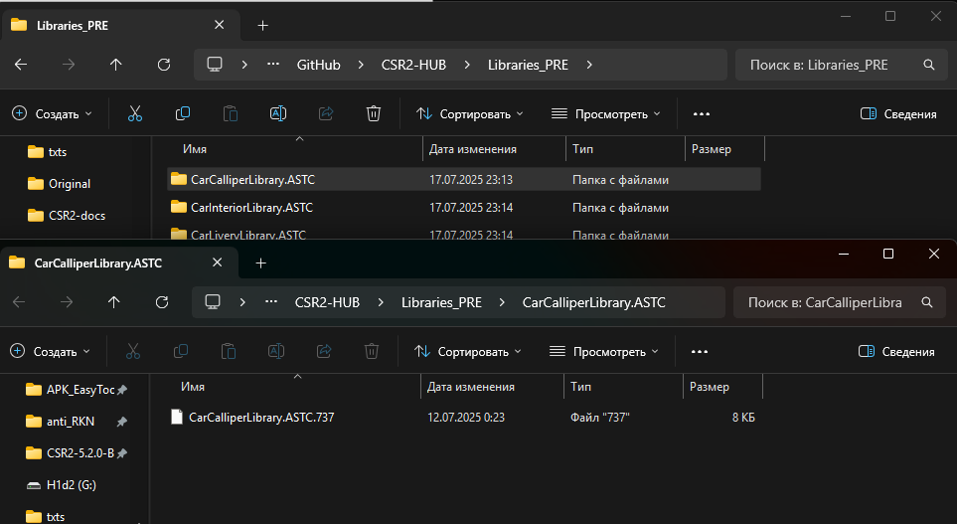

1. Rename each file to __data (!!! In name double underscore!!!)

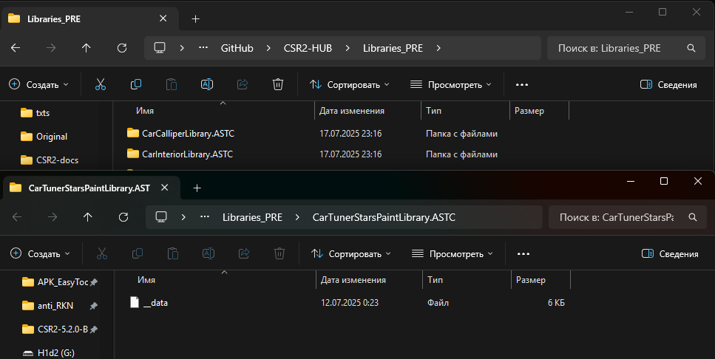

* 1. ***Localisation files update***



***To update localization files, the hub has a special folder Libraries_PRE. Please use only this folder for updating!***

Now we need to load new version files.

1. Open root/data/data/com.naturalmotion.customstreetracer2/files/NativeDownload/AssetBundles/ASTC
2. Search for Localisation_ and sort by date:

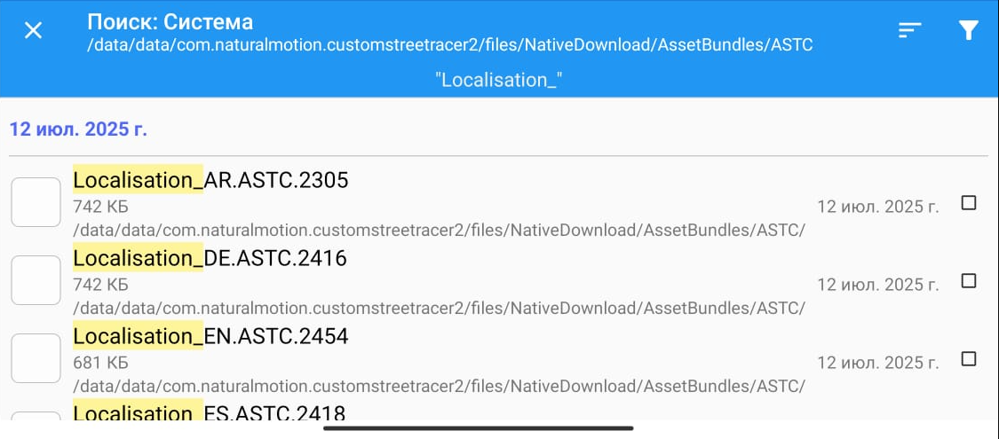

1. Find all the 12 localisations you need and copy them to a convenient location and then send them to Libraries_PRE folder:

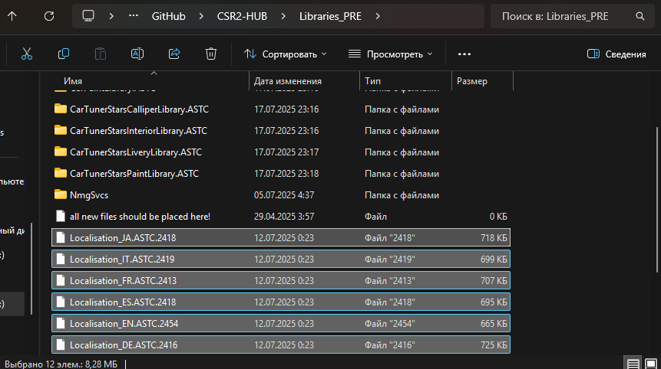

1. Rename the files by removing unnecessary numeric extensions:

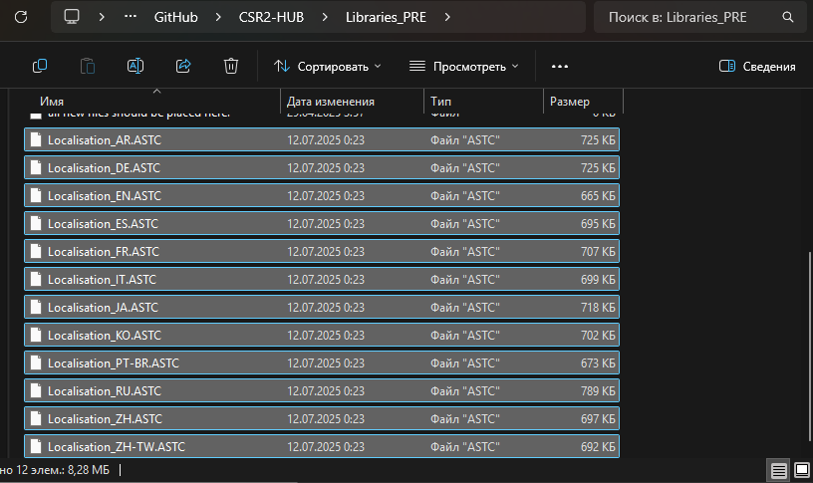

1. ***NmgSvcs files update***

In this step we will use the document files from the android/data folder of the game. So, make sure that it is up to date (has access to the crew view).

List of required configs:

- CarFusionProfileData

- CarMilestoneData

- CarPricingCompact

- CollectionCarsUnlock

- CollectionSlots

- NewCarsInThisAppVersionList

- OldCarsInThisAppVersionList

- ProfileBanners

- SeasonPassMilestoneRewards

- SeasonPassSchedule



***To update localization files, the hub has a special folder Libraries_PRE. Please use only this folder for updating!***

1. Open android/data/com.naturalmotion.customstreetracer2/files/Documents/NmgSvcsData/1/ConfigData
2. Copy all folder files to NmgSvcs folder:

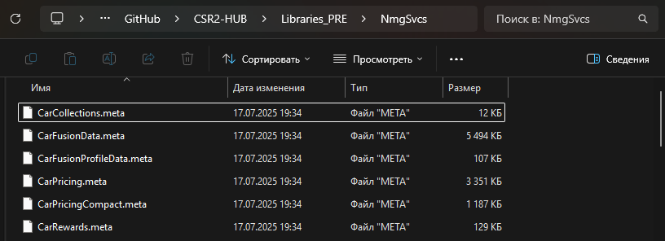

1. Find all necessary configs (except OldCarsInThisAppVersionList) and rename meta to json. Delete other files. *(Some files may be missing if they haven't been updated by the developers, so that's okay)*

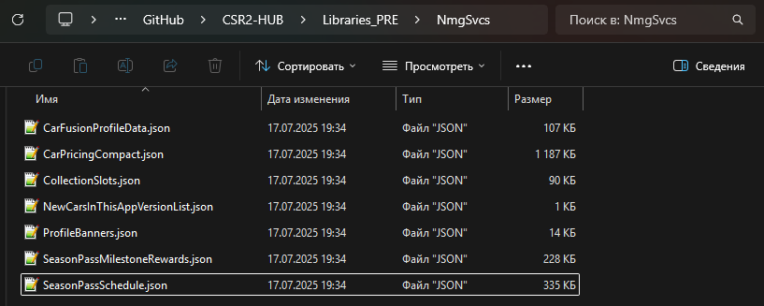

1. Make duplicate NewCarsInThisAppVersionList.json from Libraries/NmgSvcs and move file to Libraries_PRE/NmgSvcs -> Then rename this file to OldCarsInThisAppVersionList.json:

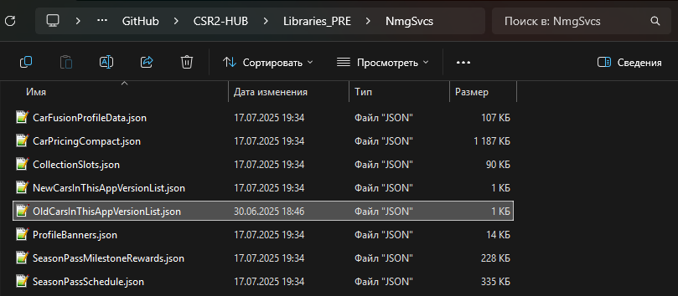

1. Open all json files (except CarsInThisAppVersionList) in Notepad++ and make JsonSort

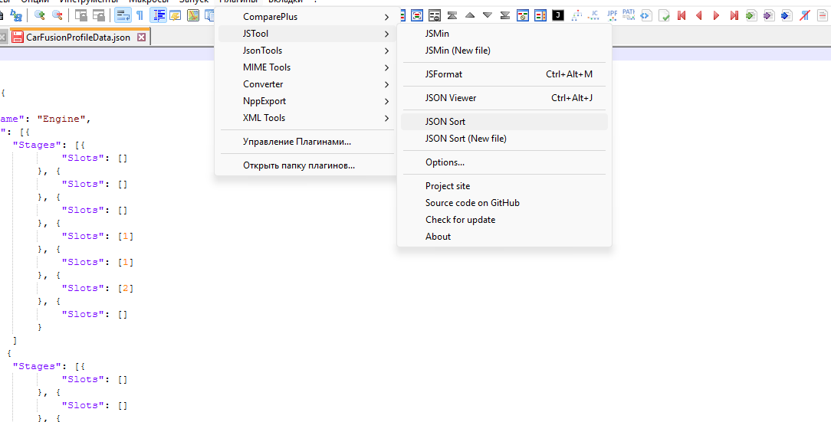

1. ***Processing purple cars***

In this and subsequent stages there will be work with NSB and cars. Now it is necessary to add purple/legend/TNR cars for get snapshots [512x]

1. Load account and get NSB
2. Add new cars (except gold) to inbox via picl. [gacha -1]

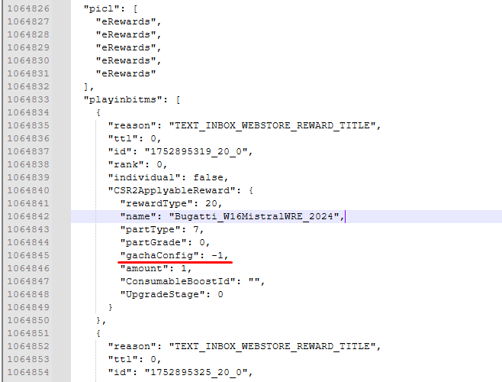

1. Launch the game, get new cars and close the game



***To update snapshots, the hub has a special folder Snapshots_PRE. Please use only this folder for updating!***

1. Go to android/data/com.naturalmotion.customtreetracer2/files/CarSnapshots/id/Default and copy snapshots new cars:

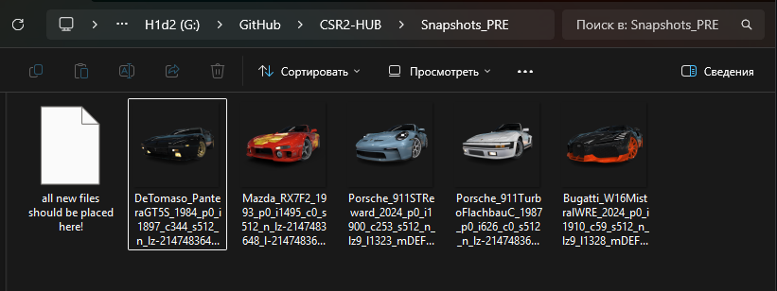

1. Next, you need to create folders according to the hierarchy principle: brand -> crdb; for each car:

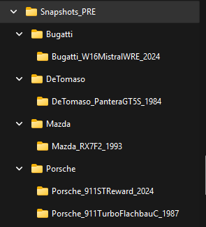

1. Move each snapshot in its corresponding folder and rename it to snap.png

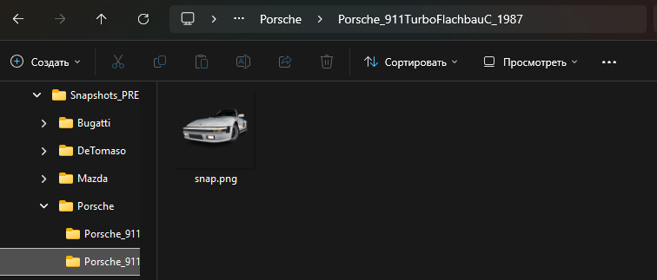

1. ***Processing gold cars***

Now it is necessary to add gold cars with all gacha options and get snapshots [512x]

Repeat the following steps for each car separately:

1. Go to CVD_PRE and open CarVisualData target car in AS

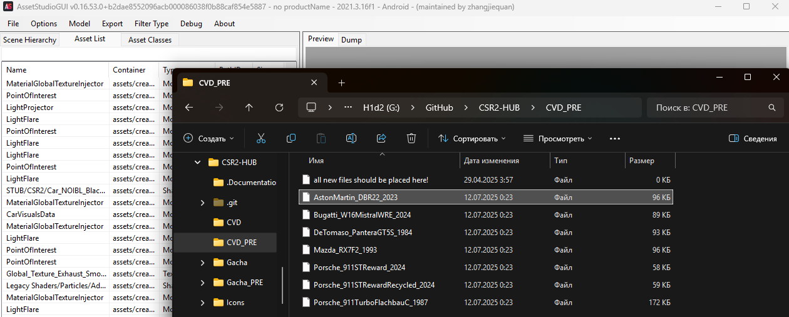

1. Open CarVisualData file and count the number of elements in GachaConfigs

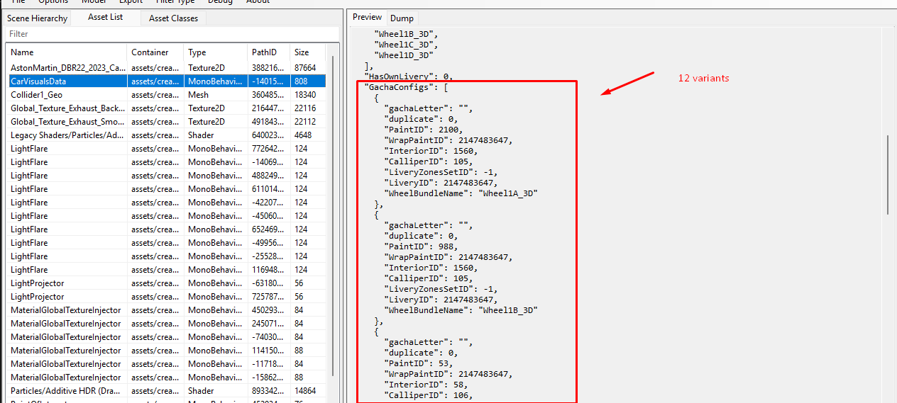

* If the elements do not contain duplicates (“duplicate” always 0): add all cars from 0 to the last element. Example: Aston has 12 variants, so we will add cars with index from 0 to 11
* If elements contain duplicates: skip all cars with duplicate value -1, but continue counting. Example: Aston has 4 variants, but we see that the second variant has 1 duplicate, therefore: we will use only indexes 0, 1, 3 *(2 is skipped because it is a duplicate)*

1. Add new cars to inbox via picl according to indexes:

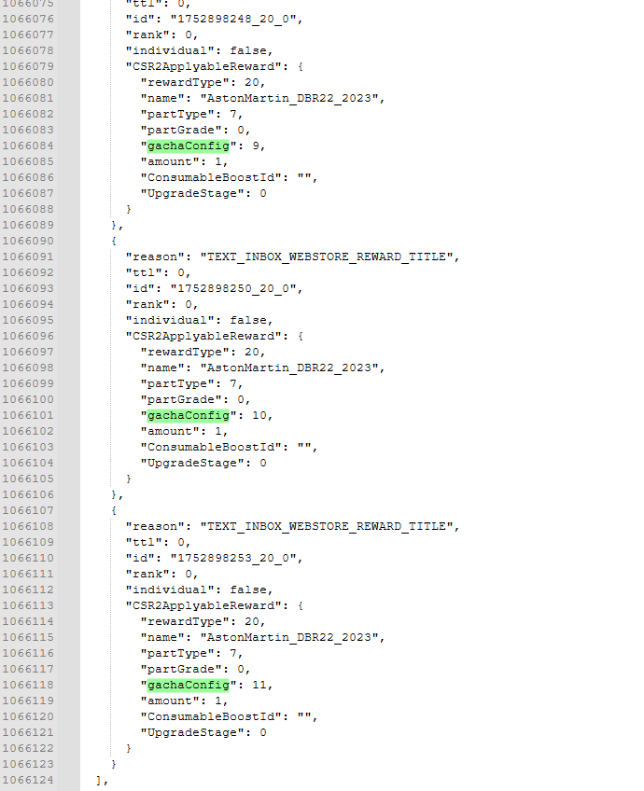

1. Launch the game, get cars and close the game
2. Create folder for car also according to the hierarchy principle:

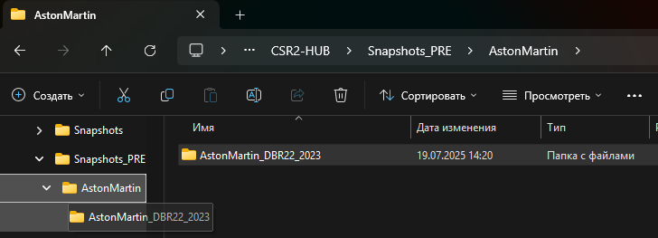

1. Go to android/data/com.naturalmotion.customtreetracer2/files/CarSnapshots/id/Default and copy all snapshots new car to folder:

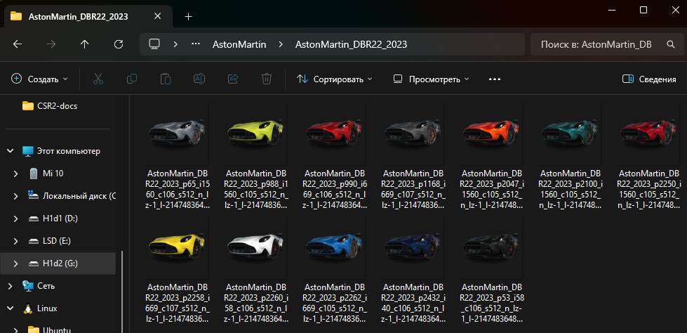

1. Rename each snapshot according to fgc: for example, if fgc4 - 4.png

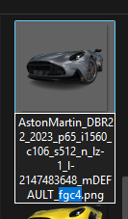 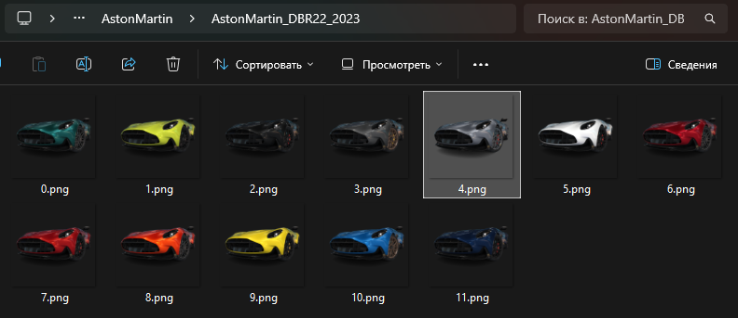

1. ***Processing full snapshots***

Now it is necessary to get full cars snapshots [1024x]



***To update snapshots, the hub has a special folder Snapshots_PRE. Please use only this folder for updating!***

1. Enable 1024x function in Fusion:

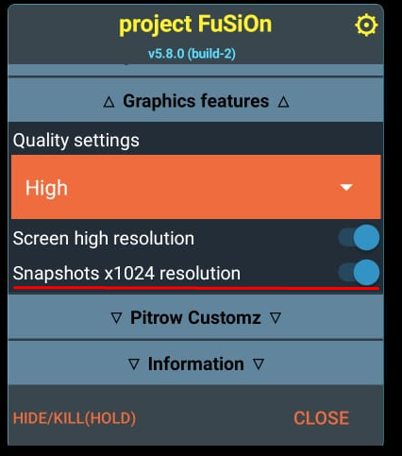

1. Add all new cars to inbox via picl. [gacha 0]

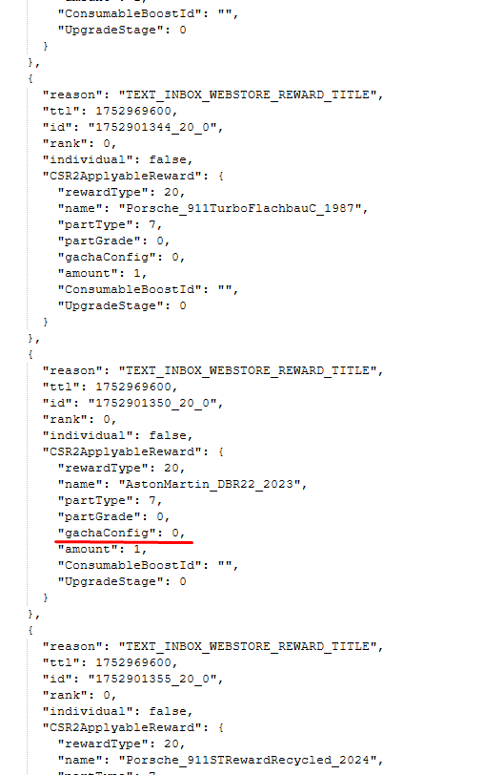

1. Launch the game, open the box and wait until all the snapshots are ready. (no need to pick up the cars)

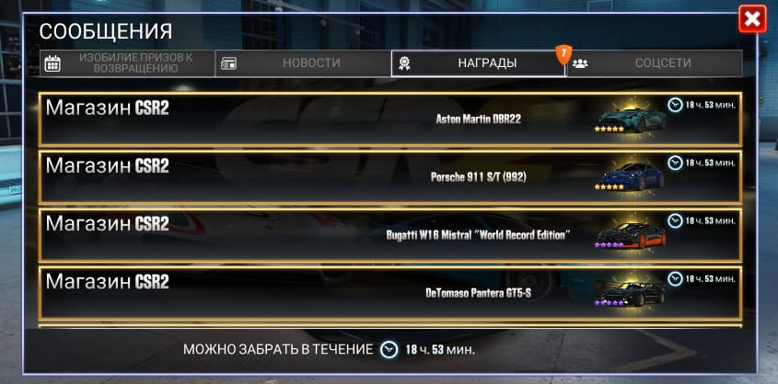

1. Go to android/data/com.naturalmotion.customtreetracer2/files/CarSnapshots/id and copy snapshots new cars to folder:

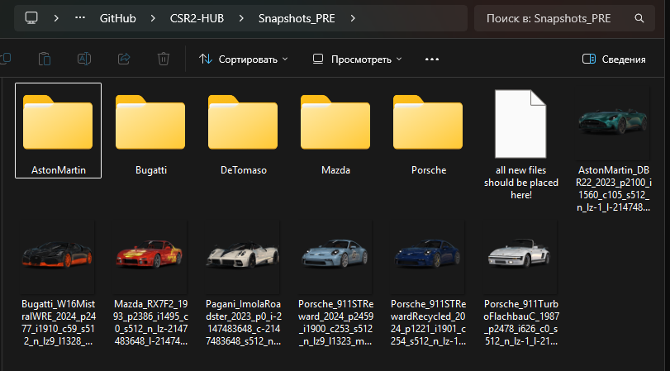

1. Move each snapshot in its corresponding folder and rename it to snap_full.png:

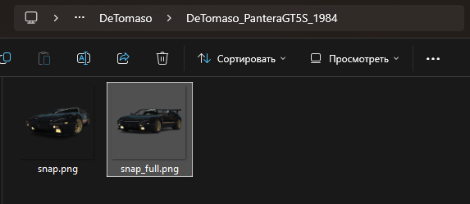

1. ***GitHub upload***
2. Open GitHub desktop and click fetch origin or/and pull origin:

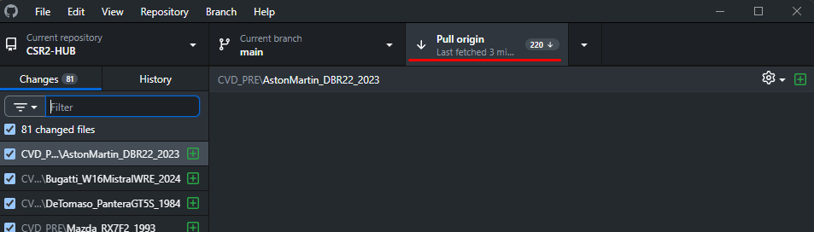

1. Write summary and click commit:

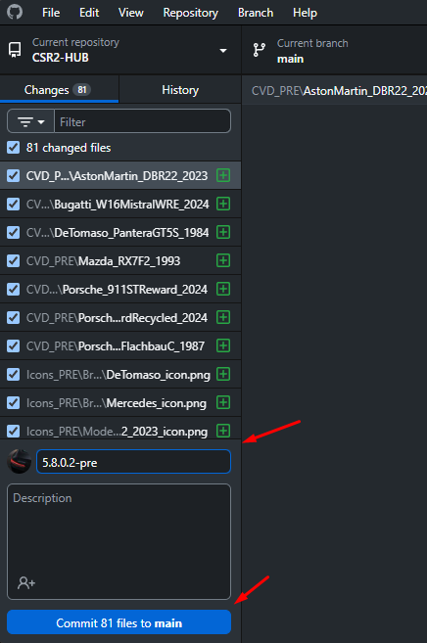

1. The final step is to press push origin:

