Ujian Akhir Praktikum - Semester Ganjil 2020/2021
Practicum Final Exam –Odd Semester Year 2020/2021
Matakuliah  Subject |  |  | ISYS6169 – Database Systems |  |  | 
Kelas  Class | : | BI01 / BG01 / BF01 |  | Tanggal Mulai  Start Date | : 21 December 2020
Kelas  Class | : |  |  | Waktu Mulai  Start Time | : 15:20
Dosen  Lecturer | : | D4605 - Roy Kurniawan, S.Kom., M.M.  D5053 - Richard, S.Kom., M.M  D5295 - Lay Christian, S.Kom., M.MSI |  | Tanggal Selesai  End Date | : 21 December 2020
Dosen  Lecturer | : |  |  | Waktu Selesai  End Time | : 17:20

PERATURAN UJIAN:
Exam Regulations:
- Mahasiswa tidak diperbolehkan berdiskusi dan/atau bekerja sama dengan peserta ujian lainnya
Student is not allowed to discuss and/or work together with other exam participants
- Mahasiswa tidak diperbolehkan untuk membuka dan menyalin dari BUKU atau CATATAN, VIDEO dari pengajar (recording kelas, VBL, Youtube, dsb) dan REFERENSI lainnya
Student isn't allowed to open and copy from any resources such as notes, videos (class recording, VBL, Youtube, etc) and other references
- Mahasiswa tidak diperbolehkan membuka dan menyalin jawaban dari internet (google, stackoverflow, dsb)
Student isn't allowed to open and copy answer from the internet (google, stackoverflow, etc)
- Asisten BERHAK memberi nilai 0 (NOL) bagi peserta ujian yang melakukan segala bentuk kecurangan
Assistant is able to give 0 (ZERO) score for exam participant who does any cheating actions
- Kumpulkan jawaban tepat pada waktunya, apabila terlambat mengumpulkan maka jawaban tidak akan dikoreksi dan nilai mahasiswa adalah 0
Submit the answer on time, if not, then the answer will not be checked, and the students will receive 0 (ZERO)
- Bila Anda tidak membaca peraturan ini, maka Anda dianggap telah membaca dan menyetujuinya
If you have missed to read these regulations, so you are considered to have read and agreed on it



SOFTWARE YANG DIGUNAKAN:
Software will be used:
- SQL Server Management Studio 18.5.1
- SQL Server Developer 2019
- Microsoft Office 365

FILE YANG DIKUMPULKAN:
File must be collected:
- SQL

PERHATIAN!
Attention!
- Bagi yang mengerjakan tidak sesuai dengan soal, maka akan diberikan nilai NOL (0)
For those who do not work in accordance with the exam case will be marked as ZERO (0)
- Bagi yang mengerjakan tidak sesuai dengan software dan versi yang telah ditetapkan, maka akan tetap dikoreksi dengan software dan versi yang telah ditetapkan
For those who do not work in accordance with the software and specific version will be corrected by the predefined software and version
- Kompres semua jawaban yang akan diunggah. Pastikan format pengumpulan nama file dan ekstensi sesuai dengan format berikut: [NIM]-[NAMA].zip
Compress all file that will be uploaded. Make sure the format for collecting file name and extension according to the following format: [NIM]-[NAME].zip

Tabel Relasional
Relational Table

Barbell Shop

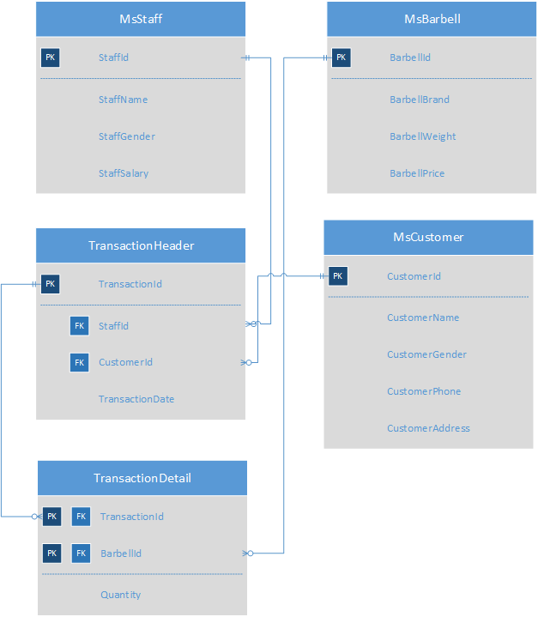

Soal
Case

- Display all customer data where customer name’s length is at least 10 characters.
(len)
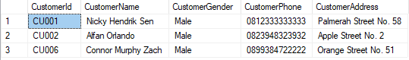

- Display CustomerName and Day of Transaction (obtained from the day of their transaction).
(datename, weekday)
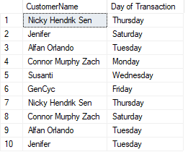

- Display Total Transaction (obtained from the total of staff who served transaction before March 2020)
(month, year)
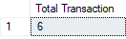

- Display Month (obtained from month name of transaction date), Total Barbells Sold (by adding all the barbells sold) and Average Barbells Sold (by showing the average of barbells sold for every transaction) for transactions done in February 2020. Then, combine it with displaying Month (obtained from month name of transaction date), Total Barbells Sold (by adding all the barbells sold) and Average Barbells Sold (by showing the average of barbells sold for every transaction) for transactions done in March 2020.
(union, month, year)
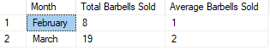

- Display Customer Initial (obtained from first character of customer name) and Total (obtained from total of the barbell bought and adding ‘ Barbell(s)’ in the end) for every Male Customers who bought barbell with weight 10 or 20.
(substring, cast)
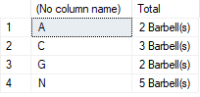

- Display CustomerName (obtained from customer last name) and Money Spent (obtained from sum of barbell quantity multiplied with barbell price) for customer who spent money more than the average of money spent.
(substring, len, charindex, reverse)
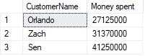

- Create a view named ‘ViewCustomerInformation’ by showing CustomerName in capital letters, CustomerGender, CustomerPhone (obtained by replacing the first two number ‘08’ with ‘+62’), and CustomerAddress
(upper, stuff)
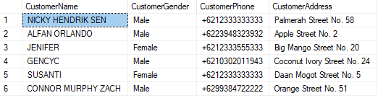

- Create a view named ‘ViewBarbellBrandTotalWeight’ to show BarbellBrand and Total Weight (obtained from the total of weight according to the brand by adding ‘ kg(s)’ in the end) for all barbell who weight more than 10 kg(s). Must be ordered by descending (from the heaviest)
(sum, cast, order by)
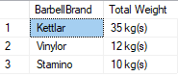

- Add ‘StaffAddress’ column to MsStaff table with type varchar(100) and add constraint that the address must have the word ‘Street’.
(alter table, add, add constraint)
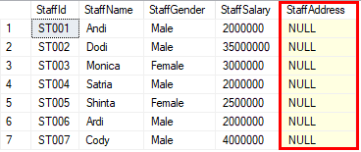

- Update all staff salary by adding it with 10% of its original value.
(update)
Before:
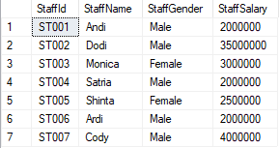

After:
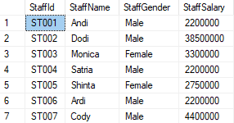

For questions regarding this exam, feel free to ask your teaching assistant!
Good Luck

