Problem 4 – Text Bombardment
Write a program that reads a text and line width from the console. The program should distribute the text so that it fits in a table with a specific line width. Each cell should contain only 1 character. It should then read a line with numbers, holding the columns that should be bombarded.
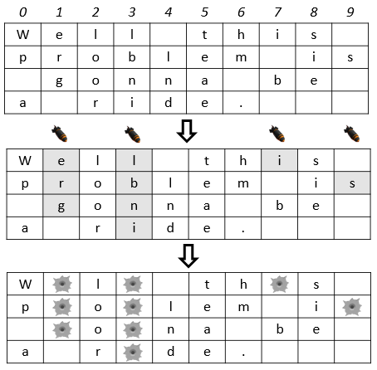
For example, we read the text "Well this problem is gonna be a ride." and line width 10. We distribute the text among 4 rows with 10 columns. We read the numbers "1 3 7 9" and drop bombs on those columns in the table.
The bombs destroy the character they fall on + all the neighboring characters below it. Note: Empty spaces below destroyed characters stop the bombs (see column 7).
Finally, we print the bombarded text on the console: "W l th s p o lem i o na be a r de."
Note: The empty cells in the table after the text should NOT be printed.

Input
The input data is read from the console.
- On the first line you will be given the text
- On the next lines you will be given the line width
- On the third line you will receive the columns that should be bombed (space-separated)
The input data will always be valid and in the format described. There is no need to check it explicitly.

Output
The output data must be printed on the console and should contain only 1 line: the bombarded text as a single string.

Constraints
- The text will contain only ASCII characters and will be no longer than 1000 symbols.
- The line width will be in the range [1…100].
- The columns will be valid integers in the range [1…<line width> - 1].
- A column will not be bombed more than once.
- Time limit: 0.25 seconds. Allowed memory: 16 MB.

Examples

Input | Output
Well this problem is gonna be a ride.  10  1 3 7 9 | W l th s p o lem i o na be a r de.

