Problem 2 – Jumping Sums
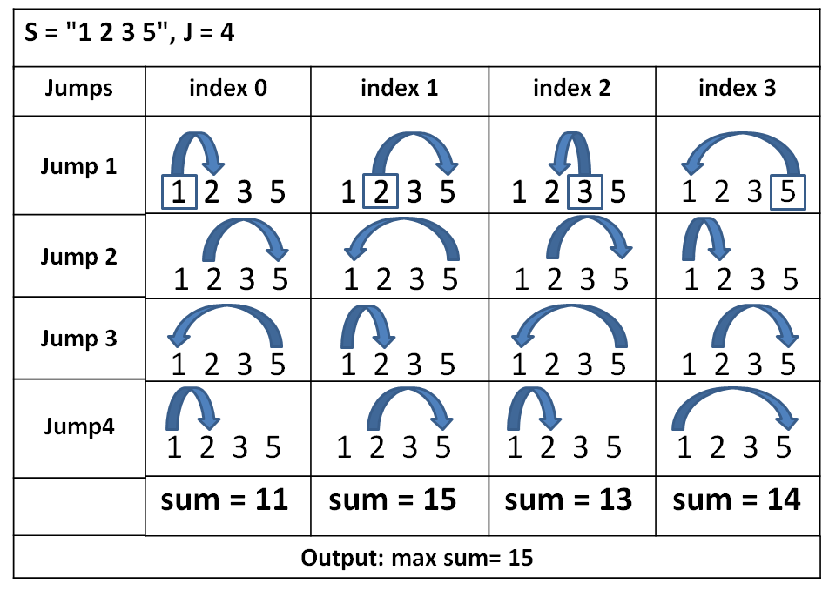
You are given a string S consisting of N numbers. Each of them have indexes ranging from 0 to N-1 and a value (integer number). You are also given a number J which represents the number of jumps to be made. Each of the numbers jumps J times to the right. Your task is to find all sums after each of the numbers has made its J jumps. The value of the number and the current index show the next index that we have to jump to (e.g. index = 3, value = 4, nextIndex = 3+4 =7). Example: if S = “2 1 2” and J=2. The first number “2” (index0) (sum1 += 2) should jump 2 positions to the right, so it jumps to the last number (index2). This index holds value 2 (sum1 += 2), so it jumps 2 indexes to the right. In this case, we don’t have enough indexes to the right so we restart from the beginning and the jump will land on index1 (sum1 += 1, sum1 = 5). For the second sum we start from the second position (index1, sum2 += 1). The next index is 1 position on the right (index2, sum2 += 2). The next position is 2 positions on the right with restart from the beginning (index1, sum2 += 1). Finally sum2 = 4. We repeat that process for every number in S. Your task is to find the biggest sum after every number has made enough jumps. Look at the picture on the right to understand your task better.

Input
The input data should be read from the console. It consists of 2 lines:
- At the first line you will be given string S holding integer numbers separated by a single space.
- At the second line you will be given integer J representing the number of jumps each number should make.
The input data will always be valid and in the format described. There is no need to check it explicitly.

Output
The output should be printed on the console. It should consist of exactly 1 line:
- On the first line print the maximal sum in the format “max sum = {0}”.

Constraints
- The string S will hold maximum of 100 numbers in the range [0…1000]
- The J input value will be an integer in the range [1…10000]
- Allowed working time: 0.2 seconds. Allowed memory: 16 MB.

Examples
Input | Output |  | Input | Output
1 2 3 5  4 | max sum = 15 |  | 165 782 15 77 15 20  102 | max sum = 23229

Input | Output |  | Input | Output
2 7 4 10 6 9  14 | max sum = 90 |  | 1 1 1 1 1 1 1  50 | max sum = 51

