# OWASP 04 – XML External Entities

## Walkthrough – Bank App

1. Log in to the application
2. Look at the template xml document used for the upload input (accountApplication_xxe.xml)
3. Notice the label that includes “test.txt” – this is a file on the local file system

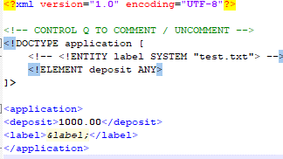

1. Upload the maliciously configured xml document to the application
2. Notice the label that returns the content of test.txt

## Exercises – Bank App

1. Update the bank application to filter out xxe entities of the xml text before passing in the contents into the legacy code